This workds only on p89v51rd2

Youttube channel

<https://www.youtube.com/watch?v=HTZ3CIswCso&t=323s>

flasgh magic download for 8051 option

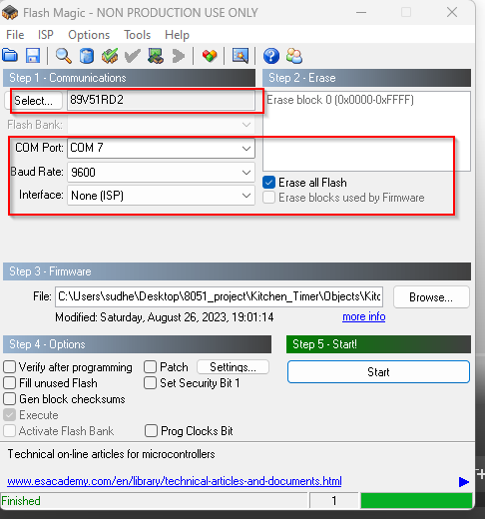

Untick everting in adavnc eoprtion

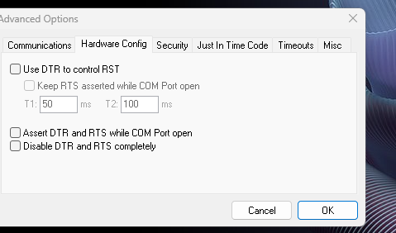

Press reset button

