FASHION FOR EVERYONE
An AI-Powered Fashion Styling Platform Using Generative AI and LoRA Fine-Tuning
By
SUDHARSAN BALAJEE | 23BAI1097
LAKSHAN CHANDRASEKAR | 23BAI1393
DHEERAJ REDDY S | 23BLC1233

A project report submitted to
Dr. Vijayarajan
SCHOOL OF COMPUTER SCIENCE AND ENGINEERING
In partial fulfillment of the requirements for the course of
BCSE303L – Deep Learning
In
B.Tech. COMPUTER SCIENCE AND ENGINEERING (SPECIALIZATION IN AI)
Vellore Institute of Technology, Chennai
Vandalur-Kelambakkam Road, Chennai – 600127

FASHION FOR EVERYONE
An AI-Powered Fashion Styling Platform Using Generative AI and LoRA Fine-Tuning
1. Introduction & Motivation
The fashion industry has historically been gated by access — bespoke tailoring and personalised styling remain luxuries available to few. Fashion For Everyone is an AI-driven platform designed to democratise personalised fashion by enabling any user to generate custom clothing designs through a natural-language chat interface. By combining state-of-the-art generative diffusion models with domain-specific fine-tuning, the platform delivers photorealistic garment visualisations tailored to individual preferences in seconds.
The system is built as a full-stack web application backed by a multi-stage machine learning pipeline: automated data collection from major fashion retailers, AI-driven garment segmentation to produce a clean training corpus, and LoRA fine-tuning of FLUX 2.0 Klein to specialise the model on fashion vocabulary. A production-grade Next.js web application exposes the model to end users through a conversational interface with persistent history, user authentication, and per-user generation quotas.
1.1 Objectives
- Construct a high-quality fashion dataset by scraping and filtering product images from Myntra and Zara India.
- Implement an automated segmentation pipeline using Grounding DINO and SAM 2.1 to extract clean flat-lay garment images.
- Fine-tune FLUX 2.0 Klein with LoRA on 348 structured garment image-caption pairs to specialise it for fashion generation.
- Build a prompt engineering and sanitisation layer to constrain model outputs to the trained distribution.
- Develop a full-stack Next.js web application with chat-based interaction, user authentication, quota management, and image generation.
- Implement production-grade security including prompt sanitisation, rate limiting, and content policy enforcement.

2. Dataset & Pre-Processing
2.1 Data Sources
Two major Indian fashion e-commerce platforms are used as data sources. Myntra provides product listings with structured descriptions across men's and women's categories including t-shirts, casual shirts, formal shirts, sweatshirts, jackets, blazers, suits, jeans, trousers, and ethnic wear. Zara India serves as the primary source for the final LoRA training corpus, supplying high-resolution product photography across 20 clothing categories (10 men's, 10 women's) with rich metadata including product names and descriptions.
2.2 Web Scraping Pipeline
Two purpose-built scrapers are developed for automated data collection.
Myntra Scraper
A Playwright-based headless Chrome scraper extracts product images and descriptions from Myntra. It handles dynamic JavaScript-rendered pages, applies anti-detection measures, and navigates category-specific URLs to collect image URLs and captions at scale.
Zara Scraper
An asynchronous scraper with JavaScript rendering support is built for Zara India's Single Page Application. It handles product catalogue pagination with lazy-loading, extracts multi-image galleries from product detail pages, and applies a three-strategy human detection filter to retain only flat-lay product photography:
- Primary: YOLOv8 nano person detection (COCO class 0, >8% frame area threshold triggers rejection).
- Fallback 1: OpenCV Haar cascade face detection.
- Fallback 2: HSV skin-tone ratio analysis (>12% threshold triggers rejection).
Each category targets 100 clean flat-lay images. After human filtering, approximately 1,500 raw products are reduced to the final curated set.
2.3 Clothing Segmentation Pipeline
Raw product images often contain backgrounds, props, or partial occlusions unsuitable for LoRA training. A two-stage segmentation pipeline is developed and executed on Google Colab GPU:
Stage 1 — Grounding DINO Detection
The IDEA-Research/grounding-dino-tiny model is used for open-vocabulary, text-grounded bounding box detection. Category-specific text prompts (e.g., "t-shirt. crew neck top.") are issued per image with tuned confidence thresholds (0.25–0.30 for Western wear, 0.15–0.20 for ethnic garments) to maximise recall while suppressing false positives.
Stage 2 — SAM 2.1 Segmentation
The Segment Anything 2.1 Hiera Large checkpoint refines each bounding box into a pixel-accurate segmentation mask. Post-processing applies convex hull filling to close garment openings such as neck holes and sleeve ends. Each garment is exported with three outputs: a white-background JPEG, a transparent-background PNG, and a binary mask PNG. A metadata JSON records detection scores, class labels, and bounding coordinates per image.
2.4 Training Dataset Construction
The final LoRA training dataset comprises 348 image-caption pairs sourced from the segmented Zara dataset. Captions follow a strict structured format derived from an audit of Zara product descriptions:
- Always begin with the activation phrase "front view of" or "back view of".
- Describe: fit (slim, relaxed, oversized), garment type, fabric composition, and construction details.
- Explicitly exclude: colours, scenes, lighting conditions, and aesthetic adjectives.
- Caption length capped at 400 characters to match inference-time prompt constraints.
Example caption: "front view of brown slim fit blazer made from a main viscose fabric. featuring a notched lapel collar, long sleeves with buttoned cuffs, a chest welt pocket, hip flap pockets, inside pocket details, back vents and front button fastening."
3. Model Architecture
3.1 Grounding DINO — Open-Vocabulary Detector
Grounding DINO (IDEA-Research/grounding-dino-tiny) is a vision-language detection transformer that accepts arbitrary natural-language category descriptions as input rather than a fixed class vocabulary. It produces bounding boxes with confidence scores for each described category. In this pipeline it serves as the first stage of garment localisation, enabling detection of diverse garment types without retraining.
3.2 SAM 2.1 Hiera Large — Segment Anything
Segment Anything Model 2.1 (Hiera Large checkpoint) is a promptable image segmentation model capable of producing high-quality pixel masks from bounding box or point prompts. Given Grounding DINO's bounding box outputs as spatial prompts, SAM 2.1 generates precise garment masks. Post-processing with convex hull operations fills anatomical gaps (necklines, armholes) to produce contiguous silhouettes suitable for LoRA training.
3.3 FLUX 2.0 Klein — Generative Diffusion Model
FLUX 2.0 Klein is a rectified-flow diffusion transformer developed by Black Forest Labs, designed for high-fidelity text-to-image synthesis. The base model is specialised for the fashion domain through LoRA (Low-Rank Adaptation) fine-tuning.
LoRA Fine-Tuning
LoRA injects trainable low-rank decomposition matrices into the attention layers of the frozen base model. Only the rank-decomposition matrices are updated during training, dramatically reducing trainable parameter count while preserving base model generalisation. The trained LoRA weights are serialised as fashion_for_everyone_v1.safetensors (~80 MB) and deployed via the fal.ai inference API with a strength of 0.85.
Inference Parameters
- Steps: 28 (standard FLUX-recommended inference steps).
- Guidance scale: 3.5 (low classifier-free guidance for naturalistic outputs).
- Image size: portrait_4_3 (800 × 1000 pixels).
- LoRA strength: 0.85 (high adherence to the fashion training distribution).
4. Training Procedure
The LoRA fine-tuning is conducted on the 348-image training corpus using a compatible trainer (kohya_ss, ai-toolkit, or SimpleTuner). The training process is guided by a carefully engineered caption schema to maximise activation phrase consistency and garment vocabulary specificity.
4.1 Dataset Preparation
The file_renamer.py utility consolidates multi-category segmented outputs into a flat numbered directory structure expected by standard LoRA trainers: 1.jpg / 1.txt, 2.jpg / 2.txt, …, 348.jpg / 348.txt. Each .txt file contains the structured caption for its paired image.
4.2 Caption Engineering Strategy
Caption quality is the primary driver of LoRA activation and output consistency. The following rules are enforced across all 348 training captions:
- Activation token: every caption begins with "front view of" or "back view of" to establish a consistent LoRA trigger phrase.
- Structured vocabulary: fit → garment type → fabric → construction details (pockets, closures, collar, cuffs, vents).
- No colour references: colours are excluded to prevent colour bias in generated outputs.
- No scene or lighting descriptors: ensures the model focuses on garment structure rather than photographic style.
- Length constraint: captions are capped at 400 characters to align with inference-time prompt budgets.
4.3 LoRA Hyperparameters
The LoRA adapter is configured with rank and alpha values appropriate for a domain-specific fine-tune on a compact dataset. Training is performed on GPU (A100 or equivalent recommended) using mixed-precision (bf16) to reduce memory footprint. The base FLUX 2.0 Klein weights remain fully frozen throughout training; only the injected low-rank matrices are updated.
4.4 Deployment
The trained LoRA weights (fashion_for_everyone_v1.safetensors) are uploaded to the fal.ai model hub. The web application references the LoRA via the LORA_URL environment variable and invokes it through the FAL_MODEL_ID endpoint at inference time. The LoRA is purely an inference-time adapter and adds no latency overhead beyond standard FLUX inference.
5. Web Application
The platform is delivered as a full-stack Next.js 14 application with React 18, TypeScript, Tailwind CSS, and a PostgreSQL database managed through Prisma ORM. User authentication is handled by Clerk. The application exposes a conversational chat interface backed by persistent message history and server-side image generation.
5.1 Configuration & Technology Stack
Layer | Technology | Purpose
Frontend | Next.js 14, React 18, TypeScript | Server-rendered UI with client-side interactivity
Styling | Tailwind CSS 3.4, Material Design 3 | Responsive, accessible component styling
Authentication | Clerk (@clerk/nextjs 6.9) | User sign-up, sign-in, session management
Database | PostgreSQL + Prisma ORM 5.22 | Persistent chats, messages, users, quotas
Image Generation | fal.ai API + FLUX 2.0 Klein LoRA | Serverless diffusion model inference
Validation | Zod 3.23 | Runtime schema validation for API inputs
Deployment | Next.js build + Node.js runtime | Production SSR with API routes

5.2 Prompt Sanitisation
Raw user messages pass through a server-side prompt sanitiser (lib/promptSanitizer.ts) before reaching the inference API. The sanitiser enforces the LoRA training distribution at inference time:
- Input length capped at 2,000 characters; control characters stripped.
- Injection patterns and out-of-distribution requests (NSFW, non-fashion topics) are blocked.
- Activation phrase ("front view of" / "back view of") is prepended automatically.
- Sanitised prompt capped at 400 characters to match training caption length.
- Raw and sanitised prompt versions are persisted to the Prompt table for reproducibility auditing.
5.3 Rate Limiting & Quota Management
A two-tier resource control system prevents abuse and manages inference costs:
Mechanism | Parameters | Behaviour
Per-request token bucket | 10 burst, 0.1 tokens/sec refill | Throttles rapid successive requests per user
Monthly generation quota | 50 credits per user (default) | Decremented on each successful generation
Credit refund | Automatic on generation failure | Ensures fair billing on API errors
Audit ledger | CreditTransaction table | Logs grant / consume / refund / adjustment events

5.4 API Routes & Features
The backend exposes RESTful API routes under /api/:
- chats/ — CRUD operations for conversation threads.
- messages/ — Message persistence with role tagging (user / assistant / system).
- generate/ — Image generation endpoint with auth guard, quota check, prompt sanitisation, and fal.ai dispatch.
- wardrobe/ — Smart closet management (upload, tag by category, colour, brand, season).
- favorites/ — Save and list favourite generated looks.
- me/ — User profile with style preferences (gender, body type, size, preferred colours, style tags).
- webhooks/clerk/ — Clerk event handler for user sync on registration and deletion.
5.5 Security
- Content Security Policy (CSP) headers restrict resource loading to trusted origins.
- X-Frame-Options: DENY and Referrer-Policy headers prevent clickjacking and data leakage.
- Origin header validated against Host to mitigate CSRF.
- Image URL allowlist restricts rendered images to trusted hosts (e.g., fal.media).
- All database access is mediated through Prisma parameterised queries, preventing SQL injection.
6. Evaluation & Performance
6.1 Segmentation Pipeline Quality
Segmentation quality is assessed through visual inspection using the built-in quality assurance visualiser, which renders annotated images with bounding boxes, confidence scores, and overlaid masks. Category-specific detection thresholds are tuned via a threshold sweep to balance recall (avoiding missed garments) and precision (avoiding background inclusions). Convex hull post-processing significantly reduces mask fragmentation on open-neck and sleeveless garments.
6.2 Generation Quality
The fine-tuned FLUX 2.0 Klein + LoRA model is evaluated through prompt-response inspection on a held-out set of novel garment descriptions. Key qualitative metrics include:
- Activation fidelity: correct response to the LoRA trigger phrase ("front view of" / "back view of").
- Vocabulary adherence: accurate rendering of fit, garment type, fabric texture, and construction details described in the prompt.
- Generalisation: plausible outputs for garment descriptions not seen verbatim in the training corpus.
- Photorealism: sharp, high-fidelity images at 800 × 1000 resolution without visible artefacts.

Sample images generated:
Prompt:
‘front view of slim fit blazer made from navy wool fabric. featuring a notched lapel collar, long sleeves with buttoned cuffs, a chest welt pocket, hip flap pockets, back vents and front button fastening.’
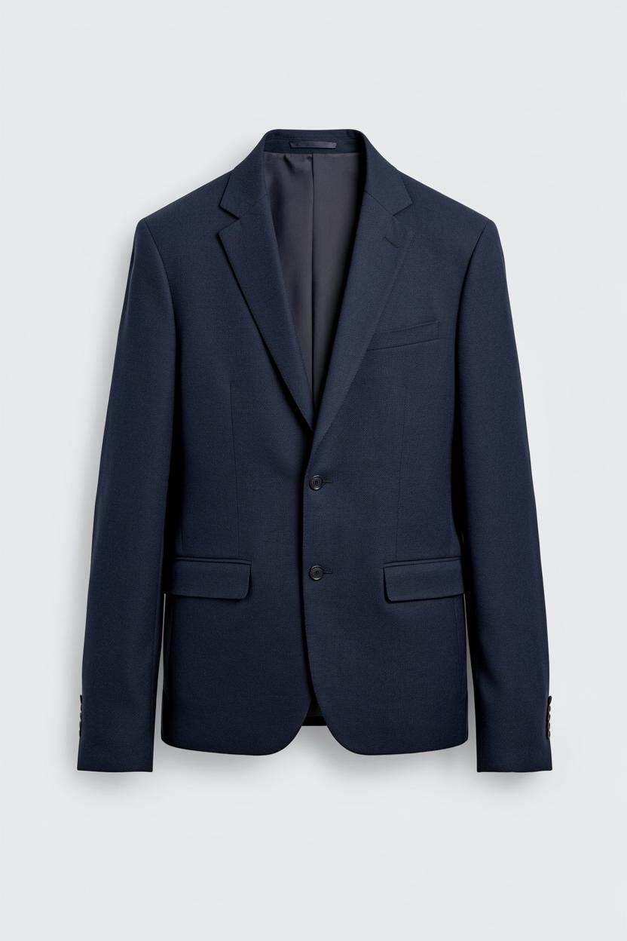

Prompt:
‘back view of relaxed fit hoodie sweatshirt made of heavyweight cotton fabric with a looped lining. hoodie neck and long sleeves. front kangaroo pocket. ribbed trims.’
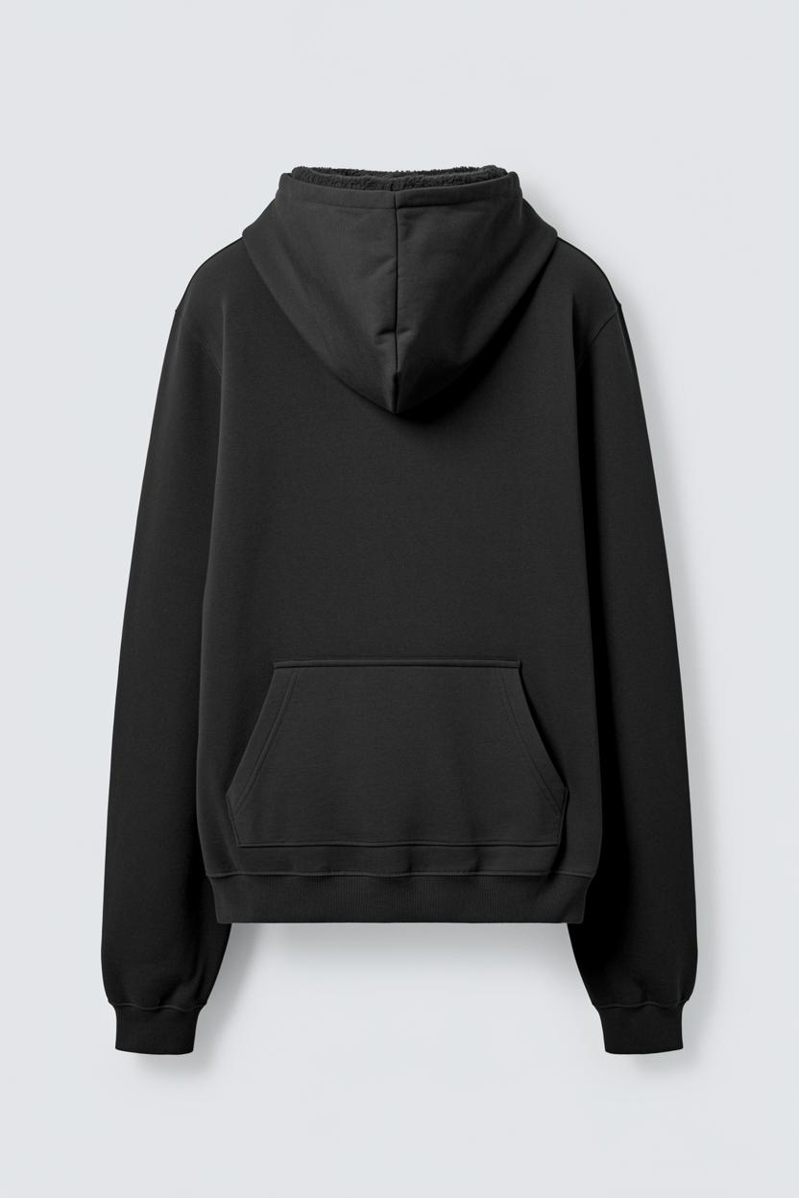

Prompt:
‘front view of wide flare fit jeans made from washed cotton denim. mid-rise. rigid fabric. front pockets and patch back pockets. zip fly and button fastening.’
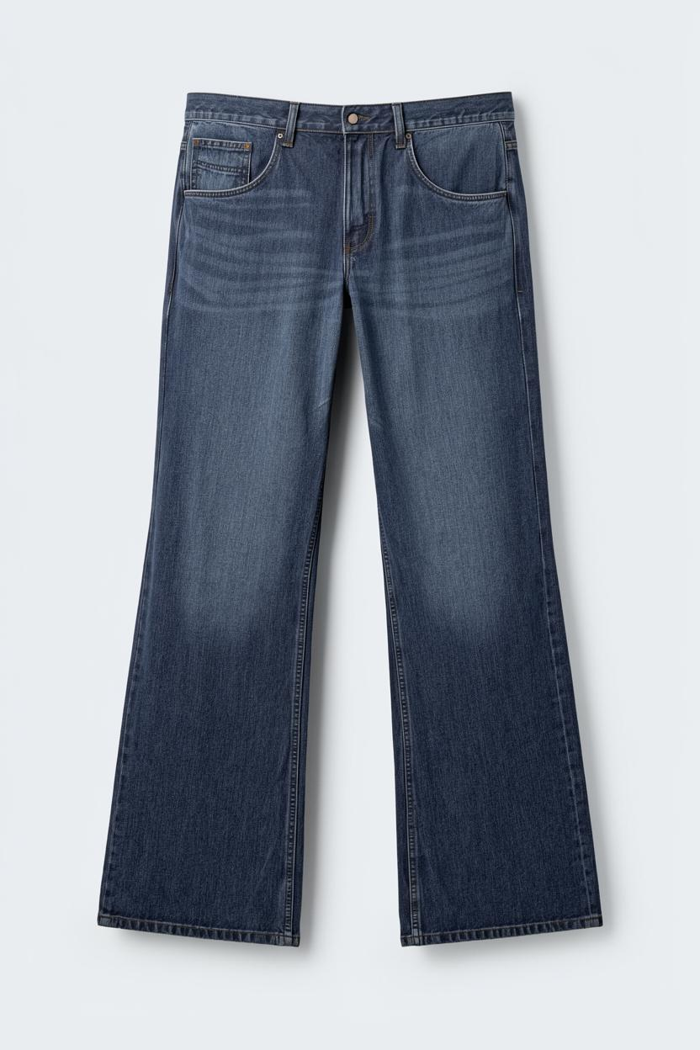

Prompt:
‘back view of relaxed fit trousers made from a wool blend fabric. featuring front pockets, rear welt pockets and zip fly and top button fastening.’
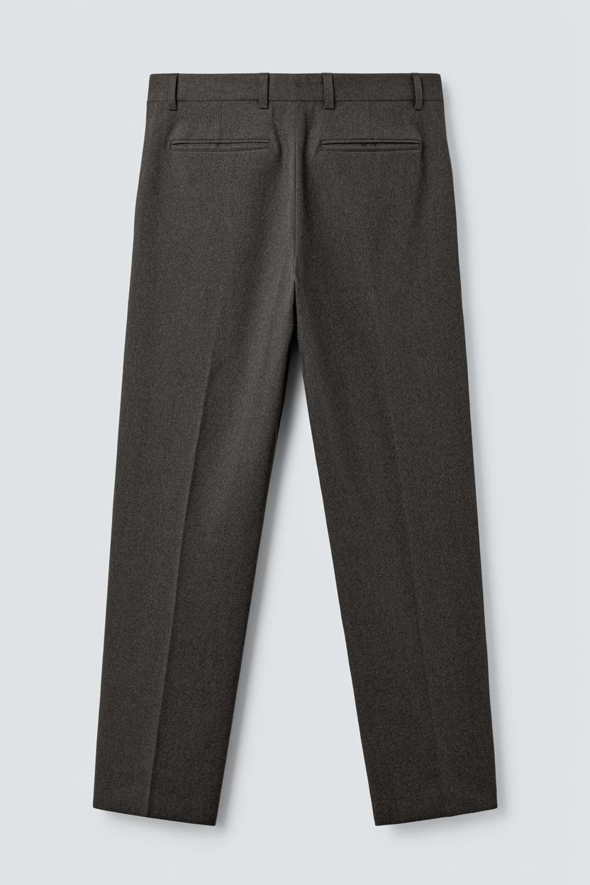

6.3 Web Application Performance
The Next.js application achieves fast initial page loads through server-side rendering of static content and dynamic streaming of the chat interface. Image generation latency is dependent on fal.ai inference throughput (typically 10–30 seconds per image). Chat message round-trips are handled asynchronously with optimistic UI updates to maintain perceived responsiveness.
7. System Architecture Summary
Module | Technology | Role
Myntra Scraper | Playwright, BeautifulSoup4 | Category-level product image + caption collection
Zara Scraper | Playwright async, YOLOv8, OpenCV | Flat-lay image collection with human detection filter
Garment Detector | Grounding DINO (HuggingFace) | Open-vocabulary text-grounded bounding box detection
Segmentation | SAM 2.1 Hiera Large, NumPy | Pixel-accurate garment mask extraction
Dataset Builder | Python, file_renamer.py | Flat-numbered image-caption pairs for LoRA training
Generative Model | FLUX 2.0 Klein + LoRA (fal.ai) | Text-to-image garment generation
Prompt Sanitiser | TypeScript (lib/promptSanitizer.ts) | Distribution-constrained prompt validation
Web Frontend | Next.js 14, React 18, Tailwind CSS | Chat interface, image display, wardrobe management
Backend API | Next.js API Routes, Prisma ORM | CRUD for chats, messages, users, quota ledger
Authentication | Clerk | User identity, session management, webhook sync
Database | PostgreSQL | Persistent storage for all application entities
Quota System | Token bucket + credit ledger | Per-request throttling and monthly usage limits

8. Limitations & Future Work
8.1 Current Limitations
- The training dataset of 348 images is limited to men's clothing from Zara India; the model shows reduced fidelity on women's garments and non-Western ethnic wear.
- LoRA fine-tuning on a small dataset can cause overfitting to Zara's specific product photography style, limiting generalisation to other visual styles.
- Colour information is entirely excluded from training captions, meaning colour-specific generation requests are handled solely by the base FLUX model without LoRA guidance.
- The segmentation pipeline requires GPU-enabled Google Colab execution and cannot run locally without significant hardware resources.
- Generation latency (10–30 seconds via fal.ai) may degrade user experience; no streaming or partial-result preview is currently implemented.
- Multi-garment outfit composition (combining top, bottom, and accessories in a single image) is not supported in the current LoRA design.
8.2 Future Improvements
- Expand the training corpus to include women's garments, ethnic wear, and multi-brand imagery to improve generalisation.
- Reintroduce colour as a conditioned input using a colour-token prefix strategy to enable colour-specific generation.
- Integrate a virtual try-on module (e.g., IDM-VTON or CatVTON) to overlay generated garments onto user-provided body images.
- Add multi-garment composition by training a separate LoRA for outfit-level captioning.
- Implement streaming image generation with progressive preview using fal.ai's real-time event API.
- Quantise the LoRA adapter to INT8 / GGUF format to enable on-device inference on consumer laptops.
- Add an admin analytics dashboard for monitoring generation patterns, quota usage, and model drift.
- Extend the wardrobe module with automatic garment categorisation from user-uploaded photos using the existing Grounding DINO pipeline.
9. Conclusion
Fashion For Everyone demonstrates a complete end-to-end pipeline from raw data acquisition to production-deployed generative AI. The project synthesises web scraping, computer vision (Grounding DINO + SAM 2.1), generative modelling (FLUX 2.0 Klein + LoRA), and full-stack web engineering (Next.js, Prisma, Clerk) into a cohesive, deployable platform. The 348-image LoRA training corpus is assembled entirely through automated pipelines — scraping, human detection filtering, segmentation, and caption engineering — without manual annotation.
The platform validates the viability of domain-specific LoRA fine-tuning on compact, high-quality datasets as an effective strategy for specialising large diffusion models to vertical applications. The combination of structured prompt engineering, server-side sanitisation, and inference-time parameter control ensures that the generative model operates reliably within its trained distribution at scale.

