**Black Box Testing**

|  |  |  |  |  |  |
| --- | --- | --- | --- | --- | --- |
| **Test no.** | **Test Scenario** | **Testing Data** | **Expecting Result** | **Result** | **Remark** |
| **1.** | Username and password is valid | Both input is valid | Successfully logged in | Successful | Pass |
| **2.** | User input invalid username or password | At least one input is invalid | Log in unsuccessful | Invalid username or password | Fail |
| **3.** | Book details added by users are valid | All inputs are valid | Added successfully | Successful | Pass |
| **4.** | Personal details added by users are valid | All inputs are valid | Registered successfully | Successful | Pass |
| **5.** | User input valid ID to update | ID is valid | ID matched with existing data | Valid ID | Pass |

**UNIT TESTING**

1. 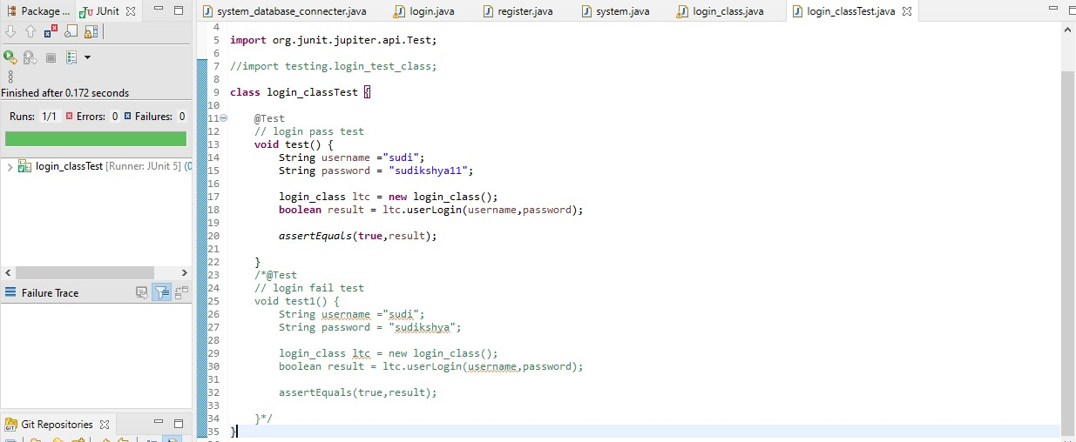**Login test (pass)**
2. 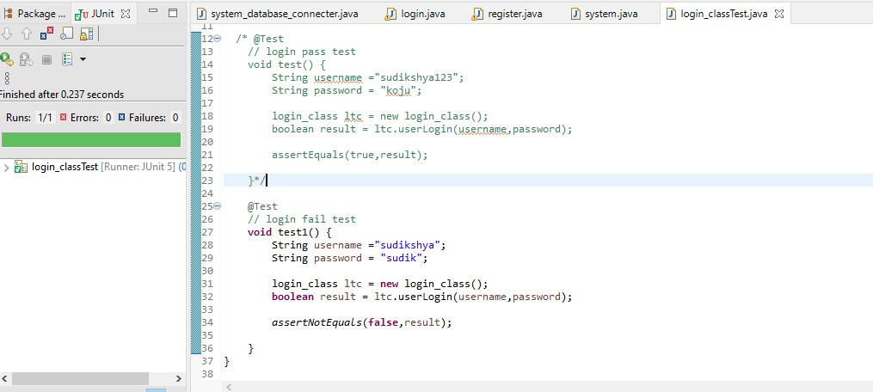**Login test**
3. 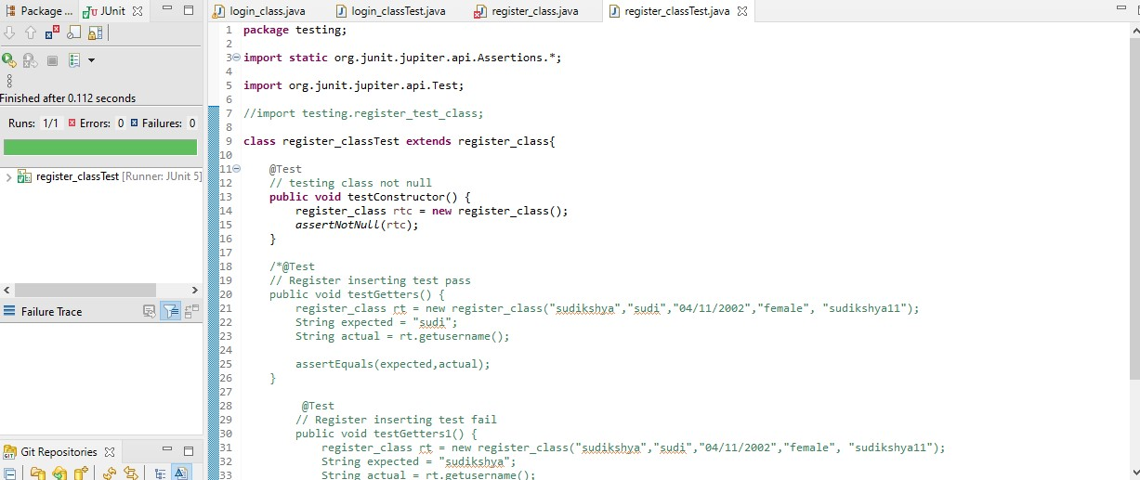**Register class not null**
4. 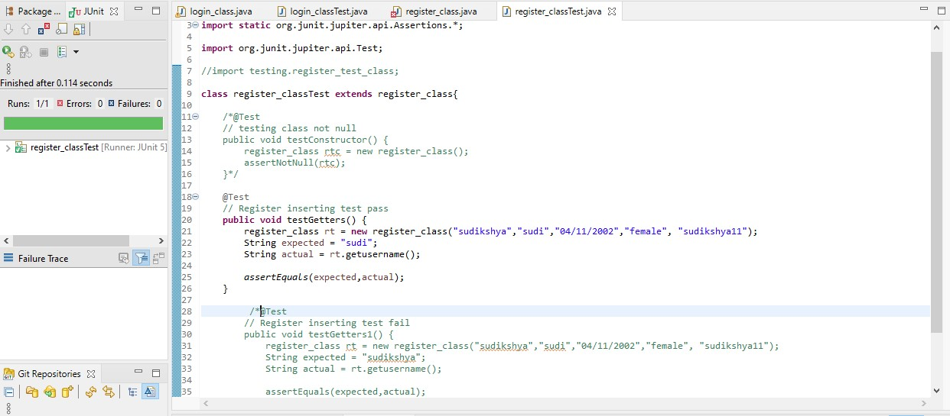**Register insert (pass)**
5. 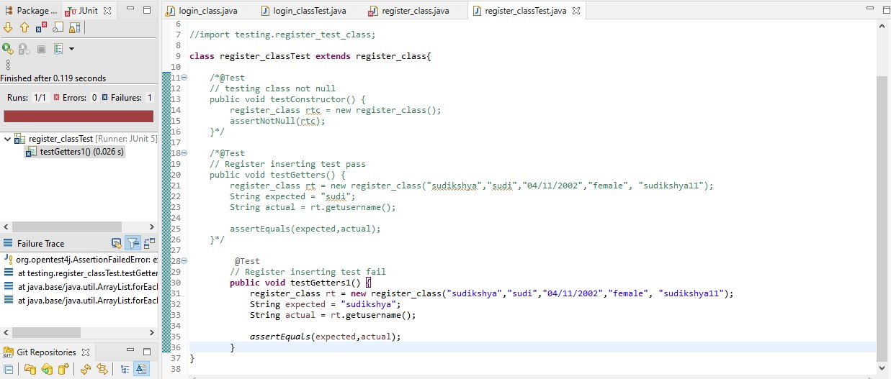**Register insert (fail)**