1. Recruiter Dashboard
The recruiter module of CareerBridge provides recruiters with the tools required to manage job opportunities and candidates throughout the recruitment process. After successful authentication, the recruiter can access a dashboard that provides an overview of important recruitment activities.

Development Approach
The project follows an Agile development approach. Agile is suitable for CareerBridge because the system contains different modules and user roles. The work can be divided into smaller tasks and developed incrementally. Regular reviews, testing, feedback, and improvements allow the team to identify issues and refine the system during development.

Trello Project Management
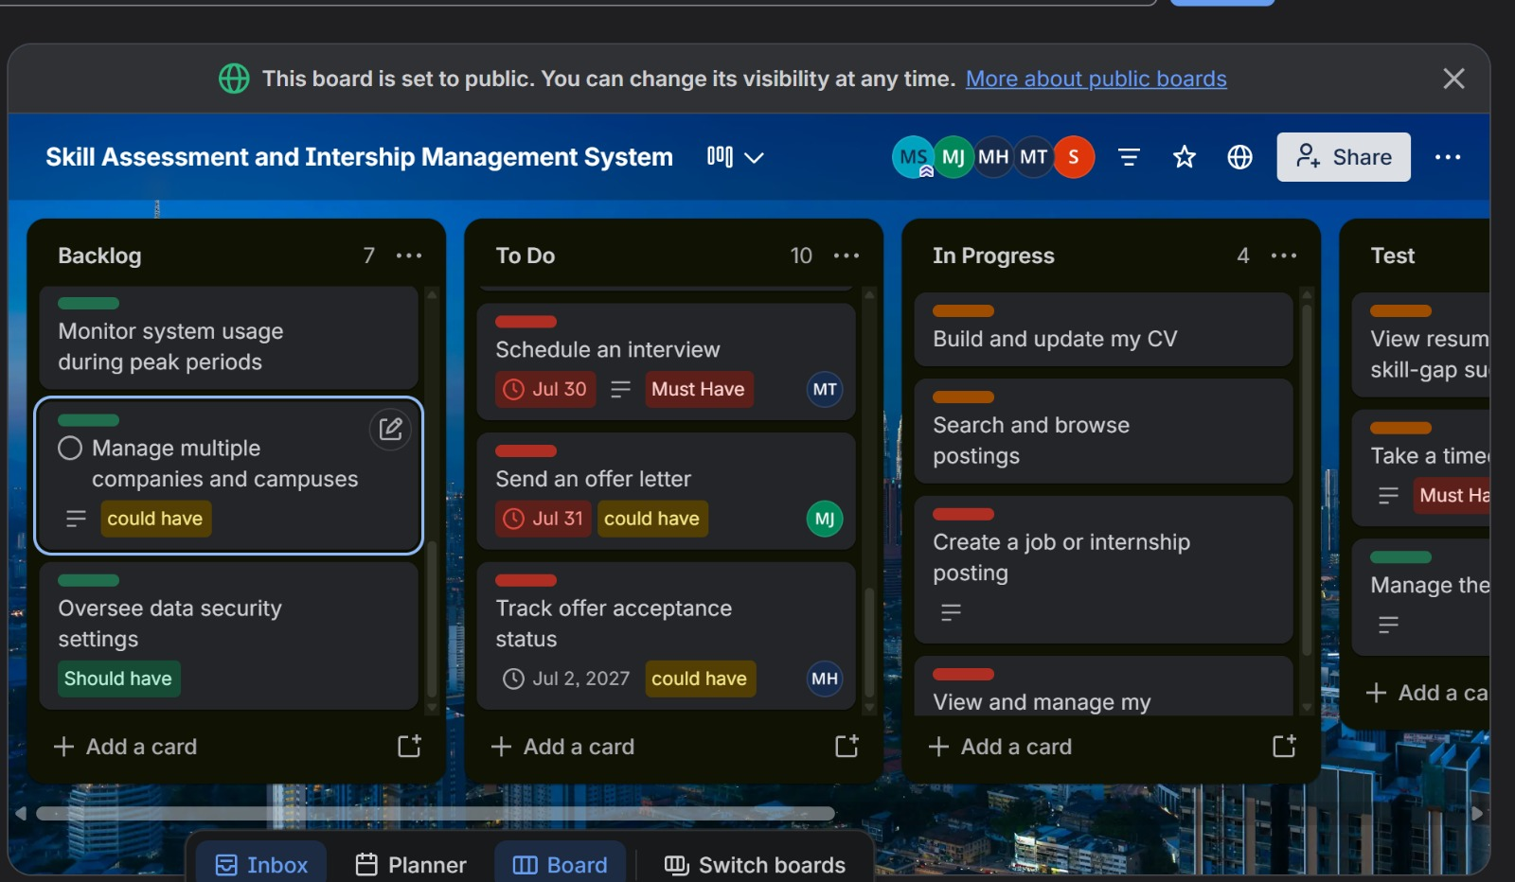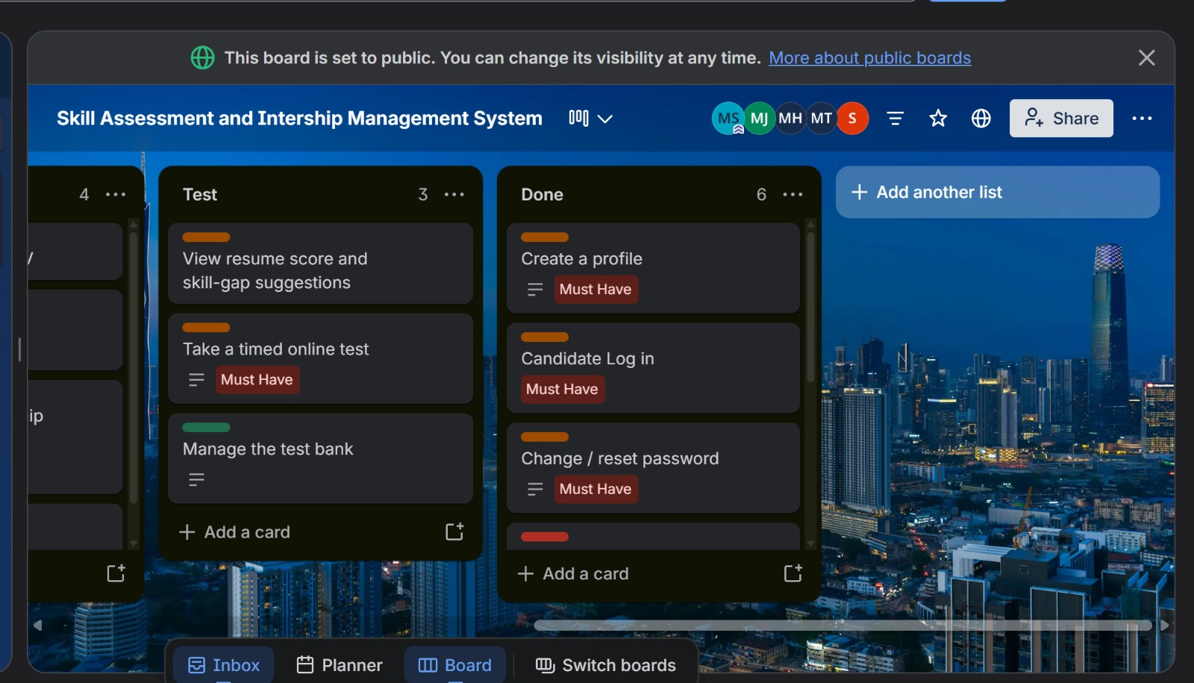 Figure 1: Trello board showing recruiter-module task planning and progress.

Recruiter Dashboard
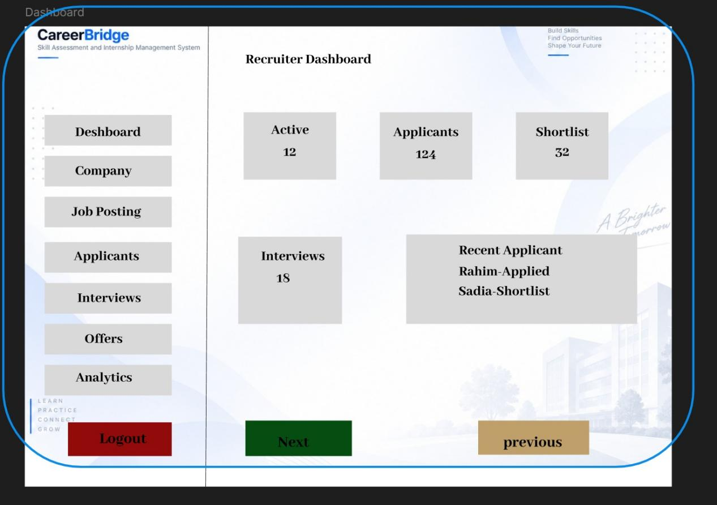Figure 2: Recruiter Dashboard Interface
Screen 07 provides the recruiter with a centralized dashboard for managing recruitment activities. After logging in, the recruiter can access different sections of the system, including job posting, applicants, interviews, offers, analytics, and company information.
The dashboard makes it easier for recruiters to navigate between different recruitment functions and monitor their activities from one place. It acts as the main entry point for the recruiter module.

Functional Requirements Covered
- Recruiter authentication.
- Access to the recruiter dashboard.
- Access to job posting management.
- Applicant management.
- Interview and offer management.
- Access to recruitment analytics.
- Access to company information.

Non-Functional Requirements
Usability: The dashboard should provide clear navigation so recruiters can easily access different functions.
Performance: Dashboard information should load efficiently and respond quickly to user actions.
Security: Recruiter accounts and recruitment information should be protected from unauthorized access.
Reliability: Dashboard functions and recruitment information should work consistently.
Maintainability: The dashboard should be organized into separate modules so that features can be maintained and updated easily.

2. Job Posting and Management
CareerBridge allows recruiters to create and manage job and internship opportunities. This functionality helps recruiters provide candidates with accurate information about available positions.

Job Posting and Management

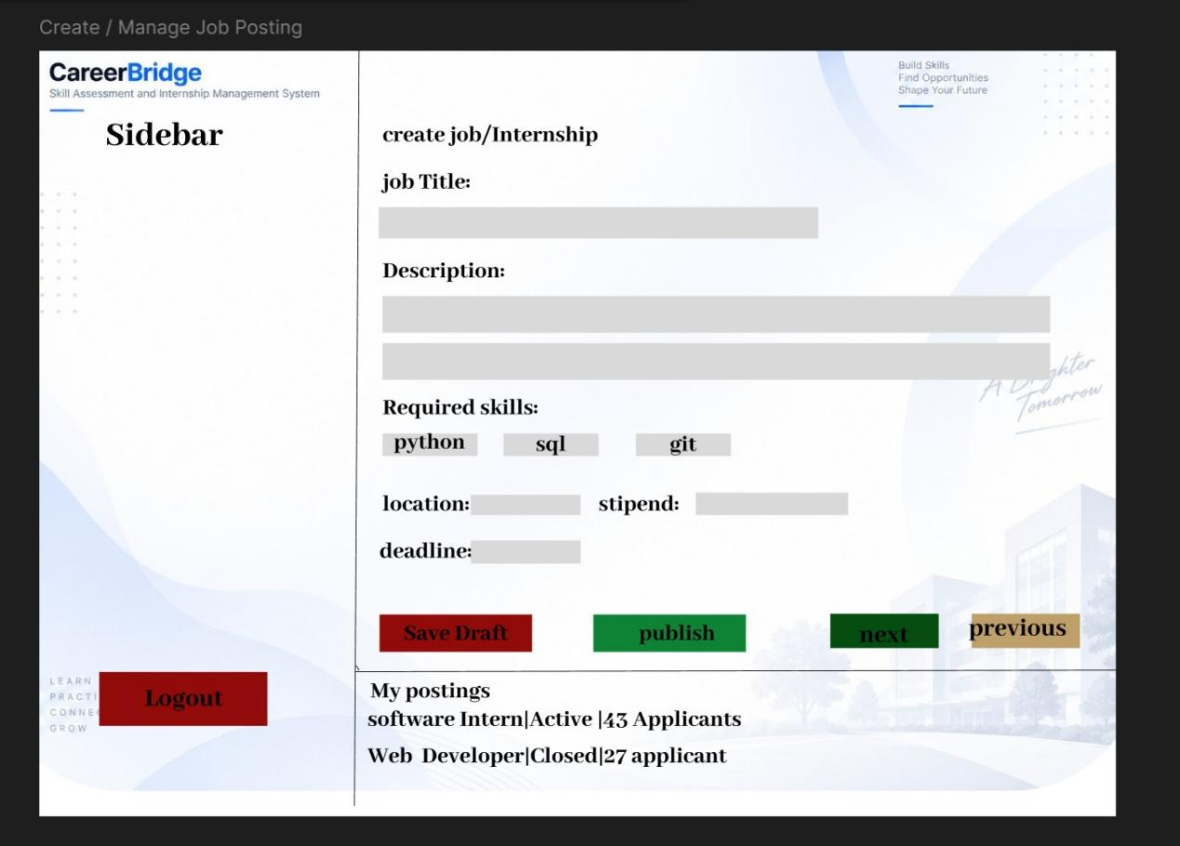Figure 3: Recruiter Job Posting and Management Interface
Screen 08 provides the recruiter with the necessary fields to create and manage a job or internship posting. The recruiter can enter important information such as the job title, description, required skills, location, stipend or salary, and application deadline.
After entering the required information, recruiters can publish the job posting so that candidates can view the opportunity. The system can also support saving a posting as a draft, editing existing postings, and closing postings when they are no longer available.
This screen supports recruiter-side job management by providing a structured way to create and maintain available opportunities.

2.1 Functional Requirements
- Create job and internship postings.
- Enter job title and description.
- Specify required skills.
- Add location information.
- Add stipend or salary information.
- Set an application deadline.
- Publish job postings.
- Save job postings as drafts.
- Edit existing job postings.
- Close job postings.

2.2 Non-Functional Requirements
Usability: The job-posting form should be clearly organized and easy for recruiters to complete.
Performance: Job creation and management actions should be processed efficiently.
Security: Only authorized recruiters should be able to create, edit, or close their job postings.
Reliability: Job information should be saved and displayed correctly.
Maintainability: The job-posting module should be structured so additional job fields and management features can be added in the future.

3. Applicant and Candidate Management
After publishing a job or internship, recruiters need to review candidates who apply for the opportunity. CareerBridge provides recruiters with an applicant management interface to review candidate information and make recruitment decisions.

Applicant List and Candidate Details
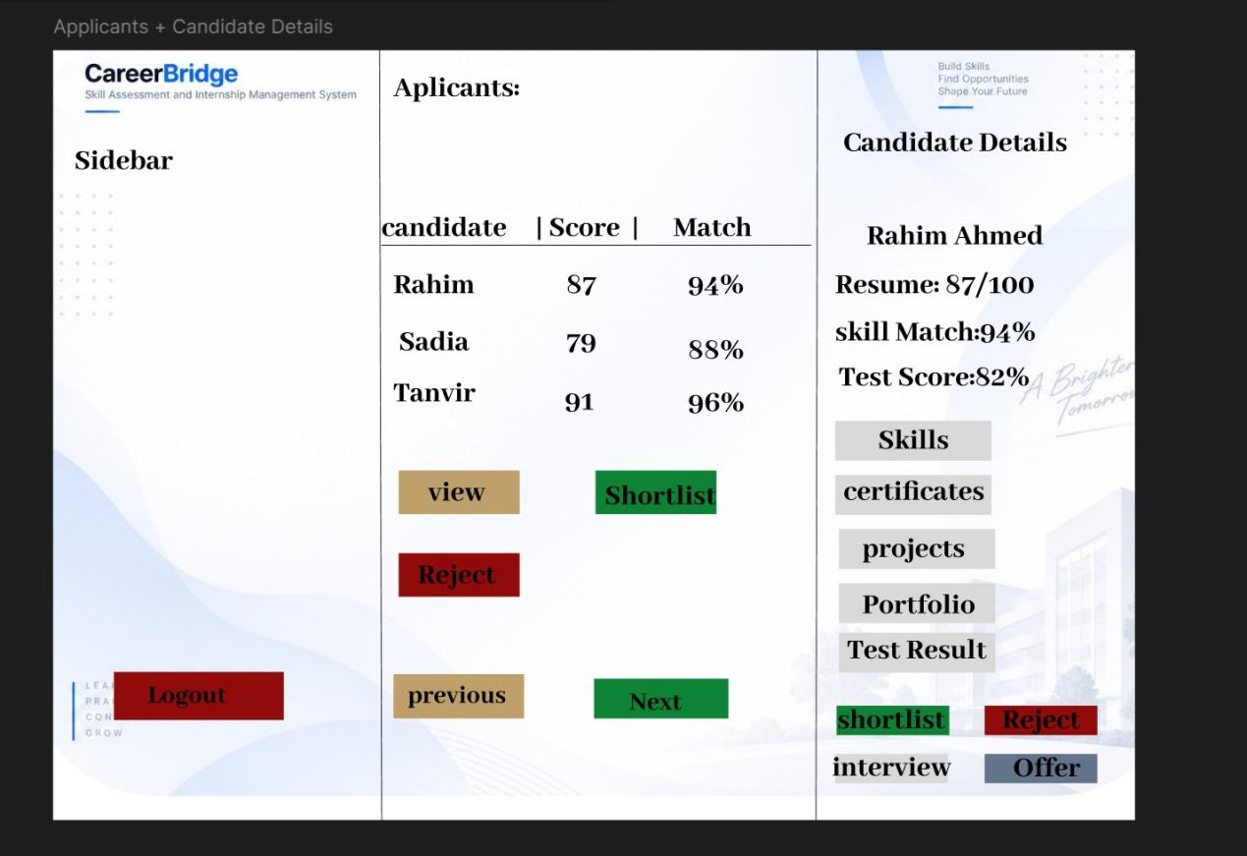Figure 4: Applicant List and Candidate Details Interface
Screen 09 allows recruiters to view applicants for their job postings and access detailed candidate information. Recruiters can review candidate profiles, CV/resumes, certificates, portfolios, and assessment or test results where available.
Based on the available candidate information, recruiters can shortlist suitable candidates or reject candidates who do not meet the requirements. Suitable candidates can then progress toward the interview stage.
This screen helps recruiters make informed recruitment decisions by bringing important candidate information together in one place.

3.1 Functional Requirements
- View applicants for job postings.
- View candidate profiles.
- Review candidate CV/resume information.
- Review certificates and portfolio information.
- View assessment or test results.
- Shortlist suitable candidates.
- Reject candidates.
- Move selected candidates toward the interview stage.

3.2 Non-Functional Requirements
Usability: Candidate information should be organized clearly so recruiters can review applicants efficiently.
Performance: Applicant lists and candidate details should load within a reasonable time.
Security: Candidate personal information, CVs, certificates, and test results should only be accessible to authorized recruiters.
Reliability: Applicant information and recruitment decisions should be stored and displayed consistently.
Maintainability: Applicant management should be modular so additional candidate information and recruitment features can be added later.

3.3 Summary
Screens 07–09 represent the main recruiter workflow in CareerBridge:
Dashboard → Create/Manage Job → Review Applicants → Candidate Selection
Screen 07 provides the recruiter with a centralized dashboard, Screen 08 supports the creation and management of job and internship postings, and Screen 09 allows recruiters to review applicants and select suitable candidates. Together, these screens demonstrate how CareerBridge supports recruiters throughout the initial stages of the recruitment process.

