1. Recruiter Approval and Company Management
CareerBridge includes an administrative module that allows administrators to manage recruiters and companies using the system. This is important for maintaining control over recruitment activities and supporting secure operation of the platform.

Development Approach
The project follows an Agile development approach. Agile is suitable for CareerBridge because the system contains multiple modules and different user roles. The work can be divided into smaller tasks and developed incrementally. Regular planning, review, testing, feedback, and improvement allow the team to develop the system in manageable stages.

Trello Project Management
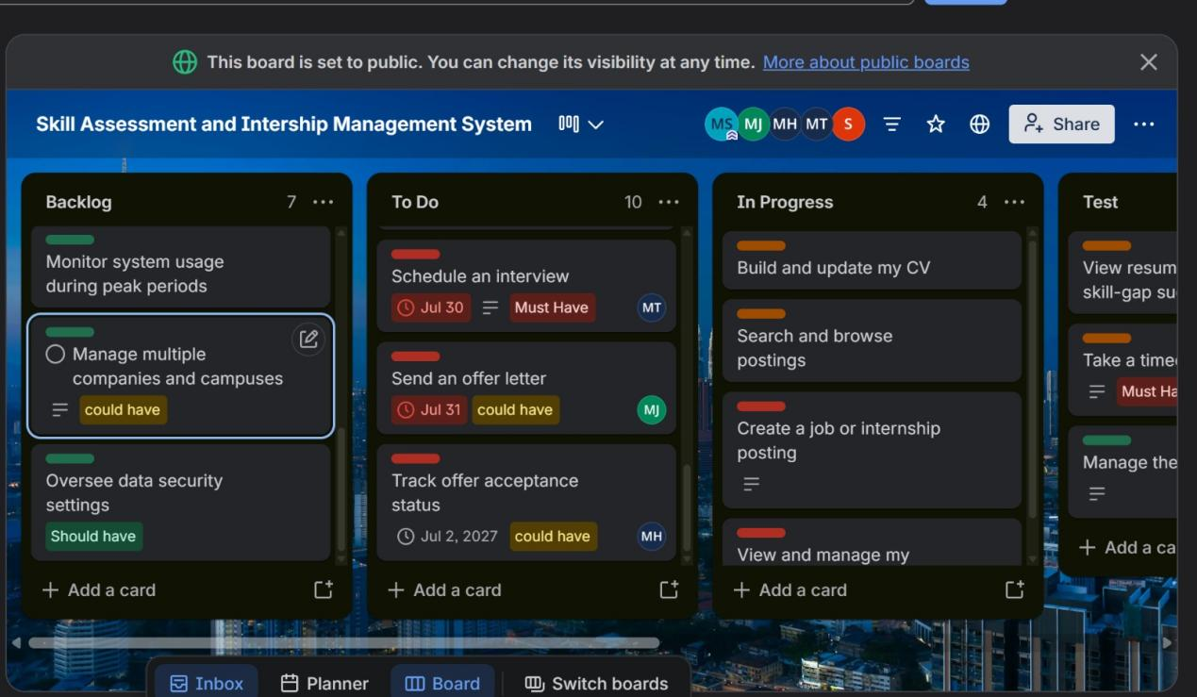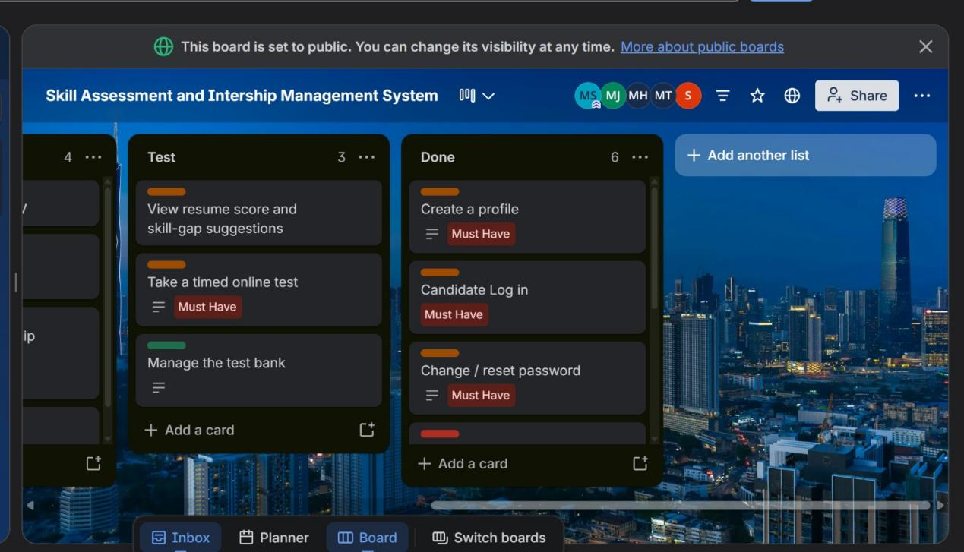 Figure 1: Trello board showing administrative task planning and project progress.

Recruiter Approval and Company Management
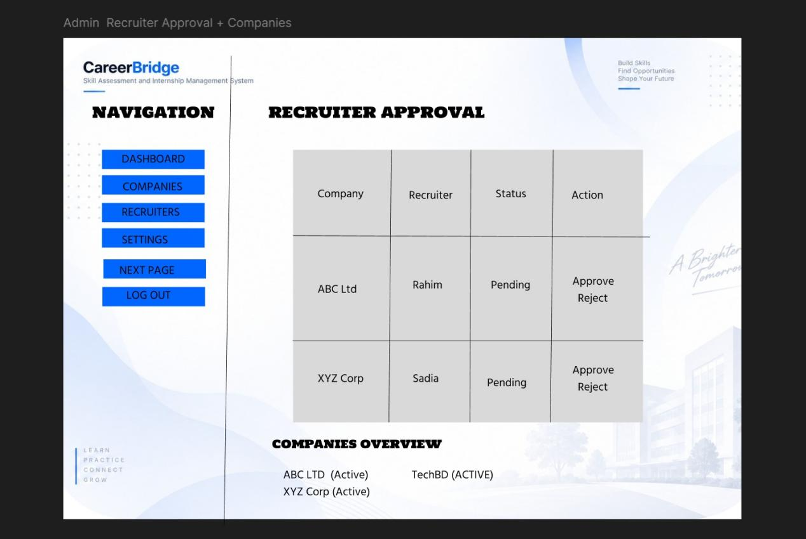Figure 2: Recruiter Approval and Company Management Interface
Screen 13 allows the administrator to view and manage recruiters and companies within CareerBridge. Administrators can review recruiter accounts and approve or reject them according to the system requirements.
The screen also provides company management functionality. By controlling recruiter and company accounts, the administrator can help ensure that only approved recruitment accounts operate within the platform. This supports the secure and organized operation of the CareerBridge system.

Functional Requirements Covered
- View recruiter accounts.
- Approve recruiters.
- Reject recruiters.
- Manage companies.
- Maintain control over approved recruitment accounts.
- Perform administrative management activities.

Non-Functional Requirements
Security: Only authorized administrators should be able to approve or reject recruiters and manage company information.
Reliability: Recruiter and company information should be stored and displayed consistently.
Usability: The management interface should be clear and easy for administrators to use.
Data Integrity: Recruiter and company information should remain accurate and consistent during management activities.
Maintainability: The management module should be organized so that it can be maintained and extended in the future.
2. Question Bank and Security Management
The CareerBridge assessment system requires a structured collection of questions that can be used to evaluate candidates' skills. Administrators are responsible for managing the assessment question bank and related security controls.

Question Bank and Security Management
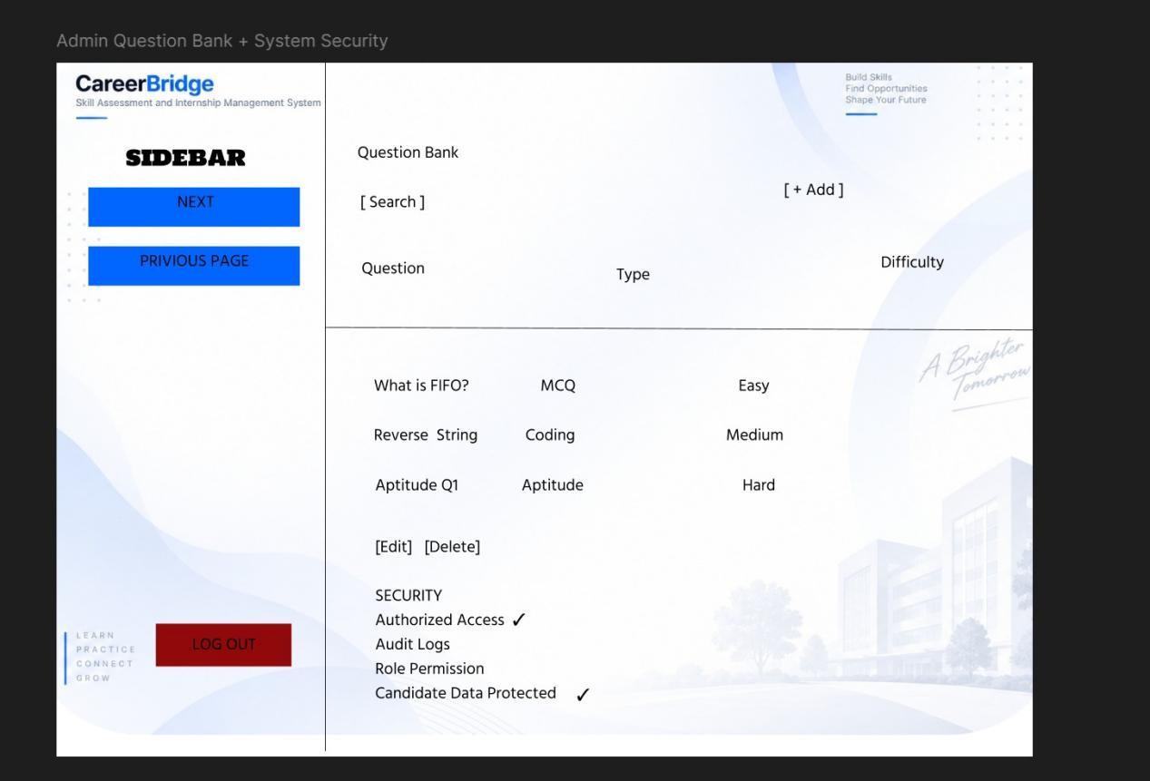Figure 3: Admin Question Bank and Security Management Interface
Screen 14 provides administrators with functionality for managing assessment questions. Administrators can add new questions, edit existing questions, and delete questions when required. This allows the question bank to be maintained and updated according to the assessment requirements.
The question bank supports the candidate assessment process by providing the questions required for skill evaluation. Proper management of the question bank helps ensure that candidates receive appropriate assessment content.
The screen also provides access to security-related administrative controls. These controls help protect assessment content and other important system information from unauthorized access.

2.1 Functional Requirements
- Manage assessment questions.
- Add new questions.
- Edit existing questions.
- Delete questions.
- Maintain question-bank content.
- Access security-related administrative controls.

2.2 Non-Functional Requirements
Security: Assessment questions and administrative functions should be protected from unauthorized access.
Usability: Question management functions should be simple and clearly organized.
Reliability: Questions should be stored, updated, and retrieved correctly.
Data Integrity: The question bank should maintain accurate and consistent assessment content.
Maintainability: The question-bank module should allow questions to be managed and updated efficiently.

3. Analytics, Reports and System Usage
CareerBridge provides administrators with analytics and reporting functionality to help monitor recruitment activities and overall system usage. These features can support administrative decision-making by providing useful information about the platform.

Analytics, Reports and System Usage
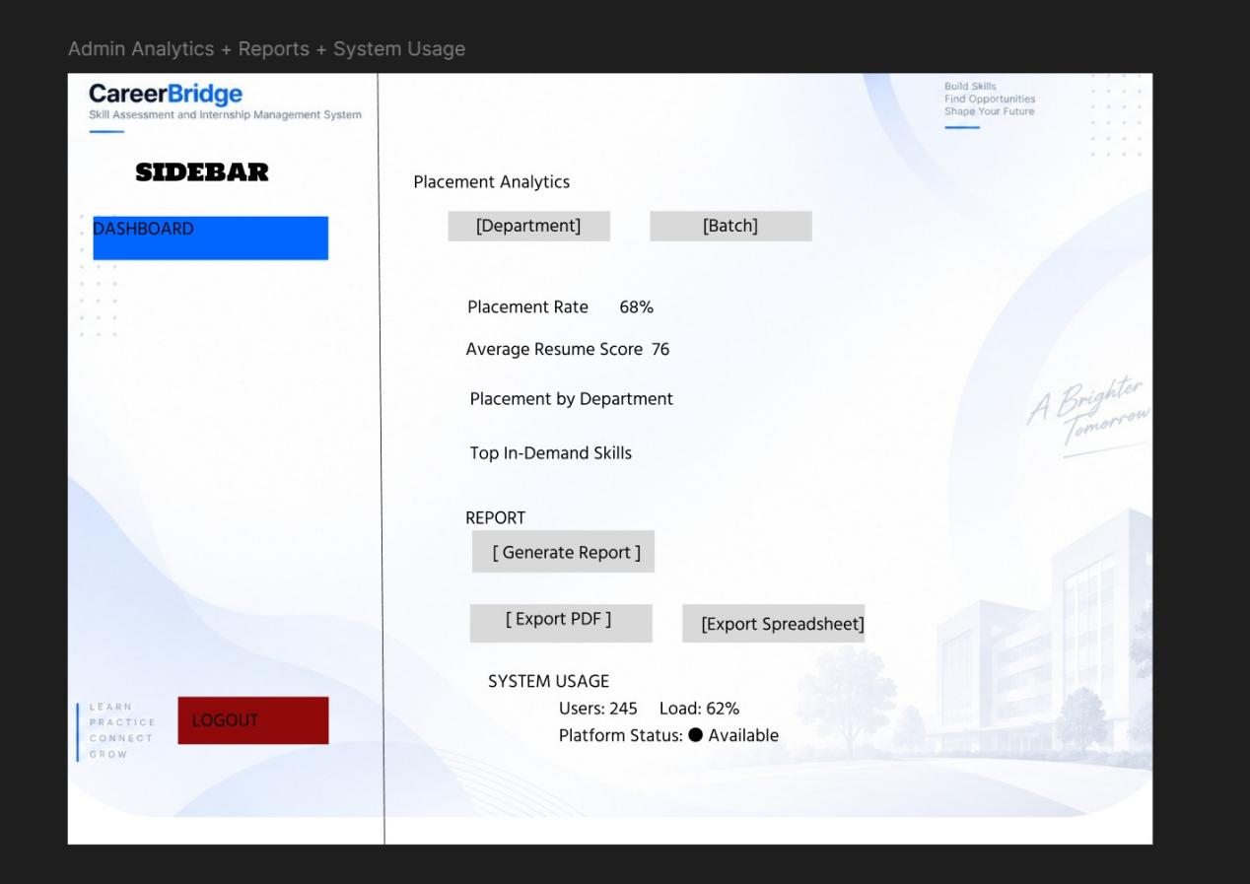Figure 4: Admin Analytics, Reports and System Usage Interface
Screen 15 provides administrators with access to placement and recruitment analytics, system usage information, and reporting functions. Administrators can review information related to recruitment activities and monitor system performance and activity.
The reporting functionality allows administrators to generate reports and export information for further use. These reports can help administrators understand system activities and make informed decisions regarding the CareerBridge platform.
Monitoring analytics and system usage also helps administrators maintain an overview of how the platform is being used and how recruitment activities are progressing.

3.1 Functional Requirements
- View placement and recruitment analytics.
- View system usage information.
- Generate reports.
- Export reports.
- Monitor system performance and activity.
- Use analytics to support administrative decision-making.

3.2 Non-Functional Requirements
Usability: Analytics and reports should be presented in a clear and understandable format.
Performance: Reports and analytics should be generated efficiently.
Security: System usage and recruitment data should only be accessible to authorized administrators.
Reliability: Analytics and reports should provide consistent and dependable information.
Maintainability: The reporting and analytics module should be structured so that additional reports and analytical features can be added in the future.

3.3 Overall Project Conclusion
CareerBridge integrates Candidate, Recruiter, and Admin modules into one complete Skill Assessment & Internship Management System. Candidates can search and apply for suitable opportunities, complete assessments, and manage interviews and offers. Recruiters can create and manage jobs, review applicants, and manage recruitment activities. Administrators manage recruiter and company approval, security, assessment content, analytics, reports, and overall system activities.
The Figma prototype demonstrates how the identified system requirements are translated into a structured user interface and connected workflow. The prototype provides a clear representation of how different users interact with CareerBridge and how the major system functions are organized.

