CareerBridge – Skill Assessment & Internship Management System
Prepared by: Roman Sawom
Figma Screens Covered: 10, 11 and 12

1. Recruiter Interview, Offer and Analytics Module
CareerBridge provides recruiters with features to manage candidates after the initial application and selection stages. Recruiters can schedule interviews, manage offers, and use recruitment analytics to monitor the progress and performance of their recruitment activities.

Development Approach
The project follows an Agile development approach. Agile is suitable for CareerBridge because the system contains multiple modules and different user roles. The work can be divided into smaller tasks and developed incrementally. Regular reviews, testing, feedback, and improvements help the team identify problems and improve the system during development.

Trello Project Management
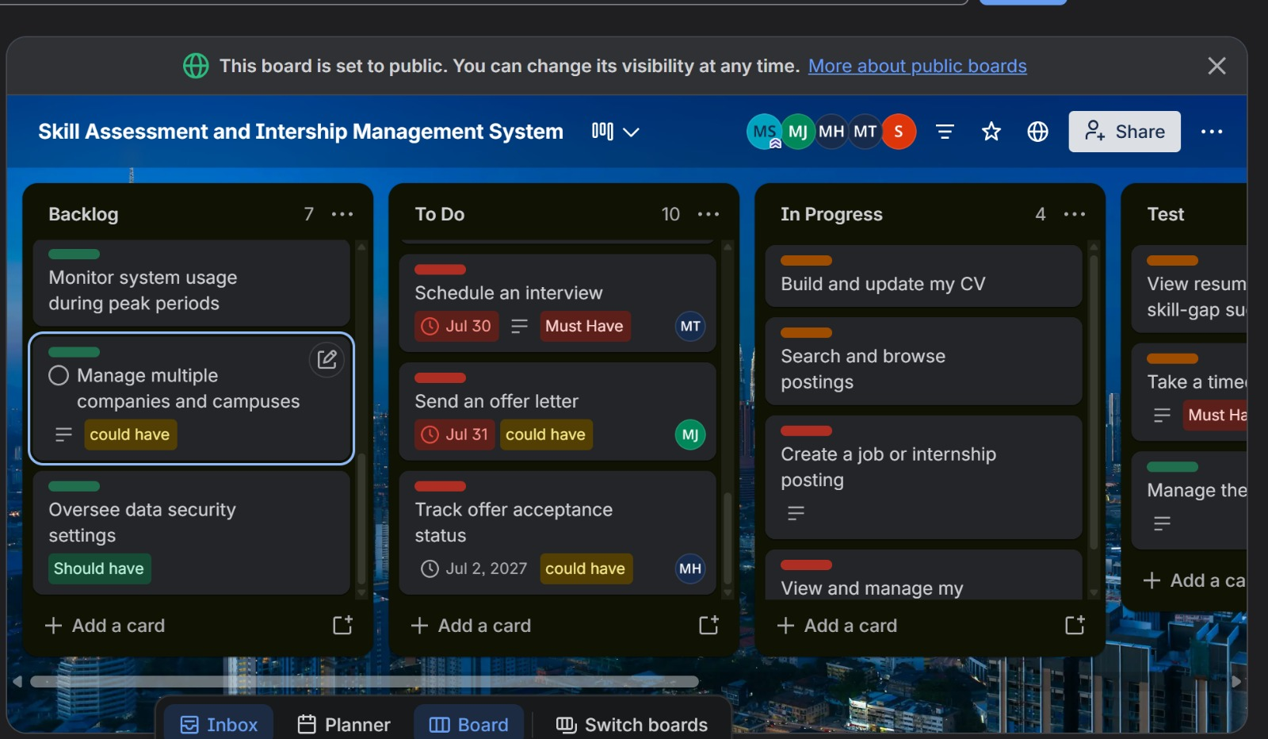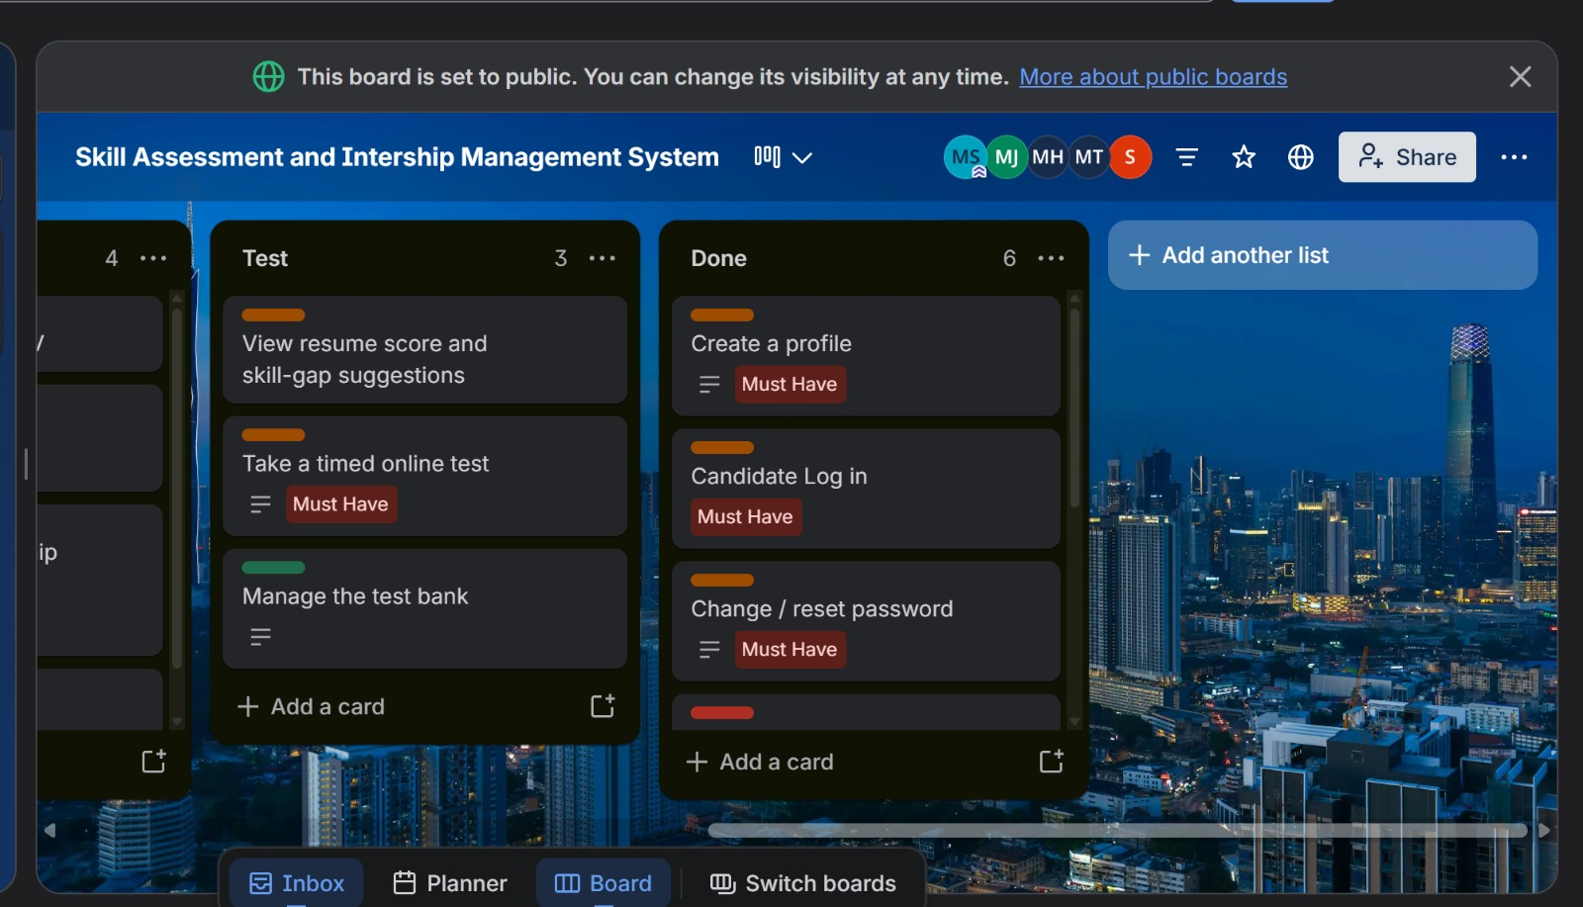 Figure 1: Trello board showing project tasks and progress.

Recruiter Interview, Offer and Analytics
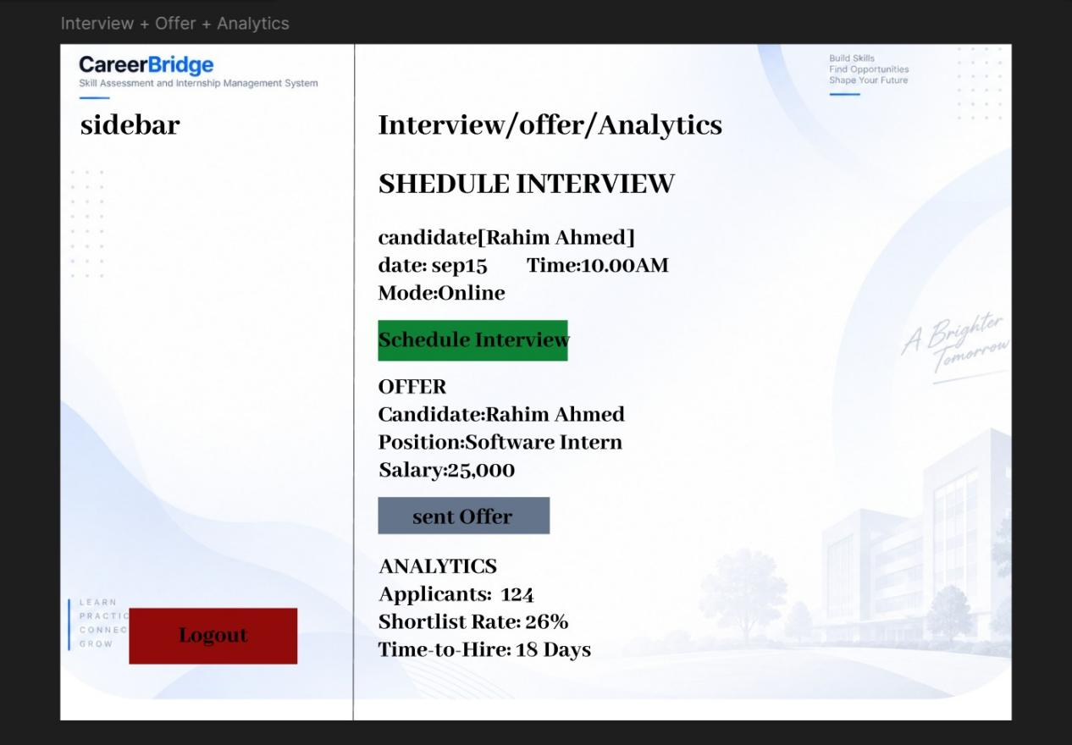
Figure 2: Recruiter Interview, Offer and Analytics Interface
Screen 10 provides recruiters with functions for managing the later stages of the recruitment process. Recruiters can schedule interviews for selected candidates by specifying the interview date and time. The interface also supports the management of interview activities and the sending of offers to suitable candidates.
Recruiters can manage offer information and monitor recruitment analytics. The analytics section helps recruiters understand recruitment performance and track candidate progression through different stages of the recruitment process.

Functional Requirements Covered
- Schedule candidate interviews.
- Manage interview activities.
- Send offers to selected candidates.
- Manage offer status.
- Monitor recruitment analytics.
- Track candidate progression.

Non-Functional Requirements
Usability: Interview, offer, and analytics information should be presented clearly and be easy for recruiters to use.
Performance: Recruitment information and analytics should load efficiently.
Security: Interview, candidate, and offer information should only be accessible to authorized recruiters.
Reliability: Interview schedules, offers, and recruitment data should be stored and displayed consistently.
Maintainability: The module should be organized so that additional recruitment and analytics features can be added and maintained easily.

2. Admin Login and Authentication
CareerBridge includes a separate administrative module for managing important system-level activities. Administrators must authenticate before accessing administrative functions. This helps protect sensitive system information and prevents unauthorized users from accessing administrative features.

Admin Login
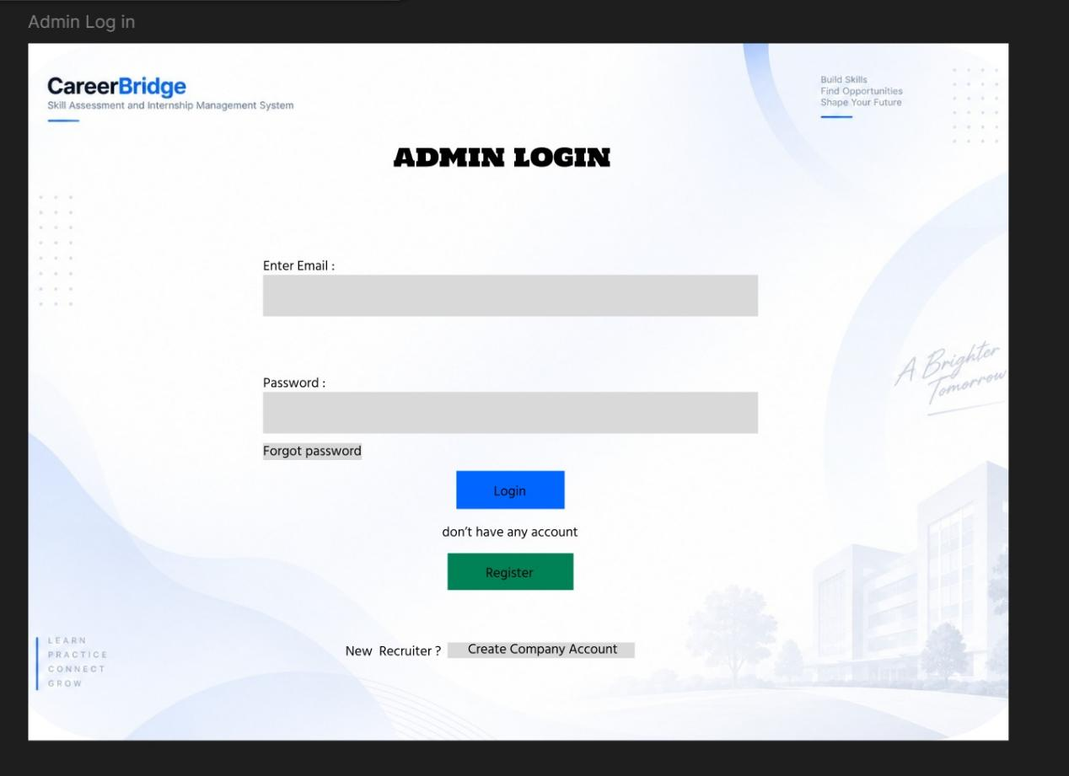Figure 3: Admin Login Interface
Screen 11 provides the Admin Login interface. The administrator must provide valid login information to access the administrative section of CareerBridge.
Admin access requires additional protection because administrators can manage important system-level information, including recruiters, companies, assessment-related content, security functions, analytics, and reports.
The system also separates the Admin, Candidate, and Recruiter roles. Each role receives access only to the functions required for that type of user. This role-based access control improves system security and helps prevent unauthorized access to restricted functions.

2.1 Functional Requirements
- Administrator authentication.
- Secure administrator login.
- Access to administrative functions.
- Role-based access control.
- Separation of Admin, Candidate, and Recruiter functions.

2.2 Non-Functional Requirements
Security: Administrative access must be protected to prevent unauthorized users from accessing system-level functions.
Usability: The login interface should be simple and easy for administrators to use.
Performance: Login requests should be processed efficiently.
Reliability: The authentication process should work consistently.
Maintainability: Separating user roles makes the system easier to manage and update.

3. Admin Dashboard and System Management
After successful authentication, administrators can access the main dashboard of CareerBridge. The admin dashboard provides centralized access to important system management functions and gives an overview of the overall platform.

Admin Dashboard
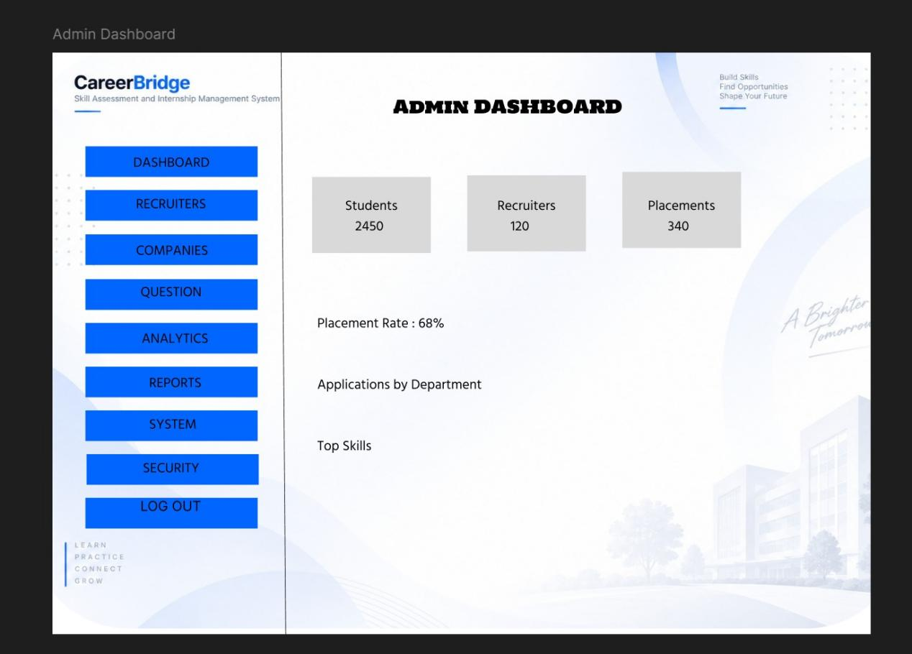Figure 4: Admin Dashboard Interface
Screen 12 provides an overview of the CareerBridge platform and acts as the central control point for administrative activities. From the dashboard, administrators can access recruiter management, company management, question and security management, analytics and reports, and system usage information.
The centralized dashboard allows administrators to manage different areas of the platform without accessing separate systems. It also helps administrators monitor overall system activities and access important management functions efficiently.

3.1 Functional Requirements
- View the overall system overview.
- Manage recruiters.
- Manage companies.
- Access question-bank management.
- Access security management.
- Access analytics and reports.
- Monitor system usage.

3.2 Non-Functional Requirements
Usability: The dashboard should provide clear navigation to different administrative functions.
Performance: Dashboard information and system statistics should load efficiently.
Security: Administrative information and system-management functions should be protected from unauthorized access.
Reliability: System information and management functions should operate consistently.
Maintainability: The admin module should be organized into manageable sections so that future features can be added easily.

3.3 Summary
Screens 10–12 demonstrate the transition from recruiter recruitment management to centralized administrative control in CareerBridge.
The workflow can be summarized as:
Recruiter Interview/Offer/Analytics → Admin Authentication → Admin Dashboard and System Management
Screen 10 supports recruiter interview, offer, and analytics activities. Screen 11 provides secure administrator authentication, while Screen 12 provides centralized control over the CareerBridge platform. Together, these screens demonstrate how the system separates user responsibilities while maintaining an organized recruitment and administration workflow.

