PROJECT TITLE:
CareerBridge – Skill Assessment & Internship Management System

This section is prepared by:MD.Hishamur Rahman ID:24-57939-2

This report must cover Figma Screens 01, 02 and 03.

PROJECT OVERVIEW:
CareerBridge is a Skill Assessment & Internship Management System designed to connect candidates with internship/job opportunities while allowing recruiters to manage jobs and applicants and administrators to manage and monitor the overall system.

DEVELOPMENT APPROACH:
Explain that an Agile development approach was selected because the system contains multiple user roles and features that can be developed and reviewed incrementally. Explain how the team can divide the system into smaller modules, develop them step-by-step, test them, collect feedback and improve the design.

FUNCTIONAL REQUIREMENTS:
the requirements used to Screens 01–03:
- Candidate login/authentication
- Candidate access to profile/dashboard
- Candidate profile information
- CV/resume information
- Resume score and skill-gap information
- Job and internship searching
- Job/internship filtering
- Showing suitable/recommended opportunities
- Showing job matching information where applicable

NON-FUNCTIONAL REQUIREMENTS:
- Usability: the interface should be simple and easy to understand.
- Performance: pages and dashboard information should load efficiently.
- Security: user authentication and account information should be protected.
- Reliability: the system should provide consistent access to candidate information.
- Maintainability: the system should be organized into manageable modules.
- Scalability: the system should be able to support more candidates, recruiters and jobs in the future.

1. CareerBridge Project Overview and Development Approach
CareerBridge – Skill Assessment & Internship Management System is a software system designed to help candidates find suitable internship and job opportunities based on their skills and qualifications. The system also provides recruiters with tools to manage job postings and applicants, while administrators manage and monitor the overall platform.The system has three main types of users: Candidate, Recruiter, and Admin. Candidates can create and manage their profiles, maintain CV/resume information, view their skill gaps, search for suitable jobs and internships, and track their career opportunities. Recruiters can manage job postings and candidates during the recruitment process. Admins are responsible for managing recruiters, companies, assessment questions, security, analytics, reports, and overall system activities.

1.1 Development Approach
The project follows an Agile development approach. Agile was selected because CareerBridge contains several modules and different user roles. Instead of developing the entire system at once, the project can be divided into smaller features and modules.
Using Agile, the team can work on different tasks, develop the system incrementally, test each part, identify problems, collect feedback, and make improvements. This makes the development process more flexible and allows changes to be made when required.

1.2 Work Process
The general development process followed for CareerBridge is:
Requirement Analysis → Planning → UI/Prototype Design → Development → Testing → Feedback → Improvement
The requirements are first analyzed to understand what the system needs to provide. The tasks are then planned and distributed among team members. The user interface is designed in Figma before development. After implementation, the features are tested and reviewed. Feedback is then used to improve the system.
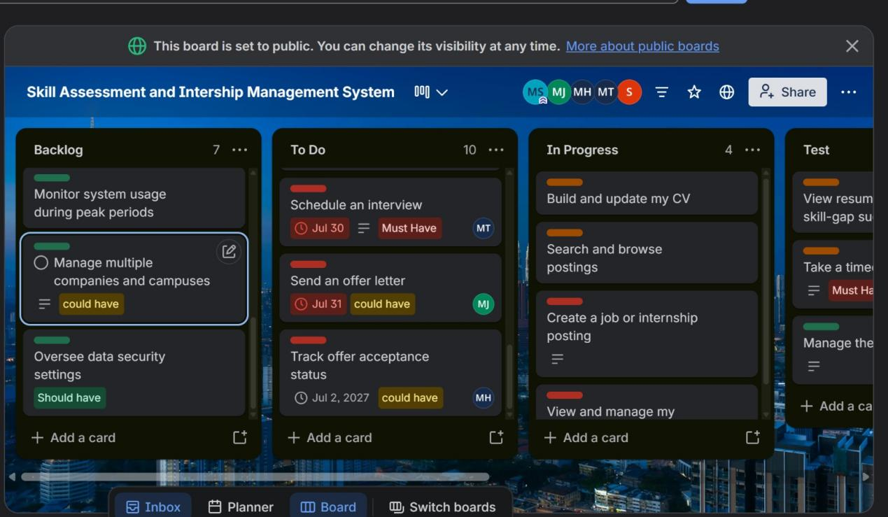
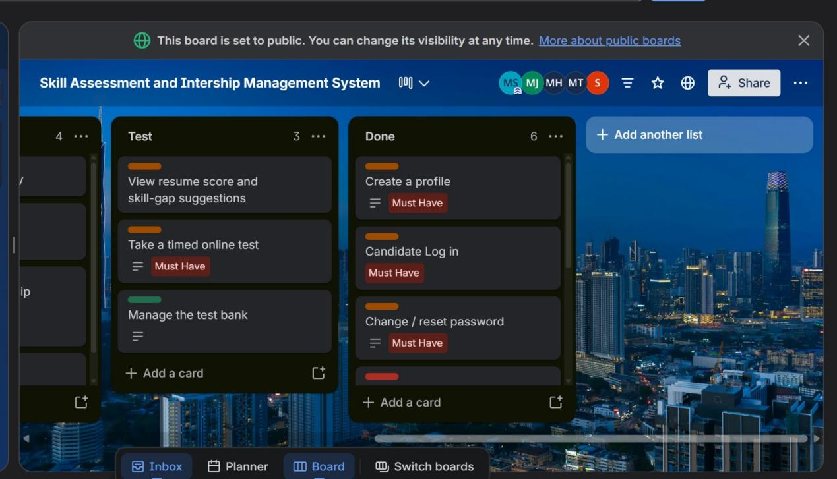Figure 1: Trello board showing task planning and project work distribution.

1 Candidate Module – Login and Dashboard
The first part of the CareerBridge candidate module focuses on authentication and candidate information management. The candidate first accesses the system through the login/registration interface. After successful authentication, the candidate can access the dashboard and view important information related to their profile and career activities.
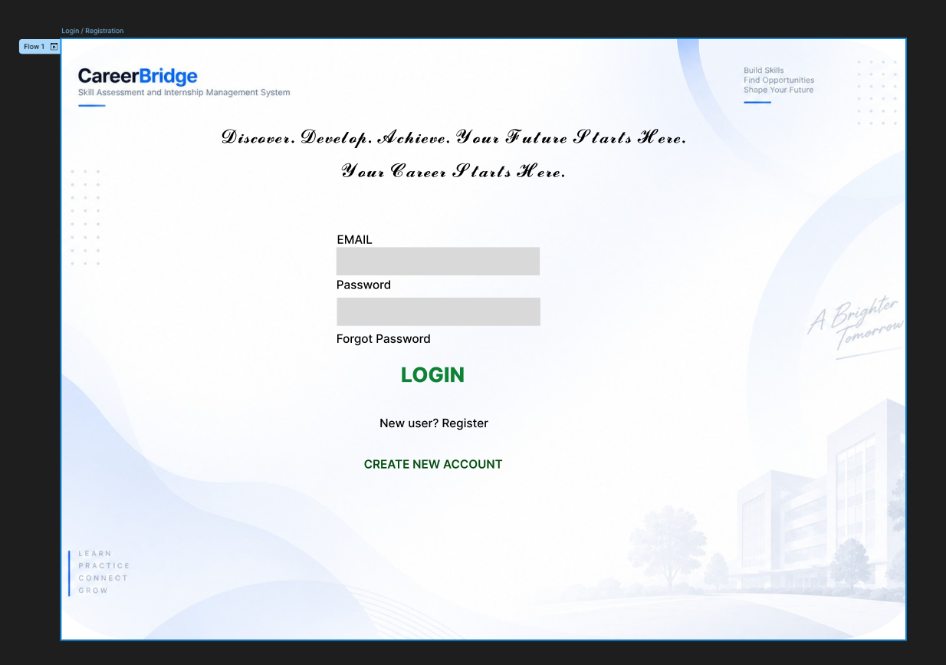Figure 2: Candidate Login/Registration Interface

The Candidate Login/Registration screen provides the entry point for candidates into the system. It supports candidate authentication and provides a controlled way for users to access their account.
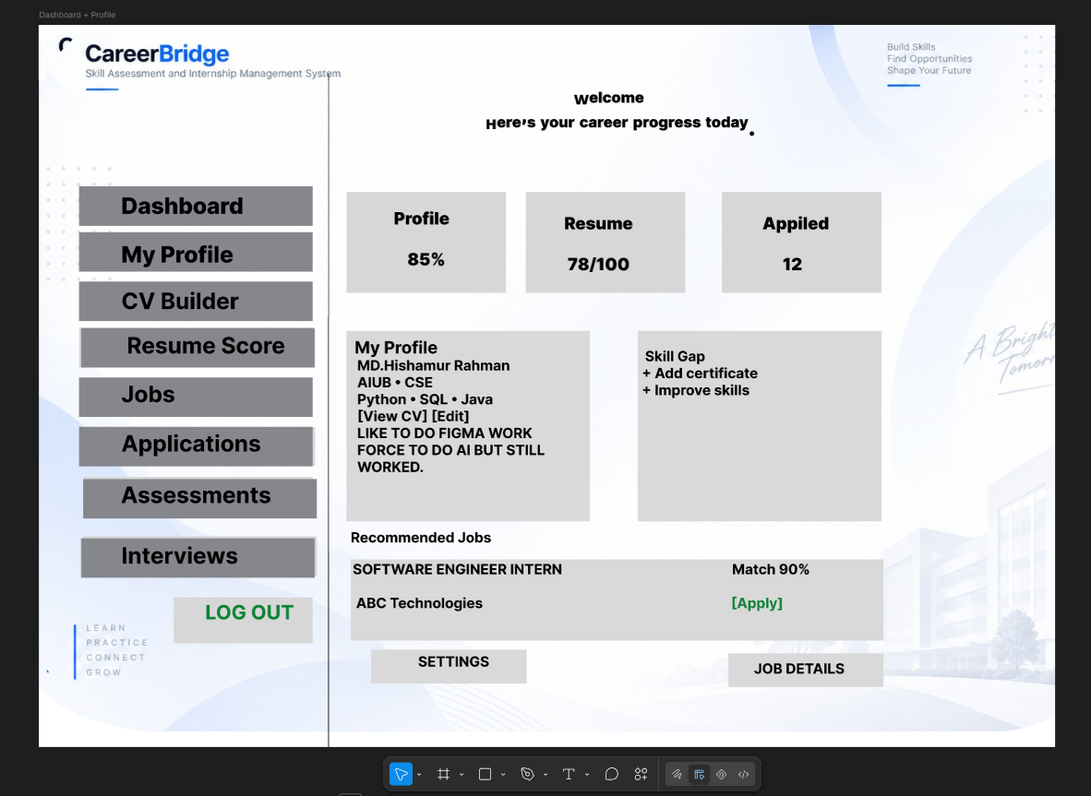Figure 3: Candidate Dashboard and Profile Interface
The Candidate Dashboard provides an overview of the candidate's information and activities. It includes profile information, CV/resume information, resume score, skill-gap information, and recommended job or internship opportunities. This allows candidates to understand their current profile and identify suitable career opportunities.

2.1 Functional Requirements Covered
The following functional requirements are represented by these screens:
- Candidate registration and login.
- Secure access to the candidate account.
- Access to the candidate profile.
- Management and viewing of CV/resume information.
- Display of resume score.
- Identification of skill gaps.
- Display of suitable or recommended opportunities.
These functions provide the basic foundation for the candidate's interaction with the CareerBridge system.

2.2 Non-Functional Requirements
Usability: The login and dashboard interfaces should be simple and easy for candidates to understand and use.
Security: Authentication is required to protect candidate account and profile information from unauthorized access.
Performance: The dashboard should load candidate information and relevant opportunities efficiently.
Reliability: Candidate information should be displayed consistently and the system should provide dependable access to the user's account.

Page 3

3. Candidate Jobs and Internship Module
After accessing the dashboard, candidates can search for available jobs and internship opportunities. The Jobs and Internship module allows candidates to find opportunities that match their interests, skills, and qualifications.
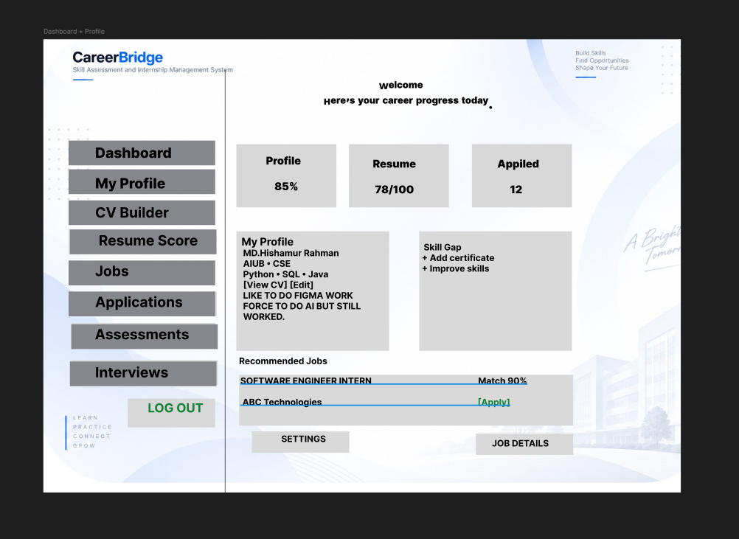Figure 4: Jobs and Internship Search and Job Details Interface
The screen provides a search and filtering interface so that candidates can find relevant opportunities more easily. Candidates can view information about a job or internship, including the required skills and other important details. The system can also display a match percentage to help candidates understand how suitable an opportunity is for their profile.
Candidates can select an opportunity to view its details and can apply for suitable positions. A save option can also be provided so that candidates can keep an opportunity for later consideration.

3.1 Functional Requirements
The Jobs and Internship module supports the following functions:
- Search for available jobs and internships.
- Filter opportunities based on relevant criteria.
- View job and internship details.
- View required skills.
- View the matching percentage.
- Apply for suitable opportunities.
- Save job opportunities for later.

3.2 Non-Functional Requirements
Usability: Search, filtering, and job details should be presented clearly so candidates can easily find suitable opportunities.
Performance: Search results and job information should be displayed within a reasonable response time.
Reliability: Job information and application-related actions should work consistently.
Maintainability: The job-search module should be organized so that additional filters and features can be added in the future.
Screens 01–03 represent the beginning of the candidate journey in CareerBridge:
Login → Dashboard/Profile → Search and Discover Opportunities
The first screen provides secure access to the system, the second screen gives candidates an overview of their profile and skills, and the third screen allows them to search for suitable jobs and internships. Together, these screens establish the basic candidate workflow of the CareerBridge system.

