Candidate Application and Assessment Module
CareerBridge supports candidates throughout the internship and job application process. After finding a suitable opportunity, candidates can submit applications and monitor their progress through different recruitment stages. The system also provides assessment functionality to evaluate the candidate’s skills.

Development Approach
The project follows an Agile development approach. Agile is suitable for CareerBridge because the system contains multiple modules and different types of users. The work can be divided into smaller tasks and developed incrementally. Regular review, testing, feedback, and improvement help the team identify problems early and make necessary changes during development.

Trello Project Management
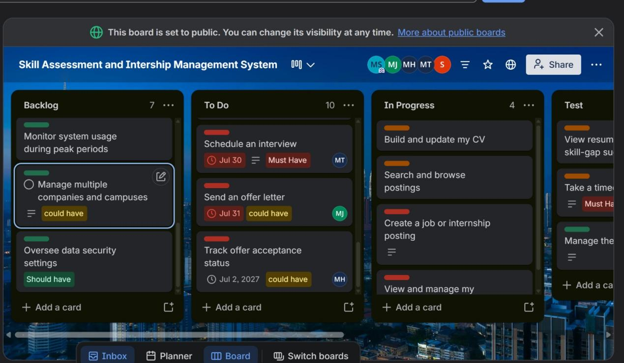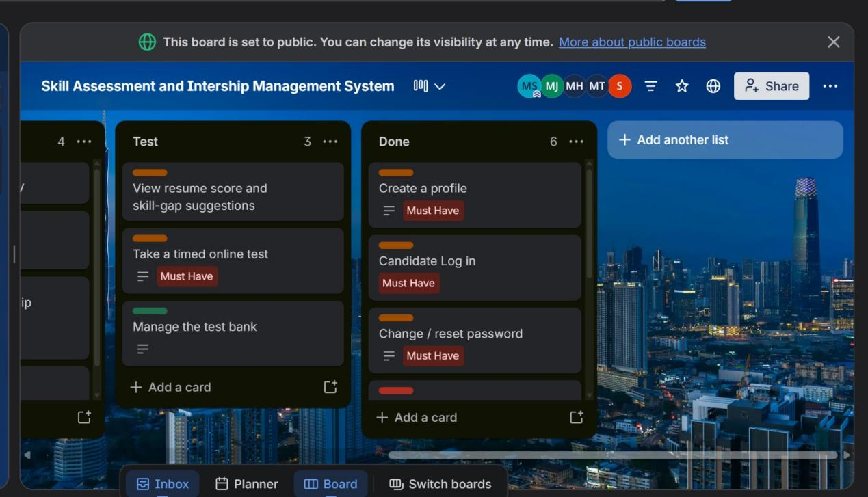 Figure 1: Trello board showing task allocation and progress.

Candidate Applications and Assessment
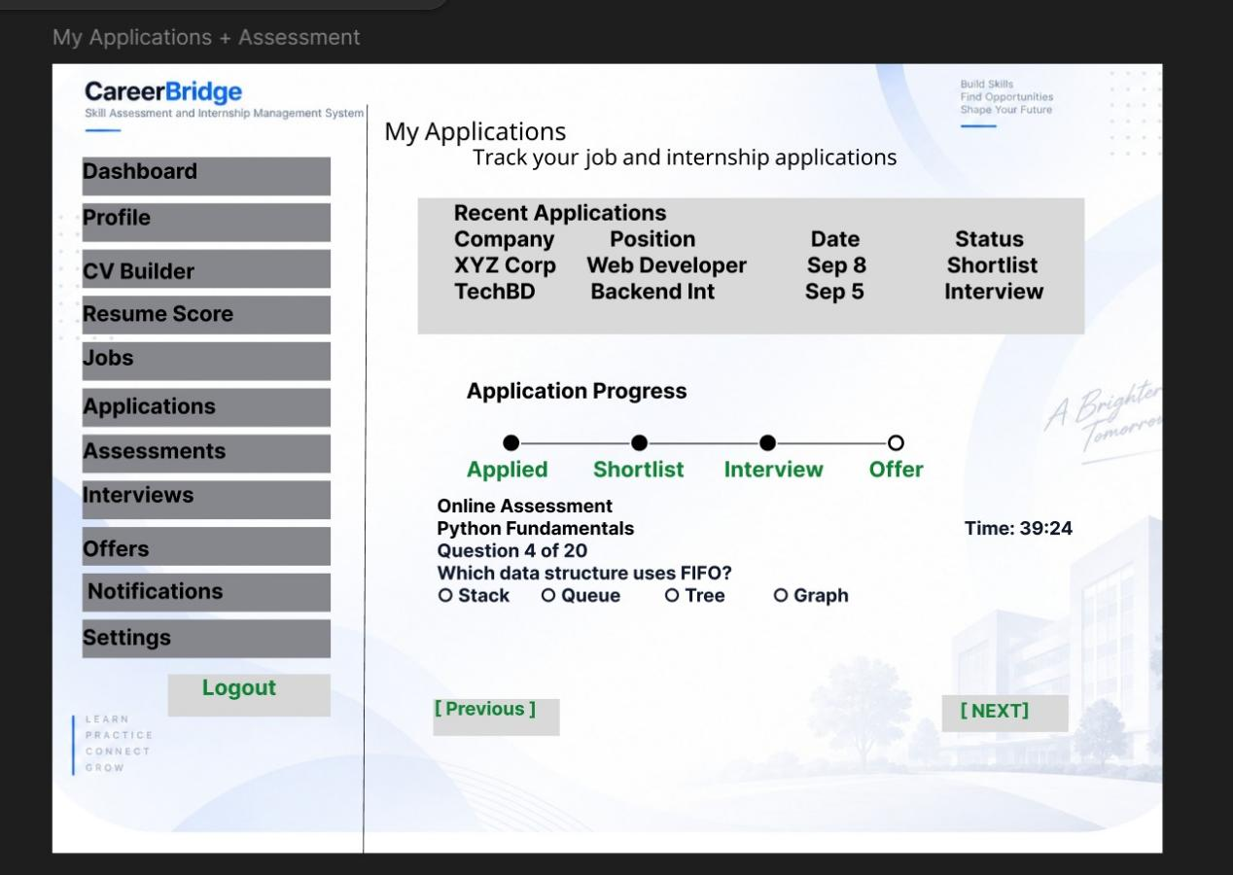Figure 2: Candidate Applications and Assessment Interface
Screen 04 provides candidates with a central place to view their submitted applications and track their recruitment progress. The application status can move through stages such as Applied, Shortlisted, Interview, and Offer. This allows candidates to understand the current status of each application.
The screen also includes a timed assessment where candidates can answer assessment questions within a specified time. The candidate can view the question number, available options, and move between questions while completing the assessment.

Functional Requirements Covered
- Application submission and status tracking.
- Tracking application progress through different recruitment stages.
- Candidate skill assessment.
- Timed assessment.
- Viewing assessment questions and answering them.
- Viewing test history or results where applicable.

Non-Functional Requirements
Performance: Application information and assessment questions should load efficiently.
Usability: The application tracking and assessment interface should be simple and easy to understand.
Reliability: Application statuses and assessment activities should work consistently.
Security: Candidate application and assessment information should be protected from unauthorized access.
Accuracy: Application status and assessment information should be displayed correctly.

2. Candidate Interview and Offer Module
After completing the application and assessment stages, shortlisted candidates may proceed to interviews and eventually receive an offer. CareerBridge provides candidates with a dedicated interface to manage these activities.

Candidate Interview and Offer
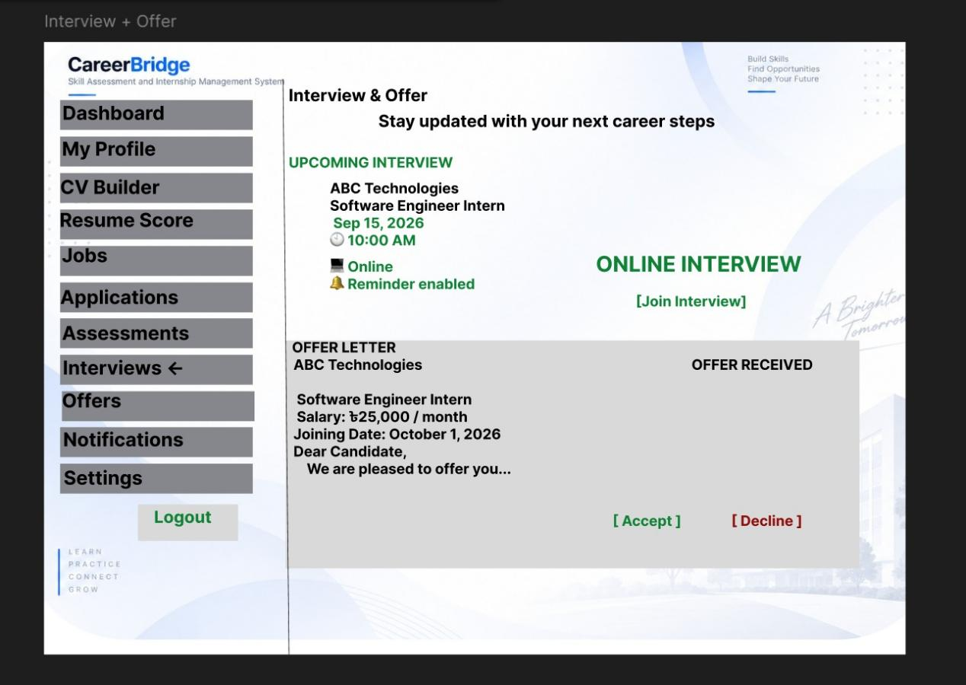Figure 3: Candidate Interview and Offer Interface
Screen 05 displays information about the candidate’s upcoming interview, including the company, position, interview date and time, and online interview details. A Join Interview option allows the candidate to access the interview when required. Interview reminders can also help candidates keep track of scheduled interviews.
The screen also provides information about an offer letter, including salary and joining date. Candidates can accept or decline the offer directly from the interface. After selecting an option, the offer status can be updated to show Accepted or Declined without navigating to another page.
This screen completes an important part of the candidate recruitment journey by connecting interview scheduling with offer management.

2.1 Functional Requirements
- View upcoming interview information.
- View interview date and time.
- Access online interview information.
- Join scheduled interviews.
- Receive or view interview reminders.
- View offer letter information.
- View salary and joining information.
- Accept or decline an offer.
- View the updated offer status.

2.2 Non-Functional Requirements
Usability: Interview and offer information should be clearly organized so candidates can understand their next steps.
Performance: Interview and offer information should load quickly.
Reliability: Interview schedules and offer statuses should be displayed consistently.
Security: Candidate interview and offer information should only be accessible to authorized users.
Accuracy: Dates, times, salary, joining information, and offer status should be displayed correctly.

3. Recruiter Login and Transition to Recruiter Module
CareerBridge provides separate interfaces for different types of users. After the candidate-related screens, Screen 06 introduces the recruiter side of the system. Recruiters must authenticate before accessing recruiter-specific functions.

Recruiter Login/Registration

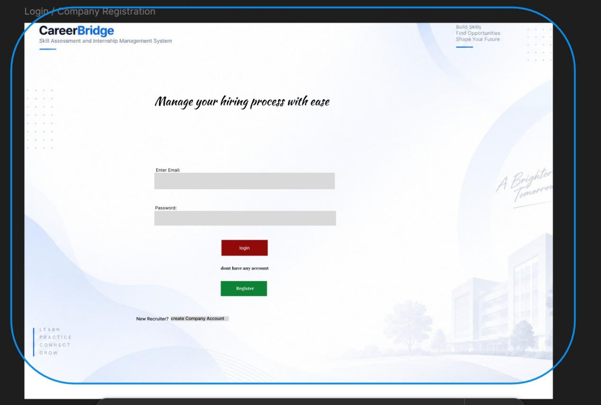Figure 4: Recruiter Login/Registration Interface
Screen 06 provides the Recruiter Login/Registration interface. Recruiters can use this interface to authenticate themselves and access the recruiter module. This creates a clear separation between candidate and recruiter activities.
The separation of user roles is important because candidates and recruiters have different responsibilities within CareerBridge. Candidates manage their profiles, applications, assessments, interviews, and offers, while recruiters manage jobs, applicants, interviews, and recruitment activities.

3.1 Functional Requirements
- Recruiter registration and authentication.
- Secure recruiter login.
- Access to recruiter-specific functions.
- Separation of candidate and recruiter modules.
- Role-based access to system features.

3.2 Non-Functional Requirements
Security: Authentication and role-based access help prevent unauthorized users from accessing recruiter functions.
Usability: The login interface should be clear and easy for recruiters to use.
Reliability: The authentication process should work consistently.
Performance: Login requests should be processed efficiently.
Maintainability: Separate user roles make the system easier to manage and maintain as new features are added.

3.3 Section Summary
Screens 04–06 continue the CareerBridge workflow from candidate application and assessment to interview and offer management, followed by secure recruiter access. Screen 04 allows candidates to track applications and complete assessments, Screen 05 supports interviews and offers, and Screen 06 provides the entry point for recruiters. Together, these screens demonstrate how different stages and user roles are connected within the CareerBridge system.

