Practical Application Assignment 5.1: Will the Customer Accept the Coupon?

Sudarsan “Sudi” Narasimhan

* Several variables here are object(categorical), and some are (int64) numerical
* Variables that seem to have potential missing data include 'Bar', 'CoffeeHouse', 'RestaurantLessThan20', 'Restaurant20To50'
* Most of the other variables seem to have 12684 entries

* Average temperature is 63 with min of 30 and max of 80
* Max children is 1

* Several datapoints are missing across a number of categories. Max NaN is for a car as demonstrated by the next graph.

* Once the null values have been dealt with by inserting the most frequent occurrence, the dataset should be fully populated.

* Regardless of dining option, 56.84% of all observations indicated that they accepted the coupon
* In comparison, 43.16% of all observations rejected the coupon.

* As demonstrated by the chart, the highest level of coupons accepted are for Restaurants <20 and Coffeehouses
* The most level of rejected coupons are also for coffee houses
* Lowest level of rejected coupon is for Carry out & Take away
* The lowest volume of accepted or rejected coupons appears to be for Restaurants (20 – 50)

* Highest volume is associated with coffee houses
* 21 year olds tend to visit coffee houses the most
* 21 year olds don’t frequent Restaurants(20<50) considering the potential cost involved
* 50+ also visit coffee houses the most in comparison to other dining options

* Both Men and women tend to visit coffee houses the most
* Restaurants 20-50 have the lowest level of observable traffic
* Men tend to visit less of all the dining establishments and in less frequency than women
* Restaurants (20 -50) has the closest parity between both genders

* As indicated in the top most ‘temperature’ chart, the highest level of observations is associated with visiting coffee houses. Higher temperatures tend to drive customers to coffee houses.
* Those who have children still tend to visit coffee houses the most

* At 30, weather tends to be both sunny and snowy. Not surprising since lower temperatures are generally associated with snow and ice
* More moderate temperatures have sunny weather and rainy weather
* Highest temperature has sunny weather

* At 10am, several observations indicate ‘No Urgent Place’. Equally so, at 10pm, 2pm and 6pm
* Destination to home at 10pm and 6pm is within expectation assuming several individuals working late beyond regular working hours
* At 7am several observations have individuals going to work

* The highest level of observations were noted for coffee house coupons when they didn’t have an urgent destination to go to
* The lowest level of observations were noted for the restaurant 20-50 when no urgent destination was chosen

* The highest level of observations indicates that coupons were accepted when no urgent place or destination was in in play
* Equal number of coupons were accepted and rejected when the destination was home indicating a possible detour may have been required or necessary
* Equal number of coupons were accepted and rejected when the destination was work indicating a possible detour may have been required or necessary

* At 10am, No ‘urgent place’ was the destination so it’s possible the observed parties were at work or at home
* At 10pm, destination was either to home or no urgent place
* At 2pm no urgent place was the destination
* At 6pm no urgent place or home were the destination.
* At 7am, the observed parties were on their way to work

* At 7am, restaurant with <$20 and morning coffee coupons in play. What’s not showing in the data at this time is the carry and take away option that would be expected if as the previous chart indicated that they were on their way to work as the destination
* At 10am, significant number of coupons were accepted or rejected for Coffee House, Restaurants, and Carry Out & Takeaway
* At 2pm, significant number of coupons were accepted or rejected for coffee house and restaurants less than $20 and $20-$50 indicating that a coffee break or snack may be in play
* At 6pm, coffee house coupons, carry out and take away, and bar coupons are in play. In comparison to the previous chart, high proportion of observations were on their way home.

* At 7am, high proportion of coupons were accepted as per the observations, the participants were on their way to work, accepting coffee house coupons, and restaurants less then $20 coupons.
* At 10am, a lower proportion of coupons were rejected but a higher proportion of coupons were accepted but more coupons were accepted.
* At 2pm, high proportion of coupons were accepted, more than were rejected.
* At 6pm, the highest r proportion of coupons were accepted than rejected, indicating that on their way home, they were stopping by for a coffee house, carry out and the bar.

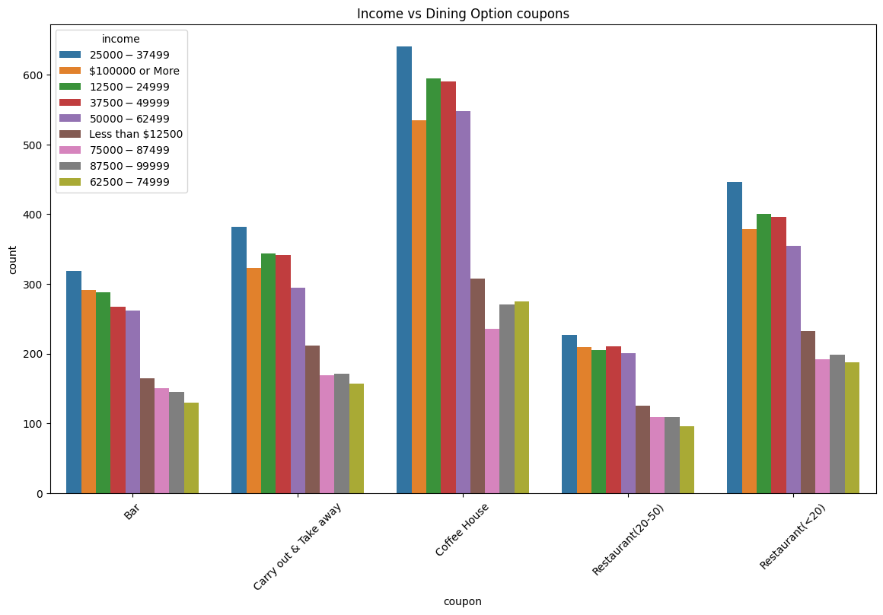

* The highest proportion of bar coupons are targeted, either accepted or rejected, at income brackets of $25,000 - $37,499.
* The lowest proportion of bar coupons are targeted, either accepted or rejected, at income brackets of $62500 - $74,999
* The high proportion of Carry & Take away coupons are targeted, either accepted or rejected, at income brackets of $25,000 - $37,499
* The lowest proportion of Carry & Take away coupons are targeted, either accepted or rejected, at income brackets of $25,000 - $37,499
* Once again, the highest proportion of Coffee House coupons are targeted at income ranges of $25,000 - $37,499
* The lowest proportion of Coffee House coupons are targeted at income ranges of $75,000 - $87,499
* The highest proportion of Restaurant(20-50) coupons are targeted at incomes of $25000 - $37,499
* The lowest proportion of Restaurant(20-50) coupons are targeted at incomes of $62500 - $74,999
* The highest proportion of Restaurants (<20) coupons are targeted at incomes of $25000 - $37,499
* The lowest proportion of Restaurant(<20) coupons are targeted at incomes of $62500 - $74,999

* The highest proportion of men make $100,000 or more in income
* The lowest proportion of men make $75,000 - $87,499 in income
* The highest proportion of women make $25,000 - $37,499 in income
* The lowest proportion of women make $62,500 - $74,999 in income

Bar Coupons

Proportion of bar coupons that were accepted was 41%. That would mean 59% of bar coupons were not accepted or rejected.

* The highest proportion of bar coupons were rejected to those participants who never visited a bar. This isn’t surprising that there’s no incentive for bar coupons to be accepted by those who never or infrequently visit a bar
* As above, higher proportion of bar coupons were rejected who infrequently visit a bar
* The dynamic starts reversing when looking at those who visit bars 1~3, higher proportion of the bar coupons were accepted
* From those who visited bars with 4~8 and greater than 8 visits, a higher proportion of coupons were accepted

* The acceptance of bar coupons is highest for those that visit at least 1 to 3 times

* The acceptance proportion is highest for the ones who visit 1~3.
* Lowest proportion of bar coupon acceptance is lowest for greater than 8 visits and for those who never visit a bar

* In comparison, the proportion of who are below 25 and who never visit a bar still have a high proportion of those who accept a bar coupon

* The acceptance of bar coupons is highest for those who frequent the bar between 1~3 visits.
* The lowest proportion of acceptance is for those who visit the bar more than 8 times

* The highest proportion of acceptance goes to drivers who frequent 1~3 times a month followed by those who frequent 4~8 times a month. What is surprising is that those who visit greater than 8 have less acceptance of the coupon

Coffee House Coupons

In comparison to bar coupons being accepted (41%),

a higher percentage of coupons were accepted for coffee houses (49%). That would mean 51% of coffee house coupons were rejected.

* A higher proportion of women rejected coffee house coupons then those who accepted them
* A higher proportion of men accepted coffee house coupons then those who rejected them

* The lowest proportion of visits is greater than 8 to a coffee house
* The highest proportion of visits to coffee houses is less than 1, 1~3 in a month or never
* The lower proportion of visits to coffee houses are between 4 to 8 in a month

* The highest proportion of coffee house coupon rejection is with participants who never visit a coffee house. This is not surprising since there’s no need for a coffee house coupon if there’s no desire or inclination to visit a coffee house
* For less than 1, a significant proportion of coupons were accepted, potentially for a single visit
* Between 1 to 3 visits, a higher proportion of coupons were accepted than rejected
* With 4 to 8 visits, a higher proportion of coupons were accepted than rejected
* This trend was also demonstrated with greater than 8 visits, which indicates that more frequently a participant is likely to visit a coffee house, the more likely they’ll be interested in accepting a coupon for that dining option