**Example**

Below is the example of the execution of server & client:

1. **Server started**

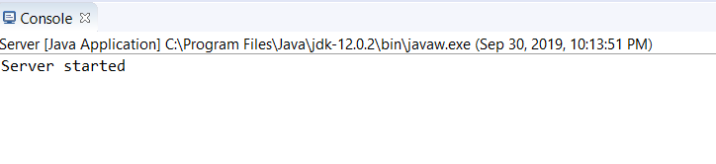

1. **Client requests the connection. Server listens and creates a socket connection.**

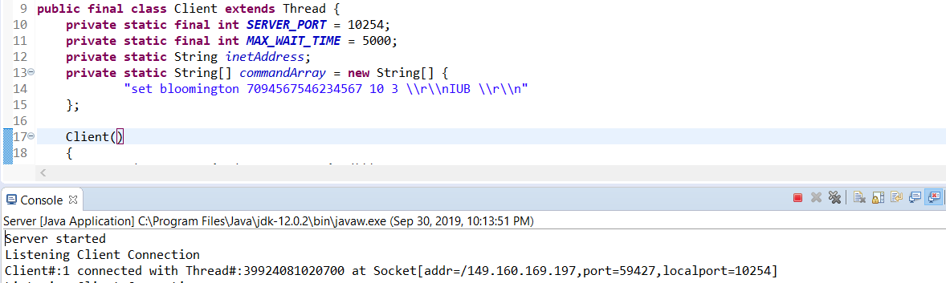

1. **Client sends the command and receives the response**

