grafana install

(https://grafana.com/docs/grafana/latest/setup-grafana/installation/debian/)

1 sudo apt update

2 sudo apt-get install -y apt-transport-https software-properties-common wget

3 sudo mkdir -p /etc/apt/keyrings/

4 wget -q -O - https://apt.grafana.com/gpg.key | gpg --dearmor | sudo tee /etc/apt/keyrings/grafana.gpg > /dev/null

5 echo "deb [signed-by=/etc/apt/keyrings/grafana.gpg] https://apt.grafana.com stable main" | sudo tee -a /etc/apt/sources.list.d/grafana.list

6 sudo apt-get update

7 sudo apt-get install grafana

8 sudo /bin/systemctl enable grafana-server

9 sudo /bin/systemctl start grafana-server

http://18.212.51.54:3000/

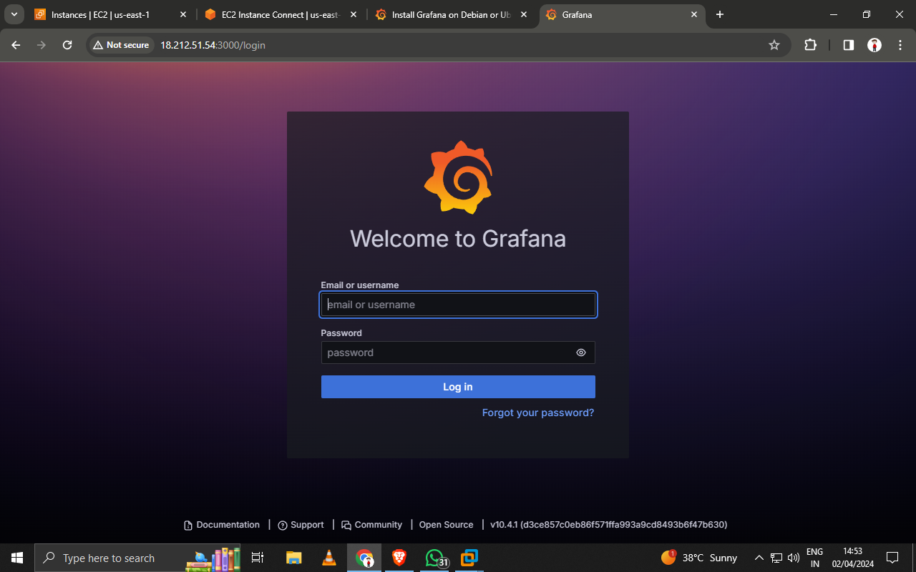

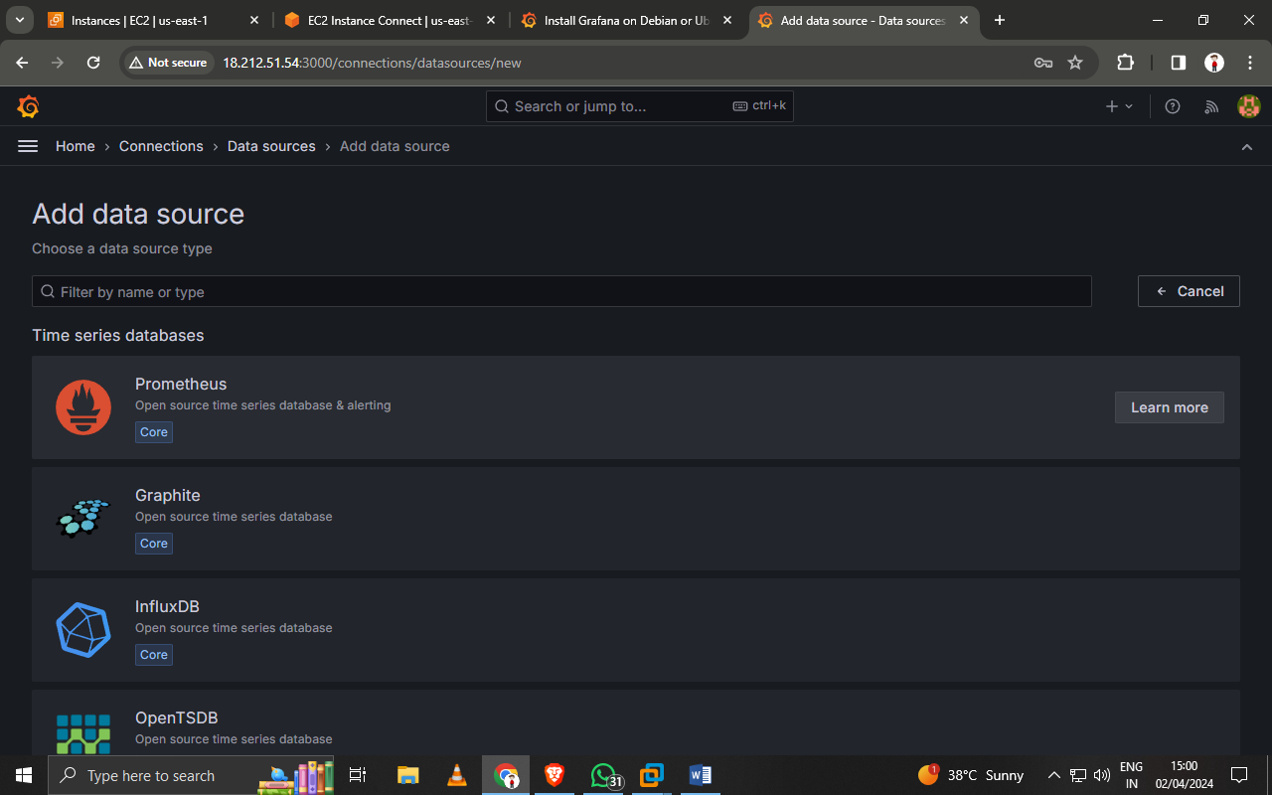

loki install and Promtil

10 sudo apt-get install docker.io

11 sudo usermod -aG docker $USER

14 mkdir grafana_config

15 cd grafana_config/

(https://grafana.com/docs/loki/latest/setup/install/docker/)

29 wget https://raw.githubusercontent.com/grafana/loki/v2.9.4/clients/cmd/promtail/promtail-docker-config.yaml -O promtail-config.yaml

33 docker run --name loki -d -v $(pwd):/mnt/config -p 3100:3100 grafana/loki:2.9.4 -config.file=/mnt/config/loki-config.yaml

34 docker run --name promtail -d -v $(pwd):/mnt/config -v /var/log:/var/log --link loki grafana/promtail:2.9.4 -config.file=/mnt/config/promtail-config.yaml

http://18.212.51.54:3100/ready

<http://18.212.51.54:3100/metrics>