

A MAJOR PROJECT REPORT ON

“NoteNest: A Web-Based Note-Taking Application with Admin Panel”

Submitted in partial fulfillment of the requirements for the
Degree of Diploma in Computer Engineering

Sudip Neupane
Umesh Budha
Nabi Akhtar Khan
[Symbol No. – Sudip Neupane]
[Symbol No. – Umesh Budha]
[Symbol No. – Nabi Akhtar Khan]
Department of Computer Engineering
Kathmandu Institute of Technology
Council for Technical Education and Vocational Training (CTEVT)
Shrawan, 2083

“NoteNest: A Web-Based Note-Taking Application with Admin Panel”

A PROJECT REPORT

Submitted by:
Sudip Neupane – [Symbol No.]
Umesh Budha – [Symbol No.]
Nabi Akhtar Khan – [Symbol No.]

Submitted to:
Department of Computer Engineering
Kathmandu Institute of Technology

In partial fulfillment of the requirements for the degree of
Diploma in Computer Engineering

Shrawan, 2083

CERTIFICATE OF APPROVAL

The undersigned certify that they have read, and recommended to the Department of Computer Engineering for acceptance, a project report entitled “NoteNest: A Web-Based Note-Taking Application with Admin Panel” submitted by Sudip Neupane, Umesh Budha, and Nabi Akhtar Khan in partial fulfillment of the requirements for the degree of Diploma in Computer Engineering.

_______________________________
Supervisor
Akash GC, Department of Computer Engineering

_______________________________
External Examiner

_______________________________
Head of Department
Department of Computer Engineering

ACKNOWLEDGMENT

We would like to express our sincere gratitude to our project supervisor, Akash GC, for the continuous guidance, valuable suggestions, and encouragement throughout the development of this project, “NoteNest”.
We are also thankful to the Department of Computer Engineering, Kathmandu Institute of Technology, for providing the resources and environment necessary to complete this project. Finally, we extend our gratitude to our family and friends for their constant support and motivation.

EXECUTIVE SUMMARY

NoteNest is a web-based note-taking application, with an accompanying admin panel, designed to give individual users a simple, reliable place to create and organize their notes while giving administrators the tools to oversee the platform. The system allows administrators to view usage statistics, manage user accounts and roles, moderate all notes, review a role-change audit log, and export data to CSV, while regular users can register, log in, and create, tag, favorite, pin, and delete their own notes.
This report presents the complete development lifecycle of the project, including the problem background, objectives, scope, feasibility study, system requirements, related literature, design methodology, implementation details, testing results, and conclusions drawn from the project. The system was developed using the MERN-style stack (React, Express.js, MongoDB, and Node.js) and follows an Incremental Model of development.
The final system successfully meets its stated objectives, providing a reliable, secure, and user-friendly platform for personal note management with administrative oversight, with recommendations for further enhancements outlined in the concluding chapter.

TABLE OF CONTENTS

1. Project Overview 1
1.1. Introduction 1
1.2. Objectives and Scope 1
1.2.1. Objectives 1
1.2.2. Scope 1
1.3. Project Features 1
1.4. Feasibility 1
1.4.1. Technical Feasibility 1
1.4.2. Economic Feasibility 1
1.4.3. Operational Feasibility 1
1.5. System Requirement 1
1.5.1. Hardware Requirements 1
1.5.2. Software Requirements 1
2. Literature Review 1
2.1. Related Works 1
2.2. Research Gap 1
3. Design and Methodology 1
3.1. Methodology 1
3.2. System Design 1
3.2.1. System Architecture 1
3.2.2. Use Case Diagram 1
3.2.3. Database Design 1
3.3. Tools and Technologies Used 1
3.4. Data Source 1
4. Result and Analysis 1
4.1. Implementation 1
4.2. Testing 1
4.3. Result Analysis 1
5. Conclusion, Recommendation and Limitations 1
5.1. Conclusion 1
5.2. Limitations 1
5.3. Recommendations for Future Work 1
Appendix A: Sample Source Code 1
Appendix B: Sample Questionnaire / Screenshots 1

LIST OF FIGURES

Figure 3.1: System Architecture Diagram ..................................................... 12
Figure 3.2: Use Case Diagram ...................................................................... 14
Figure 3.3: Entity Relationship Diagram ....................................................... 16

LIST OF TABLES

Table 3.1: Functional Requirements ............................................................. 10
Table 4.1: Test Cases and Results ................................................................ 20

LIST OF SYMBOLS

λ – Arrival rate
μ – Service rate
Σ – Summation

ABBREVIATIONS

API – Application Programming Interface
CSS – Cascading Style Sheets
DBMS – Database Management System
ERD – Entity Relationship Diagram
HTML – HyperText Markup Language
SQL – Structured Query Language
UI – User Interface

1. Project Overview

1.1. Introduction
This chapter introduces NoteNest, describing the background and motivation behind the project. Consumer note-taking apps are built for a single user and typically offer no way for an administrator to oversee accounts or content. This project proposes a web-based note-taking application that pairs a familiar personal note-taking experience with a dedicated admin panel for platform oversight.

1.2. Objectives and Scope

1.2.1. Objectives
To design and develop NoteNest, a secure, web-based note-taking application that allows registered users to create, organize, and manage personal notes, while giving administrators a dedicated panel to monitor platform activity and manage users and content.

1.2.2. Scope
The system covers user registration and authentication, note creation/editing/deletion, tagging, favoriting, pinning, and trashing of notes, and an administrator panel for viewing platform statistics, managing users and their roles, managing all notes, tracking role-change history through an audit log, and exporting user/note data to CSV. It does not cover real-time collaborative editing, offline synchronization, or a native mobile application.

1.3. Project Features
Key features include secure JWT-based authentication, role-based access control (user/admin), full note CRUD with tagging, favorites, pinning and trash, and an admin dashboard with growth charts, a role-distribution chart, a live activity feed, searchable/sortable/paginated tables, bulk user actions, inline role editing, a role-change audit log, and CSV export.
Table 3.1: Functional Requirements
ID | Requirement | Priority
FR-1 | Users shall be able to register and log in securely (JWT-based authentication). | High
FR-2 | Users shall be able to create, edit, and delete their own notes. | High
FR-3 | Users shall be able to tag, favorite, pin, and trash notes. | Medium
FR-4 | Admins shall be able to view platform statistics and charts. | High
FR-5 | Admins shall be able to search, sort, and paginate users and notes. | High
FR-6 | Admins shall be able to change a user's role, individually or in bulk. | High
FR-7 | The system shall record every role change in an audit log. | Medium
FR-8 | Admins shall be able to export users and notes to CSV. | Low
FR-9 | The system shall prevent an admin from deleting or demoting their own account. | High

1.4. Feasibility

1.4.1. Technical Feasibility
All frameworks and tools used — React, Node.js, Express.js, and MongoDB — are free, open-source, well-documented, and widely supported, with an active community and abundant learning resources. The development team had prior exposure to JavaScript, which made adopting a JavaScript-based full stack practical within the project timeline.

1.4.2. Economic Feasibility
The technology stack used is entirely free and open-source, so development incurred no licensing cost. MongoDB Atlas and common Node.js hosting platforms offer free tiers suitable for a project of this scale, keeping hosting and maintenance costs minimal relative to the productivity benefits the system provides its users.

1.4.3. Operational Feasibility
The interface follows familiar note-taking app conventions (similar to Google Keep and Notion), so end users require little to no training. The admin panel groups related actions (search, sort, bulk edit) into a single consistent layout, making it easy for a non-technical administrator to operate day-to-day.

1.5. System Requirement

1.5.1. Hardware Requirements
Minimum 4GB RAM, dual-core processor, and a stable internet connection for both development and end-user access.

1.5.2. Software Requirements
Windows/Linux/macOS operating system, a modern web browser (Chrome, Firefox, or Edge), JavaScript with the React and Node.js/Express.js frameworks, MongoDB as the database, and a Node.js-compatible server environment.

2. Literature Review
This chapter reviews existing note-taking systems relevant to this project. It discusses their approach and limitations, identifies the gap this project addresses, and justifies the approach taken in NoteNest.

2.1. Related Works
Google Keep offers a fast, minimal note-taking experience with color-coded notes and reminders, but has no user-management or administrative layer, since it is a single-user consumer product. Evernote provides richer organization through notebooks and tags and supports web clipping, but its free tier is limited and it targets individual productivity rather than group or institutional oversight. Notion offers powerful block-based notes and databases with team workspaces, but its flexibility comes with a steeper learning curve and heavier resource use for a task as simple as personal note-taking. None of these mainstream tools expose an administrator view for monitoring platform-wide usage, managing user roles, or auditing changes — a gap that is common in consumer note-taking products, which are built around a single user rather than a managed multi-user platform.

2.2. Research Gap
Existing note-taking applications are built for individual end users and provide no way for an administrator to oversee accounts, moderate content, or audit sensitive actions such as role changes. NoteNest addresses this gap by pairing a familiar note-taking experience for regular users with a dedicated admin panel that provides usage analytics, user and content management, bulk actions, and an audit trail — features more commonly found in enterprise SaaS products than in typical note-taking apps.

3. Design and Methodology

3.1. Methodology
The project was developed using an Incremental Model. Core functionality — user authentication and basic note CRUD — was built and tested first, after which the admin panel was added as a second increment, followed by further increments for the analytics dashboard, audit log, and CSV export. This approach was chosen because it allowed each working increment to be demonstrated and reviewed by the supervisor before the next set of features was built, reducing the risk of large-scale rework.

3.2. System Design

3.2.1. System Architecture
NoteNest follows a three-tier client-server architecture. The presentation tier is a React single-page application (built with Vite) that runs in the user's browser and communicates with the backend over HTTPS. The application tier is a Node.js server built with Express.js, which exposes a REST API, handles authentication with JSON Web Tokens (JWT), and contains all business logic for notes, users, and the admin panel. The data tier is a MongoDB database, accessed through the Mongoose ODM, which persists users, notes, and audit-log records. Refer to Figure 3.1.
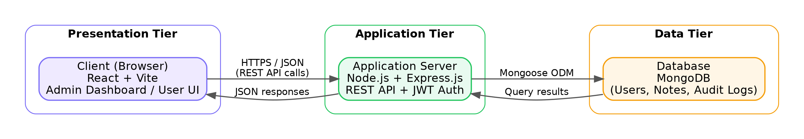
Figure 3.1: System Architecture Diagram

3.2.2. Use Case Diagram
The system has two actors: a regular User and an Admin. A User can register, log in, and create, edit, tag, favorite, pin, and delete their own notes. An Admin has all the privileges of a User, plus access to the admin panel, where they can view dashboard statistics and charts, search/sort/paginate through all users and notes, edit a user's role inline or in bulk, delete users or notes, review the role-change audit log, and export users or notes to CSV. Refer to Figure 3.2.
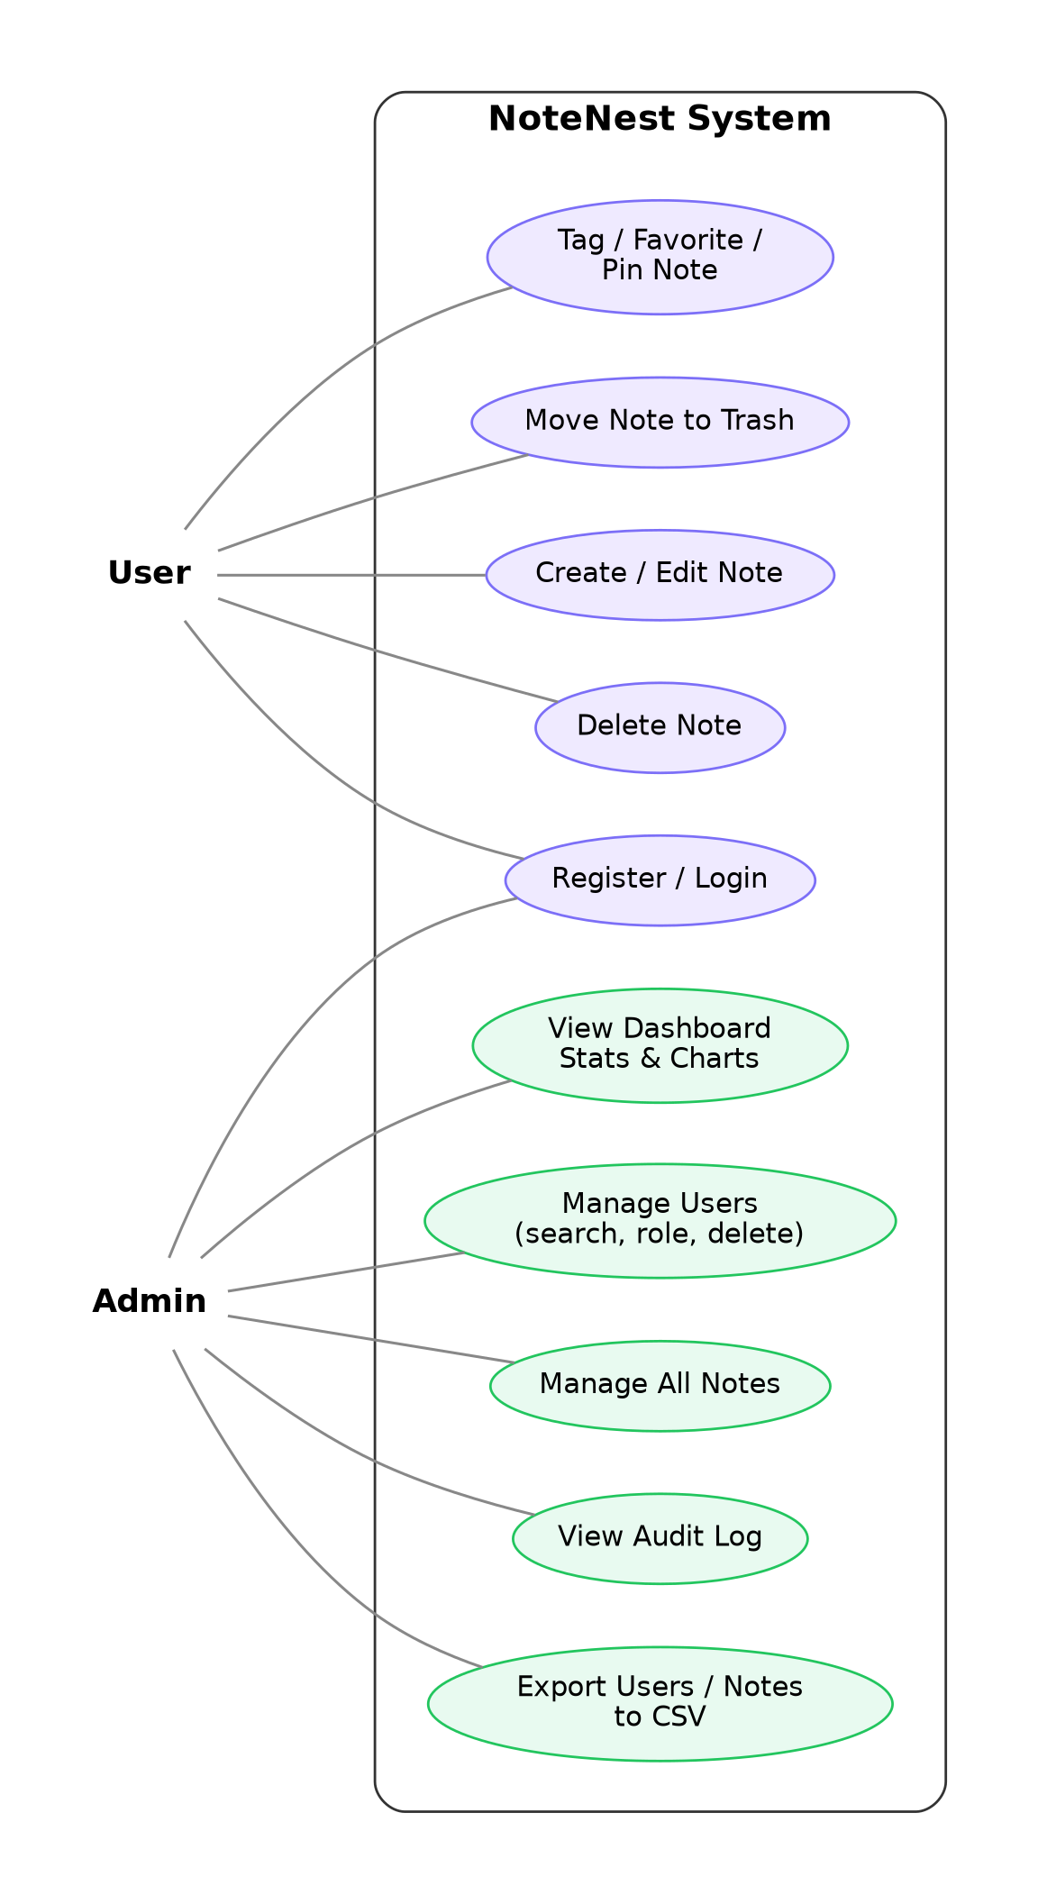
Figure 3.2: Use Case Diagram

3.2.3. Database Design
The database consists of three main collections. The User collection stores each account's username, email, hashed password, and role (user or admin). The Note collection stores each note's title, content, owner reference (user_id), tags, and favorite/pinned/trash flags, with a many-to-one relationship to User. The AuditLog collection records every role change, storing the admin who performed it (performedBy), the user affected (targetUser), the previous and new role, and a timestamp, with two separate many-to-one relationships back to User. Refer to Figure 3.3.
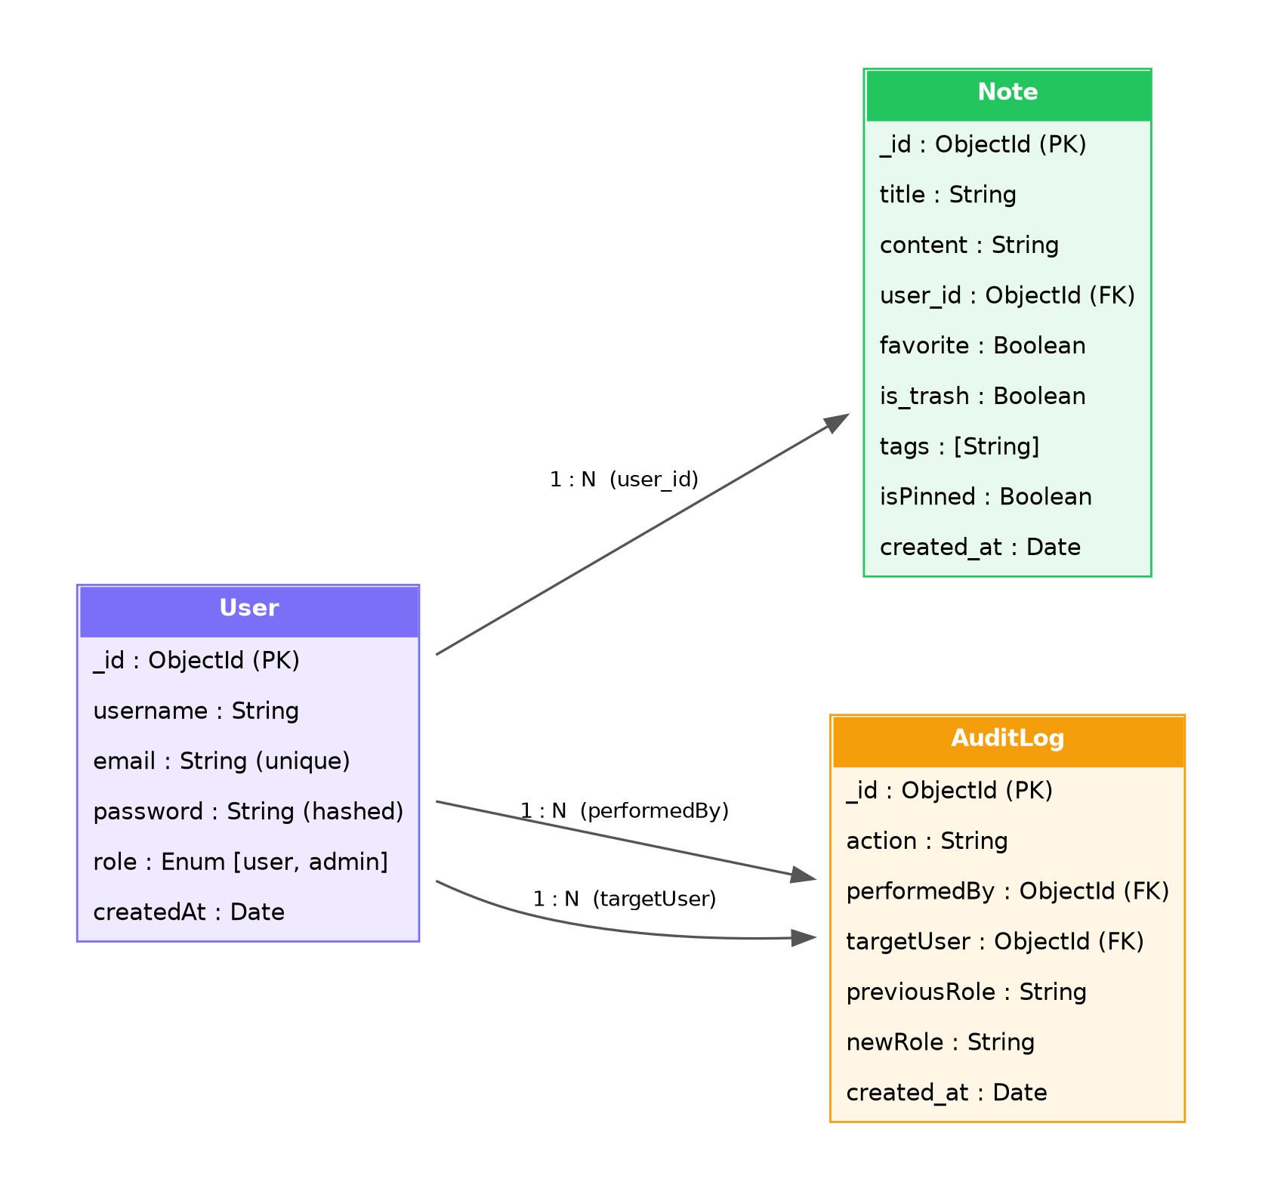
Figure 3.3: Entity Relationship Diagram

3.3. Tools and Technologies Used
Front-end: JavaScript (React, React Router, Vite), Recharts for data visualization, and Lucide React for icons. Back-end: Node.js with Express.js, JSON Web Tokens (jsonwebtoken) and cookie-parser for authentication, and CORS middleware. Database: MongoDB with the Mongoose ODM. Development tools: Visual Studio Code, Git and GitHub for version control, and Postman for API testing.

3.4. Data Source
Test data was generated by the development team through manual use of the application — creating sample user accounts and notes directly through the sign-up and note-creation flows — to validate functionality under realistic, self-produced data during development and testing.

4. Result and Analysis

4.1. Implementation
Implementation proceeded module by module. The authentication module handles registration, login, and JWT-based session verification via middleware that protects private routes. The notes module implements full CRUD for notes, along with tagging, favoriting, pinning, and soft-deletion (trash). The admin module exposes REST endpoints for platform statistics, user and note management, role updates, and audit-log retrieval, all guarded by an admin-only middleware that re-verifies the requester's role against the database on every request. On the front end, the admin panel was implemented as a single dashboard component with tabs for Overview, Users, Notes, and Audit Log, using Recharts for the growth and role-distribution charts and client-side logic for search, sorting, pagination, bulk selection, and CSV export.

4.2. Testing
The system was tested primarily through manual functional testing at three levels: unit-level checks of individual API endpoints using Postman, integration testing of the front end against the live backend and database, and system-level testing of complete user journeys such as registering, logging in, creating notes, and performing admin actions end-to-end. Particular attention was paid to edge cases such as an admin attempting to change or delete their own account, which is explicitly blocked by both the front end and the backend. Refer to Table 4.1 for test cases and results.
Table 4.1: Test Cases and Results
ID | Test Case | Expected Result | Status
TC-1 | Register with a new email | Account is created; user is logged in | Pass
TC-2 | Login with correct credentials | JWT issued; redirected to dashboard | Pass
TC-3 | Login with wrong password | Access denied with an error message | Pass
TC-4 | Create a new note | Note appears in the user's note list | Pass
TC-5 | Non-admin visits /adminDashboard | Redirected to the regular dashboard | Pass
TC-6 | Admin changes another user's role | Role updates; entry appears in audit log | Pass
TC-7 | Admin attempts to change own role | Action blocked with an error message | Pass
TC-8 | Export filtered users to CSV | Downloaded file matches the filtered rows | Pass

4.3. Result Analysis
Testing confirmed that the system meets the objectives set out in Chapter 1: users can register, authenticate, and manage their own notes, while administrators can view accurate, real-time statistics and manage users and notes through a single interface. The dashboard remained responsive with sample data of a few dozen users and notes, and the interface was found to be intuitive to navigate without prior instruction, since it follows conventions common to other note-taking and admin-panel products.

5. Conclusion, Recommendation and Limitations

5.1. Conclusion
The project successfully delivered a working note-taking application with secure authentication, full note management, and a comprehensive admin panel featuring analytics, user and content management, bulk actions, an audit log, and CSV export — meeting all objectives defined at the start of the project.

5.2. Limitations
The current system has no offline mode and requires an active internet connection at all times. It does not support real-time collaborative editing of a shared note, does not have a native mobile application, and role changes are logged but cannot currently be reverted directly from the audit log.

5.3. Recommendations for Future Work
Future iterations could add real-time collaborative note editing, a native or progressive-web-app mobile experience, rich-text/markdown formatting for notes, note-sharing between users, and the ability to revert a role change directly from the audit log.

REFERENCES

[1] React documentation. “React.” react.dev (accessed 2026).
[2] Express.js documentation. “Express – Node.js web application framework.” expressjs.com (accessed 2026).
[3] MongoDB, Inc. “MongoDB Documentation.” mongodb.com/docs (accessed 2026).
[4] Mongoose documentation. “Mongoose ODM.” mongoosejs.com (accessed 2026).

APPENDICES

Appendix A: Sample Source Code
Selected key snippets — the admin-only middleware, the role-update controller, and the audit-log schema — are included on the following pages.
A.1 Admin-only middleware (backend/middleware/adminOnly.js)
const User = require('../models/User')

const adminOnly = async (req, res, next) => {
try {
const userId = req.user?.id || req.user?._id
if (!userId) {
return res.status(401).json({ error: 'Access token required. Please log in.' })
}
const dbUser = await User.findById(userId)
if (!dbUser || dbUser.role !== 'admin') {
return res.status(403).json({ error: 'Admin access required.' })
}
req.adminUser = dbUser
next()
} catch (err) {
res.status(500).json({ error: 'Something went wrong verifying admin access.' })
}
}

module.exports = adminOnly

A.2 Role-update controller (backend/controllers/adminController.js)
const updateUserRole = async (req, res) => {
try {
const { role } = req.body
if (!['user', 'admin'].includes(role)) {
return res.status(400).json({ error: "Role must be 'user' or 'admin'." })
}
const before = await User.findById(req.params.id)
if (!before) return res.status(404).json({ error: 'User not found.' })

if (String(req.adminUser._id) === String(req.params.id)) {
return res.status(400).json({ error: "You can't change your own role from here." })
}
if (before.role === role) {
return res.json({ id: before._id, role: before.role })
}

const updated = await User.findByIdAndUpdate(req.params.id, { role }, { new: true })

await AuditLog.create({
action: 'role_change',
performedBy: req.adminUser._id,
targetUser: updated._id,
previousRole: before.role,
newRole: updated.role,
})

res.json({ id: updated._id, role: updated.role })
} catch (err) {
res.status(500).json({ error: 'Failed to update role.' })
}
}

A.3 Audit log schema (backend/models/AuditLog.js)
const mongoose = require('mongoose')

const auditLogSchema = new mongoose.Schema({
action: { type: String, enum: ['role_change'], required: true },
performedBy: { type: mongoose.Schema.Types.ObjectId, ref: 'User', required: true },
targetUser: { type: mongoose.Schema.Types.ObjectId, ref: 'User', required: true },
previousRole: { type: String, required: true },
newRole: { type: String, required: true },
}, {
timestamps: { createdAt: 'created_at', updatedAt: false },
})

module.exports = mongoose.model('AuditLog', auditLogSchema)

Appendix B: Sample Questionnaire / Screenshots
Screenshots of the login page, the user dashboard, and each tab of the admin panel (Overview, Users, Notes, and Audit Log) are included on the following pages.
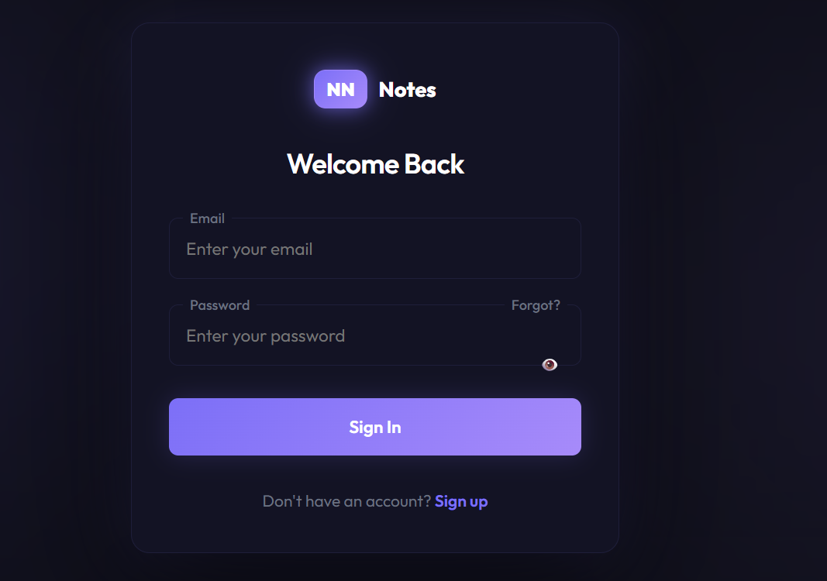
Figure B.1: Login Page

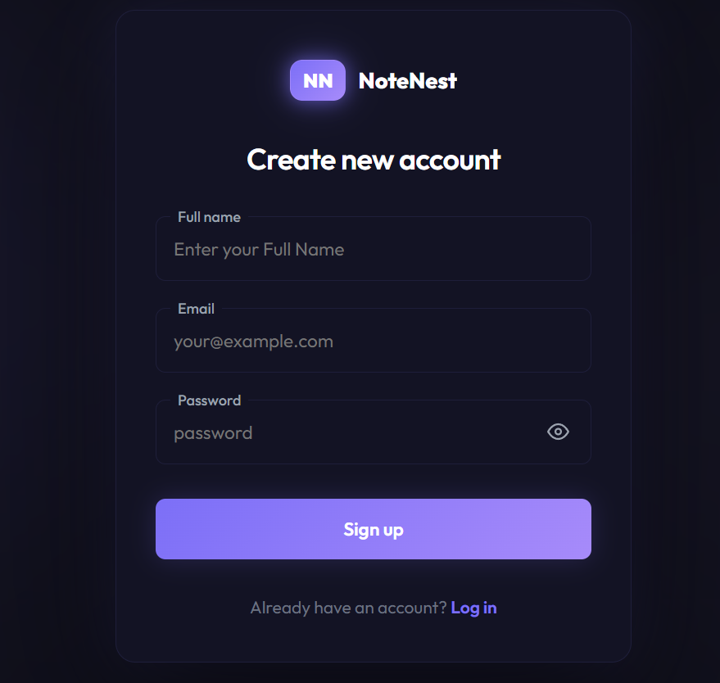
Figure B.2: Sign Up Page

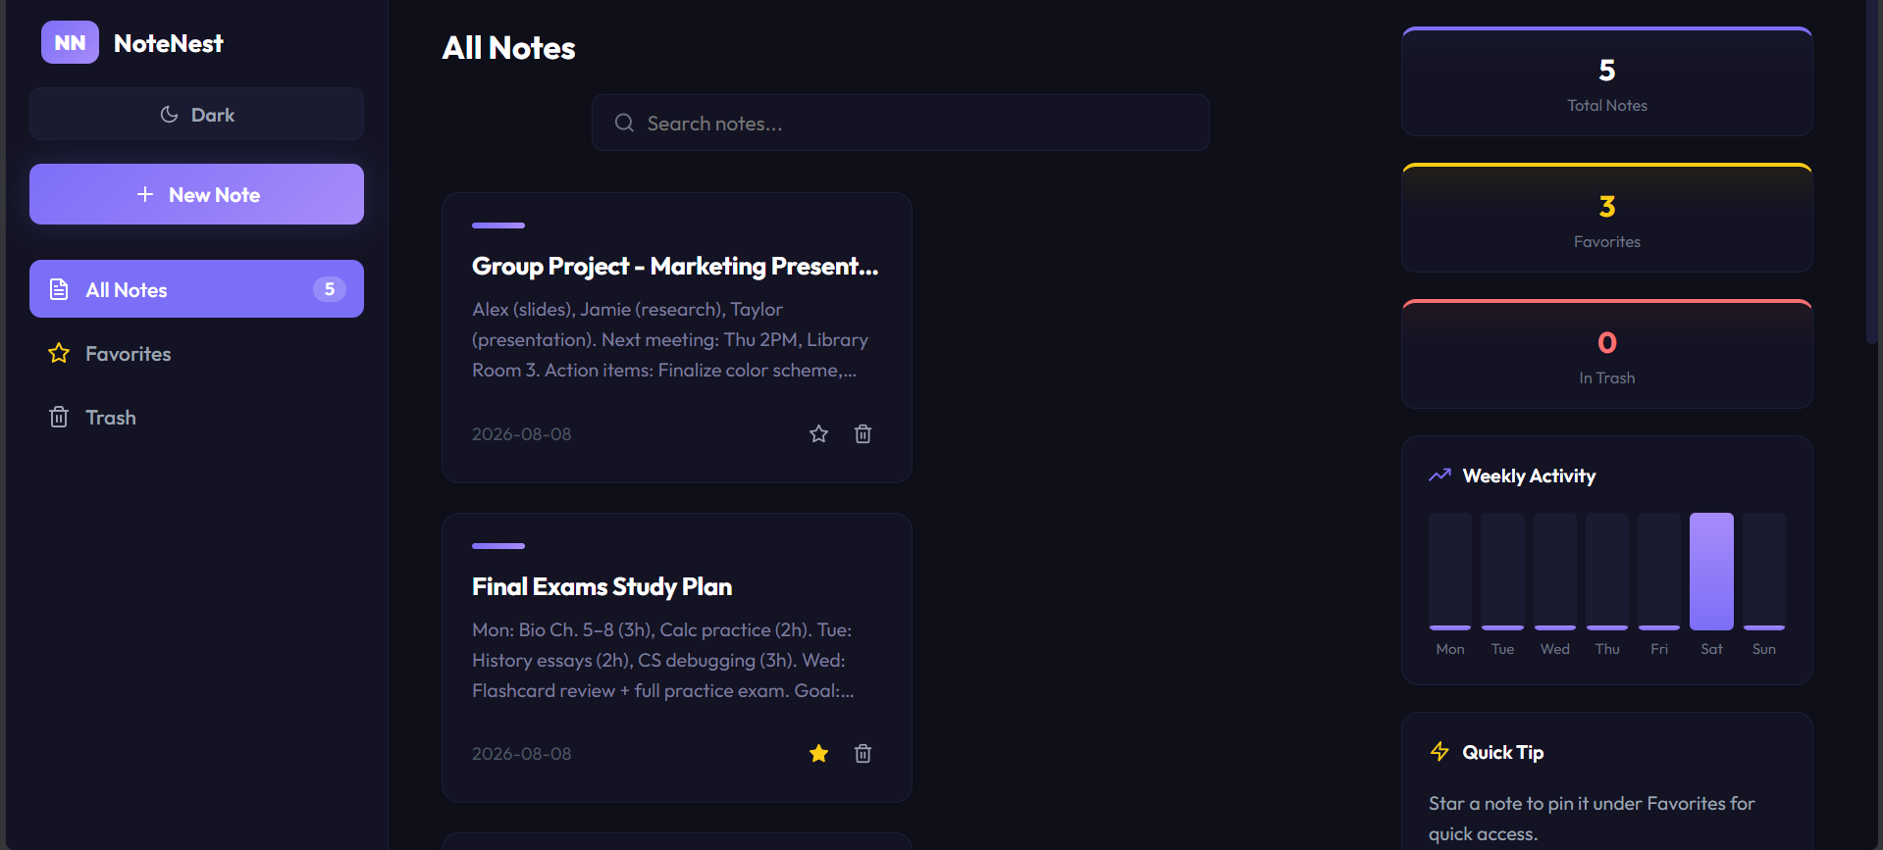
Figure B.3: User Notes Dashboard

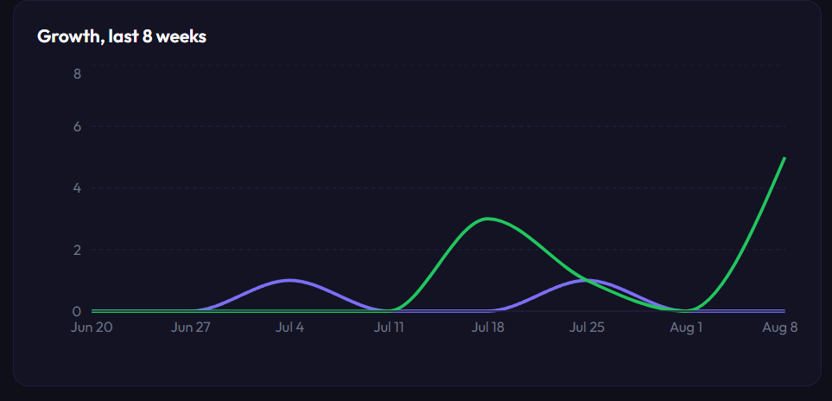
Figure B.4: Admin Overview — Growth Chart

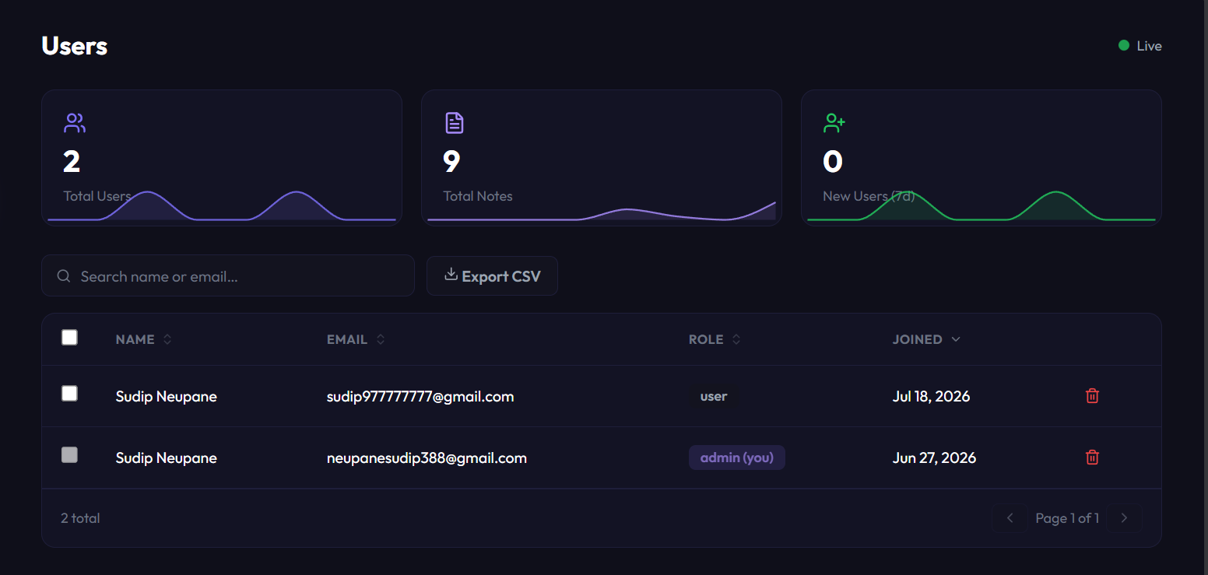
Figure B.5: Admin Panel — Users Tab

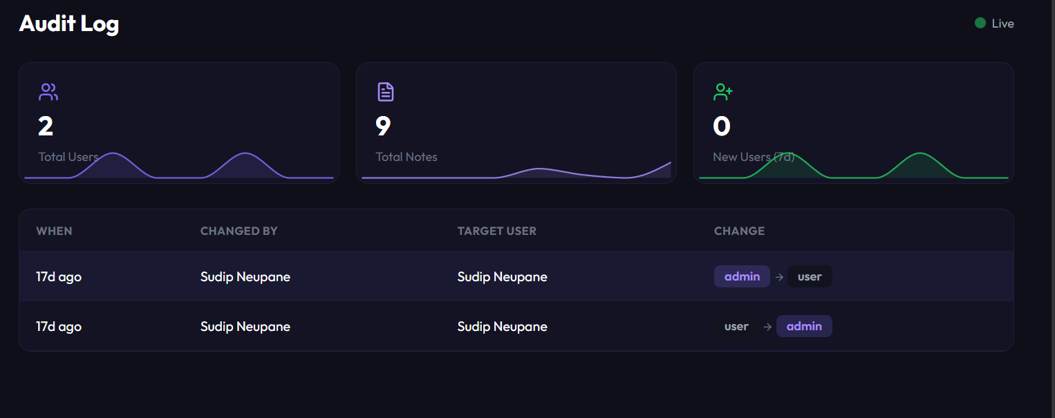
Figure B.6: Admin Panel — Audit Log Tab

