**Object oriented Programming**

**Student Id: s4613222**

**Student name: sudip khatri**

# **Details to run the program**

I have created four java classes. They are:

1. RiverCrossing: it contains the main as well as all method to run the program.
2. River: it creates a JFrame windows to launch the applications
3. RiverGUI: it is the graphical user interface for the user to interact with application
4. CommandLineInterface: it allows user to play the game which has main method as well as shows instructions to play.

This project has been done solo by me.

# **UML Diagram for the classes**

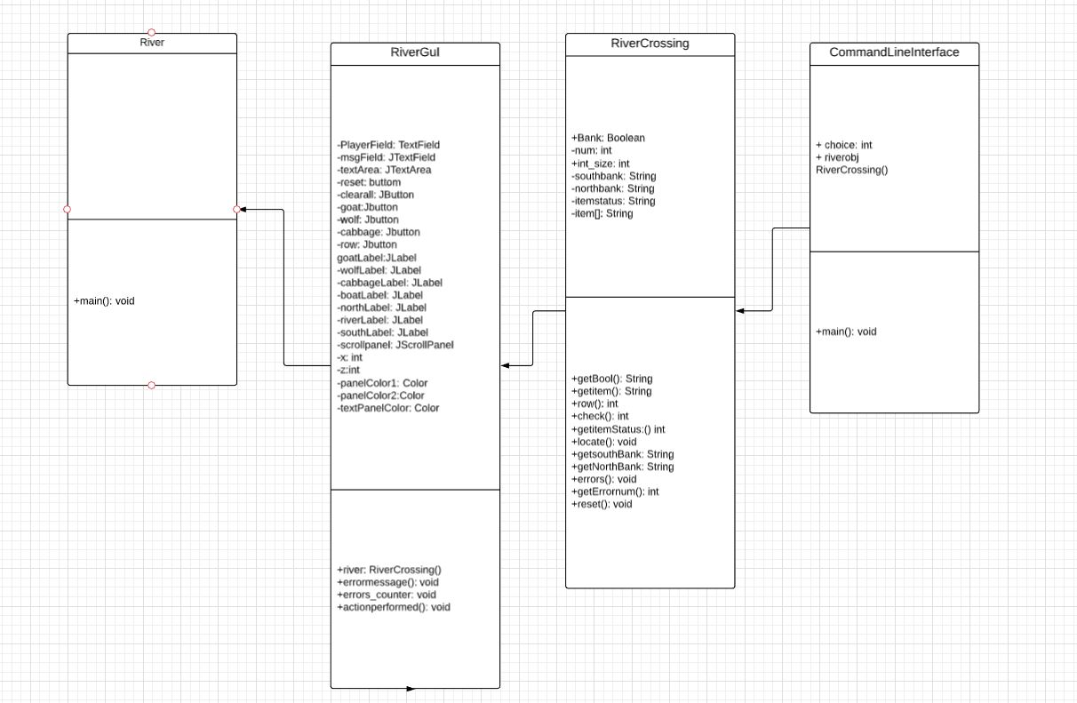

# **Screenshots for the testing game and errors:**

Below is the screenshot that are taken from application while running. Also, errors that can happen while running the codes:

