M&G Data Engineer Use Case

* Technical Architecture Diagram

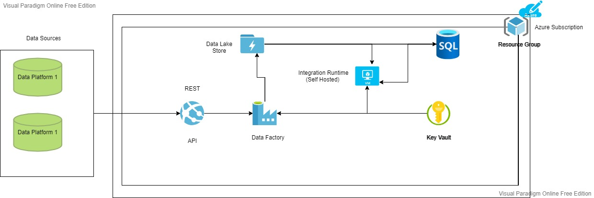

* Components:

Virtual Machine

Data Lake Store

Data Factory

Key Vault

Azure SQL Server

* Description

To fetch the data from the external data sources we need self-hosted integration runtime which can be installed on premises or virtual machine, in our case we are considering it to be VM.

There are multiple ways by which we can bring external data to Storage Account (Data Lake Store).

1. Create Azure Data Factory with copy activity with REST dataset
2. Using template Copy from REST or HTTP using OAuth
3. Using Logic Apps

In this example we are considering we will be going with the Copy Activity, so in the copy activity source our dataset will be Rest.

The Data Lake Store and the Data Factory are in Azure Virtual Environment for better security purpose. Also, we will be using Azure Key vault for storing tokens, keys etc. for more security.

The next part in the activity is the source we are considering Azure SQL database as it will give us the fully managed activity allowing us to focus more on the application.

Once we have our data in the data base, we can use it to generate reports using Power BI.

In short using Azure cloud we are taking care of the security, performance, and scalability.