Camunda Token Cost Reporter
(Outbound Connector)

Token Cost Reporter — User Manual
Table of Contents
(Right-click here and choose “Update Field”, or press F9, if the entries below don't show page numbers yet.)
1. Introduction 3
1.1 The problem 3
1.2 What this project is 3
2. Architecture 4
2.2 What happens on one call, step by step 5
3. Prerequisites 6
4. Installation, step by step 6
5. Configuring the price table (GOVERNOR_PRICE_TABLE secret) 7
Creating the secret 7
5.3 Two behaviors worth understanding before you rely on this 8
5.4 The bundled default table 8
6. Configuring the connector in Modeler, step by step 8
6.1 Installing the element template 8
6.2 Adding the connector to your process 8
6.3 The result shape 9
6.4 Two complete worked examples 11
7. BPMN error codes 12
8. Prometheus metrics 12
8.1 Why this works with no extra setup 12
8.2 Wiring up charts 13
9. Reporting in Camunda Optimize 14
9.1 Import the ready-made dashboard (recommended) 14
9.2 Why this works, and its limits 15
10. Troubleshooting / FAQ 16
13. Known limitations 17

1. Introduction

1.1 The problem
Camunda 8.10+'s native Agentic AI elements — the AI Agent Task and the AI Agent Sub-process — let a BPMN process call a large language model (Claude, GPT, etc.) directly from the process definition. This is powerful, but Camunda ships no cost visibility for it:
• There is no token count shown anywhere by default.
• There is no dollar cost shown anywhere by default.
• The only safety knob at all is maxModelCalls, a raw call-count limit (default 10) — it says nothing about how expensive each of those calls actually was.
• Camunda's own documentation tells operators, in effect, "you are responsible for watching your own LLM spend."
Without that visibility, nobody can answer a simple business question: how much did automating this step with AI actually cost, and was it worth it compared to a person doing the same work?

1.2 What this project is
The Token Cost Reporter is a single, self-contained Camunda outbound connector that answers that question for every LLM call. Drop it onto your BPMN diagram after an AI Agent element, and it tells you — as a plain process variable, and as a Prometheus metric — exactly how many input and output tokens that call used, and exactly how much it cost in USD.
It is deliberately narrow in scope:
• It only measures and reports. It never blocks, delays, or modifies a call — unlike some governance tools, it has no concept of a "budget" and cannot reject anything except a call for a model it has no price for.
• It makes no network calls of its own. No reverse proxy, no interception of the AI Agent element's traffic, nothing sitting between your process and the real LLM provider. It reads token counts the process already has (most naturally from the AI Agent element's own result) and does simple arithmetic.
• It uses no database. The one piece of external configuration it needs — a price list — lives in a single Camunda cluster secret, plus a small bundled fallback table for a zero-config start.
• It does not know what a human would have cost. It reports costUsd; comparing that number to a manual-process baseline is something you do downstream, with whatever number you already know — this connector doesn't guess at it.

2. Architecture
Everything else (token counts, model name) already exists in your process by the time this connector runs. The one external input is price data — what a provider charges per model — and that comes from, in priority order:
1. The GOVERNOR_PRICE_TABLE Camunda cluster secret — a JSON list of price rows you maintain once, centrally, for your whole cluster (see Section 5).
2. A small bundled default table shipped inside the connector, covering a handful of well-known models, used for anything the secret's table doesn't cover (or when the secret is blank).
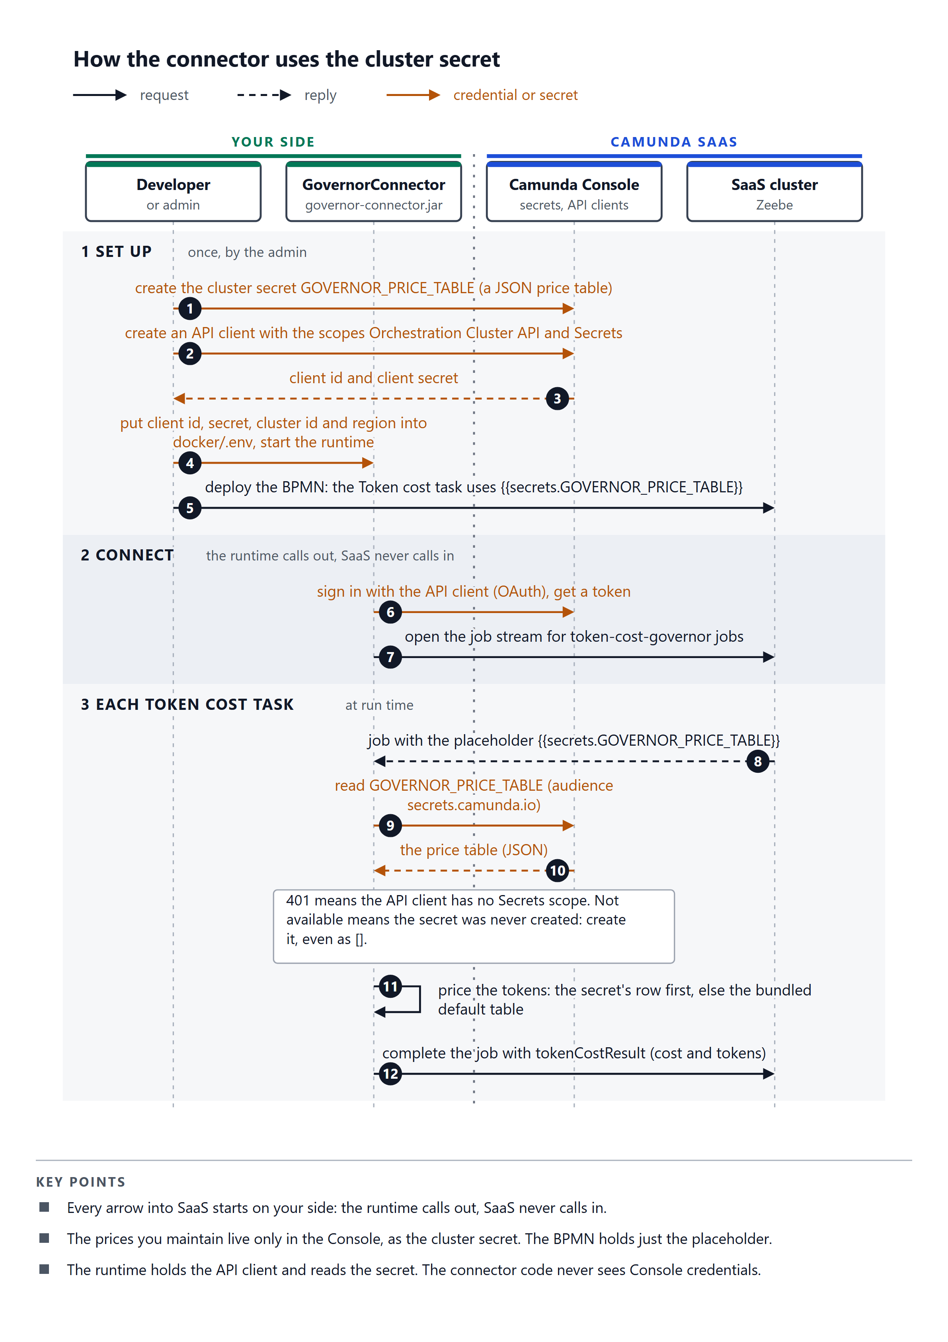

2.2 What happens on one call, step by step
1. Your BPMN process reaches an AI Agent Task (or Sub-process) element, which calls the real LLM provider directly (Camunda handles this itself — this connector is not involved at this step at all).
2. The AI Agent element's own result includes token usage, at <resultVariable>.context.metrics.tokenUsage
3. Your process passes that provider name, model name, and input/output token counts into a Token Cost Reporter task, typically placed right after the AI Agent element, via FEEL expressions.
4. The connector looks up a price for that provider:model pair — first in the GOVERNOR_PRICE_TABLE cluster secret's table.
5. If a price is found, it computes the cost (fixed-point arithmetic, never floating-point, so the numbers are exact) and returns tokenCostResult — token counts, total cost in USD and in micro-dollars, currency, and which price source was used.
6. It also records four Prometheus counters (tokens in, tokens out, cost, call count), tagged by provider and model, so the same data is chartable in aggregate across every process instance — see Section 8.
7. If no price is found anywhere, it raises a PRICE_NOT_FOUND BPMN error instead of step 5/6.

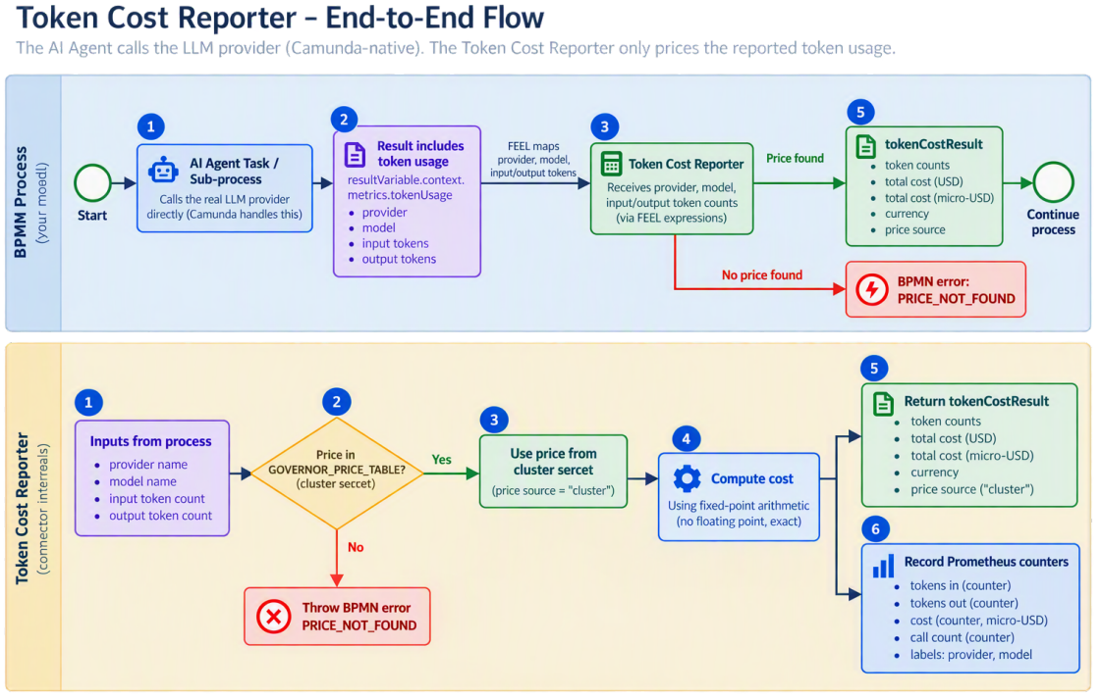

3. Prerequisites
Requirement | Version | What it's for
Java | 21 | The connector is built and runs on Java 21.
Apache Maven | 3.9+ | Builds the module and generates its element template.
Docker (and Docker Compose) | Any recent version | Optional — the recommended way to run the connector inside a connectors-bundle container.
A Camunda 8.10+ cluster (SaaS, self-managed, or a local dev cluster) | 8.10 or newer | Where your BPMN processes actually run — job type names for the native Agentic AI elements have changed release to release, so double-check yours.

4. Installation, step by step
1. Open a terminal in the project root (camunda-token-cost-governor/).
2. Build the module:
mvn package
This should end with BUILD SUCCESS. It produces two artifacts in governor-connector/target/: a thin jar (not directly runnable) and governor-connector-<version>-with-dependencies.jar (the one you actually deploy — it bundles every dependency the connector needs). It also (re)generates element-templates/token-cost-governor.json — the file you'll import into Modeler in Section 6.
3. Deploy the -with-dependencies.jar into a Camunda connector runtime. Two common ways:
◦ Docker (recommended) — see Section 10 for the full walkthrough; it mounts the jar into Camunda's own connectors-bundle image via the LOADER_PATH environment variable, the officially documented custom-connector hosting pattern.
◦ An existing connector runtime you already operate — copy the jar wherever that runtime's own LOADER_PATH (or equivalent) points, and restart it.
4. Import the element template into Modeler — see Section 6.1.
5. (Optional but recommended) Create the GOVERNOR_PRICE_TABLE cluster secret — see Section 5. Skipping this step isn't a hard failure: the connector still works out of the box for a handful of well-known models via its bundled default table.

5. Configuring the price table (GOVERNOR_PRICE_TABLE secret)

Creating the secret
1. In Camunda Console (SaaS) — or your self-managed cluster's equivalent secret store — go to your cluster's Cluster secrets screen.
2. Create a secret named exactly GOVERNOR_PRICE_TABLE.
3. Set its value to a JSON array, one object per model:
[
{ "provider": "anthropic", "model": "claude-sonnet-4-5", "inputPricePerMillionUsd": 3.00, "outputPricePerMillionUsd": 15.00, "currency": "USD" },
{ "provider": "openai", "model": "gpt-5", "inputPricePerMillionUsd": 1.25, "outputPricePerMillionUsd": 10.00, "currency": "USD" }
]
4. Save it.
Field | What to enter
provider | Matches whatever you'll pass into the connector's Provider field, e.g. anthropic, openai — case doesn't matter, the connector lowercases both sides before matching.
model | The exact model name/id as it appears in your AI Agent element's configuration, e.g. claude-sonnet-4-5.
inputPricePerMillionUsd | The provider's published price per 1,000,000 input tokens, in USD — copy it straight off their pricing page.
outputPricePerMillionUsd | The provider's published price per 1,000,000 output tokens, in USD.
currency | Currently always USD in practice — carried straight through to tokenCostResult.currency, but the connector does no currency conversion (see Section 13).

5.3 Two behaviors worth understanding before you rely on this
• A secret that was never created at all fails every job outright, before the connector's own code even runs — this is how Camunda's own secret resolution works (referencing a nonexistent secret is a hard error), not a bug in this connector.
• A secret that exists but is blank, or whose table is missing a particular model, falls back gracefully to the bundled default table, per model — not all-or-nothing. If neither has the model, then you get a PRICE_NOT_FOUND error (Section 7).

5.4 The bundled default table
For a zero-config quick start, the connector ships with a small, illustrative, not verified against live pricing table covering a few well-known models (see governor-connector/src/main/resources/default-price-table.json for the exact current list — it changes independently of this manual). Treat it as a placeholder to get started with, not a source of truth for real cost tracking; configure the cluster secret with real, current prices before relying on the numbers for anything that matters.

6. Configuring the connector in Modeler, step by step

6.1 Installing the element template
1. Build the project if you haven't already (mvn package from the project root) — this generates element-templates/token-cost-governor.json.
2. Copy that file into Modeler's element template folder:
Desktop Modeler on... | Folder
Windows | %APPDATA%\camunda-modeler\resources\element-templates
macOS | ~/Library/Application Support/camunda-modeler/resources/element-templates
Linux | ~/.config/camunda-modeler/resources/element-templates

(Using Web Modeler instead: use its own "Upload element template" option and select the same JSON file.)
3. Restart Modeler if it was already open.

6.2 Adding the connector to your process
1. Drag a Service Task onto the canvas, positioned right after your AI Agent Task (or Sub- process) element.
2. In the properties panel, under Connector type (or similar, depending on Modeler version), select Token Cost Reporter.
3. Fill in the four required fields, plus the optional agent name (these are the exact labels you'll see in the property panel — this is the entire property panel; there's no operation picker, no gateway URL, no secret field to type in):
Field label | Group | Required? | FEEL-able? | What to enter
Provider | Model | Yes | Yes | =agentProvider, or a literal like anthropic
Model | Model | Yes | Yes | =agentModel
Input tokens | Token usage | Yes | Yes | =agent.context.metrics.tokenUsage.inputTokenCount
Output tokens | Token usage | Yes | Yes | =agent.context.metrics.tokenUsage.outputTokenCount
Agent name | Agent (optional) | No | Yes | A literal like claims-triage — see below (the underlying input is called agentName)

4. This connector never throws a BPMN error on the happy path — only if the model it's asked about has no price anywhere (Section 7). Its result lands in the configured result variable (default tokenCostResult) for you to show on a form, log, branch on with FEEL, or feed into an accumulator variable across a loop.

6.3 The result shape
{
"provider": "anthropic",
"model": "claude-sonnet-4-5",
"agent": "claims-triage",
"inputTokens": 1200,
"outputTokens": 340,
"totalTokens": 1540,
"costMicros": 8700,
"costUsd": 0.0087,
"currency": "USD",
"priceSource": "CLUSTER_SECRET"
}
Field | Meaning
costMicros | The authoritative, exact figure — integer micro-dollars (1 USD = 1,000,000 micros), fixed-point so nothing ever rounds off in accumulation.
costUsd | The same number as a decimal dollar amount, for display/logging convenience — derived from costMicros, never the other way around.
priceSource | CLUSTER_SECRET or DEFAULT_TABLE — which price list actually answered this lookup, so the result is self-auditing.
agent | The agent name you set, else <processId>:<elementId>, else unspecified — never null.

6.4 Two complete worked examples
The project ships two tested, working examples:
 | Research Analyst (big context) | Quick Answer (small context)
Prompts | long system prompt and a long claim brief with guidelines | one-line system prompt and one short question
Context window / max model calls | 100 / 10 | 4 / 2
Behaviour | uses its date tool, so it makes several model calls and re-sends a large context each time | answers directly in one model call
Token cost agent name | research-analyst | quick-answer
Tokens in the test (input / output) | 12,850 / 940 (3 model calls) | 96 / 42 (1 model call)
Cost at the bundled haiku price (1.00 / 5.00 USD per million) | 17,550 micro-dollars | 306 micro-dollars

Quick Answer (small context) :
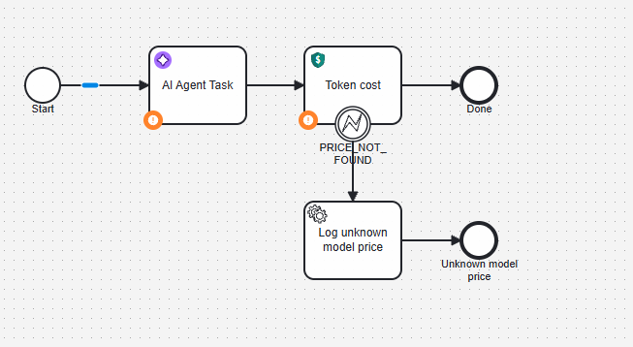

Research Analyst (big context)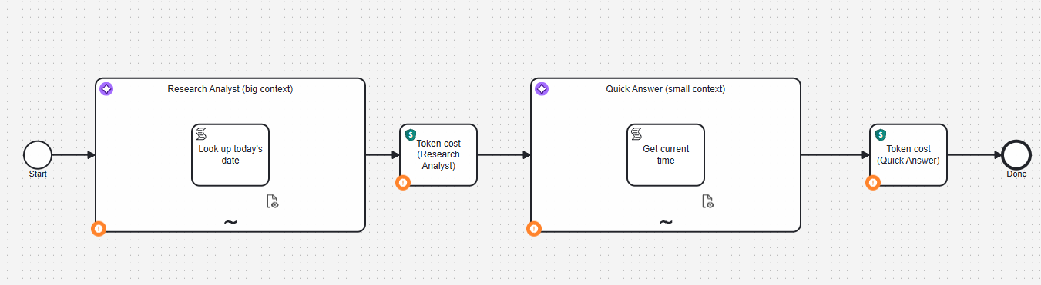

7. BPMN error codes
Code | Retryable? | Meaning | What to do
PRICE_NOT_FOUND | No | No price for the requested provider+model in the GOVERNOR_PRICE_TABLE cluster secret or the bundled default table. | Add a row for that provider+model to the cluster secret (Section 5.2).

8. Prometheus metrics
Every successful execution records four Micrometer counters, tagged by provider, model and agent (the agent tag is always present — Prometheus requires the same tag keys on every sample of a metric — falling back to <processId>:<elementId>, then unspecified):
Metric | What it counts
governor_calls_total | Number of Token Cost Reporter calls
governor_tokens_input_total | Cumulative input tokens
governor_tokens_output_total | Cumulative output tokens
governor_cost_usd_total | Cumulative USD cost

8.1 Why this works with no extra setup
The connector's jar bundles micrometer-registry-prometheus. Once it's mounted into a connectors-bundle runtime, Spring Boot's own auto-configuration notices that library on the classpath and automatically exposes a /actuator/prometheus endpoint on that same runtime — the exact same web server that already answers /actuator/health. No extra service to run, no extra port to open, no configuration beyond deploying the jar as described in Section 4. This was verified by actually running the built container and confirming the endpoint appears.

8.2 Wiring up charts
1. Point a Prometheus server's scrape config at your connectors-bundle instance's /actuator/prometheus endpoint (e.g. http://connectors-bundle:8080/actuator/prometheus on the Docker Compose network from Section 10).
2. Point Grafana at that Prometheus server as a data source.
3. Build a dashboard: total spend (sum(governor_cost_usd_total)), spend by model (sum by (model) (governor_cost_usd_total)), spend by agent (sum by (agent) (governor_cost_usd_total)), average tokens per call (governor_tokens_input_total / governor_calls_total), and so on — standard Prometheus counter/rate queries.

9. Reporting in Camunda Optimize
Prometheus/Grafana (Section 8) is for real-time, provider/model-level charts and for cost over time. For business-facing reports — "what did this process instance cost," "how much have we spent this month" — Optimize is the better tool, and the demo BPMN files' business_totalCostMicros, business_totalCostUsd and business_costAgent variables.

9.1 Import the ready-made dashboard (recommended)
optimize/ai-cost-dashboard.json contains five reports and one dashboard called AI cost:
# | Report | What it shows
1 | Cost of each process instance | Raw data table, completed instances: instance ID, start date, end date, business_totalCostUsd, business_totalCostMicros, business_costAgent.
2 | Agent-wise cost (USD) | Number: sum of business_totalCostUsd over completed instances. Add an agent filter to the dashboard after the first data arrives (below) to see one agent.
3 | Total spend this month (USD) | Number: sum, for instances started in the current calendar month.
4 | Total spend this year (USD) | Number: sum, for instances started in the current calendar year.
5 | Average cost per case (USD) | Number: average of business_totalCostUsd. The target for the human-flow comparison is switched off.

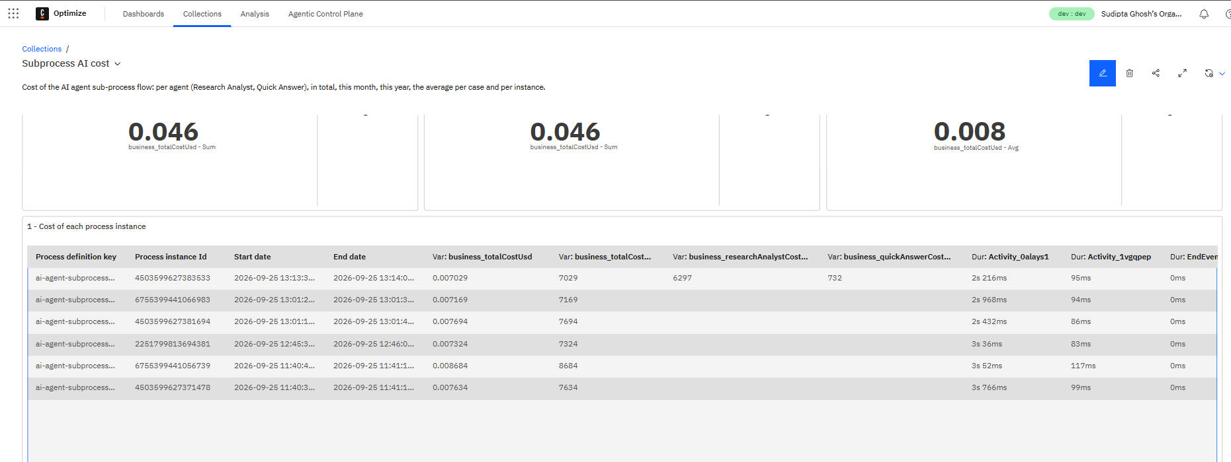

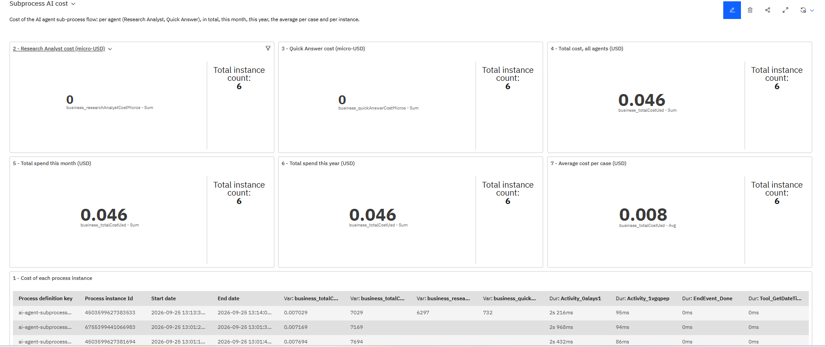

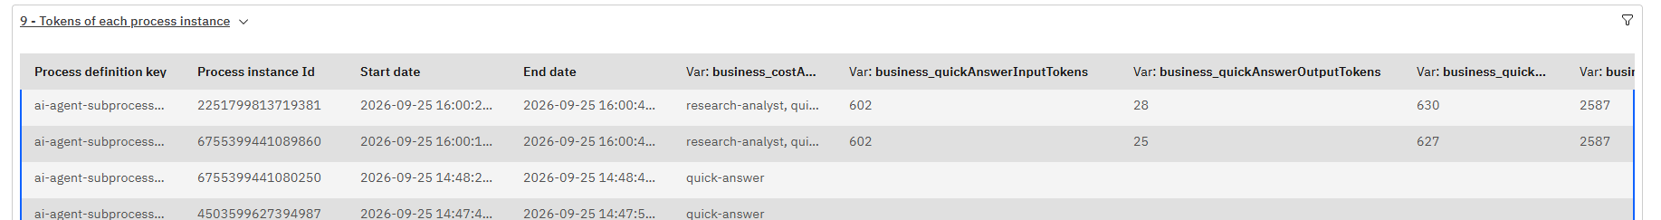

9.2 Why this works, and its limits
This works because business_totalCostUsd is a flat, top-level, numeric process variable holding its final value at process completion, with a name Optimize is allowed to import — exactly the shape the Variable view needs. It will not work on tokenCostResult itself: that is a nested object (one per call, not one per instance), and Optimize does not flatten object variables on SaaS. This is why the demo BPMN files accumulate the business_ variables alongside returning tokenCostResult as-is: one shape for per-call detail, another for per-instance and aggregate reporting.
business_totalCostMicros (integer micro-dollars) is the exact, authoritative figure; business_totalCostUsd (decimal dollars) is a display-only convenience derived from it, so point Optimize at business_totalCostUsd.

10. Troubleshooting / FAQ
Symptom | Likely cause | Fix
A Token Cost Reporter job fails immediately, before even reaching this connector's own logic | The GOVERNOR_PRICE_TABLE cluster secret was never created at all. | Create it — even as an empty array [] — per Section 5.2. A missing secret is a hard failure by Camunda's own design, not a graceful fallback.
PRICE_NOT_FOUND for a model you're sure you priced | A typo in provider or model between the cluster secret and what the BPMN task actually sends (check case — matching is case-insensitive, but the strings otherwise must match exactly), or the secret wasn't saved/deployed to the cluster the process is actually running on. | Compare the exact strings; re-save the secret; confirm you're looking at the right cluster/environment.
tokenCostResult.priceSource is always DEFAULT_TABLE, never CLUSTER_SECRET | The secret is blank, or doesn't contain that particular model — both fall back silently by design (Section 5.3), so this isn't necessarily wrong, just worth double-checking. | Check the secret's actual current value in Console; add the missing model's row.
/actuator/prometheus doesn't exist on my connector runtime | You're running the connector in a runtime that doesn't already ship spring-boot-starter-actuator (the official connectors-bundle image does), or the jar mounted isn't the -with-dependencies shaded one (only that one bundles micrometer-registry-prometheus). | Use the -with-dependencies.jar, mounted via LOADER_PATH into connectors-bundle, exactly as in Section 10.
governor_* counters aren't showing up on /actuator/prometheus yet | They're only registered the first time the connector actually executes — no process instance has reached the Token Cost Reporter task yet. | Run a process instance through it, then re-check.
The job fails and the runtime log shows "Response code: 401" with "Audience: secrets.camunda.io", followed by a HINT: about the Secrets scope | A connector runtime you host yourself reads cluster secrets from Camunda Console, and the API client it uses does not have the Secrets scope (observed on a real cluster). | Create a new API client in Console with the Secrets scope and use its ID and secret in the runtime's configuration — see the Deployment Guide, Section 12.1.
I can't tell why a call got the price it did, or nothing seems to happen | The connector logs a trace line per call at INFO (Token cost: provider=... priceSource=...), and explains its price-table decision at DEBUG. A price-table secret that isn't valid JSON logs a WARN instead of silently using the default table. It never logs the secret's text. | Look at the runtime's logs for Token cost. Set GOVERNOR_LOG_LEVEL=DEBUG (or the environment variable LOGGING_LEVEL_IO_GITHUB_CAMUNDA_CONNECTOR) for more detail; it can also be switched live through the runtime's /actuator/loggers endpoint. The Deployment Guide, Section 12.4, explains each line.
The job fails with inputTokens: must not be null (or tokens come through as 0 or blank) | The FEEL expression's path doesn't match where your AI Agent element actually stores its result (e.g. a different variable name, or a different template version that nests usage differently than agent.context.metrics.tokenUsage.inputTokenCount). | Inspect the AI Agent Task's actual output variable in a completed process instance (Operate) and adjust the FEEL expressions in Section 6.2 to match.

13. Known limitations
• Token accounting is exact for what Camunda forwards, not necessarily for what the provider bills — and this connector has no way to cross-check it.The bundled default price table is illustrative, not verified against live provider pricing. It exists to make a zero-config quick start possible, not as a source of truth — configure the GOVERNOR_PRICE_TABLE cluster secret with real, current prices before relying on this for actual cost tracking
• Where token usage lives depends on the AI Agent element's template version. On the version this project was verified against (v7, openaiCompatible provider) it is at <resultVariable>.context.metrics.tokenUsage.{inputTokenCount, outputTokenCount}. Other template versions or providers may report it elsewhere; a wrong path shows up as inputTokens: must not be null on the Token cost job (see Section 6.2).
• No multi-currency support.
• No human-baseline or "savings" calculation.

