**Codsoft**

**Artificial Intelligence**

**project**

**Name- Sudipta Samanta**

**TASK 2: TIC-TAC-TOE AI**

Implement an AI agent that plays the classic game of Tic-Tac-Toe against a human player. You can use algorithms like Minimax with or without Alpha-Beta Pruning to make the AI player unbeatable. This project will help you understand game theory and basic search algorithms

**Source Code**:

BOARD_EMPTY = 0

PLAYER_X = 1

PLAYER_O = -1

def print_board(s):

def convert(num):

    if num == PLAYER_X:

      return 'X'

    if num == PLAYER_O:

      return 'O'

    return '_'

  i = 0

  for _ in range(3):

    for _ in range(3):

      print(convert(s[i]), end=' ')

      i += 1

    print()

from collections import Counter

def player(s):

  counter = Counter(s)

  x_places = counter[1]

  o_places = counter[-1]

  if x_places + o_places == 9:

    return None

  elif x_places > o_places:

    return PLAYER_O

  else:

    return PLAYER_X

def actions(s):

  play = player(s)

  actions_list = [(play, i) for i in range(len(s)) if s[i] == BOARD_EMPTY]

  return actions_list

def result(s, a):

  (play, index) = a

  s_copy = s.copy()

  s_copy[index] = play

  return s_copy

def terminal(s):

  for i in range(3):

    # Checking if a row is filled and equal.

    if s[3 * i] == s[3 * i + 1] == s[3 * i + 2] != BOARD_EMPTY:

      return s[3 * i]

    # Checking if a column is filled and equal.

    if s[i] == s[i + 3] == s[i + 6] != BOARD_EMPTY:

      return s[i]

  # Checking if a diagonal is filled and equal.

  if s[0] == s[4] == s[8] != BOARD_EMPTY:

    return s[0]

  if s[2] == s[4] == s[6] != BOARD_EMPTY:

    return s[2]

  # Checking if the game has no more moves available

  if player(s) is None:

    return 0

  # Return None if none of the previous conditions satisfy.

  return None

def utility(s):

  term = terminal(s)

  # Return who wins the game if the game has terminated

  if term is not None:

    return term

  # Get the list of actions available

  action_list = actions(s)

  utils = []

  for action in action_list:

    # Create a new state applying the action to current state

    new_s = result(s, action)

    # Add the score of the new state to a list

    utils.append(utility(new_s))

  score = utils[0]

  play = player(s)

  # Calculate the max score if X is playing

  if play == PLAYER_X:

    for i in range(len(utils)):

      if utils[i] > score:

        score = utils[i]

  # Calculate the min score if O is playing

  else:

    for i in range(len(utils)):

      if utils[i] < score:

        score = utils[i]

  return score

def utility(s, cost):

  term = terminal(s)

  if term is not None:

    # Return the cost of reaching the terminal state

    return (term, cost)

  action_list = actions(s)

  utils = []

  for action in action_list:

    new_s = result(s, action)

    # Every recursion will be an increment in cost

    utils.append(utility(new_s, cost + 1))

  # Remember the associated cost with the score of the state.

  score = utils[0][0]

  idx_cost = utils[0][1]

  play = player(s)

  if play == PLAYER_X:

    for i in range(len(utils)):

     if utils[i][0] > score:

       score = utils[i][0]

       idx_cost = utils[i][1]

  else:

    for i in range(len(utils)):

      if utils[i][0] < score:

        score = utils[i][0]

        idx_cost = utils[i][1]

  # Return the score with the associated cost.

  return (score, idx_cost)

def minimax(s):

  action_list = actions(s)

  utils = []

  for action in action_list:

    new_s = result(s, action)

    utils.append((action, utility(new_s, 1)))

  # the score and "cost" of that action.

  if len(utils) == 0:

    return ((0, 0), (0, 0))

  # Sort the list in ascending order of cost.

  sorted_list = sorted(utils, key=lambda l : l[0][1])

  # Since the computer shall be Player O,

  # It is safe to return the object with minimum score.

  action = min(sorted_list, key = lambda l : l[1])

  return action

if __name__ == '__main__':

  # Initializing the state

  s = [BOARD_EMPTY for _ in range(9)]

  print('|------- Welcome to Tic Tac Toe! -----------|')

  print('You are X while the Computer is O. Lets play!\n')

  # Run the program while the game is not terminated

  while terminal(s) is None:

    play = player(s)

    if play == PLAYER_X:

      # Take input from user

      print('\n\nIt is your turn', end='\n\n')

      x = int(input('Enter the x-coordinate [0-2]: '))

      y = int(input('Enter the y-coordinate [0-2]: '))

      index = 3 * x + y

      if not s[index] == BOARD_EMPTY:

        print('Oops! That coordinate is already taken. Try again.\n')

        continue

      # Apply the action and print the board

      s = result(s, (PLAYER_X, index))

      print_board(s)

    else:

      print('\n\nThe is computer is playing its turn')

      # Get the action by running the minimax algorithm

      action = minimax(s)

      # Apply the returned action to the state and print the board

      s = result(s, action[0])

      print_board(s)

  # determine the winner

  winner = terminal(s)

  if winner == PLAYER_X:

    print("You have won!")

  elif winner == PLAYER_O:

    print("You have lost!")

  else:

    print("It's a tie.")

**Output:**

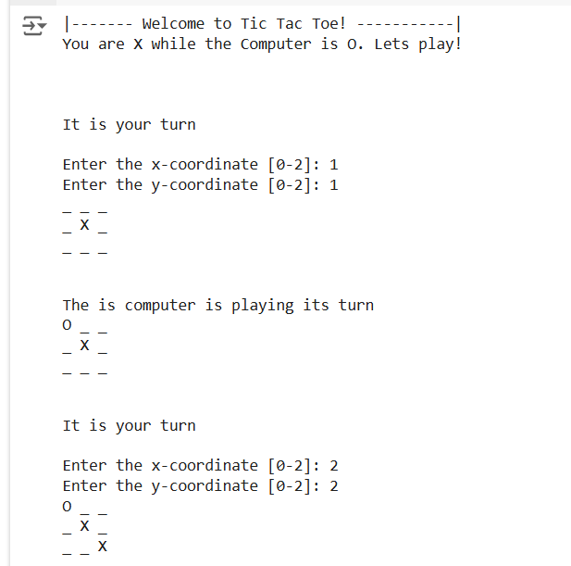

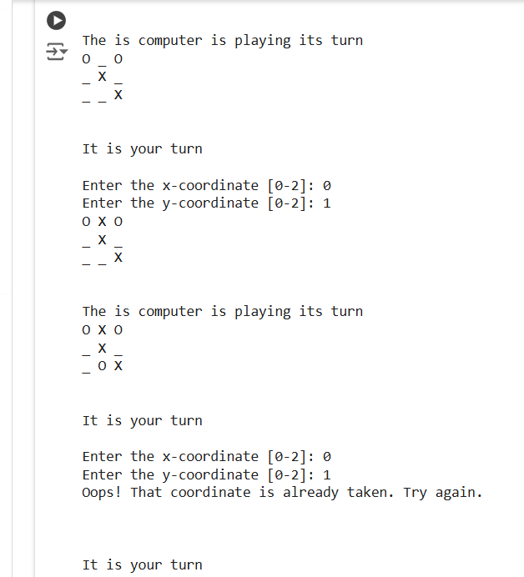

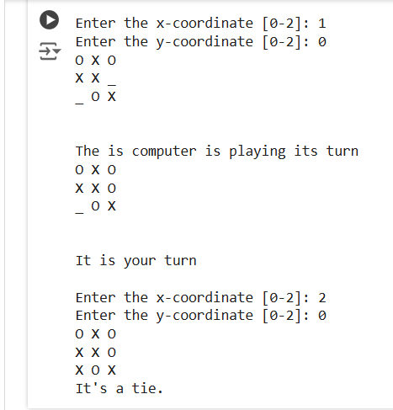

**TASK 1: CHATBOT WITH RULE-BASED RESPONSES**

Build a simple chatbot that responds to user inputs based on predefined rules. Use if-else statements or pattern matching techniques to identify user queries and provide appropriate responses. This will give you a basic understanding of natural language processing and conversation flow

**Source Code**:

# Install necessary libraries

!pip install nltk

# Import necessary modules

import nltk

import re

from nltk.chat.util import Chat, reflections

# Download NLTK data

nltk.download('punkt')

nltk.download('averaged_perceptron_tagger')

# Define patterns and responses

pairs = [

    [r"My name is (.*)", ["Hello %1, nice to meet you, how can I assist you today?",]],

    [r"Hi|Hey|Hello", ["Hello, how can I help you?", "Hi! How can I assist you today?",]],

    [r"What is your name?", ["My name is chatbot created to assist you. what's on your mind today?",]],

    [r"How are you?", ["I'm good! what about you? ",]],

    [r"Can you help me with (.*)", ["Sure, I can help you with %1. Please provide more details.",]],

    [r"Thankyou|Thanks", ["You're welcome!", "Happy to help you! Let me know if you need anything else.",]],

    [r"Bye", ["Bye! Have a nice day!", "Goodbye!",]],

    [r"What is your purpose?", ["I'am here to assist with your queries, provide information according to the pattern I have been created with!",]],

    [r"(.*)", ["I'm sorry, I don't understand that. Could you clarify?",]],

]

# Define the chatbot class

class RuleBasedChatbot:

    def __init__(self, pairs):

        self.chat = Chat(pairs, reflections)

    def respond(self, user_input):

        return self.chat.respond(user_input)

# Initialize the chatbot

chatbot = RuleBasedChatbot(pairs)

# Function to chat with the bot

def chat_with_bot():

    print("Hi, I'm your chatbot. Type 'exit' to exit chat with chatbot.")

    while True:

        user_input = input("You: ")

        if user_input.lower() == 'exit':

            print("Chatbot: Bye! Have a great day!")

            break

        response = chatbot.respond(user_input)

        print(f"Chatbot: {response}")

# Start chatting with the bot

chat_with_bot()

**Output:**

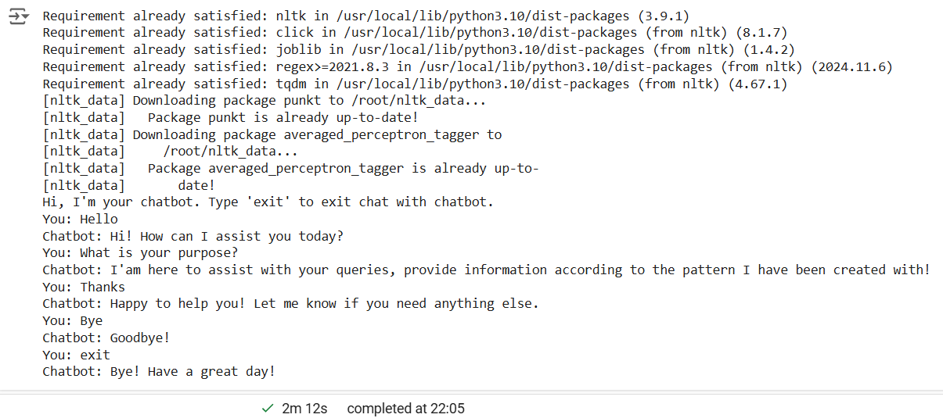

**TASK 4: RECOMMENDATION SYSTEM**

Create a simple recommendation system that suggests items to users based on their preferences. You can use techniques like collaborative filtering or content-based filtering to recommend movies, books, or products to users.

**Source Code:**

**Cell1**

#Import all necessary libraries

import numpy as np

import pandas as pd

import matplotlib.pyplot as plt

import seaborn as sns

from IPython.html.widgets import *

sns.set_style('white')

%matplotlib inline

**Cell2**

#Get the data into Pandas Dataframe object

import pandas as pd

column_names = ['user_id', 'item_id', 'rating', 'timestamp']

df = pd.read_csv('dataset.csv', sep = '\t', names = column_names)

df.head()

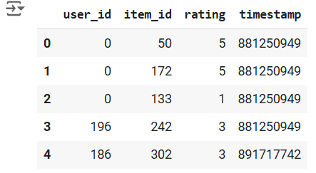

**Cell3**

#Get the Movie Titles

import pandas as pd

movie_titles = pd.read_csv('movieIdTitles.csv')

movie_titles.head()

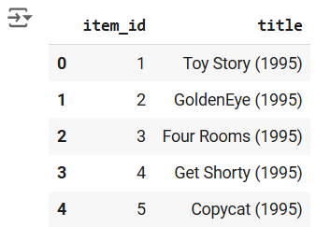

**Cell4**

#Merge the dataset with movie titles

df = pd.merge(df, movie_titles, on = 'item_id')

df.head()

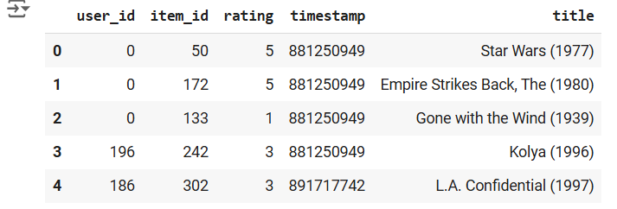

**Cell5**

df.groupby('title')['rating'].mean().sort_values(ascending = False).head()

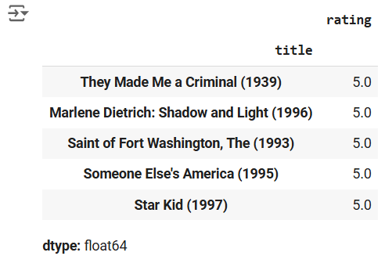

**Cell6**

df.groupby('title')['rating'].count().sort_values(ascending = False).head()

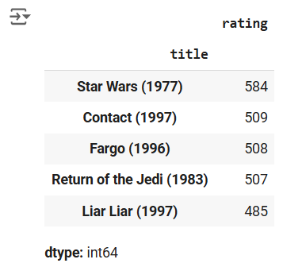

**Cell7**

ratings = pd.DataFrame(df.groupby('title')['rating'].mean())

ratings.head()

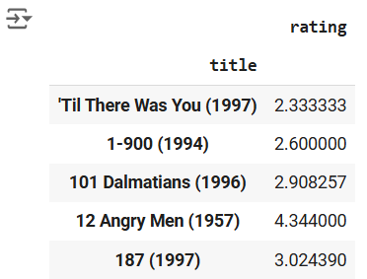

**Cell8**

ratings['numOfRatings'] = pd.DataFrame(df.groupby('title')['rating'].count())

ratings.head()

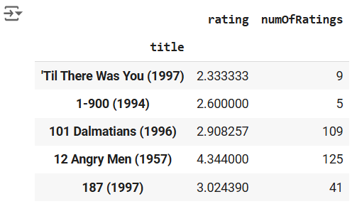

**Cell9**

import matplotlib.pyplot as plt

plt.figure(figsize = (10,4))

ratings['numOfRatings'].hist(bins = 70)

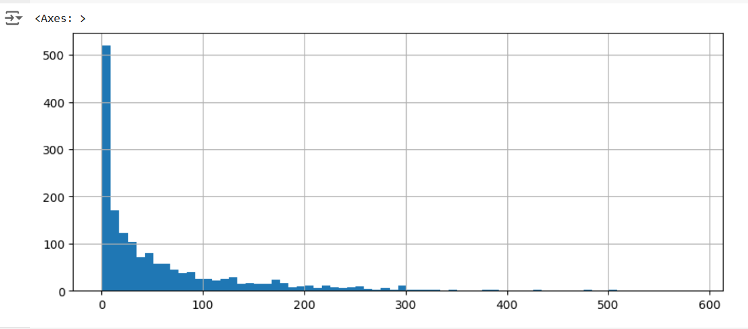

**Cell10**

plt.figure(figsize = (10,4))

ratings['rating'].hist(bins = 70)

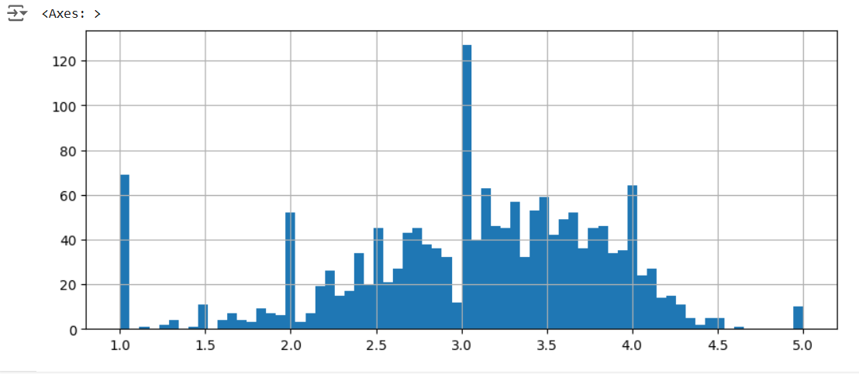

**Cell11**

moviemat = df.pivot_table(index='user_id',columns='title',values='rating')

moviemat.head()

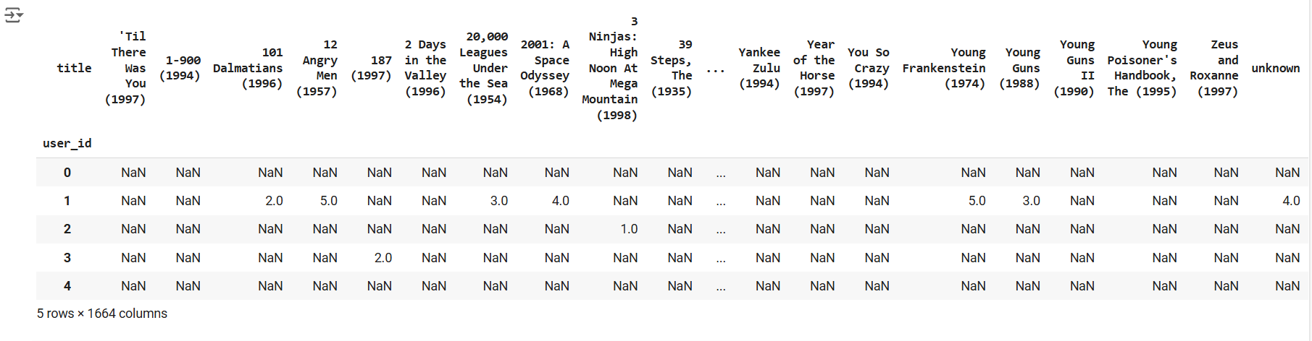

**Cell12**

#Most Rated Movies with their Average Ratings

ratings.sort_values('numOfRatings', ascending = False).head(10)

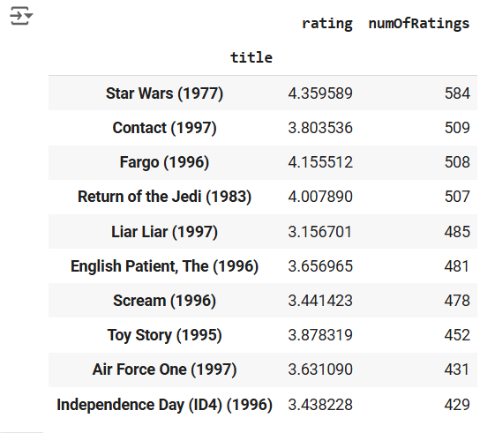

**Cell13**

for i in ratings.index:

    movieUserRatings = moviemat[i]

    similarToThatMovie = moviemat.corrwith(movieUserRatings)

    corr_toMovie = pd.DataFrame(similarToThatMovie, columns = ['Correlation'])

    corr_toMovie.dropna(inplace = True)

    corr_toMovie = corr_toMovie.join(ratings['numOfRatings'])

    result = corr_toMovie[corr_toMovie['numOfRatings'] > 100].sort_values('Correlation', ascending = False).head()

    if result['numOfRatings'].count() >= 5:

        print(i)

        ratings.loc[i, 'FirstMovieRecommendation'] = result.iloc[1:2].index.values[0]

        ratings.loc[i, 'SecondMovieRecommendation'] = result.iloc[2:3].index.values[0]

        ratings.loc[i, 'ThirdMovieRecommendation'] = result.iloc[3:4].index.values[0]

        ratings.loc[i, 'FourthMovieRecommendation'] = result.iloc[4:5].index.values[0]

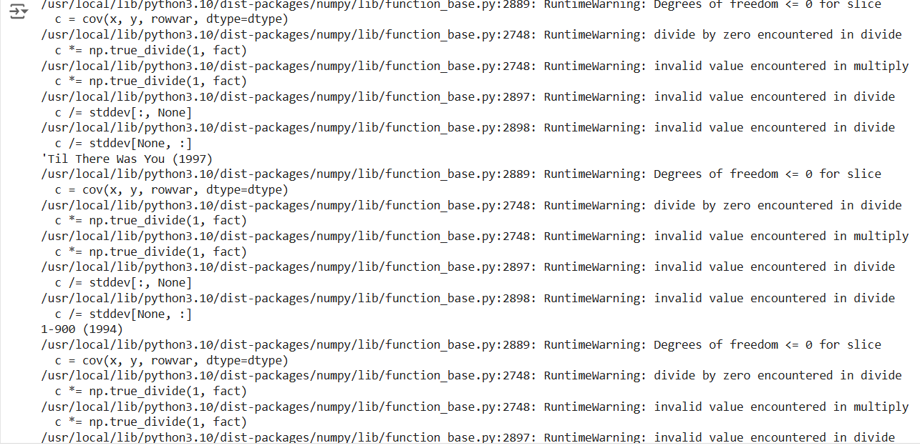

**Cell14**

#Check the result

ratings.head()

**Cell15**

ratings = ratings.fillna('-')

**Cell16**

#Save the ratings data for later use

ratings.to_csv('MovieRecommendations.csv', encoding='utf-8')

**Cell17**

#Load the dataset saved for reusability from this code block onwards

df_result = pd.read_csv('MovieRecommendations.csv')

df_result.head()

**Cell18**

import ipywidgets as widgets

from IPython.display import display

inputMovieName = widgets.Text()

def getRecommendations(sender):

    searchMovie = inputMovieName.value

    list_result = df_result[df_result['title'] == searchMovie]

    fm = list_result['FirstMovieRecommendation'].values[0]

    sm = list_result['SecondMovieRecommendation'].values[0]

    tm = list_result['ThirdMovieRecommendation'].values[0]

    fourthm = list_result['FourthMovieRecommendation'].values[0]

    finalRecommendationText = '1:' + fm + ' \n2:' + sm + ' \n3:' + tm + ' \n4:' + fourthm

    print('Your Recommendations for the Movie ' + searchMovie + ' are:\n')

    print(finalRecommendationText)