|  |  |  |
| --- | --- | --- |
| **Name** | **ID** | **STUDENT SIGN** |
| **Sudipto Saha** | **20-42143** | **Sudipto** |



**Class Test 02**

1. **Below a scenario has been given draw the ER Diagram.**

***Draw with proper annotations (use DIA, VISIO, MS WORD etc.)******For reference see ERDiagramTutorial.***

In an Ice-Cream Parlor, a customer may buy or order many ice-creams. Each customer has a unique customer id. Customer data such as customer name, phone number, card no, total purchase amount is also stored in the system. A customer can have multiple cards. An ice-cream can only be sold to or ordered by only one customer. When buying a unique transaction ID and date is stored. When ordering an order, no and delivery date is stored. The ice-creams are identified by their names. The cost price, sell price, profit, stock, flavor, manufacturer information is available in the system. The profit is calculated from the cost price and the sell price. Ice-creams are sold by employees, where each ice cream can be sold by one employee but one employee can sell many ice-creams. Each employee is identified by their own unique employee id. The system also has employee name, shift, salary, hire date, phone no, address, NID stored. Each employee works under only one manager and one manager oversees all employees of a branch. A manager works in only one branch. They have their own unique employee ID and their name, salary, hire date, phone no, address, NID are stored in the database. Managers and employees can have multiple phone numbers. Each branch has one manager. And each branch has a location and is identified by its unique branch no. All branches are outlets of one company. The company has a unique trade license no and opening date and location. Each branch has their own single account and the company has a single account. In the accounts daily profit, net profit and balance are stored. Each of the branches net profit is calculated from the ice-creams profit and the company’s net profit is calculated from all of the branches net profit. The whole company is owned by multiple owners. Among the owners there is a founder. Each of the owners are identified by their NID. Other data such as name, phone no and email are also stored in the database. The owners can have multiple phone no.

Answer 1:

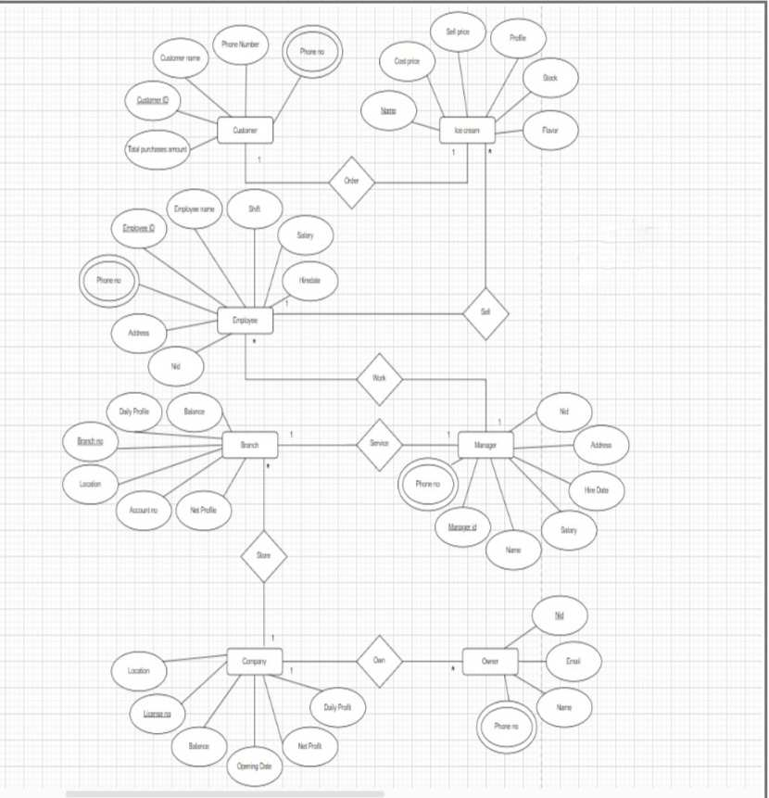

1. **Below an ER Diagram has been given write the scenario.**

***For reference see ERDiagramTutorial.***

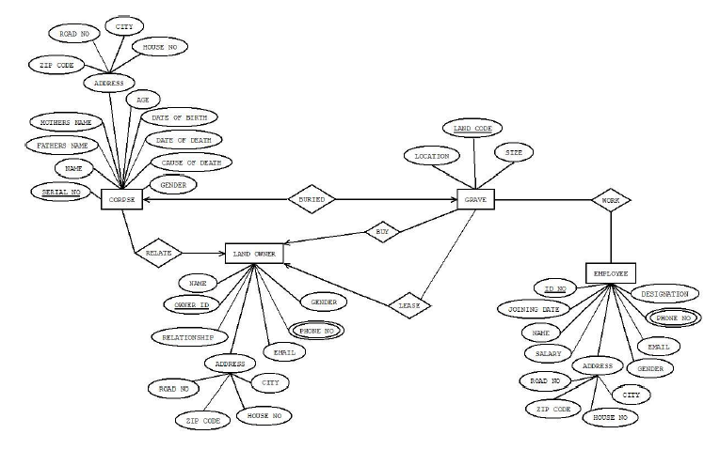

Answer 2:

Here, corpse is identified by its serial no in this system. Name, Father’s name, Mother’s name, age, date of birth, date of death, cause of death and address are stored in corpse. Address attribute have also some sub attributes which are zip code, road no, city, house no. Landowner has unique owner id. It has some attribute which are name, gender, phone number, relationship, address, email and address have some attributes that are city, house no, zip code, road no. Landowner can buy or lease grave. Grave has location, land code and size. Grave is identified by land code. Grave has some employee for work because of corpse are buried in the grave. Each employee has unique id no. The system stores some data for employee that is joining date, name, salary, address, gender, email, phone no, zip code, house no, city, landowner and employee can have more than one phone number.

***Normalization***

**Buy:**

{Land code, Location, size, Name, Owner id, Name, Relationship, Road no, Zip code, house no, city, email, phone no, gender}

**1NF:**

Phone no is multivalued attribute here.

(Land code, Location, size, Name, Owner id, Name, Relationship, Road no, Zip code, house no, city, email, phone no, gender)

**2NF:**

1. Land code, Location, size
2. Owner id, Name, Relationship, Road no, Zip code, house no, city, email, phone no, gender

**3NF:**

1. Land code, Location, size
2. Owner id, Name, Relationship, email, phone no, gender
3. A-ID, Road no, Zip code, house no, city

**Work:**

{Land code, Location, size,Owner no, Joining date, Name, Salary, Road no, Zipcode, house no, city, Gender, Email, Phone no, Designation}

**1NF:**

Phone no is multivalued attribute here.

(Land code, Location, size,Owner no, Joining date, Name, Salary, Road no, Zipcode, house no, city, Gender, Email, Phone no, Designation)

**2NF:**

1. Land code, Location, size
2. Owner no, Joining date, Name, Salary, Road no, Zipcode, house no, city, Gender, Email, Phone no, Designation.

**3NF:**

1. Land code, Location, size
2. Owner no, Joining date, Name, Salary, Gender, Email, Phone no, Designation.
3. A-id, Road no, Zipcode, house no, city.

**Buried:**

{Serial no, Father name, Mother name, Zip code, Road no, City, House no, Age, Date of birth, Date of death, Cause of death, Gender, Land Code, Size, Location}

**1NF:**

No multivalued attribute.

(Serial no, Father name, Mother name, Zip code, Road no, City, House no, Age, Date of birth, Date of death, Cause of death, Gender, Land Code, Size, Location)

**2NF:**

1. Serial no, Father name, Mother name, Zip code, Road no, City, House no, Age, Date of birth, Date of death, Cause of death, Gender
2. Land Code, Size, Location

**3NF:**

1. Serial no, Father name, Mother name, Age, Date of birth, Date of death, Cause of death, Gender
2. Land Code, Size, Location
3. A-id, Zip code, Road no, City, House no

**Relate:**

{Serial no, Father name, Mother name, Zip code, Road no, City, House no, Age, Date of birth, Date of death, Cause of death, Gender, Owner id, Relationship, Road no, Zip code, house no, city, email, phone no, gender }

**1NF:**

Phone no is multivalued attribute here.

(Serial no, Father name, Mother name, Zip code, Road no, City, House no, Age, Date of birth, Date of death, Cause of death, Gender, Owner id, Relationship, Road no, Zip code, house no, city, email, phone no, gender)

**2NF:**

1. Serial no, Father name, Mother name, Zip code, Road no, City, House no, Age, Date of birth, Date of death, Cause of death, Gender.
2. Owner id, Relationship, Road no, Zip code, house no, city, email, phone no, gender

**3NF:**

1. Serial no, Father name, Mother name, Age, Date of birth, Date of death, Cause of death, Gender.
2. Owner id, Relationship, Road no, Zip code, house no, city, email, phone no, gender
3. A-id, Zip code, Road no, City, House no.

**Lease:**

{Land code, Location, size,Owner id, Name, Relationship, Road no, Zip code, house no, city, email, phone no, gender}

**1NF:**

Phone no is multivalued attribute here.

(Land code, Location, size,Owner id, Name, Relationship, Road no, Zip code, house no, city, email, phone no, gender)

**2NF:**

1. Land code, Location, size
2. Owner id, Name, Relationship, Road no, Zip code, house no, city, email, phone no, gender

**3NF:**

1. Land code, Location, size
2. Owner id, Name, Relationship, email, phone no, gender
3. A-id, Road no, Zip code, house no, city.