**Mini Project**

Build a website which contains the reviews of new books which are uploaded by the publisher before publishing the book. It will also help the user to know the latest books of their interests being introduced into the market like fiction, science, technology etc.

**Stakeholders are:**

1. Publishers  
2. Readers  
3. Administrator

**Requirements Specification (RS):**

|  |  |  |  |  |
| --- | --- | --- | --- | --- |
| **No.** | **Module** | **Requirement/ Functionality** | **Essential or Desirable** | **Description of the Requirement** |
| RS1 | User Management | Users. | Essential | Maintain the details of users. |
| RS1 | Book Management | Books | Essential | Maintaining the details of books. |
| RS1 | Search Management | Books | Essential | Searching the details of books. |
| RS1 | Feedback | Books. | Essential | Feedback on books. |
| RS1 | Rating Engine. | Books . | Essential | Rating on books. |
| RS1 | Review Management | Books. | Essential | Reviewing the book management. |
| RS1 | Forum | Books. | Essential | Generating the forum. |
| RS1 | Analysis Management. | Books. | Essential | Analysing the details of the book. |

**Diagram:**

**Use case Diagrams:**

Use Case for Admin:

[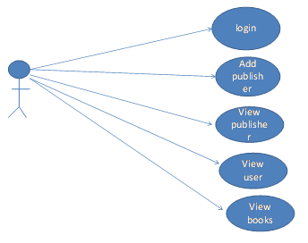](https://secureservercdn.net/160.153.137.210/11v.681.myftpupload.com/wp-content/uploads/2017/09/Online-Book-Review-Management-System-Use-Case-for-Admin.png)

Use Case for User:

[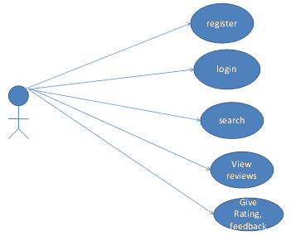](https://secureservercdn.net/160.153.137.210/11v.681.myftpupload.com/wp-content/uploads/2017/09/Online-Book-Review-Management-System-Use-Case-for-User.png)

Use Case for Publisher:

[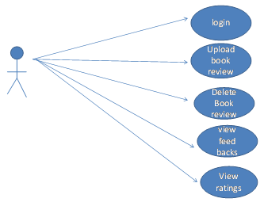](https://secureservercdn.net/160.153.137.210/11v.681.myftpupload.com/wp-content/uploads/2017/09/Online-Book-Review-Management-System-Use-Case-for-Publisher.png)

**Activity Diagrams:**

Activity Diagram for Admin:

[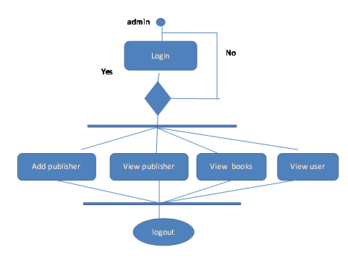](https://secureservercdn.net/160.153.137.210/11v.681.myftpupload.com/wp-content/uploads/2017/09/Online-Book-Review-Management-System-Activity-Diagram-for-Admin.png)

Activity Diagram for User:

[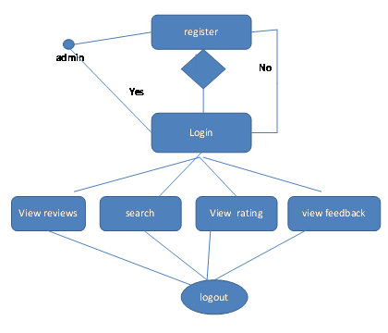](https://secureservercdn.net/160.153.137.210/11v.681.myftpupload.com/wp-content/uploads/2017/09/Online-Book-Review-Management-System-Activity-Diagram-for-User.png)

Activity Diagram for Publisher:

[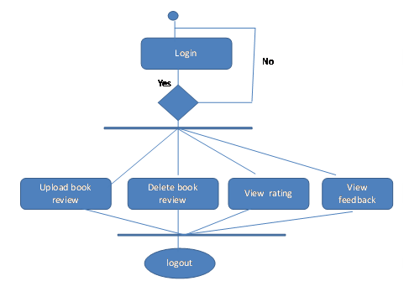](https://secureservercdn.net/160.153.137.210/11v.681.myftpupload.com/wp-content/uploads/2017/09/Online-Book-Review-Management-System-Activity-Diagram-for-Publisher.png)

**Sequence Diagrams:**

Sequence Diagram for Admin

[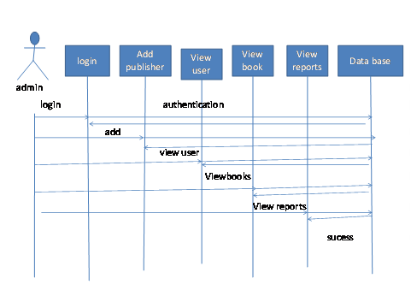](https://secureservercdn.net/160.153.137.210/11v.681.myftpupload.com/wp-content/uploads/2017/09/Online-Book-Review-Management-System-Sequence-Diagram-for-Admin.png)

Sequence Diagram for User

[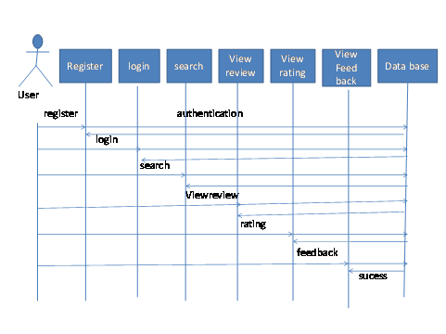](https://secureservercdn.net/160.153.137.210/11v.681.myftpupload.com/wp-content/uploads/2017/09/Online-Book-Review-Management-System-Sequence-Diagram-for-User.png)

Sequence Diagram for Publisher

[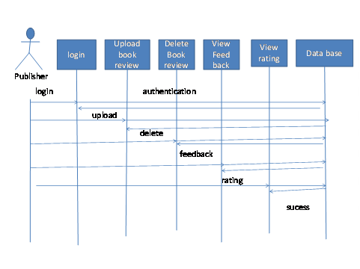](https://secureservercdn.net/160.153.137.210/11v.681.myftpupload.com/wp-content/uploads/2017/09/Online-Book-Review-Management-System-Sequence-Diagram-for-Publisher.png)

## ****MODULE DESIGN:****

The major modules of the project are

* Administrator Module
* Publisher Department Module
* User Department Module

## Test Cases:

**TEST CASE 1 :**

**Test case for Login form:**

When a user tries to login by submitting an incorrect ID or an incorrect Password then it displays an error message “NOT A VALID USERNAME”.

**TEST CASE  2:**

**Test case for User Registration form:**

When a user enters user id to register and ID already exists, then this result in displaying error message “USER ID ALREADY EXISTS”.

**TEST CASE 3 :**

**Test case for Change Password:**

When the old password does not match with the new password, then this results in displaying an error message as “ OLD PASSWORD DOES NOT MATCH WITH THE NEW PASSWORD”.

**TEST CASE 4 :**

**Test case for Forget Password:**

When a user forgets his password he is asked to enter a Login name, ZIP code, Mobile number. If these are matched with the already stored ones then the user will get his Original password.

Pages

Home Page

Admin Home Page

User Home Page

User Registration Page

User Details Page

Publisher Registration Page

Publisher Details Page

Book Store Page

Upload Book Page

Search Page

View Feed Back Page

Additional Requirement:

* Implement this project by using Node JS, Mongo DB, HTML and CSS. Include Security.
* Create respective backend REST APIs for individual use cases.
* Deploy the application on Azure Web Sites.

Final Outcome:

Provide me with the link of the portal for testing.