DWSIM Flowsheet Diagram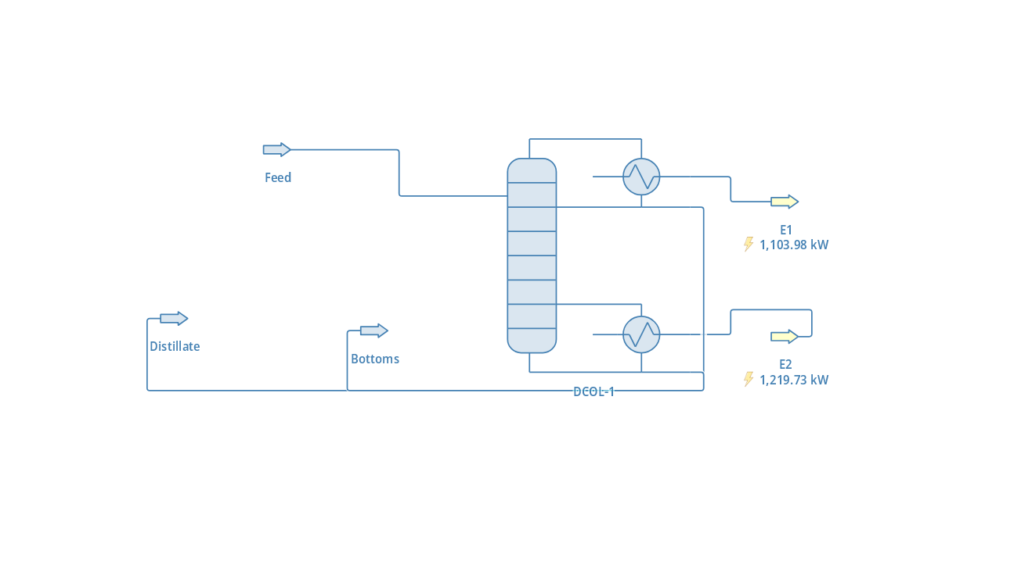
Values calculated after getting through the Fractional Distillation Process shown in the Diagram:-
- DCOL-1 (Distillation Column)
    - Condenser Pressure Drop = 0 Pa
    - Condenser Duty = 1103.98 kW
    - Reboiler Duty = -1219.73 kw
    - Number of Stages = 20
    - Column Pressure Drop = 0 Pa
    - Condenser_Specification_Value = 2.5
    - Reboiler_Specification_Value = 2
    - Global_Stage_Efficiency = N/D
    - Condenser_Calculated_Value = 2.5
    - Reboiler_Calculated_Value = 2
    - Estimated_Height = 11000 mm
    - Estimated Diameter = 1400.01 mm
- Feed (Material Stream)
  - Temperature = 298.15 K
  - Pressure = 101325 Pa
  - Mass Flow = 1Kg/s
  - Molar Flow = 11.7474 mol/s
  - Volumetric Flow = 0.00115109 m³/s
  - Molar Enthalpy (Mixture) = -34854.6 kJ/kmol
  - Molar Entropy (Mixture) = -89.3434 kJ/[Kmol.K]
  - Molar Fraction (Vapor) = 0
  - Phases = L
  - Vapor : Benzene = 0.7706593, Tolune = 0.2293407
  - Energy Flow = 372.045 kW
FRACTIONAL DISTILLATION

Distillate (Material Stream)
  - Temperature = 362.232 K
  - Pressure = 101325 Pa
  - Mass Flow = 0.815727 kg/s
  - Molar Flow = 9.74741 mol/s
  - Volumetric Flow = 0.00101451 m³/s
  - Molar Enthalpy (Mixture) = -25347.6 kJ/kmol
  - Molar Entropy (Vapor) = 0
  - Phases = L
  - Liquid 1 : Benzene = 0.60255992, Tolune = 0.39744008
  - Energy Flow = 434.073 kW
- Bottoms (Material Stream)
  - Temperature = 383.814 K
  - Pressure = 101325 Pa
  - Mass Flow = 0.184273 kg/s
  - Molar Flow = 2 mol/s
  - Volumetric Flow = 0.000236356 m³/s
  - Molar Enthalpy (Mixture) = -23311.5 kJ/kmol
  - Molar Entropy (Mixture) = -57.086 kJ/[kmol.K]
  - Molar Fraction (Vapor) = 0
  - Phases = L
  - Liquid 1 : Benzene = 0.00015346642, Tolune = 0.9984653
  - Energy Flow = 53.727 kW
- E1(Energy Stream) = 1103.98 kW
- E2(Energy Stream) = 1219.73 kW

