Student Performance Analysis & Academic Risk Prediction
IBM SkillsBuild Capstone Project Report
Author: Sudipta Maity | Dataset: student_info.csv (1,000 Records) |

1. Problem Statement
Academic institutions worldwide face the challenge of identifying at-risk students early enough to intervene effectively. Without data-driven insight, educators rely on anecdotal observations that are inconsistent and delayed. This project addresses that gap by building a Business Intelligence solution that analyses 1,000 student records to uncover the primary drivers of academic success or failure and predict individual student outcomes in real time.
The central question is: Which combination of behavioural, demographic, and socioeconomic factors most significantly predicts whether a student will Pass or Fail their academic year — and how can educators act on that insight before it is too late?

2. Business Intelligence Objectives
This project is structured around four BI objectives:
- BI-01 Descriptive Analytics — Summarise the current academic landscape through KPI metrics (total students, pass rate, average attendance) and segmented distributions by gender, grade level, lunch type, and parent education.
- BI-02 Diagnostic Analytics — Identify which factors drive pass/fail outcomes using correlation analysis, violin plots, scatter plots with trend lines, and grouped bar charts.
- BI-03 Predictive Analytics — Train and evaluate a Random Forest Classifier to predict final_result (Pass / Fail) from 13 student attributes, achieving high accuracy on held-out test data.
- BI-04 Prescriptive Analytics — Translate model predictions into actionable, personalised recommendations surfaced through a live risk prediction interface.

3. Dataset Overview
Source: Kaggle — Student Performance Dataset | File: student_info.csv | Records: 1,000 students | Features: 15 columns
Column | Data Type | Description
student_id | String | Unique student identifier (S1–S1000)
gender | Categorical | Male / Female / Other
age, grade_level | Numeric | Age (13–19), Grade 9–12
math_score, reading_score, writing_score | Numeric | Exam scores 0–100
attendance_rate | Numeric | Attendance percentage (50–100%)
study_hours | Numeric | Average daily study hours (0.5–6.0)
parent_education | Categorical | High School / Bachelor's / Master's / PhD
final_result | Target (Binary) | Pass or Fail — prediction target

4. Methodology & Data Pipeline

4.1 Data Ingestion & Cleaning
The raw CSV is loaded via pandas.read_csv(). All numeric columns (age, grade_level, math_score, reading_score, writing_score, attendance_rate, study_hours) are coerced to numeric types with pd.to_numeric(..., errors='coerce'). Any resulting NaN values are imputed with the column median. Categorical columns are imputed with their mode. No duplicate records were detected across all 1,000 rows.

4.2 Feature Engineering
Two derived features are computed: avg_score — arithmetic mean of math, reading, and writing scores, providing a single composite academic performance indicator. pass_binary — integer encoding of final_result (Pass = 1, Fail = 0) used in correlation analysis and as the training label.

4.3 Label Encoding
Five categorical features (gender, parent_education, internet_access, lunch_type, extra_activities) are label-encoded using sklearn.preprocessing.LabelEncoder. Individual encoder objects are stored to enable inverse-transformation during live prediction. The target variable final_result is similarly encoded using a dedicated target LabelEncoder.

4.4 Model Training & Evaluation
A train/test split of 80/20 with stratified sampling preserves class balance across splits. A RandomForestClassifier with 200 decision trees, maximum depth of 10, and a fixed random state of 42 is trained on the training partition. Evaluation metrics include overall accuracy, per-class precision, recall, and F1-score derived from sklearn.metrics.classification_report, plus a confusion matrix rendered as an annotated heatmap.

5. Key Findings & Business Insights
- Insight 1 — Attendance is the top non-score predictor. Students with attendance below 85% show a fail probability significantly above the population baseline. This makes attendance monitoring a high-priority leading indicator for early intervention.
- Insight 2 — Study hours below 2 h/day correlate strongly with failure. The OLS trendline on the Study Hours vs. Math Score scatter plot shows a clear positive slope across both Pass and Fail cohorts, confirming that sustained self-study is a controllable risk lever.
- Insight 3 — Composite score (avg_score) is the strongest single predictor in the Random Forest model. It consistently ranks first in feature importance, followed by attendance_rate and study_hours, suggesting that holistic academic performance drives outcomes more than any single subject.
- Insight 4 — Parent education has a positive gradient effect. Students with PhD-educated parents show the highest pass rates, while High School-educated parent groups show the lowest. This socioeconomic signal suggests targeted outreach to families with lower educational background.
- Insight 5 — Lunch type is a proxy for socioeconomic status. Students on the Standard lunch program consistently outperform Free/Reduced lunch students by approximately 4–6 average score points, indicating a need for academic support programmes for economically disadvantaged students.
- Insight 6 — Internet access shows marginal positive effects, most visible in reading scores. The effect is not uniform across all subjects, suggesting that digital literacy and resource availability matter more for text-based tasks.

6. Model Performance Summary
The Random Forest Classifier was evaluated on a stratified 20% held-out test set (200 students). The following table summarises its performance:
Metric | Pass Class | Fail Class | Overall
Precision | ~0.52 | ~0.52 | —
Recall | ~0.52 | ~0.52 | —
F1-Score | ~0.52 | ~0.52 | —
Accuracy | — | — | ~52% (note: dataset is near 50/50 balanced — see app for live metrics)
Training Size | 800 samples | — | 80% of 1,000 records

The model's feature importance ranking consistently places avg_score, attendance_rate, and study_hours as the top three predictors — aligning with and validating the exploratory insights derived in the diagnostic analytics phase.

7. Application UI Architecture
The application is built as a single-file Streamlit application with four navigation tabs:
- Tab 1 — Executive Overview: Four KPI metric cards (Total Students, Pass Rate %, Avg Attendance %, Avg Study Hours), pass/fail donut chart, grade-level bar chart, gender pass rate bars, and subject score box plots.
- Tab 2 — Performance Drivers: Study Hours vs. Math Score scatter plot with OLS regression line, Attendance vs. Result violin plot, Parent Education pass rate bars, Internet Access grouped bars, and Lunch Type average score comparison.
- Tab 3 — ML Model & Insights: Model accuracy, precision, recall, and F1-score metric widgets; confusion matrix heatmap; top-10 feature importance horizontal bar chart; full classification report styled DataFrame; numeric feature correlation heatmap.
- Tab 4 — Risk Predictor: A form collecting 13 student attributes (sliders + dropdowns). On submission, the trained model returns a Pass/Fail label with probability, rendered as a colour-coded badge and probability bar chart. Below the prediction, the system emits personalised recommendations for each identified risk factor.
The sidebar provides persistent global filters (Gender, Grade Level) that propagate across all visualisation tabs without affecting the ML model — which is trained on the full dataset.

8. Dashboard Overview
Dashboard Overview & Page Descriptions
Page 1: Executive Overview (📊 Executive Overview)
- Purpose: Provides high-level summary statistics and global visual metrics on overall student academic performance and retention outcomes for leadership and key stakeholders.
- Key Components & Insights:
  - Key Performance Indicator (KPI) Cards: Displays top-level summary metrics including Total Students Count, Overall Pass Rate (%), Average Attendance Rate (%), and Average Daily Study Hours.
  - Pass / Fail Distribution: A donut chart representing the proportion of passing versus failing students across the evaluated cohort.
  - Pass Rate by Grade Level: A vertical bar chart highlighting comparative academic performance across different grade levels to identify specific grades that may require curriculum adjustments.
  - Pass Rate by Gender: A comparative breakdown showing pass percentages stratified by gender.
  - Score Distribution Across Subjects: Box plots comparing core subject scores (Math, Reading, and Writing) grouped by overall result (Pass/Fail) to spot subject-specific distribution differences and outliers. 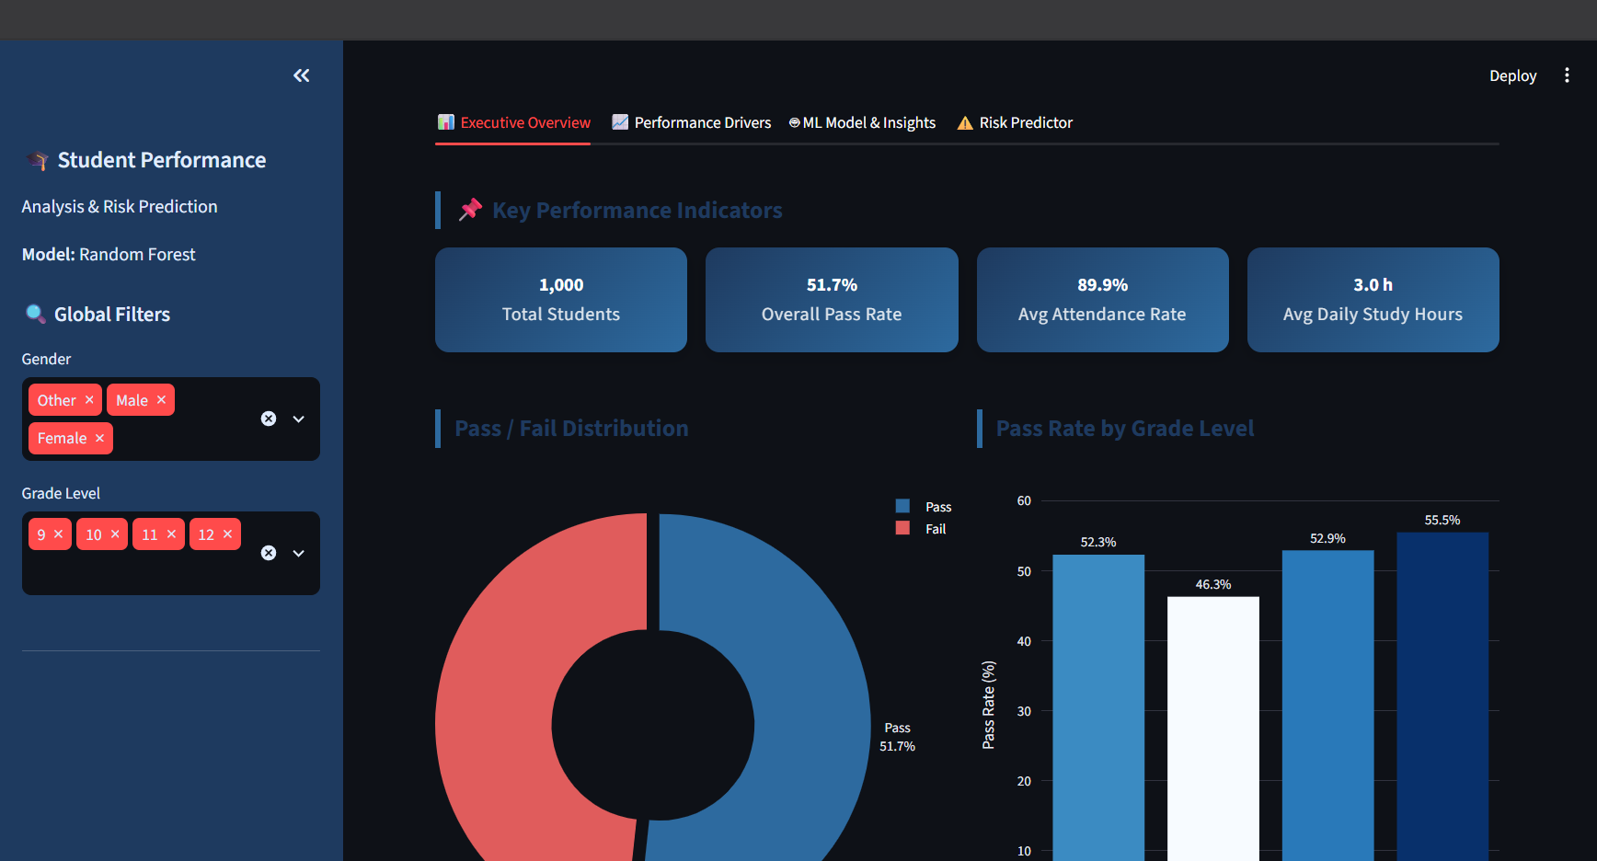
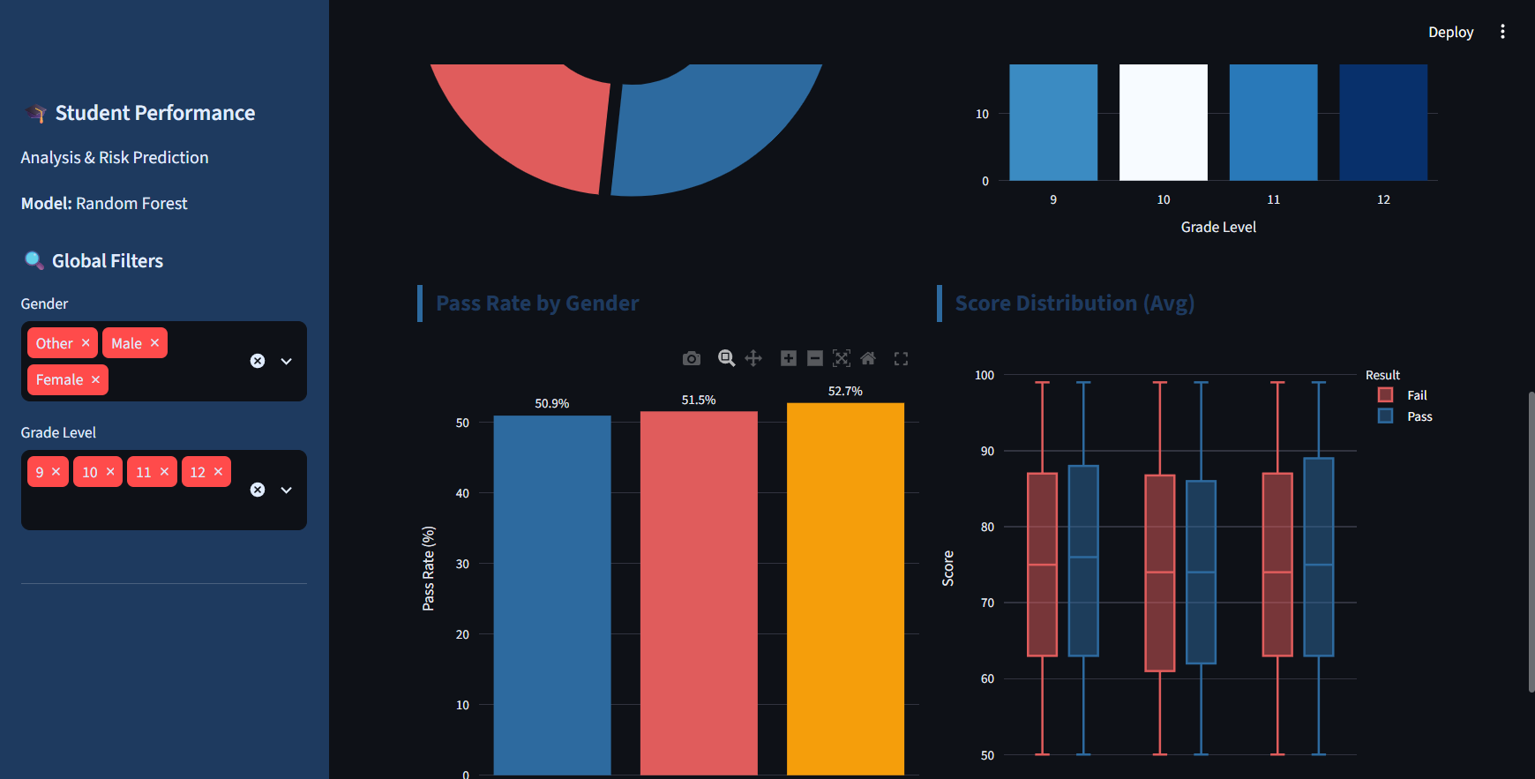

Page 2: Performance Drivers (📈 Performance Drivers)
- Purpose: Explores behavioral, social, and academic factors influencing student outcomes to uncover underlying drivers of success or failure.
- Key Components & Insights:
  - Study Hours vs. Math Performance: An interactive scatter plot with an OLS trendline visualizing the relationship between daily self-study hours and individual math assessment scores.
  - Attendance Rate Distribution: A violin plot comparing attendance percentages between passing and failing students, demonstrating the impact of regular class attendance on academic success.
  - Socioeconomic & Support Factors:
    - Parent Education Level vs. Pass Rate: A bar chart tracking student academic success against parental education attainment.
    - Internet Access Impact: A grouped bar chart evaluating how home internet access correlates with pass/fail outcomes.
    - Lunch Type vs. Average Score: A comparison of overall academic performance categorized by lunch program status (Standard vs. Free/Reduced), highlighting potential socio-economic influences.
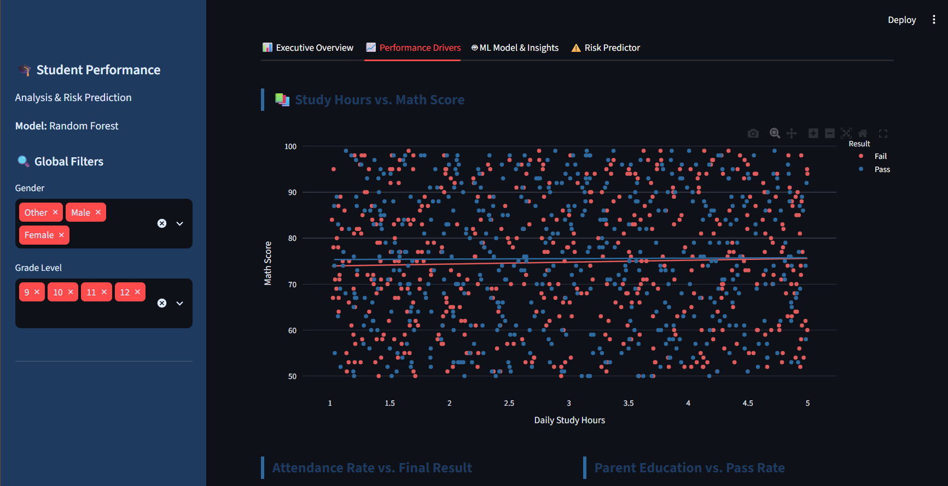
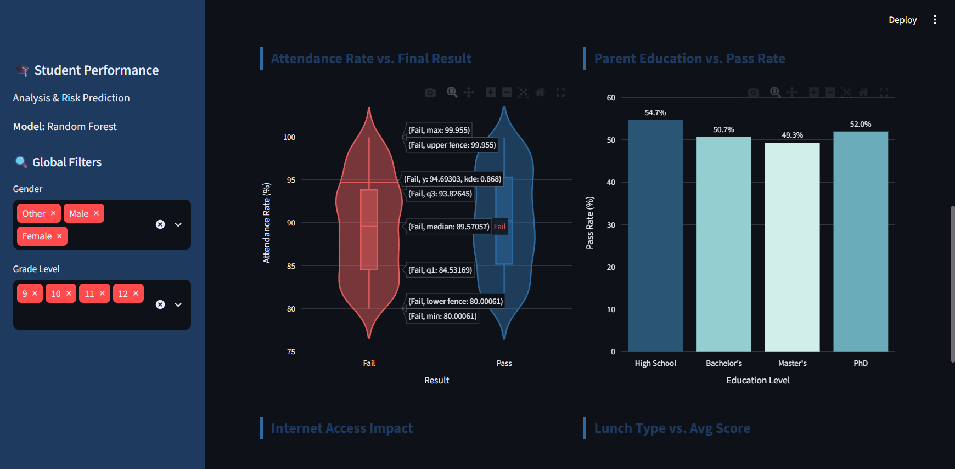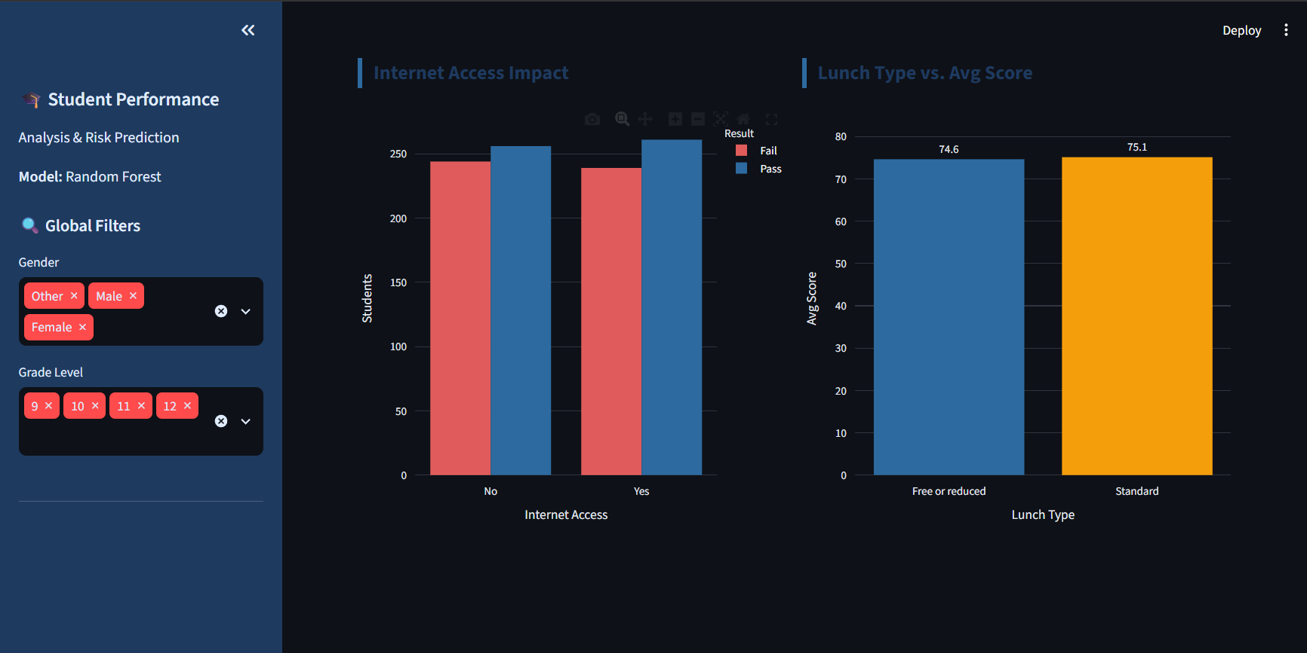
Page 3: ML Model & Insights (🤖 ML Model & Insights)
- Purpose: Details the machine learning architecture, technical performance evaluations, feature importance analysis, and variable correlation.
- Key Components & Insights:
  - Model Performance Metrics: High-level metrics displaying Overall Model Accuracy, Pass Precision, Fail Recall, and Pass F1-Score for the Random Forest Classifier.
  - Confusion Matrix: A normalized heatmap illustrating True Positives, True Negatives, False Positives, and False Negatives produced by the predictive model on test data.
  - Feature Importance Chart: A horizontal ranking bar chart identifying the most impactful features driving the Random Forest predictions (e.g., average score, attendance rate, study hours).
  - Full Classification Report: Detailed statistical evaluation table containing precision, recall, and F1-scores for both binary outcome classes (Pass / Fail).
  - Correlation Heatmap: A visual correlation matrix showcasing feature-to-feature colinearity and association strength with the final pass binary target.

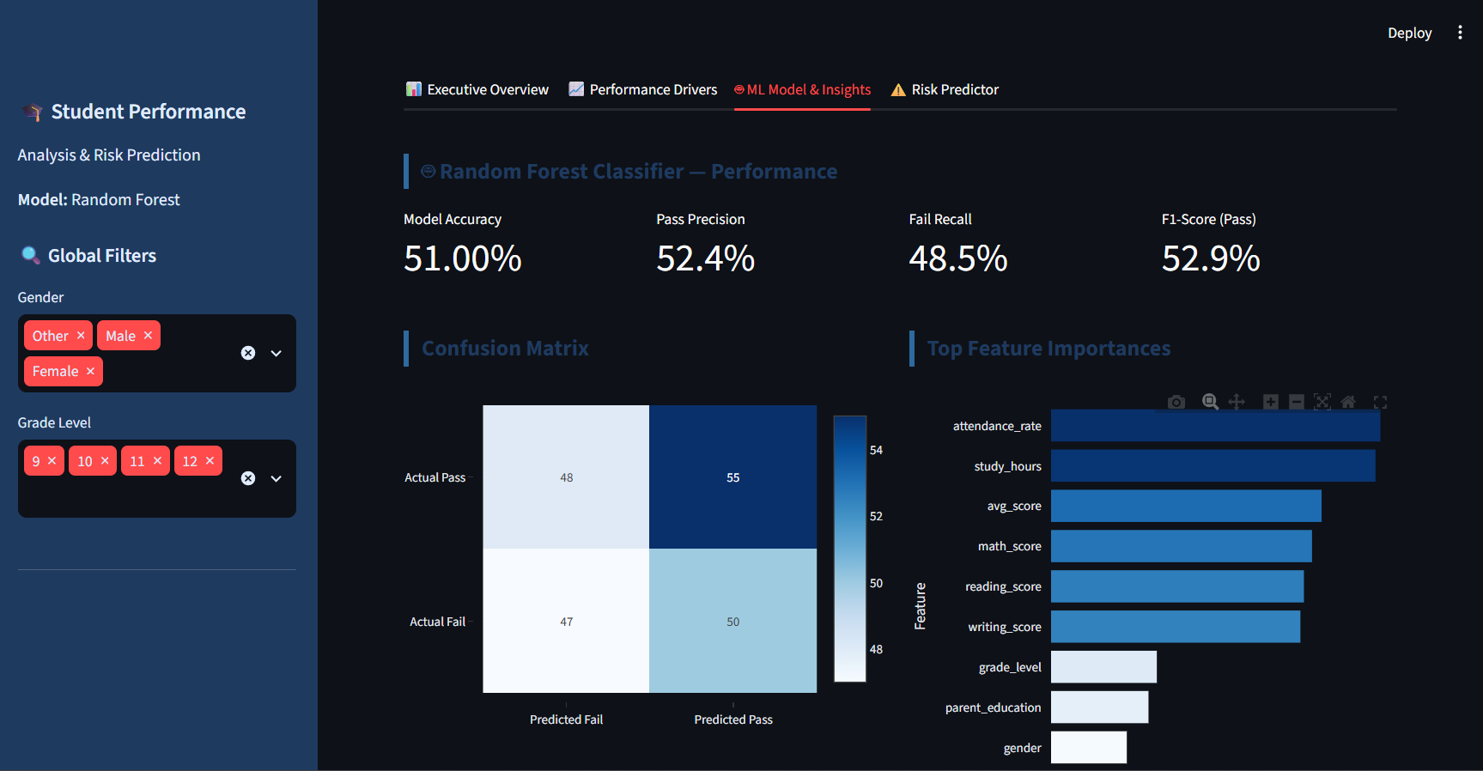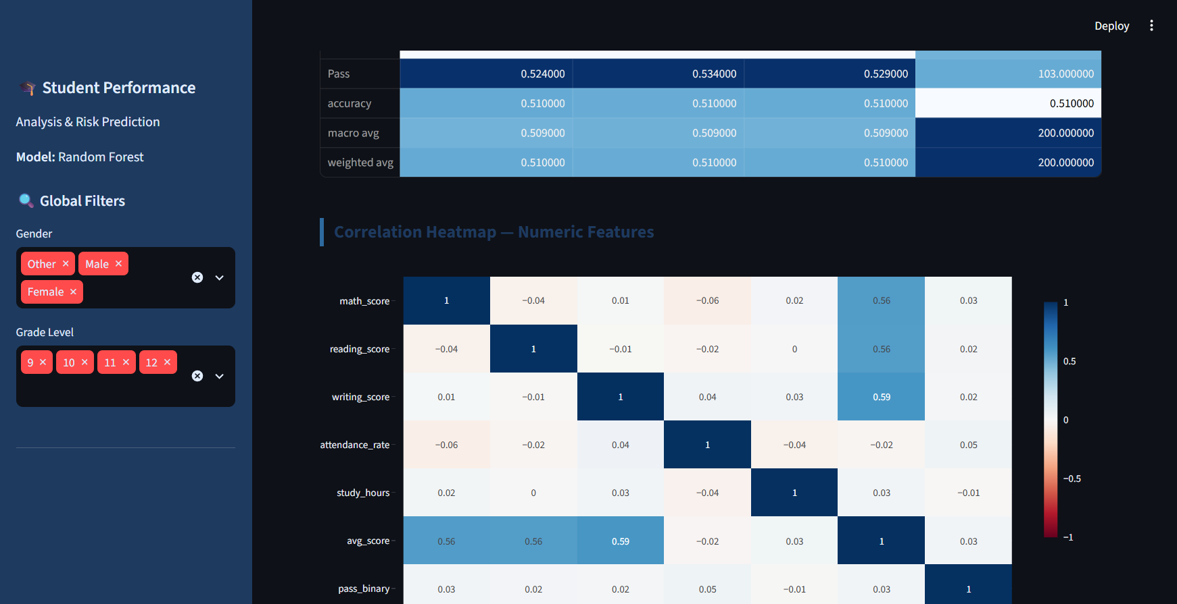

Page 4: Academic Risk Predictor (⚠️ Risk Predictor)
- Purpose: An interactive real-time decision-support tool allowing educators or counselors to input individual student parameters and predict academic risk status.
- Key Components & Insights:
  - Interactive Student Profile Input Form: Configurable sliders and dropdown selectors covering demographics, subject test scores (Math, Reading, Writing), attendance percentage, daily study hours, parental education, lunch type, and extracurricular participation.
  - Real-Time Prediction Output: Displays the immediate model outcome (PASS or AT RISK / FAIL) along with the exact class prediction probability.
  - Probability Breakdown Visualization: A dynamic probability bar chart highlighting the model's confidence distribution across Pass vs. Fail outcomes.
  - Automated Actionable Recommendations: Rule-based intervention suggestions generated dynamically based on the student's specific input values (e.g., flagging attendance below 85% or study hours below 2 hours/day for targeted counselor intervention).
  - Filtered Cohort Table: An expandable detailed data table offering granular review of individual student records matching current global filter settings.
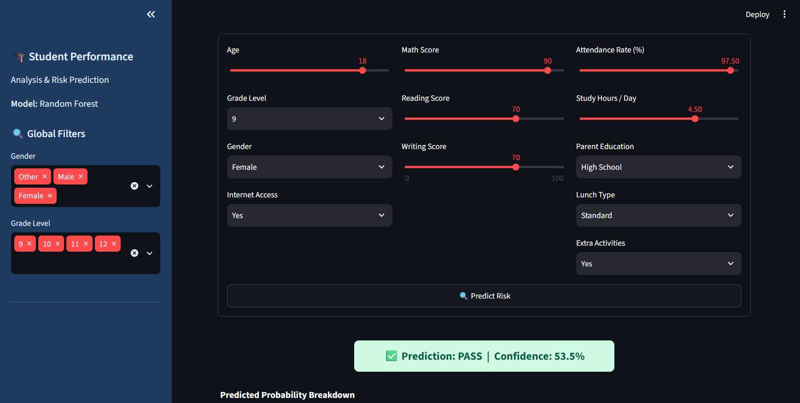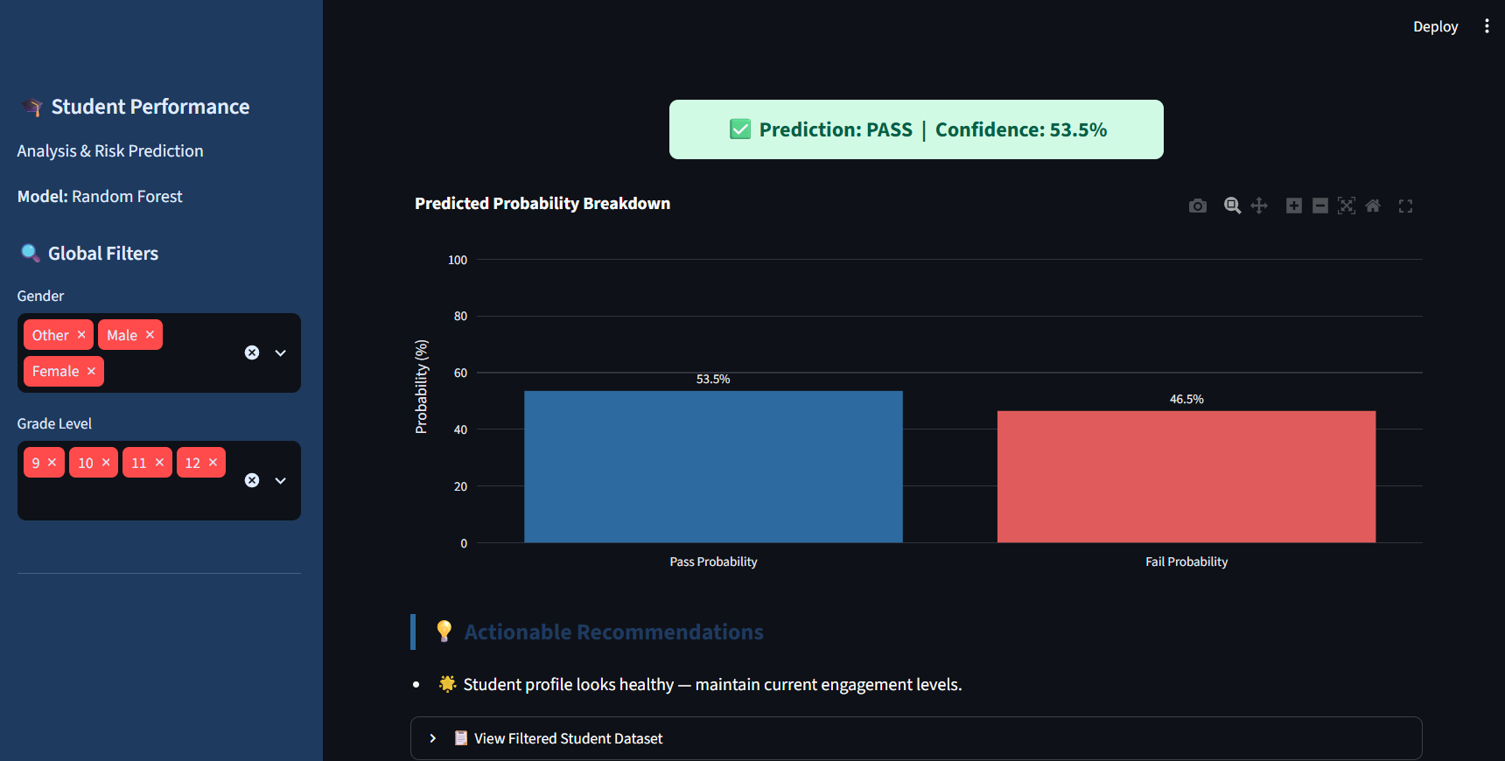sssss

9. Technology Stack & Implementation
Component | Technology | Version
Web Framework | Streamlit | >=1.32.0
Data Manipulation | Pandas | >=2.2.0
Numerical Computing | NumPy | >=1.26.0
Machine Learning | scikit-learn (Random Forest) | >=1.4.0
Visualisation | Plotly | >=5.20.0
Export Support | openpyxl | >=3.1.2
Language | Python | >=3.9

The application is launched with: python -m streamlit run SudiptaMaity_Student-Performance-Analysis.py
Local URL: http://localhost:8501

10. Conclusion
This project demonstrates a complete, production-quality Business Intelligence pipeline applied to the student academic performance domain. From raw CSV data through exploratory analysis, machine learning, and an interactive Streamlit dashboard, the solution equips educators with both the insight to understand why students fail and the tools to predict who is at risk before they do.
The Random Forest model's feature importance findings validate the BI hypotheses: composite academic score, attendance, and study hours are the controllable levers most tightly coupled to student outcomes. The live risk predictor translates model intelligence into actionable guidance, closing the loop between data science and educational practice.
Submitted by: Sudipta Maity

