|  |
| --- |
| neuroSHARE |
| Questionnaire App Updates |

|  |
| --- |
| Technical Specifications – Rev 1.0 |
| 6/25/2018 | |
|  |

Table of Contents

Scope of Work 3

Questionnaire Logic – Show If 4

Questionnaire Logic – Jump To 6

Questionnaire Logic – Other Display Logic 9

Questionnaire UI 11

Scope of Work

Patients will be able to complete an online questionnaire prior to their scheduled appointment. The questionnaire asks questions about the patient’s health. It also asks the patient if they have any concerns they would like to discuss during their next appointment. Reponses from the questionnaire will be collected and sent to the neuroSHARE clinic app, where the clinician can look at the patient’s responses during the appointment.

The primary areas of development are:

**Questionnaire Logic**

* Update Show If logic.
* Update Jump To logic.
* Other display logic updates.

**Questionnaire UI**

* Delete a question.
* Update question and response wording.
* Add additional response options.

**Assumptions:**

All changes written in this document were written under the assumption that a version of the neuroSHARE questionnaire app has already been built and completed. These changes were written as changes to the version of the Appendix 3_Questionnaire_Logic file that was sent to the vendor. Therefore, the assumption was made that the previously completed version of the questionnaire app aligns with that version of the Appendix 3_Questionnaire_Logic file.

Questionnaire Logic – Show If

When completing the online questionnaire, not all patients will see the same questions. The “Show If” logic outlines what criteria must be met in order to display each question.

Previous specification documents included a question 3, which dictated which questions from 4-20 would display based on the patient’s responses to question 3. Question 3 will be removed from the questionnaire per this specification document. Therefore, all patients will see questions 4-20 in chronological order.

| Item | Data Sources / APIs | Behavior / Logic / Notification Rules |
| --- | --- | --- |
| Question 4a,4b,4c,4d (all) | See Appendix 3_Questionnaire_Logic_11June2018 for reference. | Update logic:   * Always show this question. |
| Question 5a,5b,5c,5d (all) | See above. | Update logic:   * Always show this question. |
| Question 6a,6b,6c,6d (all) | See above. | Update logic:   * Always show this question. |
| Question 7a,7b,7c (all) | See above. | Update logic:   * Always show this question. |
| Question 8a,8b (all) | See above. | Update logic:   * Always show this question. |
| Question 9a,9b (all) | See above. | Update logic:   * Always show this question. |
| Question 10a,10b (all) | See above. | Update logic:   * Always show this question. |
| Question 11a,11b,11c (all) | See above. | Update logic:   * Always show this question. |
| Question 12 | See above. | Update logic:   * Always show this question. |
| Question 13 | See above. | Update logic:   * Always show this question. |
| Question 14 | See above. | Update logic:   * Always show this question. |
| Question 15 | See above. | Update logic:   * Always show this question. |
| Question 16a,16b (all) | See above. | Update logic:   * Always show this question. |
| Question 17a,17b (all) | See above. | Update logic:   * Always show this question. |
| Question 18 | See above. | Update logic:   * Always show this question. |
| Question 19 | See above. | Update logic:   * Always show this question. |
| Question 20 | See above. | Update logic:   * Always show this question. |
| (Review page) Question D: Topics you want to discuss | See above. | Update logic:   * If patient responded to Question 29, on the review page show patient response(s) to Question 29 (both checkboxes and free text) * If patient did not respond to Question 29, then on the review page show text “You did not list any topics to discuss at your upcoming visit.” |

Questionnaire Logic – Jump To

When completing the online questionnaire, not every patients will have to answer the same number of questions. The Jump To logic outlines which question to display next depending on the patient’s responses.

Previous specification documents included a question 3, which dictated which questions from 4-20 would display based on the patient’s responses to question 3. Question 3 will be removed from the questionnaire per this specification document. Therefore, all patients will see questions 4-20 in chronological order.

| Item | Data Sources / APIs | Behavior / Logic / Notification Rules |
| --- | --- | --- |
| Question 1a | See Appendix 3_Questionnaire_Logic_11June2018 for reference. | Update logic:   * If response option = 1 or n/a, then jump to Question 4 |
| Question 1b | See above. | Update logic:   * If response option = n/a, then jump to Question 4 |
| Question 1c | See above. | Update logic:   * If response option = n/a, then jump to Question 4 |
| Question 1da,1db,1dc,1dd | See above. | Update logic:   * If response option = n/a, then jump to Question 4 |
| Question 2 | See above. | Update logic:   * For all response options, always jump to Question 4 |
| Question 4a,4b,4c,4d (all) | See above. | Update logic:   * For all response options, always jump to Question 5 |
| Question 5a,5b,5c,5d (all) | See above. | Update logic:   * For all response options, always jump to Question 6 |
| Question 6a,6b,6c,6d (all) | See above. | Update logic:   * For all response options, always jump to Question 7 |
| Question 7a,7b,7c (all) | See above. | Update logic:   * For all response options, always jump to Question 8 |
| Question 8a,8b (all) | See above. | Update logic:   * For all response options, always jump to Question 9 |
| Question 9a,9b (all) | See above. | Update logic:   * For all response options, always jump to Question 10 |
| Question 10a,10b (all) | See above. | Update logic:   * For all response options, always jump to Question 11 |
| Question 11a,11b,11c (all) | See above. | Update logic:   * For all response options, always jump to Question 12 |
| Question 12 | See above. | Update logic:   * For all response options, always jump to Question 13 |
| Question 13 | See above. | Update logic:   * For all response options, always jump to Question 14 |
| Question 14 | See above. | Update logic:   * For all response options, always jump to Question 15 |
| Question 15 | See above. | Update logic:   * For all response options, always jump to Question 16 |
| Question 16a,16b (all) | See above. | Update logic:   * For all response options, always jump to Question 17 |
| Question 17a,17b (all) | See above. | Update logic:   * For all response options, always jump to Question 18 |
| Question 18 | See above. | Update logic:   * For all response options, always jump to Question 19 |
| Question 19 | See above. | Update logic:   * For all response options, always jump to Question 20 |
| Question 20 | See above. | Update logic:   * For all response options, always jump to Question 21 |

Questionnaire Logic – Other Display Logic

Previous specification documentation stated that patients would not see all of the response options the first time they take the questionnaire, but we are removing that logic per this specification document. Patients will always see the same response options for each question regardless of whether or not this is their first time taking the questionnaire.

| Item | Data Sources / APIs | Behavior / Logic / Notification Rules |
| --- | --- | --- |
| Question 4a,4b,4c,4d (all) | See Appendix 3_Questionnaire_Logic_11June2018 for reference. | Update logic:   * Always show all response options, including response option = 0. |
| Question 5a,5b,5c,5d (all) | See above. | Update logic:   * Always show all response options, including response option = 0. |
| Question 6a,6b,6c,6d (all) | See above. | Update logic:   * Always show all response options, including response option = 0. |
| Question 7a,7b,7c (all) | See above. | Update logic:   * Always show all response options, including response option = 0. |
| Question 8a,8b (all) | See above. | Update logic:   * Always show all response options, including response option = 0. |
| Question 9a,9b (all) | See above. | Update logic:   * Always show all response options, including response option = 0. |
| Question 10a,10b (all) | See above. | Update logic:   * Always show all response options, including response option = 0. |
| Question 11a,11b,11c (all) | See above. | Update logic:   * Always show all response options, including response option = 0. |
| Question 12 | See above. | Update logic:   * Always show all response options, including response option = 0. |
| Question 13 | See above. | Update logic:   * Always show all response options, including response option = 0. |
| Question 14 | See above. | Update logic:   * Always show all response options, including response option = 0. |
| Question 15 | See above. | Update logic:   * Always show all response options, including response option = 0. |
| Question 16a,16b (all) | See above. | Update logic:   * Always show all response options, including response option = 0. |
| Question 17a,17b (all) | See above. | Update logic:   * Always show all response options, including response option = 0. |
| Question 18 | See above. | Update logic:   * Always show all response options, including response option = 0. |
| Question 19 | See above. | Update logic:   * Always show all response options, including response option = 0. |
| Question 20 | See above. | Update logic:   * Always show all response options, including response option = 0. |

Questionnaire UI

This section includes minor wording and content changes.

Mock-Ups

See content outlined in red boxes for changes. See table below (pg. 14) for more details.

4a,4b,4c,4d:

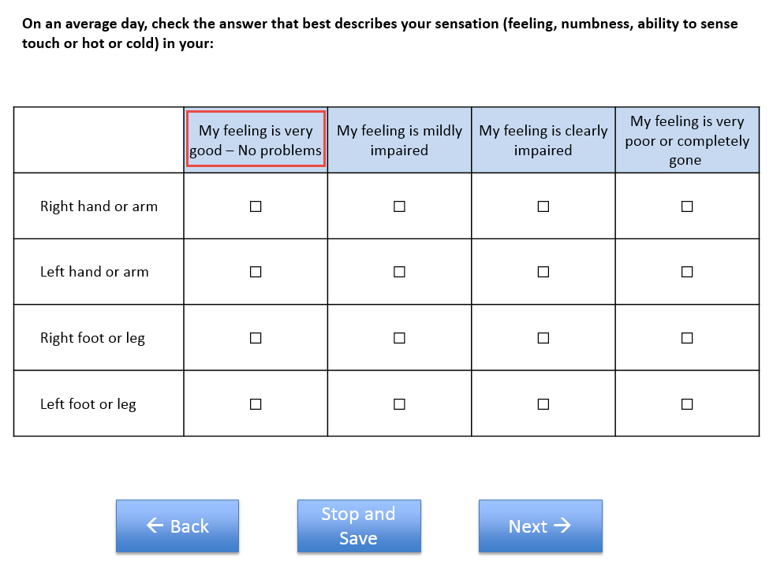

5a,5b,5c,5d:

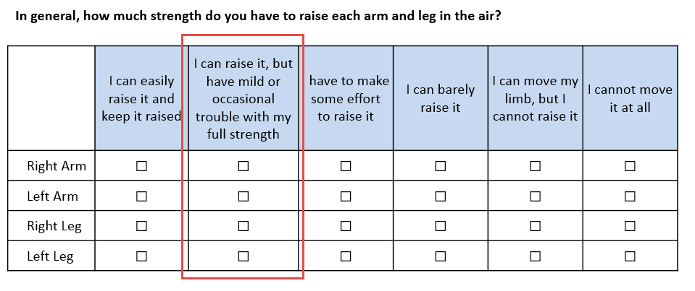

6a,6b,6c,6d:

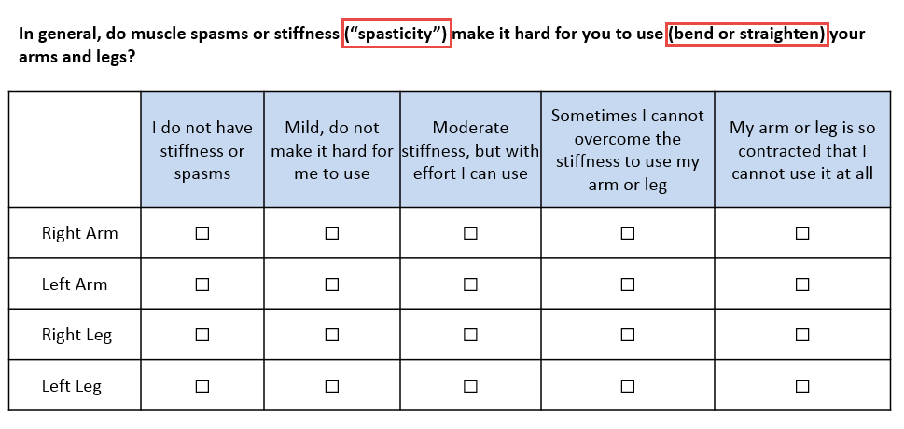

11a,11b:

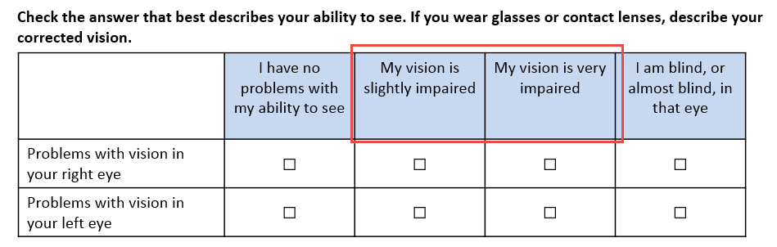

16b:

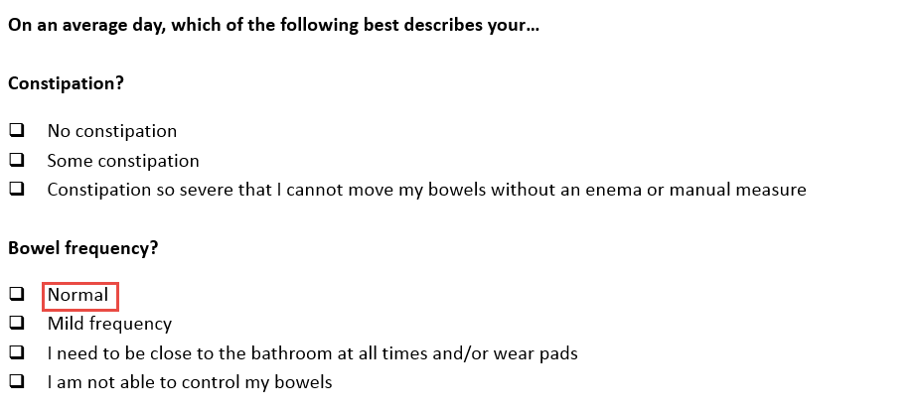

18:

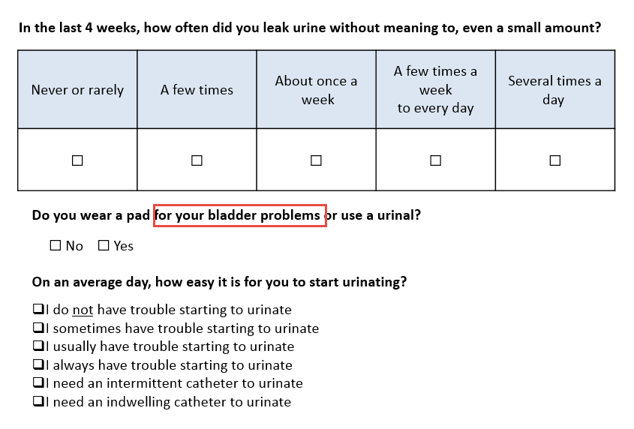

29:

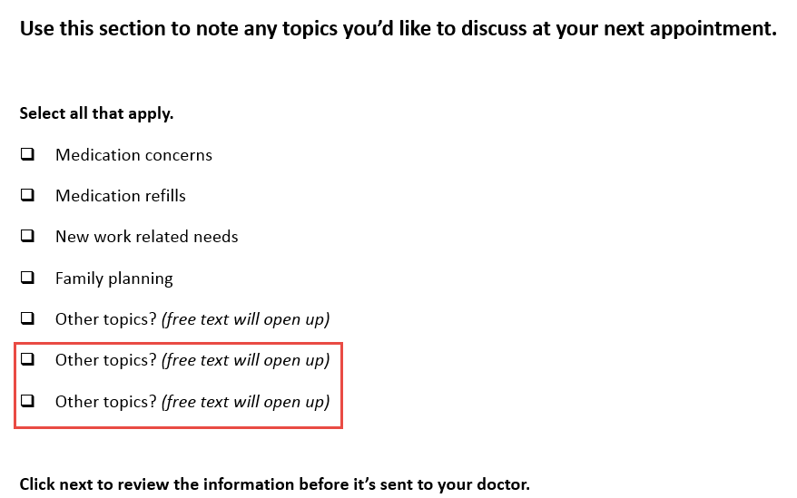

| Item | Data Sources / APIs | Behavior / Logic / Notification Rules |
| --- | --- | --- |
| Question 3a,3b,3c,3d,3e,3f,3g,3h,3i,3j,3k,3l,3m,3n,3o,3p (all) | See Appendix 3_Questionnaire_Logic_11June2018 for reference. | Remove question. |
| Question 4a,4b,4c,4d (all) | See above. | Update wording:   * New response option = 0 text:   “My feeling is very good - No problems” |
| Question 5a,5b,5c,5d (all) | See above. | Update wording:   * New response option = 1 text:   “I can raise it, but have mild or occasional trouble with my full strength” |
| Questions 6a,6b,6c,6d (all) | See above. | Update wording:   * New question text:   “In general, do muscle spasms or stiffness ("spasticity") make it hard for you to use (bend or straighten) your arms and legs?” |
| Question 11a,11b | See above. | Update wording:   * New response option = 1 text:   “My vision is slightly impaired”   * New response option = 2 text:   “My vision is very impaired” |
| Question 16b | See above. | Update wording:   * New response option = 0 text:   “Normal” |
| Question 18 | See above. | Update wording:   * New question text:   “Do you wear a pad for your bladder problems or use a urinal?” |
| Question 29 | See above. | Update response options:   * Add 2 additional “Other topics?” response options for a total of 3 “Other topics?” response options |