|  |
| --- |
| neuroSHARE |
| Opt-Out from Questionnaire Emails |

|  |
| --- |
| Technical Specifications – Rev 1.0 |
| 6/21/2018 | |
|  |

Table of Contents

Scope of Work 3

Opt-Out Process Flow 3

Opt-Out Webpage – Unsubscribe Confirmation 4

Opt-Out Webpage – Unsubscribed Thank You 5

Opt-Out Webpage – Did Not Unsubscribe Thank You 6

Scope of Work

Patients with an upcoming appointment with a pilot clinician will receive emails to complete an online questionnaire. The emails will contain a URL to launch a webpage to opt-out from receiving future questionnaire-related emails.

The primary areas of development are:

**Questionnaire Email Opt-Out Process**

* Create 3 webpages for the opt-out process.

Opt-Out Process Flow



Opt-Out Webpage – Unsubscribe Confirmation

Patients who receive questionnaire emails can click on a URL to stop receiving future emails. Clicking on the URL launches the Unsubscribe Confirmation page to confirm whether or not they want to unsubscribe. Patients can click “Unsubscribe” or “Do Not Unsubscribe”.

Mockup

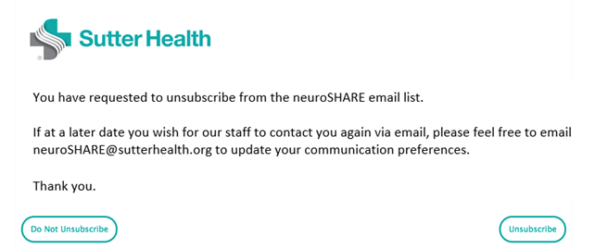

| Item | Data Sources / APIs | Behavior / Logic / Notification Rules |
| --- | --- | --- |
| Opt-Out Webpage – Unsubscribe Confirmation |  |  |

Opt-Out Webpage – Unsubscribed Thank You

Patients can click on the “Unsubscribe” button to opt-out from receiving questionnaire-related emails. Clicking on the “Unsubscribe” button will redirect them to a webpage to confirm they have successfully unsubscribed from the email list.

Mockup

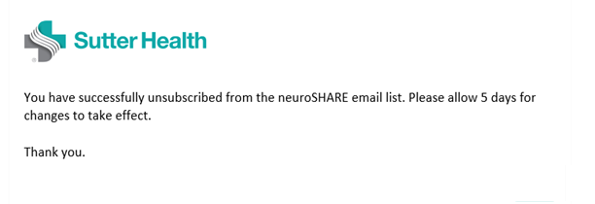

| Item | Data Sources / APIs | Behavior / Logic / Notification Rules |
| --- | --- | --- |
| Opt-Out Webpage – Unsubscribed Thank You |  |  |

Opt-Out Webpage – Did Not Unsubscribe Thank You

Patients can click on the “Do No Unsubscribe” button if they decide they do not want to opt-out of receiving questionnaire-related emails. Clicking on the “Do Not Unsubscribe” button will redirect them to a webpage to confirm they did not unsubscribe from the email list.

Mock-Up

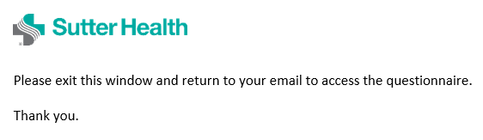

| Item | Data Sources / APIs | Behavior / Logic / Notification Rules |
| --- | --- | --- |
| Opt-Out Webpage – Did Not Unsubscribe Thank You |  |  |