Docker Task -2 - Sudir

Task Description:

Create a dockerfile, docker-compose file which when executed must display your basic details in the website.

Techstacks needs to be used :

- AWS EC2
- Docker

How do I submit my work?

- Push all your work files to GitHub (Code & O/P screenshot images must).
- Submit your URLs in the portal.

Terms and Conditions?
- You agree to not share this confidential document with anyone.
- You agree to open-source your code (it may even look good on your profile!). Do not mention our company’s name anywhere in the code.
- We will never use your source code under any circumstances for any commercial purposes; this is just a basic assessment task.
NOTE: Any violation of Terms and conditions is strictly prohibited. You are bound to adhere to it.

Step 1: Update the System
sudo apt update -y
Screenshot:
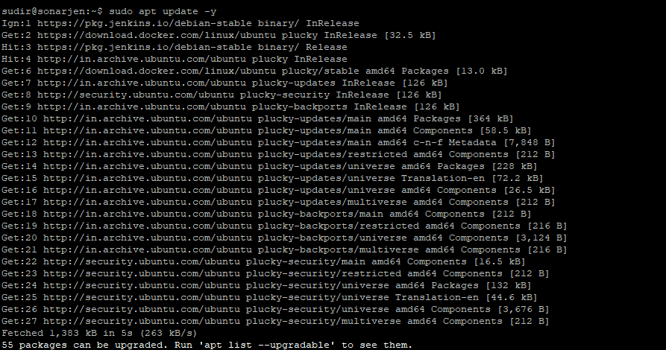

Step 2: Install Docker and Docker Compose
sudo apt install docker.io docker-compose -y
sudo systemctl enable docker
sudo systemctl start docker
sudo systemctl status docker

Screenshot:
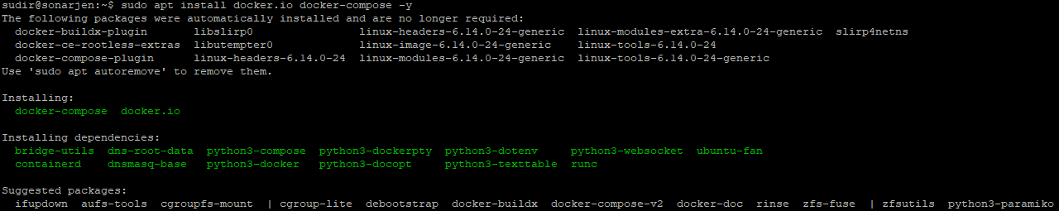
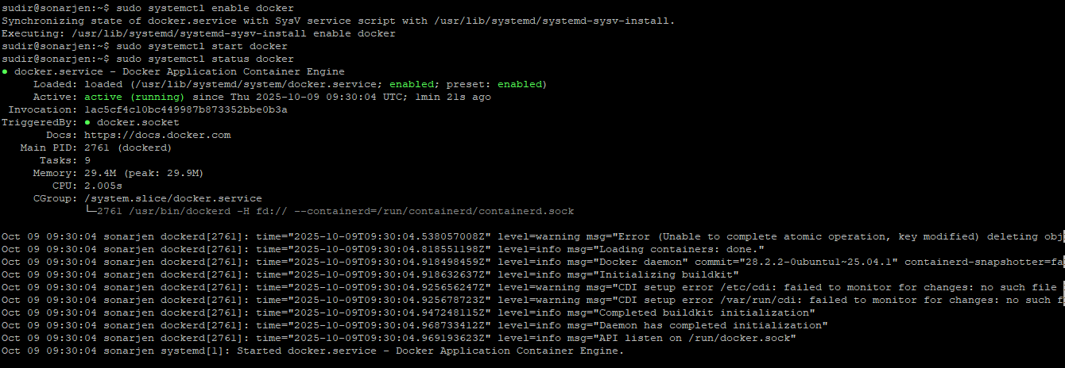

Step 3: Create Project Directory
mkdir docker-task2
cd docker-task2
Screenshot:

Step 4: Create index.html
<!DOCTYPE html>
<html>
<head>
<title>About Me - Docker Task 2</title>
</head>
<body>
<h1>Docker Task - 2</h1>
<p><b>Name:</b> Sudir</p>
<p><b>Email:</b> yourname@example.com</p>
<p><b>City:</b> Chennai</p>
<p><b>Skills:</b> AWS | Docker | Linux | Jenkins</p>
</body>
</html>
Screenshot:
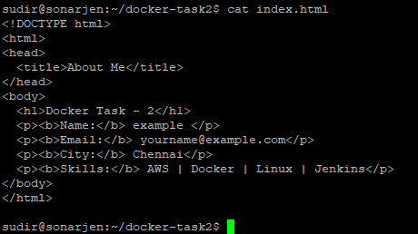

Step 5: Create Dockerfile
FROM nginx:latest
COPY index.html /usr/share/nginx/html/index.html
EXPOSE 80
Screenshot:
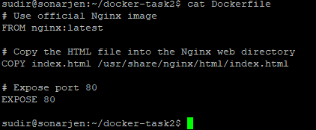

Step 6: Create docker-compose.yml
version: '3'
services:
web:
build: .
ports:
- "80:80"
container_name: myweb
Screenshot:
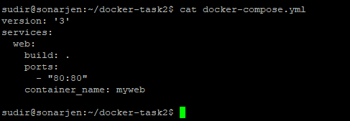

Step 7: Build and Run the Container
sudo docker-compose up -d
Screenshot:
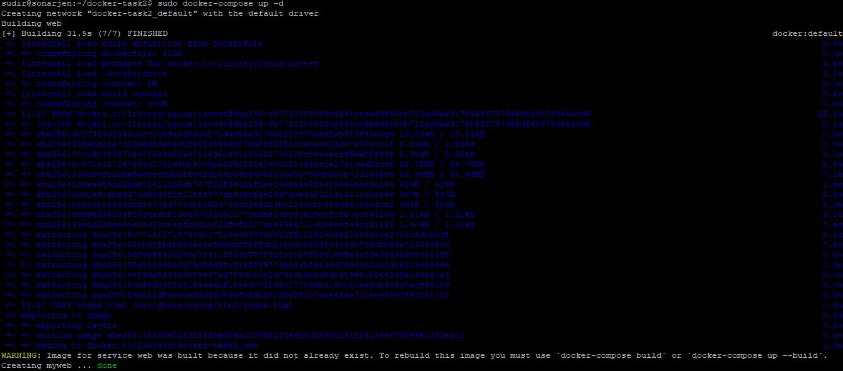
Step 8: Verify the Container
sudo docker ps
Screenshot:

Step 9: Test in Browser
Open your browser and visit:
👉 http://<your-vm-ip-address>
Screenshot:
