**Lab 1: Algorithm and Code Analysis of Website or Application (Using DVWA)**

**Objective**

To demonstrate how SQL Injection and Cross-Site Scripting (XSS) attacks work and how to analyze vulnerable code logic in insecure web applications using DVWA (Damn Vulnerable Web Application).

**Software/Tools Required**

DVWA (Damn Vulnerable Web Application)

XAMPP

Web Browser: Chrome or Firefox

Theory

**SQL Injection (SQLi)**

SQL Injection is a web vulnerability that allows an attacker to modify or inject SQL queries in a web application’s database layer.  
It typically happens when:

User input is directly inserted into SQL queries.

No input validation or escaping is performed.

**Cross-Site Scripting (XSS)**

XSS allows an attacker to **inject malicious JavaScript code** into a web page viewed by other users.  
It occurs when:

Web applications display unsanitized user input in the browser.

The browser executes the injected script as part of the page.

This can lead to:

Cookie theft

Session hijacking

Redirection to malicious sites

**SQL Injection in DVWA**

**Step 1: Open Xampp and run apache and mysql**

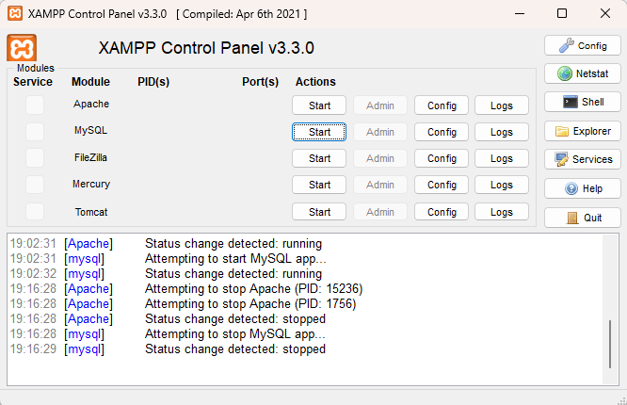

**Step 2: Login to DVWA (admin / password)**

**Step 3:** **Set security to Low and submit**

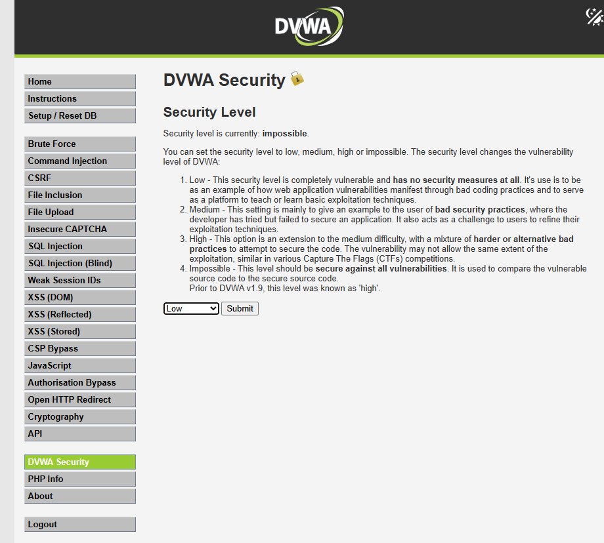

**Step 4: Go to SQL Injection option**

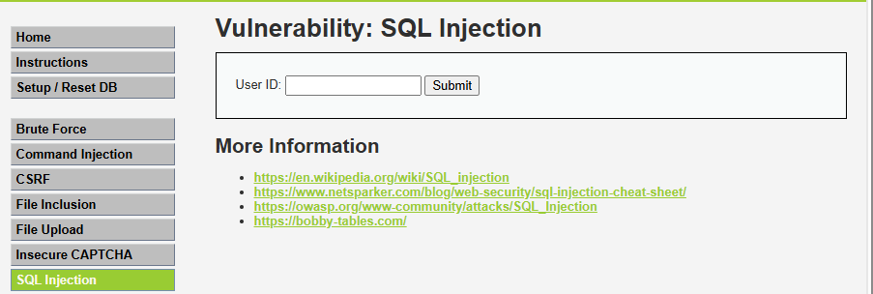

**Step 5: Go to View Source option**

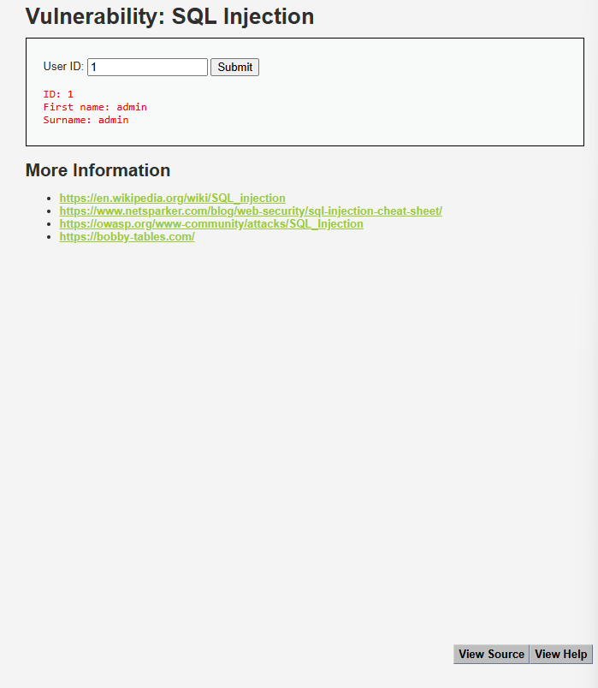

**Step 6: Analyse the code to detect the vulnerability**

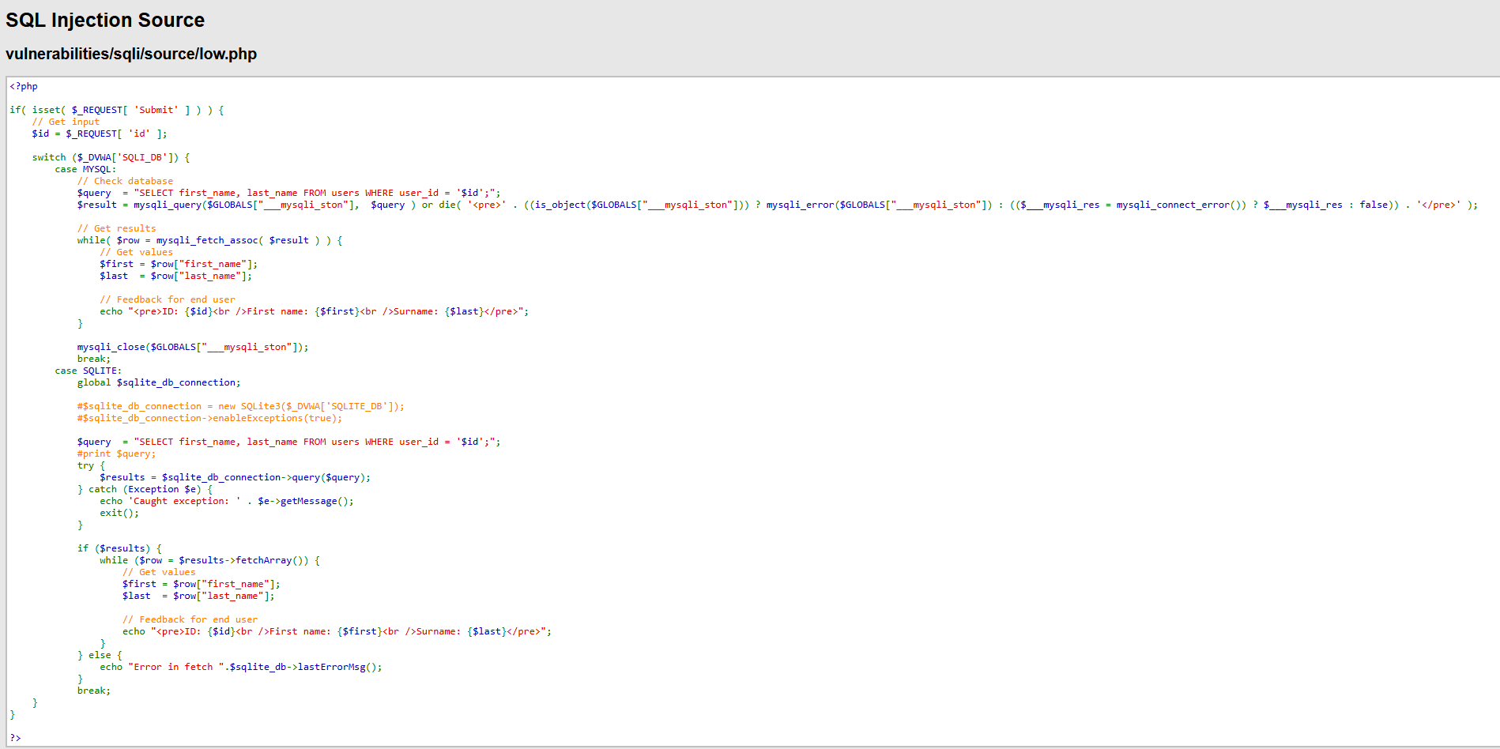

**Problem 1: Unsafe User Input**

if( isset( $_REQUEST[ 'Submit' ] ) ) {

// Get input

$id = $_REQUEST[ 'id' ];

* $_REQUEST['id'] takes user input without validation.
* Accepts anything, including special characters and SQL code like: 1' OR '1'='1

**Problem 2: Query is Built Using Raw Input**

$query = "SELECT first_name, last_name FROM users WHERE user_id = '$id';";

* User input is directly inserted into the SQL query as a string.
* This allows a user to change the logic of the query by adding SQL keywords.

Why It's Vulnerable?

Let’s say the attacker provides this as input in the browser: ?id=1' OR '1'='1

The query becomes:

SELECT first_name, last_name FROM users WHERE user_id = '1' OR '1'='1';

'1'='1' is always true, so the database returns all rows, bypassing the intention of fetching just one user.

**Step 7: Perform SQL injection (to show first name and surname from the database)**

**Payload : 1' OR 1=1 – (don’t forget to add an extra space at the end of the payload)**

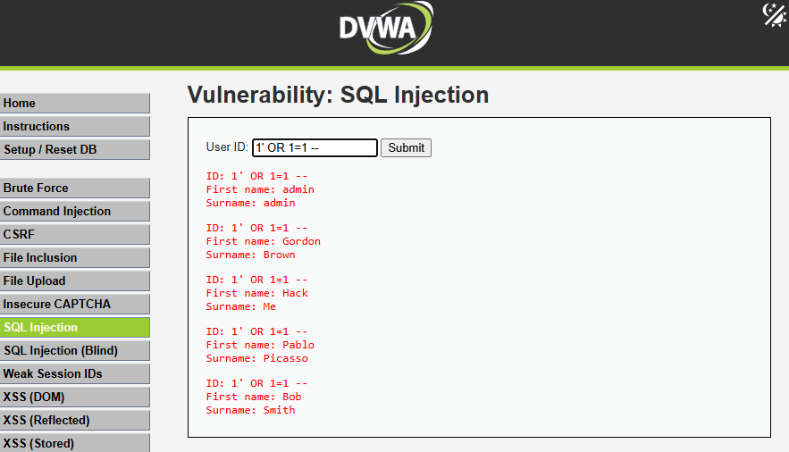

**Step 8: Perform SQL injection (to show user id and password from the database)**

**Payload : 1' UNION SELECT user, password FROM users -- (don’t forget to add an extra space at the end of the payload)**

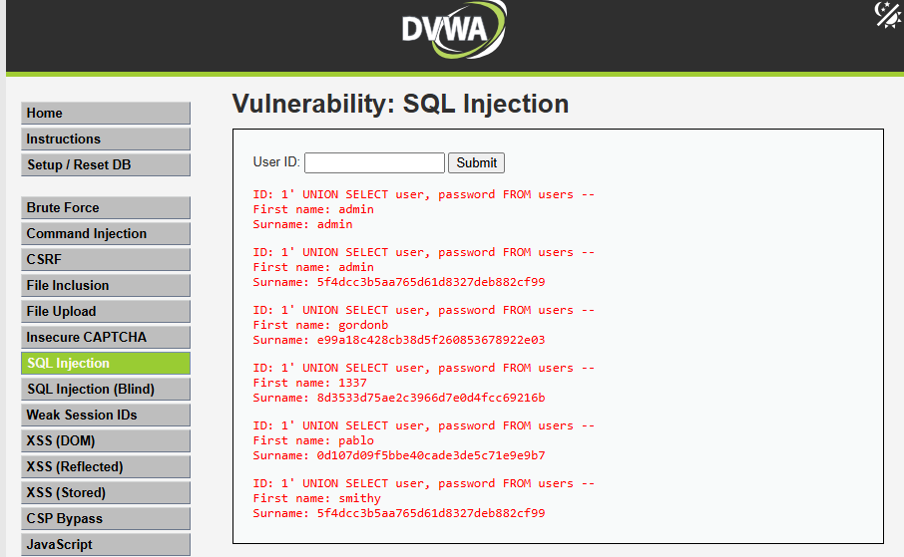

**Step 9: Copy the hashed password**

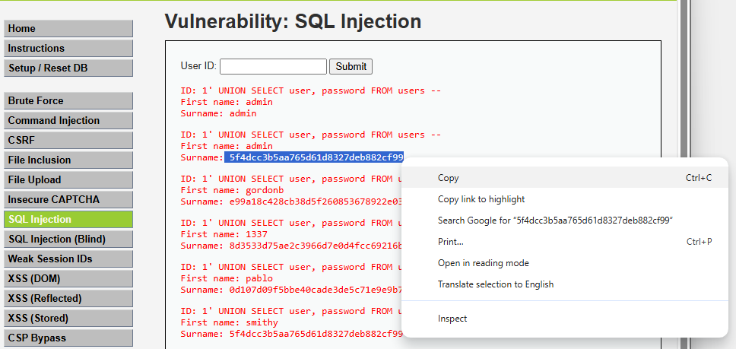

**Step 10: Go to** [**https://crackstation.net**](https://crackstation.net) **to crack the password**

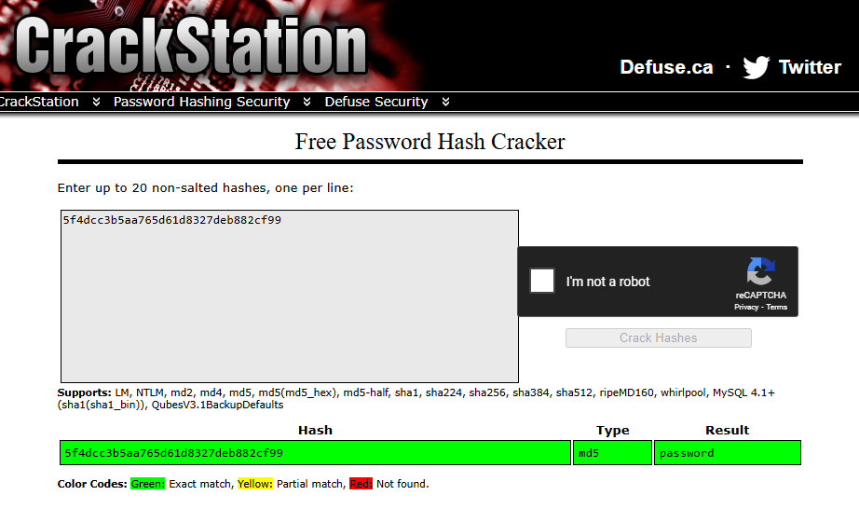

**RESULT:**

**Password is : password**

**Analysing the vulnerable code of XSS (Cross Site Scripting) in DVWA:**

**Step 1: Set security to Low and submit**



**Step 2: Go to XSS (Reflected)**

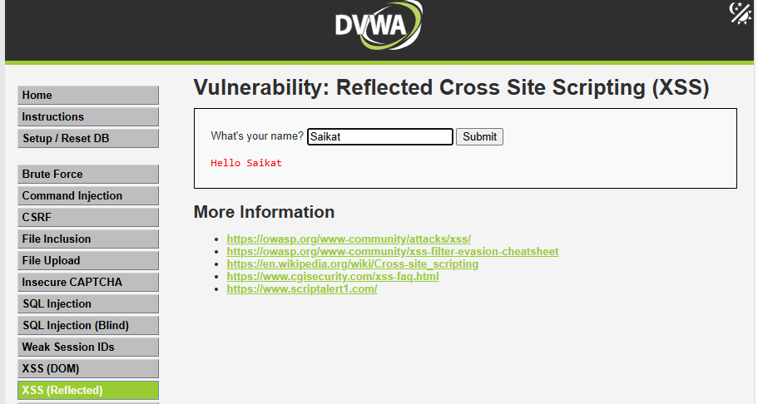

* **Try giving your name in the field**

**Step 3: Go to source code and analyse the vulnerability in the code**

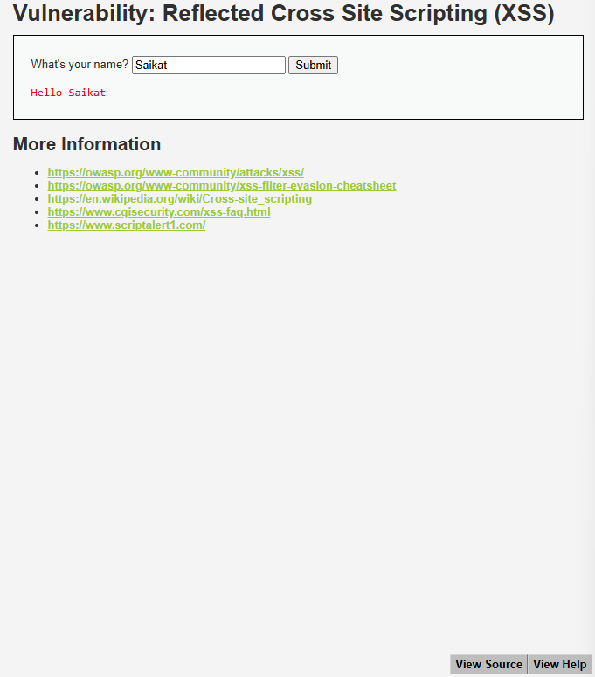

**Source code:**

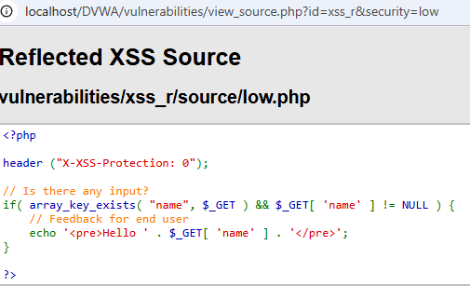

**Code Review:**

**header("X-XSS-Protection: 0");**

Disables browser's built-in XSS protection (like in Chrome).

**$_GET['name']**

Input is taken directly from the URL query parameter.

**echo '<pre>Hello ' . $_GET['name'] . '</pre>';**

User input is echoed without sanitization or encoding.

**This creates a vulnerability because the browser will interpret any HTML/JavaScript in the input.**

**Step 4: Perform XSS(Reflected) attack**

**Payload: <script>alert("hello hakor")</script>**

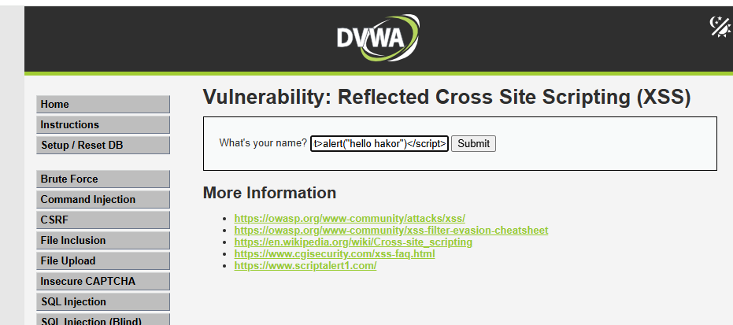

**Step 5: Analyse the URL and popup**

**Result:**

