**Lab 2: Deploy a Virtual Machine Instance (IaaS), Configure a Web Server (PaaS), and Use a Software Application (SaaS) using GCP Free Tier**

**Objective**

To demonstrate the use of Google Cloud Platform (GCP) Free Tier for deploying:

* A Virtual Machine (IaaS)
* A Web Server (PaaS)
* A Cloud-hosted Software Application (SaaS)

Software/Tools Required

* Google Cloud Platform (GCP) Free Tier Account
* Compute Engine (VM instance)
* Apache Web Server
* Web Browser (Chrome or Firefox)

**Theory**

IaaS – Infrastructure as a Service

* In IaaS, users get access to virtualized hardware resources such as VMs, networks, and storage.
* In this lab, we will launch a virtual machine instance using GCP Compute Engine.

PaaS – Platform as a Service

* In PaaS, cloud providers offer an environment for hosting applications without managing underlying OS.
* We will configure a web server (Apache) on the VM to host a basic web page.

SaaS – Software as a Service

* SaaS provides ready-to-use software applications hosted in the cloud.
* For this lab, we will use a SaaS tool like Google Docs or Gmail directly from the browser, showing how cloud apps work without installation.

**Deploy a Virtual Machine Instance (IaaS)**

**Step 1: Open Google Cloud Console and click on Create a VM**

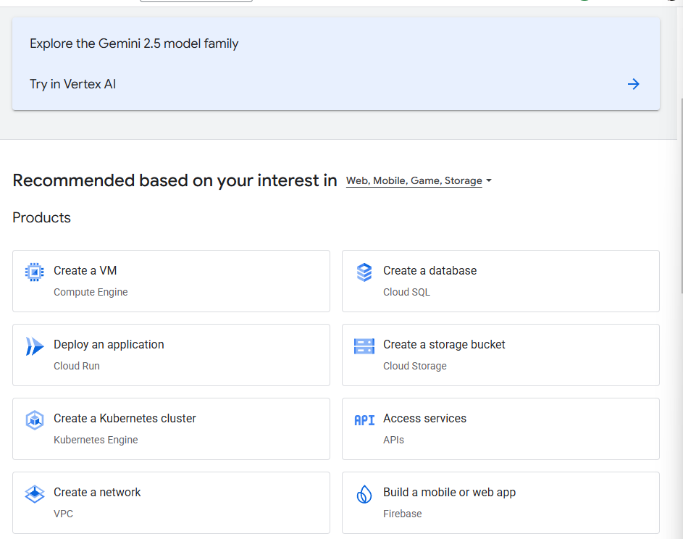

**Step 2: Configure the VM**

**Select the Region to asia-northeast2 (Mumbai)**

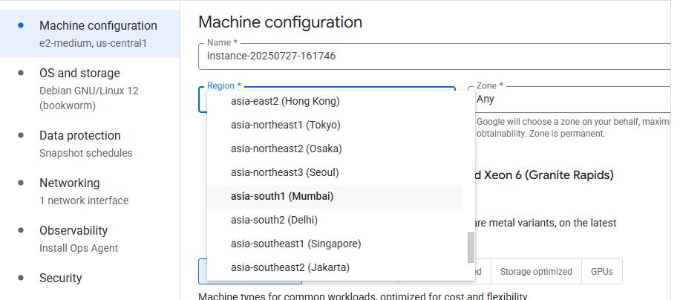

**Step 3:** **Choose the machine series to E2**

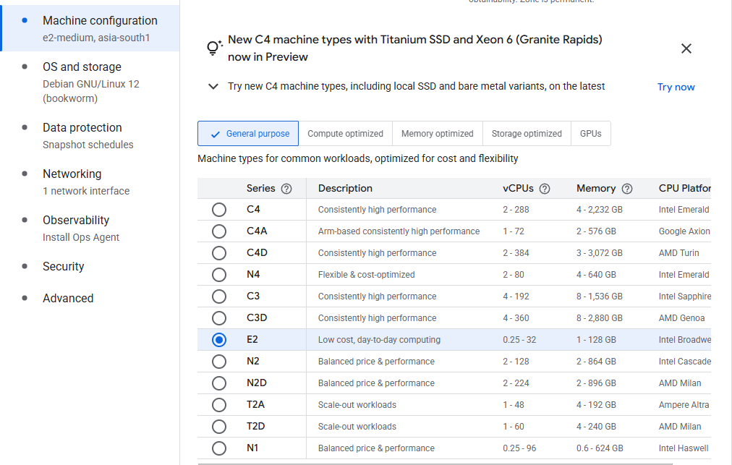

**Step 4: Choose the machine type to e2-micro**

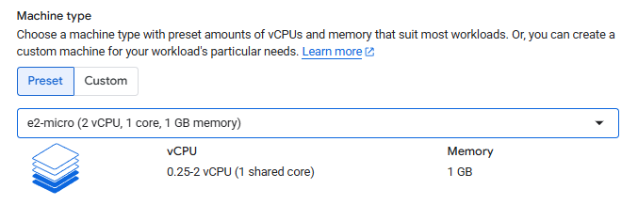

**Step 5: Go to Networking option and allow both http and https traffic**

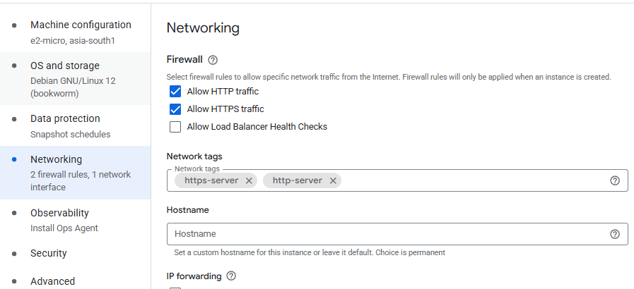

**Step 6: Click on create**

**Step 7: Click on SSH to connect linux VM**

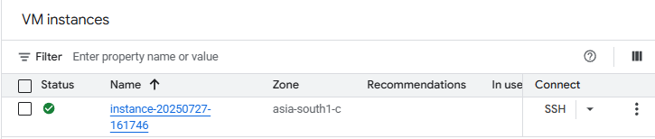

**Step 8: Go to superuser mode**

**Command: sudo su**

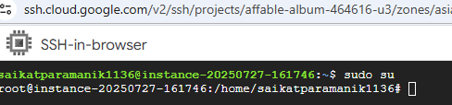

**Step 9: Install Apache web server (PaaS)**

**Command : sudo apt update**

**sudo apt install apache2 -y**

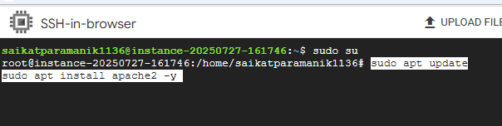

**Step 10: Make sure that apache is running**

**Command: sudo systemctl status apache2**

**Step 11: Copy external IP of the VM**

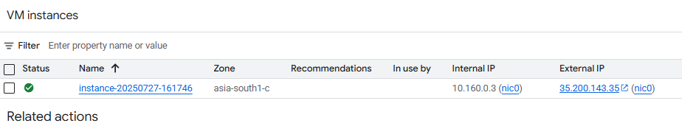

**Step 12: Paste external IP on web - browser**

**Result:**

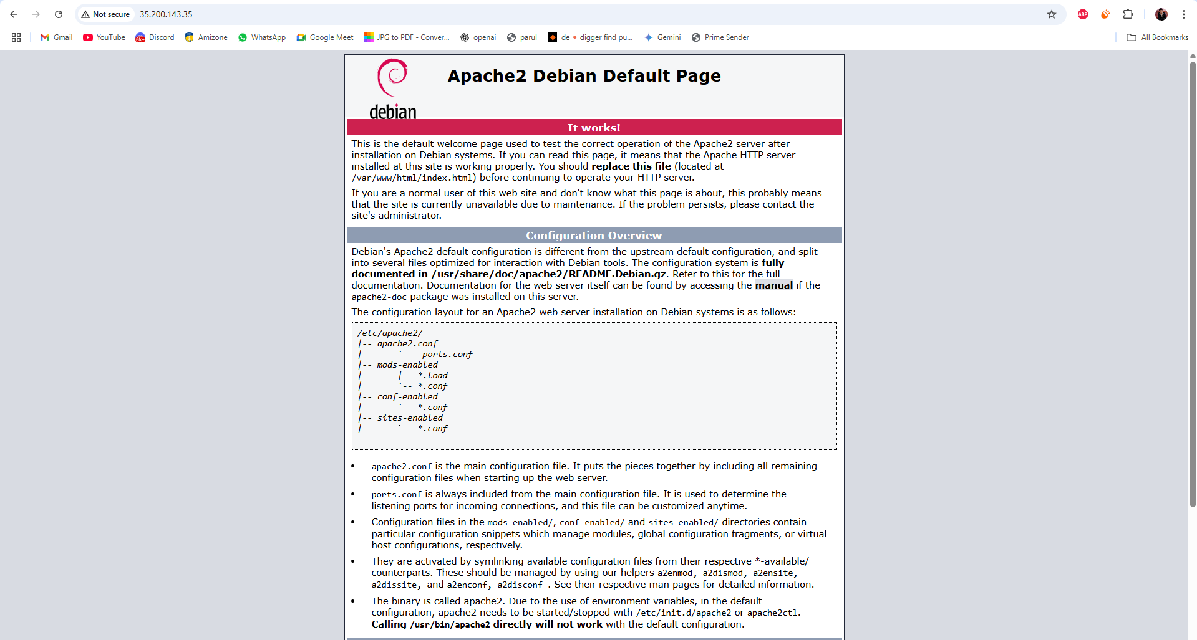

**Step 13: Use a Software Application (SaaS)**

**Open a SaaS Application**

**Example: Google Docs**

**Visit: https://docs.google.com**

**click Blank Document to create a new document.**

**You can also open:**

* **Gmail → https://mail.google.com**
* **Google Drive → https://drive.google.com**
* **Google Meet → https://meet.google.com**

