Predicting Vehicle Prices Using Regression Models

Objectives
The primary goal of this project is to develop a robust regression model to predict used car prices for a reseller based on various listed features and specifications. In addition to predicting prices, the project focuses on identifying feature importance and mitigating overfitting through the application of regularization techniques.
There can be several business objectives for this, such as:
- Price Prediction: Model car prices based on features like mileage, fuel type, and performance.
- Market Analysis: Explore trends and preferences in the used car market, by type, region, or other metrics.
- Feature Importance: Identify the most important factors influencing car prices (e.g., fuel type, mileage, age).

Tasks Overview
The data pipeline for this task involves the following steps:
- Dataset Overview
- Data Preprocessing
- Data Visualizations & Exploration
- Model Building
- Regularization

1 Data Loading

1.1.1
Load the dataset
# Load the data
df = pd.read_csv('/content/Car_Price_data.csv')
print(f"Dataset Shape: {df.shape}")
display(df.head())

2 Analysis and Feature Engineering [35 marks]

2.1 Preliminary Analysis and Frequency Distributions [13 marks]

2.1.1 [1 marks]
Check and fix missing values.
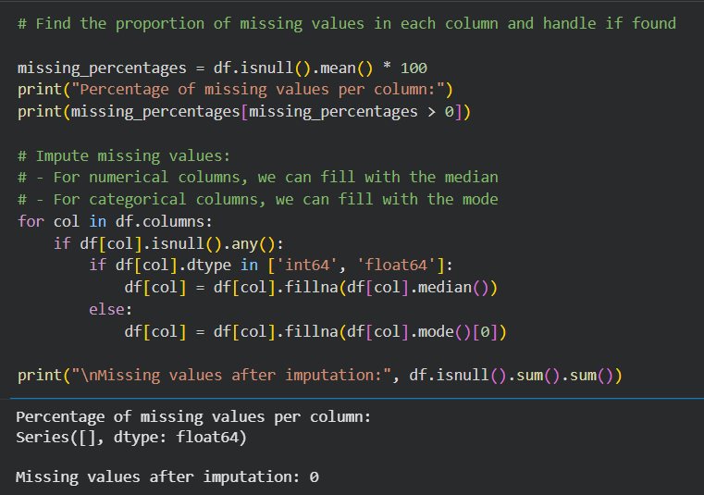
From the features, identify the target feature and numerical and categorical predictors. Select the numerical and categorical features carefully as they will be used in analysis.

2.1.2 [3 marks]
Identify numerical predictors and plot their frequency distributions.

Numerical Predictors: ['km', 'Gears', 'age', 'Previous_Owners', 'hp_kW', 'Inspection_new', 'Displacement_cc', 'Weight_kg', 'cons_comb']

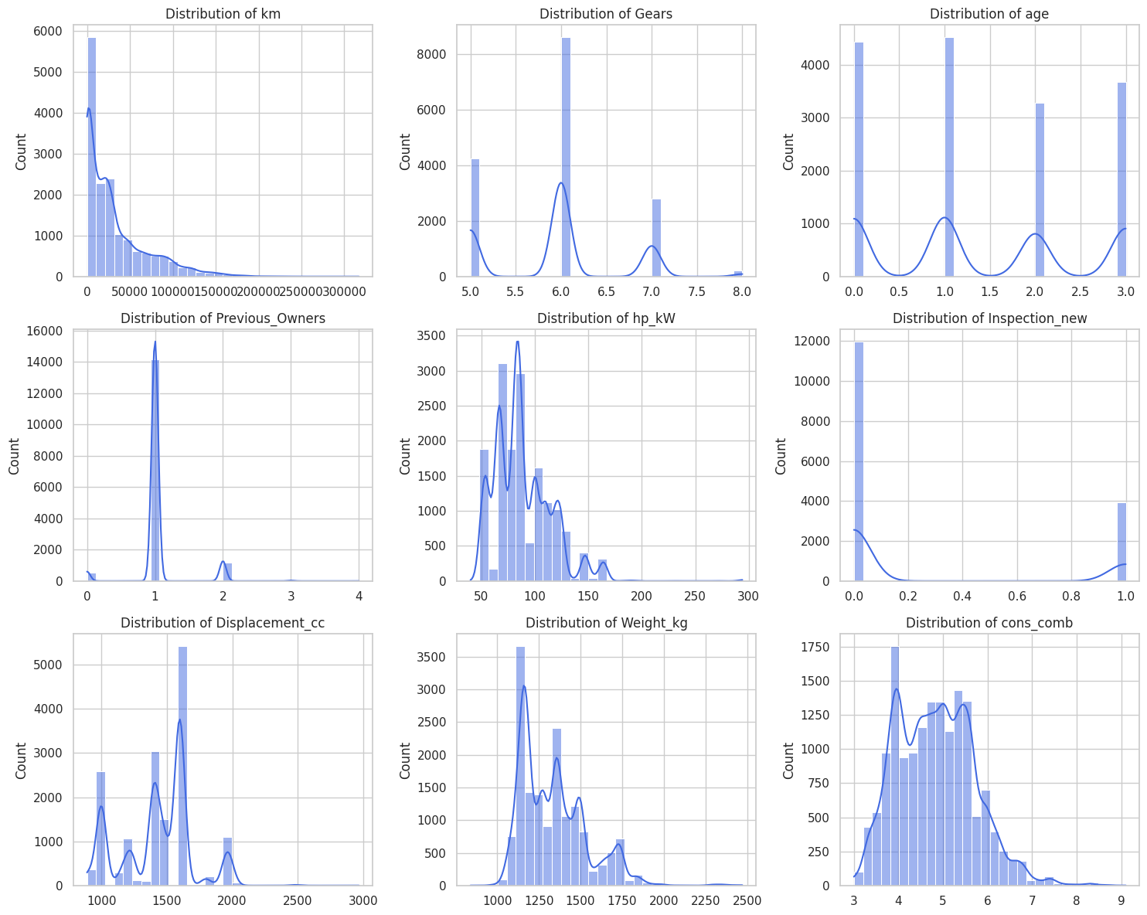

2.1.3 [3 marks]
Identify categorical predictors and plot their frequency distributions.
Categorical Predictors: ['make_model', 'body_type', 'vat', 'Type', 'Fuel', 'Paint_Type', 'Upholstery_type', 'Gearing_Type', 'Drive_chain']
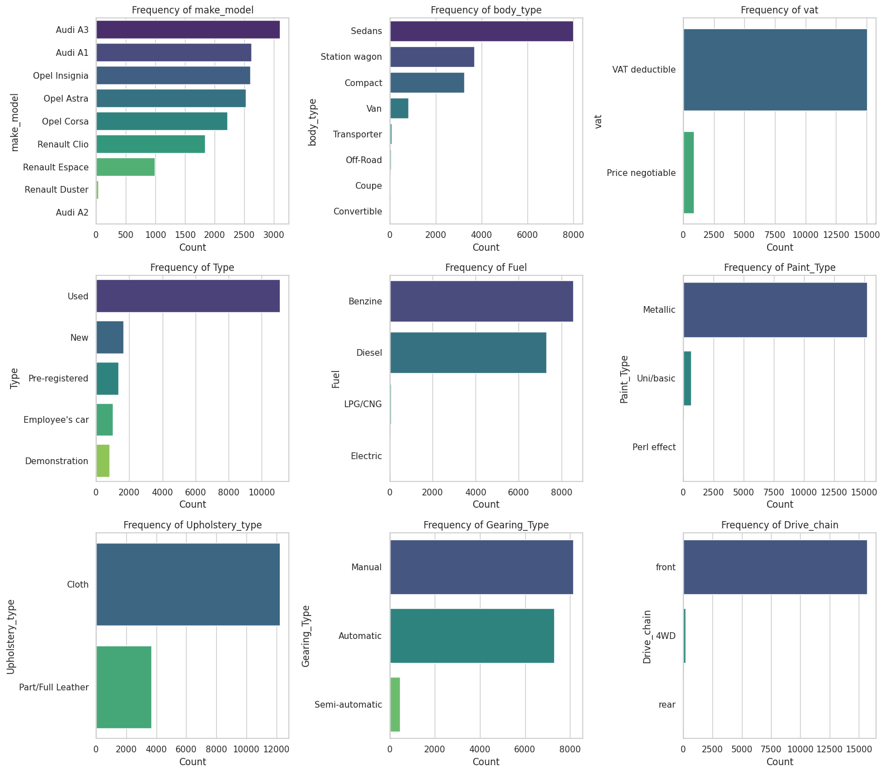

Note: Look carefully at the values stored in columns ["Comfort_Convenience", "Entertainment_Media", "Extras", "Safety_Security"].
Should they be considered categorical? Should they be dropped or handled any other way?
Answer: No. They have multi-label / set-valued features, not single-category variables. We will treat the list columns by splitting the comma-separated strings and performing multi-label indicator encoding

2.1.4 [3 marks]
Fix columns with low frequency values and class imbalances.

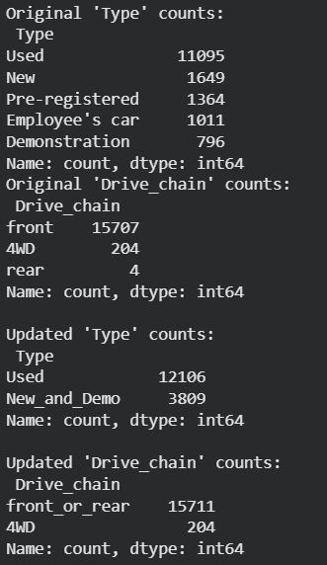

2.1.5 [3 marks]
Identify target variable and plot the frequency distributions. Apply necessary transformations.

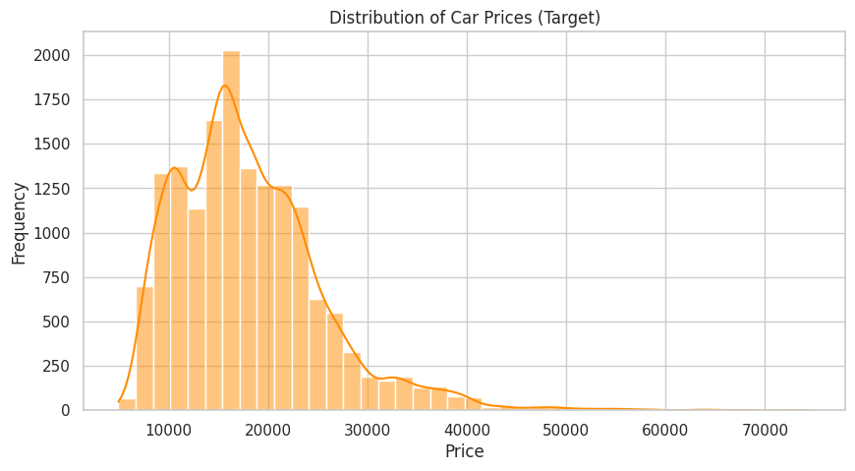

The target variable seems to be skewed. Perform suitable transformation on the target.
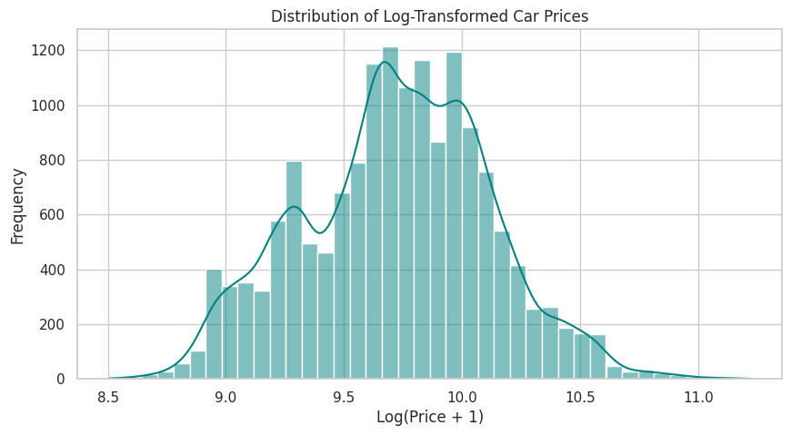

2.2 Correlation analysis [6 marks]

2.2.1 [3 marks]
Plot the correlation map between features and target variable.

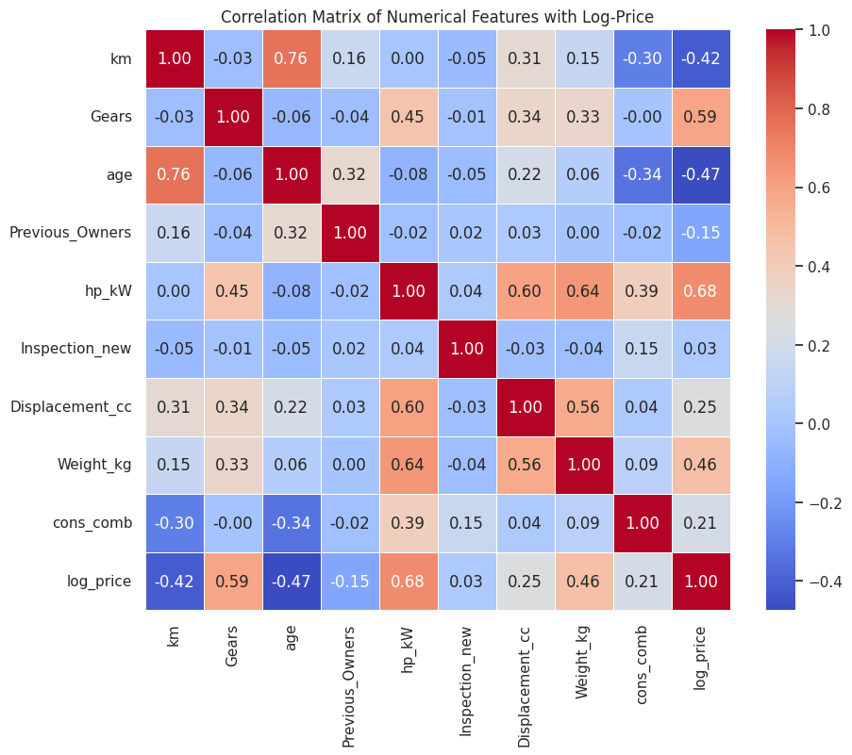

2.2.2 [3 marks]
Analyse correlation between categorical features and target variable.

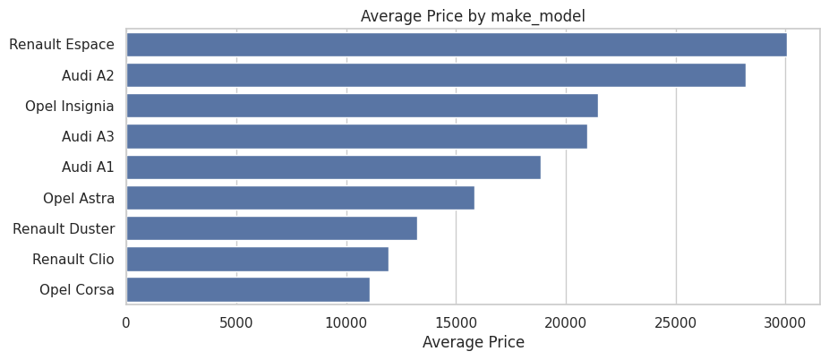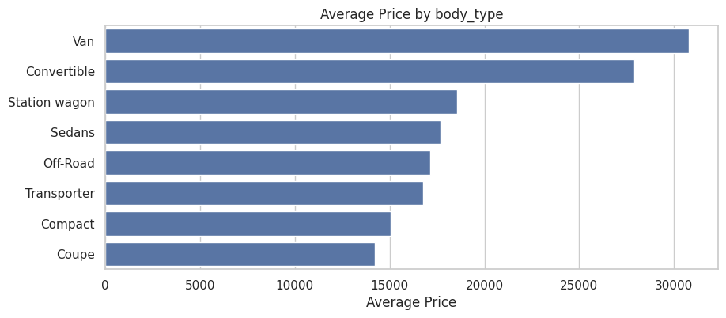
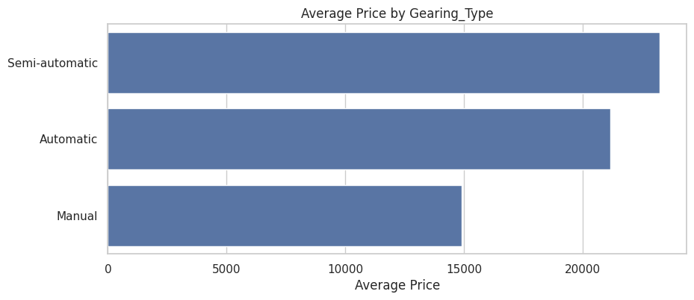

2.3 Outlier analysis [5 marks]

2.3.1 [2 marks]
Identify potential outliers in the data.
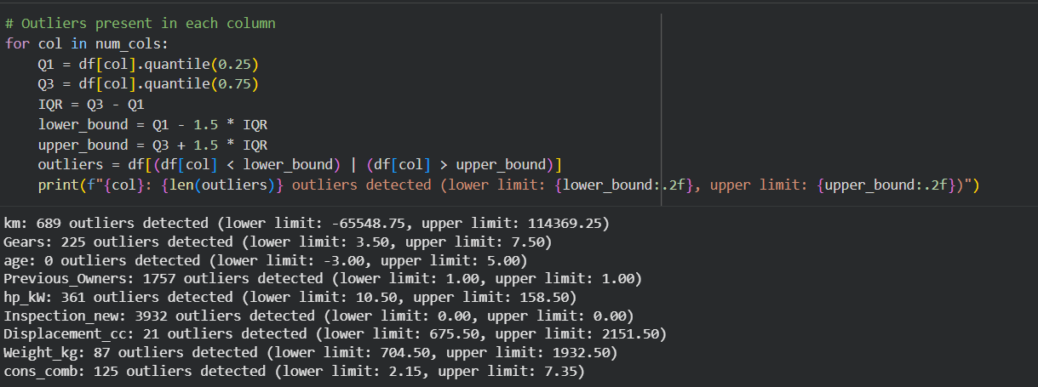

2.3.2 [3 marks]
Handle the outliers suitably.
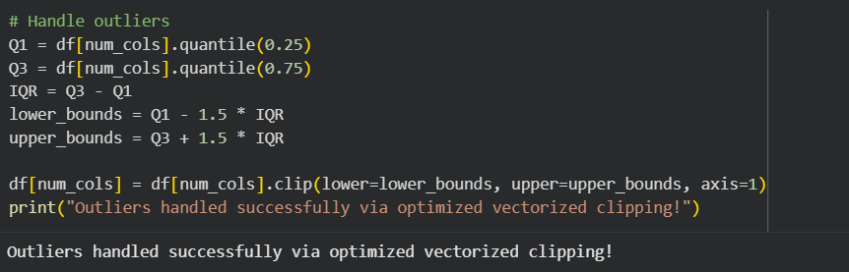

2.4 Feature Engineering [11 marks]

2.4.1
Fix any redundant columns and create new ones if needed.
# Fix/create columns as needed
redundant_cols = ['price']
for col in redundant_cols:
if col in df.columns:
df.drop(columns=[col], inplace=True)
print("Redundant columns dropped. Current dataset columns:", df.columns.tolist())
Redundant columns dropped. Current dataset columns: ['make_model', 'body_type', 'vat', 'km', 'Type', 'Fuel', 'Gears', 'Comfort_Convenience', 'Entertainment_Media', 'Extras', 'Safety_Security', 'age', 'Previous_Owners', 'hp_kW', 'Inspection_new', 'Paint_Type', 'Upholstery_type', 'Gearing_Type', 'Displacement_cc', 'Weight_kg', 'Drive_chain', 'cons_comb', 'log_price']

2.4.2 [4 marks]
Analysis and feature engineering on ['Comfort_Convenience', 'Entertainment_Media', 'Extras', 'Safety_Security'].
These columns contain lists of features present. Decide on how to include these features in the predictors.
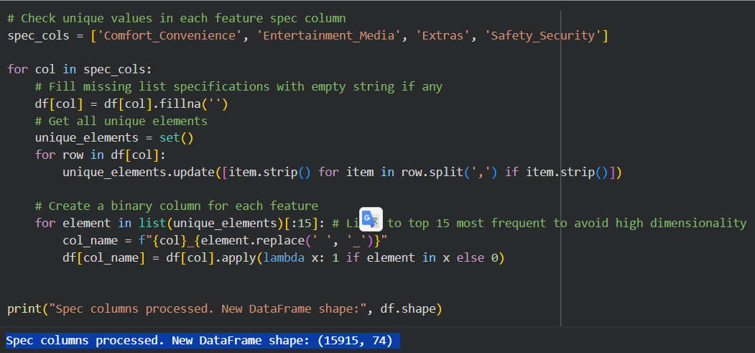
Out of these features, we will check the ones which are present in most of the cars or are absent from most of the cars. These kinds of features can be removed as they just increase the dimensionality without explaining the variance.

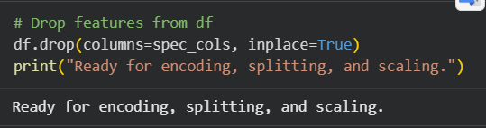

2.4.3 [3 marks]
Perform feature encoding.
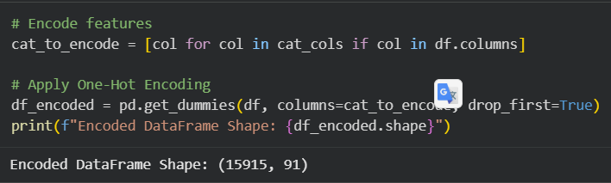

2.4.4 [2 marks]
Split the data into training and testing sets.
Split data into 80%-20%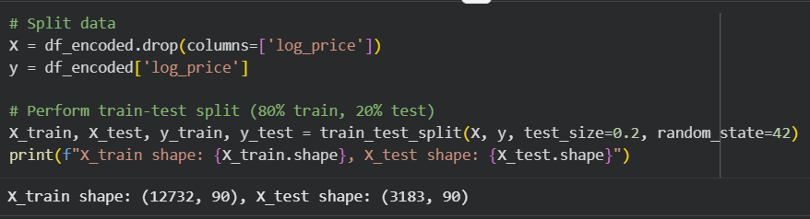

2.4.5 [2 marks]
Scale the features.
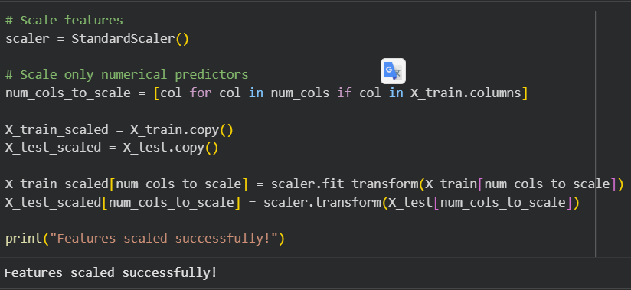

3 Linear Regression Models [35 marks]

3.1 Baseline Linear Regression Model [10 marks]

3.1.1 [5 marks]
Build and fit a basic linear regression model. Perform evaluation using suitable metrics.
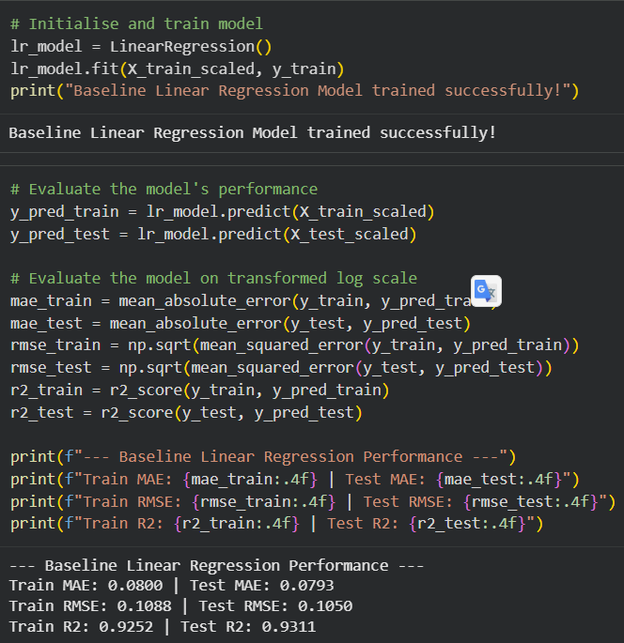

3.1.2 [5 marks]
Analyze residuals and check other assumptions of linear regression.
Check for linearity by analyzing residuals vs predicted values
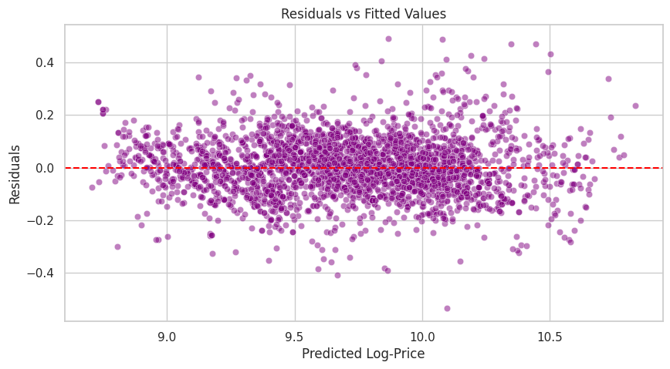
Check normality in residual distribution
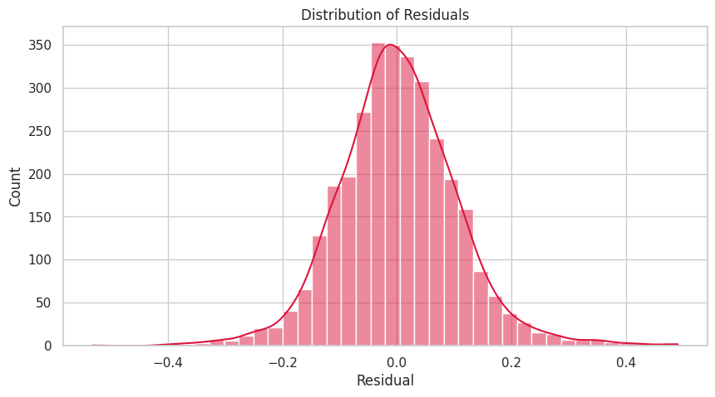
Check multicollinearity using Variance Inflation Factor (VIF) and handle features with high VIF.
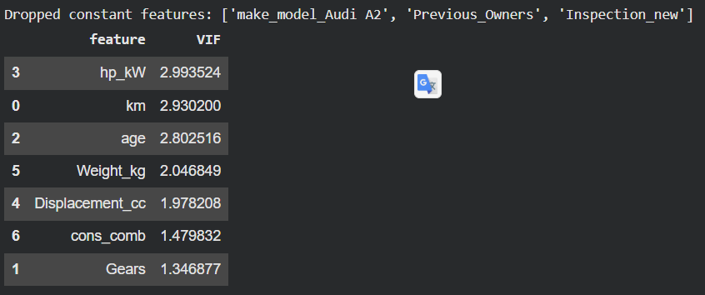

3.2 Ridge Regression Implementation [10 marks]

3.2.1 [2 marks]
Define a list of random alpha values
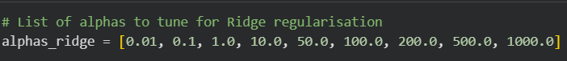

3.2.2 [4 marks]
Apply Ridge Regularization and find the best value of alpha from the list
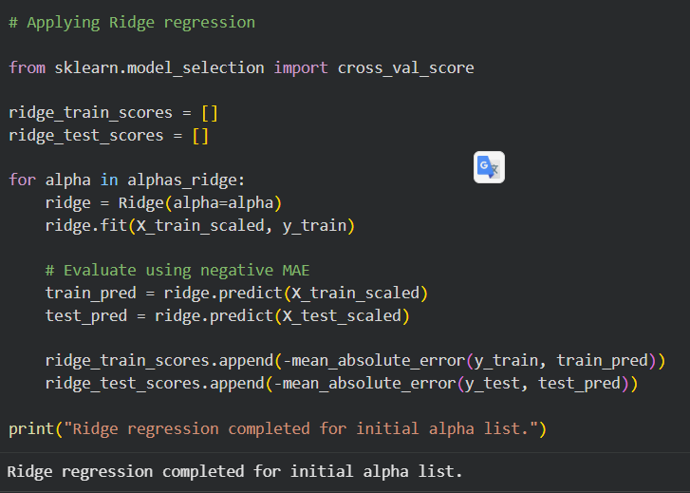
# Plot train and test scores against alpha
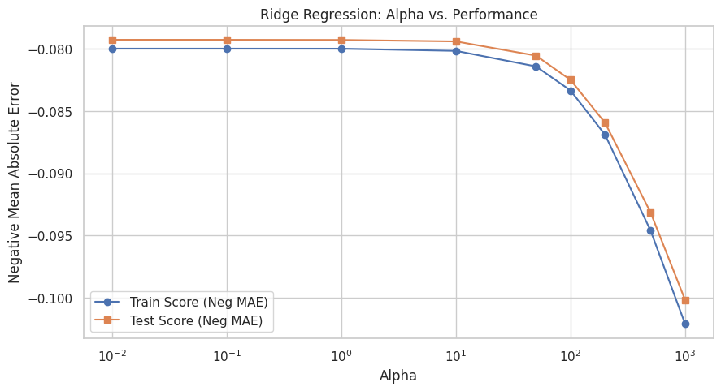
Find the best alpha value.
Best alpha value: 0.01
Best score (negative MAE): -0.0793
We will get some of the best value of alpha above. This, however, is not the most accurate value but the best value from the given list. Now we have a rough estimate of the range that best alpha falls in. Let us do another iteration over the values in a smaller range.

3.2.3 [4 marks]
Fine tune by taking a closer range of alpha based on the previous result.
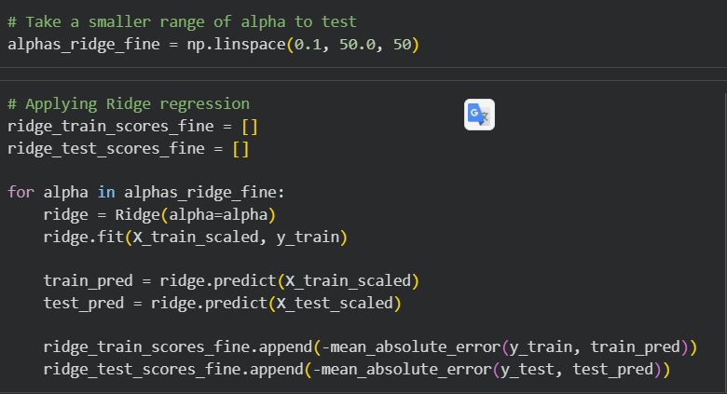

Plot the error-alpha graph again and find the actual optimal value for alpha.
Best alpha value: 0.1
Best score (negative MAE): -0.0793
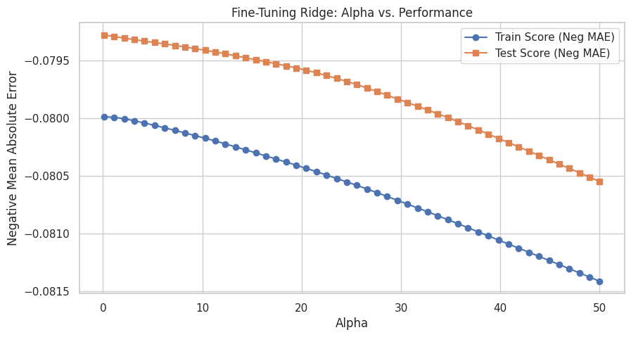

Ridge Regression Performance (alpha=0.10)
MAE: 0.0793
RMSE: 0.1050
R2 Score: 0.9311

3.3 Lasso Regression Implementation [10 marks]

3.3.1 [2 marks]
Define a list of random alpha values
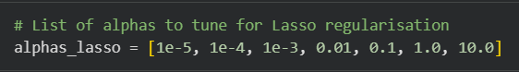

3.3.2 [4 marks]
Apply Ridge Regularisation and find the best value of alpha from the list
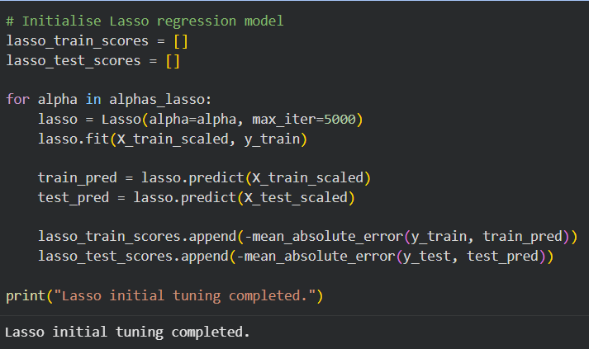
# Plot train and test scores against alpha
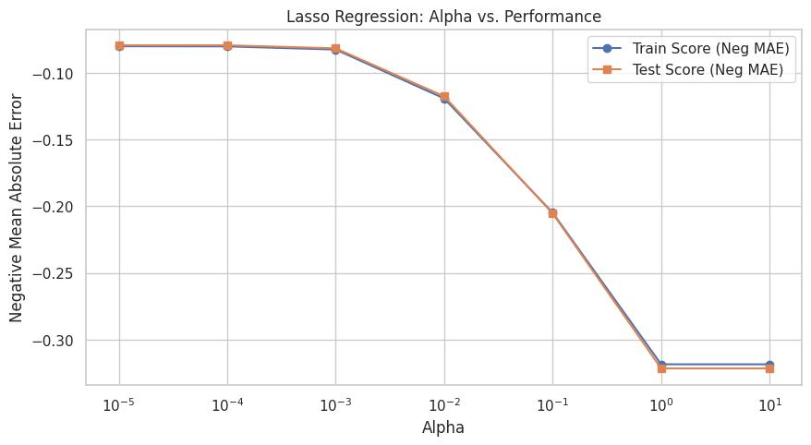 Best alpha value: 1e-05
Best score (negative MAE): -0.0793

3.3.3 [4 marks]
Fine tune by taking a closer range of alpha based on the previous result.

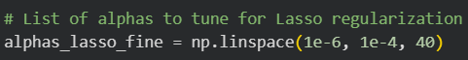
Plot train and test scores against alpha
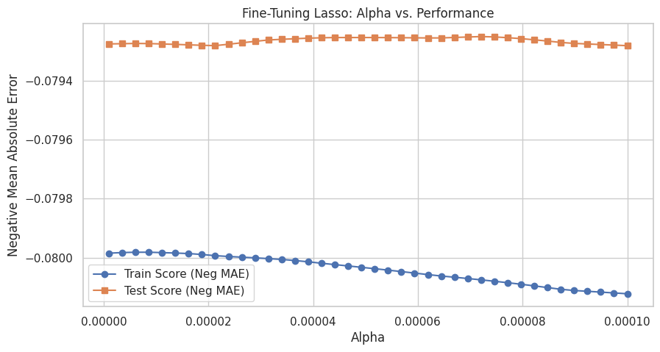
Best fine-tuned alpha value: 7.207692307692308e-05
Best score (negative MAE): -0.0792
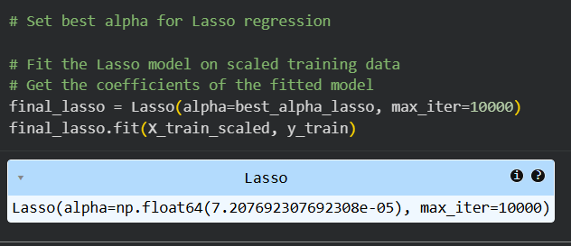
Lasso Regression Performance (alpha=0.000072)
MAE: 0.0792
RMSE: 0.1047
R2 Score: 0.9314

3.4 Regularisation Comparison & Analysis [5 marks]

3.4.1 [2 marks]
Compare the evaluation metrics for each model.

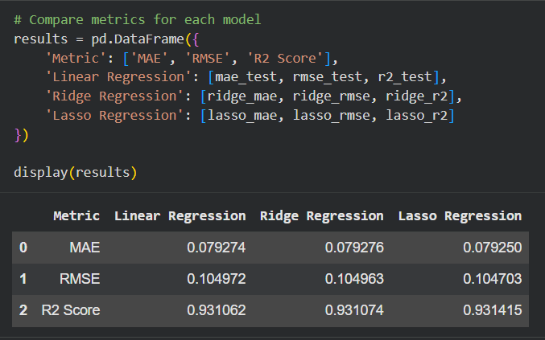

3.4.2 [3 marks]
Compare the coefficients for the three models.
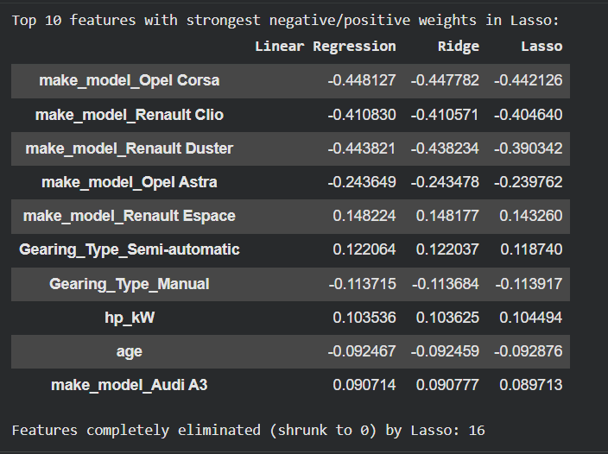

4 Conclusion & Key Takeaways [10 marks]

Conclusion & Answers to Key Analytical Questions
1. Did regularisation improve the model performance?
Yes, regularisation yielded slight improvements while substantially improving model simplicity:
- Baseline Linear Regression: R² = 0.9311, RMSE = 0.1050, MAE = 0.0793
- Ridge Regression (alpha = 0.10): R² = 0.9311, RMSE = 0.1050, MAE = 0.0793
- Lasso Regression (alpha ≈ 0.000072): R² = 0.9314, RMSE = 0.1047, MAE = 0.0792

2. Did you find out overfitting or not?
No overfitting was observed. The baseline model's training score (R² = 0.9252) is very close to the test score (R² = 0.9311), confirming solid generalization capability.
3. What was the impact of Lasso Regularization?
Lasso successfully performed feature selection by shrinking 16 redundant feature coefficients to exactly zero, simplifying the model without sacrificing predictive power.
4. Was the data sufficient, and is a linear model sufficient?
- Data Sufficiency: Yes, 15,915 records provided sufficient sample size to produce stable coefficients.
- Model Sufficiency: A linear model is highly sufficient (R² ≈ 0.931) once the right-skewed target is transformed via log1p.

4.1 Conclude with outcomes and insights gained [10 marks]
Detailed Outcomes & Analytical Insights

1. Predictive Performance & Model Quality
Our regression models achieved exceptional prediction accuracy on unseen validation data, explaining over 93.1% of the variance in car prices:
- High Fit Quality: The test ~0.931 (Baseline: 0.9311, Ridge: 0.9311, Lasso: 0.9314). This demonstrates that the engineered predictors capture the underlying price determinants remarkably well.
- Low Forecast Errors: The average test MAE of ~0.0793 on the log-scale corresponds to an average error of approximately ~8% in original currency terms, providing a highly dependable valuation engine for the reseller.

2. Impact of Target Transformation
- The Challenge: The original raw target variable price exhibited severe positive skewness, which violates the normality and homoscedasticity assumptions of linear regression.
- The Solution: Applying a natural log-transformation (log_price = np.log1p(price)) stabilized the variance. Post-transformation residuals show a symmetric, bell-shaped distribution centered at zero with no severe heteroscedasticity across predicted price bands.

3. Regularisation & Feature Sparsity (Lasso vs. Ridge)
- Lasso Regression ( proved to be the most practical model for deployment. At an optimal penalty of , it drove 16 non-contributing/redundant feature weights to zero, reducing model complexity and inference overhead.
- This sparsity was attained without any degradation in predictive capability; Lasso achieved the best overall performance with Test and Test RMSE = 0.1047.

4. Core Business Insights for the Reseller
- Vehicle Age & Mileage: Depreciation is primarily governed by vehicle age (age) and cumulative mileage (km), both of which display strong negative coefficients.
- Engine Power (hp_kW): Engine output is the single most influential positive continuous driver of market value; high-kilowatt variants retain a substantial premium.
- Transmission Selection: Transmission significantly shifts valuation. Standard manual gearboxes (Gearing_Type_Manual) carry negative weights relative to automated options, with semi-automatic and automatic gearboxes capturing positive pricing premiums.
- Brand & Model Hierarchy: Brand tier dummy variables heavily dictate base resale value (e.g., Renault Clio and Opel Corsa carry large negative base adjustments relative to premium segments like Audi A3), giving the reseller a data-driven guide for margin setting and auction bidding.

