CHAPTER 1
Introduction

Practice Questions

Problem 1.1.
What is the difference between a long forward position and a short forward position?

When a trader enters into a long forward contract, she is agreeing to buy the underlying asset for a certain price at a certain time in the future. When a trader enters into a short forward contract, she is agreeing to sell the underlying asset for a certain price at a certain time in
the future.
Problem 1.2.
Explain carefully the difference between hedging, speculation, and arbitrage.
A trader is hedging when she has an exposure to the price of an asset and takes a position in a derivative to offset the exposure. In a speculation the trader has no exposure to offset. She is betting on the future movements in the price of the asset. Arbitrage involves taking a position in two or more different markets to lock in a profit.
Problem 1.3.
What is the difference between entering into a long forward contract when the forward price is $50 and taking a long position in a call option with a strike price of $50?
In the first case the trader is obligated to buy the asset for $50. (The trader does not have a choice.) In the second case the trader has an option to buy the asset for $50. (The trader does not have to exercise the option.)
Problem 1.4.
Explain carefully the difference between selling a call option and buying a put option.
Selling a call option involves giving someone else the right to buy an asset from you. It gives you a payoff of
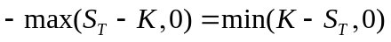
Buying a put option involves buying an option from someone else. It gives a payoff of
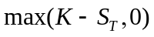
In both cases the potential payoff is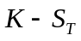. When you write a call option, the payoff is negative or zero. (This is because the counterparty chooses whether to exercise.) When you buy a put option, the payoff is zero or positive. (This is because you choose whether to exercise.)
Problem 1.5.
An investor enters into a short forward contract to sell 100,000 British pounds for US dollars at an exchange rate of 1.5000 US dollars per pound. How much does the investor gain or lose if the exchange rate at the end of the contract is (a) 1.4900 and (b) 1.5200?
- The investor is obligated to sell pounds for 1.5000 when they are worth 1.4900. The gain is (1.5000−1.4900) ×100,000 = $1,000.

- The investor is obligated to sell pounds for 1.5000 when they are worth 1.5200. The loss is (1.5200−1.5000)×100,000 = $2,000
Problem 1.6.
A trader enters into a short cotton futures contract when the futures price is 50 cents per pound. The contract is for the delivery of 50,000 pounds. How much does the trader gain or lose if the cotton price at the end of the contract is (a) 48.20 cents per pound; (b) 51.30 cents per pound?
- The trader sells for 50 cents per pound something that is worth 48.20 cents per pound. Gain .

- The trader sells for 50 cents per pound something that is worth 51.30 cents per pound. Loss .
Problem 1.7.
Suppose that you write a put contract with a strike price of $40 and an expiration date in three months. The current stock price is $41 and the contract is on 100 shares. What have you committed yourself to? How much could you gain or lose?
You have sold a put option. You have agreed to buy 100 shares for $40 per share if the party on the other side of the contract chooses to exercise the right to sell for this price. The option will be exercised only when the price of stock is below $40. Suppose, for example, that the option is exercised when the price is $30. You have to buy at $40 shares that are worth $30; you lose $10 per share, or $1,000 in total. If the option is exercised when the price is $20, you lose $20 per share, or $2,000 in total. The worst that can happen is that the price of the stock declines to almost zero during the three-month period. This highly unlikely event would cost you $4,000. In return for the possible future losses, you receive the price of the option from the purchaser.
Problem 1.8.
What is the difference between the over-the-counter market and the exchange-traded market? What are the bid and offer quotes of a market maker in the over-the-counter market?
The over-the-counter market is a telephone- and computer-linked network of financial institutions, fund managers, and corporate treasurers where two participants can enter into any mutually acceptable contract. An exchange-traded market is a market organized by an exchange where the contracts that can be traded have been defined by the exchange. When a market maker quotes a bid and an offer, the bid is the price at which the market maker is prepared to buy and the offer is the price at which the market maker is prepared to sell.
Problem 1.9.
You would like to speculate on a rise in the price of a certain stock. The current stock price is $29, and a three-month call with a strike of $30 costs $2.90. You have $5,800 to invest. Identify two alternative strategies, one involving an investment in the stock and the other involving investment in the option. What are the potential gains and losses from each?
One strategy would be to buy 200 shares. Another would be to buy 2,000 options. If the share price does well the second strategy will give rise to greater gains. For example, if the share price goes up to $40 you gain from the second strategy and only 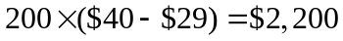 from the first strategy. However, if the share price does badly, the second strategy gives greater losses. For example, if the share price goes down to $25, the first strategy leads to a loss of 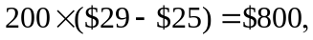 whereas the second strategy leads to a loss of the whole $5,800 investment. This example shows that options contain built in leverage.

Problem 1.10.
Suppose you own 5,000 shares that are worth $25 each. How can put options be used to provide you with insurance against a decline in the value of your holding over the next four months?
You could buy 50 put option contracts (each on 100 shares) with a strike price of $25 and an expiration date in four months. If at the end of four months the stock price proves to be less than $25, you can exercise the options and sell the shares for $25 each.
Problem 1.11.
When first issued, a stock provides funds for a company. Is the same true of an exchange-traded stock option? Discuss.
An exchange-traded stock option provides no funds for the company. It is a security sold by one investor to another. The company is not involved. By contrast, a stock when it is first issued is sold by the company to investors and does provide funds for the company.
Problem 1.12.
Explain why a futures contract can be used for either speculation or hedging.
If an investor has an exposure to the price of an asset, he or she can hedge with futures contracts. If the investor will gain when the price decreases and lose when the price increases, a long futures position will hedge the risk. If the investor will lose when the price decreases and gain when the price increases, a short futures position will hedge the risk. Thus either a long or a short futures position can be entered into for hedging purposes.
If the investor has no exposure to the price of the underlying asset, entering into a futures contract is speculation. If the investor takes a long position, he or she gains when the asset’s price increases and loses when it decreases. If the investor takes a short position, he or she loses when the asset’s price increases and gains when it decreases.
Problem 1.13.
Suppose that a March call option to buy a share for $50 costs $2.50 and is held until March. Under what circumstances will the holder of the option make a profit? Under what circumstances will the option be exercised? Draw a diagram showing how the profit on a long position in the option depends on the stock price at the maturity of the option.
The holder of the option will gain if the price of the stock is above $52.50 in March. (This ignores the time value of money.) The option will be exercised if the price of the stock is above $50.00 in March. The profit as a function of the stock price is shown in Figure S1.1.

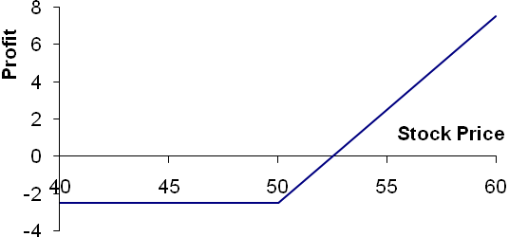

Figure S1.1: Profit from long position in Problem 1.13

Problem 1.14.
Suppose that a June put option to sell a share for $60 costs $4 and is held until June. Under what circumstances will the seller of the option (i.e., the party with a short position) make a profit? Under what circumstances will the option be exercised? Draw a diagram showing how the profit from a short position in the option depends on the stock price at the maturity of the option.
The seller of the option will lose money if the price of the stock is below $56.00 in June. (This ignores the time value of money.) The option will be exercised if the price of the stock is below $60.00 in June. The profit as a function of the stock price is shown in Figure S1.2.

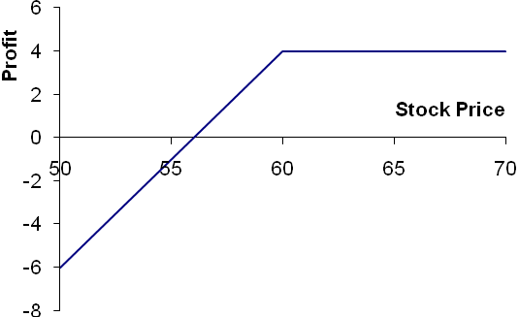

Figure S1.2: Profit from short position in Problem 1.14
Problem 1.15.
It is May and a trader writes a September call option with a strike price of $20. The stock price is $18, and the option price is $2. Describe the investor’s cash flows if the option is held until September and the stock price is $25 at this time.
The trader has an inflow of $2 in May and an outflow of $5 in September. The $2 is the cash received from the sale of the option. The $5 is the result of the option being exercised. The investor has to buy the stock for $25 in September and sell it to the purchaser of the option for $20.
Problem 1.16.
A trader writes a December put option with a strike price of $30. The price of the option is $4. Under what circumstances does the trader make a gain?
The trader makes a gain if the price of the stock is above $26 at the time of exercise. (This ignores the time value of money.)
Problem 1.17.
A company knows that it is due to receive a certain amount of a foreign currency in four months. What type of option contract is appropriate for hedging?
A long position in a four-month put option can provide insurance against the exchange rate falling below the strike price. It ensures that the foreign currency can be sold for at least the strike price.
Problem 1.18.
A US company expects to have to pay 1 million Canadian dollars in six months. Explain how the exchange rate risk can be hedged using (a) a forward contract and (b) an option.
The company could enter into a long forward contract to buy 1 million Canadian dollars in six months. This would have the effect of locking in an exchange rate equal to the current forward exchange rate. Alternatively the company could buy a call option giving it the right (but not the obligation) to purchase 1 million Canadian dollars at a certain exchange rate in six months. This would provide insurance against a strong Canadian dollar in six months while still allowing the company to benefit from a weak Canadian dollar at that time.

Problem 1.19.
A trader enters into a short forward contract on 100 million yen. The forward exchange rate is $0.0090 per yen. How much does the trader gain or lose if the exchange rate at the end of the contract is (a) $0.0084 per yen; (b) $0.0101 per yen?
- The trader sells 100 million yen for $0.0090 per yen when the exchange rate is $0.0084 per yen. The gain is 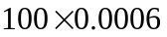 millions of dollars or $60,000.
- The trader sells 100 million yen for $0.0090 per yen when the exchange rate is $0.0101 per yen. The loss is 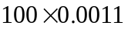 millions of dollars or $110,000.
Problem 1.20.
The CME Group offers a futures contract on long-term Treasury bonds. Characterize the investors likely to use this contract.
Most investors will use the contract because they want to do one of the following:
- Hedge an exposure to long-term interest rates.
- Speculate on the future direction of long-term interest rates.
- Arbitrage between the spot and futures markets for Treasury bonds.
This contract is discussed in Chapter 6.
Problem 1.21.
“Options and futures are zero-sum games.” What do you think is meant by this statement?
The statement means that the gain (loss) to the party with the short position is equal to the loss (gain) to the party with the long position. In aggregate, the net gain to all parties is zero.
Problem 1.22.
Describe the profit from the following portfolio: a long forward contract on an asset and a long European put option on the asset with the same maturity as the forward contract and a strike price that is equal to the forward price of the asset at the time the portfolio is set up.
The terminal value of the long forward contract is:
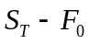
where 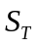 is the price of the asset at maturity and 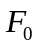 is the delivery price, which is the same as the forward price of the asset at the time the portfolio is set up). The terminal value of the put option is:
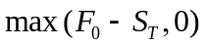
The terminal value of the portfolio is therefore
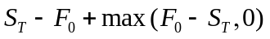
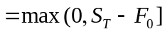
This is the same as the terminal value of a European call option with the same maturity as the forward contract and a strike price equal to. This result is illustrated in the Figure S1.3. The profit equals the terminal value of the call option less the amount paid for the put option. (It does not cost anything to enter into the forward contract.

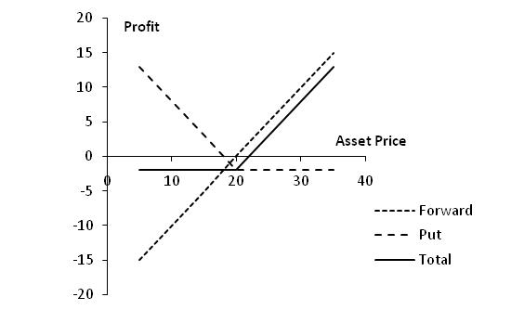
Figure S1.3: Profit from portfolio in Problem 1.22

Problem 1.23.
In the 1980s, Bankers Trust developed index currency option notes (ICONs). These are bonds in which the amount received by the holder at maturity varies with a foreign exchange rate. One example was its trade with the Long Term Credit Bank of Japan. The ICON specified that if the yen–U.S. dollar exchange rate,, is greater than 169 yen per dollar at maturity (in 1995), the holder of the bond receives $1,000. If it is less than 169 yen per dollar, the amount received by the holder of the bond is
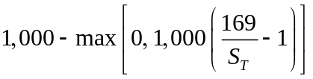
When the exchange rate is below 84.5, nothing is received by the holder at maturity. Show that this ICON is a combination of a regular bond and two options.
Suppose that the yen exchange rate (yen per dollar) at maturity of the ICON is. The payoff from the ICON is

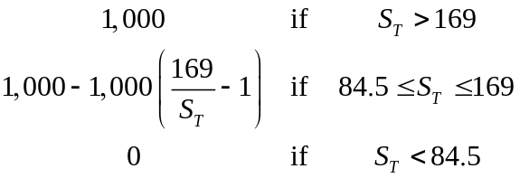

When 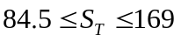 the payoff can be written
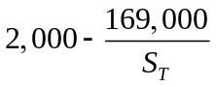

The payoff from an ICON is the payoff from:
(a) A regular bond
(b) A short position in call options to buy 169,000 yen with an exercise price of 1/169
(c) A long position in call options to buy 169,000 yen with an exercise price of 1/84.5
This is demonstrated by the following table, which shows the terminal value of the various components of the position

 | Bond | Short Calls | Long Calls | Whole position
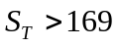 | 1000 | 0 | 0 | 1000
 | 1000 | 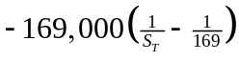 | 0 | 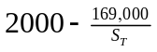
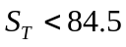 | 1000 |  | 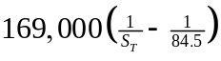 | 0

Problem 1.24.
On July 1, 2011, a company enters into a forward contract to buy 10 million Japanese yen on January 1, 2012. On September 1, 2011, it enters into a forward contract to sell 10 million Japanese yen on January 1, 2012. Describe the payoff from this strategy.
Suppose that the forward price for the contract entered into on July 1, 2011 is 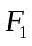 and that the forward price for the contract entered into on September 1, 2011 is 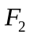 with both and being measured as dollars per yen. If the value of one Japanese yen (measured in US dollars) is on January 1, 2012, then the value of the first contract (in millions of dollars) at that time is
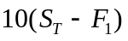
while the value of the second contract at that time is:
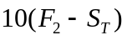
The total payoff from the two contracts is therefore
Thus if the forward price for delivery on January 1, 2012 increased between July 1, 2011 and September 1, 2011 the company will make a profit. (Note that the yen/USD exchange rate is usually expressed as the number of yen per USD not as the number of USD per yen)

Problem 1.25.
Suppose that USD-sterling spot and forward exchange rates are as follows:

Spot | 1.5580
90-day forward | 1.5556
180-day forward | 1.5518

What opportunities are open to an arbitrageur in the following situations?
- A 180-day European call option to buy £1 for $1.52 costs 2 cents.
- A 90-day European put option to sell £1 for $1.59 costs 2 cents.
Note that there is a typo in the problem in the book. 1.42 and 1.49 should be 1.52 and 1.59 in the last two lines of the problem s
- The arbitrageur buys a 180-day call option and takes a short position in a 180-day forward contract. If is the terminal spot rate, the profit from the call option is
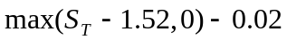
The profit from the short forward contract is
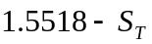

The profit from the strategy is therefore

or
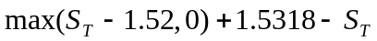

This is
1.5318−S_{T} when S_{T} <1.52
0.0118 when S_{T} >1.52

This shows that the profit is always positive. The time value of money has been ignored in these calculations. However, when it is taken into account the strategy is still likely to be profitable in all circumstances. (We would require an extremely high interest rate for $0.0118 interest to be required on an outlay of $0.02 over a 180-day period.)

- The trader buys 90-day put options and takes a long position in a 90 day forward contract. If is the terminal spot rate, the profit from the put option is
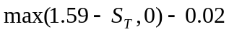
The profit from the long forward contract is
S_{T}−1.5556
The profit from this strategy is therefore
or
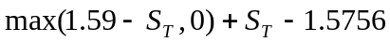
This is
S_{T} −1.5756 when S_{T} >1.59
0.0144 when S_{T} <1.59

The profit is therefore always positive. Again, the time value of money has been ignored but is unlikely to affect the overall profitability of the strategy. (We would require interest rates to be extremely high for $0.0144 interest to be required on an outlay of $0.02 over a 90-day period.)

Problem 1.26.
A trader buys a call option with a strike price of $30 for $3. Does the trader ever exercise the option and lose money on the trade. Explain.

If the stock price is between $30 and $33 at option maturity the trader will exercise the option, but lose money on the trade. Consider the situation where the stock price is $31. If the trader exercises, she loses $2 on the trade. If she does not exercise she loses $3 on the trade. It is clearly better to exercise than not exercise.

Problem 1.27.
A trader sells a put option with a strike price of $40 for $5. What is the trader's maximum gain and maximum loss? How does your answer change if it is a call option?

The trader’s maximum gain from the put option is $5. The maximum loss is $35, corresponding to the situation where the option is exercised and the price of the underlying asset is zero. If the option were a call, the trader’s maximum gain would still be $5, but there would be no bound to the loss as there is in theory no limit to how high the asset price could rise.

Problem 1.28.
``Buying a put option on a stock when the stock is owned is a form of insurance.'' Explain this statement.

If the stock price declines below the strike price of the put option, the stock can be sold for the strike price.

Further Questions

Problem 1.29.
On May 8, 2013, as indicated in Table 1.2, the spot offer price of Google stock is $871.37
and the offer price of a call option with a strike price of $880 and a maturity date of
September is $41.60. A trader is considering two alternatives: buy 100 shares of the stock
and buy 100 September call options. For each alternative, what is (a) the upfront cost, (b)
the total gain if the stock price in September is $950, and (c) the total loss if the stock
price in September is $800. Assume that the option is not exercised before September and
if stock is purchased it is sold in September.

- The upfront cost for the stock alternative is $87,137. The upfront cost for the option alternative is $4,160.
- The gain from the stock alternative is $95,000−$87,137=$7,863. The total gain from the option alternative is ($950-$880)×100−$4,160=$2,840.
- The loss from the stock alternative is $87,137−$80,000=$7,137. The loss from the option alternative is $4,160.

Problem 1.30.
What is arbitrage? Explain the arbitrage opportunity when the price of a dually listed
mining company stock is $50 (USD) on the New York Stock Exchange and $52 (CAD) on the Toronto Stock Exchange. Assume that the exchange rate is such that 1 USD equals 1.01 CAD. Explain what is likely to happen to prices as traders take advantage of this opportunity.

Arbitrage involves carrying out two or more different trades to lock in a profit. In this case, traders can buy shares on the NYSE and sell them on the TSX to lock in a USD profit of 52/1.01−50=1.485 per share. As they do this the NYSE price will rise and the TSX price will fall so that the arbitrage opportunity disappears

Problem 1.31 (Excel file)
Trader A enters into a forward contract to buy an asset for $1000 in one year. Trader B buys a call option to buy the asset for $1000 in one year. The cost of the option is $100. What is the difference between the positions of the traders? Show the profit as a function of the price of the asset in one year for the two traders.

Trader A makes a profit of S_{T} ̶ 1000 and Trader B makes a profit of max (S_{T} ̶ 1000, 0) –100 where S_{T} is the price of the asset in one year. Trader A does better if S_{T} is above $900 as indicated in Figure S1.4.

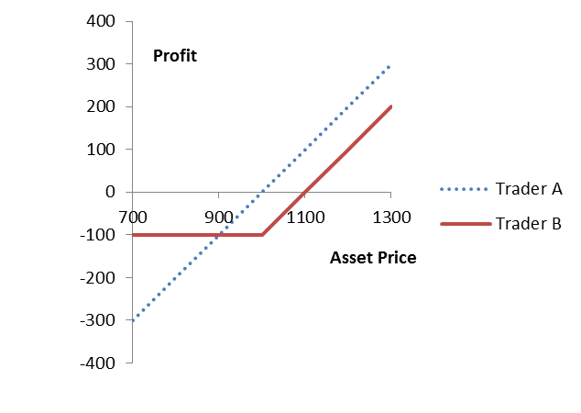

Figure S1.4: Profit to Trader A and Trader B in Problem 1.31

Problem 1.32.
In March, a US investor instructs a broker to sell one July put option contract on a stock. The stock price is $42 and the strike price is $40. The option price is $3. Explain what the investor has agreed to. Under what circumstances will the trade prove to be profitable? What are the risks?

The investor has agreed to buy 100 shares of the stock for $40 in July (or earlier) if the party on the other side of the transaction chooses to sell. The trade will prove profitable if the option is not exercised or if the stock price is above $37 at the time of exercise. The risk to the investor is that the stock price plunges to a low level. For example, if the stock price drops to $1 by July , the investor loses $3,600. This is because the put options are exercised and $40 is paid for 100 shares when the value per share is $1. This leads to a loss of $3,900 which is only a little offset by the premium of $300 received for the options.

Problem 1.33.
A US company knows it will have to pay 3 million euros in three months. The current exchange rate is 1.3500 dollars per euro. Discuss how forward and options contracts can be used by the company to hedge its exposure.

The company could enter into a forward contract obligating it to buy 3 million euros in three months for a fixed price (the forward price). The forward price will be close to but not exactly the same as the current spot price of 1.3500. An alternative would be to buy a call option giving the company the right but not the obligation to buy 3 million euros for a particular exchange rate (the strike price) in three months. The use of a forward contract locks in, at no cost, the exchange rate that will apply in three months. The use of a call option provides, at a cost, insurance against the exchange rate being higher than the strike price.

Problem 1.34. (Excel file)
A stock price is $29. An investor buys one call option contract on the stock with a strike price of $30 and sells a call option contract on the stock with a strike price of $32.50. The market prices of the options are $2.75 and $1.50, respectively. The options have the same maturity date. Describe the investor's position.

This is known as a bull spread (see Chapter 12). The profit is shown in Figure S1.5.
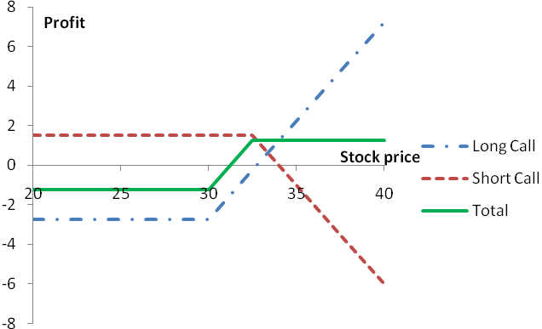
Figure S1.5: Profit in Problem 1.34

Problem 1.35.
The price of gold is currently $1,400 per ounce. The forward price for delivery in one year is $1,500. An arbitrageur can borrow money at 4% per annum. What should the arbitrageur do? Assume that the cost of storing gold is zero and that gold provides no income.
The arbitrageur should borrow money to buy a certain number of ounces of gold today and short forward contracts on the same number of ounces of gold for delivery in one year. This means that gold is purchased for $1,400 per ounce and sold for $1,500 per ounce. Interest on the borrowed funds will be 0.04×$1400 or $56 per ounce. A profit of $44 per ounce will therefore be made.
Problem 1.36.
The current price of a stock is $94, and three-month call options with a strike price of $95 currently sell for $4.70. An investor who feels that the price of the stock will increase is trying to decide between buying 100 shares and buying 2,000 call options (20 contracts). Both strategies involve an investment of $9,400. What advice would you give? How high does the stock price have to rise for the option strategy to be more profitable?
The investment in call options entails higher risks but can lead to higher returns. If the stock price stays at $94, an investor who buys call options loses $9,400 whereas an investor who buys shares neither gains nor loses anything. If the stock price rises to $120, the investor who buys call options gains
An investor who buys shares gains
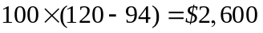
The strategies are equally profitable if the stock price rises to a level, S, where
or
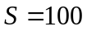
The option strategy is therefore more profitable if the stock price rises above $100.

Problem 1.37.
On May 8, 2013, an investor owns 100 Google shares. As indicated in Table 1.3, the share price is about $871 and a December put option with a strike price $820 costs $37.50. The investor is comparing two alternatives to limit downside risk. The first involves buying one December put option contract with a strike price of $820. The second involves instructing a broker to sell the 100 shares as soon as Google’s price reaches $820. Discuss the advantages and disadvantages of the two strategies.

The second alternative involves what is known as a stop or stop-loss order. It costs nothing and ensures that $82,000, or close to $82,000, is realized for the holding in the event the stock price ever falls to $820. The put option costs $3,750 and guarantees that the holding can be sold for $8,200 any time up to December. If the stock price falls marginally below $820 and then rises the option will not be exercised, but the stop-loss order will lead to the holding being liquidated. There are some circumstances where the put option alternative leads to a better outcome and some circumstances where the stop-loss order leads to a better outcome. If the stock price ends up below $820, the stop-loss order alternative leads to a better outcome because the cost of the option is avoided. If the stock price falls to $800 in November and then rises to $850 by December, the put option alternative leads to a better outcome. The investor is paying $3,750 for the chance to benefit from this second type of outcome.
Problem 1.38.
A bond issued by Standard Oil some time ago worked as follows. The holder received no interest. At the bond’s maturity the company promised to pay $1,000 plus an additional amount based on the price of oil at that time. The additional amount was equal to the product of 170 and the excess (if any) of the price of a barrel of oil at maturity over $25. The maximum additional amount paid was $2,550 (which corresponds to a price of $40 per barrel). Show that the bond is a combination of a regular bond, a long position in call options on oil with a strike price of $25, and a short position in call options on oil with a strike price of $40.
Suppose is the price of oil at the bond’s maturity. In addition to $1000 the Standard Oil bond pays:
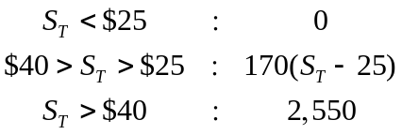

This is the payoff from 170 call options on oil with a strike price of 25 less the payoff from 170 call options on oil with a strike price of 40. The bond is therefore equivalent to a regular bond plus a long position in 170 call options on oil with a strike price of $25 plus a short position in 170 call options on oil with a strike price of $40. The investor has what is termed a bull spread on oil. This is discussed in Chapter 12.

Problem 1.39.
Suppose that in the situation of Table 1.1 a corporate treasurer said: “I will have £1 million to sell in six months. If the exchange rate is less than 1.52, I want you to give me 1.52. If it is greater than 1.58 I will accept 1.58. If the exchange rate is between 1.52 and 1.58, I will sell the sterling for the exchange rate.” How could you use options to satisfy the treasurer?
You sell the treasurer a put option on GBP with a strike price of 1.52 and buy from the treasurer a call option on GBP with a strike price of 1.58. Both options are on one million pounds and have a maturity of six months. This is known as a range forward contract and is discussed in Chapter 17.
Problem 1.40.
Describe how foreign currency options can be used for hedging in the situation considered in Section 1.7 so that (a) ImportCo is guaranteed that its exchange rate will be less than 1.5700, and (b) ExportCo is guaranteed that its exchange rate will be at least 1.5300. Use DerivaGem to calculate the cost of setting up the hedge in each case assuming that the exchange rate volatility is 12%, interest rates in the United States are 5% and interest rates in Britain are 5.7%. Assume that the current exchange rate is the average of the bid and offer in Table 1.1.
ImportCo should buy three-month call options on $10 million with a strike price of 1.5700. ExportCo should buy three-month put options on $10 million with a strike price of 1.5300. In this case the spot foreign exchange rate is 1.5543 (the average of the bid and offer quotes in Table 1.1.), the (domestic) risk-free rate is 5%, the foreign risk-free rate is 5.7%, the volatility is 12%, and the time to exercise is 0.25 years. Using the Equity_FX_Index_Futures_Options worksheet in the DerivaGem Options Calculator select Currency as the underlying and Black-Scholes European as the option type. The software shows that a call with a strike price of 1.57 is worth 0.0285 and a put with a strike of 1.53 is worth 0.0267. This means that the hedging would cost 0.0285×10,000,000 or $285,000 for ImportCo and 0.0267×30,000,000 or about$801,000 for ExportCo.
Problem 1.41.
A trader buys a European call option and sells a European put option. The options have the same underlying asset, strike price and maturity. Describe the trader’s position. Under what circumstances does the price of the call equal the price of the put?

The trader has a long European call option with strike price  and a short European put option with strike price. Suppose the price of the underlying asset at the maturity of the option is. If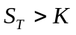, the call option is exercised by the investor and the put option expires worthless. The payoff from the portfolio is then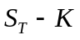. If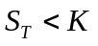, the call option expires worthless and the put option is exercised against the investor. The cost to the investor is. Alternatively we can say that the payoff to the investor in this case is (a negative amount). In all cases, the payoff is , the same as the payoff from the forward contract. The trader’s position is equivalent to a forward contract with delivery price.

Suppose thatis the forward price. If 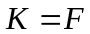, the forward contract that is created has zero value. Because the forward contract is equivalent to a long call and a short put, this shows that the price of a call equals the price of a put when the strike price is F.

