CHAPTER 3
Hedging Strategies Using Futures

Practice Questions

Problem 3.1.
Under what circumstances are (a) a short hedge and (b) a long hedge appropriate?
A short hedge is appropriate when a company owns an asset and expects to sell that asset in the future. It can also be used when the company does not currently own the asset but expects to do so at some time in the future. A long hedge is appropriate when a company knows it will have to purchase an asset in the future. It can also be used to offset the risk from an existing short position.
Problem 3.2.
Explain what is meant by basis risk when futures contracts are used for hedging.
Basis risk arises from the hedger’s uncertainty as to the difference between the spot price and futures price at the expiration of the hedge.
Problem 3.3.
Explain what is meant by a perfect hedge. Does a perfect hedge always lead to a better outcome than an imperfect hedge? Explain your answer.
A perfect hedge is one that completely eliminates the hedger’s risk. A perfect hedge does not always lead to a better outcome than an imperfect hedge. It just leads to a more certain outcome.
Consider a company that hedges its exposure to the price of an asset. Suppose the asset’s price movements prove to be favorable to the company. A perfect hedge totally neutralizes the company’s gain from these favorable price movements. An imperfect hedge, which only partially neutralizes the gains, might well give a better outcome.
Problem 3.4.
Under what circumstances does a minimum-variance hedge portfolio lead to no hedging at all?
A minimum variance hedge leads to no hedging when the coefficient of correlation between the futures price changes and changes in the price of the asset being hedged is zero.
Problem 3.5.
Give three reasons why the treasurer of a company might not hedge the company’s exposure to a particular risk.
(a) If the company’s competitors are not hedging, the treasurer might feel that the company will experience less risk if it does not hedge. (See Table 3.1.) (b) The shareholders might not want the company to hedge because the risks are hedged within their portfolios. (c) If there is a loss on the hedge and a gain from the company’s exposure to the underlying asset, the treasurer might feel that he or she will have difficulty justifying the hedging to other executives within the organization.
Problem 3.6.
Suppose that the standard deviation of quarterly changes in the prices of a commodity is $0.65, the standard deviation of quarterly changes in a futures price on the commodity is $0.81, and the coefficient of correlation between the two changes is 0.8. What is the optimal hedge ratio for a three-month contract? What does it mean?
The optimal hedge ratio is
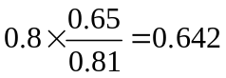
This means that the size of the futures position should be 64.2% of the size of the company’s exposure in a three-month hedge.

Problem 3.7.
A company has a $20 million portfolio with a beta of 1.2. It would like to use futures contracts on a stock index to hedge its risk. The index futures is currently standing at 1080, and each contract is for delivery of $250 times the index. What is the hedge that minimizes risk? What should the company do if it wants to reduce the beta of the portfolio to 0.6?
The formula for the number of contracts that should be shorted gives
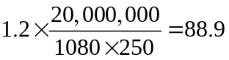
Rounding to the nearest whole number, 89 contracts should be shorted. To reduce the beta to 0.6, half of this position, or a short position in 44 contracts, is required.

Problem 3.8.
In the corn futures contract, the following delivery months are available: March, May, July, September, and December. State the contract that should be used for hedging when the expiration of the hedge is in a) June, b) July, and c) January
A good rule of thumb is to choose a futures contract that has a delivery month as close as possible to, but later than, the month containing the expiration of the hedge. The contracts that should be used are therefore
  - July
  - September
  - March
Problem 3.9.
Does a perfect hedge always succeed in locking in the current spot price of an asset for a future transaction? Explain your answer.
No. Consider, for example, the use of a forward contract to hedge a known cash inflow in a foreign currency. The forward contract locks in the forward exchange rate — which is in general different from the spot exchange rate.
Problem 3.10.
Explain why a short hedger’s position improves when the basis strengthens unexpectedly and worsens when the basis weakens unexpectedly.
The basis is the amount by which the spot price exceeds the futures price. A short hedger is long the asset and short futures contracts. The value of his or her position therefore improves as the basis increases. Similarly, it worsens as the basis decreases.
Problem 3.11.
Imagine you are the treasurer of a Japanese company exporting electronic equipment to the United States. Discuss how you would design a foreign exchange hedging strategy and the arguments you would use to sell the strategy to your fellow executives.
The simple answer to this question is that the treasurer should
- Estimate the company’s future cash flows in Japanese yen and U.S. dollars
- Enter into forward and futures contracts to lock in the exchange rate for the U.S. dollar cash flows.
However, this is not the whole story. As the gold jewelry example in Table 3.1 shows, the company should examine whether the magnitudes of the foreign cash flows depend on the exchange rate. For example, will the company be able to raise the price of its product in U.S. dollars if the yen appreciates? If the company can do so, its foreign exchange exposure may be quite low. The key estimates required are those showing the overall effect on the company’s profitability of changes in the exchange rate at various times in the future. Once these estimates have been produced the company can choose between using futures and options to hedge its risk. The results of the analysis should be presented carefully to other executives. It should be explained that a hedge does not ensure that profits will be higher. It means that profit will be more certain. When futures/forwards are used both the downside and upside are eliminated. With options a premium is paid to eliminate only the downside.

Problem 3.12.
Suppose that in Example 3.2 of Section 3.3 the company decides to use a hedge ratio of 0.8. How does the decision affect the way in which the hedge is implemented and the result?
If the hedge ratio is 0.8, the company takes a long position in 16 December oil futures contracts on June 8 when the futures price is $88.00. It closes out its position on November 10. The spot price and futures price at this time are $90.00 and $89.10. The gain on the futures position is
(89.10 − 88.00) × 16,000 = 17,600
The effective cost of the oil is therefore
20,000 × 90 – 17,600 = 1,782, 400
or $89.12 per barrel. (This compares with $88.90 per barrel when the company is fully hedged.)
Problem 3.13.
“If the minimum-variance hedge ratio is calculated as 1.0, the hedge must be perfect." Is this statement true? Explain your answer.
The statement is not true. The minimum variance hedge ratio is
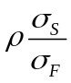
It is 1.0 when 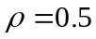 and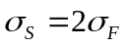. Since 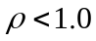 the hedge is clearly not perfect.

Problem 3.14.
“If there is no basis risk, the minimum variance hedge ratio is always 1.0." Is this statement true? Explain your answer.
The statement is true. Using the notation in the text, if the hedge ratio is 1.0, the hedger locks in a price of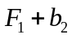. Since both 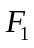 and 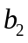 are known this has a variance of zero and must be the best hedge.
Problem 3.15
“For an asset where futures prices for contracts on the asset are usually less than spot prices, long hedges are likely to be particularly attractive." Explain this statement.
A company that knows it will purchase a commodity in the future is able to lock in a price close to the futures price. This is likely to be particularly attractive when the futures price is less than the spot price.
Problem 3.16.
The standard deviation of monthly changes in the spot price of live cattle is (in cents per pound) 1.2. The standard deviation of monthly changes in the futures price of live cattle for the closest contract is 1.4. The correlation between the futures price changes and the spot price changes is 0.7. It is now October 15. A beef producer is committed to purchasing 200,000 pounds of live cattle on November 15. The producer wants to use the December live-cattle futures contracts to hedge its risk. Each contract is for the delivery of 40,000 pounds of cattle. What strategy should the beef producer follow?
The optimal hedge ratio is
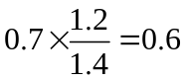
The beef producer requires a long position in 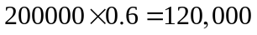 lbs of cattle. The beef producer should therefore take a long position in 3 December contracts closing out the position on November 15.
Problem 3.17.
A corn farmer argues “I do not use futures contracts for hedging. My real risk is not the price of corn. It is that my whole crop gets wiped out by the weather.”Discuss this viewpoint. Should the farmer estimate his or her expected production of corn and hedge to try to lock in a price for expected production?
If weather creates a significant uncertainty about the volume of corn that will be harvested, the farmer should not enter into short forward contracts to hedge the price risk on his or her expected production. The reason is as follows. Suppose that the weather is bad and the farmer’s production is lower than expected. Other farmers are likely to have been affected similarly. Corn production overall will be low and as a consequence the price of corn will be relatively high. The farmer’s problems arising from the bad harvest will be made worse by losses on the short futures position. This problem emphasizes the importance of looking at the big picture when hedging. The farmer is correct to question whether hedging price risk while ignoring other risks is a good strategy.

Problem 3.18.
On July 1, an investor holds 50,000 shares of a certain stock. The market price is $30 per share. The investor is interested in hedging against movements in the market over the next month and decides to use the September Mini S&P 500 futures contract. The index is currently 1,500 and one contract is for delivery of $50 times the index. The beta of the stock is 1.3. What strategy should the investor follow? Under what circumstances will it be profitable?
A short position in
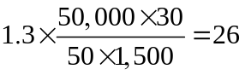
contracts is required. It will be profitable if the stock outperforms the market in the sense that its return is greater than that predicted by the capital asset pricing model.
Problem 3.19.
Suppose that in Table 3.5 the company decides to use a hedge ratio of 1.5. How does the decision affect the way the hedge is implemented and the result?
If the company uses a hedge ratio of 1.5 in Table 3.5 it would at each stage short 150 contracts. The gain from the futures contracts would be
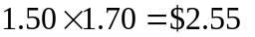
per barrel and the company would be $0.85 per barrel better off than with a hedge ratio of 1.
Problem 3.20.
A futures contract is used for hedging. Explain why the daily settlement of the contract can give rise to cash flow problems.
Suppose that you enter into a short futures contract to hedge the sale of an asset in six months. If the price of the asset rises sharply during the six months, the futures price will also rise and you may get margin calls. The margin calls will lead to cash outflows. Eventually the cash outflows will be offset by the extra amount you get when you sell the asset, but there is a mismatch in the timing of the cash outflows and inflows. Your cash outflows occur earlier than your cash inflows. A similar situation could arise if you used a long position in a futures contract to hedge the purchase of an asset at a future time and the asset’s price fell sharply. An extreme example of what we are talking about here is provided by Metallgesellschaft (see Business Snapshot 3.2).
Problem 3.21.
An airline executive has argued: “There is no point in our using oil futures. There is just as much chance that the price of oil in the future will be less than the futures price as there is that it will be greater than this price.” Discuss the executive’s viewpoint.
It may well be true that there is just as much chance that the price of oil in the future will be above the futures price as that it will be below the futures price. This means that the use of a futures contract for speculation would be like betting on whether a coin comes up heads or tails. But it might make sense for the airline to use futures for hedging rather than speculation. The futures contract then has the effect of reducing risks. It can be argued that an airline should not expose its shareholders to risks associated with the future price of oil when there are contracts available to hedge the risks.

Problem 3.22.
Suppose the one-year gold lease rate is 1.5% and the one-year risk-free rate is 5.0%. Both rates are compounded annually. Use the discussion in Business Snapshot 3.1 to calculate the maximum one-year forward price Goldman Sachs should quote for gold when the spot price is $1,200.
Goldman Sachs can borrow 1 ounce of gold and sell it for $1200. It invests the $1,200 at 5% so that it becomes $1,260 at the end of the year. It must pay the lease rate of 1.5% on $1,200. This is $18 and leaves it with $1,242. It follows that if it agrees to buy the gold for less than $1,242 in one year it will make a profit.

Problem 3.23.
The expected return on the S&P 500 is 12% and the risk-free rate is 5%. What is the expected return on the investment with a beta of (a) 0.2, (b) 0.5, and (c) 1.4?

- or 6.4%
- or 8.5%
- 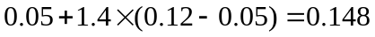 or 14.8%

Further Questions
Problem 3.24.
It is now June. A company knows that it will sell 5,000 barrels of crude oil in September.
It uses the October CME Group futures contract to hedge the price it will receive. Each contract is on 1,000 barrels of ‘‘light sweet crude.’’ What position should it take? What price risks is it still exposed to after taking the position?

It should short five contracts. It has basis risk. It is exposed to the difference between the October futures price and the spot price of light sweet crude at the time it closes out its position in September. It is also possibly exposed to the difference between the spot price of light sweet crude and the spot price of the type of oil it is selling.

Problem 3.25.
Sixty futures contracts are used to hedge an exposure to the price of silver. Each futures
contract is on 5,000 ounces of silver. At the time the hedge is closed out, the basis is $0.20
per ounce. What is the effect of the basis on the hedger’s financial position if (a) the trader
is hedging the purchase of silver and (b) the trader is hedging the sale of silver?

The excess of the spot over the futures at the time the hedge is closed out is $0.20 per ounce. If the trader is hedging the purchase of silver, the price paid is the futures price plus the basis. The trader therefore loses 60×5,000×$0.20=$60,000. If the trader is hedging the sales of silver, the price received is the futures price plus the basis. The trader therefore gains $60,000.

Problem 3.26.
A trader owns 55,000 units of a particular asset and decides to hedge the value of her
position with futures contracts on another related asset. Each futures contract is on 5,000
units. The spot price of the asset that is owned is $28 and the standard deviation of the
change in this price over the life of the hedge is estimated to be $0.43. The futures price of
the related asset is $27 and the standard deviation of the change in this over the life of the
hedge is $0.40. The coefficient of correlation between the spot price change and futures
price change is 0.95.
(a) What is the minimum variance hedge ratio?
(b) Should the hedger take a long or short futures position?
(c) What is the optimal number of futures contracts with no tailing of the hedge?
(d) What is the optimal number of futures contracts with tailing of the hedge?

  - The minimum variance hedge ratio is 0.95×0.43/0.40=1.02125.
  - The hedger should take a short position.
  - The optimal number of contracts with no tailing is 1.02125×55,000/5,000=11.23 (or 11 when rounded to the nearest whole number)
  - The optimal number of contracts with tailing is 1.012125×(55,000×28)/(5,000×27)=11.65 (or 12 when rounded to the nearest whole number).

Problem 3.27.
A company wishes to hedge its exposure to a new fuel whose price changes have a 0.6 correlation with gasoline futures price changes. The company will lose $1 million for each 1 cent increase in the price per gallon of the new fuel over the next three months. The new fuel's price change has a standard deviation that is 50% greater than price changes in gasoline futures prices. If gasoline futures are used to hedge the exposure what should the hedge ratio be? What is the company's exposure measured in gallons of the new fuel? What position measured in gallons should the company take in gasoline futures? How many gasoline futures contracts should be traded? Each contract is on 42,000 gallons.

Equation (3.1) shows that the hedge ratio should be 0.6 × 1.5 = 0.9. The company has an exposure to the price of 100 million gallons of the new fuel. It should therefore take a position of 90 million gallons in gasoline futures. Each futures contract is on 42,000 gallons. The number of contracts required is therefore
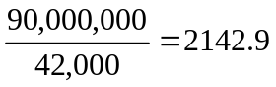
or, rounding to the nearest whole number, 2143.

Problem 3.28.
A portfolio manager has maintained an actively managed portfolio with a beta of 0.2. During the last year the risk-free rate was 5% and equities performed very badly providing a return of −30%. The portfolio manage produced a return of −10% and claims that in the circumstances it was good. Discuss this claim.

When the expected return on the market is −30% the expected return on a portfolio with a beta of 0.2 is
0.05 + 0.2 × (−0.30 − 0.05) = −0.02
or –2%. The actual return of –10% is worse than the expected return. The portfolio manager done 8% worse than a simple strategy of forming a portfolio that is 20% invested in an equity index and 80% invested in risk-free investments. (The manager has achieved an alpha of –8%!)

Problem 3.29. (Excel file)
The following table gives data on monthly changes in the spot price and the futures price for a certain commodity. Use the data to calculate a minimum variance hedge ratio.

Spot Price Change | +0.50 | +0.61 | −0.22 | −0.35 | +0.79
Futures Price Change | +0.56 | +0.63 | −0.12 | −0.44 | +0.60
Spot Price Change | +0.04 | +0.15 | +0.70 | −0.51 | −0.41
Futures Price Change | −0.06 | +0.01 | +0.80 | −0.56 | −0.46

Denoteandby the -th observation on the change in the futures price and the change in the spot price respectively.
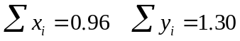

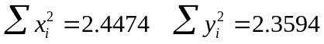

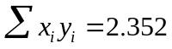
An estimate of 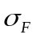 is
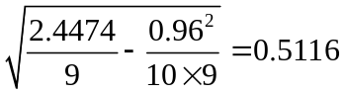
An estimate of 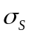 is
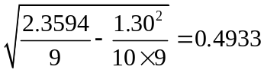
An estimate of 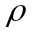 is
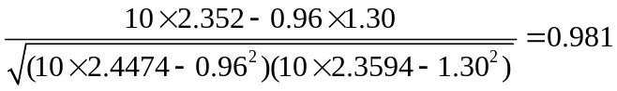
The minimum variance hedge ratio is
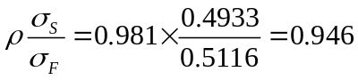

Problem 3.30.
It is July 16. A company has a portfolio of stocks worth $100 million. The beta of the portfolio is 1.2. The company would like to use the December futures contract on a stock index to change beta of the portfolio to 0.5 during the period July 16 to November 16. The index is currently 1,000, and each contract is on $250 times the index.
- What position should the company take?
- Suppose that the company changes its mind and decides to increase the beta of the portfolio from 1.2 to 1.5. What position in futures contracts should it take?
- The company should short
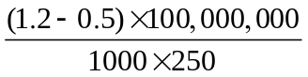
or 280 contracts.
- The company should take a long position in
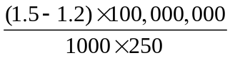
or 120 contracts.
Problem 3.31. (Excel file)
A fund manager has a portfolio worth $50 million with a beta of 0.87. The manager is concerned about the performance of the market over the next two months and plans to use three-month futures contracts on the S&P 500 to hedge the risk. The current level of the index is 1250, one contract is on 250 times the index, the risk-free rate is 6% per annum, and the dividend yield on the index is 3% per annum. The current 3 month futures price is 1259.
- What position should the fund manager take to eliminate all exposure to the market over the next two months?
- Calculate the effect of your strategy on the fund manager’s returns if the level of the market in two months is 1,000, 1,100, 1,200, 1,300, and 1,400. Assume that the one-month futures price is 0.25% higher than the index level at this time.

- The number of contracts the fund manager should short is
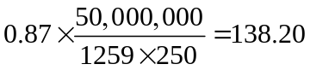
Rounding to the nearest whole number, 138 contracts should be shorted.
- The following table shows that the impact of the strategy. To illustrate the calculations in the table consider the first column. If the index in two months is 1,000, the futures price is 1000×1.0025. The gain on the short futures position is therefore
The return on the index is 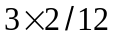=0.5% in the form of dividend and 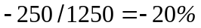 in the form of capital gains. The total return on the index is therefore 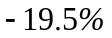. The risk-free rate is 1% per two months. The return is therefore 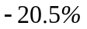 in excess of the risk-free rate. From the capital asset pricing model we expect the return on the portfolio to be 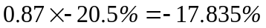 in excess of the risk-free rate. The portfolio return is therefore 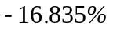. The loss on the portfolio is 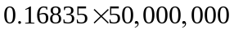 or $8,417,500. When this is combined with the gain on the futures the total gain is $431,750.
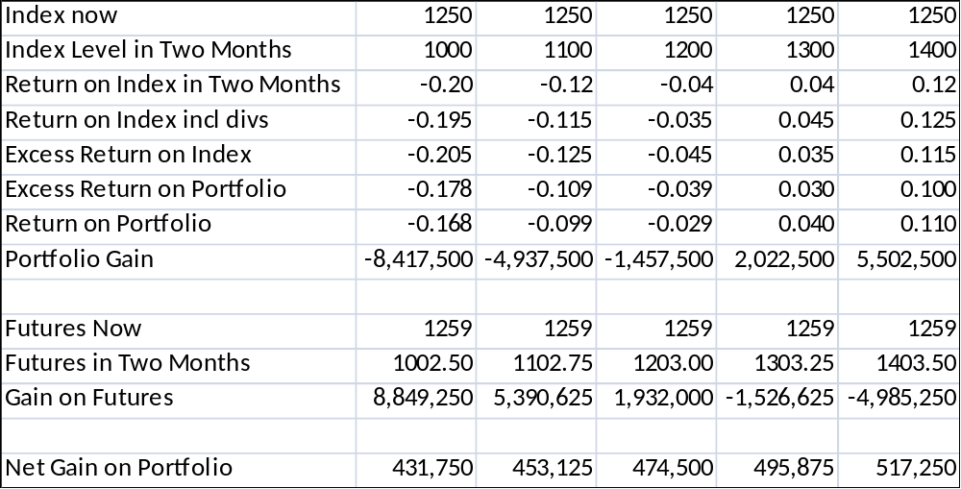

Problem 3.32.
It is now October 2014. A company anticipates that it will purchase 1 million pounds of copper in each of February 2015, August 2015, February 2016, and August 2016. The company has decided to use the futures contracts traded in the COMEX division of the CME Group to hedge its risk. One contract is for the delivery of 25,000 pounds of copper. The initial margin is $2,000 per contract and the maintenance margin is $1,500 per contract. The company’s policy is to hedge 80% of its exposure. Contracts with maturities up to 13 months into the future are considered to have sufficient liquidity to meet the company’s needs. Devise a hedging strategy for the company. (Do not make the “tailing” adjustment described in Section 3.4.)
Assume the market prices (in cents per pound) today and at future dates are as follows. What is the impact of the strategy you propose on the price the company pays for copper? What is the initial margin requirement in October 2014? Is the company subject to any margin calls?
Date | Oct 2014 | Feb 2015 | Aug 2015 | Feb 2016 | Aug 2016
Spot Price | 372.00 | 369.00 | 365.00 | 377.00 | 388.00
Mar 2015 Futures Price | 372.30 | 369.10
Sep 2015 Futures Price | 372.80 | 370.20 | 364.80
Mar 2016 Futures Price |  | 370.70 | 364.30 | 376.70
Sep 2016 Futures Price |  |  | 364.20 | 376.50 | 388.20

To hedge the February 2015 purchase the company should take a long position in March 2015 contracts for the delivery of 800,000 pounds of copper. The total number of contracts required is 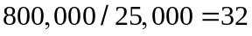. Similarly a long position in 32 September 2015 contracts is required to hedge the August 2015 purchase. For the February 2016 purchase the company could take a long position in 32 September 2015 contracts and roll them into March 2016 contracts during August 2015. (As an alternative, the company could hedge the February 2016 purchase by taking a long position in 32 March 2015 contracts and rolling them into March 2016 contracts.) For the August 2016 purchase the company could take a long position in 32 September 2015 and roll them into September 2016 contracts during August 2015.
The strategy is therefore as follows
Oct. 2014: Enter into long position in 96 Sept. 2015 contracts
Enter into a long position in 32 Mar. 2015 contracts
Feb 2015: Close out 32 Mar. 2015 contracts
Aug 2015: Close out 96 Sept. 2015 contracts
Enter into long position in 32 Mar. 2016 contracts
Enter into long position in 32 Sept. 2016 contracts
Feb 2016: Close out 32 Mar. 2016 contracts
Aug 2016: Close out 32 Sept. 2016 contracts

With the market prices shown the company pays
for copper in February, 2015. It pays
for copper in August 2015. As far as the February 2016 purchase is concerned, it loses 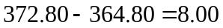 on the September 2015 futures and gains 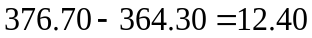 on the February 2016 futures. The net price paid is therefore
As far as the August 2016 purchase is concerned, it loses on the September 2015 futures and gains 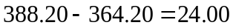 on the September 2016 futures. The net price paid is therefore
The hedging strategy succeeds in keeping the price paid in the range 371.40 to 375.20.
In October 2014 the initial margin requirement on the 128 contracts is 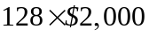 or $256,000. There is a margin call when the futures price drops by more than 2 cents. This happens to the March 2015 contract between October 2014 and February 2015, to the September 2015 contract between October 2014 and February 2015, and to the September 2015 contract between February 2015 and August 2015. (Under the plan above the March 2016 contract is not held between February 2015 and August 2015, but if it were there would be a margin call during this period.)

