CHAPTER 5
Determination of Forward and Futures Prices

Practice Questions
Problem 5.1.
Explain what happens when an investor shorts a certain share.
The investor’s broker borrows the shares from another client’s account and sells them in the usual way. To close out the position, the investor must purchase the shares. The broker then replaces them in the account of the client from whom they were borrowed. The party with the short position must remit to the broker dividends and other income paid on the shares. The broker transfers these funds to the account of the client from whom the shares were borrowed. Occasionally the broker runs out of places from which to borrow the shares. The investor is then short squeezed and has to close out the position immediately. A fee may be charged for borrowing shares.
Problem 5.2.
What is the difference between the forward price and the value of a forward contract?
The forward price of an asset today is the price at which you would agree to buy or sell the asset at a future time. The value of a forward contract is zero when you first enter into it. As time passes the underlying asset price changes and the value of the contract may become positive or negative.
Problem 5.3.
Suppose that you enter into a six-month forward contract on a non-dividend-paying stock when the stock price is $30 and the risk-free interest rate (with continuous compounding) is 12% per annum. What is the forward price?
The forward price is
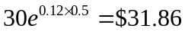

Problem 5.4.
A stock index currently stands at 350. The risk-free interest rate is 8% per annum (with continuous compounding) and the dividend yield on the index is 4% per annum. What should the futures price for a four-month contract be?
The futures price is
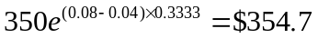

Problem 5.5.
Explain carefully why the futures price of gold can be calculated from its spot price and other observable variables whereas the futures price of copper cannot.
Gold is an investment asset. If the futures price is too high, investors will find it profitable to increase their holdings of gold and short futures contracts. If the futures price is too low, they will find it profitable to decrease their holdings of gold and go long in the futures market. Copper is a consumption asset. If the futures price is too high, a strategy of buy copper and short futures works. However, because investors do not in general hold the asset, the strategy of sell copper and buy futures is not available to them. There is therefore an upper bound, but no lower bound, to the futures price.
Problem 5.6.
Explain carefully the meaning of the terms convenience yield and cost of carry. What is the relationship between futures price, spot price, convenience yield, and cost of carry?
Convenience yield measures the extent to which there are benefits obtained from ownership of the physical asset that are not obtained by owners of long futures contracts. The cost of carry is the interest cost plus storage cost less the income earned. The futures price, 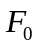, and spot price, 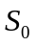, are related by
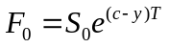
where is the cost of carry, is the convenience yield, and is the time to maturity of the futures contract.
Problem 5.7.
Explain why a foreign currency can be treated as an asset providing a known yield.
A foreign currency provides a known interest rate, but the interest is received in the foreign currency. The value in the domestic currency of the income provided by the foreign currency is therefore known as a percentage of the value of the foreign currency. This means that the income has the properties of a known yield.
Problem 5.8.
Is the futures price of a stock index greater than or less than the expected future value of the index? Explain your answer.
The futures price of a stock index is always less than the expected future value of the index. This follows from Section 5.14 and the fact that the index has positive systematic risk. For an alternative argument, let  be the expected return required by investors on the index so that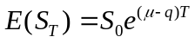. Because 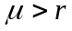 and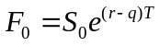, it follows that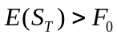.
Problem 5.9.
A one-year long forward contract on a non-dividend-paying stock is entered into when the stock price is $40 and the risk-free rate of interest is 10% per annum with continuous compounding.
- What are the forward price and the initial value of the forward contract?
- Six months later, the price of the stock is $45 and the risk-free interest rate is still 10%. What are the forward price and the value of the forward contract?
- The forward price, , is given by equation (5.1) as:
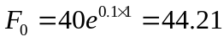
or $44.21. The initial value of the forward contract is zero.
- The delivery price  in the contract is $44.21. The value of the contract, , after six months is given by equation (5.5) as:
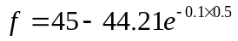
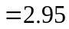
i.e., it is $2.95. The forward price is:
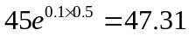
or $47.31.
Problem 5.10.
The risk-free rate of interest is 7% per annum with continuous compounding, and the dividend yield on a stock index is 3.2% per annum. The current value of the index is 150. What is the six-month futures price?
Using equation (5.3) the six month futures price is
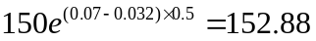
or $152.88.
Problem 5.11.
Assume that the risk-free interest rate is 9% per annum with continuous compounding and that the dividend yield on a stock index varies throughout the year. In February, May, August, and November, dividends are paid at a rate of 5% per annum. In other months, dividends are paid at a rate of 2% per annum. Suppose that the value of the index on July 31 is 1,300. What is the futures price for a contract deliverable on December 31 of the same year?
The futures contract lasts for five months. The dividend yield is 2% for three of the months and 5% for two of the months. The average dividend yield is therefore
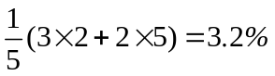
The futures price is therefore
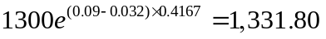
or $1331.80.
Problem 5.12.
Suppose that the risk-free interest rate is 10% per annum with continuous compounding and that the dividend yield on a stock index is 4% per annum. The index is standing at 400, and the futures price for a contract deliverable in four months is 405. What arbitrage opportunities does this create?
The theoretical futures price is
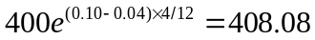
The actual futures price is only 405. This shows that the index futures price is too low relative to the index. The correct arbitrage strategy is
- Buy futures contracts
- Short the shares underlying the index.
Problem 5.13.
Estimate the difference between short-term interest rates in Canada and the United States on May 14, 2013 from the information in Table 5.4.
The settlement prices for the futures contracts are to
Jun: 0.9886
Sept: 0.9865
Dec: 0.9844
The September price is 0.21% below the June price. The December price is about 0.21% below the September price. This suggests that the short-term interest rate in Canada exceeded short-term interest rate in the United States by about 0.21% per three months or about 0.84% per year.
Problem 5.14.
The two-month interest rates in Switzerland and the United States are, respectively, 1% and 2% per annum with continuous compounding. The spot price of the Swiss franc is $1.0500. The futures price for a contract deliverable in two months is also $1.0500. What arbitrage opportunities does this create?
The theoretical futures price is
1.0500e^{(0.02-0.01)×2/12}= 1.0518
The actual futures price is too low. This suggests that a Swiss arbitrageur should sell Swiss francs for US dollars and buy Swiss francs back in the futures market.
Problem 5.15.
The spot price of silver is $25 per ounce. The storage costs are $0.24 per ounce per year payable quarterly in advance. Assuming that interest rates are 5% per annum for all maturities, calculate the futures price of silver for delivery in nine months.
The present value of the storage costs for nine months are
0.06+0.06e^{-0.05×0.25}+0.06e^{-0.05×0.5}= 0.178
or $0.178. The futures price is from equation (5.11) given by where
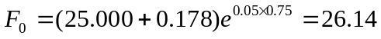
i.e., it is $26.14 per ounce.
Problem 5.16.
Suppose that 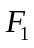 and 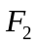 are two futures contracts on the same commodity with times to maturity, and , where 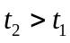. Prove that
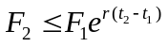
where is the interest rate (assumed constant) and there are no storage costs. For the purposes of this problem, assume that a futures contract is the same as a forward contract.
If
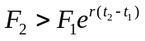
an investor could make a riskless profit by
- Taking a long position in a futures contract which matures at time
- Taking a short position in a futures contract which matures at time
When the first futures contract matures, the asset is purchased for using funds borrowed at rate r. It is then held until time at which point it is exchanged for under the second contract. The costs of the funds borrowed and accumulated interest at time is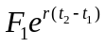. A positive profit of
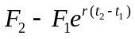
is then realized at time . This type of arbitrage opportunity cannot exist for long. Hence:

Problem 5.17.
When a known future cash outflow in a foreign currency is hedged by a company using a forward contract, there is no foreign exchange risk. When it is hedged using futures contracts, the daily settlement process does leave the company exposed to some risk. Explain the nature of this risk. In particular, consider whether the company is better off using a futures contract or a forward contract when
- The value of the foreign currency falls rapidly during the life of the contract
- The value of the foreign currency rises rapidly during the life of the contract
- The value of the foreign currency first rises and then falls back to its initial value
- The value of the foreign currency first falls and then rises back to its initial value
Assume that the forward price equals the futures price.
In total the gain or loss under a futures contract is equal to the gain or loss under the corresponding forward contract. However the timing of the cash flows is different. When the time value of money is taken into account a futures contract may prove to be more valuable or less valuable than a forward contract. Of course the company does not know in advance which will work out better. The long forward contract provides a perfect hedge. The long futures contract provides a slightly imperfect hedge.
- In this case the forward contract would lead to a slightly better outcome. The company will make a loss on its hedge. If the hedge is with a forward contract the whole of the loss will be realized at the end. If it is with a futures contract the loss will be realized day by day throughout the contract. On a present value basis the former is preferable.
- In this case the futures contract would lead to a slightly better outcome. The company will make a gain on the hedge. If the hedge is with a forward contract the gain will be realized at the end. If it is with a futures contract the gain will be realized day by day throughout the life of the contract. On a present value basis the latter is preferable.
- In this case the futures contract would lead to a slightly better outcome. This is because it would involve positive cash flows early and negative cash flows later.
- In this case the forward contract would lead to a slightly better outcome. This is because, in the case of the futures contract, the early cash flows would be negative and the later cash flow would be positive.
Problem 5.18.
It is sometimes argued that a forward exchange rate is an unbiased predictor of future exchange rates. Under what circumstances is this so?
From the discussion in Section 5.14 of the text, the forward exchange rate is an unbiased predictor of the future exchange rate when the exchange rate has no systematic risk. To have no systematic risk the exchange rate must be uncorrelated with the return on the market.
Problem 5.19.
Show that the growth rate in an index futures price equals the excess return of the portfolio underlying the index over the risk-free rate. Assume that the risk-free interest rate and the dividend yield are constant.
Suppose that is the futures price at time zero for a contract maturing at time and is the futures price for the same contract at time . It follows that

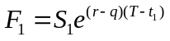
where and 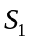 are the spot price at times zero and , is the risk-free rate, and is the dividend yield. These equations imply that
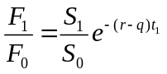
Define the excess return of the portfolio underlying the index over the risk-free rate as . The total return is 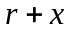 and the return realized in the form of capital gains is 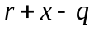. It follows that 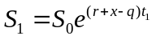 and the equation for 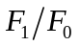 reduces to
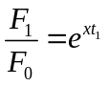
which is the required result.
Problem 5.20.
Show that equation (5.3) is true by considering an investment in the asset combined with a short position in a futures contract. Assume that all income from the asset is reinvested in the asset. Use an argument similar to that in footnotes 2 and 4 of this chapter and explain in detail what an arbitrageur would do if equation (5.3) did not hold.
Suppose we buy  units of the asset and invest the income from the asset in the asset. The income from the asset causes our holding in the asset to grow at a continuously compounded rate . By time our holding has grown to 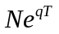 units of the asset. Analogously to footnotes 2 and 4 of Chapter 5, we therefore buy units of the asset at time zero at a cost of per unit and enter into a forward contract to sell unit for per unit at time . This generates the following cash flows:
Time 0: 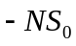
Time 1: 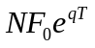
Because there is no uncertainty about these cash flows, the present value of the time inflow must equal the time zero outflow when we discount at the risk-free rate. This means that
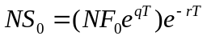
or
This is equation (5.3).
If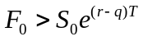, an arbitrageur should borrow money at rate and buy units of the asset. At the same time the arbitrageur should enter into a forward contract to sell units of the asset at time . As income is received, it is reinvested in the asset. At time the loan is repaid and the arbitrageur makes a profit of 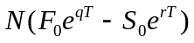 at time .
If 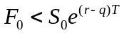, an arbitrageur should short units of the asset investing the proceeds at rate . At the same time the arbitrageur should enter into a forward contract to buy units of the asset at time . When income is paid on the asset, the arbitrageur owes money on the short position. The investor meets this obligation from the cash proceeds of shorting further units. The result is that the number of units shorted grows at rate to . The cumulative short position is closed out at time and the arbitrageur makes a profit of 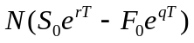.
Problem 5.21.
Explain carefully what is meant by the expected price of a commodity on a particular future date. Suppose that the futures price of crude oil declines with the maturity of the contract at the rate of 2% per year. Assume that speculators tend to be short crude oil futures and hedgers tended to be long crude oil futures. What does the Keynes and Hicks argument imply about the expected future price of oil?
To understand the meaning of the expected future price of a commodity, suppose that there are different possible prices at a particular future time: , 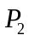, , 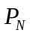. Define 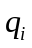 as the (subjective) probability the price being 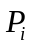 (with 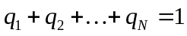). The expected future price is
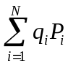

Different people may have different expected future prices for the commodity. The expected future price in the market can be thought of as an average of the opinions of different market participants. Of course, in practice the actual price of the commodity at the future time may prove to be higher or lower than the expected price.
Keynes and Hicks argue that speculators on average make money from commodity futures trading and hedgers on average lose money from commodity futures trading. If speculators tend to have short positions in crude oil futures, the Keynes and Hicks argument implies that futures prices overstate expected future spot prices. If crude oil futures prices decline at 2% per year the Keynes and Hicks argument therefore implies an even faster decline for the expected price of crude oil in this case.

Problem 5.22.
The Value Line Index is designed to reflect changes in the value of a portfolio of over 1,600 equally weighted stocks. Prior to March 9, 1988, the change in the index from one day to the next was calculated as the geometric average of the changes in the prices of the stocks underlying the index. In these circumstances, does equation (5.8) correctly relate the futures price of the index to its cash price? If not, does the equation overstate or understate the futures price?
When the geometric average of the price relatives is used, the changes in the value of the index do not correspond to changes in the value of a portfolio that is traded. Equation (5.8) is therefore no longer correct. The changes in the value of the portfolio are monitored by an index calculated from the arithmetic average of the prices of the stocks in the portfolio. Since the geometric average of a set of numbers is always less than the arithmetic average, equation (5.8) overstates the futures price. It is rumored that at one time (prior to 1988), equation (5.8) did hold for the Value Line Index. A major Wall Street firm was the first to recognize that this represented a trading opportunity. It made a financial killing by buying the stocks underlying the index and shorting the futures.

Problem 5.23.
A U.S. company is interested in using the futures contracts traded by the CME Group to hedge its Australian dollar exposure. Define as the interest rate (all maturities) on the U.S. dollar and 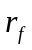 as the interest rate (all maturities) on the Australian dollar. Assume that and are constant and that the company uses a contract expiring at time to hedge an exposure at time 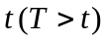.
- Show that the optimal hedge ratio is
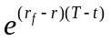

- Show that, when is one day, the optimal hedge ratio is almost exactly 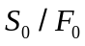 where is the current spot price of the currency and is the current futures price of the currency for the contract maturing at time .
- Show that the company can take account of the daily settlement of futures contracts for a hedge that lasts longer than one day by adjusting the hedge ratio so that it always equals the spot price of the currency divided by the futures price of the currency.
  - The relationship between the futures price 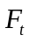 and the spot price 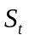 at time is
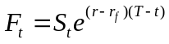
Suppose that the hedge ratio is . The price obtained with hedging is
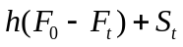
where is the initial futures price. This is
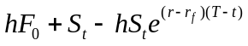
If 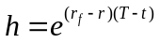, this reduces to 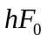 and a zero variance hedge is obtained.
  - When is one day, is approximately 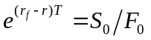. The appropriate hedge ratio is therefore 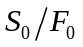.
  - When a futures contract is used for hedging, the price movements in each day should in theory be hedged separately. This is because the daily settlement means that a futures contract is closed out and rewritten at the end of each day. From (b) the correct hedge ratio at any given time is, therefore, 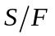 where is the spot price and  is the futures price. Suppose there is an exposure to units of the foreign currency and  units of the foreign currency underlie one futures contract. With a hedge ratio of 1 we should trade 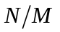contracts. With a hedge ratio of we should trade
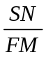
contracts. In other words we should calculate the number of contracts that should be traded as the dollar value of our exposure divided by the dollar value of one futures contract. (This is not the same as the dollar value of our exposure divided by the dollar value of the assets underlying one futures contract.) Since a futures contract is settled daily, we should in theory rebalance our hedge daily so that the outstanding number of futures contracts is always 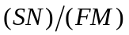. This is known as tailing the hedge. (See Chapter 3.)

Problem 5.24.
What is meant by (a) an investment asset and (b) a consumption asset. Why is the distinction between investment and consumption assets important in the determination of forward and futures prices?

An investment asset is an asset held for investment by a significant number of people or companies. A consumption asset is an asset that is nearly always held to be consumed (either directly or in some sort of manufacturing process). The forward/futures price can be determined from the spot price for an investment asset. In the case of a consumption asset all that can be determined is an upper bound for the forward/futures price.

Problem 5.25.
What is the cost of carry for (a) a non-dividend-paying stock, (b) a stock index, (c) a
commodity with storage costs, and (d) a foreign currency?

a) the risk-free rate, b) the excess of the risk-free rate over the dividend yield c) the risk-free rate plus the storage cost, d) the excess of the domestic risk-free rate over the foreign risk-free rate.
Further Questions
Problem 5.26.
In early 2012, the spot exchange rate between the Swiss Franc and U.S. dollar was 1.0404 ($ per franc). Interest rates in the U.S. and Switzerland were 0.25% and 0% per annum,respectively, with continuous compounding. The three-month forward exchange rate was1.0300 ($ per franc). What arbitrage strategy was possible? How does your answer change if the exchange rate is 1.0500 ($ per franc).

The theoretical forward exchange rate is 1.0404e^{(0.0025−0)×0.25} = 1.041.
If the actual forward exchange rate is 1.03, an arbitrageur can a) borrow X Swiss francs, b) convert the Swiss francs to 1.0404X dollars and invest the dollars for three months at 0.25% and c) buy X Swiss francs at 1.03 in the three-month forward market. In three months, the arbitrageur has 1.0404Xe^{0.0025×0.25} = 1.041X dollars. A total of 1.3X dollars are used to buy the Swiss francs under the terms of the forward contract and a gain of 0.011X is made.
If the actual forward exchange rate is 1.05, an arbitrageur can a) borrow X dollars, b) convert the dollars to X/1.0404 Swiss francs and invest the Swiss francs for three months at zero interest rate, and c) enter into a forward contract to sell X/1.0404 Swiss francs in three months. In three months the arbitrageur has X/1.0404 Swiss francs. The forward contract converts these to (1.05X)/1.0404=1.0092X dollars. A total of Xe^{0.0025×0.25} =1.0006X is needed to repay the dollar loan. A profit of 0.0086X dollars is therefore made.

Problem 5.27.
An index is 1,200. The three-month risk-free rate is 3% per annum and the dividend yield over the next three months is 1.2% per annum. The six-month risk-free rate is 3.5% per annum and the dividend yield over the next six months is 1% per annum. Estimate the futures price of the index for three-month and six-month contracts. All interest rates and dividend yields are continuously compounded.

The futures price for the three month contract is 1200e^{(0.03-0.012)×0.25} =1205.41. The futures price for the six month contract is 1200e^{(0.035-0.01)×0.5} =1215.09.

Problem 5.28.
The current USD/euro exchange rate is 1.4000 dollar per euro. The six month forward exchange rate is 1.3950. The six month USD interest rate is 1% per annum continuously compounded. Estimate the six month euro interest rate.

If the six-month euro interest rate is r_{f} then
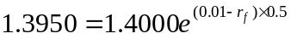
so that
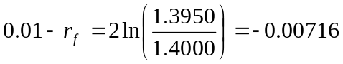
and r_{f} = 0.01716. The six-month euro interest rate is 1.716%.

Problem 5.29.
The spot price of oil is $80 per barrel and the cost of storing a barrel of oil for one year is $3, payable at the end of the year. The risk-free interest rate is 5% per annum, continuously compounded. What is an upper bound for the one-year futures price of oil?

The present value of the storage costs per barrel is 3e^{̶-0.05×1} = 2.854. An upper bound to the one-year futures price is (80+2.854)e^{0.05×1} = 87.10.

Problem 5.30.
A stock is expected to pay a dividend of $1 per share in two months and in five months. The stock price is $50, and the risk-free rate of interest is 8% per annum with continuous compounding for all maturities. An investor has just taken a short position in a six-month forward contract on the stock.
- What are the forward price and the initial value of the forward contract?
- Three months later, the price of the stock is $48 and the risk-free rate of interest is still 8% per annum. What are the forward price and the value of the short position in the forward contract?

- The present value, , of the income from the security is given by:
From equation (5.2) the forward price, , is given by:
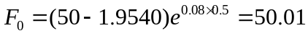
or $50.01. The initial value of the forward contract is (by design) zero. The fact that the forward price is very close to the spot price should come as no surprise. When the compounding frequency is ignored the dividend yield on the stock equals the risk-free rate of interest.
- In three months:
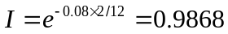
The delivery price, , is 50.01. From equation (5.6) the value of the short forward contract, , is given by
and the forward price is
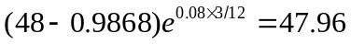

Problem 5.31.
A bank offers a corporate client a choice between borrowing cash at 11% per annum and borrowing gold at 2% per annum. (If gold is borrowed, interest must be repaid in gold. Thus, 100 ounces borrowed today would require 102 ounces to be repaid in one year.) The risk-free interest rate is 9.25% per annum, and storage costs are 0.5% per annum. Discuss whether the rate of interest on the gold loan is too high or too low in relation to the rate of interest on the cash loan. The interest rates on the two loans are expressed with annual compounding. The risk-free interest rate and storage costs are expressed with continuous compounding.
My explanation of this problem to students usually goes as follows. Suppose that the price of gold is $1000 per ounce and the corporate client wants to borrow $1,000,000. The client has a choice between borrowing $1,000,000 in the usual way and borrowing 1,000 ounces of gold. If it borrows $1,000,000 in the usual way, an amount equal to 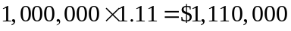 must be repaid. If it borrows 1,000 ounces of gold it must repay 1,020 ounces. In equation (5.12), 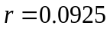 and 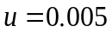 so that the forward price is
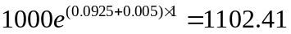
By buying 1,020 ounces of gold in the forward market the corporate client can ensure that the repayment of the gold loan costs
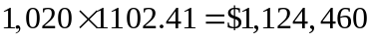
Clearly the cash loan is the better deal (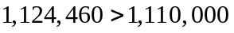).
This argument shows that the rate of interest on the gold loan is too high. What is the correct rate of interest? Suppose that  is the rate of interest on the gold loan. The client must repay 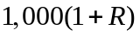 ounces of gold. When forward contracts are used the cost of this is
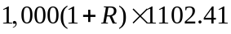
This equals the $1,110,000 required on the cash loan when 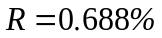. The rate of interest on the gold loan is too high by about 1.31%. However, this might be simply a reflection of the higher administrative costs incurred with a gold loan.
It is interesting to note that this is not an artificial question. Many banks are prepared to make gold loans.

Problem 5.32.
A company that is uncertain about the exact date when it will pay or receive a foreign currency may try to negotiate with its bank a forward contract that specifies a period during which delivery can be made. The company wants to reserve the right to choose the exact delivery date to fit in with its own cash flows. Put yourself in the position of the bank. How would you price the product that the company wants?
It is likely that the bank will price the product on assumption that the company chooses the delivery date least favorable to the bank. If the foreign interest rate is higher than the domestic interest rate then
- The earliest delivery date will be assumed when the company has a long position.
- The latest delivery date will be assumed when the company has a short position.
If the foreign interest rate is lower than the domestic interest rate then
- The latest delivery date will be assumed when the company has a long position.
- The earliest delivery date will be assumed when the company has a short position.
If the company chooses a delivery which, from a purely financial viewpoint, is suboptimal the bank makes a gain.

Problem 5.33.
A trader owns a commodity that provides no income and has no storage costs as part of a long-term investment portfolio. The trader can buy the commodity for $1250 per ounce and sell gold for $1249 per ounce. The trader can borrow funds at 6% per year and invest funds at 5.5% per year. (Both interest rates are expressed with annual compounding.) For what range of one-year forward prices does the trader have no arbitrage opportunities? Assume there is no bid–offer spread for forward prices.

Suppose that is the one-year forward price of the commodity. If is relatively high, the trader can borrow $1250 at 6%, buy one ounce of the commodity and enter into a forward contract to sell it in one year for . The profit made in one year is
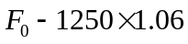
This is profitable if F₀ >1325. If is relatively low, the trader can sell one ounce of the commodity for $1249, invest the proceeds at 5.5%, and enter into a forward contract to buy it back for . The profit (relative to the position the trader would be in if the commodity were held in the portfolio during the year) is
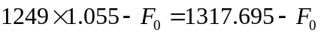
This shows that there is no arbitrage opportunity if the forward price is between $1317.695 and $1325 per ounce.

Problem 5.34.
A company enters into a forward contract with a bank to sell a foreign currency for 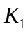 at time . The exchange rate at time proves to be (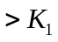). The company asks the bank if it can roll the contract forward until time 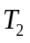 (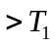) rather than settle at time . The bank agrees to a new delivery price, 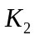. Explain how should be calculated.

The value of the contract to the bank at time is 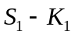. The bank will choose so that the new (rolled forward) contract has a value of. This means that
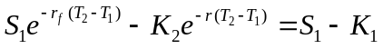
where and and the domestic and foreign risk-free rate observed at time and applicable to the period between time and . This means that
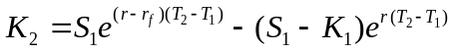
This equation shows that there are two components to. The first is the forward price at time . The second is an adjustment to the forward price equal to the bank’s gain on the first part of the contract compounded forward at the domestic risk-free rate.

