CHAPTER 6
Interest Rate Futures

Practice Questions

Problem 6.1.
A U.S. Treasury bond pays a 7% coupon on January 7 and July 7. How much interest accrues per $100 of principal to the bond holder between July 7, 2014 and August 8, 2014? How would your answer be different if it were a corporate bond?
There are 32 calendar days between July 7, 2014 and August 8, 2014. There are 184 calendar days between July 7, 2014 and January 7, 2015. The interest earned per $100 of principal is therefore 3.5×32/184=$0.6087. For a corporate bond we assume 31 days between July 7 and August 8, 2014 and 180 days between July 7, 2014 and January 7, 2015. The interest earned is 3.5×31/180 = $0.6028 .
Problem 6.2.
It is January 9, 2015. The price of a Treasury bond with a 12% coupon that matures on October 12, 2030, is quoted as 102-07. What is the cash price?
There are 89 days between October 12, 2014, and January 9, 2015. There are 182 days between October 12, 2014, and April 12, 2014. The cash price of the bond is obtained by adding the accrued interest to the quoted price. The quoted price is 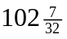 or 102.21875. The cash price is therefore
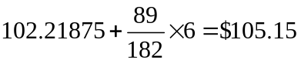

Problem 6.3.
How is the conversion factor of a bond calculated by the CME Group? How is it used?
The conversion factor for a bond is equal to the quoted price the bond would have per dollar of principal on the first day of the delivery month on the assumption that the interest rate for all maturities equals 6% per annum (with semiannual compounding). The bond maturity and the times to the coupon payment dates are rounded down to the nearest three months for the purposes of the calculation. The conversion factor defines how much an investor with a short bond futures contract receives when bonds are delivered. If the conversion factor is 1.2345 the amount investor receives is calculated by multiplying 1.2345 by the most recent futures price and adding accrued interest.
Problem 6.4.
A Eurodollar futures price changes from 96.76 to 96.82. What is the gain or loss to an investor who is long two contracts?
The Eurodollar futures price has increased by 6 basis points. The investor makes a gain per contract of 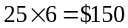 or $300 in total.

Problem 6.5.
What is the purpose of the convexity adjustment made to Eurodollar futures rates? Why is the convexity adjustment necessary?
Suppose that a Eurodollar futures quote is 95.00. This gives a futures rate of 5% for the three-month period covered by the contract. The convexity adjustment is the amount by which futures rate has to be reduced to give an estimate of the forward rate for the period. The convexity adjustment is necessary because a) the futures contract is settled daily and b) the futures contract expires at the beginning of the three months. Both of these lead to the futures rate being greater than the forward rate.
Problem 6.6.
The 350-day LIBOR rate is 3% with continuous compounding and the forward rate calculated from a Eurodollar futures contract that matures in 350 days is 3.2% with continuous compounding. Estimate the 440-day zero rate.
From equation (6.4) the rate is
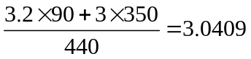
or 3.0409%.
Problem 6.7.
It is January 30. You are managing a bond portfolio worth $6 million. The duration of the portfolio in six months will be 8.2 years. The September Treasury bond futures price is currently 108-15, and the cheapest-to-deliver bond will have a duration of 7.6 years in September. How should you hedge against changes in interest rates over the next six months?
The value of a contract is 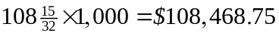. The number of contracts that should be shorted is
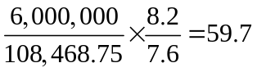
Rounding to the nearest whole number, 60 contracts should be shorted. The position should be closed out at the end of July.
Problem 6.8.
The price of a 90-day Treasury bill is quoted as 10.00. What continuously compounded return (on an actual/365 basis) does an investor earn on the Treasury bill for the 90-day period?
The cash price of the Treasury bill is
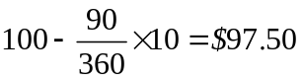

The annualized continuously compounded return is
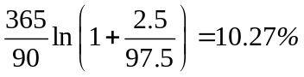

Problem 6.9.
It is May 5, 2014. The quoted price of a government bond with a 12% coupon that matures on July 27, 2024, is 110-17. What is the cash price?
The number of days between January 27, 2014 and May 5, 2014 is 98. The number of days between January 27, 2014 and July 27, 2014 is 181. The accrued interest is therefore
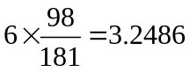
The quoted price is 110.5312. The cash price is therefore
or $113.78.

Problem 6.10.
Suppose that the Treasury bond futures price is 101-12. Which of the following four bonds is cheapest to deliver?

Bond | Price | Conversion Factor
1 | 125-05 | 1.2131
2 | 142-15 | 1.3792
3 | 115-31 | 1.1149
4 | 144-02 | 1.4026

The cheapest-to-deliver bond is the one for which
is least. Calculating this factor for each of the 4 bonds we get

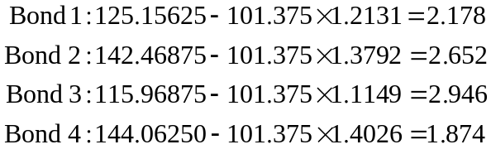
Bond 4 is therefore the cheapest to deliver.
Problem 6.11.
It is July 30, 2015. The cheapest-to-deliver bond in a September 2015 Treasury bond futures contract is a 13% coupon bond, and delivery is expected to be made on September 30, 2015. Coupon payments on the bond are made on February 4 and August 4 each year. The term structure is flat, and the rate of interest with semiannual compounding is 12% per annum. The conversion factor for the bond is 1.5. The current quoted bond price is $110. Calculate the quoted futures price for the contract.
There are 176 days between February 4 and July 30 and 181 days between February 4 and August 4. The cash price of the bond is, therefore:
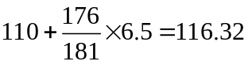
The rate of interest with continuous compounding is 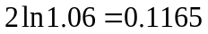 or 11.65% per annum. A coupon of 6.5 will be received in 5 days or 0.1370 years) time. The present value of the coupon is
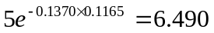
The futures contract lasts for 62 days 0r 0.1699 years). The cash futures price if the contract were written on the 13% bond would be
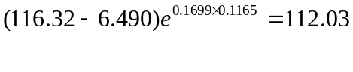
At delivery there are 57 days of accrued interest. The quoted futures price if the contract were written on the 13% bond would therefore be
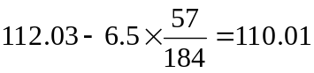

Taking the conversion factor into account the quoted futures price should be:
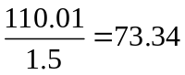

Problem 6.12.
An investor is looking for arbitrage opportunities in the Treasury bond futures market. What complications are created by the fact that the party with a short position can choose to deliver any bond with a maturity of between 15 and 25 years?
If the bond to be delivered and the time of delivery were known, arbitrage would be straightforward. When the futures price is too high, the arbitrageur buys bonds and shorts an equivalent number of bond futures contracts. When the futures price is too low, the arbitrageur shorts bonds and goes long an equivalent number of bond futures contracts.
Uncertainty as to which bond will be delivered introduces complications. The bond that appears cheapest-to-deliver now may not in fact be cheapest-to-deliver at maturity. In the case where the futures price is too high, this is not a major problem since the party with the short position (i.e., the arbitrageur) determines which bond is to be delivered. In the case where the futures price is too low, the arbitrageur’s position is far more difficult since he or she does not know which bond to short; it is unlikely that a profit can be locked in for all possible outcomes.
Problem 6.13.
Suppose that the nine-month LIBOR interest rate is 8% per annum and the six-month LIBOR interest rate is 7.5% per annum (both with actual/365 and continuous compounding). Estimate the three-month Eurodollar futures price quote for a contract maturing in six months.
The forward interest rate for the time period between months 6 and 9 is 9% per annum with continuous compounding. This is because 9% per annum for three months when combined with 7% per annum for six months gives an average interest rate of 8% per annum for the nine-month period.
With quarterly compounding the forward interest rate is
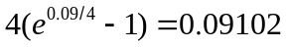
or 9.102%. This assumes that the day count is actual/actual. With a day count of actual/360 the rate is 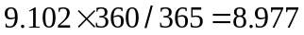. The three-month Eurodollar quote for a contract maturing in six months is therefore
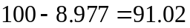

Problem 6.14.
Suppose that the 300-day LIBOR zero rate is 4% and Eurodollar quotes for contracts maturing in 300, 398 and 489 days are 95.83, 95.62, and 95.48. Calculate 398-day and 489-day LIBOR zero rates. Assume no difference between forward and futures rates for the purposes of your calculations.

The forward rates calculated form the first two Eurodollar futures are 4.17% and 4.38%. These are expressed with an actual/360 day count and quarterly compounding. With continuous compounding and an actual/365 day count they are (365/90)ln(1+0.0417/4)=4.2060% and (365/90)ln(1+0.0438/4)= 4.4167%. It follows from equation (6.4) that the 398 day rate is
(4×300+4.2060×98)/398=4.0507
or 4.0507%. The 489 day rate is
(4.0507×398+4.4167× 91)/489=4.1188
or 4.1188%. We are assuming that the first futures rate applies to 98 days rather than the usual 91 days. The third futures quote is not needed.

Problem 6.15.
Suppose that a bond portfolio with a duration of 12 years is hedged using a futures contract in which the underlying asset has a duration of four years. What is likely to be the impact on the hedge of the fact that the 12-year rate is less volatile than the four-year rate?
Duration-based hedging procedures assume parallel shifts in the yield curve. Since the 12-year rate tends to move by less than the 4-year rate, the portfolio manager may find that he or she is over-hedged.

Problem 6.16.
Suppose that it is February 20 and a treasurer realizes that on July 17 the company will have to issue $5 million of commercial paper with a maturity of 180 days. If the paper were issued today, the company would realize $4,820,000. (In other words, the company would receive $4,820,000 for its paper and have to redeem it at $5,000,000 in 180 days’ time.) The September Eurodollar futures price is quoted as 92.00. How should the treasurer hedge the company’s exposure?
The company treasurer can hedge the company’s exposure by shorting Eurodollar futures contracts. The Eurodollar futures position leads to a profit if rates rise and a loss if they fall.
The duration of the commercial paper is twice that of the Eurodollar deposit underlying the Eurodollar futures contract. The contract price of a Eurodollar futures contract is 980,000. The number of contracts that should be shorted is, therefore,
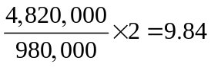
Rounding to the nearest whole number 10 contracts should be shorted.

Problem 6.17.
On August 1 a portfolio manager has a bond portfolio worth $10 million. The duration of the portfolio in October will be 7.1 years. The December Treasury bond futures price is currently 91-12 and the cheapest-to-deliver bond will have a duration of 8.8 years at maturity. How should the portfolio manager immunize the portfolio against changes in interest rates over the next two months?
The treasurer should short Treasury bond futures contract. If bond prices go down, this futures position will provide offsetting gains. The number of contracts that should be shorted is
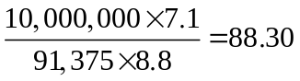
Rounding to the nearest whole number 88 contracts should be shorted.

Problem 6.18.
How can the portfolio manager change the duration of the portfolio to 3.0 years in Problem 6.17?
The answer in Problem 6.17 is designed to reduce the duration to zero. To reduce the duration from 7.1 to 3.0 instead of from 7.1 to 0, the treasurer should short
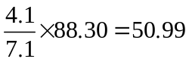
or 51 contracts.

Problem 6.19.
Between October 30, 2015, and November 1, 2015, you have a choice between owning a U.S. government bond paying a 12% coupon and a U.S. corporate bond paying a 12% coupon. Consider carefully the day count conventions discussed in this chapter and decide which of the two bonds you would prefer to own. Ignore the risk of default.
You would prefer to own the Treasury bond. Under the 30/360 day count convention there is one day between October 30 and November 1. Under the actual/actual (in period) day count convention, there are two days. Therefore you would earn approximately twice as much interest by holding the Treasury bond.

Problem 6.20.
Suppose that a Eurodollar futures quote is 88 for a contract maturing in 60 days. What is the LIBOR forward rate for the 60- to 150-day period? Ignore the difference between futures and forwards for the purposes of this question.
The Eurodollar futures contract price of 88 means that the Eurodollar futures rate is 12% per annum with quarterly compounding. This is the forward rate for the 60- to 150-day period with quarterly compounding and an actual/360 day count convention.
Problem 6.21.
The three-month Eurodollar futures price for a contract maturing in six years is quoted as 95.20. The standard deviation of the change in the short-term interest rate in one year is 1.1%. Estimate the forward LIBOR interest rate for the period between 6.00 and 6.25 years in the future.
Using the notation of Section 6.3, 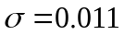, 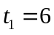, and 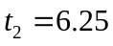. The convexity adjustment is
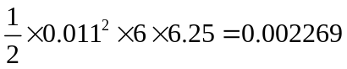
or about 23 basis points. The futures rate is 4.8% with quarterly compounding and an actual/360 day count. This becomes 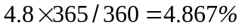 with an actual/actual day count. It is 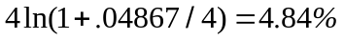 with continuous compounding. The forward rate is therefore 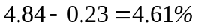 with continuous compounding.

Problem 6.22.
Explain why the forward interest rate is less than the corresponding futures interest rate calculated from a Eurodollar futures contract.
Suppose that the contracts apply to the interest rate between times and 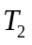. There are two reasons for a difference between the forward rate and the futures rate. The first is that the futures contract is settled daily whereas the forward contract is settled once at time . The second is that without daily settlement a futures contract would be settled at time not . Both reasons tend to make the futures rate greater than the forward rate.

Further Questions

Problem 6.23.
It is April 7, 2014. The quoted price of a U.S. government bond with a 6% per annum
coupon (paid semiannually) is 120-00. The bond matures on July 27, 2023. What is the
cash price? How does your answer change if it is a corporate bond?

The actual number of days between the last coupon date (Jan 27) and today is 70. The number of days between the last coupon (Jan 27) and the next coupon (Jul 27) is 181. The accrued interest for the government bond is therefore (70/181)×3 = 1.16. The cash price of the bond is therefore 121.16. Using a 30/360 day count the number of days between Jan 27 and today is 71 and the number of days between Jan 27 and Jul 27 is 180. The accrued interest for the corporate bond is therefore (71/180)×3 =1.18 so that the cash price is 121.18.

Problem 6.24.
A Treasury bond futures price is 103-12. The prices of three deliverable bonds are 115-06,
135-12, and 155-28. Their conversion factors are 1.0679, 1.2264, and 1.4169, respectively.
Which bond is cheapest to deliver?

The futures price is 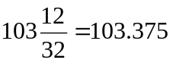. The first bond price is 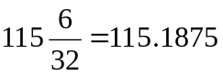. The second and third bond prices are similarly 135.375 and 155.875, respectively. The costs of delivering the three bonds are
115.1875 – 103.375×1.0679 = 4.7933
135.375 – 103.375×1.2264 = 8.5959
155.875– 103.375×1.4169 = 9.4030
The first bond is cheapest to deliver.

Problem 6.25.
The December Eurodollar futures contract is quoted as 98.40 and a company plans to borrow $8 million for three months starting in December at LIBOR plus 0.5%.
(a) What rate can then company lock in by using the Eurodollar futures contract?
(b) What position should the company take in the contracts?
(c) If the actual three-month rate turns out to be 1.3%, what is the final settlement price on the futures contracts.
Explain why timing mismatches reduce the effectiveness of the hedge.

(a) The company can lock in a 3-month rate of 100 − 98.4 =1.60%. The rate it pays is therefore locked in at 1.6 + 0.5 = 2.1%.
(b) The company should sell (i.e., short) 8 contracts. If rates increase, the futures quote goes down and the company gains on the futures. Similarly, if rates decrease, the futures quote goes up and the company loses on the futures.
(c) The final settlement price is 100 − 1.30 = 98.70.
The December Eurodollar futures contract is settled daily with the final settlement in December. The interest is actually paid three months later than December.

Problem 6.26.
A Eurodollar futures quote for the period between 5.1 and 5.35 year in the future is 97.1. The standard deviation of the change in the short-term interest rate in one year is 1.4%. Estimate the forward interest rate in an FRA.

The futures rate is 2.9%. The forward rate can be estimated using equation (6.3) as
0.029 − 0.5× 0.014² ×5.1×5.35 = 0.0263
or 2.63%.

Problem 6.27.
It is March 10, 2014. The cheapest-to-deliver bond in a December 2014 Treasury bond futures contract is an 8% coupon bond, and delivery is expected to be made on December 31
31, 2014. Coupon payments on the bond are made on March 1 and September 1 each year. The rate of interest with continuous compounding is 5% per annum for all maturities. The conversion factor for the bond is 1.2191. The current quoted bond price is $137. Calculate the quoted futures price for the contract.

The cash bond price is currently
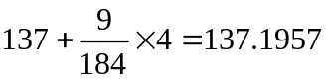
A coupon of 4 will be received after 175 days or 0.4795 years. The present value of the coupon on the bond is 4e^{-0.05×0.4795}=3.9053. The futures contract lasts 296 days or 0.8110 years. The cash futures price if it were written on the 8% bond would therefore be
(137.1957 − 3.9053)e^{0.05×0.8110} =138.8061
At delivery there are 121 days of accrued interest. The quoted futures if the contract were written on the 8% bond would therefore be
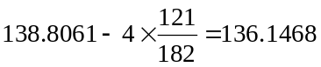
The quoted price should therefore be
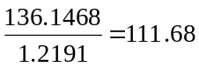

Problem 6.28.
Assume that a bank can borrow or lend money at the same interest rate in the LIBOR market. The 90-day rate is 10% per annum, and the 180-day rate is 10.2% per annum, both expressed with continuous compounding. The Eurodollar futures price for a contract maturing in 91 days is quoted as 89.5. What arbitrage opportunities are open to the bank?
The Eurodollar futures contract price of 89.5 means that the Eurodollar futures rate is 10.5% per annum with quarterly compounding and an actual/360 day count. This becomes 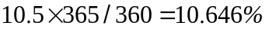 with an actual/actual day count. This is
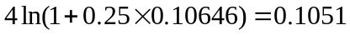
or 10.51% with continuous compounding. The forward rate given by the 90-day rate and the 180-day rate is 10.4% with continuous compounding. This suggests the following arbitrage opportunity:
- Buy Eurodollar futures.
- Borrow 180-day money.
- Invest the borrowed money for 90 days.

Problem 6.29.
A Canadian company wishes to create a Canadian LIBOR futures contract from a U.S. Eurodollar futures contract and forward contracts on foreign exchange. Using an example, explain how the company should proceed. For the purposes of this problem, assume that a futures contract is the same as a forward contract.
The U.S. Eurodollar futures contract maturing at time enables an investor to lock in the forward rate for the period between and 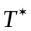 where is three months later than . If is the forward rate, the U.S. dollar cash flows that can be locked in are
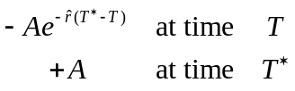
where  is the principal amount. To convert these to Canadian dollar cash flows, the Canadian company must enter into a short forward foreign exchange contract to sell Canadian dollars at time and a long forward foreign exchange contract to buy Canadian dollars at time . Suppose  and 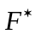 are the forward exchange rates for contracts maturing at times and . (These represent the number of Canadian dollars per U.S. dollar.) The Canadian dollars to be sold at time are
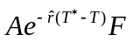
and the Canadian dollars to be purchased at time are
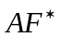
The forward contracts convert the U.S. dollar cash flows to the following Canadian dollar cash flows:
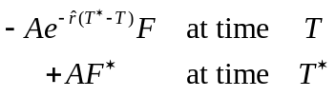
This is a Canadian dollar LIBOR futures contract where the principal amount is.

Problem 6.30.
On June 25, 2014, the futures price for the June 2014 bond futures contract is 118-23.
    - Calculate the conversion factor for a bond maturing on January 1, 2030, paying a coupon of 10%.
    - Calculate the conversion factor for a bond maturing on October 1, 2035, paying coupon of 7%.
    - Suppose that the quoted prices of the bonds in (a) and (b) are 169.00 and 136.00, respectively. Which bond is cheaper to deliver?
    - Assuming that the cheapest to deliver bond is actually delivered on June 25, 2013, what is the cash price received for the bond?
- On the first day of the delivery month the bond has 15 years and 7 months to maturity. The value of the bond assuming it lasts 15.5 years and all rates are 6% per annum with semiannual compounding is
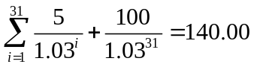
The conversion factor is therefore 1.4000.
- On the first day of the delivery month the bond has 21 years and 4 months to maturity. The value of the bond assuming it lasts 21.25 years and all rates are 6% per annum with semiannual compounding is
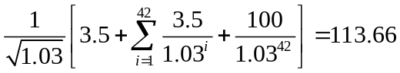
Subtracting the accrued interest of 1.75, this becomes 111.91. The conversion factor is therefore 1.1191.
- For the first bond, the quoted futures price times the conversion factor is
118.71875×1.4000 = 166.2063
This is 2.7938 less than the quoted bond price. For the second bond, the quoted futures price times the conversion factor is
118.71875×1.1191 = 132.8576
This is 3.1418 less than the quoted bond price. The first bond is therefore the cheapest to deliver.
- The price received for the bond is 166.2063 plus accrued interest. There are 175 days between January 1, 2014 and June 25, 2014. There are 181 days between January 1, 2014 and July 1, 2014. The accrued interest is therefore
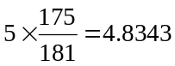

The cash price received for the bond is therefore 171.0406.

Problem 6.31.
A portfolio manager plans to use a Treasury bond futures contract to hedge a bond portfolio over the next three months. The portfolio is worth $100 million and will have a duration of 4.0 years in three months. The futures price is 122, and each futures contract is on $100,000 of bonds. The bond that is expected to be cheapest to deliver will have a duration of 9.0 years at the maturity of the futures contract. What position in futures contracts is required?
- What adjustments to the hedge are necessary if after one month the bond that is expected to be cheapest to deliver changes to one with a duration of seven years?
- Suppose that all rates increase over the three months, but long-term rates increase less than short-term and medium-term rates. What is the effect of this on the performance of the hedge?
The number of short futures contracts required is
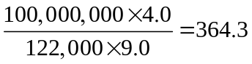
Rounding to the nearest whole number 364 contracts should be shorted.
- This increases the number of contracts that should be shorted to
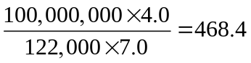
or 468 when we round to the nearest whole number.
- In this case the gain on the short futures position is likely to be less than the loss on the loss on the bond portfolio. This is because the gain on the short futures position depends on the size of the movement in long-term rates and the loss on the bond portfolio depends on the size of the movement in medium-term rates. Duration-based hedging assumes that the movements in the two rates are the same.

