CHAPTER 7
Swaps
Practice Questions

Problem 7.1.
Companies A and B have been offered the following rates per annum on a $20 million five-year loan:

 | Fixed Rate | Floating Rate
Company A | 5.0% | LIBOR+0.1%
Company B | 6.4% | LIBOR+0.6%

Company A requires a floating-rate loan; company B requires a fixed-rate loan. Design a swap that will net a bank, acting as intermediary, 0.1% per annum and that will appear equally attractive to both companies.
A has an apparent comparative advantage in fixed-rate markets but wants to borrow floating. B has an apparent comparative advantage in floating-rate markets but wants to borrow fixed. This provides the basis for the swap. There is a 1.4% per annum differential between the fixed rates offered to the two companies and a 0.5% per annum differential between the floating rates offered to the two companies. The total gain to all parties from the swap is therefore 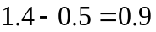% per annum. Because the bank gets 0.1% per annum of this gain, the swap should make each of A and B 0.4% per annum better off. This means that it should lead to A borrowing at LIBOR 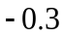% and to B borrowing at 6.0%. The appropriate arrangement is therefore as shown in Figure S7.1.
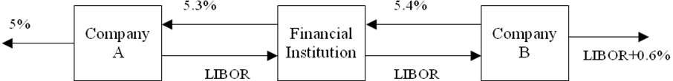

Figure S7.1: Swap for Problem 7.1

Problem 7.2.
Company X wishes to borrow U.S. dollars at a fixed rate of interest. Company Y wishes to borrow Japanese yen at a fixed rate of interest. The amounts required by the two companies are roughly the same at the current exchange rate. The companies have been quoted the following interest rates, which have been adjusted for the impact of taxes:

 | Yen | Dollars
Company X | 5.0% | 9.6%
Company Y | 6.5% | 10.0%

Design a swap that will net a bank, acting as intermediary, 50 basis points per annum. Make the swap equally attractive to the two companies and ensure that all foreign exchange risk is assumed by the bank.
X has a comparative advantage in yen markets but wants to borrow dollars. Y has a comparative advantage in dollar markets but wants to borrow yen. This provides the basis for the swap. There is a 1.5% per annum differential between the yen rates and a 0.4% per annum differential between the dollar rates. The total gain to all parties from the swap is therefore 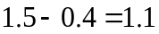% per annum. The bank requires 0.5% per annum, leaving 0.3% per annum for each of X and Y. The swap should lead to X borrowing dollars at 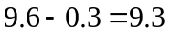% per annum and to Y borrowing yen at 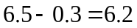% per annum. The appropriate arrangement is therefore as shown in Figure S7.2. All foreign exchange risk is borne by the bank.
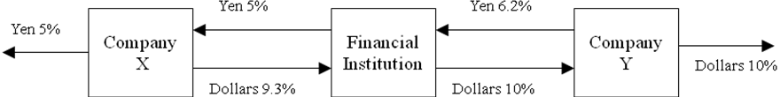
Figure S7.2: Swap for Problem 7.2

Problem 7.3.
A $100 million interest rate swap has a remaining life of 10 months. Under the terms of the swap, six-month LIBOR is exchanged for 7% per annum (compounded semiannually). The average of the bid–offer rate being exchanged for six-month LIBOR in swaps of all maturities is currently 5% per annum with continuous compounding. The six-month LIBOR rate was 4.6% per annum two months ago. What is the current value of the swap to the party paying floating? What is its value to the party paying fixed?
In four months $3.5 million (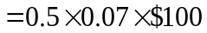 million) will be received and $2.3 million (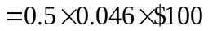 million) will be paid. (We ignore day count issues.) In 10 months $3.5 million will be received, and the LIBOR rate prevailing in four months’ time will be paid. The value of the fixed-rate bond underlying the swap is
The value of the floating-rate bond underlying the swap is
The value of the swap to the party paying floating is million. The value of the swap to the party paying fixed is 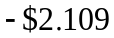 million.
These results can also be derived by decomposing the swap into forward contracts. Consider the party paying floating. The first forward contract involves paying $2.3 million and receiving $3.5 million in four months. It has a value of 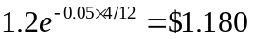 million. To value the second forward contract, we note that the forward interest rate is 5% per annum with continuous compounding, or 5.063% per annum with semiannual compounding. The value of the forward contract is
The total value of the forward contracts is therefore 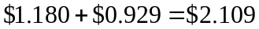 million.
Problem 7.4.
Explain what a swap rate is. What is the relationship between swap rates and par yields?
A swap rate for a particular maturity is the average of the bid and offer fixed rates that a market maker is prepared to exchange for LIBOR in a standard plain vanilla swap with that maturity. The swap rate for a particular maturity is the LIBOR/swap par yield for that maturity.
Problem 7.5.
A currency swap has a remaining life of 15 months. It involves exchanging interest at 10% on £20 million for interest at 6% on $30 million once a year. The term structure of interest rates in both the United Kingdom and the United States is currently flat, and if the swap were negotiated today the interest rates exchanged would be 4% in dollars and 7% in sterling. All interest rates are quoted with annual compounding. The current exchange rate (dollars per pound sterling) is 1.5500. What is the value of the swap to the party paying sterling? What is the value of the swap to the party paying dollars?
The swap involves exchanging the sterling interest of 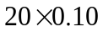 or £2 million for the dollar interest of 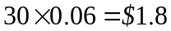 million. The principal amounts are also exchanged at the end of the life of the swap. The value of the sterling bond underlying the swap is
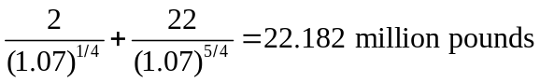
The value of the dollar bond underlying the swap is
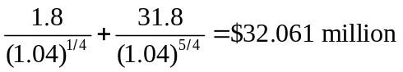
The value of the swap to the party paying sterling is therefore
32.061−(22.182×1.55) =−$2.321million

The value of the swap to the party paying dollars is $2.321 million. The results can also be obtained by viewing the swap as a portfolio of forward contracts. The continuously compounded interest rates in sterling and dollars are 6.766% per annum and 3.922% per annum. The 3-month and 15-month forward exchange rates are 1.55e^{(0.03922-0.06766)×0.25}=1.5390 and 1.55e^{(0.03922-0.06766)×1.25}=1.4959 . The values of the two forward contracts corresponding to the exchange of interest for the party paying sterling are therefore
(1.8−2×1.5390)e^{-0.03922×0.25} = −$1.2656 million
and
(1.8−2×1.4959)e^{-0.03922×1.25} = −$1.1347 million
The value of the forward contract corresponding to the exchange of principals is
(30−20×1.4959)e^{-0.03922×1.25} = +$0.0787 million
The total value of the swap is −$1.2656 −$1.1347 +$0.0787 million or −$2.322 million (which allowing for rounding errors is the same as that given by valuing bonds).
Problem 7.6.
Explain the difference between the credit risk and the market risk in a financial contract.
Credit risk arises from the possibility of a default by the counterparty. Market risk arises from movements in market variables such as interest rates and exchange rates. A complication is that the credit risk in a swap is contingent on the values of market variables. A company’s position in a swap has credit risk only when the value of the swap to the company is positive.
Problem 7.7.
A corporate treasurer tells you that he has just negotiated a five-year loan at a competitive fixed rate of interest of 5.2%. The treasurer explains that he achieved the 5.2% rate by borrowing at six-month LIBOR plus 150 basis points and swapping LIBOR for 3.7%. He goes on to say that this was possible because his company has a comparative advantage in the floating-rate market. What has the treasurer overlooked?
The rate is not truly fixed because, if the company’s credit rating declines, it will not be able to roll over its floating rate borrowings at LIBOR plus 150 basis points. The effective fixed borrowing rate then increases. Suppose, for example, that the treasurer’s spread over LIBOR increases from 150 basis points to 200 basis points. The borrowing rate increases from 5.2% to 5.7%.

Problem 7.8.
Explain why a bank is subject to credit risk when it enters into two offsetting swap contracts.
At the start of the swap, both contracts have a value of approximately zero. As time passes, it is likely that the swap values will change, so that one swap has a positive value to the bank and the other has a negative value to the bank. If the counterparty on the other side of the positive-value swap defaults, the bank still has to honor its contract with the other counterparty. It is liable to lose an amount equal to the positive value of the swap.

Problem 7.9.
Companies X and Y have been offered the following rates per annum on a $5 million 10-year investment:

 | Fixed Rate | Floating Rate
Company X | 8.0% | LIBOR
Company Y | 8.8% | LIBOR

Company X requires a fixed-rate investment; company Y requires a floating-rate investment. Design a swap that will net a bank, acting as intermediary, 0.2% per annum and will appear equally attractive to X and Y.
The spread between the interest rates offered to X and Y is 0.8% per annum on fixed rate investments and 0.0% per annum on floating rate investments. This means that the total apparent benefit to all parties from the swap is 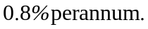 Of this 0.2% per annum will go to the bank. This leaves 0.3% per annum for each of X and Y. In other words, company X should be able to get a fixed-rate return of 8.3% per annum while company Y should be able to get a floating-rate return LIBOR + 0.3% per annum. The required swap is shown in Figure S7.3. The bank earns 0.2%, company X earns 8.3%, and company Y earns LIBOR + 0.3%.
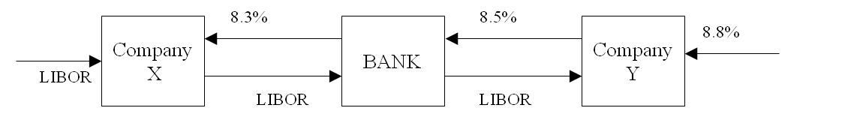

Figure S7.3: Swap for Problem 7.9
Problem 7.10.
A financial institution has entered into an interest rate swap with company X. Under the terms of the swap, it receives 10% per annum and pays six-month LIBOR on a principal of $10 million for five years. Payments are made every six months. Suppose that company X defaults on the sixth payment date (end of year 3) when the LIBOR/swap interest rate (with semiannual compounding) is 8% per annum for all maturities. What is the loss to the financial institution? Assume that six-month LIBOR was 9% per annum halfway through year 3.
At the end of year 3 the financial institution was due to receive $500,000 (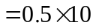% of $10 million) and pay $450,000 (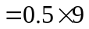% of $10 million). The immediate loss is therefore $50,000. To value the remaining swap we assume than forward rates are realized. All forward rates are 8% per annum. The remaining cash flows are therefore valued on the assumption that the floating payment is and the net payment that would be received is 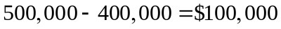. The total cost of default is therefore the cost of foregoing the following cash flows:
3 year: $50,000
3.5 year: $100,000
4 year: $100,000
4.5 year: $100,000
5 year: $100,000

Discounting these cash flows to year 3 at 4% per six months we obtain the cost of the default as $413,000.

Problem 7.11.
Companies A and B face the following interest rates (adjusted for the differential impact of taxes):

 | A | B
US dollars (floating rate) | LIBOR+0.5% | LIBOR+1.0%
Canadian dollars (fixed rate) | 5.0% | 6.5%

Assume that A wants to borrow U.S. dollars at a floating rate of interest and B wants to borrow Canadian dollars at a fixed rate of interest. A financial institution is planning to arrange a swap and requires a 50-basis-point spread. If the swap is equally attractive to A and B, what rates of interest will A and B end up paying?
Company A has a comparative advantage in the Canadian dollar fixed-rate market. Company B has a comparative advantage in the U.S. dollar floating-rate market. (This may be because of their tax positions.) However, company A wants to borrow in the U.S. dollar floating-rate market and company B wants to borrow in the Canadian dollar fixed-rate market. This gives rise to the swap opportunity.
The differential between the U.S. dollar floating rates is 0.5% per annum, and the differential between the Canadian dollar fixed rates is 1.5% per annum. The difference between the differentials is 1% per annum. The total potential gain to all parties from the swap is therefore 1% per annum, or 100 basis points. If the financial intermediary requires 50 basis points, each of A and B can be made 25 basis points better off. Thus a swap can be designed so that it provides A with U.S. dollars at LIBOR 0.25% per annum, and B with Canadian dollars at 6.25% per annum. The swap is shown in Figure S7.4.
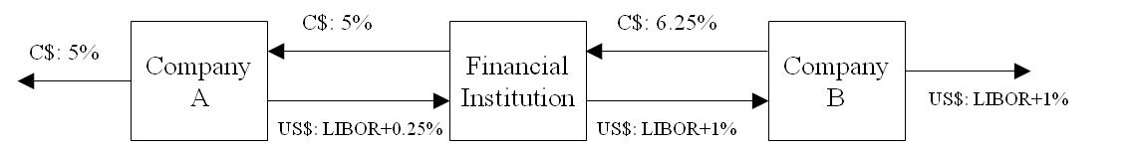

Figure S7.4: Swap for Problem 7.11
Principal payments flow in the opposite direction to the arrows at the start of the life of the swap and in the same direction as the arrows at the end of the life of the swap. The financial institution would be exposed to some foreign exchange risk which could be hedged using forward contracts.

Problem 7.12.
A financial institution has entered into a 10-year currency swap with company Y. Under the terms of the swap, the financial institution receives interest at 3% per annum in Swiss francs and pays interest at 8% per annum in U.S. dollars. Interest payments are exchanged once a year. The principal amounts are 7 million dollars and 10 million francs. Suppose that company Y declares bankruptcy at the end of year 6, when the exchange rate is $0.80 per franc. What is the cost to the financial institution? Assume that, at the end of year 6, the interest rate is 3% per annum in Swiss francs and 8% per annum in U.S. dollars for all maturities. All interest rates are quoted with annual compounding.
When interest rates are compounded annually
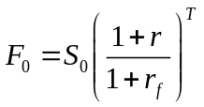
where 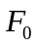 is the -year forward rate, 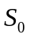 is the spot rate, is the domestic risk-free rate, and 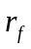 is the foreign risk-free rate. As 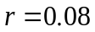 and 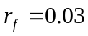, the spot and forward exchange rates at the end of year 6 are
Spot: 0.8000
1 year forward: 0.8388
2 year forward: 0.8796
3 year forward: 0.9223
4 year forward: 0.9670
The value of the swap at the time of the default can be calculated on the assumption that forward rates are realized. The cash flows lost as a result of the default are therefore as follows:

Year | Dollar Paid | CHF Received | Forward Rate | Dollar Equiv of CHF Received | Cash Flow Lost
6 | 560,000 | 300,000 | 0.8000 | 240,000 | -320,000
7 | 560,000 | 300,000 | 0.8388 | 251,600 | -308,400
8 | 560,000 | 300,000 | 0.8796 | 263,900 | -296,100
9 | 560,000 | 300,000 | 0.9223 | 276,700 | -283,300
10 | 7,560,000 | 10,300,000 | 0.9670 | 9,960,100 | 2,400,100

Discounting the numbers in the final column to the end of year 6 at 8% per annum, the cost of the default is $679,800.
Note that, if this were the only contract entered into by company Y, it would make no sense for the company to default at the end of year six as the exchange of payments at that time has a positive value to company Y. In practice, company Y is likely to be defaulting and declaring bankruptcy for reasons unrelated to this particular contract and payments on the contract are likely to stop when bankruptcy is declared.
Problem 7.13.
After it hedges its foreign exchange risk using forward contracts, is the financial institution’s average spread in Figure 7.11 likely to be greater than or less than 20 basis points? Explain your answer.
The financial institution will have to buy 1.1% of the AUD principal in the forward market for each year of the life of the swap. Since AUD interest rates are higher than dollar interest rates, AUD is at a discount in forward markets. This means that the AUD purchased for year 2 is less expensive than that purchased for year 1; the AUD purchased for year 3 is less expensive than that purchased for year 2; and so on. This works in favor of the financial institution and means that its spread increases with time. The spread is always above 20 basis points.
Problem 7.14.
“Companies with high credit risks are the ones that cannot access fixed-rate markets directly. They are the companies that are most likely to be paying fixed and receiving floating in an interest rate swap.” Assume that this statement is true. Do you think it increases or decreases the risk of a financial institution’s swap portfolio? Assume that companies are most likely to default when interest rates are high.
Consider a plain-vanilla interest rate swap involving two companies X and Y. We suppose that X is paying fixed and receiving floating while Y is paying floating and receiving fixed.
The quote suggests that company X will usually be less creditworthy than company Y. (Company X might be a BBB-rated company that has difficulty in accessing fixed-rate markets directly; company Y might be a AAA-rated company that has no difficulty accessing fixed or floating rate markets.) Presumably company X wants fixed-rate funds and company Y wants floating-rate funds.
The financial institution will realize a loss if company Y defaults when rates are high or if company X defaults when rates are low. These events are relatively unlikely since (a) Y is unlikely to default in any circumstances and (b) defaults are less likely to happen when rates are low. For the purposes of illustration, suppose that the probabilities of various events are as follows:
Default by Y: 0.001
Default by X: 0.010
Rates high when default occurs: 0.7
Rates low when default occurs: 0.3
The probability of a loss is
If the roles of X and Y in the swap had been reversed the probability of a loss would be
Assuming companies are more likely to default when interest rates are high, the above argument shows that the observation in quotes has the effect of decreasing the risk of a financial institution’s swap portfolio. It is worth noting that the assumption that defaults are more likely when interest rates are high is open to question. The assumption is motivated by the thought that high interest rates often lead to financial difficulties for corporations. However, there is often a time lag between interest rates being high and the resultant default. When the default actually happens interest rates may be relatively low.

Problem 7.15.
Why is the expected loss from a default on a swap less than the expected loss from the default on a loan to the same counterparty with the same principal?
In an interest-rate swap a financial institution’s exposure depends on the difference between a fixed-rate of interest and a floating-rate of interest. It has no exposure to the notional principal. In a loan the whole principal can be lost.

Problem 7.16.
A bank finds that its assets are not matched with its liabilities. It is taking floating-rate deposits and making fixed-rate loans. How can swaps be used to offset the risk?
The bank is paying a floating-rate on the deposits and receiving a fixed-rate on the loans. It can offset its risk by entering into interest rate swaps (with other financial institutions or corporations) in which it contracts to pay fixed and receive floating.
Problem 7.17.
Explain how you would value a swap that is the exchange of a floating rate in one currency for a fixed rate in another currency.

The floating payments can be valued in currency A by (i) assuming that the forward rates are realized, and (ii) discounting the resulting cash flows at appropriate currency A discount rates. Suppose that the value is 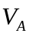. The fixed payments can be valued in currency B by discounting them at the appropriate currency B discount rates. Suppose that the value is 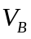. If  is the current exchange rate (number of units of currency A per unit of currency B), the value of the swap in currency A is 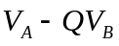. Alternatively, it is 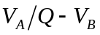 in currency B.

Problem 7.18.
The LIBOR zero curve is flat at 5% (continuously compounded) out to 1.5 years. Swap rates for 2- and 3-year semiannual pay swaps are 5.4% and 5.6%, respectively. Estimate the LIBOR zero rates for maturities of 2.0, 2.5, and 3.0 years. (Assume that the 2.5-year swap rate is the average of the 2- and 3-year swap rates.)
The two-year swap rate is 5.4%. This means that a two-year LIBOR bond paying a semiannual coupon at the rate of 5.4% per annum sells for par. If  is the two-year LIBOR zero rate
Solving this gives 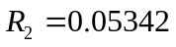. The 2.5-year swap rate is assumed to be 5.5%. This means that a 2.5-year LIBOR bond paying a semiannual coupon at the rate of 5.5% per annum sells for par. If 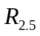 is the 2.5-year LIBOR zero rate
Solving this gives 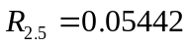. The 3-year swap rate is 5.6%. This means that a 3-year LIBOR bond paying a semiannual coupon at the rate of 5.6% per annum sells for par. If 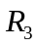 is the three-year LIBOR zero rate
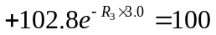
Solving this gives 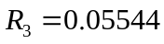. The zero rates for maturities 2.0, 2.5, and 3.0 years are therefore 5.342%, 5.442%, and 5.544%, respectively.

Problem 7.19.
How would you measure the dollar duration of a swap?

The dollar duration of a bond is −ΔB/Δy where Δy is the size of a small parallel shift in the zero curve and ΔB is the effect of this on the bond price. We can define the dollar duration of a swap similarly. We measure it by making a small parallel shift to the LIBOR/swap zero curve and observe the effect on the value of the swap.

Further Questions

Problem 7.20.
(a) Company A has been offered the rates shown in Table 7.3. It can borrow for three years at 6.45%. What floating rate can it swap this fixed rate into?
(b) Company B has been offered the rates shown in Table 7.3. It can borrow for 5 years at LIBOR plus 75 basis points. What fixed rate can it swap this floating rate into?

(a) Company A can pay LIBOR and receive 6.21% for three years. It can therefore exchange a loan at 6.45% into a loan at LIBOR plus 0.24% or LIBOR plus 24 basis points
(b) Company B can receive LIBOR and pay 6.51% for five years. It can therefore exchange a loan at LIBOR plus 0.75% for a loan at 7.26%.

Problem 7.21.
(a) Company X has been offered the rates shown in Table 7.3. It can invest for four years at 5.5%. What floating rate can it swap this fixed rate into?
(b) Company Y has been offered the rates shown in Table 7.3. It can invest for 10 years at LIBOR minus 50 basis points. What fixed rate can it swap this floating rate into?

(a) Company X can pay 6.39% for four years and receive LIBOR. It can therefore exchange the investment at 5.5% for an investment at LIBOR minus 0.89% or LIBOR minus 89 basis points.
(b) Company Y can receive 6.83% and pay LIBOR for 10 years. It can therefore exchange an investment at LIBOR minus 0.5% for an investment at 6.33%.

Problem 7.22.
The one-year LIBOR rate is 10% with annual compounding. A bank trades swaps where a fixed rate of interest is exchanged for 12-month LIBOR with payments being exchanged annually. Two- and three-year swap rates (expressed with annual compounding) are 11% and 12% per annum. Estimate the two- and three-year LIBOR zero rates.
The two-year swap rate implies that a two-year LIBOR bond with a coupon of 11% sells for par. If is the two-year zero rate
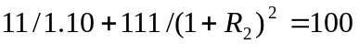
so that 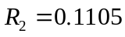. The three-year swap rate implies that a three-year LIBOR bond with a coupon of 12% sells for par. If is the three-year zero rate
so that 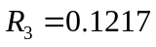. The two- and three-year rates are therefore 11.05% and 12.17% with annual compounding.

Problem 7.23.
Under the terms of an interest rate swap, a financial institution has agreed to pay 10% per annum and receive three-month LIBOR in return on a notional principal of $100 million with payments being exchanged every three months. The swap has a remaining life of 14 months. The average of the bid and offer fixed rates currently being swapped for three-month LIBOR is 12% per annum for all maturities. The three-month LIBOR rate one month ago was 11.8% per annum. All rates are compounded quarterly. What is the value of the swap?
The swap can be regarded as a long position in a floating-rate bond combined with a short position in a fixed-rate bond. The correct discount rate is 12% per annum with quarterly compounding or 11.82% per annum with continuous compounding.
Immediately after the next payment the floating-rate bond will be worth $100 million. The next floating payment ($ million) is
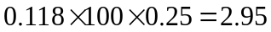
The value of the floating-rate bond is therefore
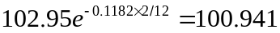
The value of the fixed-rate bond is
The value of the swap is therefore

As an alternative approach we can value the swap as a series of forward rate agreements. The calculated value is
which is in agreement with the answer obtained using the first approach.

Problem 7.24.
Company A, a British manufacturer, wishes to borrow U.S. dollars at a fixed rate of interest. Company B, a US multinational, wishes to borrow sterling at a fixed rate of interest. They have been quoted the following rates per annum (adjusted for differential tax effects):

 | Sterling | US Dollars
Company A | 11.0% | 7.0%
Company B | 10.6% | 6.2%

Design a swap that will net a bank, acting as intermediary, 10 basis points per annum and that will produce a gain of 15 basis points per annum for each of the two companies.
The spread between the interest rates offered to A and B is 0.4% (or 40 basis points) on sterling loans and 0.8% (or 80 basis points) on U.S. dollar loans. The total benefit to all parties from the swap is therefore
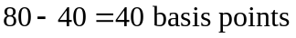
It is therefore possible to design a swap which will earn 10 basis points for the bank while making each of A and B 15 basis points better off than they would be by going directly to financial markets. One possible swap is shown in Figure S7.5. Company A borrows at an effective rate of 6.85% per annum in U.S. dollars.
Company B borrows at an effective rate of 10.45% per annum in sterling. The bank earns a 10-basis-point spread. The way in which currency swaps such as this operate is as follows. Principal amounts in dollars and sterling that are roughly equivalent are chosen. These principal amounts flow in the opposite direction to the arrows at the time the swap is initiated. Interest payments then flow in the same direction as the arrows during the life of the swap and the principal amounts flow in the same direction as the arrows at the end of the life of the swap.
Note that the bank is exposed to some exchange rate risk in the swap. It earns 65 basis points in U.S. dollars and pays 55 basis points in sterling. This exchange rate risk could be hedged using forward contracts.
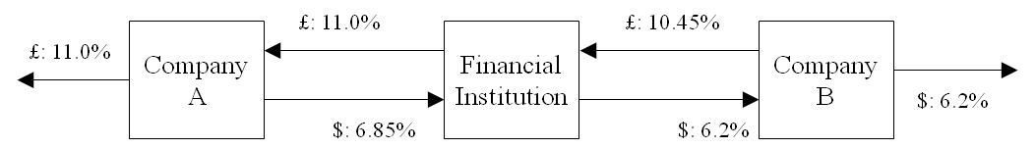

Figure S7.5: One Possible Swap for Problem 7.24
Problem 7.25.
Suppose that the term structure of interest rates is flat in the United States and Australia. The USD interest rate is 7% per annum and the AUD rate is 9% per annum. The current value of the AUD is 0.62 USD. In a swap agreement, a financial institution pays 8% per annum in AUD and receives 4% per annum in USD. The principals in the two currencies are $12 million USD and 20 million AUD. Payments are exchanged every year, with one exchange having just taken place. The swap will last two more years. What is the value of the swap to the financial institution? Assume all interest rates are continuously compounded.

The financial institution is long a dollar bond and short a USD bond. The value of the dollar bond (in millions of dollars) is
The value of the AUD bond (in millions of AUD) is
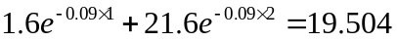
The value of the swap (in millions of dollars) is therefore
or –$795,000.
As an alternative we can value the swap as a series of forward foreign exchange contracts. The one-year forward exchange rate is 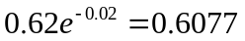. The two-year forward exchange rate is 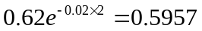. The value of the swap in millions of dollars is therefore
which is in agreement with the first calculation.

Problem 7.26.
Company X is based in the United Kingdom and would like to borrow $50 million at a fixed rate of interest for five years in U.S. funds. Because the company is not well known in the United States, this has proved to be impossible. However, the company has been quoted 12% per annum on fixed-rate five-year sterling funds. Company Y is based in the United States and would like to borrow the equivalent of $50 million in sterling funds for five years at a fixed rate of interest. It has been unable to get a quote but has been offered U.S. dollar funds at 10.5% per annum. Five-year government bonds currently yield 9.5% per annum in the United States and 10.5% in the United Kingdom. Suggest an appropriate currency swap that will net the financial intermediary 0.5% per annum.

There is a 1% differential between the yield on sterling and dollar 5-year bonds. The financial intermediary could use this differential when designing a swap. For example, it could (a) allow company X to borrow dollars at 1% per annum less than the rate offered on sterling funds, that is, at 11% per annum and (b) allow company Y to borrow sterling at 1% per annum more than the rate offered on dollar funds, that is, at 11% per annum. However, as shown in Figure S7.6, the financial intermediary would not then earn a positive spread.
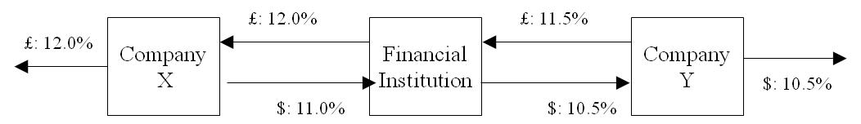

Figure S7.6: First attempt at designing swap for Problem 7.26
To make 0.5% per annum, the financial intermediary could add 0.25% per annum, to the rates paid by each of X and Y. This means that X pays 11.25% per annum, for dollars and Y pays 11.75% per annum, for sterling and leads to the swap shown in Figure S7.7. The financial intermediary would be exposed to some foreign exchange risk in this swap. This could be hedged using forward contracts.
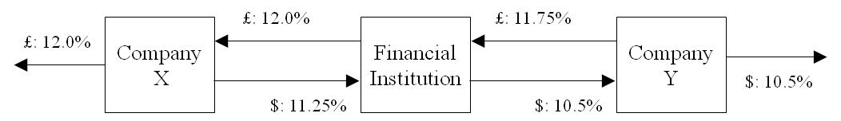

Figure S7.7: Final swap for Problem 7.26

