Chapter 9
OIS Discounting, Credit Issues, and Funding Costs

Practice Questions
Problem 9.1.
Explain what is meant by (a) the 3-month LIBOR rate and (b) the 3-month OIS rate.
Which is higher? Why?

The 3-month LIBOR rate is the rate at which a AA-rated bank can borrow from other banks. (Banks report these rates to the British Bankers Association at 11am each day.) The three-month OIS rate is the rate that can be swapped for the geometric average of the effective overnight federal funds rate. The 3-month LIBOR rate is higher. The difference is shown in Figure 9.1. The difference arises from the fact that there is more risk in making a single three-month loan to a creditworthy bank than a series of overnight loans to creditworthy banks. If a bank’s creditworthiness declines during the 3 months, it will no longer be able to borrow in overnight markets, but the 3 month loan will still be outstanding.

Problem 9.2.
‘‘When banks become reluctant to lend to each other the 3-month LIBOR-OIS spread
increases.’’ Explain this statement.

As explained in the answer to the previous question, the LIBOR-OIS spread depends on the perceived difference between the riskiness of a three-month loan to a bank and the riskiness of a series of overnight loans to the same bank. This difference increases when market conditions are such that banks are reluctant to lend to each other.

Problem 9.3.
Suppose that in Example 9.2 where LIBOR discounting is used the 3-year LIBOR-for-fixed
swap rate with annual payments is 7% (annually compounded). What is the 3-year
LIBOR/swap zero rate? What is the LIBOR forward rate for the period between 2 and
3 years?

A three year bond paying 7% is worth par. Hence, the three-year LIBOR/swap zero rate is given by R where
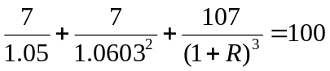
showing that the three-year LIBOR/swap zero rate is 7.097%
The LIBOR forward rate for the third year is
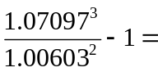9.263%

Problem 9.4.
Suppose that in Example 9.3 where OIS discounting is used the 3-year LIBOR-for-fixed
swap rate with annual payments is 7% (annually compounded). The 3-year OIS zero rate
is 6.5% (annually compounded). What is the LIBOR forward rate for the period between
2 and 3 years?

The value of the three-year swap is zero so that the LIBOR forward rate for the third year is F where
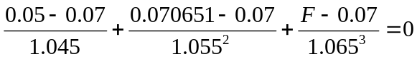
This gives the LIBOR forward rate for the third year as 9.241%. This is a little more than 2 basis points different from the LIBOR forward rate calculated using LIBOR discounting in the previous problem.

Problem 9.5.
Why do derivatives traders sometimes use more than one risk-free zero curve for
discounting?

Derivatives traders like to match the discount rate to their cost of funding even though this is not correct theoretically. When derivatives are collateralized, they are funded by the collateral and the interest rate paid on collateral is usually the federal funds rate. This leads to OIS discounting because the OIS rate is the longer term rate corresponding to the federal funds rate. When derivatives are not collateralized, they are considered to be funded by the bank at its overall average funding cost, which is higher than the OIS rate.

Problem 9.6.
Explain what CVA and DVA measure?

CVA measures the cost to a derivatives market participant because its counterparty might default. DVA measures the benefit to the market participant (equals cost to the counterparty) because the market participant itself might default.

Problem 9.7.
If the market considers that the default probability for a bank has increased, what
happens to its DVA? What happens to the income it reports?

If the market considers that a bank has become less creditworthy so that it is more likely to default, its DVA will increase. This will lead to an increase in its income and its equity. This seems paradoxical. How can there be an automatic increase to a bank’s income and its equity wwhen it becomes less creditworthy? The answer is as follows. When a bank becomes less creditworthy, there is an increase in the expected benefit to the bank from the fact that it might default on a) outstanding transactions such as derivatives and b) outstanding funding . In the third quarter of 2011, the credit spreads of Wells Fargo, JPMorgan, Citigroup, Bank of America, and Morgan Stanley increased by 63, 81, 179, 266, and 328 basis points, respectively. As a result, these banks reported DVA gains that tended to swamp other income statement items. DVA gains and losses are approved by accounting bodies, but have now been excluded from the definition of common equity in determining regulatory capital.

Problem 9.8.
Explain the collateral rate adjustment. Under what circumstances is it nonzero?

The collateral rate adjustment is an adjustment made if the interest paid on collateral is different from the assumed risk-free rate. The latter is usually the OIS rate for collateralized transaction. If the rate paid on collateral were the federal funds rate (which is linked to the OIS rate) plus 10 basis points, the collateral rate adjustment would reflect the extra 10 basis points that is paid or received on cash collateral. For fully collateral transactions where all collateral is provided in the form of cash, the effect of the collateral rate adjustment is to increase the discount rate by 10 basis points.

Problem 9.9.
The average funding cost for a company is 5% per annum when the risk-free rate is 3%.
The company is currently undertaking projects worth $9 million. It plans to increase its
size by undertaking $1 million of risk-free projects. What would you expect to happen to
its average funding cost.

The average funding cost should come down. The company will become less risky. Its average funding cost should be a weighted average of 5% for the old projects and 3% for the new ones. This is 0.9×5%+0.1×3% or 4.8%.

Problem 9.10.
OIS rates have been estimated as 3.4% per annum for all maturities. The 3-month LIBOR
rate is 3.5% per annum. For a 6-month swap where payments are exchanged every 3
months the swap rate is 3.6% per annum. All rates are expressed with quarterly
compounding. What is the LIBOR forward rate for the 3- to 6-month period if OIS
discounting is used?

Suppose that the LIBOR forward rate is F. Assume a principal of $1000. A swap where 3.6% ($9 per quarter) is received and LIBOR is paid is worth zero. The exchange at the three-month point to the party receiving fixed is worth
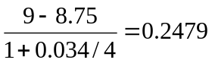
The exchange at the six-month point to the party receiving fixed is worth
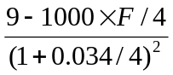
Hence
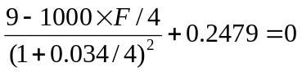
so that F = 3.701%.
Problem 9.11.
Explain why CVA and DVA are calculated for the whole portfolio of transactions a bank
has with a counterparty, not on a transaction-by-transaction basis.

Netting means that the transactions between two counterparties are considered as a single transaction in the event of a default. This means that estimating losses depends on estimating the value of the portfolio of transactions a bank has with a counterparty at possible default times.

Further Questions

Problem 9.12.
Suppose that the 1-year LIBOR rate is 4% and 2-year, 3-year, and 4-year LIBOR-for-fixed
swap rates with annual payments are 4.2%, 4.4%, and 4.5%. All rates are annually
compounded.
(a) If LIBOR is used for discounting, what are the LIBOR/swap zero rates for maturities
of 2, 3, and 4 years?
(b) If LIBOR is used for discounting, what are the LIBOR forward rates for the second,
third, and fourth years?
(c) If OIS zero rates for maturities of 1, 2, 3, and 4 years are 3.6%, 3.8%, 4%, and 4.1%
per annum with annual compounding and OIS discounting is used, what are the
LIBOR forward rates for the second, third, and fourth years?

- The 2-year par yield is 4.2%. Hence if R is the 2-year zero rate
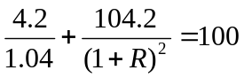
so that the two-year zero rate is 4.204%
The 3-year par yield is 4.4%. Hence if R is the three-year zero rate
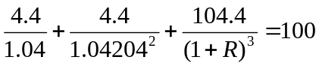
so that the three-year zero rate is 4.412%
The 4-year par yield is 4.5%. Hence if R is the four-year zero rate
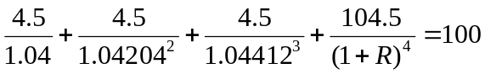
so that the four-year zero rate is 4.516%.
- The LIBOR forward rate for the second year is
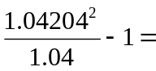4.409%
The LIBOR forward rate for the third year is
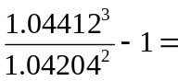4.829%
The LIBOR forward rate for the fourth year is
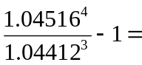4.829%
- Because the 2-year swap has a value of zero, the forward rate for the second year is given by F where
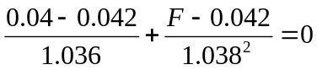
so that the second year forward rate is 4.408%
Because the 3-year swap has a value of zero, the forward rate for the third year is given by F where
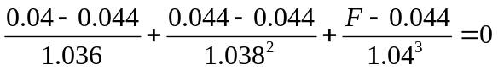
so that the third year forward rate is 4.801%
Because the 4-year swap has a value of zero, the forward rate for the fourth year is given by F where
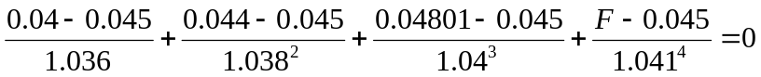
so that the third year forward rate is 4.853%

Problem 9.13.
The 1-year LIBOR zero rate is 3% per annum and the LIBOR forward rate for the 1- to
2-year period is 3.2%. The 3-year swap rate for a swap with annual payments is 3.2%. All
rates are annually compounded. What is the LIBOR forward rate for the 2- to 3-year
period if OIS discounting is used and the OIS zero rates for maturities of 1, 2, and 3 years
are 2.5%, 2.7%, and 2.9%, respectively. What is the value of a 3-year swap where 4% is
received and LIBOR is paid on a principal of $100 million?
The swap with a fixed rate of 3.2% is worth zero. The value of the first exchange to the party receiving fixed per dollar of principal is
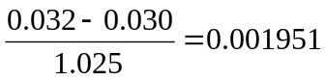
The value of the second exchange is
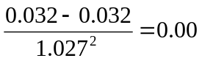
If F is the forward rate for the third year, the value of the third exchange is
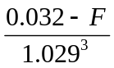
Hence
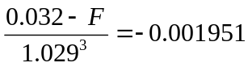
so that F = 0.034126 or 3.4126%.
A swap where 4% is received on a principal of $100 million provides 0.8% of $100 million or $800,000 per year more than a swap worth zero. Its value is
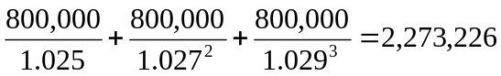
or about $2.27 million.
Problem 9.14.
Suppose the 1-year and 10-year LIBOR-for-fixed swap rates are 3% and X% (with annual payments). The 1-year and 10-year OIS swap rates are 50 basis points lower than the corresponding LIBOR-for-fixed swap rates. Use the zero curve worksheet in DerivaGem to investigate the difference between the 10-year LIBOR zero rate with OIS discounting and the 10-year LIBOR zero rate with LIBOR discounting. In particular, consider what happens as X increases from 3 to 10.

As X increases from 3% to 10%, DerivaGem 3.00 shows that the difference increases from 0 to 8.5 basis points.
Problem 9.15.
This problem should not have been included. Problem 7.27, to which the problem refers, was deleted at the last minute.

