CHAPTER 10
Mechanics of Options Markets
Practice Questions
Problem 10.1.
An investor buys a European put on a share for $3. The stock price is $42 and the strike price is $40. Under what circumstances does the investor make a profit? Under what circumstances will the option be exercised? Draw a diagram showing the variation of the investor’s profit with the stock price at the maturity of the option.
The investor makes a profit if the price of the stock on the expiration date is less than $37. In these circumstances the gain from exercising the option is greater than $3. The option will be exercised if the stock price is less than $40 at the maturity of the option. The variation of the investor’s profit with the stock price in Figure S10.1.

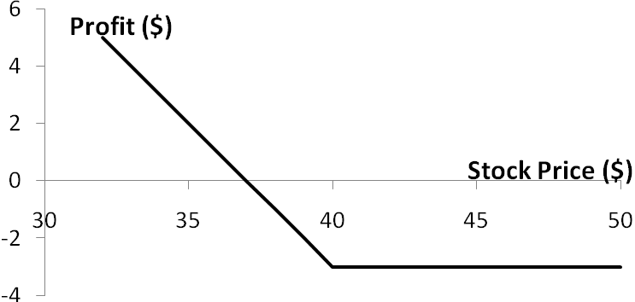

Figure S10.1: Investor’s profit in Problem 10.1

Problem 10.2.
An investor sells a European call on a share for $4. The stock price is $47 and the strike price is $50. Under what circumstances does the investor make a profit? Under what circumstances will the option be exercised? Draw a diagram showing the variation of the investor’s profit with the stock price at the maturity of the option.
The investor makes a profit if the price of the stock is below $54 on the expiration date. If the stock price is below $50, the option will not be exercised, and the investor makes a profit of $4. If the stock price is between $50 and $54, the option is exercised and the investor makes a profit between $0 and $4. The variation of the investor’s profit with the stock price is as shown in Figure S10.2.
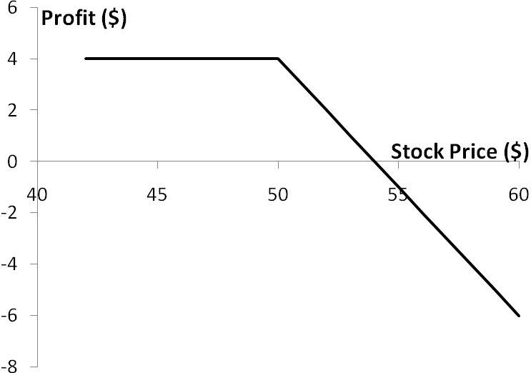
Figure S10.2: Investor’s profit in Problem 10.2

Problem 10.3.
An investor sells a European call option with strike price of  and maturity and buys a put with the same strike price and maturity. Describe the investor’s position.
The payoff to the investor is
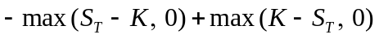

This is 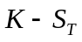 in all circumstances. The investor’s position is the same as a short position in a forward contract with delivery price .
Problem 10.4.
Explain why margin accounts are required when clients write options but not when they buy options.
When an investor buys an option, cash must be paid up front. There is no possibility of future liabilities and therefore no need for a margin account. When an investor sells an option, there are potential future liabilities. To protect against the risk of a default, margins are required.
Problem 10.5.
A stock option is on a February, May, August, and November cycle. What options trade on (a) April 1 and (b) May 30?
On April 1 options trade with expiration months of April, May, August, and November. On May 30 options trade with expiration months of June, July, August, and November.

Problem 10.6.
A company declares a 2-for-1 stock split. Explain how the terms change for a call option with a strike price of $60.
The strike price is reduced to $30, and the option gives the holder the right to purchase twice as many shares.
Problem 10.7.
“Employee stock options issued by a company are different from regular exchange-traded call options on the company’s stock because they can affect the capital structure of the company.” Explain this statement.
The exercise of employee stock options usually leads to new shares being issued by the company and sold to the employee. This changes the amount of equity in the capital structure. When a regular exchange-traded option is exercised no new shares are issued and the company’s capital structure is not affected.
Problem 10.8.
A corporate treasurer is designing a hedging program involving foreign currency options. What are the pros and cons of using (a) the NASDAQ OMX and (b) the over-the-counter market for trading?
The NASDAQ OMX offers options with standard strike prices and times to maturity. Options in the over-the-counter market have the advantage that they can be tailored to meet the precise needs of the treasurer. Their disadvantage is that they expose the treasurer to some credit risk. Exchanges organize their trading so that there is virtually no credit risk.

Problem 10.9.
Suppose that a European call option to buy a share for $100.00 costs $5.00 and is held until maturity. Under what circumstances will the holder of the option make a profit? Under what circumstances will the option be exercised? Draw a diagram illustrating how the profit from a long position in the option depends on the stock price at maturity of the option.
Ignoring the time value of money, the holder of the option will make a profit if the stock price at maturity of the option is greater than $105. This is because the payoff to the holder of the option is, in these circumstances, greater than the $5 paid for the option. The option will be exercised if the stock price at maturity is greater than $100. Note that if the stock price is between $100 and $105 the option is exercised, but the holder of the option takes a loss overall. The profit from a long position is as shown in Figure S10.3.

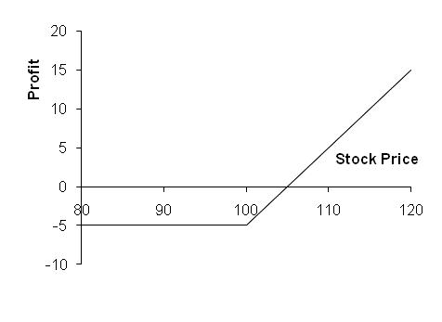

Figure S10.3: Profit from long position in Problem 10.9

Problem 10.10.
Suppose that a European put option to sell a share for $60 costs $8 and is held until maturity. Under what circumstances will the seller of the option (the party with the short position) make a profit? Under what circumstances will the option be exercised? Draw a diagram illustrating how the profit from a short position in the option depends on the stock price at maturity of the option.
Ignoring the time value of money, the seller of the option will make a profit if the stock price at maturity is greater than $52.00. This is because the cost to the seller of the option is in these circumstances less than the price received for the option. The option will be exercised if the stock price at maturity is less than $60.00. Note that if the stock price is between $52.00 and $60.00 the seller of the option makes a profit even though the option is exercised. The profit from the short position is as shown in Figure S10.4.

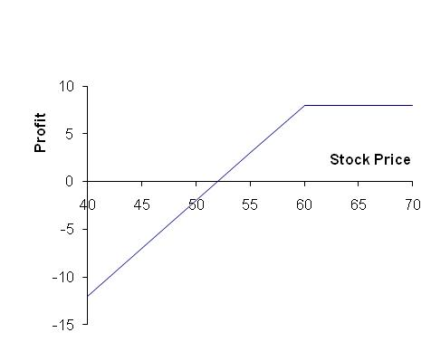

Figure S10.4: Profit from short position in Problem 10.10

Problem 10.11.
Describe the terminal value of the following portfolio: a newly entered-into long forward contract on an asset and a long position in a European put option on the asset with the same maturity as the forward contract and a strike price that is equal to the forward price of the asset at the time the portfolio is set up. Show that the European put option has the same value as a European call option with the same strike price and maturity.
The terminal value of the long forward contract is:
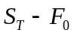
where 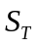 is the price of the asset at maturity and 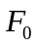 is the forward price of the asset at the time the portfolio is set up. (The delivery price in the forward contract is also .)
The terminal value of the put option is:
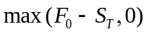
The terminal value of the portfolio is therefore
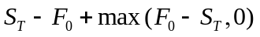
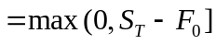
This is the same as the terminal value of a European call option with the same maturity as the forward contract and an exercise price equal to . This result is illustrated in the Figure S10.5.

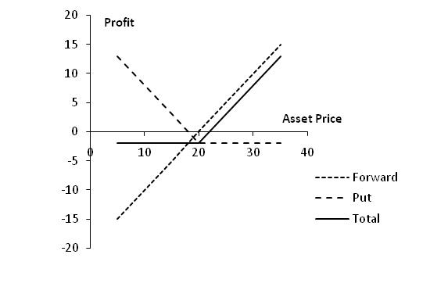

Figure S10.5: Profit from portfolio in Problem 10.11

We have shown that the forward contract plus the put is worth the same as a call with the same strike price and time to maturity as the put. The forward contract is worth zero at the time the portfolio is set up. It follows that the put is worth the same as the call at the time the portfolio is set up.

Problem 10.12.
A trader buys a call option with a strike price of $45 and a put option with a strike price of $40. Both options have the same maturity. The call costs $3 and the put costs $4. Draw a diagram showing the variation of the trader’s profit with the asset price.
Figure S10.6 shows the variation of the trader’s position with the asset price. We can divide the alternative asset prices into three ranges:
- When the asset price less than $40, the put option provides a payoff of 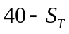 and the call option provides no payoff. The options cost $7 and so the total profit is 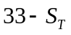.
- When the asset price is between $40 and $45, neither option provides a payoff. There is a net loss of $7.
- When the asset price greater than $45, the call option provides a payoff of 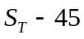 and the put option provides no payoff. Taking into account the $7 cost of the options, the total profit is 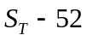.
The trader makes a profit (ignoring the time value of money) if the stock price is less than $33 or greater than $52. This type of trading strategy is known as a strangle and is discussed in Chapter 12.

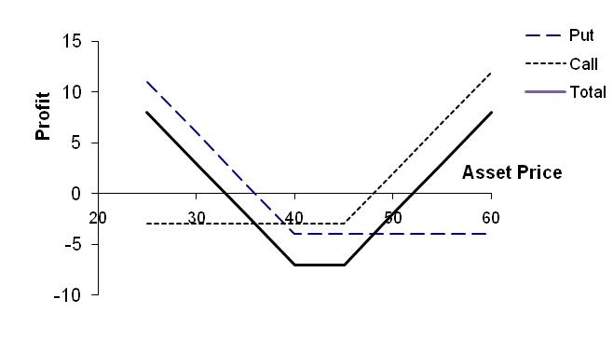

Figure S10.6: Profit from trading strategy in Problem 10.12

Problem 10.13.
Explain why an American option is always worth at least as much as a European option on the same asset with the same strike price and exercise date.
The holder of an American option has all the same rights as the holder of a European option and more. It must therefore be worth at least as much. If it were not, an arbitrageur could short the European option and take a long position in the American option.

Problem 10.14.
Explain why an American option is always worth at least as much as its intrinsic value.
The holder of an American option has the right to exercise it immediately. The American option must therefore be worth at least as much as its intrinsic value. If it were not an arbitrageur could lock in a sure profit by buying the option and exercising it immediately.

Problem 10.15.
Explain carefully the difference between writing a put option and buying a call option.
Writing a put gives a payoff of 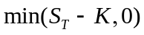. Buying a call gives a payoff of 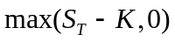. In both cases the potential payoff is 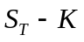. The difference is that for a written put the counterparty chooses whether you get the payoff (and will allow you to get it only when it is negative to you). For a long call you decide whether you get the payoff (and you choose to get it when it is positive to you.)
Problem 10.16.
The treasurer of a corporation is trying to choose between options and forward contracts to hedge the corporation’s foreign exchange risk. Discuss the advantages and disadvantages of each.
Forward contracts lock in the exchange rate that will apply to a particular transaction in the future. Options provide insurance that the exchange rate will not be worse than some level. The advantage of a forward contract is that uncertainty is eliminated as far as possible. The disadvantage is that the outcome with hedging can be significantly worse than the outcome with no hedging. This disadvantage is not as marked with options. However, unlike forward contracts, options involve an up-front cost.
Problem 10.17.
Consider an exchange-traded call option contract to buy 500 shares with a strike price of $40 and maturity in four months. Explain how the terms of the option contract change when there is
- A 10% stock dividend
- A 10% cash dividend
- A 4-for-1 stock split
- The option contract becomes one to buy 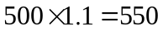 shares with an exercise price 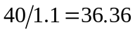.
- There is no effect. The terms of an options contract are not normally adjusted for cash dividends.
- The option contract becomes one to buy 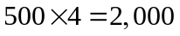 shares with an exercise price of 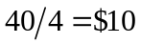.

Problem 10.18.
“If most of the call options on a stock are in the money, it is likely that the stock price has risen rapidly in the last few months.” Discuss this statement.
The exchange has certain rules governing when trading in a new option is initiated. These mean that the option is close-to-the-money when it is first traded. If all call options are in the money it is therefore likely that the stock price has increased since trading in the option began.

Problem 10.19.
What is the effect of an unexpected cash dividend on (a) a call option price and (b) a put option price?
An unexpected cash dividend would reduce the stock price on the ex-dividend date. This stock price reduction would not be anticipated by option holders. As a result there would be a reduction in the value of a call option and an increase the value of a put option. (Note that the terms of an option are adjusted for cash dividends only in exceptional circumstances.)

Problem 10.20.
Options on General Motors stock are on a March, June, September, and December cycle. What options trade on (a) March 1, (b) June 30, and (c) August 5?
- March, April, June and September
- July, August, September, December
- August, September, December, March.
Longer dated options may also trade.
Problem 10.21.
Explain why the market maker’s bid-offer spread represents a real cost to options investors.
A “fair” price for the option can reasonably be assumed to be half way between the bid and the offer price quoted by a market maker. An investor typically buys at the market maker’s offer and sells at the market maker’s bid. Each time he or she does this there is a hidden cost equal to half the bid-offer spread.

Problem 10.22.
A United States investor writes five naked call option contracts. The option price is $3.50, the strike price is $60.00, and the stock price is $57.00. What is the initial margin requirement?
The two calculations are necessary to determine the initial margin. The first gives
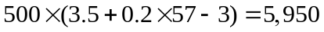
The second gives
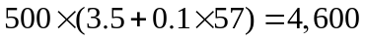
The initial margin is the greater of these, or $5,950. Part of this can be provided by the initial amount of 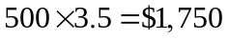 received for the options.

Further Questions

Problem 10.23.
Calculate the intrinsic value and time value from the mid-market (average of bid and
offer) prices the September 2013 call options in Table 1.2. Do the same for the September 2013 put options in Table 1.3. Assume in each case that the current mid-market stock price is $871.30.

For strike prices of 820, 840, 860, 880, 900, and 920 the intrinsic values of call options are 51.30, 31.30, 11.30, 0, 0, and 0. The mid-market values of the options are 76.90, 63.40, 51.75, 41.30, 32.45 and 25.20. The time values of the options are given by what is left from the mid-market value after the intrinsic value has been subtracted. They are 25.60, 32.10, 40.45, 41.30, 32.45, and 25.20, respectively.

For strike prices of 820, 840, 860, 880, 900, and 920, the intrinsic values of put options are 0, 0, 0, 8.70, 28.70, and 48.70. The mid-market values of the options are 24.55, 31.40, 39.65, 49.30, 60.05, and 72.55. The time values of the options are given by what is left from the mid-market value after the intrinsic value has been subtracted. They are 24.55, 31.40, 39.65, 40.60, 31.35 and 23.85, respectively.

Note that for both puts and calls the time value is greatest when the option is close to the money.

Problem 10.24.
A trader has a put option contract to sell 100 shares of a stock for a strike price of $60.
What is the effect on the terms of the contract of:
(a) A $2 dividend being declared
(b) A $2 dividend being paid
(c) A 5-for-2 stock split
(d) A 5% stock dividend being paid.

- No effect
- No effect
- The put option contract gives the right to sell 250 shares for $24 each
- The put option contract gives the right to sell 105 shares for 60/1.05 = $57.14

Problem 10.25.
A trader writes five naked put option contracts, with each contract being on 100 shares.
The option price is $10, the time to maturity is six months, and the strike price is $64.
(a) What is the margin requirement if the stock price is $58?
(b) How would the answer to (a) change if the rules for index options applied?
(c) How would the answer to (a) change if the stock price were $70?
(d) How would the answer to (a) change if the trader is buying instead of selling the
options?

- The margin requirement is the greater of 500×(10 + 0.2×58) = 10,800 and 500×(10+0.1×64) = 8,200. It is $10,800.
- The margin requirement is the greater of 500×(10+0.15×58) = 9,350 and 500×(10+0.1×64) = 8,200. It is $9,350.
- The margin requirement is the greater of 500×(10+0.2×70-6) = 9,000 and 500×(10+0.1×64) = 8,200. It is $9,000.
- No margin is required if the trader is buying

Problem 10.26.
The price of a stock is $40. The price of a one-year European put option on the stock with a strike price of $30 is quoted as $7 and the price of a one-year European call option on the stock with a strike price of $50 is quoted as $5. Suppose that an investor buys 100 shares, shorts 100 call options, and buys 100 put options. Draw a diagram illustrating how the investor’s profit or loss varies with the stock price over the next year. How does your answer change if the investor buys 100 shares, shorts 200 call options, and buys 200 put options?
Figure S10.7 shows the way in which the investor’s profit varies with the stock price in the first case. For stock prices less than $30 there is a loss of $1,200. As the stock price increases from $30 to $50 the profit increases from –$1,200 to $800. Above $50 the profit is $800. Students may express surprise that a call which is $10 out of the money is less expensive than a put which is $10 out of the money. This could be because of dividends or the crashophobia phenomenon discussed in Chapter 20.
Figure S10.8 shows the way in which the profit varies with stock price in the second case. In this case the profit pattern has a zigzag shape. The problem illustrates how many different patterns can be obtained by including calls, puts, and the underlying asset in a portfolio.

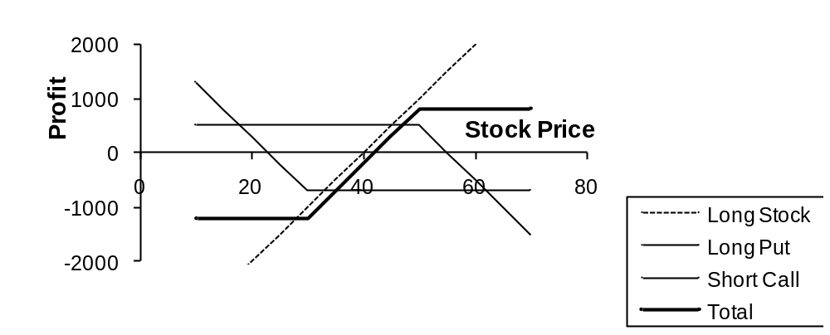

Figure S10.7: Profit in first case considered Problem 10.26

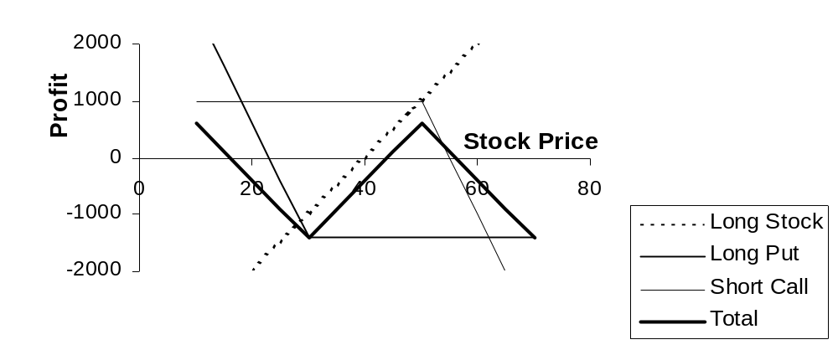

Figure S10.8: Profit for the second case considered Problem 10.26
Problem 10.27.
“If a company does not do better than its competitors but the stock market goes up, executives do very well from their stock options. This makes no sense” Discuss this viewpoint. Can you think of alternatives to the usual executive stock option plan that take the viewpoint into account.
Executive stock option plans account for a high percentage of the total remuneration received by executives. When the market is rising fast, many corporate executives do very well out of their stock option plans — even when their company does worse than its competitors. Large institutional investors have argued that executive stock options should be structured so that the payoff depends how the company has performed relative to an appropriate industry index. In a regular executive stock option the strike price is the stock price at the time the option is issued. In the type of relative-performance stock option favored by institutional investors, the strike price at time is 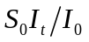 where 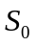 is the company’s stock price at the time the option is issued, 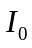 is the value of an equity index for the industry in which the company operates at the time the option is issued, and is the value of the index at time . If the company’s performance equals the performance of the industry, the options are always at-the-money. If the company outperforms the industry, the options become in the money. If the company underperforms the industry, the options become out of the money. Note that a relative performance stock option can provide a payoff when both the market and the company’s stock price decline.
Relative performance stock options clearly provide a better way of rewarding senior management for superior performance. Some companies have argued that, if they introduce relative performance options when their competitors do not, they will lose some of their top management talent.

Problem 10.28.
Use DerivaGem to calculate the value of an American put option on a nondividend paying stock when the stock price is $30, the strike price is $32, the risk-free rate is 5%, the volatility is 30%, and the time to maturity is 1.5 years. (Choose Binomial American for the “option type” and 50 time steps.)
- What is the option’s intrinsic value?
- What is the option’s time value?
- What would a time value of zero indicate? What is the value of an option with zero time value?
- Using a trial and error approach calculate how low the stock price would have to be for the time value of the option to be zero.
DerivaGem shows that the value of the option is 4.57. The option’s intrinsic value is 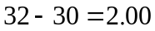. The option’s time value is therefore 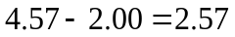. A time value of zero would indicate that it is optimal to exercise the option immediately. In this case the value of the option would equal its intrinsic value. When the stock price is 20, DerivaGem gives the value of the option as 12, which is its intrinsic value. When the stock price is 25, DerivaGem gives the value of the options as 7.54, indicating that the time value is still positive (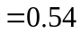). Keeping the number of time steps equal to 50, trial and error indicates the time value disappears when the stock price is reduced to 21.6 or lower. (With 500 time steps this estimate of how low the stock price must become is reduced to 21.3.)

Problem 10.29.
On July 20, 2004 Microsoft surprised the market by announcing a $3 dividend. The ex-dividend date was November 17, 2004 and the payment date was December 2, 2004. Its stock price at the time was about $28. It also changed the terms of its employee stock options so that each exercise price was adjusted downward to
Pre-dividend Exercise Price 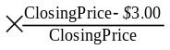
The number of shares covered by each stock option outstanding was adjusted upward to
Number of Shares Pre-dividend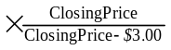
"Closing Price" means the official NASDAQ closing price of a share of Microsoft common stock on the last trading day before the ex-dividend date.
Evaluate this adjustment. Compare it with the system used by exchanges to adjust for extraordinary dividends (see Business Snapshot 10.1).
Suppose that the closing stock price is $28 and an employee has 1000 options with a strike price of $24. Microsoft’s adjustment involves changing the strike price to 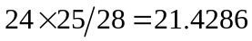 and changing the number of options to 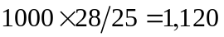. The system used by exchanges would involve keeping the number of options the same and reducing the strike price by $3 to $21.
The Microsoft adjustment is more complicated than that used by the exchange because it requires a knowledge of the Microsoft’s stock price immediately before the stock goes ex-dividend. However, arguably it is a better adjustment than the one used by the exchange. Before the adjustment the employee has the right to pay $24,000 for Microsoft stock that is worth $28,000. After the adjustment the employee also has the option to pay $24,000 for Microsoft stock worth $28,000. Under the adjustment rule used by exchanges the employee would have the right to buy stock worth $25,000 for $21,000. If the volatility of Microsoft remains the same this is a less valuable option.
One complication here is that Microsoft’s volatility does not remain the same. It can be expected to go up because some cash (a zero risk asset) has been transferred to shareholders. The employees therefore have the same basic option as before but the volatility of Microsoft can be expected to increase. The employees are slightly better off because the value of an option increases with volatility.

