CHAPTER 11
Properties of Stock Options

Practice Questions
Problem 11.1.
List the six factors affecting stock option prices.
The six factors affecting stock option prices are the stock price, strike price, risk-free interest rate, volatility, time to maturity, and dividends.
Problem 11.2.
What is a lower bound for the price of a four-month call option on a non-dividend-paying stock when the stock price is $28, the strike price is $25, and the risk-free interest rate is 8% per annum?
The lower bound is
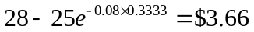

Problem 11.3.
What is a lower bound for the price of a one-month European put option on a non-dividend-paying stock when the stock price is $12, the strike price is $15, and the risk-free interest rate is 6% per annum?
The lower bound is
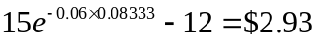

Problem 11.4.
Give two reasons that the early exercise of an American call option on a non-dividend-paying stock is not optimal. The first reason should involve the time value of money. The second reason should apply even if interest rates are zero.
Delaying exercise delays the payment of the strike price. This means that the option holder is able to earn interest on the strike price for a longer period of time. Delaying exercise also provides insurance against the stock price falling below the strike price by the expiration date. Assume that the option holder has an amount of cash  and that interest rates are zero. When the option is exercised early it is worth 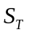 at expiration. Delaying exercise means that it will be worth 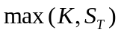 at expiration.
Problem 11.5.
“The early exercise of an American put is a trade-off between the time value of money and the insurance value of a put." Explain this statement.
An American put when held in conjunction with the underlying stock provides insurance. It guarantees that the stock can be sold for the strike price, K. If the put is exercised early, the insurance ceases. However, the option holder receives the strike price immediately and is able to earn interest on it between the time of the early exercise and the expiration date.
Problem 11.6.
Why is an American call option on a dividend-paying stock is always worth at least as much as its intrinsic value. Is the same true of a European call option? Explain your answer.
An American call option can be exercised at any time. If it is exercised its holder gets the intrinsic value. It follows that an American call option must be worth at least its intrinsic value. A European call option can be worth less than its intrinsic value. Consider, for example, the situation where a stock is expected to provide a very high dividend during the life of an option. The price of the stock will decline as a result of the dividend. Because the European option can be exercised only after the dividend has been paid, its value may be less than the intrinsic value today.
Problem 11.7.
The price of a non-dividend paying stock is $19 and the price of a three-month European call option on the stock with a strike price of $20 is $1. The risk-free rate is 4% per annum. What is the price of a three-month European put option with a strike price of $20?
In this case, 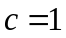, 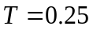, 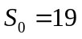, 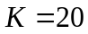, and 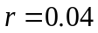. From put–call parity
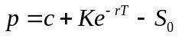
or
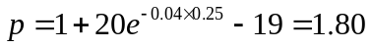
so that the European put price is $1.80.
Problem 11.8.
Explain why the arguments leading to put–call parity for European options cannot be used to give a similar result for American options.
When early exercise is not possible, we can argue that two portfolios that are worth the same at time must be worth the same at earlier times. When early exercise is possible, the argument falls down. Suppose that 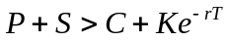. This situation does not lead to an arbitrage opportunity. If we buy the call, short the put, and short the stock, we cannot be sure of the result because we do not know when the put will be exercised.

Problem 11.9.
What is a lower bound for the price of a six-month call option on a non-dividend-paying stock when the stock price is $80, the strike price is $75, and the risk-free interest rate is 10% per annum?
The lower bound is
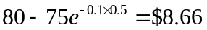

Problem 11.10.
What is a lower bound for the price of a two-month European put option on a non-dividend-paying stock when the stock price is $58, the strike price is $65, and the risk-free interest rate is 5% per annum?
The lower bound is
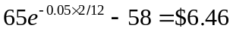

Problem 11.11.
A four-month European call option on a dividend-paying stock is currently selling for $5. The stock price is $64, the strike price is $60, and a dividend of $0.80 is expected in one month. The risk-free interest rate is 12% per annum for all maturities. What opportunities are there for an arbitrageur?
The present value of the strike price is 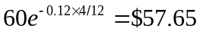. The present value of the dividend is 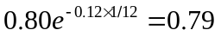. Because
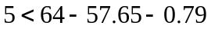
the condition in equation (11.8) is violated. An arbitrageur should buy the option and short the stock. This generates 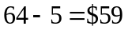. The arbitrageur invests $0.79 of this at 12% for one month to pay the dividend of $0.80 in one month. The remaining $58.21 is invested for four months at 12%. Regardless of what happens a profit will materialize.
If the stock price declines below $60 in four months, the arbitrageur loses the $5 spent on the option but gains on the short position. The arbitrageur shorts when the stock price is $64, has to pay dividends with a present value of $0.79, and closes out the short position when the stock price is $60 or less. Because $57.65 is the present value of $60, the short position generates at least 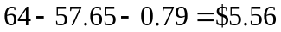 in present value terms. The present value of the arbitrageur’s gain is therefore at least 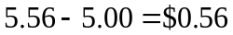.
If the stock price is above $60 at the expiration of the option, the option is exercised. The arbitrageur buys the stock for $60 in four months and closes out the short position. The present value of the $60 paid for the stock is $57.65 and as before the dividend has a present value of $0.79. The gain from the short position and the exercise of the option is therefore exactly . The arbitrageur’s gain in present value terms is exactly .

Problem 11.12.
A one-month European put option on a non-dividend-paying stock is currently selling for 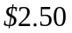. The stock price is $47, the strike price is $50, and the risk-free interest rate is 6% per annum. What opportunities are there for an arbitrageur?
In this case the present value of the strike price is 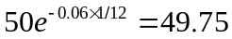. Because
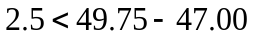
the condition in equation (11.5) is violated. An arbitrageur should borrow $49.50 at 6% for one month, buy the stock, and buy the put option. This generates a profit in all circumstances.
If the stock price is above $50 in one month, the option expires worthless, but the stock can be sold for at least $50. A sum of $50 received in one month has a present value of $49.75 today. The strategy therefore generates profit with a present value of at least $0.25.
If the stock price is below $50 in one month the put option is exercised and the stock owned is sold for exactly $50 (or $49.75 in present value terms). The trading strategy therefore generates a profit of exactly $0.25 in present value terms.
Problem 11.13.
Give an intuitive explanation of why the early exercise of an American put becomes more attractive as the risk-free rate increases and volatility decreases.
The early exercise of an American put is attractive when the interest earned on the strike price is greater than the insurance element lost. When interest rates increase, the value of the interest earned on the strike price increases making early exercise more attractive. When volatility decreases, the insurance element is less valuable. Again this makes early exercise more attractive.

Problem 11.14.
The price of a European call that expires in six months and has a strike price of $30 is $2. The underlying stock price is $29, and a dividend of $0.50 is expected in two months and again in five months. Interest rates (all maturities) are 10%. What is the price of a European put option that expires in six months and has a strike price of $30?
Using the notation in the chapter, put-call parity [equation (11.10)] gives
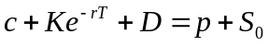
or
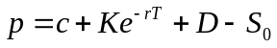
In this case
In other words the put price is $2.51.

Problem 11.15.
Explain the arbitrage opportunities in Problem 11.14 if the European put price is $3.
If the put price is $3.00, it is too high relative to the call price. An arbitrageur should buy the call, short the put and short the stock. This generates 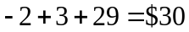 in cash which is invested at 10%. Regardless of what happens a profit with a present value of 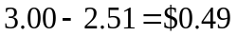 is locked in.
If the stock price is above $30 in six months, the call option is exercised, and the put option expires worthless. The call option enables the stock to be bought for $30, or 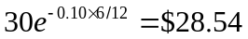 in present value terms. The dividends on the short position cost 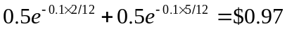 in present value terms so that there is a profit with a present value of 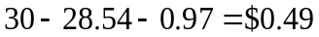.
If the stock price is below $30 in six months, the put option is exercised and the call option expires worthless. The short put option leads to the stock being bought for $30, or in present value terms. The dividends on the short position cost in present value terms so that there is a profit with a present value of .

Problem 11.16.
The price of an American call on a non-dividend-paying stock is $4. The stock price is $31, the strike price is $30, and the expiration date is in three months. The risk-free interest rate is 8%. Derive upper and lower bounds for the price of an American put on the same stock with the same strike price and expiration date.
From equation (11.7)
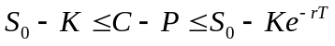
In this case
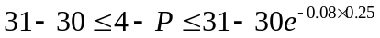
or
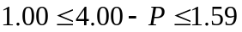
or
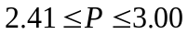
Upper and lower bounds for the price of an American put are therefore $2.41 and $3.00.

Problem 11.17.
Explain carefully the arbitrage opportunities in Problem 11.16 if the American put price is greater than the calculated upper bound.
If the American put price is greater than $3.00 an arbitrageur can sell the American put, short the stock, and buy the American call. This realizes at least 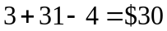 which can be invested at the risk-free interest rate. At some stage during the 3-month period either the American put or the American call will be exercised. The arbitrageur then pays $30, receives the stock and closes out the short position. The cash flows to the arbitrageur are 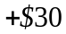 at time zero and 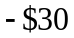 at some future time. These cash flows have a positive present value.

Problem 11.18.
Prove the result in equation (11.7). (Hint: For the first part of the relationship consider (a) a portfolio consisting of a European call plus an amount of cash equal to and (b) a portfolio consisting of an American put option plus one share.)
As in the text we use and  to denote the European call and put option price, and  and  to denote the American call and put option prices. Because 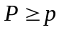, it follows from put–call parity that
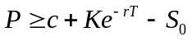
and since 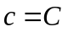,
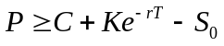
or
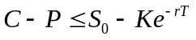

For a further relationship between and , consider
Portfolio I: One European call option plus an amount of cash equal to .
Portfolio J: One American put option plus one share.
Both options have the same exercise price and expiration date. Assume that the cash in portfolio I is invested at the risk-free interest rate. If the put option is not exercised early portfolio J is worth
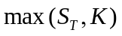
at time . Portfolio I is worth
at this time. Portfolio I is therefore worth more than portfolio J. Suppose next that the put option in portfolio J is exercised early, say, at time . This means that portfolio J is worth at time . However, even if the call option were worthless, portfolio I would be worth 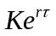 at time . It follows that portfolio I is worth at least as much as portfolio J in all circumstances. Hence
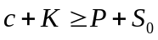
Since ,
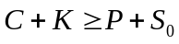
or
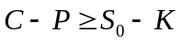
Combining this with the other inequality derived above for 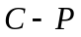, we obtain
Problem 11.19.
Prove the result in equation (11.11). (Hint: For the first part of the relationship consider (a) a portfolio consisting of a European call plus an amount of cash equal to 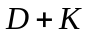 and (b) a portfolio consisting of an American put option plus one share.)
As in the text we use and to denote the European call and put option price, and and to denote the American call and put option prices. The present value of the dividends will be denoted by . As shown in the answer to Problem 11.18, when there are no dividends
Dividends reduce and increase . Hence this relationship must also be true when there are dividends.
For a further relationship between and , consider
Portfolio I: one European call option plus an amount of cash equal to
Portfolio J: one American put option plus one share
Both options have the same exercise price and expiration date. Assume that the cash in portfolio I is invested at the risk-free interest rate. If the put option is not exercised early, portfolio J is worth
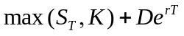
at time . Portfolio I is worth
at this time. Portfolio I is therefore worth more than portfolio J. Suppose next that the put option in portfolio J is exercised early, say, at time . This means that portfolio J is worth at most 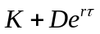 at time . However, even if the call option were worthless, portfolio I would be worth 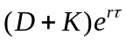 at time . It follows that portfolio I is worth more than portfolio J in all circumstances. Hence
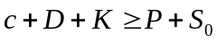
Because 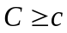
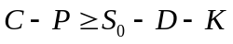

Problem 11.20.
Consider a five-year call option on a non-dividend-paying stock granted to employees. The option can be exercised at any time after the end of the first year. Unlike a regular exchange-traded call option, the employee stock option cannot be sold. What is the likely impact of this restriction on early exercise?
An employee stock option may be exercised early because the employee needs cash or because he or she is uncertain about the company’s future prospects. Regular call options can be sold in the market in either of these two situations, but employee stock options cannot be sold. In theory an employee can short the company’s stock as an alternative to exercising. In practice this is not usually encouraged and may even be illegal for senior managers.
Problem 11.21.
Use the software DerivaGem to verify that Figures 11.1 and 11.2 are correct.
The graphs can be produced from the first worksheet in DerivaGem. Select Equity as the Underlying Type. Select Black-Scholes as the Option Type. Input stock price as 50, volatility as 30%, risk-free rate as 5%, time to exercise as 1 year, and exercise price as 50. Leave the dividend table blank because we are assuming no dividends. Select the button corresponding to call. Do not select the implied volatility button. Hit the Enter key and click on calculate. DerivaGem will show the price of the option as 7.15562248. Move to the Graph Results on the right hand side of the worksheet. Enter Option Price for the vertical axis and Asset price for the horizontal axis. Choose the minimum strike price value as 10 (software will not accept 0) and the maximum strike price value as 100. Hit Enter and click on Draw Graph. This will produce Figure 11.1a. Figures 11.1c, 11.1e, 11.2a, and 11.2c can be produced similarly by changing the horizontal axis. By selecting put instead of call and recalculating the rest of the figures can be produced. You are encouraged to experiment with this worksheet. Try different parameter values and different types of options.

Further Questions

Problem 11.22.
Calls were traded on exchanges before puts. During the period of time when calls were
traded but puts were not traded, how would you create a European put option on a nondividend-paying stock synthetically?

Put-call parity can be used to create a put from a call. A put plus the stock equals a call plus the present value of the strike price when both the call and the put have the same strike price and maturity date. A put can be created by buying the call, shorting the stock, and keeping an amount of cash that when invested at the risk-free rate will grow to be sufficient to exercise the call. If the stock price is above the strike price, the call is exercised and the short position is closed out for no net payoff. If the stock price is below the strike price, the call is not exercised and the short position is closed out for a gain equal to the put payoff.

Problem 11.23.
The prices of European call and put options on a non-dividend-paying stock with
12 months to maturity, a strike price of $120, and an expiration date in 12 months are $20 and $5, respectively. The current stock price is $130. What is the implied risk-free rate?

From put-call parity
20+120e^{-r×1}=5+130
Solving this
e^{-r} = 115/120
so that r=−ln(115/120) = 0.0426 or 4.26%

Problem 11.24.
A European call option and put option on a stock both have a strike price of $20 and an expiration date in three months. Both sell for $3. The risk-free interest rate is 10% per annum, the current stock price is $19, and a $1 dividend is expected in one month. Identify the arbitrage opportunity open to a trader.
If the call is worth $3, put-call parity shows that the put should be worth
This is greater than $3. The put is therefore undervalued relative to the call. The correct arbitrage strategy is to buy the put, buy the stock, and short the call. This costs $19. If the stock price in three months is greater than $20, the call is exercised. If it is less than $20, the put is exercised. In either case the arbitrageur sells the stock for $20 and collects the $1 dividend in one month. The present value of the gain to the arbitrageur is

Problem 11.25.
Suppose that , 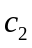, and 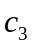 are the prices of European call options with strike prices 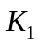, 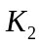, and 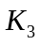, respectively, where 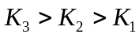 and 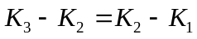. All options have the same maturity. Show that
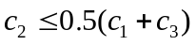

(Hint: Consider a portfolio that is long one option with strike price , long one option with strike price , and short two options with strike price .)
Consider a portfolio that is long one option with strike price , long one option with strike price , and short two options with strike price . The value of the portfolio can be worked out in four different situations
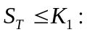 Portfolio Value 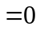
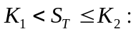 Portfolio Value 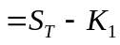
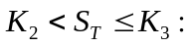 Portfolio Value 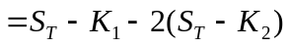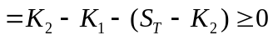
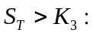 Portfolio Value 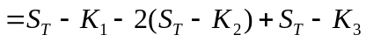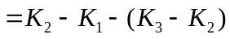
The value is always either positive or zero at the expiration of the option. In the absence of arbitrage possibilities it must be positive or zero today. This means that
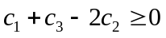
or
Note that students often think they have proved this by writing down
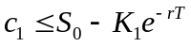
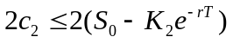
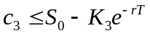
and subtracting the middle inequality from the sum of the other two. But they are deceiving themselves. Inequality relationships cannot be subtracted. For example, 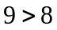 and 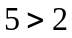, but it is not true that 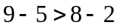!

Problem 11.26.
What is the result corresponding to that in Problem 11.25 for European put options?

The corresponding result is
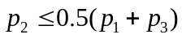
where 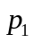, 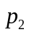 and 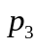 are the prices of European put option with the same maturities and strike prices , and respectively. This can be proved from the result in Problem 11.25 using put-call parity. Alternatively we can consider a portfolio consisting of a long position in a put option with strike price , a long position in a put option with strike price , and a short position in two put options with strike price . The value of this portfolio in different situations is given as follows
Portfolio Value 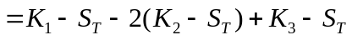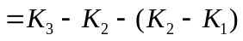
Portfolio Value 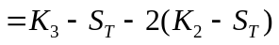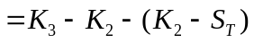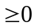
Portfolio Value 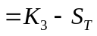
Portfolio Value
Because the portfolio value is always zero or positive at some future time the same must be true today. Hence
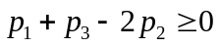
or

Problem 11.27.
You are the manager and sole owner of a highly leveraged company. All the debt will mature in one year. If at that time the value of the company is greater than the face value of the debt, you will pay off the debt. If the value of the company is less than the face value of the debt, you will declare bankruptcy and the debt holders will own the company.
- Express your position as an option on the value of the company.
- Express the position of the debt holders in terms of options on the value of the company.
- What can you do to increase the value of your position?

- Suppose 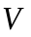 is the value of the company and is the face value of the debt. The value of the manager’s position in one year is
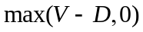
This is the payoff from a call option on with strike price.

- The debt holders get
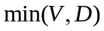
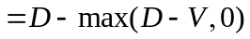
Since 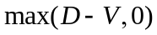 is the payoff from a put option on with strike price , the debt holders have in effect made a risk-free loan (worth at maturity with certainty) and written a put option on the value of the company with strike price . The position of the debt holders in one year can also be characterized as
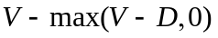
This is a long position in the assets of the company combined with a short position in a call option on the assets with a strike price of . The equivalence of the two characterizations can be presented as an application of put–call parity. (See Business Snapshot 11.1.)
- The manager can increase the value of his or her position by increasing the value of the call option in (a). It follows that the manager should attempt to increase both and the volatility of . To see why increasing the volatility of is beneficial, imagine what happens when there are large changes in . If increases, the manager benefits to the full extent of the change. If decreases, much of the downside is absorbed by the company’s lenders.

Problem 11.28.
Consider an option on a stock when the stock price is $41, the strike price is $40, the risk-free rate is 6%, the volatility is 35%, and the time to maturity is 1 year. Assume that a dividend of $0.50 is expected after six months.
- Use DerivaGem to value the option assuming it is a European call.
- Use DerivaGem to value the option assuming it is a European put.
- Verify that put–call parity holds.
- Explore using DerivaGem what happens to the price of the options as the time to maturity becomes very large and there are no dividends. Explain your results.

DerivaGem shows that the price of the call option is 6.9686 and the price of the put option is 4.1244. In this case
Also
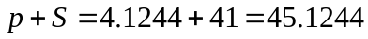
As the time to maturity becomes very large and there are no dividends, the price of the call option approaches the stock price of 41. (For example, when T = 100 it is 40.94.) This is because the call option can be regarded as a position in the stock where the price does not have to be paid for a very long time. The present value of what has to be paid is close to zero. As the time to maturity becomes very large the price of the European put option becomes close to zero. (For example, when T = 100 it is 0.04.) This is because the present value of the expected payoff from the put option tends to zero as the time to maturity increases.

Problem 11.29.
Consider a put option on a non-dividend-paying stock when the stock price is $40, the strike price is $42, the risk-free rate of interest is 2%, the volatility is 25% per annum, and the time to maturity is 3 months. Use DerivaGem to determine:
- The price of the option if it is European (Use Black-Scholes: European)
- The price of the option if it is American (Use Binomial: American with 100 tree steps)
- Point B in Figure 11.7

(a) $3.06
(b) $3.08
(c) $35.4 (using trial and error to determine when the European option price equals its intrinsic value).

Problem 11.30.
Section 11.1 gives an example of a situation where the value of a European call option decreases with the time to maturity. Give an example of a situation where the same thing happens for a European put option

There are some circumstances when it is optimal to exercise an American put option early On such situation is when it is deep in the money with interest rates high. In this situation it is better to have a short-life European option than a long life European option. The strike price is almost certain to be received and the earlier this happens the better.

