CHAPTER 12
Trading Strategies Involving Options

Practice Questions

Problem 12.1.
What is meant by a protective put? What position in call options is equivalent to a protective put?
A protective put consists of a long position in a put option combined with a long position in the underlying shares. It is equivalent to a long position in a call option plus a certain amount of cash. This follows from put–call parity:
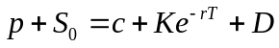

Problem 12.2.
Explain two ways in which a bear spread can be created.
A bear spread can be created using two call options with the same maturity and different strike prices. The investor shorts the call option with the lower strike price and buys the call option with the higher strike price. A bear spread can also be created using two put options with the same maturity and different strike prices. In this case, the investor shorts the put option with the lower strike price and buys the put option with the higher strike price.
Problem 12.3.
When is it appropriate for an investor to purchase a butterfly spread?
A butterfly spread involves a position in options with three different strike prices (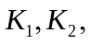 and 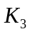). A butterfly spread should be purchased when the investor considers that the price of the underlying stock is likely to stay close to the central strike price, 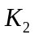.
Problem 12.4.
Call options on a stock are available with strike prices of $15,$17.5 , and $20 and expiration dates in three months. Their prices are $4, $2, and,$0.5 respectively. Explain how the options can be used to create a butterfly spread. Construct a table showing how profit varies with stock price for the butterfly spread.
An investor can create a butterfly spread by buying call options with strike prices of $15 and $20 and selling two call options with strike prices of $17. The initial investment is 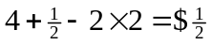. The following table shows the variation of profit with the final stock price:

Stock Price, S_{T} | Profit
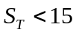 | 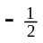
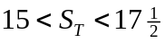 | 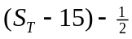
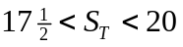 | 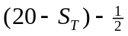
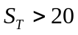

Problem 12.5.
What trading strategy creates a reverse calendar spread?
A reverse calendar spread is created by buying a short-maturity option and selling a long-maturity option, both with the same strike price.
Problem 12.6.
What is the difference between a strangle and a straddle?
Both a straddle and a strangle are created by combining a long position in a call with a long position in a put. In a straddle the two have the same strike price and expiration date. In a strangle they have different strike prices and the same expiration date.
Problem 12.7.
A call option with a strike price of $50 costs $2. A put option with a strike price of $45 costs $3. Explain how a strangle can be created from these two options. What is the pattern of profits from the strangle?
A strangle is created by buying both options. The pattern of profits is as follows:
Stock Price, S_{T} | Profit
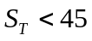 | 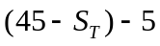
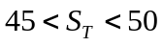 | −5
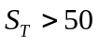 | 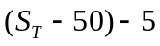

Problem 12.8.
Use put–call parity to relate the initial investment for a bull spread created using calls to the initial investment for a bull spread created using puts.
A bull spread using calls provides a profit pattern with the same general shape as a bull spread using puts (see Figures 12.2 and 12.3 in the text). Define 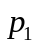 and as the prices of put and call with strike price 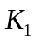 and 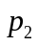 and 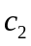 as the prices of a put and call with strike price . From put-call parity
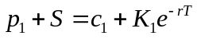

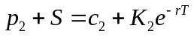
Hence:
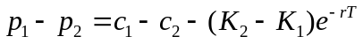
This shows that the initial investment when the spread is created from puts is less than the initial investment when it is created from calls by an amount 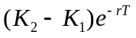. In fact as mentioned in the text the initial investment when the bull spread is created from puts is negative, while the initial investment when it is created from calls is positive.
The profit when calls are used to create the bull spread is higher than when puts are used by 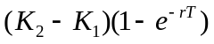. This reflects the fact that the call strategy involves an additional risk-free investment of over the put strategy. This earns interest of .

Problem 12.9.
Explain how an aggressive bear spread can be created using put options.
An aggressive bull spread using call options is discussed in the text. Both of the options used have relatively high strike prices. Similarly, an aggressive bear spread can be created using put options. Both of the options should be out of the money (that is, they should have relatively low strike prices). The spread then costs very little to set up because both of the puts are worth close to zero. In most circumstances the spread will provide zero payoff. However, there is a small chance that the stock price will fall fast so that on expiration both options will be in the money. The spread then provides a payoff equal to the difference between the two strike prices, 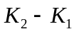.
Problem 12.10.
Suppose that put options on a stock with strike prices $30 and $35 cost $4 and $7, respectively. How can the options be used to create (a) a bull spread and (b) a bear spread? Construct a table that shows the profit and payoff for both spreads.
A bull spread is created by buying the $30 put and selling the $35 put. This strategy gives rise to an initial cash inflow of $3. The outcome is as follows:

Stock Price | Payoff | Profit
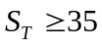 | 0 | 3
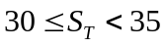 | 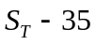 | 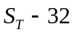
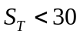 | 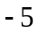 | 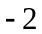
A bear spread is created by selling the $30 put and buying the $35 put. This strategy costs $3 initially. The outcome is as follows:

Stock Price | Payoff | Profit
 | 0 | 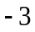
 | 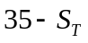 | 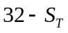
 | 5 | 2

Problem 12.11.
Use put–call parity to show that the cost of a butterfly spread created from European puts is identical to the cost of a butterfly spread created from European calls.
Define , , and 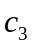 as the prices of calls with strike prices , and . Define , and 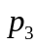 as the prices of puts with strike prices , and . With the usual notation
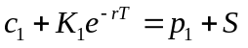

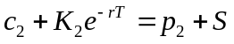

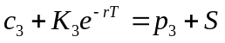
Hence
Because 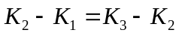, it follows that 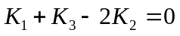 and
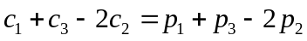
The cost of a butterfly spread created using European calls is therefore exactly the same as the cost of a butterfly spread created using European puts.

Problem 12.12.
A call with a strike price of $60 costs $6. A put with the same strike price and expiration date costs $4. Construct a table that shows the profit from a straddle. For what range of stock prices would the straddle lead to a loss?
A straddle is created by buying both the call and the put. This strategy costs $10. The profit/loss is shown in the following table:

Stock Price | Payoff | Profit
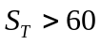 | 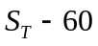 | 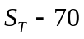
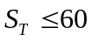 | 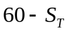 | 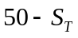

This shows that the straddle will lead to a loss if the final stock price is between $50 and $70.
Problem 12.13.
Construct a table showing the payoff from a bull spread when puts with strike prices and with K₂>K₁ are used.
The bull spread is created by buying a put with strike price and selling a put with strike price . The payoff is calculated as follows:

Stock Price | Payoff from Long Put | Payoff from Short Put | Total Payoff
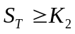 | 0 | 0 | 0
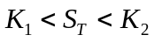 | 0 | 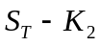 | 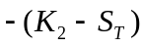
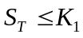 | 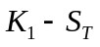 |  | 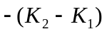

Problem 12.14.
An investor believes that there will be a big jump in a stock price, but is uncertain as to the direction. Identify six different strategies the investor can follow and explain the differences among them.
Possible strategies are:
Strangle
Straddle
Strip
Strap
Reverse calendar spread
Reverse butterfly spread
The strategies all provide positive profits when there are large stock price moves. A strangle is less expensive than a straddle, but requires a bigger move in the stock price in order to provide a positive profit. Strips and straps are more expensive than straddles but provide bigger profits in certain circumstances. A strip will provide a bigger profit when there is a large downward stock price move. A strap will provide a bigger profit when there is a large upward stock price move. In the case of strangles, straddles, strips and straps, the profit increases as the size of the stock price movement increases. By contrast in a reverse calendar spread and a reverse butterfly spread there is a maximum potential profit regardless of the size of the stock price movement.

Problem 12.15.
How can a forward contract on a stock with a particular delivery price and delivery date be created from options?
Suppose that the delivery price is  and the delivery date is . The forward contract is created by buying a European call and selling a European put when both options have strike price and exercise date . This portfolio provides a payoff of 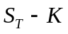 under all circumstances where 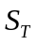 is the stock price at time . Suppose that 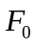 is the forward price. If 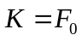, the forward contract that is created has zero value. This shows that the price of a call equals the price of a put when the strike price is .

Problem 12.16.
“A box spread comprises four options. Two can be combined to create a long forward position and two can be combined to create a short forward position.” Explain this statement.
A box spread is a bull spread created using calls and a bear spread created using puts. With the notation in the text it consists of a) a long call with strike , b) a short call with strike , c) a long put with strike , and d) a short put with strike . a) and d) give a long forward contract with delivery price ; b) and c) give a short forward contract with delivery price . The two forward contracts taken together give the payoff of.
Problem 12.17.
What is the result if the strike price of the put is higher than the strike price of the call in a strangle?
The result is shown in Figure S12.1. The profit pattern from a long position in a call and a put when the put has a higher strike price than a call is much the same as when the call has a higher strike price than the put. Both the initial investment and the final payoff are much higher in the first case
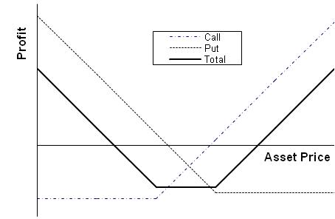
Figure S12.1: Profit Pattern in Problem 12.17

Problem 12.18.
A foreign currency is currently worth $0.64. A one-year butterfly spread is set up using European call options with strike prices of $0.60, $0.65, and $0.70. The risk-free interest rates in the United States and the foreign country are 5% and 4% respectively, and the volatility of the exchange rate is 15%. Use the DerivaGem software to calculate the cost of setting up the butterfly spread position. Show that the cost is the same if European put options are used instead of European call options.
To use DerivaGem select the first worksheet and choose Currency as the Underlying Type. Select Black--Scholes European as the Option Type. Input exchange rate as 0.64, volatility as 15%, risk-free rate as 5%, foreign risk-free interest rate as 4%, time to exercise as 1 year, and exercise price as 0.60. Select the button corresponding to call. Do not select the implied volatility button. Hit the Enter key and click on calculate. DerivaGem will show the price of the option as 0.0618. Change the exercise price to 0.65, hit Enter, and click on calculate again. DerivaGem will show the value of the option as 0.0352. Change the exercise price to 0.70, hit Enter, and click on calculate. DerivaGem will show the value of the option as 0.0181.
Now select the button corresponding to put and repeat the procedure. DerivaGem shows the values of puts with strike prices 0.60, 0.65, and 0.70 to be 0.0176, 0.0386, and 0.0690, respectively.
The cost of setting up the butterfly spread when calls are used is therefore
The cost of setting up the butterfly spread when puts are used is
Allowing for rounding errors these two are the same.

Problem 12.19.
An index provides a dividend yield of 1% and has a volatility of 20%. The risk-free interest rate is 4%. How long does a principal-protected note, created as in Example 12.1, have to last for it to be profitable to the bank? Use DerivaGem.

Assume that the investment in the index is initially $100. (This is a scaling factor that makes no difference to the result.) DerivaGem can be used to value an option on the index with the index level equal to 100, the volatility equal to 20%, the risk-free rate equal to 4%, the dividend yield equal to 1%, and the exercise price equal to 100. For different times to maturity, T, we value a call option (using Black-Scholes European) and the amount available to buy the call option, which is 100-100e^{-0.04×T}. Results are as follows:

Time to maturity, T | Funds Available | Value of Option
1 | 3.92 | 9.32
2 | 7.69 | 13.79
5 | 18.13 | 23.14
10 | 32.97 | 33.34
11 | 35.60 | 34.91

This table shows that the answer is between 10 and 11 years. Continuing the calculations we find that if the life of the principal-protected note is 10.35 year or more, it is profitable for the bank. (Excel’s Solver can be used in conjunction with the DerivaGem functions to facilitate calculations.)

Further Questions

Problem 12.20.
A trader creates a bear spread by selling a six-month put option with a $25 strike price
for $2.15 and buying a six-month put option with a $29 strike price for $4.75. What is
the initial investment? What is the total payoff when the stock price in six months is (a) $23, (b) $28, and (c) $33.

The initial investment is $2.60. (a) $4, (b) $1, and (c) 0.

Problem 12.21.
A trader sells a strangle by selling a call option with a strike price of $50 for $3 and
selling a put option with a strike price of $40 for $4. For what range of prices of the
underlying asset does the trader make a profit?

The trader makes a profit if the total payoff is less than $7. This happens when the price of the asset is between $33 and $57.

Problem 12.22.
Three put options on a stock have the same expiration date and strike prices of $55, $60, and $65. The market prices are $3, $5, and $8, respectively. Explain how a butterfly spread can be created. Construct a table showing the profit from the strategy. For what range of stock prices would the butterfly spread lead to a loss?
A butterfly spread is created by buying the $55 put, buying the $65 put and selling two of the $60 puts. This costs 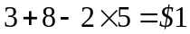 initially. The following table shows the profit/loss from the strategy.
Stock Price | Payoff | Profit
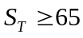 | 0 | 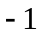
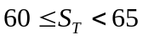 | 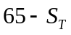 | 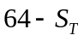
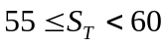 | 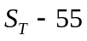 | 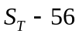
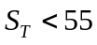 | 0

The butterfly spread leads to a loss when the final stock price is greater than $64 or less than $56.

Problem 12.23.
A diagonal spread is created by buying a call with strike price and exercise date 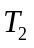 and selling a call with strike price and exercise date 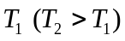. Draw a diagram showing the profit at time T₁ when (a) 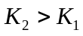 and (b) 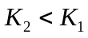.
There are two alternative profit patterns for part (a). These are shown in Figures S12.2 and S12.3. In Figure S12.2 the long maturity (high strike price) option is worth more than the short maturity (low strike price) option. In Figure S12.3 the reverse is true. There is no ambiguity about the profit pattern for part (b). This is shown in Figure S12.4.
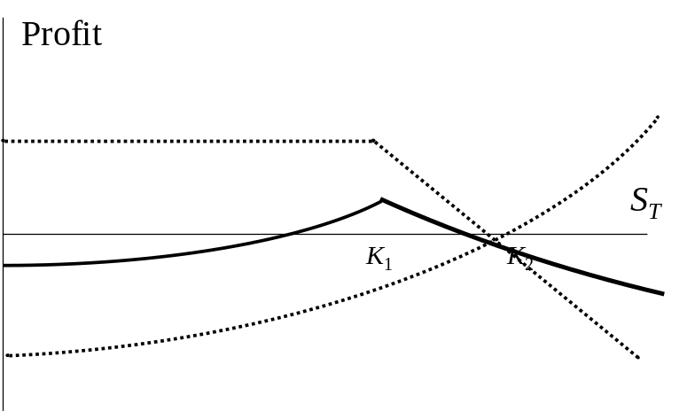

Figure S12.2: Investor’s Profit/Loss in Problem 12.23a when long maturity call is worth more than short maturity call

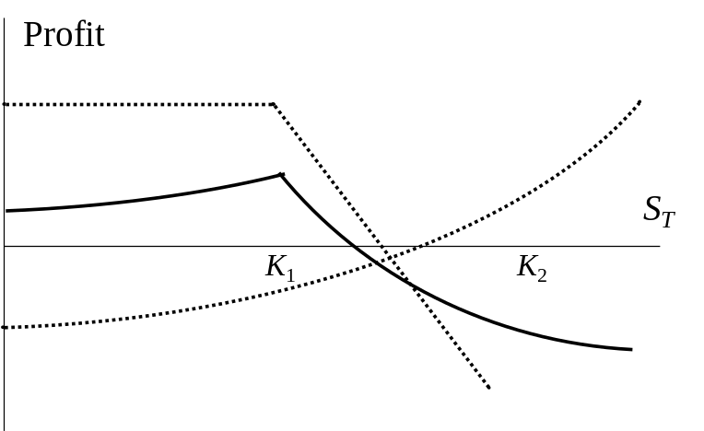

Figure S12.3 Investor’s Profit/Loss in Problem 12.23b when short maturity call is worth more than long maturity call

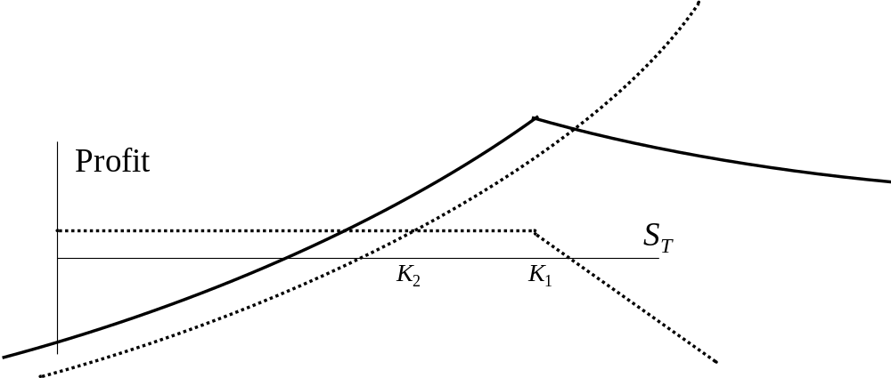

Figure S12.4 Investor’s Profit/Loss in Problem 12.23b

Problem 12.24.
Draw a diagram showing the variation of an investor’s profit and loss with the terminal stock price for a portfolio consisting of
- One share and a short position in one call option
- Two shares and a short position in one call option
- One share and a short position in two call options
- One share and a short position in four call options
In each case, assume that the call option has an exercise price equal to the current stock price.
The variation of an investor’s profit/loss with the terminal stock price for each of the four strategies is shown in Figure S12.5. In each case the dotted line shows the profits from the components of the investor’s position and the solid line shows the total net profit.

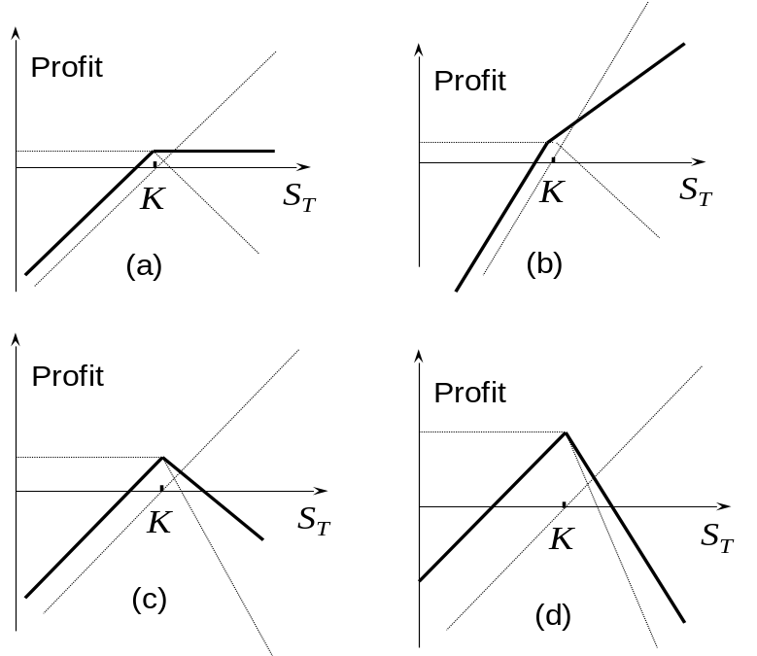

Figure S12.5 Answer to Problem 12.24

Problem 12.25.
Suppose that the price of a non-dividend-paying stock is $32, its volatility is 30%, and the risk-free rate for all maturities is 5% per annum. Use DerivaGem to calculate the cost of setting up the following positions. In each case provide a table showing the relationship between profit and final stock price. Ignore the impact of discounting.
- A bull spread using European call options with strike prices of $25 and $30 and a maturity of six months.
- A bear spread using European put options with strike prices of $25 and $30 and a maturity of six months
- A butterfly spread using European call options with strike prices of $25, $30, and $35 and a maturity of one year.
- A butterfly spread using European put options with strike prices of $25, $30, and $35 and a maturity of one year.
- A straddle using options with a strike price of $30 and a six-month maturity.
- A strangle using options with strike prices of $25 and $35 and a six-month maturity.
In each case provide a table showing the relationship between profit and final stock price. Ignore the impact of discounting.
- A call option with a strike price of 25 costs 7.90 and a call option with a strike price of 30 costs 4.18. The cost of the bull spread is therefore 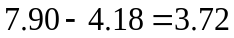. The profits ignoring the impact of discounting are

Stock Price Range | Profit
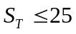 | 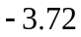
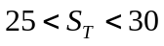 | 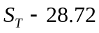
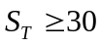 | 1.28

(b) A put option with a strike price of 25 costs 0.28 and a put option with a strike price of 30 costs 1.44. The cost of the bear spread is therefore 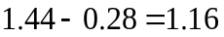. The profits ignoring the impact of discounting are

Stock Price Range | Profit
 | 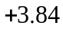
 | 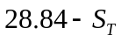
 | 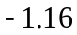

(c) Call options with maturities of one year and strike prices of 25, 30, and 35 cost 8.92, 5.60, and 3.28, respectively. The cost of the butterfly spread is therefore 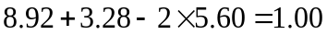. The profits ignoring the impact of discounting are

Stock Price Range | Profit
 | 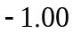
 | 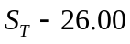
 | 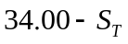

(d) Put options with maturities of one year and strike prices of 25, 30, and 35 cost 0.70, 2.14, 4.57, respectively. The cost of the butterfly spread is therefore 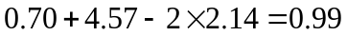. Allowing for rounding errors, this is the same as in (c). The profits are the same as in (c).

(e) A call option with a strike price of 30 costs 4.18. A put option with a strike price of 30 costs 1.44. The cost of the straddle is therefore 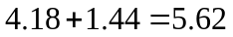. The profits ignoring the impact of discounting are

Stock Price Range | Profit
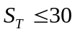 | 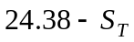
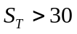 | 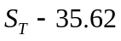

(f) A six-month call option with a strike price of 35 costs 1.85. A six-month put option with a strike price of 25 costs 0.28. The cost of the strangle is therefore 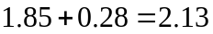. The profits ignoring the impact of discounting are

Stock Price Range | Profit
 | 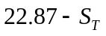
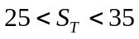 | −2.13
 | 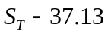

Problem 12.26.
What trading position is created from a long strangle and a short straddle when both have the same time to maturity? Assume that the strike price in the straddle is halfway between the two strike prices of the strangle.

A butterfly spread (together with a cash position) is created.

Problem 12.27. (Excel file)
Describe the trading position created in which a call option is bought with strike price K₁ and a put option is sold with strike price K₂ when both have the same time to maturity and K₂ > K₁. What does the position become when K₁ = K₂?

The position is as shown in the diagram below (for K₁ = 25 and K₂ = 35). It is known as a range forward and is discussed further in Chapter 17. When K₁ =K₂, the position becomes a regular long forward.

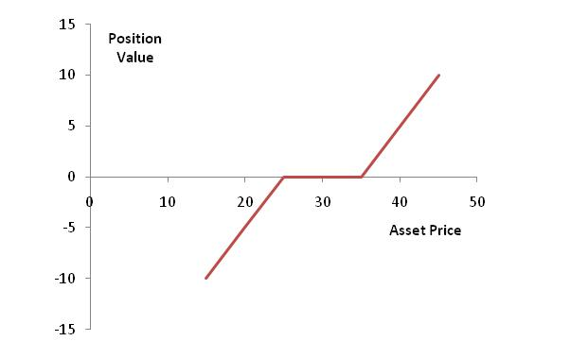

Figure S12.6: Trading position in Problem 12.27

Problem 12.28.
A bank decides to create a five-year principal-protected note on a non-dividend-paying stock by offering investors a zero-coupon bond plus a bull spread created from calls. The risk-free rate is 4% and the stock price volatility is 25%. The low strike price option in the bull spread is at the money. What is the maximum ratio of the higher strike price to the lower strike price in the bull spread? Use DerivaGem.

Assume that the amount invested is 100. (This is a scaling factor.) The amount available to create the option is 100-100e^{-0.04×5}=18.127. The cost of the at-the money option can be calculated from DerivaGem by setting the stock price equal to 100, the volatility equal to 25%, the risk-free interest rate equal to 4%, the time to exercise equal to 5 and the exercise price equal to 100. It is 30.313. We therefore require the option given up by the investor to be worth at least 30.313−18.127 = 12.186. Results obtained are as follows:

Strike | Option Value
125 | 21.12
150 | 14.71
175 | 10.29
165 | 11.86

Continuing in this way we find that the strike must be set below 163.1. The ratio of the high strike to the low strike must therefore be less than 1.631 for the bank to make a profit. (Excel’s Solver can be used in conjunction with the DerivaGem functions to facilitate calculations.)

