CHAPTER 13
Binomial Trees
Practice Questions

Problem 13.1.
A stock price is currently $40. It is known that at the end of one month it will be either $42 or $38. The risk-free interest rate is 8% per annum with continuous compounding. What is the value of a one-month European call option with a strike price of $39?
Consider a portfolio consisting of
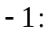 Call option
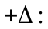 Shares
If the stock price rises to $42, the portfolio is worth 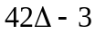. If the stock price falls to $38, it is worth 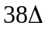. These are the same when
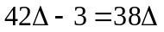
or 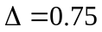. The value of the portfolio in one month is 28.5 for both stock prices. Its value today must be the present value of 28.5, or 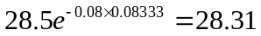. This means that
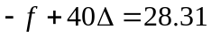
where  is the call price. Because , the call price is 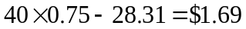. As an alternative approach, we can calculate the probability, , of an up movement in a risk-neutral world. This must satisfy:
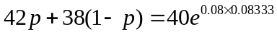
so that
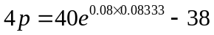
or 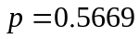. The value of the option is then its expected payoff discounted at the risk-free rate:
or $1.69. This agrees with the previous calculation.
Problem 13.2.
Explain the no-arbitrage and risk-neutral valuation approaches to valuing a European option using a one-step binomial tree.
In the no-arbitrage approach, we set up a riskless portfolio consisting of a position in the option and a position in the stock. By setting the return on the portfolio equal to the risk-free interest rate, we are able to value the option. When we use risk-neutral valuation, we first choose probabilities for the branches of the tree so that the expected return on the stock equals the risk-free interest rate. We then value the option by calculating its expected payoff and discounting this expected payoff at the risk-free interest rate.

Problem 13.3.
What is meant by the delta of a stock option?
The delta of a stock option measures the sensitivity of the option price to the price of the stock when small changes are considered. Specifically, it is the ratio of the change in the price of the stock option to the change in the price of the underlying stock.

Problem 13.4.
A stock price is currently $50. It is known that at the end of six months it will be either $45 or $55. The risk-free interest rate is 10% per annum with continuous compounding. What is the value of a six-month European put option with a strike price of $50?
Consider a portfolio consisting of
Put option
Shares
If the stock price rises to $55, this is worth 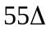. If the stock price falls to $45, the portfolio is worth 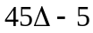. These are the same when
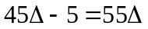
or 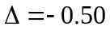. The value of the portfolio in six months is 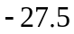 for both stock prices. Its value today must be the present value of , or 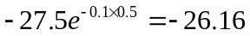. This means that
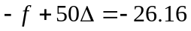
where is the put price. Because , the put price is $1.16. As an alternative approach we can calculate the probability, , of an up movement in a risk-neutral world. This must satisfy:
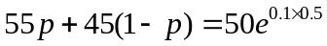
so that
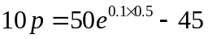
or 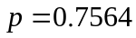. The value of the option is then its expected payoff discounted at the risk-free rate:
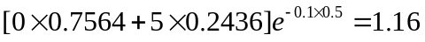
or $1.16. This agrees with the previous calculation.

Problem 13.5.
A stock price is currently $100. Over each of the next two six-month periods it is expected to go up by 10% or down by 10%. The risk-free interest rate is 8% per annum with continuous compounding. What is the value of a one-year European call option with a strike price of $100?
In this case 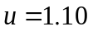, 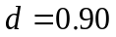, 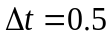, and 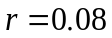, so that
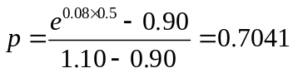
The tree for stock price movements is shown in Figure S13.1. We can work back from the end of the tree to the beginning, as indicated in the diagram, to give the value of the option as $9.61. The option value can also be calculated directly from equation (13.10):
or $9.61.

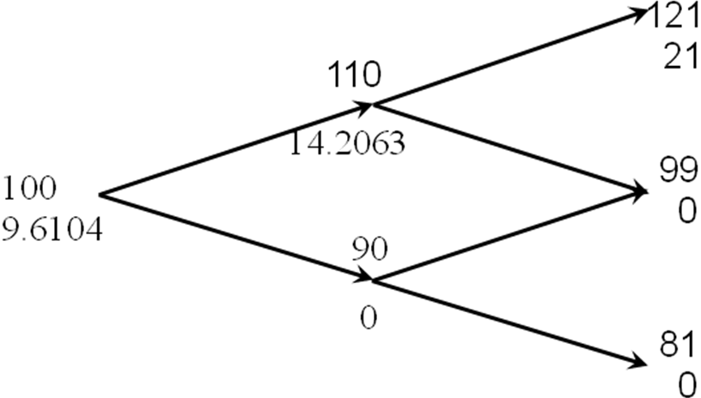

Figure S13.1: Tree for Problem 13.5

Problem 13.6.
For the situation considered in Problem 13.5, what is the value of a one-year European put option with a strike price of $100? Verify that the European call and European put prices satisfy put–call parity.
Figure S13.2 shows how we can value the put option using the same tree as in Problem 13.5. The value of the option is $1.92. The option value can also be calculated directly from equation (13.10):
or $1.92. The stock price plus the put price is 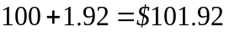. The present value of the strike price plus the call price is 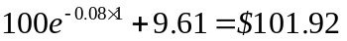. These are the same, verifying that put–call parity holds.
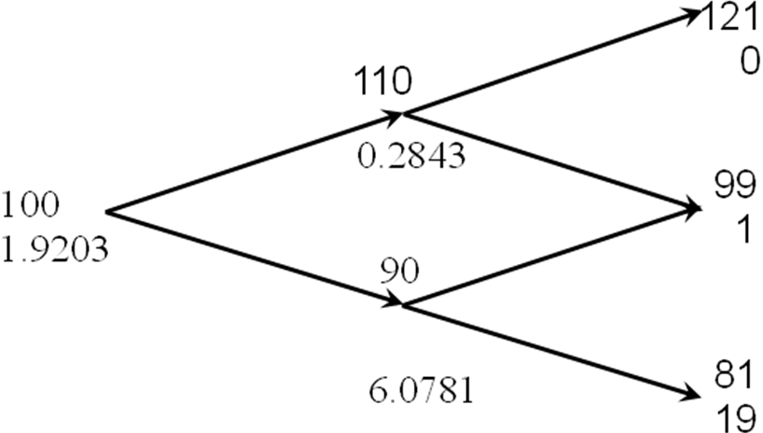

Figure S13.2: Tree for Problem 13.6

Problem 13.7.
What are the formulas for and in terms of volatility?
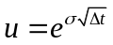 and 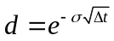

Problem 13.8.
Consider the situation in which stock price movements during the life of a European option are governed by a two-step binomial tree. Explain why it is not possible to set up a position in the stock and the option that remains riskless for the whole of the life of the option.
The riskless portfolio consists of a short position in the option and a long position in shares. Because changes during the life of the option, this riskless portfolio must also change.
Problem 13.9.
A stock price is currently $50. It is known that at the end of two months it will be either $53 or $48. The risk-free interest rate is 10% per annum with continuous compounding. What is the value of a two-month European call option with a strikeprice of $49? Use no-arbitrage arguments.
At the end of two months the value of the option will be either $4 (if the stock price is $53) or $0 (if the stock price is $48). Consider a portfolio consisting of:
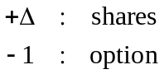
The value of the portfolio is either 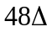 or 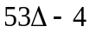 in two months. If
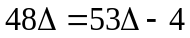
i.e.,
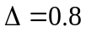
the value of the portfolio is certain to be 38.4. For this value of the portfolio is therefore riskless. The current value of the portfolio is:
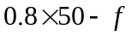
where is the value of the option. Since the portfolio must earn the risk-free rate of interest
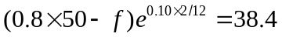
i.e.,
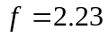
The value of the option is therefore $2.23.
This can also be calculated directly from equations (13.2) and (13.3). 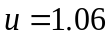, 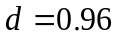 so that
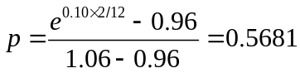
and
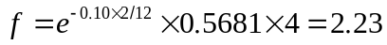

Problem 13.10.
A stock price is currently $80. It is known that at the end of four months it will be either $75 or $85. The risk-free interest rate is 5% per annum with continuous compounding. What is the value of a four-month European put option with a strike price of $80? Use no-arbitrage arguments.
At the end of four months the value of the option will be either $5 (if the stock price is $75) or $0 (if the stock price is $85). Consider a portfolio consisting of:
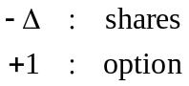
(Note: The delta, of a put option is negative. We have constructed the portfolio so that it is +1 option and 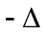 shares rather than 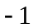 option and 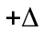 shares so that the initial investment is positive.)
The value of the portfolio is either 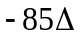 or 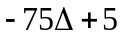 in four months. If
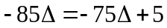
i.e.,
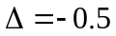
the value of the portfolio is certain to be 42.5. For this value of the portfolio is therefore riskless. The current value of the portfolio is:
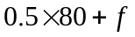
where is the value of the option. Since the portfolio is riskless
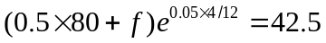
i.e.,
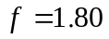
The value of the option is therefore $1.80.
This can also be calculated directly from equations (13.2) and (13.3). 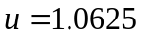, 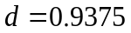 so that
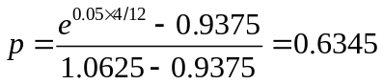
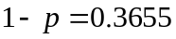 and
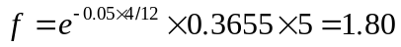

Problem 13.11.
A stock price is currently $40. It is known that at the end of three months it will be either $45 or $35. The risk-free rate of interest with quarterly compounding is 8% per annum. Calculate the value of a three-month European put option on the stock with an exercise price of $40. Verify that no-arbitrage arguments and risk-neutral valuation arguments give the same answers.
At the end of three months the value of the option is either $5 (if the stock price is $35) or $0 (if the stock price is $45).
Consider a portfolio consisting of:
(Note: The delta, , of a put option is negative. We have constructed the portfolio so that it is +1 option and shares rather than option and shares so that the initial investment is positive.)
The value of the portfolio is either 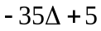 or 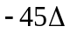. If:
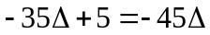
i.e.,
the value of the portfolio is certain to be 22.5. For this value of the portfolio is therefore riskless. The current value of the portfolio is
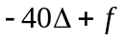
where is the value of the option. Since the portfolio must earn the risk-free rate of interest
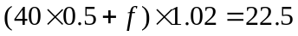
Hence
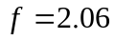
i.e., the value of the option is $2.06.
This can also be calculated using risk-neutral valuation. Suppose that is the probability of an upward stock price movement in a risk-neutral world. We must have
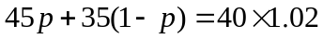
i.e.,
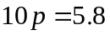
or:
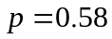
The expected value of the option in a risk-neutral world is:
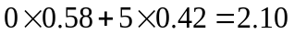
This has a present value of
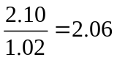
This is consistent with the no-arbitrage answer.

Problem 13.12.
A stock price is currently $50. Over each of the next two three-month periods it is expected to go up by 6% or down by 5%. The risk-free interest rate is 5% per annum with continuous compounding. What is the value of a six-month European call option with a strike price of $51?
A tree describing the behavior of the stock price is shown in Figure S13.3. The risk-neutral probability of an up move, , is given by
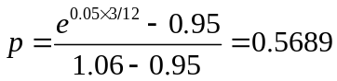
There is a payoff from the option of 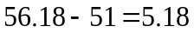 for the highest final node (which corresponds to two up moves) zero in all other cases. The value of the option is therefore
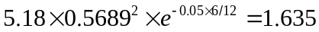
This can also be calculated by working back through the tree as indicated in Figure S13.3. The value of the call option is the lower number at each node in the figure.

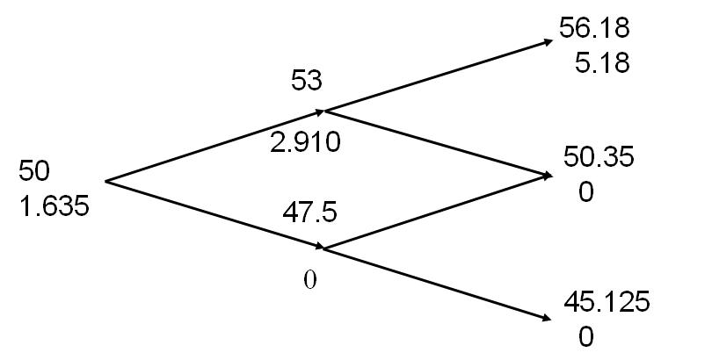

Figure S13.3: Tree for Problem 13.12

Problem 13.13.
For the situation considered in Problem 13.12, what is the value of a six-month European put option with a strike price of $51? Verify that the European call and European put prices satisfy put–call parity. If the put option were American, would it ever be optimal to exercise it early at any of the nodes on the tree?
The tree for valuing the put option is shown in Figure S13.4. We get a payoff of 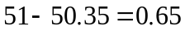 if the middle final node is reached and a payoff of 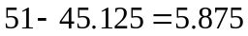 if the lowest final node is reached. The value of the option is therefore
This can also be calculated by working back through the tree as indicated in Figure S13.4.
The value of the put plus the stock price is
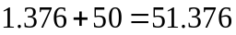
The value of the call plus the present value of the strike price is
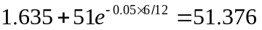
This verifies that put–call parity holds
To test whether it worth exercising the option early we compare the value calculated for the option at each node with the payoff from immediate exercise. At node C the payoff from immediate exercise is 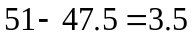. Because this is greater than 2.8664, the option should be exercised at this node. The option should not be exercised at either node A or node B.
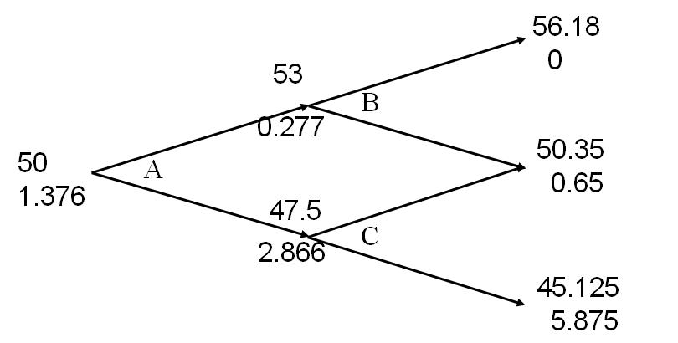

Figure S13.4: Tree for Problem 13.13

Problem 13.14.
A stock price is currently $25. It is known that at the end of two months it will be either $23 or $27. The risk-free interest rate is 10% per annum with continuous compounding. Suppose 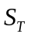 is the stock price at the end of two months. What is the value of a derivative that pays off 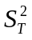 at this time?
At the end of two months the value of the derivative will be either 529 (if the stock price is 23) or 729 (if the stock price is 27). Consider a portfolio consisting of:
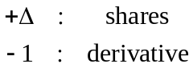
The value of the portfolio is either 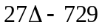 or 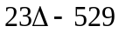 in two months. If
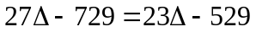
i.e.,
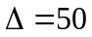
the value of the portfolio is certain to be 621. For this value of the portfolio is therefore riskless. The current value of the portfolio is:
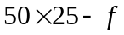
where is the value of the derivative. Since the portfolio must earn the risk-free rate of interest
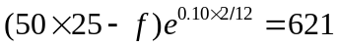
i.e.,
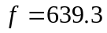
The value of the option is therefore $639.3.
This can also be calculated directly from equations (13.2) and (13.3). 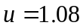, 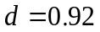 so that
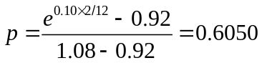
and

Problem 13.15.
Calculate u, d, and p when a binomial tree is constructed to value an option on a foreign currency. The tree step size is one month, the domestic interest rate is 5% per annum, the foreign interest rate is 8% per annum, and the volatility is 12% per annum.
In this case
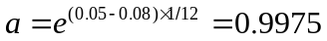

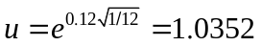

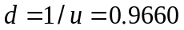

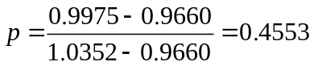

Problem 13.16.
The volatility of a non-dividend-paying stock whose price is $78, is 30%. The risk-free
rate is 3% per annum (continuously compounded) for all maturities. Calculate values for
u, d, and p when a two-month time step is used. What is the value of a four-month
European call option with a strike price of $80 given by a two-step binomial tree.
Suppose a trader sells 1,000 options (10 contracts). What position in the stock is
necessary to hedge the trader’s position at the time of the trade?

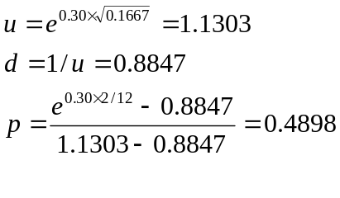
The tree is given in Figure S13.5. The value of the option is $4.67. The initial delta is 9.58/(88.16 – 69.01) which is almost exactly 0.5 so that 500 shares should be purchased.

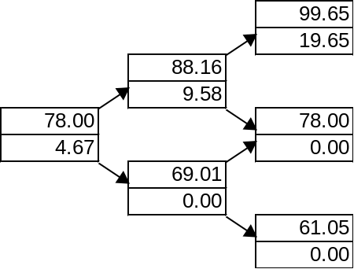

Figure S13.5: Tree for Problem 13.16

Problem 13.17.
A stock index is currently 1,500. Its volatility is 18%. The risk-free rate is 4% per annum
(continuously compounded) for all maturities and the dividend yield on the index is
2.5%. Calculate values for u, d, and p when a six-month time step is used. What is the
value a 12-month American put option with a strike price of 1,480 given by a two-step
binomial tree.

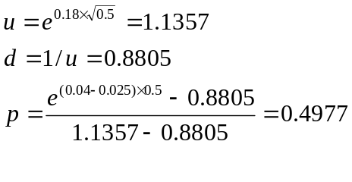
The tree is shown in Figure S13.6. The option is exercised at the lower node at the six-month point. It is worth 78.41.

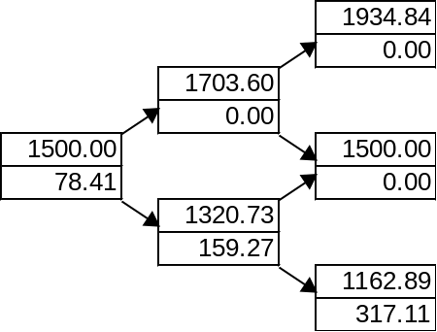

Figure S13.6: Tree for Problem 13.17

Problem 13.18.
The futures price of a commodity is $90. Use a three-step tree to value (a) a nine-month
American call option with strike price $93 and (b) a nine-month American put option
with strike price $93. The volatility is 28% and the risk-free rate (all maturities) is 3%
with continuous compounding.

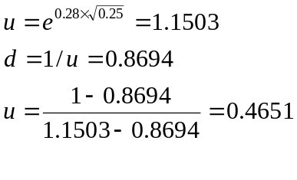
The tree for valuing the call is in Figure S13.7a and that for valuing the put is in Figure S13.7b. The values are 7.94 and 10.88, respectively.

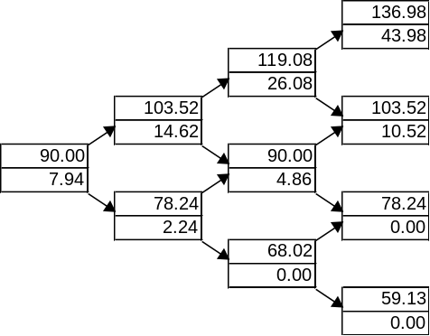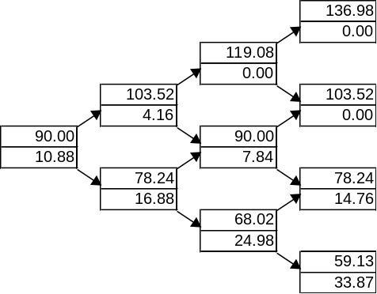

Figure S13.7a: Call Figure S13.7b: Put

Further Questions

Problem 13.19.
The current price of a non-dividend-paying biotech stock is $140 with a volatility of
25%. The risk-free rate is 4%. For a three-month time step:
(a) What is the percentage up movement?
(b) What is the percentage down movement?
(c) What is the probability of an up movement in a risk-neutral world?
(d) What is the probability of a down movement in a risk-neutral world?
Use a two-step tree to value a six-month European call option and a six-month
European put option. In both cases the strike price is $150.

- 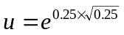= 1.1331. The percentage up movement is 13.31%
- d = 1/u = 0.8825. The percentage down movement is 11.75%
- The probability of an up movement is
- The probability of a down movement is0.4911.

The tree for valuing the call is in Figure S13.8a and that for valuing the put is in Figure S13.8b. The values are 7.56 and 14.58, respectively.

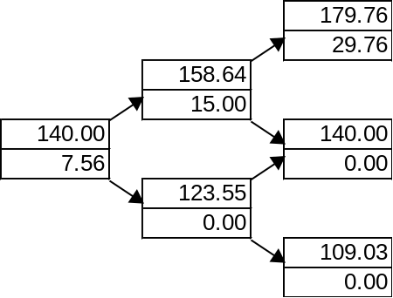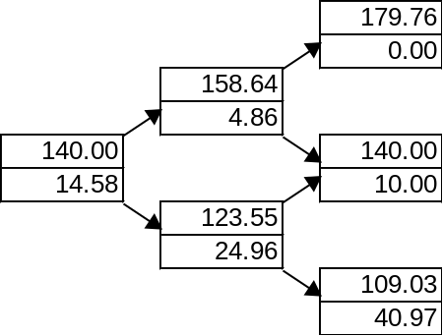

Figure S13.8a: Call Figure S13.8b: Put

Problem 13.20.
In Problem 13.19, suppose that a trader sells 10,000 European call options. How many shares of the stock are needed to hedge the position for the first and second three-month period? For the second time period, consider both the case where the stock price moves up during the first period and the case where it moves down during the first period.

The delta for the first period is 15/(158.64 – 123.55) = 0.4273. The trader should take a long position in 4,273 shares. If there is an up movement the delta for the second period is 29.76/(179.76 – 140) = 0.7485. The trader should increase the holding to 7,485 shares. If there is a down movement the trader should decrease the holding to zero.

Problem 13.21.
A stock price is currently $50. It is known that at the end of six months it will be either $60 or $42. The risk-free rate of interest with continuous compounding is 12% per annum. Calculate the value of a six-month European call option on the stock with an exercise price of $48. Verify that no-arbitrage arguments and risk-neutral valuation arguments give the same answers.
At the end of six months the value of the option will be either $12 (if the stock price is $60) or $0 (if the stock price is $42). Consider a portfolio consisting of:
The value of the portfolio is either 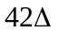 or 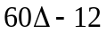 in six months. If
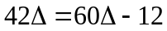
i.e.,
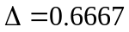
the value of the portfolio is certain to be 28. For this value of the portfolio is therefore riskless. The current value of the portfolio is:
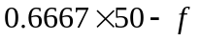
where is the value of the option. Since the portfolio must earn the risk-free rate of interest
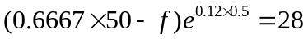
i.e.,
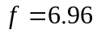
The value of the option is therefore $6.96.
This can also be calculated using risk-neutral valuation. Suppose that is the probability of an upward stock price movement in a risk-neutral world. We must have
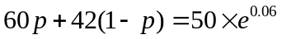
i.e.,
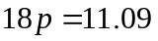
or:
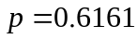
The expected value of the option in a risk-neutral world is:
This has a present value of
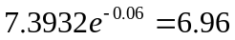
Hence the above answer is consistent with risk-neutral valuation.

Problem 13.22.
A stock price is currently $40. Over each of the next two three-month periods it is expected to go up by 10% or down by 10%. The risk-free interest rate is 12% per annum with continuous compounding.
- What is the value of a six-month European put option with a strike price of $42?
- What is the value of a six-month American put option with a strike price of $42?
- A tree describing the behavior of the stock price is shown in Figure S13.9. The risk-neutral probability of an up move, , is given by
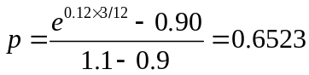
Calculating the expected payoff and discounting, we obtain the value of the option as
The value of the European option is 2.118. This can also be calculated by working back through the tree as shown in Figure S13.9. The second number at each node is the value of the European option.
- The value of the American option is shown as the third number at each node on the tree. It is 2.537. This is greater than the value of the European option because it is optimal to exercise early at node C.

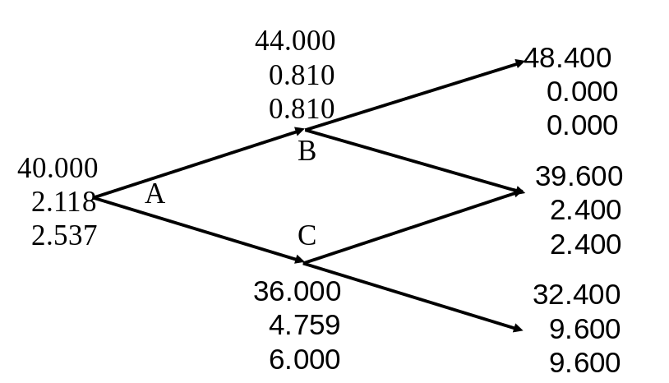

Figure S13.9: Tree to evaluate European and American put options in Problem 13.22. At each node, upper number is the stock price, the next number is the European put price, and the final number is the American put price

Problem 13.23.
Using a “trial-and-error” approach, estimate how high the strike price has to be in Problem 13.17 for it to be optimal to exercise the option immediately.
Trial and error shows that immediate early exercise is optimal when the strike price is above 43.2. This can be also shown to be true algebraically. Suppose the strike price increases by a relatively small amount . This increases the value of being at node C by and the value of being at node B by 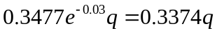. It therefore increases the value of being at node A by
For early exercise at node A we require 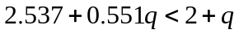 or 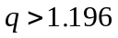. This corresponds to the strike price being greater than 43.196.

Problem 13.24.
A stock price is currently $30. During each two-month period for the next four months it is expected to increase by 8% or reduce by 10%. The risk-free interest rate is 5%. Use a two-step tree to calculate the value of a derivative that pays off 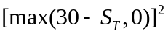 where is the stock price in four months? If the derivative is American-style, should it be exercised early?

This type of option is known as a power option. A tree describing the behavior of the stock price is shown in Figure S13.10. The risk-neutral probability of an up move, , is given by
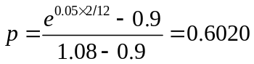
Calculating the expected payoff and discounting, we obtain the value of the option as
The value of the European option is 5.393. This can also be calculated by working back through the tree as shown in Figure S13.10. The second number at each node is the value of the European option. Early exercise at node C would give 9.0 which is less than 13.2435. The option should therefore not be exercised early if it is American.
30.0000
5.3928
32.4000
0.2785
27.0000
13.2435
34.9220
0.0000
29.1600
0.7056
24.3000
32.4900
A
B
C
D
E
F

Figure S13.10: Tree to evaluate European power option in Problem 13.24. At each node, upper number is the stock price and the next number is the option price
Problem 13.25.
Consider a European call option on a non-dividend-paying stock where the stock price is $40, the strike price is $40, the risk-free rate is 4% per annum, the volatility is 30% per annum, and the time to maturity is six months.
- Calculate , , and for a two step tree
- Value the option using a two step tree.
- Verify that DerivaGem gives the same answer
- Use DerivaGem to value the option with 5, 50, 100, and 500 time steps.
(a) This problem is based on the material in Section 13.8. In this case 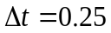 so that 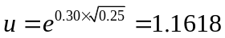, 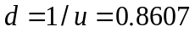, and
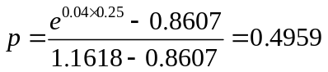

(b) and (c) The value of the option using a two-step tree as given by DerivaGem is shown in Figure S13.11 to be 3.3739. To use DerivaGem choose the first worksheet, select Equity as the underlying type, and select Binomial European as the Option Type. After carrying out the calculations select Display Tree.
(d) With 5, 50, 100, and 500 time steps the value of the option is 3.9229, 3.7394, 3.7478, and 3.7545, respectively.

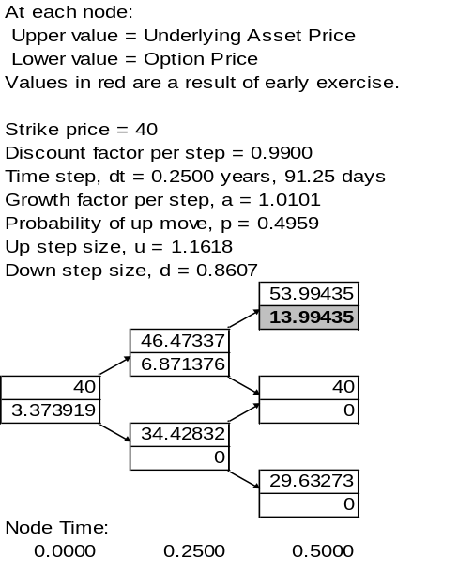

Figure S13.11: Tree produced by DerivaGem to evaluate European option in Problem 13.25
Problem 13.26.
Repeat Problem 13.25 for an American put option on a futures contract. The strike price and the futures price are $50, the risk-free rate is 10%, the time to maturity is six months, and the volatility is 40% per annum.
(a) In this case and 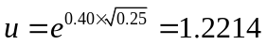, 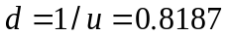, and
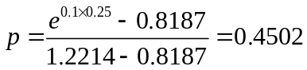

(b) and (c) The value of the option using a two-step tree is 4.8604.
(d) With 5, 50, 100, and 500 time steps the value of the option is 5.6858, 5.3869, 5.3981, and 5.4072, respectively.

Problem 13.27.
Footnote 1 shows that the correct discount rate to use for the real world expected payoff in the case of the call option considered in Figure 13.1 is 42.6%. Show that if the option is a put rather than a call the discount rate is –52.5%. Explain why the two real-world discount rates are so different.
The value of the put option is
The expected payoff in the real world is
The discount rate  that should be used in the real world is therefore given by solving
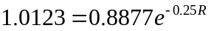
The solution to this is 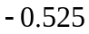 or 52.5%.
The underlying stock has positive systematic risk because it expected return is higher than the risk free rate. This means that the stock will tend to do well when the market does well. The call option has a high positive systematic risk because it tends to do very well when the market does well. As a result a high discount rate is appropriate for its expected payoff. The put option is in the opposite position. It tends to provide a high return when the market does badly. As a result it is appropriate to use a highly negative discount rate for its expected payoff.

Problem 13.28.
A stock index is currently 990, the risk-free rate is 5%, and the dividend yield on the
index is 2%. Use a three-step tree to value an 18-month American put option with a
strike price of 1,000 when the volatility is 20% per annum. How much does the option
holder gain by being able to exercise early? When is the gain made?

The tree is shown in Figure S13.12. The value of the option is 87.51. It is optimal to exercise at the lowest node at time one year. If early exercise were not possible the value at this node would be 236.63. The gain made at the one year point is therefore 253.90 – 236.63
= 17.27.

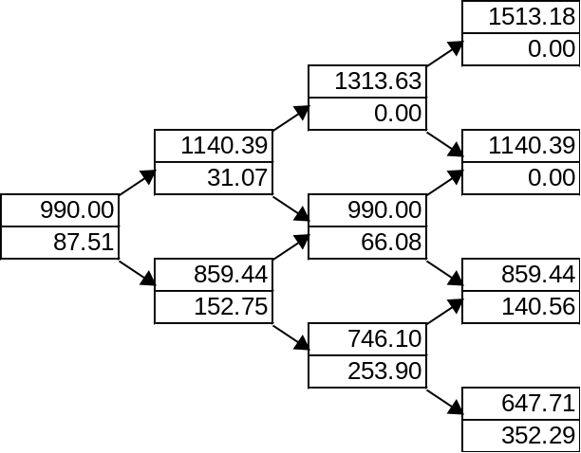

Figure 13.12: Tree for Problem 13.28

Problem 13.29.
Calculate the value of nine-month American call option on a foreign currency using a
three-step binomial tree. The current exchange rate is 0.79 and the strike price is 0.80
(both expressed as dollars per unit of the foreign currency). The volatility of the
exchange rate is 12% per annum. The domestic and foreign risk-free rates are 2%
and 5%, respectively. Suppose a company has bought options on 1 million units of the
foreign currency. What position in the foreign currency is initially necessary to hedge its
risk?

The tree is shown in Figure S13.13. The cost of an American option to buy one million units of the foreign currency is $18,100. The delta initially is (0.0346 −0.0051)/(0.8261 – 0.7554) = 0.4176. The company should sell 417,600 units of the foreign currency

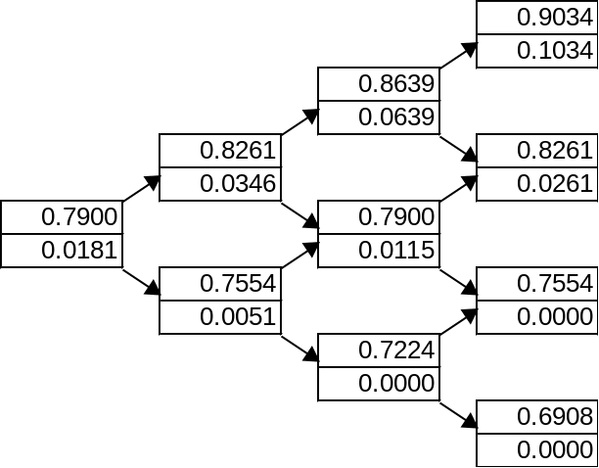

Figure S13.13: Tree for Problem 13.29

