CHAPTER 16
Employee Stock Options

Practice Questions
Problem 16.1.
Why was it attractive for companies to grant at-the-money stock options prior to 2005? What changed in 2005?
Prior to 2005 companies did not have to expense at-the-money options on the income statement. They merely had to report the value of the options in notes to the accounts. FAS 123 and IAS 2 required the fair value of the options to be reported as a cost on the income statement starting in 2005.

Problem 16.2.
What are the main differences between a typical employee stock option and an American call option traded on an exchange or in the over-the-counter market?
The main differences are a) employee stock options last much longer than the typical exchange-traded or over-the-counter option, b) there is usually a vesting period during which they cannot be exercised, c) the options cannot be sold by the employee, d) if the employee leaves the company the options usually either expire worthless or have to be exercised immediately, and e) exercise of the options usually leads to the company issuing more shares.
Problem 16.3.
Explain why employee stock options on a non-dividend-paying stock are frequently exercised before the end of their lives whereas an exchange-traded call option on such a stock is never exercised early.
It is always better for the option holder to sell a call option on a non-dividend -paying stock rather than exercise it. Employee stock options cannot be sold and so the only way an employee can monetize the option is to exercise the option and sell the stock.

Problem 16.4.
“Stock option grants are good because they motivate executives to act in the best interests of shareholders.” Discuss this viewpoint.
This is questionable. Executives benefit from share price increases but do not bear the costs of share price decreases. Employee stock options are liable to encourage executives to take decisions that boost the value of the stock in the short term at the expense of the long term health of the company. It may even be the case that executives are encouraged to take high risks so as to maximize the value of their options.

Problem 16.5.
“Granting stock options to executives is like allowing a professional footballer to bet on the outcome of games.” Discuss this viewpoint.
Professional footballers are not allowed to bet on the outcomes of games because they themselves influence the outcomes. Arguably, an executive should not be allowed to bet on the future stock price of her company because her actions influence that price. However, it could be argued that there is nothing wrong with a professional footballer betting that his team will win (but everything wrong with betting that it will lose). Similarly there is nothing wrong with an executive betting that her company will do well.
Problem 16.6.
Why did some companies backdate stock option grants in the US prior to 2002? What changed in 2002?
Backdating allowed the company to issue employee stock options with a strike price equal to the price at some previous date and claim that they were at the money. At the money options did not lead to an expense on the income statement until 2005. The amount recorded for the value of the options in the notes to the income was less than the actual cost on the true grant date. In 2002 the SEC required companies to report stock option grants within two business days of the grant date. This eliminated the possibility of backdating for companies that complied with this rule.

Problem 16.7.
In what way would the benefits of backdating be reduced if a stock option grant had to be revalued at the end of each quarter?
If a stock option grant had to be revalued each quarter the value of the option of the grant date (however determined) would become less important. Stock price movements following the reported grant date would be incorporated in the next revaluation. The total cost of the options would be independent of the stock price on the grant date.

Problem 16.8.
Explain how you would do the analysis to produce a chart such as the one in Figure 16.2.
It would be necessary to look at returns on each stock in the sample (possibly adjusted for the returns on the market and the beta of the stock) around the reported employee stock option grant date. One could designate Day 0 as the grant date and look at returns on each stock each day from Day –30 to Day +30. The returns would then be averaged across the stocks.

Problem 16.9.
On May 31 a company’s stock price is $70. One million shares are outstanding. An executive exercises 100,000 stock options with a strike price of $50. What is the impact of this on the stock price?
There should be no impact on the stock price because the stock price will already reflect the dilution expected from the executive’s exercise decision.

Problem 16.10.
The notes accompanying a company’s financial statements say: “Our executive stock options last 10 years and vest after four years. We valued the options granted this year using the Black–Scholes–Merton model with an expected life of 5 years and a volatility of 20%. ”What does this mean? Discuss the modeling approach used by the company.
The notes indicate that the Black–Scholes–Merton model was used to produce the valuation with , the option life, being set equal to 5 years and the stock price volatility being set equal to 20%.

Problem 16.11.
In a Dutch auction of 10,000 options, bids are as follows
A bids $30 for 3,000
B bids $33 for 2,500
C bids $29 for 5,000
D bids $40 for 1,000
E bids $22 for 8,000
F bids $35 for 6,000
What is the result of the auction? Who buys how many at what price?
The price at which 10,000 options can be sold is $30. B, D, and F get their order completely filled at this price. A buys 500 options (out of its total bid for 3,000 options) at this price.

Problem 16.12.
A company has granted 500,000 options to its executives. The stock price and strike price are both $40. The options last for 12 years and vest after four years. The company decides to value the options using an expected life of five years and a volatility of 30% per annum. The company pays no dividends and the risk-free rate is 4%. What will the company report as an expense for the options on its income statement?
The options are valued using Black–Scholes–Merton with 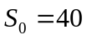, 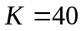, 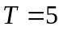, 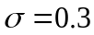 and 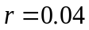. The value of each option is $13.585. The total expense reported is 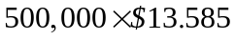 or $6.792 million.

Problem 16.13.
A company’s CFO says: “The accounting treatment of stock options is crazy. We granted 10,000,000 at-the-money stock options to our employees last year when the stock price was $30. We estimated the value of each option on the grant date to be $5. At our year end the stock price had fallen to $4, but we were still stuck with a $50 million charge to the P&L.” Discuss.
The problem is that under the current rules the options are valued only once—on the grant date. Arguably it would make sense to treat the options in the same way as other derivatives entered into by the company and revalue them on each reporting date. However, this does not happen under the current rules in the United States unless the options are settled in cash.

Further Questions

Problem 16.14.
What is the (risk-neutral) expected life for the employee stock option in Example 16.2? What is the value of the option obtained by using this expected life in Black-Scholes-Merton?
The expected life at time zero can be calculated by rolling back through the tree asking the question at each node: “What is the expected life if the node is reached?" This is what has been done in Figure S16.1. It is assumed that 5% of employees leave at times 2, 4, 6, and 8 years. For example, at node G (time 6 years) there is a 81% chance that the option will be exercised (80% chance that the holder chooses to exercise and a 5% times 20% chance that the holder chooses not to exercise but leaves the company after 6 years) and a 19% chance that it will last an extra two years. The expected life if node G is reached is therefore 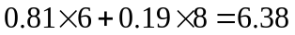 years. Similarly, the expected life if node H is reached is 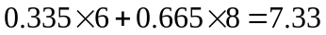 years. The expected life if node I or J is reached is 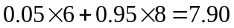 years. The expected life if node D is reached is
Continuing in this way the expected life at time zero is 6.76 years. (As in Example 16.2 we assume that no employees leave at time zero.)
The value of the option assuming an expected life of 6.76 years is given by Black-Scholes-Merton with , , 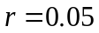, and T = 6.76 . It is 17.04.
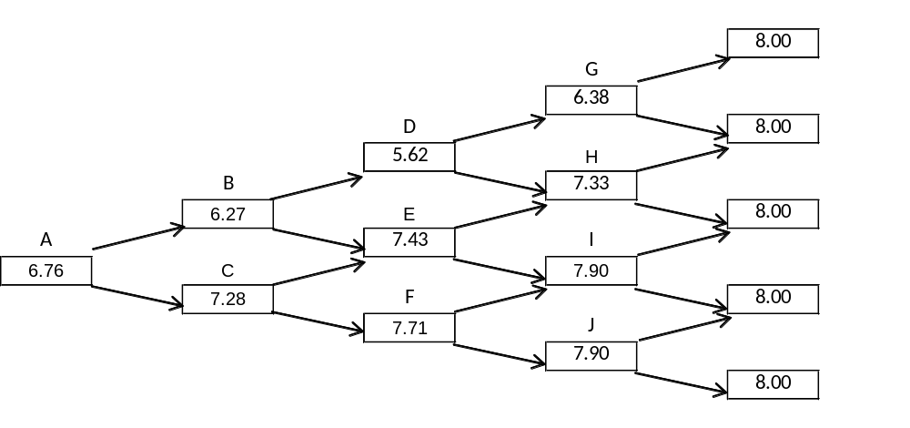

Figure S16.1: Tree for calculating expected life in Problem 16.14

Problem 16.15.
A company has granted 2,000,000 options to its employees. The stock price and strike price are both $60. The options last for 8 years and vest after two years. The company decides to value the options using an expected life of six years and a volatility of 22% per annum. The dividend on the stock is $1, payable half way through each year, and the risk-free rate is 5%. What will the company report as an expense for the options on its income statement?

The options are valued using Black-Scholes-Merton with K=60, T=6, σ =0.22, r =0.05. The present value of the dividends during the six years assumed life is

1×e^{-0.05×0.5}+1×e^{-0.05×1.5}+1×e^{-0.05×2.5}+1×e^{-0.05×3.5}+1×e^{-0.05×4.5}+1×e^{-0.05×5.5} = 5.183

The stock price, S₀, adjusted for dividend is therefore 60 −5.183=54.817. The Black--Scholes model gives the price of one option as $16.492. The company will therefore report as an expense 2,000,000×5.183 or $32.984 million.

Problem 16.16.
A company has granted 1,000,000 options to its employees. The stock price and strike price are both $20. The options last 10 years and vest after three years. The stock price volatility is 30%, the risk-free rate is 5%, and the company pays no dividends. Use a four-step tree to value the options. Assume that there is a probability of 4% that an employee leaves the company at the end of each of the time steps on your tree. Assume also that the probability of voluntary early exercise at a node, conditional on no prior exercise, when a) the option has vested and b) the option is in the money, is
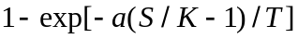
where is the stock price,  is the strike price, is the time to maturity and 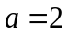.
The valuation is shown in Figure S16.2. The tree is similar to Figure 16.1 in the text. The upper number at each node is the stock price and the lower number is the value of the option. In this case 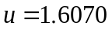 and 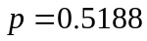. The probability of voluntary exercise at nodes A, B, and C are 0.4690, 0.9195, and 0.3846, respectively. The total probability of exercise at these nodes (including the impact of employees leaving the company) is 0.4902, 0.9227, and 0.4093. The value of each option is $8.54 and the value of the option grant is $8.54 million.

Figure S16.2: Valuation of employee stock option in Problem 16.16

Problem 16.17.
- Hedge funds earn a management fee plus an incentive fee that is a percentage of the profits, if any, that they generate (see Business Snapshot 1.3). How is a fund manager motivated to behave with this type of compensation package?
- "Granting options to an executive gives the executive the same type of compensation package as a hedge fund manager and motivates him or her to behave in the same way as a hedge fund manager" Discuss this statement.

- Suppose that is the value of the fund at the beginning of the year and 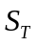 is the net value of the fund at the end of the year (after fees and expenses). In addition to the management fee the hedge fund earns
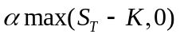
where is a constant.
This shows that a hedge fund manager has a call option on the net value of the fund at the end of the year. One parameter determining the value of the call option is the volatility of the fund. The fund manager has an incentive to make the fund as volatile as possible! This may not correspond with the desires of the investors. One way of making the fund highly volatile would be by investing only in high-beta stocks. Another would be by using the whole fund to buy call options on a market index.
Amaranth provides an example of a hedge fund that took large speculative positions to maximize the value of its call options.
It is interesting to note that the managers of the fund could personally take positions that are opposite to those taken by the fund to ensure a profit in all circumstances (although there is no evidence that they do this).
- An executive who has a salary plus options has a remuneration package similar to that of the hedge fund. The hedge fund’s management fee corresponds to the executive’s salary and the hedge fund’s investments correspond to the stock on which the executive has options. In theory, granting the executive options encourages him/her to take risks so that volatility is increased in the same way that the hedge fund’s remuneration package encourages it to take risks. However, while examples such as Amaranth show that some hedge fund managers do take risks to increase the value of their option, it is less clear that executives behave similarly.

