CHAPTER 17
Options on Stock Indices and Currencies

Practice Questions

Problem 17.1.
A portfolio is currently worth $10 million and has a beta of 1.0. An index is currently standing at 800. Explain how a put option on the index with a strike of 700 can be used to provide portfolio insurance.
When the index goes down to 700, the value of the portfolio can be expected to be 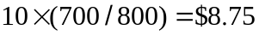 million. (This assumes that the dividend yield on the portfolio equals the dividend yield on the index.) Buying put options on 10,000,000/800 12,500 times the index with a strike of 700 therefore provides protection against a drop in the value of the portfolio below $8.75 million. If each contract is on 100 times the index a total of 125 contracts would be required.
Problem 17.2.
“Once we know how to value options on a stock paying a dividend yield, we know how to value options on stock indices, currencies, and futures.” Explain this statement.
A stock index is analogous to a stock paying a continuous dividend yield, the dividend yield being the dividend yield on the index. A currency is analogous to a stock paying a continuous dividend yield, the dividend yield being the foreign risk-free interest rate.
Problem 17.3.
A stock index is currently 300, the dividend yield on the index is 3% per annum, and the risk-free interest rate is 8% per annum. What is a lower bound for the price of a six-month European call option on the index when the strike price is 290?
The lower bound is given by equation 17.1 as

Problem 17.4.
A currency is currently worth $0.80 and has a volatility of 12%. The domestic and foreign risk-free interest rates are 6% and 8%, respectively. Use a two-step binomial tree to value a) a European four-month call option with a strike price of $0.79 and b) an American four-month call option with the same strike price
In this case 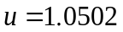 and 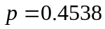. The tree is shown in Figure S17.1. The value of the option if it is European is $0.0235; the value of the option if it is American is $0.0250.

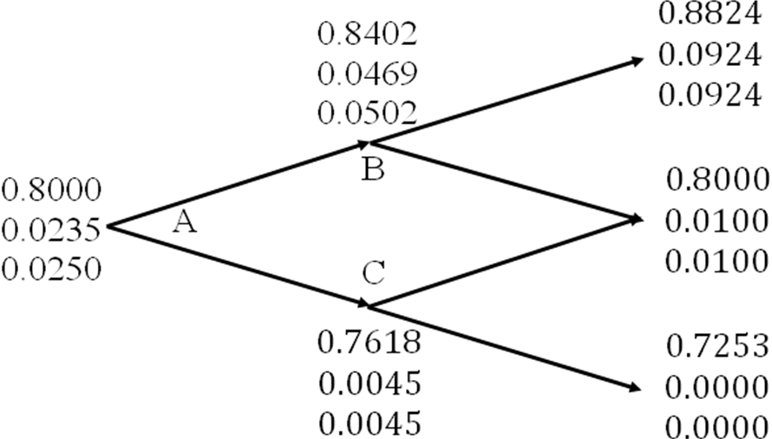
Figure S17.1: Tree to evaluate European and American call options in Problem 17.4.
At each node, upper number is the stock price; next number is the European call price; final number is the American call price

Problem 17.5.
Explain how corporations can use range forward contracts to hedge their foreign exchange risk when they are due to receive a certain amount of the foreign currency in the future.
A range forward contract allows a corporation to ensure that the exchange rate applicable to a transaction will not be worse that one exchange rate and will not be better than another exchange rate. In this case, a corporation would buy a put with the lower exchange rate and sell a call with the higher exchange rate.
Problem 17.6.
Calculate the value of a three-month at-the-money European call option on a stock index when the index is at 250, the risk-free interest rate is 10% per annum, the volatility of the index is 18% per annum, and the dividend yield on the index is 3% per annum.
In this case, 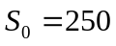, 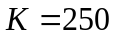, 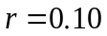, 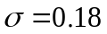, 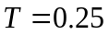, 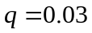 and
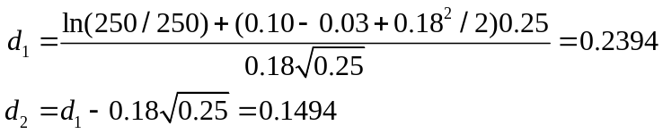
and the call price is

or 11.15.
Problem 17.7.
Calculate the value of an eight-month European put option on a currency with a strike price of 0.50. The current exchange rate is 0.52, the volatility of the exchange rate is 12%, the domestic risk-free interest rate is 4% per annum, and the foreign risk-free interest rate is 8% per annum.
In this case 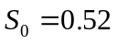, 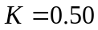, 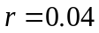, 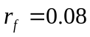, 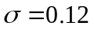, 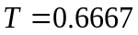, and
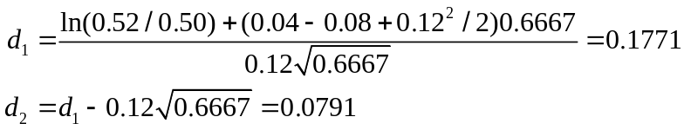
and the put price is

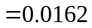
Problem 17.8.
Show that the formula in equation (17.12) for a put option to sell one unit of currency A for currency B at strike price  gives the same value as equation (17.11) for a call option to buy units of currency B for currency A at a strike price of 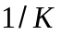.
A put option to sell one unit of currency A for units of currency B is worth
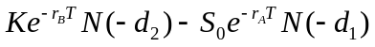
where
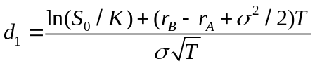

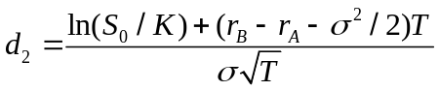
and 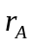 and 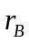 are the risk-free rates in currencies A and B, respectively. The value of the option is measured in units of currency B. Defining 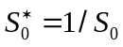 and 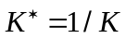
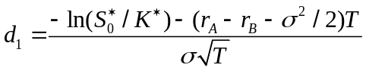

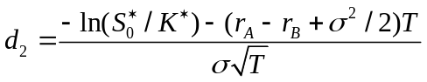
The put price is therefore
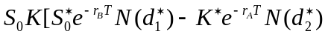
where
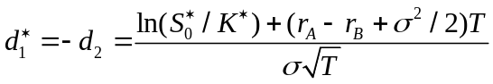

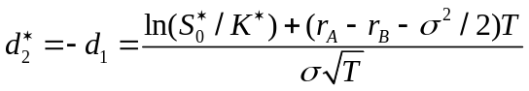
This shows that put option is equivalent to 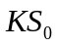 call options to buy 1 unit of currency A for units of currency B. In this case the value of the option is measured in units of currency A. To obtain the call option value in units of currency B (thesame units as the value of the put option was measured in) we must divide by 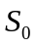. This proves the result.

Problem 17.9.
A foreign currency is currently worth $1.50. The domestic and foreign risk-free interest rates are 5% and 9%, respectively. Calculate a lower bound for the value of a six-month call option on the currency with a strike price of $1.40 if it is (a) European and (b) American.
Lower bound for European option is
Lower bound for American option is
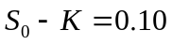

Problem 17.10.
Consider a stock index currently standing at 250. The dividend yield on the index is 4% per annum, and the risk-free rate is 6% per annum. A three-month European call option on the index with a strike price of 245 is currently worth $10. What is the value of a three-month put option on the index with a strike price of 245?
In this case , 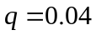, 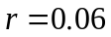, , 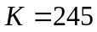, and 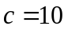. Using put–call parity
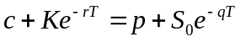
or
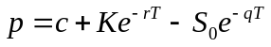
Substituting:
The put price is 3.84.
Problem 17.11.
An index currently stands at 696 and has a volatility of 30% per annum. The risk-free rate of interest is 7% per annum and the index provides a dividend yield of 4% per annum. Calculate the value of a three-month European put with an exercise price of 700.
In this case 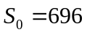, 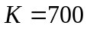, 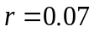, 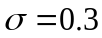, and . The option can be valued using equation (17.5).
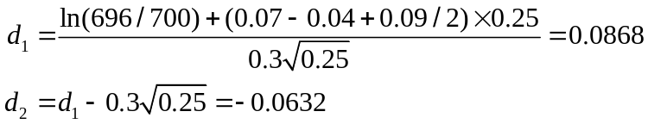
and
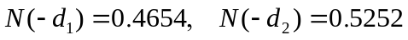
The value of the put, , is given by:
i.e., it is $40.6.
Problem 17.12.
Show that if  is the price of an American call with exercise price and maturity on a stock paying a dividend yield of , and  is the price of an American put on the same stock with the same strike price and exercise date,
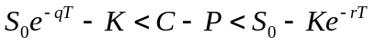
where is the stock price, is the risk-free rate, and 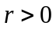. (Hint: To obtain the first half of the inequality, consider possible values of:
Portfolio A; a European call option plus an amount invested at the risk-free rate
Portfolio B: an American put option plus 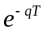 of stock with dividends being reinvested in the stock
To obtain the second half of the inequality, consider possible values of:
Portfolio C: an American call option plus an amount 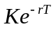 invested at the risk-free rate
Portfolio D: a European put option plus one stock with dividends being reinvested in the stock)
Following the hint, we first consider
Portfolio A: A European call option plus an amount invested at the risk-free rate
Portfolio B: An American put option plus of stock with dividends being reinvested in the stock.

Portfolio A is worth 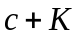 while portfolio B is worth 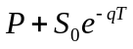. If the put option is exercised at time 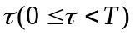, portfolio B becomes:
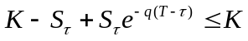
where 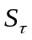 is the stock price at time . Portfolio A is worth
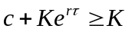
Hence portfolio A is worth at least as much as portfolio B. If both portfolios are held to maturity (time ), portfolio A is worth
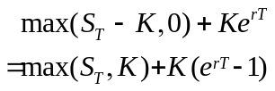
Portfolio B is worth 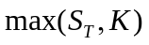. Hence portfolio A is worth more than portfolio B.
Because portfolio A is worth at least as much as portfolio B in all circumstances
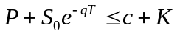
Because 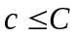:
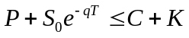
or
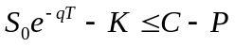
This proves the first part of the inequality.

For the second part consider:
Portfolio C: An American call option plus an amount invested at the risk-free rate
Portfolio D: A European put option plus one stock with dividends being reinvested in the stock.
Portfolio C is worth 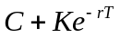 while portfolio D is worth 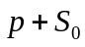. If the call option is exercised at time portfolio C becomes:
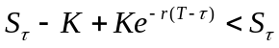
while portfolio D is worth
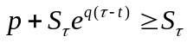
Hence portfolio D is worth more than portfolio C. If both portfolios are held to maturity (time ), portfolio C is worth while portfolio D is worth
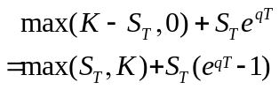
Hence portfolio D is worth at least as much as portfolio C.
Since portfolio D is worth at least as much as portfolio C in all circumstances:
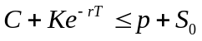
Since 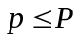:
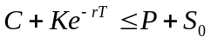
or
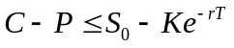
This proves the second part of the inequality. Hence:
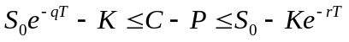

Problem 17.13.
Show that a European call option on a currency has the same price as the corresponding European put option on the currency when the forward price equals the strike price.
This follows from put–call parity and the relationship between the forward price, 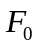, and the spot price, .
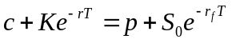
and
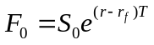
so that
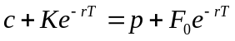
If 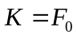 this reduces to 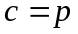. The result that when is true for options on all underlying assets, not just options on currencies. An at-the-money option is frequently defined as one where (or ) rather than one where 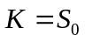.
Problem 17.14.
Would you expect the volatility of a stock index to be greater or less than the volatility of a typical stock? Explain your answer.
The volatility of a stock index can be expected to be less than the volatility of a typical stock. This is because some risk (i.e., return uncertainty) is diversified away when a portfolio of stocks is created. In capital asset pricing model terminology, there exists systematic and unsystematic risk in the returns from an individual stock. However, in a stock index, unsystematic risk has been diversified away and only the systematic risk contributes to volatility.
Problem 17.15.
Does the cost of portfolio insurance increase or decrease as the beta of a portfolio increases? Explain your answer.
The cost of portfolio insurance increases as the beta of the portfolio increases. This is because portfolio insurance involves the purchase of a put option on the portfolio. As beta increases, the volatility of the portfolio increases causing the cost of the put option to increase. When index options are used to provide portfolio insurance, both the number of options required and the strike price increase as beta increases.
Problem 17.16.
Suppose that a portfolio is worth $60 million and the S&P 500 is at 1200. If the value of the portfolio mirrors the value of the index, what options should be purchased to provide protection against the value of the portfolio falling below $54 million in one year’s time?
If the value of the portfolio mirrors the value of the index, the index can be expected to have dropped by 10% when the value of the portfolio drops by 10%. Hence when the value of the portfolio drops to $54 million the value of the index can be expected to be 1080. This indicates that put options with an exercise price of 1080 should be purchased. The options should be on:
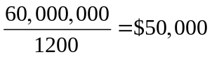
times the index. Each option contract is for $100 times the index. Hence 500 contracts should be purchased.
Problem 17.17.
Consider again the situation in Problem 17.16. Suppose that the portfolio has a beta of 2.0, the risk-free interest rate is 5% per annum, and the dividend yield on both the portfolio and the index is 3% per annum. What options should be purchased to provide protection against the value of the portfolio falling below $54 million in one year’s time?
When the value of the portfolio falls to $54 million the holder of the portfolio makes a capital loss of 10%. After dividends are taken into account the loss is 7% during the year. This is 12% below the risk-free interest rate. According to the capital asset pricing model, the expected excess return of the portfolio above the risk-free rate equals beta times the expected excess return of the market above the risk-free rate.
Therefore, when the portfolio provides a return 12% below the risk-free interest rate, the market’s expected return is 6% below the risk-free interest rate. As the index can be assumed to have a beta of 1.0, this is also the excess expected return (including dividends) from the index. The expected return from the index is therefore 1% per annum. Since the index provides a 3% per annum dividend yield, the expected movement in the index is 4%. Thus when the portfolio’s value is $54 million the expected value of the index is 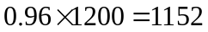. Hence European put options should be purchased with an exercise price of 1152. Their maturity date should be in one year.
The number of options required is twice the number required in Problem 17.16. This is because we wish to protect a portfolio which is twice as sensitive to changes in market conditions as the portfolio in Problem 17.16. Hence options on $100,000 (or 1,000 contracts) should be purchased. To check that the answer is correct consider what happens when the value of the portfolio declines by 20% to $48 million. The return including dividends is 17%. This is 22% less than the risk-free interest rate. The index can be expected to provide a return (including dividends) which is 11% less than the risk-free interest rate, i.e. a return of 6%. The index can therefore be expected to drop by 9% to 1092. The payoff from the put options is 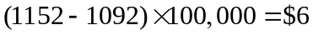 million. This is exactly what is required to restore the value of the portfolio to $54 million.

Problem 17.18.
An index currently stands at 1,500. European call and put options with a strike price of 1,400 and time to maturity of six months have market prices of 154.00 and 34.25, respectively. The six-month risk-free rate is 5%.What is the implied dividend yield?
The implied dividend yield is the value of that satisfies the put–call parity equation. It is the value of that solves
This is 1.99%.
Problem 17.19.
A total return index tracks the return, including dividends, on a certain portfolio. Explain how you would value (a) forward contracts and (b) European options on the index.
A total return index behaves like a stock paying no dividends. In a risk-neutral world it can be expected to grow on average at the risk-free rate. Forward contracts and options on total return indices should be valued in the same way as forward contractsand options on non-dividend-paying stocks.
Problem 17.20.
What is the put–call parity relationship for European currency options?
The put–call parity relationship for European currency options is
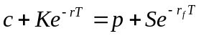
To prove this result, the two portfolios to consider are:
Portfolio A: one call option plus one discount bond which will be worth at time
Portfolio B: one put option plus 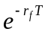 of foreign currency invested at the foreign risk-free interest rate.
Both portfolios are worth at time . They must therefore be worth the same today. The result follows.

Problem 17.21.
Prove the results in equation (17.1), (17.2), and (17.3) using the portfolios indicated.
In portfolio A, the cash, if it is invested at the risk-free interest rate, will grow to at time . If 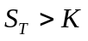, the call option is exercised at time and portfolio A is worth 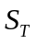. If 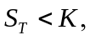 the call option expires worthless and the portfolio is worth . Hence, at time T, portfolio A is worth
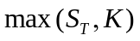
Because of the reinvestment of dividends, portfolio B becomes one share at time . It is, therefore, worth at this time. It follows that portfolio A is always worth as much as, and is sometimes worth more than, portfolio B at time . In the absence of arbitrage opportunities, this must also be true today. Hence,
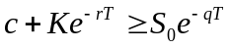
or
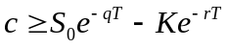
This proves equation (17.1).
In portfolio C, the reinvestment of dividends means that the portfolio is one put option plus one share at time T. If 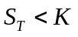, the put option is exercised at time and portfolio C is worth . If 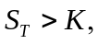 the put option expires worthless and the portfolio is worth . Hence, at time , portfolio C is worth
Portfolio D is worth at time . It follows that portfolio C is always worth as much as, and is sometimes worth more than, portfolio D at time . In the absence of arbitrage opportunities, this must also be true today. Hence,
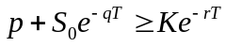
or
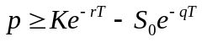
This proves equation (17.2).
Portfolios A and C are both worth at time T. They must, therefore, be worth the same today, and the put–call parity result in equation (17.3) follows.

Problem 17.22.
Can an option on the yen-euro exchange rate be created from two options, one on the dollar-euro exchange rate, and the other on the dollar-yen exchange rate? Explain your answer.
There is no way of doing this. A natural idea is to create an option to exchange euros for one yen from an option to exchange dollars for 1 yen and an option to exchange euros for dollars. The problem with this is that it assumes that either both options are exercised or that neither option is exercised. There are always some circumstances where the first option is in-the-money at expiration while the second is not and vice versa.

Further Questions

Problem 17.23.
The Dow Jones Industrial Average on January 12, 2007 was 12,556 and the price of the March 126 call was $2.25. Use the DerivaGem software to calculate the implied volatility of this option. Assume that the risk-free rate was 5.3% and the dividend yield was 3%. The option expires on March 20, 2007. Estimate the price of a March 126 put. What is the volatility implied by the price you estimate for this option? (Note that options are on the Dow Jones index divided by 100.)
Options on the DJIA are European. There are 47 trading days between January 12, 2007 and March 20, 2007. Setting the time to maturity equal to 47/252 = 0.1865, DerivaGem gives the implied volatility as 10.23%. (If instead we use calendar days the time to maturity is 67/365=0.1836 and the implied volatility is 10.33%.)
From put call parity (equation 17.3) the price of the put, , (using trading time) is given by
so that 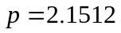. DerivaGem shows that the implied volatility is 10.23% (as for the call). (If calendar time is used the price of the put is 2.1597 and the implied volatility is 10.33% as for the call.)
A European call has the same implied volatility as a European put when both have the same strike price and time to maturity. This is formally proved in Chapter 20.
Problem 17.24.
A stock index currently stands at 300 and has a volatility of 20%. The risk-free interest rate is 8% and the dividend yield on the index is 3%. Use a three-step binomial tree to value a six-month put option on the index with a strike price of 300 if it is (a) European and (b) American?
(a) The price is 14.39 as indicated by the tree in Figure S17.2.
(b) The price is 14.97 as indicated by the tree in Figure S17.3

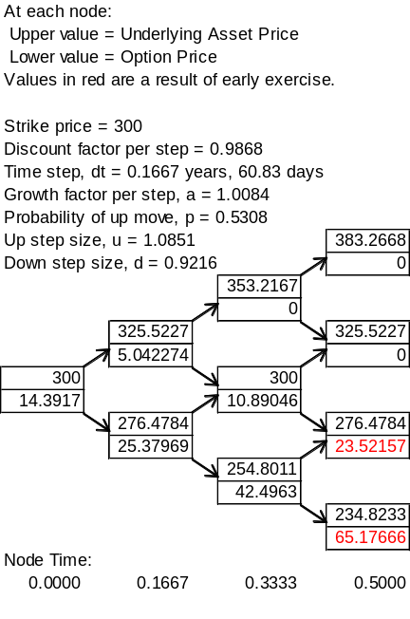
Figure S17.2: Tree for valuing the European option in Problem 17.24

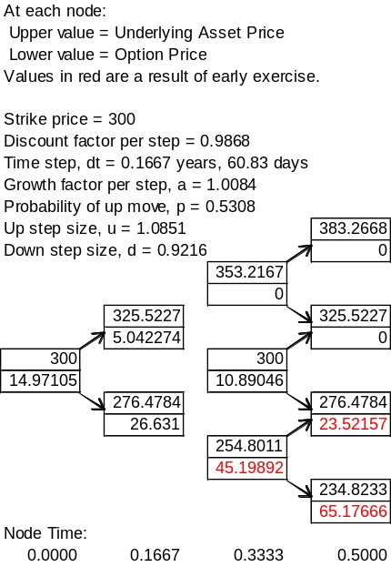

Figure S17.3: Tree for valuing the American option in Problem 17.24
Problem 17.25.
Suppose that the spot price of the Canadian dollar is U.S. $0.95 and that the Canadian dollar/U.S. dollar exchange rate has a volatility of 8% per annum. The risk-free rates of interest in Canada and the United States are 4% and 5% per annum, respectively. Calculate the value of a European call option to buy one Canadian dollar for U.S. $0.95 in nine months. Use put-call parity to calculate the price of a European put option to sell one Canadian dollar for U.S. $0.95 in nine months. What is the price of a call option to buy U.S. $0.95 with one Canadian dollar in nine months?
In this case 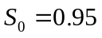, 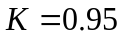, 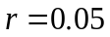, 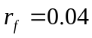, 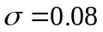 and 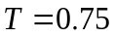. The option can be valued using equation (17.8)
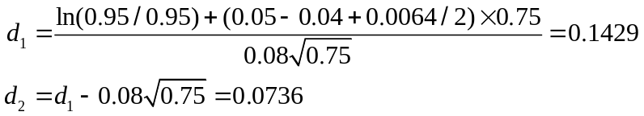
and
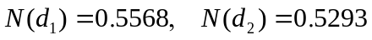
The value of the call, , is given by
c = 0.95e^{−0.04×0.75}×0.5568−0.95e^{−0.05×0.75}×0.5293 = 0.0290
i.e., it is 2.90 cents. From put–call parity
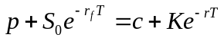
so that
The option to buy US$0.95 with C$1.00 is the same as the same as an option to sell one Canadian dollar for US$0.95. This means that it is a put option on the Canadian dollar and its price is US$0.0221.

Problem 17.26.
The spot price of an index is 1,000 and the risk-free rate is 4%. The prices of three month
European call and put options when the strike price is 950 are 78 and 26. Estimate (a) the dividend yield and (b) the implied volatility.

- From the formula at the end of Section 17.4
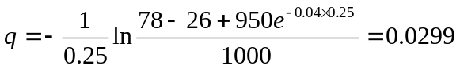

The dividend yield is 2.99%

- We can calculate the implied volatility using either the call or the put. The answer (given by DerivaGem) is 24.68% in both cases.

Problem 17.27.
Assume that the price of currency A expressed in terms of the price of currency B follows the process
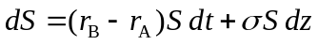
where 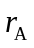 is the risk-free interest rate in currency A and 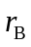 is the risk-free interest rate in currency B. What is the process followed by the price of currency B expressed in terms of currency A?
The price of currency B expressed in terms of currency A is 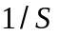. From Ito’s lemma the process followed by 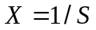 is
or
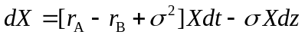

This is Siegel’s paradox and is discussed further in Business Snapshot 30.1.
Problem 17.28.
The USD/euro exchange rate is 1.3000. The exchange rate volatility is 15%. A US company will receive 1 million euros in three months. The euro and USD risk-free rates are 5% and 4%, respectively. The company decides to use a range forward contract with the lower strike equal to 1.2500.
- What should the higher strike be to create a zero-cost contract?
- What position in calls and puts should the company take?
- Show that your answer to (a) does not depend on interest rates providing the interest rate differential between the two currencies, r –r_{f} , remains the same.

- A put with a strike price of 1.25 is worth $0.019. By trial and error DerivaGem can be used to show that the strike price of a call that leads to a call having a price of $0.019 is 1.3477. This is the higher strike price to create a zero cost contract.
- The company should buy a put with strike price 1.25 and sell a call with strike price 1.3477. This ensures that the exchange rate it pays for the euros is between 1.2500 and 1.3477.
- This can be verified using DerivaGem. We can also prove that it is true. If the interest rate differential remains the same the forward rate remains the same. Equations (17.13) and (17.14) show that a change in the domestic risk-free rate affects the prices of calls and puts by the same percentage amount. Hence if 1.25 is the lower strike, 1.3477 will always be the upper strike.

Problem 17.29.
In Business Snapshot 17.1 what is the cost of a guarantee that the return on the fund will not be negative over the next 10 years?

In this case the guarantee is valued as a put option with S₀ = 1000, K = 1000, r = 5%, q = 1%, σ = 15%, and T=10. The value of the guarantee is given by equation (17.5) as 38.46 or 3.8% of the value of the portfolio.

Problem 17.30.
The one-year forward price of the Mexican peso is $0.0750 per MXN. The U.S. risk-free
rate is 1.25% and the Mexican risk-free rate is 4.5%. The exchange rate volatility is 13%. What is the value of one-year European call and put options with a strike price of 0.0800.

Using equations (17.13) and (17.14) the values of the call and put are 0.0020 and 0.0069, respectively Note that we do not need the Mexican risk-free rate when we use forward prices for the valuation.

