CHAPTER 18
Futures Options
Practice Questions
Problem 18.1.
Explain the difference between a call option on yen and a call option on yen futures.
A call option on yen gives the holder the right to buy yen in the spot market at an exchange rate equal to the strike price. A call option on yen futures gives the holder the right to receive the amount by which the futures price exceeds the strike price. If the yen futures option is exercised, the holder also obtains a long position in the yen futures contract.
Problem 18.2.
Why are options on bond futures more actively traded than options on bonds?
The main reason is that a bond futures contract is a more liquid instrument than a bond. The price of a Treasury bond futures contract is known immediately from trading on the exchange. The price of a bond can be obtained only by contacting dealers.
Problem 18.3.
“A futures price is like a stock paying a dividend yield.” What is the dividend yield?
A futures price behaves like a stock paying a dividend yield at the risk-free interest rate.
Problem 18.4.
A futures price is currently 50. At the end of six months it will be either 56 or 46. The risk-free interest rate is 6% per annum. What is the value of a six-month European call option with a strike price of 50?
In this case 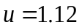 and 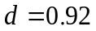. The probability of an up movement in a risk-neutral world is
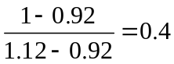
From risk-neutral valuation, the value of the call is
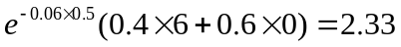

Problem 18.5.
How does the put–call parity formula for a futures option differ from put–call parity for an option on a non-dividend-paying stock?
The put–call parity formula for futures options is the same as the put–call parity formula for stock options except that the stock price is replaced by 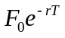, where 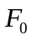 is the current futures price, is the risk-free interest rate, and is the life of the option.
Problem 18.6.
Consider an American futures call option where the futures contract and the option contract expire at the same time. Under what circumstances is the futures option worth more than the corresponding American option on the underlying asset?
The American futures call option is worth more than the corresponding American option on the underlying asset when the futures price is greater than the spot price prior to the maturity of the futures contract. This is the case when the risk-free rate is greater than the income on the asset plus the convenience yield.
Problem 18.7.
Calculate the value of a five-month European put futures option when the futures price is $19, the strike price is $20, the risk-free interest rate is 12% per annum, and the volatility of the futures price is 20% per annum.
In this case 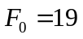, 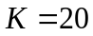, 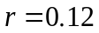, 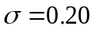, and 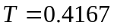. The value of the European put futures option is

where
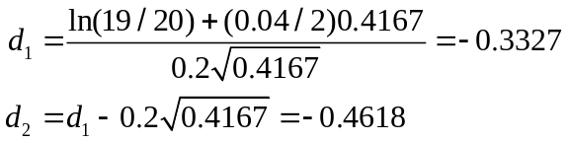

This is

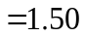
or $1.50.
Problem 18.8.
Suppose you buy a put option contract on October gold futures with a strike price of $1400 per ounce. Each contract is for the delivery of 100 ounces. What happens if you exercise when the October futures price is $1,380?
An amount (1,400 – 1,380)×100 = $2,000 is added to your margin account and you acquire a short futures position obligating you to sell 100 ounces of gold in October. This position is marked to market in the usual way until you choose to close it out.

Problem 18.9.
Suppose you sell a call option contract on April live cattle futures with a strike price of 130 cents per pound. Each contract is for the delivery of 40,000 pounds. What happens if the contract is exercised when the futures price is 135 cents?
In this case an amount (1.35−1.30)×40,000 = $2,000 is subtracted from your margin account and you acquire a short position in a live cattle futures contract to sell 40,000 pounds of cattle in April. This position is marked to market in the usual way until you choose to close it out.

Problem 18.10.
Consider a two-month call futures option with a strike price of 40 when the risk-free interest rate is 10% per annum. The current futures price is 47. What is a lower bound for the value of the futures option if it is (a) European and (b) American?

Lower bound if option is European is
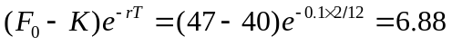
Lower bound if option is American is
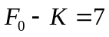

Problem 18.11.
Consider a four-month put futures option with a strike price of 50 when the risk-free interest rate is 10% per annum. The current futures price is 47. What is a lower bound for the value of the futures option if it is (a) European and (b) American?

Lower bound if option is European is
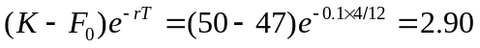
Lower bound if option is American is
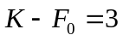

Problem 18.12.
A futures price is currently 60 and its volatility is 30%. The risk-free interest rate is 8% per annum. Use a two-step binomial tree to calculate the value of a six-month European call option on the futures with a strike price of 60? If the call were American, would it ever be worth exercising it early?
In this case 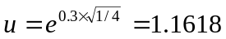; 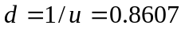; and
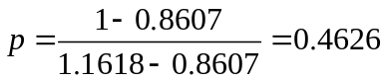
In the tree shown in Figure S18.1 the middle number at each node is the price of the European option and the lower number is the price of the American option. The tree shows that the value of the European option is 4.3155 and the value of the American option is 4.4026. The American option should sometimes be exercised early.
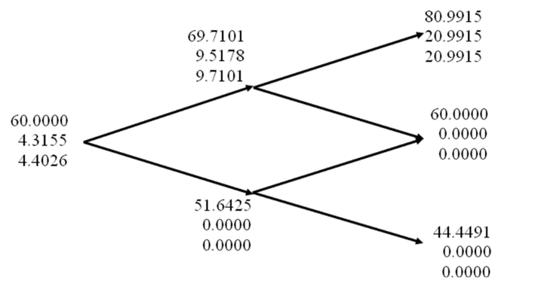

Figure S18.1: Tree to evaluate European and American call options in Problem 18.12

Problem 18.13.
In Problem 18.12 what does the binomial tree give for the value of a six-month European put option on futures with a strike price of 60? If the put were American, would it ever be worth exercising it early? Verify that the call prices calculated in Problem 18.12 and the put prices calculated here satisfy put–call parity relationships.
The parameters , and  are the same as in Problem 18.12. The tree in Figure S18.2 shows that the prices of the European and American put options are the same as those calculated for call options in Problem 18.12. This illustrates a symmetry that exists for at-the-money futures options. The American option should sometimes be exercised early. Because 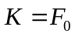 and 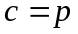, the European put–call parity result holds.
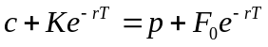
Also because 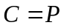, 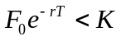, and 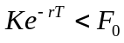 the result in equation (18.2) holds. (The first expression in equation (18.2) is negative; the middle expression is zero, and the last expression is positive.)
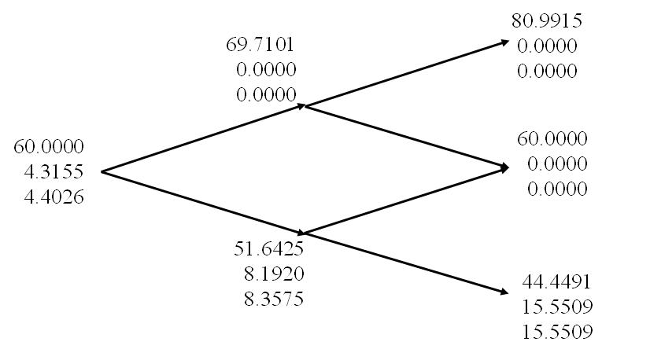

Figure S18.2: Tree to evaluate European and American put options in Problem 18.13

Problem 18.14.
A futures price is currently 25, its volatility is 30% per annum, and the risk-free interest rate is 10% per annum. What is the value of a nine-month European call on the futures with a strike price of 26?
In this case 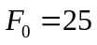, 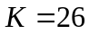, 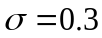, 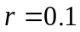, 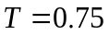
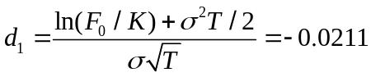

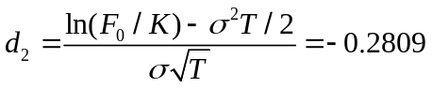

Problem 18.15.
A futures price is currently 70, its volatility is 20% per annum, and the risk-free interest rate is 6% per annum. What is the value of a five-month European put on the futures with a strike price of 65?
In this case 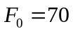, 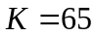, 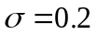, 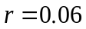,
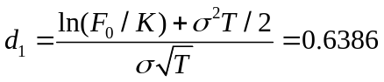

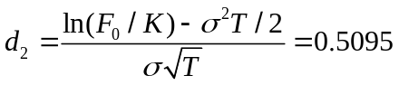

Problem 18.16.
Suppose that a one-year futures price is currently 35. A one-year European call option and a one-year European put option on the futures with a strike price of 34 are both priced at 2 in the market. The risk-free interest rate is 10% per annum. Identify an arbitrage opportunity.
In this case
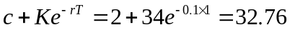

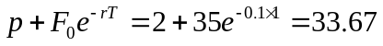
Put-call parity shows that we should buy one call, short one put and short a futures contract. This costs nothing up front. In one year, either we exercise the call or the put is exercised against us. In either case, we buy the asset for 34 and close out the futures position. The gain on the short futures position is 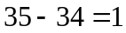.

Problem 18.17.
“The price of an at-the-money European call futures option always equals the price of a similar at-the-money European put futures option.” Explain why this statement is true.
The put price is
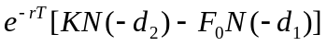
Because 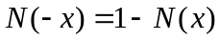 for all the put price can also be written
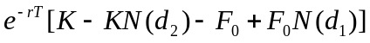
Because 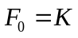 this is the same as the call price:
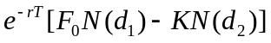
This result also follows from put–call parity showing that it is not model dependent.
Problem 18.18.
Suppose that a futures price is currently 30. The risk-free interest rate is 5% per annum. A three-month American call futures option with a strike price of 28 is worth 4. Calculate bounds for the price of a three-month American put futures option with a strike price of 28.
From equation (18.2), 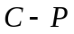 must lie between
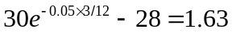
and
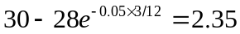
Because 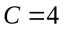 we must have 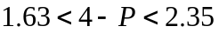 or
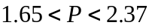

Problem 18.19.
Show that if  is the price of an American call option on a futures contract when the strike price is  and the maturity is , and  is the price of an American put on the same futures contract with the same strike price and exercise date,
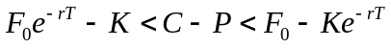
where is the futures price and is the risk-free rate. Assume that 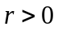 and that there is no difference between forward and futures contracts. (Hint: Use an analogous approach to that indicated for Problem 17.12.)
In this case we consider
Portfolio A: A European call option on futures plus an amount invested at the risk-free interest rate
Portfolio B: An American put option on futures plus an amount invested at the risk-free interest rate plus a long futures contract maturing at time .
Following the arguments in Chapter 5 we will treat all futures contracts as forward contracts. Portfolio A is worth 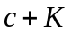 while portfolio B is worth 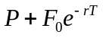. If the put option is exercised at time 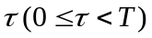, portfolio B is worth
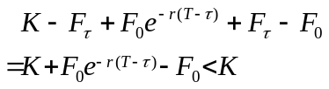
at time where 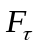 is the futures price at time . Portfolio A is worth
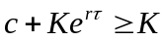
Hence Portfolio A more than Portfolio B. If both portfolios are held to maturity (time ), Portfolio A is worth
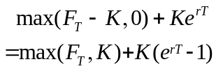
Portfolio B is worth
Hence portfolio A is worth more than portfolio B.
Because portfolio A is worth more than portfolio B in all circumstances:
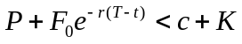
Because 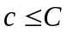 it follows that
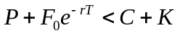
or
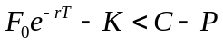
This proves the first part of the inequality.

For the second part of the inequality consider:
Portfolio C: An American call futures option plus an amount 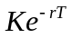 invested at the risk-free interest rate
Portfolio D: A European put futures option plus an amount invested at the risk-free interest rate plus a long futures contract.
Portfolio C is worth 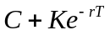 while portfolio D is worth 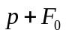. If the call option is exercised at time 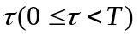 portfolio C becomes:
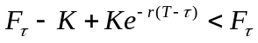
while portfolio D is worth
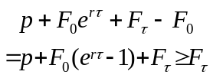
Hence portfolio D is worth more than portfolio C. If both portfolios are held to maturity (time ), portfolio C is worth 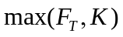 while portfolio D is worth
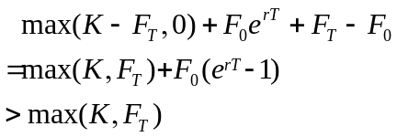
Hence portfolio D is worth more than portfolio C.
Because portfolio D is worth more than portfolio C in all circumstances
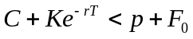
Because 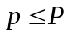 it follows that
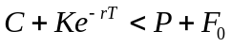
or
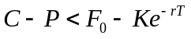
This proves the second part of the inequality. The result:
has therefore been proved.

Problem 18.20.
Calculate the price of a three-month European call option on the spot price of silver. The three-month futures price is $12, the strike price is $13, the risk-free rate is 4%, and the volatility of the price of silver is 25%.
This has the same value as a three-month call option on silver futures where the futures contract expires in three months. It can therefore be valued using equation (18.9) with 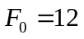, 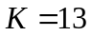, 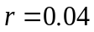, 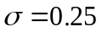 and 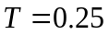. The value is 0.244.

Problem 18.21.
A corporation knows that in three months it will have $5 million to invest for 90 days at LIBOR minus 50 basis points and wishes to ensure that the rate obtained will be at least 6.5%. What position in exchange-traded interest-rate options should it take to hedge?
The rate received will be less than 6.5% when LIBOR is less than 7%. The corporation requires a three-month call option on a Eurodollar futures option with a strike price of 93. If three-month LIBOR is greater than 7% at the option maturity, the Eurodollar futures quote at option maturity will be less than 93 and there will be no payoff from the option. If the three-month LIBOR is less than 7%, one Eurodollar futures options provide a payoff of $25 per 0.01%. Each 0.01% of interest costs the corporation $125 (=5,000,000×0.0001×0.25). A total of 125/25 = 5 contracts are therefore required.

Further Questions

Problem 18.22.
A futures price is currently 40. It is known that at the end of three months the price will be either 35 or 45. What is the value of a three-month European call option on the futures with a strike price of 42 if the risk-free interest rate is 7% per annum?
In this case 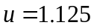 and 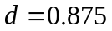. The risk-neutral probability of an up move is
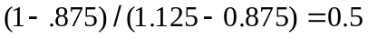
The value of the option is
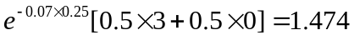

Problem 18.23.
The futures price of an asset is currently 78 and the risk-free rate is 3%. A six-month put on the futures with a strike price of 80 is currently worth 6.5. What is the value of a six-month call on the futures with a strike price of 80 if both the put and call are European? What is the range of possible values of the six-month call with a strike price of 80 if both put and call are American?

Put call parity for European options gives
6.5+78e^{-0.03×0.5} = c+80e^{-0.03×0.5}
so that c=4.53.
The relation for American options gives
78 e^{-0.03×0.5} – 80 < C − 6.5 < 78 − 80 e^{-0.03×0.5}
so that
−3.16 < C −6.5 < −0.81
so that C lies between 3.34 and 5.69

Problem 18.24.
Use a three-step tree to value an American put futures option when the futures price is
50, the life of the option is 9 months, the strike price is 50, the risk-free rate is 3%, and
the volatility is 25%.

u=1.331, d = 0.8825, and =0.4688. As the tree in Figure S18.3 shows the value of the option is 4.59

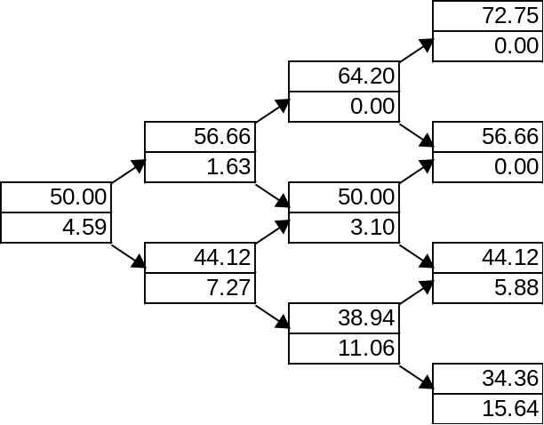

Figure S18.3: Tree for Problem 18.24

Problem 18.25.
It is February 4. July call options on corn futures with strike prices of 260, 270, 280, 290, and 300 cost 26.75, 21.25, 17.25, 14.00, and 11.375, respectively. July put options with these strike prices cost 8.50, 13.50, 19.00, 25.625, and 32.625, respectively. The options mature on June 19, the current July corn futures price is 278.25, and the risk-free interest rate is 1.1%. Calculate implied volatilities for the options using DerivaGem. Comment on the results you get.
There are 135 days to maturity (assuming this is not a leap year). Using DerivaGem with 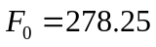, 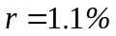, = 135/365, and 500 time steps gives the implied volatilities shown in the table below.
Strike Price | Call Price | Put Price | Call Implied Vol | Put Implied Vol
260 | 26.75 | 8.50 | 24.69 | 24.59
270 | 21.25 | 13.50 | 25.40 | 26.14
280 | 17.25 | 19.00 | 26.85 | 26.86
290 | 14.00 | 25.625 | 28.11 | 27.98
300 | 11.375 | 32.625 | 29.24 | 28.57

We do not expect put–call parity to hold exactly for American options and so there is no reason why the implied volatility of a call should be exactly the same as the implied volatility of a put. Nevertheless it is reassuring that they are close.
There is a tendency for high strike price options to have a higher implied volatility. As explained in Chapter 20, this is an indication that the probability distribution for corn futures prices in the future has a heavier right tail and less heavy left tail than the lognormal distribution.

Problem 18.26.
Calculate the implied volatility of soybean futures prices from the following information concerning a European put on soybean futures:
Current futures price | 525
Exercise price | 525
Risk-free rate | 6% per annum
Time to maturity | 5 months
Put price | 20

In this case 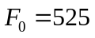, 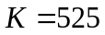, , . We wish to find the value of for which 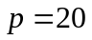 where:
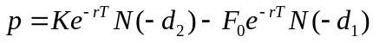
This must be done by trial and error. When ,.p=26.35. When 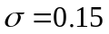.p=19.77 When 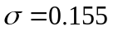, p=20.43. When 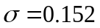, p=20.03. These calculations show that the implied volatility is approximately 15.2% per annum.
Problem 18.27.
Calculate the price of a six-month European put option on the spot value of the S&P 500. The six-month forward price of the index is 1,400, the strike price is 1,450, the risk-free rate is 5%, and the volatility of the index is 15%.
The price of the option is the same as the price of a European put option on the forward price of the index where the forward contract has a maturity of six months. It is given by equation (18.10) with 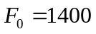, 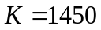, 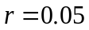, , and 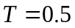. It is 86.35.

Problem 18.28.
The strike price of a futures option is 550 cents, the risk-free rate of interest is 3%, the volatility of the futures price is 20%, and the time to maturity of the option is 9 months. The futures price is 500 cents.
- What is the price of the option if it is a European call?
- What is the price of the option if it is a European put?
- Verify that put-call parity holds
- What is the futures price for a futures style option if it is a call?
- What is the futures price for a futures style option if it is a put?

- The price given by equation (18.9) or DerivaGem is 16.20 cents
- The price given by equation (18.10) or DerivaGem is 65.08 cents
- In this case, the left hand side of equation (18.1) is 16.2+550e^{−0.03×0.75} = 553.96. The right hand side of equation (18.1) is 65.03+500 e^{−0.03×0.75}=553.96. This verifies that put-call parity holds.
- The futures price for a futures-style call is 16.20e^{0.03×0.75}=16.57
- The futures price for a futures-style put is 65.08e^{0.03×0.75}=66.56

