CHAPTER 20
Volatility Smiles

Practice Questions
Problem 20.1.
What volatility smile is likely to be observed when
- Both tails of the stock price distribution are less heavy than those of the lognormal distribution?
- The right tail is heavier, and the left tail is less heavy, than that of a lognormal distribution?

  - A smile similar to that in Figure 20.7 is observed.
  - An upward sloping volatility smile is observed
Problem 20.2.
What volatility smile is observed for equities?
A downward sloping volatility smile is usually observed for equities.
Problem 20.3.
What volatility smile is likely to be caused by jumps in the underlying asset price? Is the pattern likely to be more pronounced for a two-year option than for a three-month option?
Jumps tend to make both tails of the stock price distribution heavier than those of the lognormal distribution. This creates a volatility smile similar to that in Figure 20.1. The volatility smile is likely to be more pronounced for the three-month option.
Problem 20.4.
A European call and put option have the same strike price and time to maturity. The call has an implied volatility of 30% and the put has an implied volatility of 25%. What trades would you do?
The put has a price that is too low relative to the call’s price. The correct trading strategy is to buy the put, buy the stock, and sell the call.
Problem 20.5.
Explain carefully why a distribution with a heavier left tail and less heavy right tail than the lognormal distribution gives rise to a downward sloping volatility smile.
The heavier left tail should lead to high prices, and therefore high implied volatilities, for out-of-the-money (low-strike-price) puts. Similarly the less heavy right tail should lead to low prices, and therefore low volatilities for out-of-the-money (high-strike-price) calls. A volatility smile where volatility is a decreasing function of strike price results.
Problem 20.6.
The market price of a European call is $3.00 and its price given by Black-Scholes-Merton model with a volatility of 30% is $3.50. The price given by this Black-Scholes-Merton model for a European put option with the same strike price and time to maturity is $1.00. What should the market price of the put option be? Explain the reasons for your answer.
With the notation in the text
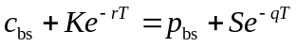

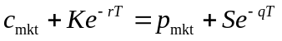
It follows that
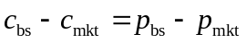
In this case, 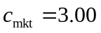; 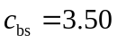; and 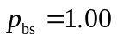. It follows that 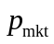 should be 0.50.
Problem 20.7.
Explain what is meant by crashophobia.
The crashophobia argument is an attempt to explain the pronounced volatility skew in equity markets since 1987. (This was the year equity markets shocked everyone by crashing more than 20% in one day). The argument is that traders are concerned about another crash and as a result increase the price of out-of-the-money puts. This creates the volatility skew.

Problem 20.8.
A stock price is currently $20. Tomorrow, news is expected to be announced that will either increase the price by $5 or decrease the price by $5. What are the problems in using Black–Scholes-Merton to value one-month options on the stock?

The probability distribution of the stock price in one month is not lognormal. Possibly it consists of two lognormal distributions superimposed upon each other and is bimodal. Black–Scholes is clearly inappropriate, because it assumes that the stock price at any future time is lognormal.

Problem 20.9.
What volatility smile is likely to be observed for six-month options when the volatility is uncertain and positively correlated to the stock price?
When the asset price is positively correlated with volatility, the volatility tends to increase as the asset price increases, producing less heavy left tails and heavier right tails. Implied volatility then increases with the strike price.
Problem 20.10.
What problems do you think would be encountered in testing a stock option pricing model empirically?
There are a number of problems in testing an option pricing model empirically. These include the problem of obtaining synchronous data on stock prices and option prices, the problem of estimating the dividends that will be paid on the stock during the option’s life, the problem of distinguishing between situations where the market is inefficient and situations where the option pricing model is incorrect, and the problems of estimating stock price volatility.
Problem 20.11.
Suppose that a central bank’s policy is to allow an exchange rate to fluctuate between 0.97 and 1.03. What pattern of implied volatilities for options on the exchange rate would you expect to see?
In this case the probability distribution of the exchange rate has a thin left tail and a thin right tail relative to the lognormal distribution. We are in the opposite situation to that described for foreign currencies in Section 20.2. Both out-of-the-money and in-the-money calls and puts can be expected to have lower implied volatilities than at-the-money calls and puts. The pattern of implied volatilities is likely to be similar to Figure 20.7.
Problem 20.12.
Option traders sometimes refer to deep-out-of-the-money options as being options on volatility. Why do you think they do this?
A deep-out-of-the-money option has a low value. Decreases in its volatility reduce its value. However, this reduction is small because the value can never go below zero. Increases in its volatility, on the other hand, can lead to significant percentage increases in the value of the option. The option does, therefore, have some of the same attributes as an option on volatility.
Problem 20.13.
A European call option on a certain stock has a strike price of $30, a time to maturity of one year, and an implied volatility of 30%. A European put option on the same stock has a strike price of $30, a time to maturity of one year, and an implied volatility of 33%. What is the arbitrage opportunity open to a trader? Does the arbitrage work only when the lognormal assumption underlying Black–Scholes–Merton holds? Explain carefully the reasons for your answer.

Put–call parity implies that European put and call options have the same implied volatility. If a call option has an implied volatility of 30% and a put option has an implied volatility of 33%, the call is priced too low relative to the put. The correct trading strategy is to buy the call, sell the put and short the stock. This does not depend on the lognormal assumption underlying Black–Scholes–Merton. Put–call parity is true for any set of assumptions.

Problem 20.14.
Suppose that the result of a major lawsuit affecting a company is due to be announced tomorrow. The company’s stock price is currently $60. If the ruling is favorable to the company, the stock price is expected to jump to $75. If it is unfavorable, the stock is expected to jump to $50. What is the risk-neutral probability of a favorable ruling? Assume that the volatility of the company’s stock will be 25% for six months after the ruling if the ruling is favorable and 40% if it is unfavorable. Use DerivaGem to calculate the relationship between implied volatility and strike price for six-month European options on the company today. The company does not pay dividends. Assume that the six-month risk-free rate is 6%. Consider call options with strike prices of $30, $40, $50, $60, $70, and $80.
Suppose that  is the probability of a favorable ruling. The expected price of the company’s stock tomorrow is
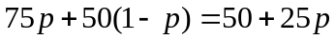
This must be the price of the stock today. (We ignore the expected return to an investor over one day.) Hence
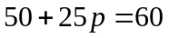
or 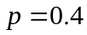.
If the ruling is favorable, the volatility, , will be 25%. Other option parameters are
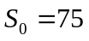, 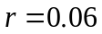, and 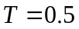. For a value of  equal to 50, DerivaGem gives the value of a European call option price as 26.502.
If the ruling is unfavorable, the volatility, will be 40% Other option parameters are 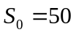, , and . For a value of equal to 50, DerivaGem gives the value of a European call option price as 6.310.
The value today of a European call option with a strike price today is the weighted average of 26.502 and 6.310 or:
DerivaGem can be used to calculate the implied volatility when the option has this price. The parameter values are 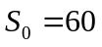, 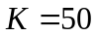, , and 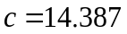. The implied volatility is 47.76%.
These calculations can be repeated for other strike prices. The results are shown in the table below. The pattern of implied volatilities is shown in Figure S20.1.

Strike Price | Call Price:  Favorable Outcome | Call Price: Unfavorable Outcome | Weighted Price | Implied Volatility (%)
30 | 45.887 | 21.001 | 30.955 | 46.67
40 | 36.182 | 12.437 | 21.935 | 47.78
50 | 26.502 | 6.310 | 14.387 | 47.76
60 | 17.171 | 2.826 | 8.564 | 46.05
70 | 9.334 | 1.161 | 4.430 | 43.22
80 | 4.159 | 0.451 | 1.934 | 40.36
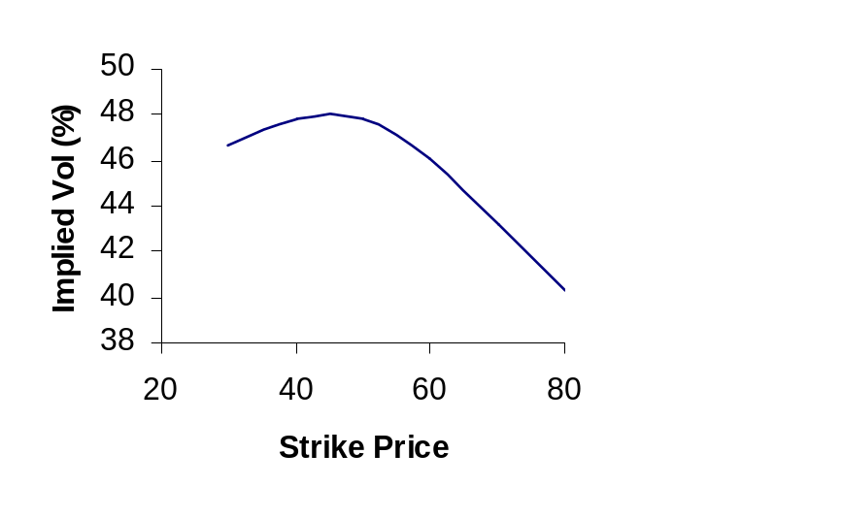

Figure S20.1: Implied Volatilities in Problem 20.14

Problem 20.15.
An exchange rate is currently 0.8000. The volatility of the exchange rate is quoted as 12% and interest rates in the two countries are the same. Using the lognormal assumption, estimate the probability that the exchange rate in three months will be (a) less than 0.7000, (b) between 0.7000 and 0.7500, (c) between 0.7500 and 0.8000, (d) between 0.8000 and 0.8500, (e) between 0.8500 and 0.9000, and (f) greater than 0.9000. Based on the volatility smile usually observed in the market for exchange rates, which of these estimates would you expect to be too low and which would you expect to be too high?
As pointed out in Chapters 5 and 17 an exchange rate behaves like a stock that provides a dividend yield equal to the foreign risk-free rate. Whereas the growth rate in a non-dividend-paying stock in a risk-neutral world is , the growth rate in the exchange rate in a risk-neutral world is 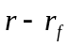. Exchange rates have low systematic risks and so we can reasonably assume that this is also the growth rate in the real world. In this case the foreign risk-free rate equals the domestic risk-free rate (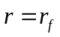). The expected growth rate in the exchange rate is therefore zero. If 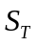 is the exchange rate at time its probability distribution is given by equation (14.3) with 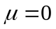:
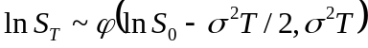
where 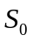 is the exchange rate at time zero and is the volatility of the exchange rate. In this case 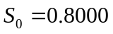 and 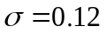, and 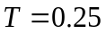 so that

or
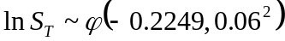

- ln 0.70 = –0.3567. The probability that 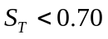 is the same as the probability that 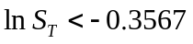. It is
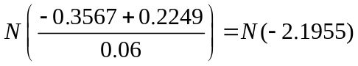
This is 1.41%.

- ln 0.75 = –0.2877. The probability that 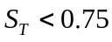 is the same as the probability that 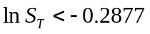. It is
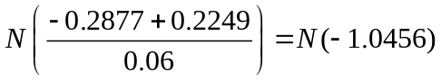
This is 14.79%. The probability that the exchange rate is between 0.70 and 0.75 is therefore 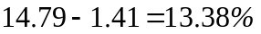.

- ln 0.80 = –0.2231. The probability that 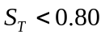 is the same as the probability that 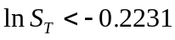. It is
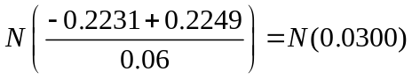
This is 51.20%. The probability that the exchange rate is between 0.75 and 0.80 is therefore 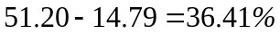.

- ln 0.85 = –0.1625. The probability that 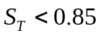 is the same as the probability that 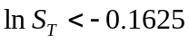. It is
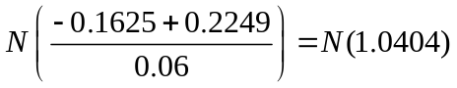
This is 85.09%. The probability that the exchange rate is between 0.80 and 0.85 is therefore 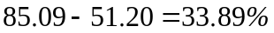.

- ln 0.90 = –0.1054. The probability that 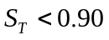 is the same as the probability that 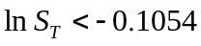. It is
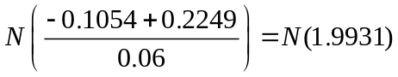
This is 97.69%. The probability that the exchange rate is between 0.85 and 0.90 is therefore 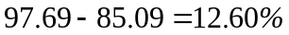.
- The probability that the exchange rate is greater than 0.90 is 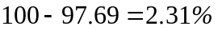.

The volatility smile encountered for foreign exchange options is shown in Figure 20.1 of the text and implies the probability distribution in Figure 20.2. Figure 20.2 suggests that we would expect the probabilities in (a), (c), (d), and (f) to be too low and the probabilities in (b) and (e) to be too high.
Problem 20.16.
A stock price is $40. A six-month European call option on the stock with a strike price of $30 has an implied volatility of 35%. A six-month European call option on the stock with a strike price of $50 has an implied volatility of 28%. The six-month risk-free rate is 5% and no dividends are expected. Explain why the two implied volatilities are different. Use DerivaGem to calculate the prices of the two options. Use put–call parity to calculate the prices of six-month European put options with strike prices of $30 and $50. Use DerivaGem to calculate the implied volatilities of these two put options.
The difference between the two implied volatilities is consistent with Figure 20.3 in the text. For equities the volatility smile is downward sloping. A high strike price option has a lower implied volatility than a low strike price option. The reason is that traders consider that the probability of a large downward movement in the stock price is higher than that predicted by the lognormal probability distribution. The implied distribution assumed by traders is shown in Figure 20.4.
To use DerivaGem to calculate the price of the first option, proceed as follows. Select Equity as the Underlying Type in the first worksheet. Select Black-Scholes European as the Option Type. Input the stock price as 40, volatility as 35%, risk-free rate as 5%, time to exercise as 0.5 year, and exercise price as 30. Leave the dividend table blank because we are assuming no dividends. Select the button corresponding to call. Do not select the implied volatility button. Hit the Enter key and click on calculate. DerivaGem will show the price of the option as 11.155. Change the volatility to 28% and the strike price to 50. Hit the Enter key and click on calculate. DerivaGem will show the price of the option as 0.725.
Put–call parity is
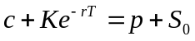
so that
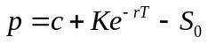
For the first option, 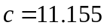, 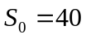, 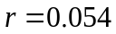, 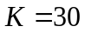, and so that
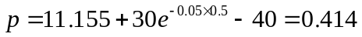
For the second option, 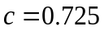, , , , and so that
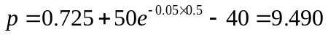

To use DerivaGem to calculate the implied volatility of the first put option, input the stock price as 40, the risk-free rate as 5%, time to exercise as 0.5 year, and the exercise price as 30. Input the price as 0.414 in the second half of the Option Data table. Select the buttons for a put option and implied volatility. Hit the Enter key and click on calculate. DerivaGem will show the implied volatility as 34.99%.
Similarly, to use DerivaGem to calculate the implied volatility of the first put option, input the stock price as 40, the risk-free rate as 5%, time to exercise as 0.5 year, and the exercise price as 50. Input the price as 9.490 in the second half of the Option Data table. Select the buttons for a put option and implied volatility. Hit the Enter key and click on calculate. DerivaGem will show the implied volatility as 27.99%.
These results are what we would expect. DerivaGem gives the implied volatility of a put with strike price 30 to be almost exactly the same as the implied volatility of a call with a strike price of 30. Similarly, it gives the implied volatility of a put with strike price 50 to be almost exactly the same as the implied volatility of a call with a strike price of 50.
Problem 20.17.
“The Black–Scholes–Merton model is used by traders as an interpolation tool.” Discuss this view.
When plain vanilla call and put options are being priced, traders do use the Black-Scholes-Merton model as an interpolation tool. They calculate implied volatilities for the options whose prices they can observe in the market. By interpolating between strike prices and between times to maturity, they estimate implied volatilities for other options. These implied volatilities are then substituted into Black-Scholes-Merton to calculate prices for these options. In practice much of the work in producing a table such as Table 20.2 in the over-the-counter market is done by brokers. Brokers often act as intermediaries between participants in the over-the-counter market and usually have more information on the trades taking place than any individual financial institution. The brokers provide a table such as Table 20.2 to their clients as a service.

Problem 20.18.
Using Table 20.2 calculate the implied volatility a trader would use for an 8-month option with K/S₀ = 1.04.
The implied volatility is 13.45%. We get the same answer by (a) interpolating between strike prices of 1.00 and 1.05 and then between maturities six months and one year and (b) interpolating between maturities of six months and one year and then between strike prices of 1.00 and 1.05.

Further Questions

Problem 20.19.
A company’s stock is selling for $4. The company has no outstanding debt. Analysts consider the liquidation value of the company to be at least $300,000 and there are 100,000 shares outstanding. What volatility smile would you expect to see?
In liquidation the company’s stock price must be at least 300,000/100,000 = $3. The company’s stock price should therefore always be at least $3. This means that the stock price distribution that has a thinner left tail and fatter right tail than the lognormal distribution. An upward sloping volatility smile can be expected.

Problem 20.20.
A company is currently awaiting the outcome of a major lawsuit. This is expected to be known within one month. The stock price is currently $20. If the outcome is positive, the stock price is expected to be $24 at the end of one month. If the outcome is negative, it is expected to be $18 at this time. The one-month risk-free interest rate is 8% per annum.
- What is the risk-neutral probability of a positive outcome?
- What are the values of one-month call options with strike prices of $19, $20, $21, $22, and $23?
- Use DerivaGem to calculate a volatility smile for one-month call options.
- Verify that the same volatility smile is obtained for one-month put options.
- If is the risk-neutral probability of a positive outcome (stock price rises to $24), we must have
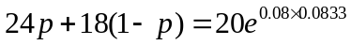
so that 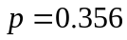
- The price of a call option with strike price is 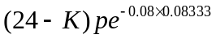 when 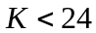. Call options with strike prices of 19, 20, 21, 22, and 23 therefore have prices 1.766, 1.413, 1.060, 0.707, and 0.353, respectively.
- From DerivaGem the implied volatilities of the options with strike prices of 19, 20, 21, 22, and 23 are 49.8%, 58.7%, 61.7%, 60.2%, and 53.4%, respectively. The volatility smile is therefore a “frown” with the volatilities for deep-out-of-the-money and deep-in-the-money options being lower than those for close-to-the-money options.
- The price of a put option with strike price is 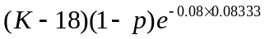. Put options with strike prices of 19, 20, 21, 22, and 23 therefore have prices of 0.640, 1.280, 1.920, 2.560, and 3.200. DerivaGem gives the implied volatilities as 49.81%, 58.68%, 61.69%, 60.21%, and 53.38%. Allowing for rounding errors these are the same as the implied volatilities for put options.
Problem 20.21. (Excel file)
A futures price is currently $40. The risk-free interest rate is 5%. Some news is expected tomorrow that will cause the volatility over the next three months to be either 10% or 30%. There is a 60% chance of the first outcome and a 40% chance of the second outcome. Use DerivaGem to calculate a volatility smile for three-month options.

The calculations are shown in the following table. For example, when the strike price is 34, the price of a call option with a volatility of 10% is 5.926, and the price of a call option when the volatility is 30% is 6.312. When there is a 60% chance of the first volatility and 40% of the second, the price is . The implied volatility given by this price is 23.21. The table shows that the uncertainty about volatility leads to a classic volatility smile similar to that in Figure 20.1 of the text. In general when volatility is stochastic with the stock price and volatility uncorrelated we get a pattern of implied volatilities similar to that observed for currency options.

Strike Price | Call Price  10% Volatility | Call Price 30% Volatility | Weighted Price | Implied Volatility (%)
34 | 5.926 | 6.312 | 6.080 | 23.21
36 | 3.962 | 4.749 | 4.277 | 21.03
38 | 2.128 | 3.423 | 2.646 | 18.88
40 | 0.788 | 2.362 | 1.418 | 18.00
42 | 0.177 | 1.560 | 0.730 | 18.80
44 | 0.023 | 0.988 | 0.409 | 20.61
46 | 0.002 | 0.601 | 0.242 | 22.43

Problem 20.22. (Excel file)
Data for a number of foreign currencies are provided on the author’s Web site:
http://www.rotman.utoronto.ca/~hull/data
Choose a currency and use the data to produce a table similar to Table 20.1.
The data provided for this problem is new to the 8th edition. The following table shows the percentage of daily returns greater than 1, 2, 3, 4, 5, and 6 standard deviations for each currency. The pattern is similar to that in Table 20.1.

 | >1sd | >2sd | >3sd | >4sd | >5sd | >6sd
EUR | 22.62 | 5.21 | 1.70 | 0.50 | 0.20 | 0.10
CAD | 23.12 | 5.01 | 1.60 | 0.50 | 0.20 | 0.10
GBP | 22.62 | 4.70 | 1.30 | 0.80 | 0.50 | 0.10
JPY | 25.23 | 4.80 | 1.50 | 0.40 | 0.30 | 0.10
Normal | 31.73 | 4.55 | 0.27 | 0.01 | 0.00 | 0.00

Problem 20.23. (Excel file)
Data for a number of stock indices are provided on the author’s Web site:
http://www.rotman.utoronto.ca/~hull/data
Choose an index and test whether a three standard deviation down movement happens more often than a three standard deviation up movement.
The data provided for this problem is new to the 8Th edition. The percentage of times up and down movements happen are shown in the table below.

 | >3sd down | >3sd up
S&P 500 | 1.10 | 0.90
NASDAQ | 0.80 | 0.90
FTSE | 1.30 | 0.90
Nikkei | 1.00 | 0.60
Average | 1.05 | 0.83

As might be expected from the shape of the volatility smile large down movements occur more often than large up movements. However, the results are not significant at the 95% level. (The standard error of the Average >3sd down percentage is 0.185% and the standard error of the Average >3sd up percentage is 0.161%. The standard deviation of the difference between the two is 0.245%)

Problem 20.24.
Consider a European call and a European put with the same strike price and time to maturity. Show that they change in value by the same amount when the volatility increases from a level, 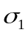, to a new level, 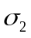 within a short period of time. (Hint Use put–call parity.)
Define and 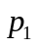 as the values of the call and the put when the volatility is . Define 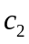 and 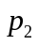 as the values of the call and the put when the volatility is . From put–call parity
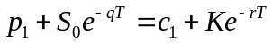

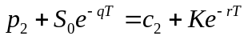
If follows that
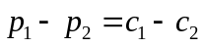

Problem 20.25.
An exchange rate is currently 1.0 and the implied volatilities of six-month European options with strike prices 0.7, 0.8, 0.9, 1.0, 1.1, 1.2, and 1.3 are 13%, 12%, 11%, 10%, 11%, 12%, and 13%. The domestic and foreign risk free rates are both 2.5%. Calculate the implied probability distribution using an approach similar to that used in the appendix for Example 20A.1. Compare it with the implied distribution where all the implied volatilities are 11.5%.
Define:
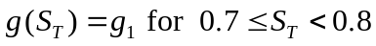

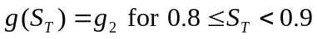

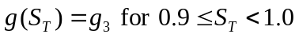

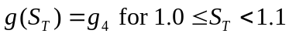

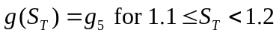

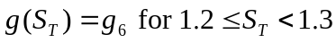

The value of 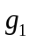 can be calculated by interpolating to get the implied volatility for a six-month option with a strike price of 0.75 as 12.5%. This means that options with strike prices of 0.7, 0.75, and 0.8 have implied volatilities of 13%, 12.5% and 12%, respectively. From DerivaGem their prices are $0.2963, $0.2469, and $0.1976, respectively. Using equation (20A.1) with 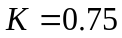 and 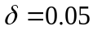 we get
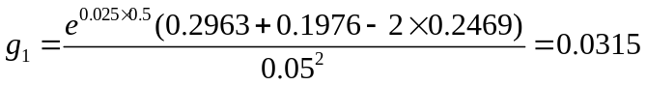
Similar calculations show that 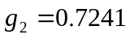, 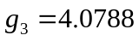, 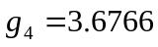, g₅ = 0.7285, and 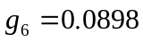. The total probability between 0.7 and 1.3 is the sum of these numbers multiplied by 0.1 or 0.9329. If the volatility had been flat at 11.5% the values of , 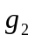, 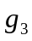, 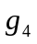, 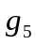, and 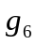 would have been 0.0239, 0.9328, 4.2248, 3.7590, 0.9613, and 0.0938. The total probability between 0.7 and 1.3 is in this case 0.9996. This shows that the volatility smile gives rise to heavy tails for the distribution.

Problem 20.26.
Using Table 20.2 calculate the implied volatility a trader would use for an 11-month option with K/S₀= 0.98
Interpolation gives the volatility for a six-month option with a strike price of 98 as 12.82%. Interpolation also gives the volatility for a 12-month option with a strike price of 98 as 13.7%. A final interpolation gives the volatility of an 11-month option with a strike price of 98 as 13.55%. The same answer is obtained if the sequence in which the interpolations are done is reversed.

