CHAPTER 22
Value at Risk

Practice Questions

Problem 22.1.
Consider a position consisting of a $100,000 investment in asset A and a $100,000 investment in asset B. Assume that the daily volatilities of both assets are 1% and that the coefficient of correlation between their returns is 0.3. What is the 5-day 99% VaR for the portfolio?
The standard deviation of the daily change in the investment in each asset is $1,000. The variance of the portfolio’s daily change is
The standard deviation of the portfolio’s daily change is the square root of this or $1,612.45. The standard deviation of the 5-day change is
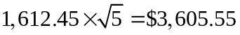
Because N⁻¹(0.01) = 2.326 1% of a normal distribution lies more than 2.326 standard deviations below the mean. The 5-day 99 percent value at risk is therefore 2.326×3605.55 = $8388.
Problem 22.2.
Describe three ways of handling interest-rate-dependent instruments when the model building approach is used to calculate VaR. How would you handle interest-rate-dependent instruments when historical simulation is used to calculate VaR?
The three alternative procedures mentioned in the chapter for handling interest rates when the model building approach is used to calculate VaR involve (a) the use of the duration model, (b) the use of cash flow mapping, and (c) the use of principal components analysis. When historical simulation is used we need to assume that the change in the zero-coupon yield curve between Day and Day 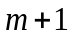 is the same as that between Day and Day 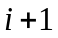 for different values of . In the case of a LIBOR, the zero curve is usually calculated from deposit rates, Eurodollar futures quotes, and swap rates. We can assume that the percentage change in each of these between Day and Day is the same as that between Day and Day . In the case of a Treasury curve it is usually calculated from the yields on Treasury instruments. Again we can assume that the percentage change in each of these between Day and Day is the same as that between Day and Day .

Problem 22.3.
A financial institution owns a portfolio of options on the U.S. dollar–sterling exchange rate. The delta of the portfolio is 56.0. The current exchange rate is 1.5000. Derive an approximate linear relationship between the change in the portfolio value and the percentage change in the exchange rate. If the daily volatility of the exchange rate is 0.7%, estimate the 10-day 99% VaR.
The approximate relationship between the daily change in the portfolio value, 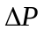, and the daily change in the exchange rate, 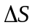, is
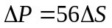
The percentage daily change in the exchange rate, 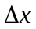, equals 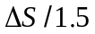. It follows that
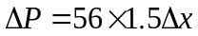
or
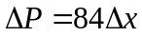
The standard deviation of equals the daily volatility of the exchange rate, or 0.7 percent. The standard deviation of is therefore 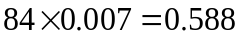. It follows that the 10-day 99 percent VaR for the portfolio is
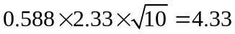

Problem 22.4.
Suppose you know that the gamma of the portfolio in the previous question is 16.2. How does this change your estimate of the relationship between the change in the portfolio value and the percentage change in the exchange rate?
The relationship is
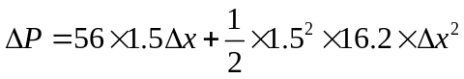
or
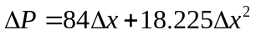

Problem 22.5.
Suppose that the daily change in the value of a portfolio is, to a good approximation, linearly dependent on two factors, calculated from a principal components analysis. The delta of a portfolio with respect to the first factor is 6 and the delta with respect to the second factor is –4. The standard deviations of the factors are 20 and 8, respectively. What is the 5-day 90% VaR?
The factors calculated from a principal components analysis are uncorrelated. The daily variance of the portfolio is
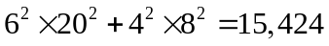
and the daily standard deviation is 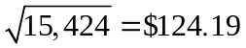. Since 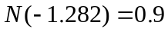, the 5-day 90% value at risk is
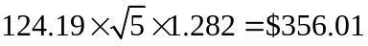

Problem 22.6.
Suppose a company has a portfolio consisting of positions in stocks and bonds Assume there are no derivatives. Explain the assumptions underlying (a) the linear model and (b) the historical simulation model for calculating VaR.
The linear model assumes that the percentage daily change in each market variable has a normal probability distribution. The historical simulation model assumes that the probability distribution observed for the percentage daily changes in the market variables in the past is the probability distribution that will apply over the next day.

Problem 22.7.
Explain how an interest rate swap is mapped into a portfolio of zero-coupon bonds with standard maturities for the purposes of a VaR calculation.
When a final exchange of principal is added in, the floating side is equivalent a zero coupon bond with a maturity date equal to the date of the next payment. The fixed side is a coupon-bearing bond, which is equivalent to a portfolio of zero-coupon bonds. The swap can therefore be mapped into a portfolio of zero-coupon bonds with maturity dates corresponding to the payment dates. Each of the zero-coupon bonds can then be mapped into positions in the adjacent standard-maturity zero-coupon bonds.
Problem 22.8.
Explain the difference between Value at Risk and Expected Shortfall.
Value at risk is the loss that is expected to be exceeded 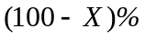 of the time in  days for specified parameter values,  and . Expected shortfall is the expected loss conditional that the loss is greater than the Value at Risk.
Problem 22.9.
Explain why the linear model can provide only approximate estimates of VaR for a portfolio containing options.
The change in the value of an option is not linearly related to the change in the value of the underlying variables. When the change in the values of underlying variables is normal, the change in the value of the option is non-normal. The linear model assumes that it is normal and is, therefore, only an approximation.
Problem 22.10.
Some time ago a company has entered into a forward contract to buy £1 million for $1.5 million. The contract now has six months to maturity. The daily volatility of a six-month zero-coupon sterling bond (when its price is translated to dollars) is 0.06% and the daily volatility of a six-month zero-coupon dollar bond is 0.05%. The correlation between returns from the two bonds is 0.8. The current exchange rate is 1.53. Calculate the standard deviation of the change in the dollar value of the forward contract in one day. What is the 10-day 99% VaR? Assume that the six-month interest rate in both sterling and dollars is 5% per annum with continuous compounding.
The contract is a long position in a sterling bond combined with a short position in a dollar bond. The value of the sterling bond is 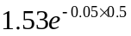 or $1.492 million. The value of the dollar bond is 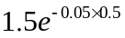 or $1.463 million. The variance of the change in the value of the contract in one day is
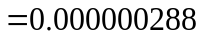
The standard deviation is therefore $0.000537 million. The 10-day 99% VaR is 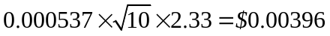 million.
Problem 22.11.
The text calculates a VaR estimate for the example in Table 22.9 assuming two factors. How does the estimate change if you assume (a) one factor and (b) three factors.
If we assume only one factor, the model is
ΔP = −0.05f₁

The standard deviation of 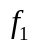 is 17.55. The standard deviation of is therefore 0.05×17.55=0.8775 and the 1-day 99 percent value at risk is 0.8775×2.326=2.0. If we assume three factors, our exposure to the third factor is
10×(−0.157)+4×(−0.256)−8×(−0.355)−7×(−0.195)+2×0.068 = 1.75
The model is therefore
ΔP = −0.05f₁−3.87f₂+1.75f₃
The variance of is
0.05²×17.55²+3.87²×4.77²+1.75²×2.08²=354.8

The standard deviation of is 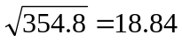 and the 1-day 99% value at risk is 18.84×2.326=$43.8.
The example illustrates that the relative importance of different factors depends on the portfolio being considered. Normally the second factor is less important than the first, but in this case it is much more important.
Problem 22.12.
A bank has a portfolio of options on an asset. The delta of the options is –30 and the gamma is –5. Explain how these numbers can be interpreted. The asset price is 20 and its volatility per day is 1%. Adapt Sample Application E in the DerivaGem Application Builder software to calculate VaR.

The delta of the options is the rate if change of the value of the options with respect to the price of the asset. When the asset price increases by a small amount the value of the options decrease by 30 times this amount. The gamma of the options is the rate of change of their delta with respect to the price of the asset. When the asset price increases by a small amount, the delta of the portfolio decreases by five times this amount.
By entering 20 for , 1% for the volatility per day, -30 for delta, -5 for gamma, and recomputing we see that 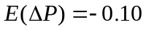, 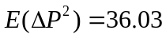, and 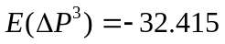. The 1-day, 99% VaR given by the software for the quadratic approximation is 14.5. This is a 99% 1-day VaR. The VaR is calculated using the formulas in footnote 9 and the results in Technical Note 10.

Problem 22.13.
Suppose that in Problem 22.12 the vega of the portfolio is -2 per 1% change in the annual volatility. Derive a model relating the change in the portfolio value in one day to delta, gamma, and vega. Explain without doing detailed calculations how you would use the model to calculate a VaR estimate.
Define as the volatility per year, 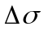 as the change in in one day, and 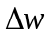 and the proportional change in in one day. We measure in as a multiple of 1% so that the current value of is 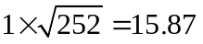. The delta-gamma-vega model is
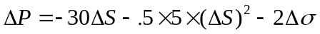
or
which simplifies to
The change in the portfolio value now depends on two market variables. Once the daily volatility of and the correlation between and have been estimated we can estimate moments of and use a Cornish–Fisher expansion.

Problem 22.14.
The one-day 99% VaR is calculated for the four-index example in Section 22.2 as $253,385. Look at the underlying spreadsheets on the author’s website and calculate the a) the 95% one-day VaR and b) the 97% one-day VaR.

The 95% one-day VaR is the 25th worst loss. This is $156,511. The 97% one-day VaR is the 15th worst loss. This is $172,224.
Problem 22.15.
Use the spreadsheets on the author’s web site to calculate the one-day 99% VaR, using the basic methodology in Section 22.2 if the four-index portfolio considered in Section 22.2 is equally divided between the four indices.
In the “Scenarios” worksheet the portfolio investments are changed to 2500 in cells L2:O2. The losses are then sorted from the largest to the smallest. The fifth worst loss is $238,526. This is the one-day 99% VaR.

Further Questions
Problem 22.16.
A company has a position in bonds worth $6 million. The modified duration of the portfolio is 5.2 years. Assume that only parallel shifts in the yield curve can take place and that the standard deviation of the daily yield change (when yield is measured in percent) is 0.09. Use the duration model to estimate the 20-day 90% VaR for the portfolio. Explain carefully the weaknesses of this approach to calculating VaR. Explain two alternatives that give more accuracy.
The change in the value of the portfolio for a small change 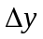 in the yield is approximately 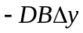 where  is the duration and  is the value of the portfolio. It follows that the standard deviation of the daily change in the value of the bond portfolio equals 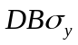 where 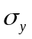 is the standard deviation of the daily change in the yield. In this case 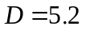, 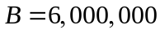, and 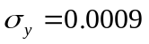 so that the standard deviation of the daily change in the value of the bond portfolio is
The 20-day 90% VaR for the portfolio is 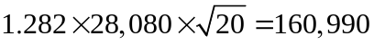 or $160,990. This approach assumes that only parallel shifts in the term structure can take place. Equivalently it assumes that all rates are perfectly correlated or that only one factor drives term structure movements. Alternative more accurate approaches described in the chapter are (a) cash flow mapping and (b) a principal components analysis.
Problem 22.17.
Consider a position consisting of a $300,000 investment in gold and a $500,000 investment in silver. Suppose that the daily volatilities of these two assets are 1.8% and 1.2% respectively, and that the coefficient of correlation between their returns is 0.6. What is the 10-day 97.5% VaR for the portfolio? By how much does diversification reduce the VaR?
The variance of the portfolio (in thousands of dollars) is
The standard deviation is 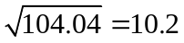. Since 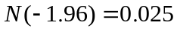, the 1-day 97.5% VaR is 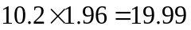 and the 10-day 97.5% VaR is 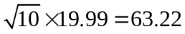. The 10-day 97.5% VaR is therefore $63,220. The 10-day 97.5% value at risk for the gold investment is 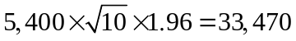. The 10-day 97.5% value at risk for the silver investment is 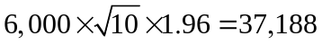. The diversification benefit is

Problem 22.18.
Consider a portfolio of options on a single asset. Suppose that the delta of the portfolio is 12, the value of the asset is $10, and the daily volatility of the asset is 2%. Estimate the 1-day 95% VaR for the portfolio from the delta. Suppose next that the gamma of the portfolio is 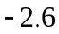. Derive a quadratic relationship between the change in the portfolio value and the percentage change in the underlying asset price in one day. How would you use this in a Monte Carlo simulation?
An approximate relationship between the daily change in the value of the portfolio, and the proportional daily change in the value of the asset is
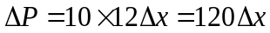
The standard deviation of is 0.02. It follows that the standard deviation of is 2.4. The 1-day 95% VaR is 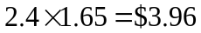. The quadratic relationship is
or
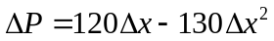
This could be used in conjunction with Monte Carlo simulation. We would sample values for and use this equation to convert the samples to samples.
Problem 22.19.
A company has a long position in a two-year bond and a three-year bond as well as a short position in a five-year bond. Each bond has a principal of $100 and pays a 5% coupon annually. Calculate the company’s exposure to the one-year, two-year, three-year, four-year, and five-year rates. Use the data in Tables 22.7 and 22.8 to calculate a 20 day 95% VaR on the assumption that rate changes are explained by (a) one factor, (b) two factors, and (c) three factors. Assume that the zero-coupon yield curve is flat at 5%.

The cash flows are as follows

Year | 1 | 2 | 3 | 4 | 5
2-yr bond | 5 | 105
3-yr bond | 5 | 5 | 105
5-yr bond | -5 | -5 | -5 | -5 | -105
Total | 5 | 105 | 100 | -5 | -105
Present Value | 4.756 | 95.008 | 86.071 | -4.094 | -81.774
Impact of 1bp change | -0.0005 | -0.0190 | -0.0258 | 0.0016 | 0.0409

The duration relationship is used to calculate the last row of the table. When the one-year rate increases by one basis point, the value of the cash flow in year 1 decreases by 1 × 0.0001 × 4.756 = 0.0005; when the two year rate increases by one basis point, the value of the cash flow in year 2 decreases by 2×0.0001×95.008 = 0.0190; and so on.

The sensitivity to the first factor is
−0.0005 × 0.216 − 0.0190 × 0.331 − 0.0258 × 0.372 + 0.0016 × 0.392 + 0.0409 × 0.404
or −0.00116. Similarly the sensitivity to the second and third factors are 0.01589 and −0.01283.
Assuming one factor, the standard deviation of the one-day change in the portfolio value is 0.00116 × 17.55 = 0.02043. The 20-day 95% VaR is therefore 0.0203 × 1.645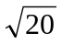 = 0.149. Assuming two factors, the standard deviation of the one-day change in the portfolio value is
The 20-day 95% VaR is therefore 0.0785 × 1.645 = 0.577.
Assuming three factors, the standard deviation of the one-day change in the portfolio value is
The 20-day 95% VaR is therefore 0.0683 × 1.645 = 0.502.
In this case the second has the most important impact on VaR.

Problem 22.20.
A bank has written a call option on one stock and a put option on another stock. For the first option the stock price is 50, the strike price is 51, the volatility is 28% per annum, and the time to maturity is nine months. For the second option the stock price is 20, the strike price is 19, the volatility is 25% per annum, and the time to maturity is one year. Neither stock pays a dividend, the risk-free rate is 6% per annum, and the correlation between stock price returns is 0.4. Calculate a 10-day 99% VaR
- Using only deltas.
- Using the partial simulation approach.
- Using the full simulation approach.
This assignment is useful for consolidating students’ understanding of alternative approaches to calculating VaR, but it is calculation intensive. Realistically students need some programming skills to make the assignment feasible. My answer follows the usual practice of assuming that the 10-day 99% value at risk is 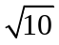 times the 1-day 99% value at risk. Some students may try to calculate a 10-day VaR directly, which is fine.
- From DerivaGem, the values of the two option positions are –5.413 and –1.014. The deltas are –0.589 and 0.284, respectively. An approximate linear model relating the change in the portfolio value to proportional change, 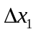, in the first stock price and the proportional change, 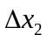, in the second stock price is
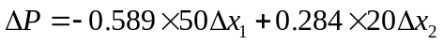
or
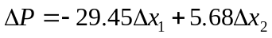
The daily volatility of the two stocks are 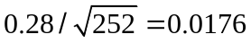 and 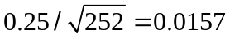, respectively. The one-day variance of is
The one day standard deviation is, therefore, 0.4895 and the 10-day 99% VaR is 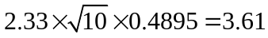.
- In the partial simulation approach, we simulate changes in the stock prices over a one-day period (building in the correlation) and then use the quadratic approximation to calculate the change in the portfolio value on each simulation trial. The one percentile point of the probability distribution of portfolio value changes turns out to be 1.22. The 10-day 99% value at risk is, therefore, 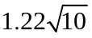 or about 3.86.
- In the full simulation approach, we simulate changes in the stock price over one-day (building in the correlation) and revalue the portfolio on each simulation trial. The results are very similar to (b) and the estimate of the 10-day 99% value at risk is about 3.86.
Problem 22.21.
A common complaint of risk managers is that the model building approach (either linear or quadratic) does not work well when delta is close to zero. Test what happens when delta is close to zero in using Sample Application E in the DerivaGem Application Builder software. (You can do this by experimenting with different option positions and adjusting the position in the underlying to give a delta of zero.) Explain the results you get.
We can create a portfolio with zero delta in Sample Application E by changing the position in the stock from 1,000 to 513.58. (This reduces delta by 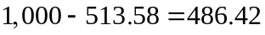.) In this case the true VaR is 48.86; the VaR given by the linear model is 0.00; and the VaR given by the quadratic model is −35.71.
Other zero-delta examples can be created by changing the option portfolio and then zeroing out delta by adjusting the position in the underlying asset. The results are similar. The software shows that neither the linear model nor the quadratic model gives good answers when delta is zero. The linear model always gives a VaR of zero because the model assumes that the portfolio has no risk. (For example, in the case of one underlying asset 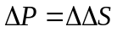.) The quadratic model gives a negative VaR because is always positive in this model. 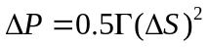.
In practice many portfolios do have deltas close to zero because of the hedging activities described in Chapter 19. This has led many financial institutions to prefer historical simulation to the model building approach.

Problem 22.22. (Excel file)
Suppose that the portfolio considered in Section 22.2 has (in $000s) 3,000 in DJIA, 3,000 in FTSE, 1,000 in CAC40, and 3,000 in Nikkei 225. Use the spreadsheet on the author’s web site to calculate what difference this makes to the one-day 99% VaR that is calculated in Section 22.2.

First the investments worksheet is changed to reflect the new portfolio allocation. (see row 2 of the Scenarios worksheet for historical simulation). The losses are then sorted from the greatest to the least. The one-day 99% VaR is the fifth worst loss or $230,785.

