CHAPTER 24
Credit Risk

Practice Questions

Problem 24.1.
The spread between the yield on a three-year corporate bond and the yield on a similar risk-free bond is 50 basis points. The recovery rate is 30%. Estimate the average hazard rate per year over the three-year period.

From equation (24.2) the average hazard rate over the three years is 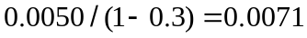 or 0.71% per year.
Problem 24.2.
Suppose that in Problem 24.1 the spread between the yield on a five-year bond issued by the same company and the yield on a similar risk-free bond is 60 basis points. Assume the same recovery rate of 30%. Estimate the average hazard rate per year over the five-year period. What do your results indicate about the average hazard rate in years 4 and 5?

From equation (24.2) the average hazard rate over the five years is 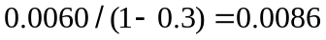 or 0.86% per year. Using the results in the previous question, the hazard rate is 0.71% per year for the first three years and

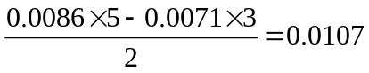
or 1.07% per year in years 4 and 5.
Problem 24.3.
Should researchers use real-world or risk-neutral default probabilities for a) calculating credit value at risk and b) adjusting the price of a derivative for defaults?

Real-world probabilities of default should be used for calculating credit value at risk. Risk-neutral probabilities of default should be used for adjusting the price of a derivative for default.
Problem 24.4.
How are recovery rates usually defined?

he recovery rate for a bond is the value of the bond immediately after the issuer defaults as a percent of its face value.
Problem 24.5.
Explain the difference between an unconditional default probability density and a hazard rate.
The hazard rate, 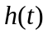 at time is defined so that 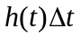 is the probability of default between times and 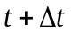 conditional on no default prior to time . The unconditional default probability density 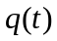 is defined so that 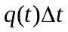 is the probability of default between times and as seen at time zero.
Problem 24.6.
Verify a) that the numbers in the second column of Table 24.3 are consistent with the numbers in Table 24.1 and b) that the numbers in the fourth column of Table 24.4 are consistent with the numbers in Table 24.3 and a recovery rate of 40%.

The first number in the second column of Table 24.3 is calculated as

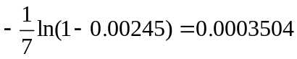

or 0.04% per year when rounded. Other numbers in the column are calculated similarly. The numbers in the fourth column of Table 24.4 are the numbers in the second column of Table 24.3 multiplied by one minus the expected recovery rate. In this case the expected recovery rate is 0.4.
Problem 24.7.
Describe how netting works. A bank already has one transaction with a counterparty on its books. Explain why a new transaction by a bank with a counterparty can have the effect of increasing or reducing the bank’s credit exposure to the counterparty.

Suppose company A goes bankrupt when it has a number of outstanding contracts with company B. Netting means that the contracts with a positive value to A are netted against those with a negative value in order to determine how much, if anything, company A owes company B. Company A is not allowed to “cherry pick” by keeping the positive-value contracts and defaulting on the negative-value contracts.
The new transaction will increase the bank’s exposure to the counterparty if the contract tends to have a positive value whenever the existing contract has a positive value and a negative value whenever the existing contract has a negative value. However, if the new transaction tends to offset the existing transaction, it is likely to have the incremental effect of reducing credit risk.
Problem 24.8.
“DVA can improve the bottom line when a bank is experiencing financial difficulty.” Explain why this statement is true.

When a bank is experiencing financial difficulties, its credit spread is likely to increase. This increases q_{i}* and DVA increases. This is a benefit to the bank: the fact that it is more likely to default means that its derivatives are worth less.

Problem 24.9.
Explain the difference between the Gaussian copula model for the time to default and CreditMetrics as far as the following are concerned: a) the definition of a credit loss and b) the way in which default correlation is modeled.

(a) In the Gaussian copula model for time to default a credit loss is recognized only when a default occurs. In CreditMetrics it is recognized when there is a credit downgrade as well as when there is a default.
(b) In the Gaussian copula model of time to default, the default correlation arises because the value of the factor . This defines the default environment or average default rate in the economy. In CreditMetrics a copula model is applied to credit ratings migration and this determines the joint probability of particular changes in the credit ratings of two companies.
Problem 24.10.
Suppose that the LIBOR/swap curve is flat at 6% with continuous compounding and a five-year bond with a coupon of 5% (paid semiannually) sells for 90.00. How would an asset swap on the bond be structured? What is the asset swap spread that would be calculated in this situation?

Suppose that the principal is $100. The asset swap is structured so that the $10 is paid initially. After that $2.50 is paid every six months. In return LIBOR plus a spread is received on the principal of $100. The present value of the fixed payments is

The spread over LIBOR must therefore have a present value of 5.3579. The present value of $1 received every six months for five years is 8.5105. The spread received every six months must therefore be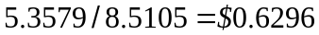. The asset swap spread is therefore 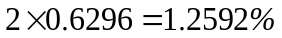 per annum.
Problem 24.11.
Show that the value of a coupon-bearing corporate bond is the sum of the values of its constituent zero-coupon bonds when the amount claimed in the event of default is the no-default value of the bond, but that this is not so when the claim amount is the face value of the bond plus accrued interest.

When the claim amount is the no-default value, the loss for a corporate bond arising from a default at time is
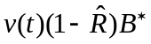

where 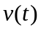 is the discount factor for time and 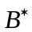 is the no-default value of the bond at time . Suppose that the zero-coupon bonds comprising the corporate bond have no-default values at time of 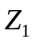, 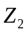, , 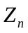, respectively. The loss from the th zero-coupon bond arising from a default at time is
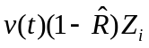

The total loss from all the zero-coupon bonds is

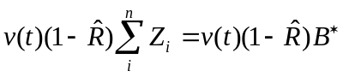

This shows that the loss arising from a default at time is the same for the corporate bond as for the portfolio of its constituent zero-coupon bonds. It follows that the value of the corporate bond is the same as the value of its constituent zero-coupon bonds.
When the claim amount is the face value plus accrued interest, the loss for a corporate bond arising from a default at time is

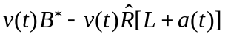

where is the face value and 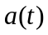 is the accrued interest at time . In general this is not the same as the loss from the sum of the losses on the constituent zero-coupon bonds.
Problem 24.12.
A four-year corporate bond provides a coupon of 4% per year payable semiannually and has a yield of 5% expressed with continuous compounding. The risk-free yield curve is flat at 3% with continuous compounding. Assume that defaults can take place at the end of each year (immediately before a coupon or principal payment and the recovery rate is 30%. Estimate the risk-neutral default probability on the assumption that it is the same each year.

Define  as the risk-free rate. The calculations are as follows

Time  (yrs) | Def.  Prob. | Recovery Amount ($) | Risk-free  Value ($) | Loss Given  Default ($) | Discount  Factor | PV of Expected  Loss ($)
1.0 |  | 30 | 104.78 | 74.78 | 0.9704 | 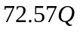
2.0 |  | 30 | 103.88 | 73.88 | 0.9418 | 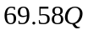
3.0 |  | 30 | 102.96 | 72.96 | 0.9139 | 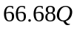
4.0 |  | 30 | 102.00 | 72.00 | 0.8869 | 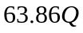
Total |  |  |  |  |  | 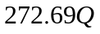

The bond pays a coupon of 2 every six months and has a continuously compounded yield of 5% per year. Its market price is 96.19. The risk-free value of the bond is obtained by discounting the promised cash flows at 3%. It is 103.66. The total loss from defaults should therefore be equated to 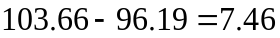. The value of implied by the bond price is therefore given by 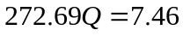. or 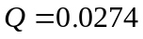. The implied probability of default is 2.74% per year.
Problem 24.13.
A company has issued 3- and 5-year bonds with a coupon of 4% per annum payable annually. The yields on the bonds (expressed with continuous compounding) are 4.5% and 4.75%, respectively. Risk-free rates are 3.5% with continuous compounding for all maturities. The recovery rate is 40%. Defaults can take place half way through each year. The risk-neutral default rates per year are 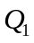 for years 1 to 3 and 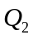 for years 4 and 5. Estimate and .
The table for the first bond is

Time  (yrs) | Def.  Prob. | Recovery Amount ($) | Risk-free  Value ($) | Loss Given  Default ($) | Discount  Factor | PV of Expected  Loss ($)
0.5 |  | 40 | 103.01 | 63.01 | 0.9827 | 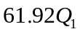
1.5 |  | 40 | 102.61 | 62.61 | 0.9489 | 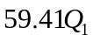
2.5 |  | 40 | 102.20 | 62.20 | 0.9162 | 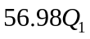
Total |  |  |  |  |  | 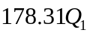

The market price of the bond is 98.35 and the risk-free value is 101.23. It follows that is given by
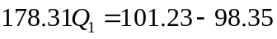

so that 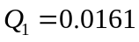.
The table for the second bond is

Time  (yrs) | Def.  Prob. | Recovery Amount ($) | Risk-free  Value ($) | Loss Given  Default ($) | Discount  Factor | PV of Expected  Loss ($)
0.5 |  | 40 | 103.77 | 63.77 | 0.9827 | 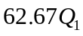
1.5 |  | 40 | 103.40 | 63.40 | 0.9489 | 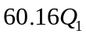
2.5 |  | 40 | 103.01 | 63.01 | 0.9162 | 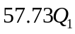
3.5 |  | 40 | 102.61 | 62.61 | 0.8847 | 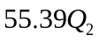
4.5 |  | 40 | 102.20 | 62.20 | 0.8543 | 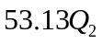
Total |  |  |  |  |  | 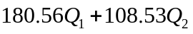

The market price of the bond is 96.24 is and the risk-free value is 101.97. It follows that

From which we get 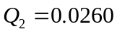 The bond prices therefore imply a probability of default of 1.61% per year for the first three years and 2.60% for the next two years.
Problem 24.14.
Suppose that a financial institution has entered into a swap dependent on the sterling interest rate with counterparty X and an exactly offsetting swap with counterparty Y. Which of the following statements are true and which are false.
- The total present value of the cost of defaults is the sum of the present value of the cost of defaults on the contract with X plus the present value of the cost of defaults on the contract with Y.
- The expected exposure in one year on both contracts is the sum of the expected exposure on the contract with X and the expected exposure on the contract with Y.
- The 95% upper confidence limit for the exposure in one year on both contracts is the sum of the 95% upper confidence limit for the exposure in one year on the contract with X and the 95% upper confidence limit for the exposure in one year on the contract with Y.
Explain your answers.

The statements in (a) and (b) are true. The statement in (c) is not. Suppose that 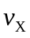 and 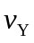 are the exposures to X and Y. The expected value of 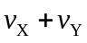 is the expected value of plus the expected value of . The same is not true of 95% confidence limits.
Problem 24.15.
“A long forward contract subject to credit risk is a combination of a short position in a no-default put and a long position in a call subject to credit risk.” Explain this statement.

Assume that defaults happen only at the end of the life of the forward contract. In a default-free world the forward contract is the combination of a long European call and a short European put where the strike price of the options equals the delivery price and the maturity of the options equals the maturity of the forward contract. If the no-default value of the contract is positive at maturity, the call has a positive value and the put is worth zero. The impact of defaults on the forward contract is the same as that on the call. If the no-default value of the contract is negative at maturity, the call has a zero value and the put has a positive value. In this case defaults have no effect. Again the impact of defaults on the forward contract is the same as that on the call. It follows that the contract has a value equal to a long position in a call that is subject to default risk and short position in a default-free put.
Problem 24.16.
Explain why the credit exposure on a matched pair of forward contracts resembles a straddle.

Suppose that the forward contract provides a payoff at time . With our usual notation, the value of a long forward contract is 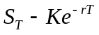. The credit exposure on a long forward contract is therefore 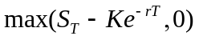; that is, it is a call on the asset price with strike price 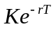. Similarly the credit exposure on a short forward contract is 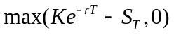; that is, it is a put on the asset price with strike price . The total credit exposure is, therefore, a straddle with strike price .
Problem 24.17.
Explain why the impact of credit risk on a matched pair of interest rate swaps tends to be less than that on a matched pair of currency swaps.

The credit risk on a matched pair of interest rate swaps is 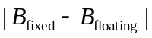. As maturity is approached all bond prices tend to par and this tends to zero. The credit risk on a matched pair of currency swaps is 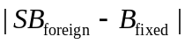 where is the exchange rate. The expected value of this tends to increase as the swap maturity is approached because of the uncertainty in .
Problem 24.18.
“When a bank is negotiating currency swaps, it should try to ensure that it is receiving the lower interest rate currency from a company with a low credit risk.” Explain.

As time passes there is a tendency for the currency which has the lower interest rate to strengthen. This means that a swap where we are receiving this currency will tend to move in the money (i.e., have a positive value). Similarly a swap where we are paying the currency will tend to move out of the money (i.e., have a negative value). From this it follows that our expected exposure on the swap where we are receiving the low-interest currency is much greater than our expected exposure on the swap where we are receiving the high-interest currency. We should therefore look for counterparties with a low credit risk on the side of the swap where we are receiving the low-interest currency. On the other side of the swap we are far less concerned about the creditworthiness of the counterparty.
Problem 24.19.
Does put–call parity hold when there is default risk? Explain your answer.

No, put–call parity does not hold when there is default risk. Suppose 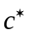 and 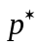 are the no-default prices of a European call and put with strike price  and maturity on a non-dividend-paying stock whose price is , and that and  are the corresponding values when there is default risk. The text shows that when we make the independence assumption (that is, we assume that the variables determining the no-default value of the option are independent of the variables determining default probabilities and recovery rates), 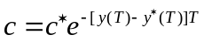 and 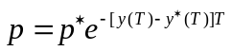. The relationship

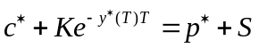

which holds in a no-default world therefore becomes

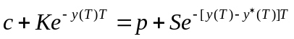

when there is default risk. This is not the same as regular put–call parity. What is more, the relationship depends on the independence assumption and cannot be deduced from the same sort of simple no-arbitrage arguments that we used in Chapter 11 for the put–call parity relationship in a no-default world.
Problem 24.20.
Suppose that in an asset swap  is the market price of the bond per dollar of principal, is the default-free value of the bond per dollar of principal, and 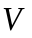 is the present value of the asset swap spread per dollar of principal. Show that 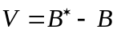.

We can assume that the principal is paid and received at the end of the life of the swap without changing the swap’s value. If the spread were zero the present value of the floating payments per dollar of principal would be 1. The payment of LIBOR plus the spread therefore has a present value of 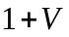. The payment of the bond cash flows has a present value per dollar of principal of . The initial payment required from the payer of the bond cash flows per dollar of principal is 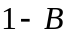. (This may be negative; an initial amount of 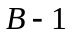 is then paid by the payer of the floating rate). Because the asset swap is initially worth zero we have

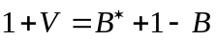
so that

Problem 24.21.
Show that under Merton’s model in Section 24.6 the credit spread on a -year zero-coupon bond is 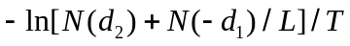 where 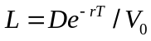.

The value of the debt in Merton’s model is 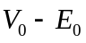 or

If the credit spread is this should equal 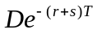 so that

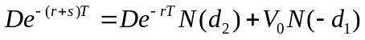

Substituting 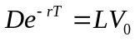
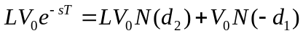

or
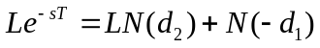

so that
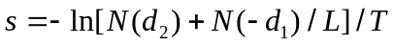

Problem 24.22.
Suppose that the spread between the yield on a 3-year zero-coupon riskless bond and a 3-year zero-coupon bond issued by a corporation is 1%. By how much does Black-Scholes-Merton overstate the value of a 3-year European option sold by the corporation.

When the default risk of the seller of the option is taken into account the option value is the Black–Scholes price multiplied by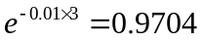. Black–Scholes overprices the option by about 3%.

Problem 24.23.
Give an example of a) right-way risk and b) wrong-way risk.
Right way risk describes the situation when a default by the counterparty is most likely to occur when the contract has a positive value to the counterparty. An example of right way risk would be when a counterparty’s future depends on the price of a commodity and it enters into a contract to partially hedging that exposure.
Wrong way risk describes the situation when a default by the counterparty is most likely to occur when the contract has a negative value to the counterparty. An example of right way risk would be when a counterparty is a speculator and the contract has the same exposure as the rest of the counterparty’s portfolio.

Further Questions
Problem 24.24. (Spreadsheet Provided)
Suppose a three-year corporate bond provides a coupon of 7% per year payable semiannually and has a yield of 5% (expressed with semiannual compounding). The yields for all maturities on risk-free bonds is 4% per annum (expressed with semiannual compounding). Assume that defaults can take place every six months (immediately before a coupon payment) and the recovery rate is 45%. Estimate the hazard rate (assumed constant) for the three years

The market price of the bond is 105.51. The risk-free price is 108.40. The expected cost of defaults is therefore 2.89. We need to find the hazard rate λ that leads to the expected cost of defaults being 2.89. We need to make an assumption about how the probability of default at a time is calculated from the hazard rate. A natural assumption is that the probability of default at a six month point equals the probability of default given by the hazard rate for the previous six months. The following table shows then shows the calculations

Time  (yrs) | Def.  Prob. | Recovery  Amount ($) | Risk-free  Value ($) | Loss Given  Default ($) | Discount  Factor | PV of Loss Given Default ($)
0.5 | 1−e^{−0.5λ} | 45 | 110.57 | 65.57 | 0.9804 | 64.28
1.0 | e^{−1.0λ}−e^{−0.5λ} | 45 | 109.21 | 64.21 | 0.9612 | 61.73
1.5 | e^{−1.5λ}−e^{−1.0λ} | 45 | 107.83 | 62.83 | 0.9423 | 59.20
2.0 | e^{−2.0λ}−e^{−1.5λ} | 45 | 106.41 | 61.41 | 0.9238 | 56.74
2.5 | e^{−2.5λ}−e^{−2.0λ} | 45 | 104.97 | 59.97 | 0.9057 | 54.32
3.0 | e^{−3.0λ}−e^{−2.5λ} | 45 | 103.50 | 58.50 | 0.8880 | 51.95

Solver can be used to determine the value of λ such that
(1−e^{−0.5λ})×64.28 + (e^{−1.0λ}−e^{−0.5λ})×61.73 + (e^{−1.5λ}−e^{−1.0λ})×59.20 + (e^{−2.0λ}−e^{−1.5λ})×56.74
+ ( e^{−2.5λ}−e^{−2.0λ})×54.32 + ( e^{−3.0λ}−e^{−2.5λ})×51.95 = 2.89
It is 1.70%.

An alternative (better) assumption is that the probability of default at times 0.5, 1.0, 1.5, 2.0, 2.5 and 3.0 years are
1−e^{−0.75λ}, e^{−1.25λ}−e^{−0.75λ}, e^{−1.75λ}−e^{−1.25λ}, e^{−2.25λ}−e^{−1.75λ}, e^{−2.75λ}−e^{−2.25λ}, and e^{−3.25λ}−e^{−2.75λ}

The estimate of the hazard rate is then 1.56%.

Problem 24.25.
A company has one- and two-year bonds outstanding, each providing a coupon of 8% per year payable annually. The yields on the bonds (expressed with continuous compounding are 6.0% and 6.6%, respectively. Risk-free rates are 4.5% for all maturities. The recovery rate is 35%. Defaults can take place half way through each year. Estimate the risk-neutral default rate each year.

Consider the first bond. Its market price is 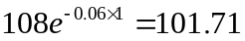. Its default-free price is 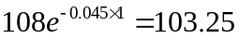. The present value of the loss from defaults is therefore 1.54. In this case losses can take place at only one time, halfway through the year. Suppose that the probability of default at this time is . The default-free value of the bond is 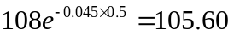. The loss in the event of a default is 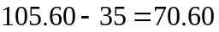. The present value of the expected loss is 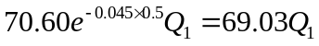. It follows that

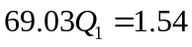

so that 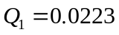.
Now consider the second bond. It market price is 102.13 and its default-free value is 106.35. The present value of the loss from defaults is therefore 4.22. At time 0.5 the default free value of the bond is 108.77. The loss in the event of a default is therefore 73.77. The present value of the loss from defaults at this time is 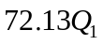 or 1.61. This means that the present value of the loss from defaults at the 1.5 year point is 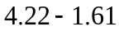 or 2.61. The default-free value of the bond at the 1.5 year point is 105.60. The loss in the event of a default is 70.60. The present value of the expected loss is 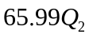 where is the probability of default in the second year. It follows that
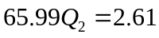
so that 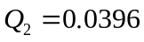.
The probabilities of default in years one and two are therefore 2.23% and 3.96%.
Problem 24.26.
Explain carefully the distinction between real-world and risk-neutral default probabilities. Which is higher? A bank enters into a credit derivative where it agrees to pay $100 at the end of one year if a certain company’s credit rating falls from A to Baa or lower during the year. The one-year risk-free rate is 5%. Using Table 24.5, estimate a value for the derivative. What assumptions are you making? Do they tend to overstate or understate the value of the derivative?

Real world default probabilities are the true probabilities of defaults. They can be estimated from historical data. Risk-neutral default probabilities are the probabilities of defaults in a world where all market participants are risk neutral. They can be estimated from bond prices. Risk-neutral default probabilities are higher. This means that returns in the risk-neutral world are lower. From Table 24.5 the probability of a company moving from A to Baa or lower in one year is 5.73%. An estimate of the value of the derivative is therefore 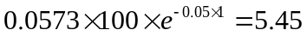. The approximation in this is that we are using the real-world probability of a downgrade. To value the derivative correctly we should use the risk-neutral probability of a downgrade. Since the risk-neutral probability of a default is higher than the real-world probability, it seems likely that the same is true of a downgrade. This means that 5.45 is likely to be too low as an estimate of the value of the derivative.
Problem 24.27.
The value of a company’s equity is $4 million and the volatility of its equity is 60%. The debt that will have to be repaid in two years is $15 million. The risk-free interest rate is 6% per annum. Use Merton’s model to estimate the expected loss from default, the probability of default, and the recovery rate in the event of default. (Hint The Solver function in Excel can be used for this question, as indicated in footnote 10)

In this case 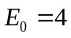, 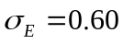, 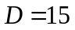, 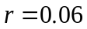. Setting up the data in Excel, we can solve equations (24.3) and (24.4) by using the approach in footnote 10. The solution to the equations proves to be 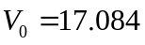 and 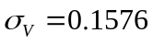. The probability of default is 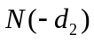 or 15.61%. The market value of the debt is 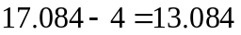. The present value of the promised payment on the debt is 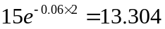. The expected loss on the debt is, therefore, 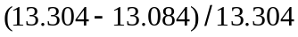 or 1.65% of its no-default value. The expected recovery rate in the event of default is therefore 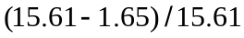 or about 89%. The reason the recovery rate is so high is as follows. There is a default if the value of the assets moves from 17.08 to below 15. A value for the assets significantly below 15 is unlikely. Conditional on a default, the expected value of the assets is, therefore, not a huge amount below 15. In practice it is likely that companies manage to delay defaults until asset values are well below the face value of the debt.
Problem 24.28.
Suppose that a bank has a total of $10 million of exposures of a certain type. The one-year probability of default averages 1% and the recovery rate averages 40%. The copula correlation parameter is 0.2. Estimate the 99.5% one-year credit VaR.

From equation (24.10) the 99.5% worst case probability of default is

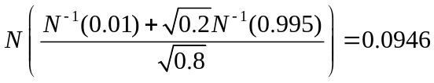

This gives the 99.5% credit VaR as 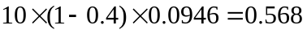 millions of dollars or $568,000.
Problem 24.29. (Excel file)
Extend Example 24.6 to calculate CVA when default can happen in the middle of each
month. Assume that the default probability per month during the first year is 0.001667
and the default probability per month during the second year is 0.0025.
The spreadsheet shows the answer is 5.73

Problem 24.30. (Excel file)
Calculate DVA in Example 24.6. Assume that default can happen in the middle of each
month. The default probability of the bank is 0.001 per month for the two years.

In this case we look at the exposure from the point of view of the coumnterparty. The exposure at time t is

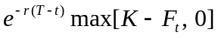
The expected exposure at time t is therefore
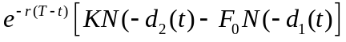
The spreadsheet shows that the DVA is 1.13. This assumes that the recovery rate of the counterparty when the bank defaults is 0.3, the same as the recovery rate of the bank when the counterparty defaults.

