CHAPTER 29
Interest Rate Derivatives: The Standard Market Models
Practice Questions

Problem 29.1.
A company caps three-month LIBOR at 10% per annum. The principal amount is $20 million. On a reset date, three-month LIBOR is 12% per annum. What payment would this lead to under the cap? When would the payment be made?
An amount
would be paid out 3 months later.
Problem 29.2.
Explain why a swap option can be regarded as a type of bond option.
A swap option (or swaption) is an option to enter into an interest rate swap at a certain time in the future with a certain fixed rate being used. An interest rate swap can be regarded as the exchange of a fixed-rate bond for a floating-rate bond. A swaption is therefore the option to exchange a fixed-rate bond for a floating-rate bond. The floating-rate bond will be worth its face value at the beginning of the life of the swap. The swaption is therefore an option on a fixed-rate bond with the strike price equal to the face value of the bond.
Problem 29.3.
Use the Black’s model to value a one-year European put option on a 10-year bond. Assume that the current value of the bond is $125, the strike price is $110, the one-year risk-free interest rate is 10% per annum, the bond’s forward price volatility is 8% per annum, and the present value of the coupons to be paid during the life of the option is $10.
In this case, 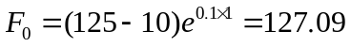, 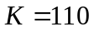, 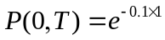, 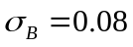, and 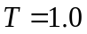.
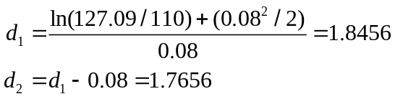
From equation (29.2) the value of the put option is
or $0.12.
Problem 29.4.
Explain carefully how you would use (a) spot volatilities and (b) flat volatilities to value a five-year cap.
When spot volatilities are used to value a cap, a different volatility is used to value each caplet. When flat volatilities are used, the same volatility is used to value each caplet within a given cap. Spot volatilities are a function of the maturity of the caplet. Flat volatilities are a function of the maturity of the cap.
Problem 29.5.
Calculate the price of an option that caps the three-month rate, starting in 15 months’ time, at 13% (quoted with quarterly compounding) on a principal amount of $1,000. The forward interest rate for the period in question is 12% per annum (quoted with quarterly compounding), the 18-month risk-free interest rate (continuously compounded) is 11.5% per annum, and the volatility of the forward rate is 12% per annum.
In this case 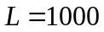, 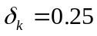, 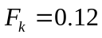, 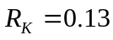, 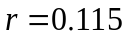, 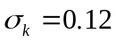, 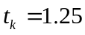, 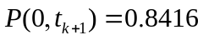.
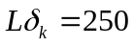

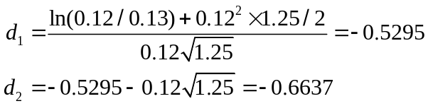
The value of the option is

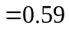
or $0.59.
Problem 29.6.
A bank uses Black’s model to price European bond options. Suppose that an implied price volatility for a 5-year option on a bond maturing in 10 years is used to price a 9-year option on the bond. Would you expect the resultant price to be too high or too low? Explain.
The implied volatility measures the standard deviation of the logarithm of the bond price at the maturity of the option divided by the square root of the time to maturity. In the case of a five year option on a ten year bond, the bond has five years left at option maturity. In the case of a nine year option on a ten year bond it has one year left. The standard deviation of a one year bond price observed in nine years can be normally be expected to be considerably less than that of a five year bond price observed in five years. (See Figure 29.1.) We would therefore expect the price to be too high.
Problem 29.7.
Calculate the value of a four-year European call option on bond that will mature five years from today using Black’s model. The five-year cash bond price is $105, the cash price of a four-year bond with the same coupon is $102, the strike price is $100, the four-year risk-free interest rate is 10% per annum with continuous compounding, and the volatility for the bond price in four years is 2% per annum.
The present value of the principal in the four year bond is 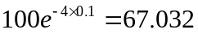. The present value of the coupons is, therefore, 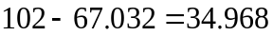. This means that the forward price of the five-year bond is
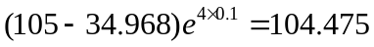
The parameters in Black’s model are therefore 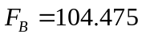, 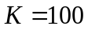, 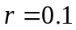, 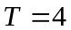, and 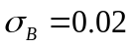.
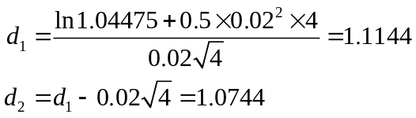
The price of the European call is
or $3.19.

Problem 29.8.
If the yield volatility for a five-year put option on a bond maturing in 10 years time is specified as 22%, how should the option be valued? Assume that, based on today’s interest rates the modified duration of the bond at the maturity of the option will be 4.2 years and the forward yield on the bond is 7%.
The option should be valued using Black’s model in equation (29.2) with the bond price volatility being
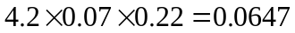
or 6.47%.
Problem 29.9.
What other instrument is the same as a five-year zero-cost collar where the strike price of the cap equals the strike price of the floor? What does the common strike price equal?
A 5-year zero-cost collar where the strike price of the cap equals the strike price of the floor is the same as an interest rate swap agreement to receive floating and pay a fixed rate equal to the strike price. The common strike price is the swap rate. Note that the swap is actually a forward swap that excludes the first exchange. (See Business Snapshot 29.1)
Problem 29.10.
Derive a put–call parity relationship for European bond options.
There are two way of expressing the put–call parity relationship for bond options. The first is in terms of bond prices:
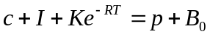
where is the price of a European call option,  is the price of the corresponding European put option, is the present value of the bond coupon payments during the life of the option,  is the strike price, is the time to maturity, 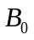 is the bond price, and  is the risk-free interest rate for a maturity equal to the life of the options. To prove this we can consider two portfolios. The first consists of a European put option plus the bond; the second consists of the European call option, and an amount of cash equal to the present value of the coupons plus the present value of the strike price. Both can be seen to be worth the same at the maturity of the options.
The second way of expressing the put–call parity relationship is
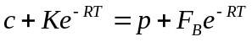
where 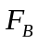 is the forward bond price. This can also be proved by considering two portfolios. The first consists of a European put option plus a forward contract on the bond plus the present value of the forward price; the second consists of a European call option plus the present value of the strike price. Both can be seen to be worth the same at the maturity of the options.
Problem 29.11.
Derive a put–call parity relationship for European swap options.
The put–call parity relationship for European swap options is
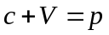
where is the value of a call option to pay a fixed rate of 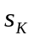 and receive floating, is the value of a put option to receive a fixed rate of and pay floating, and 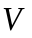 is the value of the forward swap underlying the swap option where is received and floating is paid. This can be proved by considering two portfolios. The first consists of the put option; the second consists of the call option and the swap. Suppose that the actual swap rate at the maturity of the options is greater than. The call will be exercised and the put will not be exercised. Both portfolios are then worth zero. Suppose next that the actual swap rate at the maturity of the options is less than . The put option is exercised and the call option is not exercised. Both portfolios are equivalent to a swap where is received and floating is paid. In all states of the world the two portfolios are worth the same at time . They must therefore be worth the same today. This proves the result.
Problem 29.12.
Explain why there is an arbitrage opportunity if the implied Black (flat) volatility of a cap is different from that of a floor. Do the broker quotes in Table 29.1 present an arbitrage opportunity?
Suppose that the cap and floor have the same strike price and the same time to maturity. The following put–call parity relationship must hold:
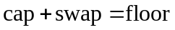
where the swap is an agreement to receive the cap rate and pay floating over the whole life of the cap/floor. If the implied Black volatilities for the cap equal those for the floor, the Black formulas show that this relationship holds. In other circumstances it does not hold and there is an arbitrage opportunity. The broker quotes in Table 29.1 do not present an arbitrage opportunity because the cap offer is always higher than the floor bid and the floor offer is always higher than the cap bid.
Problem 29.13.
When a bond’s price is lognormal can the bond’s yield be negative? Explain your answer.
Yes. If a zero-coupon bond price at some future time is lognormal, there is some chance that the price will be above par. This in turn implies that the yield to maturity on the bond is negative.
Problem 29.14.
What is the value of a European swap option that gives the holder the right to enter into a 3-year annual-pay swap in four years where a fixed rate of 5% is paid and LIBOR is received? The swap principal is $10 million. Assume that the LIBOR/swap yield curve is used for discounting and is flat at 5% per annum with annual compounding and the volatility of the swap rate is 20%. Compare your answer to that given by DerivaGem. Now suppose that all swap rates are 5% and all OIS rates are 4.7%. Use DerivaGem to calculate the LIBOR zero curve and the swap option value?
In equation (29.10), 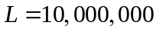, 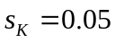, 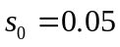, 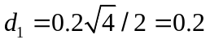, 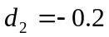, and
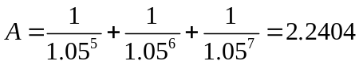
The value of the swap option (in millions of dollars) is
This is the same as the answer given by DerivaGem. (For the purposes of using the DerivaGem software, note that the interest rate is 4.879% with continuous compounding for all maturities.)

When OIS discounting is used the LIBOR zero curve is unaffected because LIBOR swap rates are the same for all maturities. (This can be verified with the Zero Curve worksheet in DerivaGem). The only difference is that

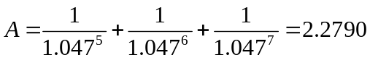

so that the value is changed to 0.181. This is also the value given by DerivaGem. (Note that the OIS rate is 4.593% with annual compounding.)
Problem 29.15.
Suppose that the yield, , on a zero-coupon bond follows the process
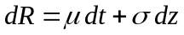
where  and are functions of and , and 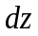 is a Wiener process. Use Ito’s lemma to show that the volatility of the zero-coupon bond price declines to zero as it approaches maturity.
The price of the bond at time is 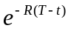 where is the time when the bond matures. Using Itô’s lemma the volatility of the bond price is
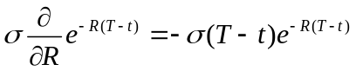
This tends to zero as approaches .
Problem 29.16.
Carry out a manual calculation to verify the option prices in Example 29.2.
The cash price of the bond is
As there is no accrued interest this is also the quoted price of the bond. The interest paid during the life of the option has a present value of
The forward price of the bond is therefore
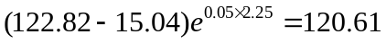
The yield with semiannual compounding is 5.0630%.
The duration of the bond at option maturity is
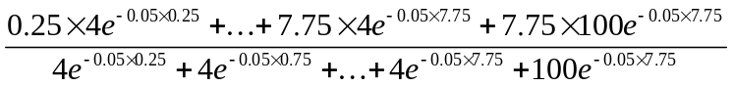
or 5.994. The modified duration is 5.994/1.025315=5.846. The bond price volatility is therefore . We can therefore value the bond option using Black’s model with 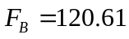, 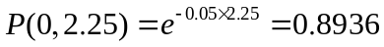, 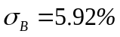, and 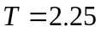. When the strike price is the cash price 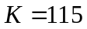 and the value of the option is 1.74. When the strike price is the quoted price 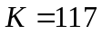 and the value of the option is 2.36. This is in agreement with DerivaGem.

Problem 29.17.
Suppose that the 1-year, 2-year, 3-year, 4-year and 5-year LIBOR-for-fixed swap rates for swaps with semiannual payments are 6%, 6.4%, 6.7%, 6.9%, and 7%. The price of a 5-year semiannual cap with a principal of $100 at a cap rate of 8% is $3. Use DerivaGem (the zero rate and Cap_and_swap_opt worksheets) to determine
- The 5-year flat volatility for caps and floors with LIBOR discounting
- The floor rate in a zero-cost 5-year collar when the cap rate is 8% and LIBOR discounting is used
- Answer (a) and (b) if OIS discounting is used and OIS swap rates are 100 basis points below LIBOR swap rates.

  - First we calculate the LIBOR zero curve using the zero curve worksheet of DerivaGem. The 1-, 2-, 3-, 4-, and 5_year zero rates with continuous compounding are 5.9118%, 6.3140%, 6.6213%, 6.8297%, and 6.9328%, respectively. We then transfer these to the choose the Caps and Swap Options worksheet and choose Cap/Floor as the Underlying Type. We enter Semiannual for the Settlement Frequency, 100 for the Principal, 0 for the Start (Years), 5 for the End (Years), 8% for the Cap/Floor Rate, and $3 for the Price. We select Black-European as the Pricing Model and choose the Cap button. We check the Imply Volatility box and Calculate. The implied volatility is 25.4%.
  - We then uncheck Implied Volatility, select Floor, check Imply Breakeven Rate. The floor rate that is calculated is 6.71%. This is the floor rate for which the floor is worth $3.A collar when the floor rate is 6.61% and the cap rate is 8% has zero cost.
  - The zero curve worksheet now shows that LIBOR zero rates for 1-, 2-, 3-, 4-, 5-year maturities are 5.9118%, 6.3117%, 6.6166%, 6.8227%, and 6.9249%. The OIS zero rates are 4.9385%, 5.3404%, 5.6468%, 5.8539%, and 5.9566%, respectively. When these are transferred to the cap and swaption worksheet and the Use OIS Discounting box is checked, the answer to a) becomes 24.81%% and the answer to b) becomes 6.60%.

Problem 29.18.
Show that 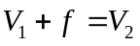 where  is the value of a swaption to pay a fixed rate of and receive LIBOR between times and 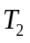,  is the value of a forward swap to receive a fixed rate of and pay LIBOR between times and , and 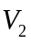 is the value of a swap option to receive a fixed rate of between times and . Deduce that 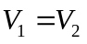 when equals the current forward swap rate.
We prove this result by considering two portfolios. The first consists of the swap option to receive ; the second consists of the swap option to pay and the forward swap. Suppose that the actual swap rate at the maturity of the options is greater than . The swap option to pay will be exercised and the swap option to receive will not be exercised. Both portfolios are then worth zero since the swap option to pay is neutralized by the forward swap. Suppose next that the actual swap rate at the maturity of the options is less than . The swap option to receive is exercised and the swap option to pay is not exercised. Both portfolios are then equivalent to a swap where is received and floating is paid. In all states of the world the two portfolios are worth the same at time . They must therefore be worth the same today. This proves the result. When equals the current forward swap rate 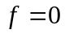 and . A swap option to pay fixed is therefore worth the same as a similar swap option to receive fixed when the fixed rate in the swap option is the forward swap rate.

Problem 29.19.
Suppose that LIBOR zero rates are as in Problem 29.17. Use DerivaGem to determine the value of an option to pay a fixed rate of 6% and receive LIBOR on a five-year swap starting in one year. Assume that the principal is $100 million, payments are exchanged semiannually, and the swap rate volatility is 21%. Use LIBOR discounting.
We choose the Caps and Swap Options worksheet of DerivaGem and choose Swap Option as the Underlying Type. We enter 100 as the Principal, 1 as the Start (Years), 6 as the End (Years), 6% as the Swap Rate, and Semiannual as the Settlement Frequency. We choose Black-European as the pricing model, enter 21% as the Volatility and check the Pay Fixed button. We do not check the Imply Breakeven Rate and Imply Volatility boxes. The value of the swap option is 5.63.

Problem 29.20.
Describe how you would (a) calculate cap flat volatilities from cap spot volatilities and (b) calculate cap spot volatilities from cap flat volatilities.
- To calculate flat volatilities from spot volatilities we choose a strike rate and use the spot volatilities to calculate caplet prices. We then sum the caplet prices to obtain cap prices and imply flat volatilities from Black’s model. The answer is slightly dependent on the strike price chosen. This procedure ignores any volatility smile in cap pricing.
- To calculate spot volatilities from flat volatilities the first step is usually to interpolate between the flat volatilities so that we have a flat volatility for each caplet payment date. We choose a strike price and use the flat volatilities to calculate cap prices. By subtracting successive cap prices we obtain caplet prices from which we can imply spot volatilities. The answer is slightly dependent on the strike price chosen. This procedure also ignores any volatility smile in caplet pricing.

Further Questions

Problem 29.21.
Consider an eight-month European put option on a Treasury bond that currently has 14.25 years to maturity. The current cash bond price is $910, the exercise price is $900, and the volatility for the bond price is 10% per annum. A coupon of $35 will be paid by the bond in three months. The risk-free interest rate is 8% for all maturities up to one year. Use Black’s model to determine the price of the option. Consider both the case where the strike price corresponds to the cash price of the bond and the case where it corresponds to the quoted price.

The present value of the coupon payment is
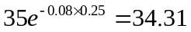
Equation (29.2) can therefore be used with 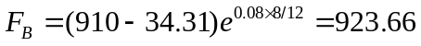, 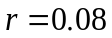, 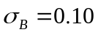 and 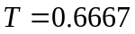. When the strike price is a cash price, 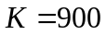 and
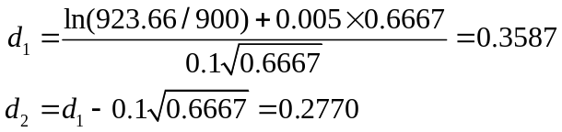
The option price is therefore
or $18.34.
When the strike price is a quoted price 5 months of accrued interest must be added to 900 to get the cash strike price. The cash strike price is 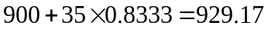. In this case
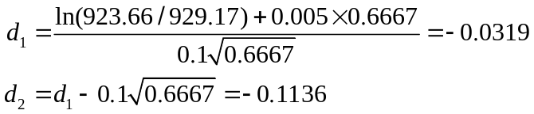
and the option price is
or $31.22.

Problem 29.22.
Calculate the price of a cap on the 90-day LIBOR rate in nine months’ time when the principal amount is $1,000. Use Black’s model with LIBOR discounting and the following information:
  - The quoted nine-month Eurodollar futures price = 92. (Ignore differences between futures and forward rates.)
  - The interest-rate volatility implied by a nine-month Eurodollar option = 15% per annum.
  - The current 12-month risk-free interest rate with continuous compounding = 7.5% per annum.
  - The cap rate = 8% per annum. (Assume an actual/360 day count.)
The quoted futures price corresponds to a forward rate of 8% per annum with quarterly compounding and actual/360. The parameters for Black’s model are therefore: 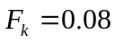, 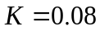, 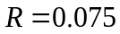, 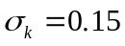, 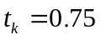, and 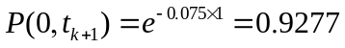
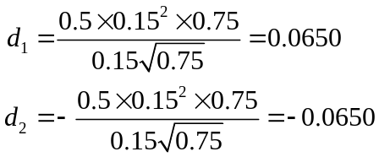
and the call price, , is given by

Problem 29.23.
Suppose that the LIBOR yield curve is flat at 8% with annual compounding. A swaption gives the holder the right to receive 7.6% in a five-year swap starting in four years. Payments are made annually. The volatility of the forward swap rate is 25% per annum and the principal is $1 million. Use Black’s model to price the swaption with LIBOR discounting. Compare your answer to that given by DerivaGem.
The payoff from the swaption is a series of five cash flows equal to 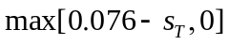 in millions of dollars where 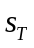 is the five-year swap rate in four years. The value of an annuity that provides $1 per year at the end of years 5, 6, 7, 8, and 9 is
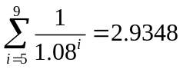
The value of the swaption in millions of dollars is therefore
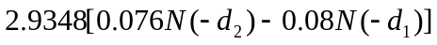
where
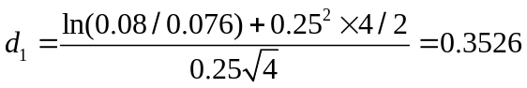
and
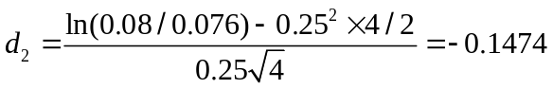
The value of the swaption is
or $39,550. This is the same answer as that given by DerivaGem. Note that for the purposes of using DerivaGem the zero rate is 7.696% continuously compounded for all maturities.
Problem 29.24.
Use the DerivaGem software to value a five-year collar that guarantees that the maximum and minimum interest rates on a LIBOR-based loan (with quarterly resets) are 7% and 5% respectively. The LIBOR and OIS zero curves are currently flat at 6% and 5.8% respectively (with continuous compounding). Use a flat volatility of 20%. Assume that the principal is $100. Use OIS discounting
We use the Caps and Swap Options worksheet of DerivaGem. Set the LIBOR zero curve as 6% with continuous compounding. ( It is only necessary to enter 6% for one maturity.) . Set the OIS zero curve as 5.8% with continuous compounding. ( It is only necessary to enter 5.8% for one maturity.) To value the cap we select Cap/Floor as the Underlying Type, enter Quarterly for the Settlement Frequency, 100 for the Principal, 0 for the Start (Years), 5 for the End (Years), 7% for the Cap/Floor Rate, and 20% for the Volatility. We select Black-European as the Pricing Model and choose the Cap button. We do not check the Imply Breakeven Rate and Imply Volatility boxes. We do check the Use OIS Discounting button. The value of the cap is 1.576. To value the floor we change the Cap/Floor Rate to 5% and select the Floor button rather than the Cap button. The value is 1.080. The collar is a long position in the cap and a short position in the floor. The value of the collar is therefore
1.576 ─ 1.080 = 0.496

Problem 29.25.
Use the DerivaGem software to value a European swap option that gives you the right in two years to enter into a 5-year swap in which you pay a fixed rate of 6% and receive floating. Cash flows are exchanged semiannually on the swap. The 1-year, 2-year, 5-year, and 10-year LIBOR-for-fixed swap rate where payments are exchanged semiannually are 5%, 6%, 6.5%, and 7%, respectively. Assume a principal of $100 and a volatility of 15% per annum. (a) Use LIBOR discounting (b) Use OIS discounting assuming that OIS swap rates are 80 basis points below LIBOR swap rates (c) Use the incorrect approach where OIS discounting is applied to swap rates calculate from LIBOR discounting. What is the error from using the incorrect approach?
We first use the zero rates worksheet to calculate the LIBOR zero curve with LIBOR discounting. We then calculate the LIBOR and OIS zero curve with OIS discounting.

          - The LIBOR zero rates are transferred to the cap and swap option worksheet. The value of the swaption is 4.602
          - The LIBOR and OIS zero rates are transferred to the cap and swap option worksheet. The value of the swaption is 4.736
          - The LIBOR zero curve from (a) and the OIS zero curve from (b) are transferred to the cap and swap option worksheet. The value of the swaption is 4.783. The error from using the incorrect approach is 4.783−4.736 = 0.047 or 4.7 basis points.

