CHAPTER 30
Convexity, Timing, and Quanto Adjustments

Practice Questions

Problem 30.1.
Explain how you would value a derivative that pays off 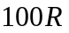 in five years where  is the one-year interest rate (annually compounded) observed in four years. What difference would it make if the payoff were in (a) 4 years and (b) 6 years?
The value of the derivative is 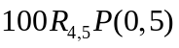 where 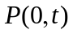 is the value of a -year zero-coupon bond today and 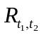 is the forward rate for the period between and , expressed with annual compounding. If the payoff is made in four years the value is 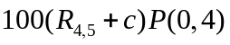 where is the convexity adjustment given by equation (30.2). The formula for the convexity adjustment is:
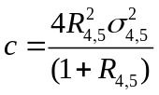
where 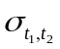 is the volatility of the forward rate between times and .
The expression 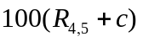 is the expected payoff in a world that is forward risk neutral with respect to a zero-coupon bond maturing at time four years. If the payoff is made in six years, the value is from equation (30.4) given by
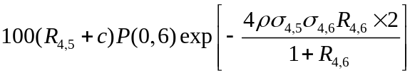
where 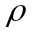 is the correlation between the (4,5) and (4,6) forward rates. As an approximation we can assume that 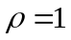, 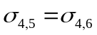, and 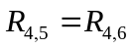. Approximating the exponential function we then get the value of the derivative as 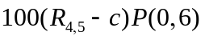.

Problem 30.2.
Explain whether any convexity or timing adjustments are necessary when
- We wish to value a spread option that pays off every quarter the excess (if any) of the five-year swap rate over the three-month LIBOR rate applied to a principal of $100. The payoff occurs 90 days after the rates are observed.
- We wish to value a derivative that pays off every quarter the three-month LIBOR rate minus the three-month Treasury bill rate. The payoff occurs 90 days after the rates are observed.

- A convexity adjustment is necessary for the swap rate
- No convexity or timing adjustments are necessary.

Problem 30.3.
Suppose that in Example 29.3 of Section 29.2 the payoff occurs after one year (i.e., when the interest rate is observed) rather than in 15 months. What difference does this make to the inputs to Black’s models?
There are two differences. The discounting is done over a 1.0-year period instead of over a 1.25-year period. Also a convexity adjustment to the forward rate is necessary. From equation (30.2) the convexity adjustment is:
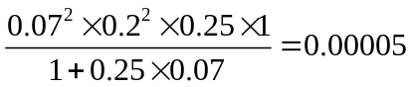
or about half a basis point.
In the formula for the caplet we set 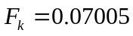 instead of 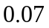. This means that 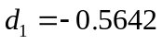 and 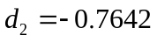. With continuous compounding the 15-month rate is 6.5% and the forward rate between 12 and 15 months is 6.94%. The 12 month rate is therefore 6.39% The caplet price becomes
or $5.29.
Problem 30.4.
The LIBOR/swap yield curve (which is used for discounting) is flat at 10% per annum with annual compounding. Calculate the value of an instrument where, in five years’ time, the two-year swap rate (with annual compounding) is received and a fixed rate of 10% is paid. Both are applied to a notional principal of $100. Assume that the volatility of the swap rate is 20% per annum. Explain why the value of the instrument is different from zero.
The convexity adjustment discussed in Section 30.1 leads to the instrument being worth an amount slightly different from zero. Define 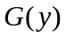 as the value as seen in five years of a two-year bond with a coupon of 10% as a function of its yield.
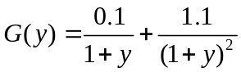

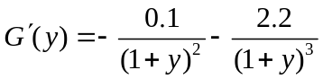

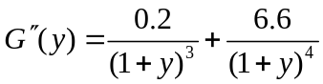
It follows that 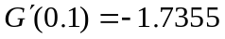 and 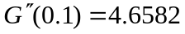 and the convexity adjustment that must be made for the two-year swap- rate is
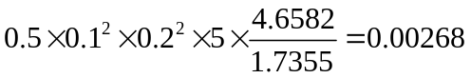
We can therefore value the instrument on the assumption that the swap rate will be 10.268% in five years. The value of the instrument is
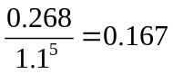
or $0.167.
Problem 30.5.
What difference does it make in Problem 30.4 if the swap rate is observed in five years, but the exchange of payments takes place in (a) six years, and (b) seven years? Assume that the volatilities of all forward rates are 20%. Assume also that the forward swap rate for the period between years five and seven has a correlation of 0.8 with the forward interest rate between years five and six and a correlation of 0.95 with the forward interest rate between years five and seven.
In this case we have to make a timing adjustment as well as a convexity adjustment to the forward swap rate. For (a) equation (30.4) shows that the timing adjustment involves multiplying the swap rate by
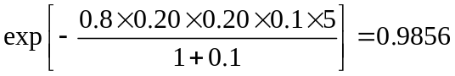
so that it becomes 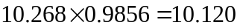. The value of the instrument is
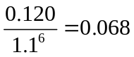
or $0.068.
For (b) equation (30.4) shows that the timing adjustment involves multiplying the swap rate by
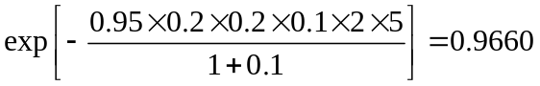
so that it becomes 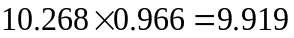. The value of the instrument is now
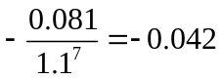
or –$0.042.
Problem 30.6.
The price of a bond at time , measured in terms of its yield, is 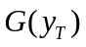. Assume geometric Brownian motion for the forward bond yield, , in a world that is forward risk neutral with respect to a bond maturing at time . Suppose that the growth rate of the forward bond yield is and its volatility 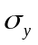.
- Use Ito’s lemma to calculate the process for the forward bond price in terms of , , , and .
- The forward bond price should follow a martingale in the world considered. Use this fact to calculate an expression for .
- Show that the expression for is, to a first approximation, consistent with equation (30.1).
  - The process for is
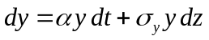
The forward bond price is . From Itô’s lemma, its process is
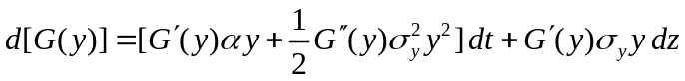

  - Since the expected growth rate of is zero
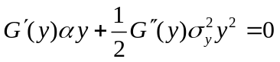
or
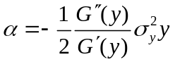

(c) Assuming as an approximation that always equals its initial value of 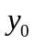, this shows that the growth rate of is
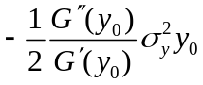
The variable starts at and ends as 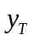. The convexity adjustment to when we are calculating the expected value of in a world that is forward risk neutral with respect to a zero-coupon bond maturing at time is approximately 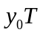 times this or
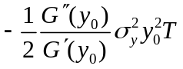
This is consistent with equation (30.1).
Problem 30.7.
The variable is an investment asset providing income at rate measured in currency A. It follows the process
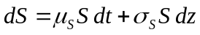
in the real world. Defining new variables as necessary, give the process followed by , and the corresponding market price of risk, in
(a) A world that is the traditional risk-neutral world for currency A.
(b) A world that is the traditional risk-neutral world for currency B.
(c) A world that is forward risk neutral with respect to a zero-coupon currency A bond maturing at time .
(d) A world that is forward risk neutral with respect to a zero coupon currency B bond maturing at time .
  - In the traditional risk-neutral world the process followed by is
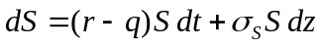
where is the instantaneous risk-free rate. The market price of 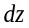-risk is zero.
  - In the traditional risk-neutral world for currency B the process is
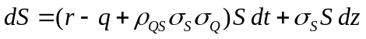
where  is the exchange rate (units of A per unit of B), 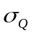 is the volatility of and 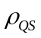 is the coefficient of correlation between and . The market price of -risk is 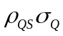
(c) In a world that is forward risk neutral with respect to a zero-coupon bond in currency A maturing at time
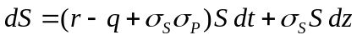
where 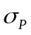 is the bond price volatility. The market price of -risk is
- In a world that is forward risk neutral with respect to a zero-coupon bond in currency B maturing at time
where  is the forward exchange rate, 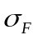 is the volatility of (units of A per unit of B, and 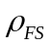 is the correlation between and . The market price of -risk is 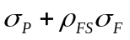.
Problem 30.8.
A call option provides a payoff at time of 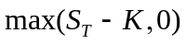 yen, where 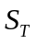 is the dollar price of gold at time and  is the strike price. Assuming that the storage costs of gold are zero and defining other variables as necessary, calculate the value of the contract.
Define
P(t,T): Price in yen at time of a bond paying 1 yen at time
E_{T}(.): Expectation in world that is forward risk neutral with respect to 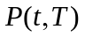
F: Dollar forward price of gold for a contract maturing at time
F₀: Value of at time zero
σ_{F}: Volatility of
G: Forward exchange rate (dollars per yen)
σ_{G}: Volatility of 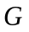
We assume that is lognormal. We can work in a world that is forward risk neutral with respect to to get the value of the call as
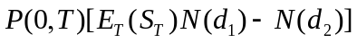
where
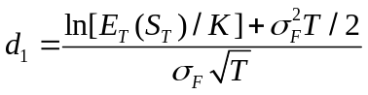

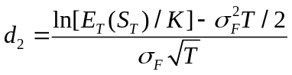
The expected gold price in a world that is forward risk-neutral with respect to a zero-coupon dollar bond maturing at time is 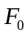. It follows from equation (30.6) that
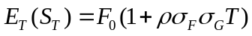
Hence the option price, measured in yen, is
where
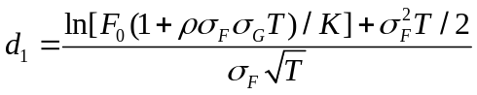

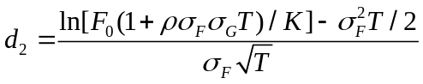
Problem 30.9.
A Canadian equity index is 400. The Canadian dollar is currently worth 0.70 U.S. dollars. The risk-free interest rates in Canada and the U.S. are constant at 6% and 4%, respectively. The dividend yield on the index is 3%. Define as the number of Canadian dollars per U.S dollar and as the value of the index. The volatility of is 20%, the volatility of is 6%, and the correlation between and is 0.4. Use DerivaGem to determine the value of a two year American-style call option on the index if
(a) It pays off in Canadian dollars the amount by which the index exceeds 400.
(b) It pays off in U.S. dollars the amount by which the index exceeds 400.
          - The value of the option can be calculated by setting 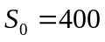, 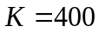, 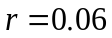, 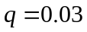, 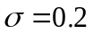, and 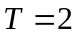. With 100 time steps the value (in Canadian dollars) is 52.92.
          - The growth rate of the index using the CDN numeraire is 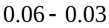 or 3%. When we switch to the USD numeraire we increase the growth rate of the index by 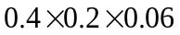 or 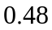% per year to 3.48%. The option can therefore be calculated using DerivaGem with , , 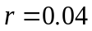, 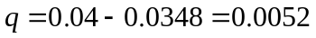, , and . With 100 time steps DerivaGem gives the value as 57.51.

Further Questions
Problem 30.10.
Consider an instrument that will pay off dollars in two years where is the value of the Nikkei index. The index is currently 20,000. The yen/dollar exchange rate is 100 ( yen per dollar). The correlation between the exchange rate and the index is 0.3 and the dividend yield on the index is 1% per annum. The volatility of the Nikkei index is 20% and the volatility of the yen–dollar exchange rate is 12%. The interest rates (assumed constant) in the U.S. and Japan are 4% and 2%, respectively.
- What is the value of the instrument?
- Suppose that the exchange rate at some point during the life of the instrument is and the level of the index is . Show that a U.S. investor can create a portfolio that changes in value by approximately 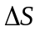 dollar when the index changes in value by yen by investing dollars in the Nikkei and shorting 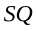 yen.
- Confirm that this is correct by supposing that the index changes from 20,000 to 20,050 and the exchange rate changes from 100 to 99.7.
- How would you delta hedge the instrument under consideration?

- We require the expected value of the Nikkei index in a dollar risk-neutral world. In a yen risk-neutral world the expected value of the index is 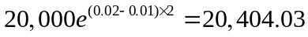. In a dollar risk-neutral world the analysis in Section 30.3 shows that this becomes
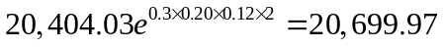
The value of the instrument is therefore
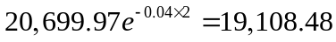

- An amount yen is invested in the Nikkei. Its value in yen changes to
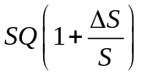
In dollars this is worth
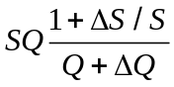
where 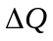 is the increase in . When terms of order two and higher are ignored, the dollar value becomes
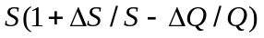
The gain on the Nikkei position is therefore 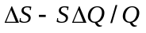
When yen are shorted the gain in dollars is
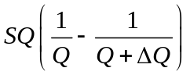
This equals 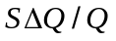 when terms of order two and higher are ignored. The gain on the whole position is therefore as required.

- In this case the investor invests $20,000 in the Nikkei. The investor converts the funds to yen and buys 100 times the index. The index rises to 20,050 so that the investment becomes worth 2,005,000 yen or
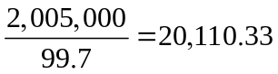
dollars. The investor therefore gains $110.33. The investor also shorts 2,000,000 yen. The value of the yen changes from $0.0100 to $0.01003. The investor therefore loses 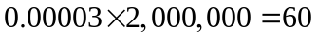 dollars on the short position. The net gain is 50.33 dollars. This is close to the required gain of $50.

- Suppose that the value of the instrument is 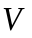. When the index changes by yen the value of the instrument changes by
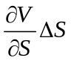
dollars. We can calculate 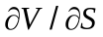. Part (b) of this question shows how to manufacture an instrument that changes by dollars. This enables us to delta-hedge our exposure to the index.
Problem 30.11.
Suppose that the LIBOR yield curve is flat at 8% (with continuous compounding). The payoff from a derivative occurs in four years. It is equal to the five-year rate minus the two-year rate at this time, applied to a principal of $100 with both rates being continuously compounded. (The payoff can be positive or negative.) Calculate the value of the derivative. Assume that the volatility for all rates is 25%. What difference does it make if the payoff occurs in five years instead of four years? Assume all rates are perfectly correlated. Use LIBOR discounting

To calculate the convexity adjustment for the five-year rate define the price of a five year bond, as a function of its yield as
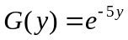

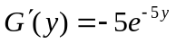

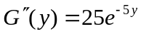
The convexity adjustment is
Similarly for the two year rate the convexity adjustment is
We can therefore value the derivative by assuming that the five year rate is 8.4% and the two-year rate is 8.16%. The value of the derivative is
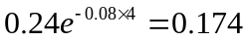
If the payoff occurs in five years rather than four years it is necessary to make a timing adjustment. From equation (30.4) this involves multiplying the forward rate by
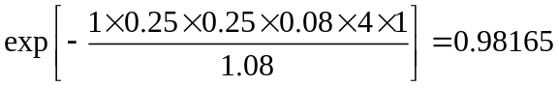
The value of the derivative is
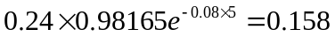

Problem 30.12.
Suppose that the payoff from a derivative will occur in ten years and will equal the three-year U.S. dollar swap rate for a semiannual-pay swap observed at that time applied to a certain principal. Assume that the LIBOR/swap yield curve, which is used for discounting, is flat at 8% (semiannually compounded) per annum in dollars and 3% (semiannually compounded) in yen. The forward swap rate volatility is 18%, the volatility of the ten year “yen per dollar” forward exchange rate is 12%, and the correlation between this exchange rate and U.S. dollar interest rates is 0.25.
- What is the value of the derivative if the swap rate is applied to a principal of $100 million so that the payoff is in dollars?
- What is its value of the derivative if the swap rate is applied to a principal of 100 million yen so that the payoff is in yen?

- In this case we must make a convexity adjustment to the forward swap rate. Define
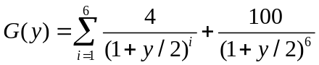
so that
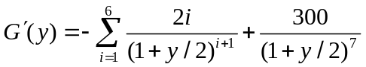

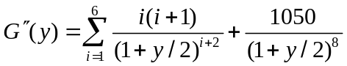
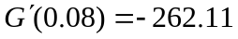 and 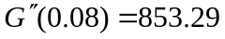 so that the convexity adjustment is
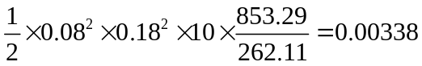
The adjusted forward swap rate is 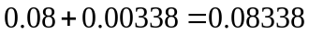 and the value of the derivative in millions of dollars is
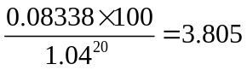

- When the swap rate is applied to a yen principal we must make a quanto adjustment in addition to the convexity adjustment. From Section 30.3 this involves multiplying the forward swap rate by 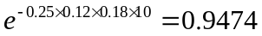. (Note that the correlation is the correlation between the dollar per yen exchange rate and the swap rate. It is therefore 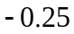 rather than 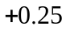.) The value of the derivative in millions of yen is
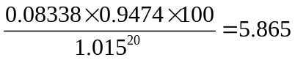

Problem 30.13.
The payoff from a derivative will occur in 8 years. It will equal the average of the one-year risk-free interest rates observed at times 5, 6, 7, and 8 years applied to a principal of $1,000. The risk-free yield curve is flat at 6% with annual compounding and the volatilities of all rates are 16%. Assume perfect correlation between all rates. What is the value of the derivative?
No adjustment is necessary for the forward rate applying to the period between years seven and eight. Using this, we can deduce from equation (30.4) that the forward rate applying to the period between years five and six must be multiplied by
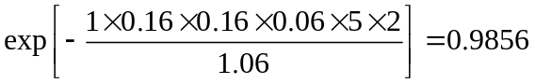
Similarly the forward rate applying to the period between year six and year seven must be multiplied by
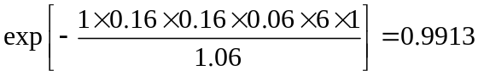
Similarly the forward rate applying to the period between year eight and nine must be multiplied by
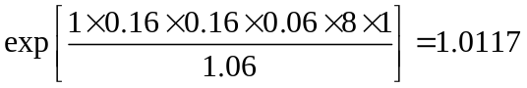
The adjusted forward average interest rate is therefore
0.25×(0.06×0.9856+0.06×0.9913+0.06+0.06×1.0117 = 0.05983
The value of the derivative is
0.05983×1000×1.06⁻⁸ = 37.54

