CHAPTER 31
Interest Rate Derivatives: Models of the Short Rate

Practice Questions

Problem 31.1.
What is the difference between an equilibrium model and a no-arbitrage model?
Equilibrium models usually start with assumptions about economic variables and derive the behavior of interest rates. The initial term structure is an output from the model. In a no-arbitrage model the initial term structure is an input. The behavior of interest rates in a no-arbitrage model is designed to be consistent with the initial term structure.
Problem 31.2.
Suppose that the short rate is currently 4% and its standard deviation is 1% per annum. What happens to the standard deviation when the short rate increases to 8% in (a) Vasicek’s model; (b) Rendleman and Bartter’s model; and (c) the Cox, Ingersoll, and Ross model?
In Vasicek’s model the standard deviation stays at 1%. In the Rendleman and Bartter model the standard deviation is proportional to the level of the short rate. When the short rate increases from 4% to 8% the standard deviation increases from 1% to 2%. In the Cox, Ingersoll, and Ross model the standard deviation of the short rate is proportional to the square root of the short rate. When the short rate increases from 4% to 8% the standard deviation increases from 1% to 1.414%.
Problem 31.3.
If a stock price were mean reverting or followed a path-dependent process there would be market inefficiency. Why is there not market inefficiency when the short-term interest rate does so?
If the price of a traded security followed a mean-reverting or path-dependent process there would be market inefficiency. The short-term interest rate is not the price of a traded security. In other words we cannot trade something whose price is always the short-term interest rate. There is therefore no market inefficiency when the short-term interest rate follows a mean-reverting or path-dependent process. We can trade bonds and other instruments whose prices do depend on the short rate. The prices of these instruments do not follow mean-reverting or path-dependent processes.
Problem 31.4.
Explain the difference between a one-factor and a two-factor interest rate model.
In a one-factor model there is one source of uncertainty driving all rates. This usually means that in any short period of time all rates move in the same direction (but not necessarily by the same amount). In a two-factor model, there are two sources of uncertainty driving all rates. The first source of uncertainty usually gives rise to a roughly parallel shift in rates. The second gives rise to a twist where long and short rates moves in opposite directions.

Problem 31.5.
Can the approach described in Section 31.4 for decomposing an option on a coupon-bearing bond into a portfolio of options on zero-coupon bonds be used in conjunction with a two-factor model? Explain your answer.
No. The approach in Section 31.4 relies on the argument that, at any given time, all bond prices are moving in the same direction. This is not true when there is more than one factor.
Problem 31.6.
Suppose that 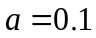 and 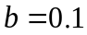 in both the Vasicek and the Cox, Ingersoll, Ross model. In both models, the initial short rate is 10% and the initial standard deviation of the short rate change in a short time 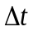 is 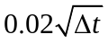. Compare the prices given by the models for a zero-coupon bond that matures in year 10.
In Vasicek’s model, , , and 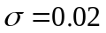 so that
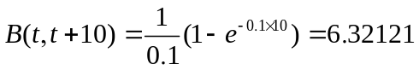

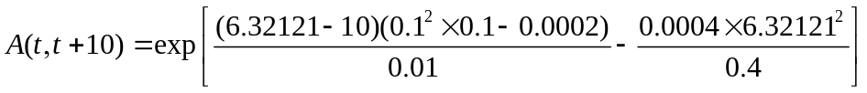

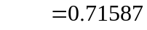
The bond price is therefore 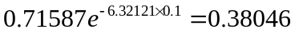
In the Cox, Ingersoll, and Ross model, , and 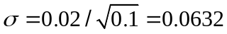. Also
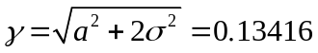
Define
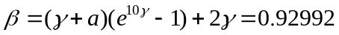

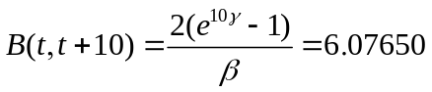

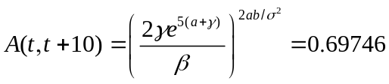
The bond price is therefore 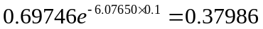
Problem 31.7.
Suppose that , 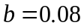, and 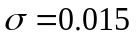 in Vasicek’s model with the initial value of the short rate being 5%. Calculate the price of a one-year European call option on a zero-coupon bond with a principal of $100 that matures in three years when the strike price is $87.
Using the notation in the text, 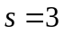, 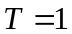, 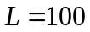, 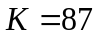, and
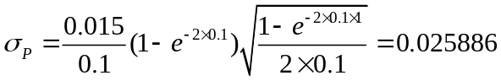
From equation (31.6), 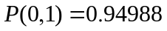, 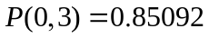, and 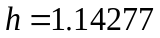 so that equation (31.20) gives the call price as call price is
or $2.59.
Problem 31.8.
Repeat Problem 31.7 valuing a European put option with a strike of $87. What is the put–call parity relationship between the prices of European call and put options? Show that the put and call option prices satisfy put–call parity in this case.
As mentioned in the text, equation (31.20) for a call option is essentially the same as Black’s model. By analogy with Black’s formulas corresponding expression for a put option is
In this case the put price is
Since the underlying bond pays no coupon, put–call parity states that the put price plus the bond price should equal the call price plus the present value of the strike price. The bond price is 85.09 and the present value of the strike price is 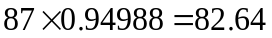. Put–call parity is therefore satisfied:
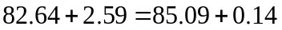

Problem 31.9.
Suppose that 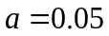, , and in Vasicek’s model with the initial short-term interest rate being 6%. Calculate the price of a 2.1-year European call option on a bond that will mature in three years. Suppose that the bond pays a coupon of 5% semiannually. The principal of the bond is 100 and the strike price of the option is 99. The strike price is the cash price (not the quoted price) that will be paid for the bond.
As explained in Section 31.4, the first stage is to calculate the value of at time 2.1 years which is such that the value of the bond at that time is 99. Denoting this value of by 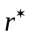, we must solve
where the  and  functions are given by equations (31.7) and (31.8). In this case A(2.1, 2.5)=0.999685, A(2.1,3.0)=0.998432, B(2.1,2.5)=0.396027, and B(2.1, 3.0)= 0.88005. and Solver shows that 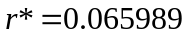. Since
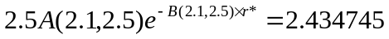
and
the call option on the coupon-bearing bond can be decomposed into a call option with a strike price of 2.434745 on a bond that pays off 2.5 at time 2.5 years and a call option with a strike price of 96.56535 on a bond that pays off 102.5 at time 3.0 years.
The options are valued using equation (31.20).
For the first option L=2.5, K= 2.434745, T = 2.1, and s=2.5. Also, A(0,T)=0.991836, B(0,T) = 1.99351, P(0,T)=0.880022 while A(0,s)=0.988604, B(0,s)=2.350062, and P(0,s)=0.858589. Furthermore σ_{P} = 0.008176 and h= 0.223351. so that the option price is 0.009084.
For the second option L=102.5, K= 96.56535, T = 2.1, and s=3.0. Also, A(0,T)=0.991836, B(0,T) = 1.99351, P(0,T)=0.880022 while A(0,s)=0.983904, B(0,s)=2.78584, and P(0,s)=0.832454. Furthermore σ_{P} = 0.018168 and h= 0.233343. so that the option price is 0.806105.

The total value of the option is therefore 0.0090084+0.806105=0.815189.
Problem 31.10.
Use the answer to Problem 31.9 and put–call parity arguments to calculate the price of a put option that has the same terms as the call option in Problem 31.9.
Put-call parity shows that:
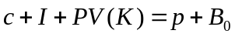
or
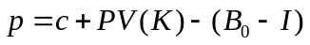
where is the call price,  is the strike price, is the present value of the coupons, and 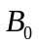 is the bond price. In this case 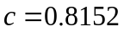, , so that the put price is
Problem 31.11.
In the Hull–White model, 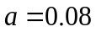 and 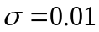. Calculate the price of a one-year European call option on a zero-coupon bond that will mature in five years when the term structure is flat at 10%, the principal of the bond is $100, and the strike price is $68.
Using the notation in the text 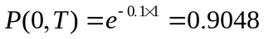 and 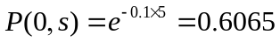. Also
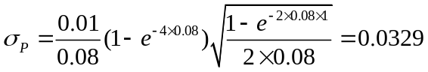
and 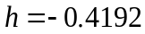 so that the call price is

Problem 31.12.
Suppose that and in the Hull–White model with the initial term structure being flat at 6% with semiannual compounding. Calculate the price of a 2.1-year European call option on a bond that will mature in three years. Suppose that the bond pays a coupon of 5% per annum semiannually. The principal of the bond is 100 and the strike price of the option is 99. The strike price is the cash price (not the quoted price) that will be paid for the bond.

This problem is similar to Problem 31.9. The difference is that the Hull–White model, which fits an initial term structure, is used instead of Vasicek’s model where the initial term structure is determined by the model.
The yield curve is flat with a continuously compounded rate of 5.9118%.
As explained in Section 31.4, the first stage is to calculate the value of at time 2.1 years which is such that the value of the bond at that time is 99. Denoting this value of by , we must solve
where the and functions are given by equations (31.16) and (31.17). In this case A(2.1, 2.5)=0.999732, A(2.1,3.0)=0.998656, B(2.1,2.5)=0.396027, and B(2.1, 3.0)= 0.88005. and Solver shows that 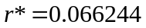. Since
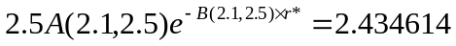
and
the call option on the coupon-bearing bond can be decomposed into a call option with a strike price of 2.434614 on a bond that pays off 2.5 at time 2.5 years and a call option with a strike price of 96.56539 on a bond that pays off 102.5 at time 3.0 years.
The options are valued using equation (31.20).
For the first option L=2.5, K= 2.434614, T = 2.1, and s=2.5. Also, P(0,T)=exp(-0.059118×2.1)=0.88325 and P(0,s)= exp(-0.059118×2.5)=0.862609. Furthermore σ_{P} = 0.008176 and h= 0.353374. so that the option price is 0.010523.
For the second option L=102.5, K= 96.56539, T = 2.1, and s=3.0. Also, P(0,T)=exp(-0.059118×2.1)=0.88325 and P(0,s)= exp(-0.059118×3.0)=0.837484. Furthermore σ_{P} = 0.018168 and h= 0.363366. so that the option price is 0.934074.

The total value of the option is therefore 0.010523+0.934074=0.944596.
Problem 31.13.
Observations spaced at intervals Δt are taken on the short rate. The ith observation is r_{i}
(1 ≤ i ≤ m). Show that the maximum likelihood estimates of a, b, and σ in Vasicek’s
model are given by maximizing
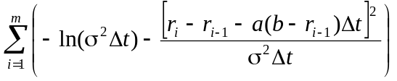
What is the corresponding result for the CIR model?

The change r_{i} –r_{i-1} is normally distributed with mean a(b − r_{i-1}) and variance σ²Δt. The probability density of the observation is

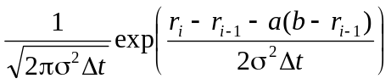

We wish to maximize

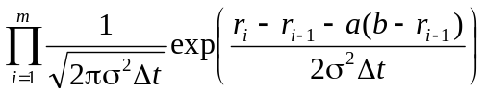

Taking logarithms, this is the same as maximizing

In the case of the CIR model, the change r_{i} –r_{i-1} is normally distributed with mean a(b − r_{i-1}) and variance 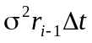and the maximum likelihood function becomes

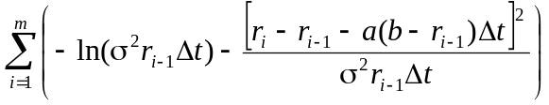

Problem 31.14.
Suppose , , and the term structure is flat at 10%. Construct a trinomial tree for the Hull–White model where there are two time steps, each one year in length.
The time step, , is 1 so that 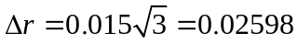. Also 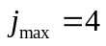 showing that the branching method should change four steps from the center of the tree. With only three steps we never reach the point where the branching changes. The tree is shown in Figure S31.1.
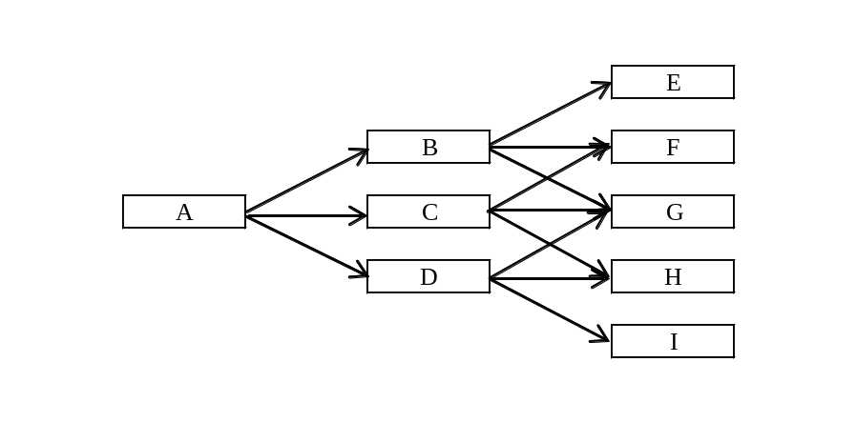

Node | A | B | C | D | E | F | G | H | I
 | 10.00% | 12.61% | 10.01% | 7.41% | 15.24% | 12.64% | 10.04% | 7.44% | 4.84%
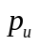 | 0.1667 | 0.1429 | 0.1667 | 0.1929 | 0.1217 | 0.1429 | 0.1667 | 0.1929 | 0.2217
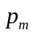 | 0.6666 | 0.6642 | 0.6666 | 0.6642 | 0.6567 | 0.6642 | 0.6666 | 0.6642 | 0.6567
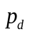 | 0.1667 | 0.1929 | 0.1667 | 0.1429 | 0.2217 | 0.1929 | 0.1667 | 0.1429 | 0.1217
Figure S31.1: Tree for Problem 31.14
Problem 31.15.
Calculate the price of a two-year zero-coupon bond from the tree in Figure 31.6.
A two-year zero-coupon bond pays off $100 at the ends of the final branches. At node B it is worth 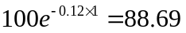. At node C it is worth 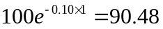. At node D it is worth 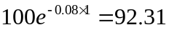. It follows that at node A the bond is worth
or $81.88
Problem 31.16.
Calculate the price of a two-year zero-coupon bond from the tree in Figure 31.9 and verify that it agrees with the initial term structure.
A two-year zero-coupon bond pays off $100 at time two years. At node B it is worth 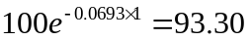. At node C it is worth 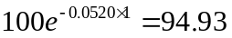. At node D it is worth 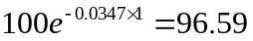. It follows that at node A the bond is worth
or $91.37. Because 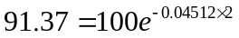, the price of the two-year bond agrees with the initial term structure.
Problem 31.17.
Calculate the price of an 18-month zero-coupon bond from the tree in Figure 31.10 and verify that it agrees with the initial term structure.
An 18-month zero-coupon bond pays off $100 at the final nodes of the tree. At node E it is worth 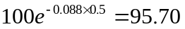. At node F it is worth 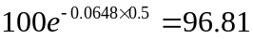. At node G it is worth 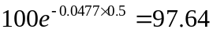. At node H it is worth 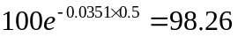. At node I it is worth 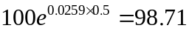. At node B it is worth
Similarly at nodes C and D it is worth 95.60 and 96.68. The value at node A is therefore
The 18-month zero rate is 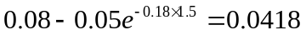. This gives the price of the 18-month zero-coupon bond as 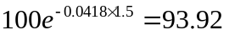 showing that the tree agrees with the initial term structure.
Problem 31.18.
What does the calibration of a one-factor term structure model involve?
The calibration of a one-factor interest rate model involves determining its volatility parameters so that it matches the market prices of actively traded interest rate options as closely as possible.
Problem 31.19.
Use the DerivaGem software to value 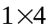, 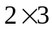, 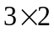, and 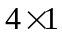 European swap options to receive fixed and pay floating. Assume that the one, two, three, four, and five year interest rates are 6%, 5.5%, 6%, 6.5%, and 7%, respectively. The payment frequency on the swap is semiannual and the fixed rate is 6% per annum with semiannual compounding. Use the Hull–White model with 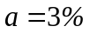 and 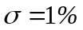. Calculate the volatility implied by Black’s model for each option.
The option prices are 0.1302, 0.0814, 0.0580, and 0.0274. The implied Black volatilities are 14.28%, 13.64%, 13.24%, and 12.81%
Problem 31.20.
Prove equations (31.25), (31.26), and (31.27).
From equation (31.15)
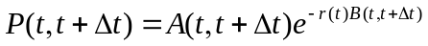
Also
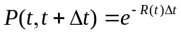
so that
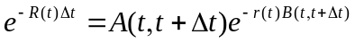
or
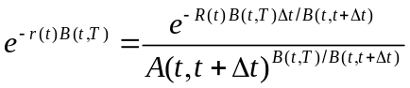
Hence equation (31.25) is true with
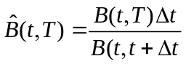
and
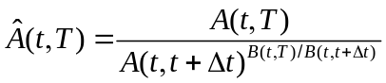
or
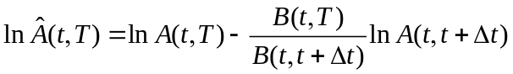

Problem 31.21.
- What is the second partial derivative of P(t,T) with respect to r in the Vasicek and CIR models?
- In Section 31.2, 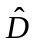is presented as an alternative to the standard duration measure D. What is a similar alternative 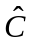 to the convexity measure in Section 4.9?
- What is for P(t,T)? How would you calculate for a coupon-bearing bond?
- Give a Taylor Series expansion for ΔP(t,T) in terms of Δr and (Δr)² for Vasicek and CIR.

- 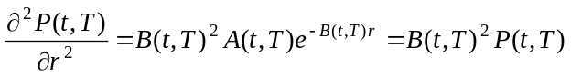
- A corresponding definition for 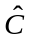is
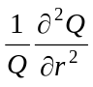

- When Q=P(t,T), 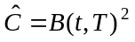For a coupon-bearing bond is a weighted average of the ’s for the constituent zero-coupon bonds where weights are proportional to bond prices.

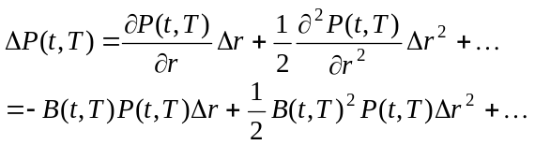

Problem 31.22.
Suppose that the short rate r is 4% and its real-world process is
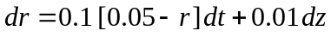
while the risk-neutral process is
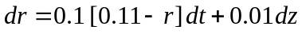
- What is the market price of interest rate risk?
- What is the expected return and volatility for a 5-year zero-coupon bond in the risk-neutral world?
- What is the expected return and volatility for a 5-year zero-coupon bond in the real world?

- The risk neutral process for r has a drift rate which is 0.006/r higher than the real world process. The volatility is 0.01/r. This means that the market price of interest rate risk is
−0.006/0.01 or −0.6.
- The expected return on the bond in the risk-neutral world is the risk free rate of 4%. The volatility is 0.01×B(0,5) where
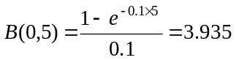
i.e., the volatility is 3.935%.
- The process followed by the bond price in a risk-neutral world is
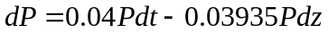
Note that the coefficient of dz is negative because bond prices are negatively correlated with interest rates. When we move to the real world the return increases by the product of the market price of dz risk and −0.03935. The bond price process becomes:
or
The expected return on the bond increases from 4% to 6.361% as we move from the risk-neutral world to the real world.

Further Questions

Problem 31.23.
Construct a trinomial tree for the Ho and Lee model where . Suppose that the initial zero-coupon interest rate for a maturities of 0.5, 1.0, and 1.5 years are 7.5%, 8%, and 8.5%. Use two time steps, each six months long. Calculate the value of a zero-coupon bond with a face value of $100 and a remaining life of six months at the ends of the final nodes of the tree. Use the tree to value a one-year European put option with a strike price of 95 on the bond. Compare the price given by your tree with the analytic price given by DerivaGem.
The tree is shown in Figure S31.2. The probability on each upper branch is 1/6; the probability on each middle branch is 2/3; the probability on each lower branch is 1/6. The six month bond prices nodes E, F, G, H, I are 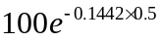, 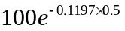, 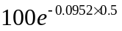, 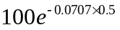, and 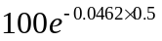, respectively. These are 93.04, 94.19, 95.35, 96.53, and 97.72. The payoffs from the option at nodes E, F, G, H, and I are therefore 1.96, 0.81, 0, 0, and 0. The value at node B is . The value at node C is . The value at node D is zero. The value at node A is
The answer given by DerivaGem using the analytic approach is 0.209.

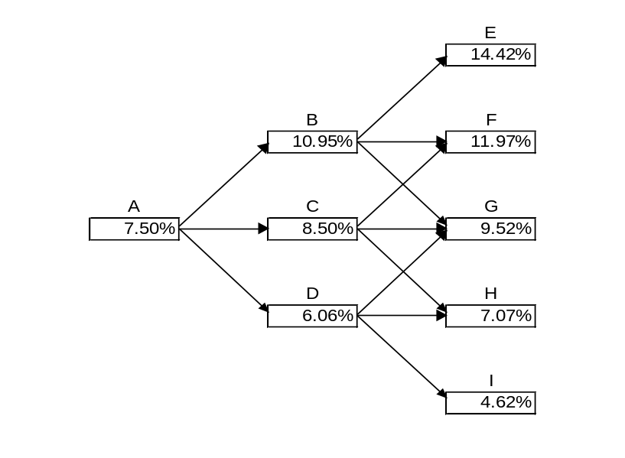

Figure S31.2: Tree for Problem 31.23

Problem 31.24.
A trader wishes to compute the price of a one-year American call option on a five-year bond with a face value of 100. The bond pays a coupon of 6% semiannually and the (quoted) strike price of the option is $100. The continuously compounded zero rates for maturities of six months, one year, two years, three years, four years, and five years are 4.5%, 5%, 5.5%, 5.8%, 6.1%, and 6.3%. The best fit reversion rate for either the normal or the lognormal model has been estimated as 5%.
A one year European call option with a (quoted) strike price of 100 on the bond is actively traded. Its market price is $0.50. The trader decides to use this option for calibration. Use the DerivaGem software with ten time steps to answer the following questions.
- Assuming a normal model, imply the parameter from the price of the European option.
- Use the parameter to calculate the price of the option when it is American.
- Repeat (a) and (b) for the lognormal model. Show that the model used does not significantly affect the price obtained providing it is calibrated to the known European price.
- Display the tree for the normal model and calculate the probability of a negative interest rate occurring.
- Display the tree for the lognormal model and verify that the option price is correctly calculated at the node where, with the notation of Section 31.7, 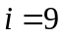 and 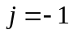.

Using 10 time steps:
  - The implied value of is 1.12%.
  - The value of the American option is 0.595
  - The implied value of is 18.45% and the value of the American option is 0.595. The two models give the same answer providing they are both calibrated to the same European price.
  - We get a negative interest rate if there are 10 down moves. The probability of this is
0.16667×0.16418×0.16172×0.15928×0.15687×0.15448×0.15212×0.14978×0.14747
×0.14518=8.3×10⁻⁹
  - The calculation is

Problem 31.25.
Use the DerivaGem software to value , , , and European swap options to receive floating and pay fixed. Assume that the one, two, three, four, and five year interest rates are 3%, 3.5%, 3.8%, 4.0%, and 4.1%, respectively. The payment frequency on the swap is semiannual and the fixed rate is 4% per annum with semiannual compounding. Use the lognormal model with 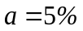, 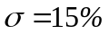, and 50 time steps. Calculate the volatility implied by Black’s model for each option.
The values of the four European swap options are 1.72, 1.73, 1.30, and 0.65, respectively. The implied Black volatilities are 13.37%, 13.41%, 13.43%, and 13.42%, respectively.

Problem 31.26.
Verify that the DerivaGem software gives Figure 31.11 for the example considered. Use the software to calculate the price of the American bond option for the lognormal and normal models when the strike price is 95, 100, and 105. In the case of the normal model, assume that = 5% and = 1%. Discuss the results in the context of the heavy-tails arguments of Chapter 20.
With 100 time steps the lognormal model gives prices of 5.585, 2.443, and 0.703 for strike prices of 95, 100, and 105. With 100 time steps the normal model gives prices of 5.508, 2.522, and 0.895 for the three strike prices respectively. The normal model gives a heavier left tail and a less heavy right tail than the lognormal model for interest rates. This translates into a less heavy left tail and a heavier right tail for bond prices. The arguments in Chapter 20 show that we expect the normal model to give higher option prices for high strike prices and lower option prices for low strike. This is indeed what we find.
Problem 31.27.
Modify Sample Application G in the DerivaGem Application Builder software to test the convergence of the price of the trinomial tree when it is used to price a two-year call option on a five-year bond with a face value of 100. Suppose that the strike price (quoted) is 100, the coupon rate is 7% with coupons being paid twice a year. Assume that the zero curve is as in Table 31.2. Compare results for the following cases:
  - Option is European; normal model with and .
  - Option is European; lognormal model with 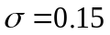 and .
  - Option is American; normal model with and .
  - Option is American; lognormal model with and .
The results are shown in Figure S31.3.

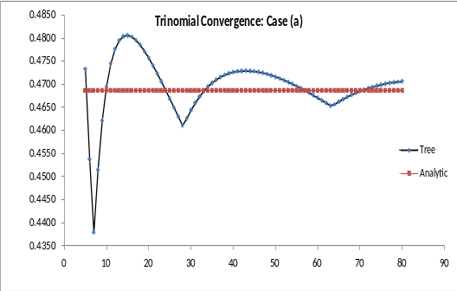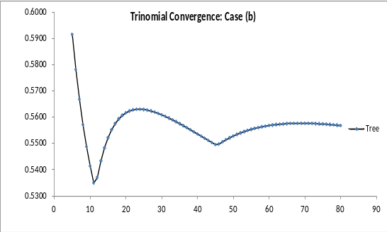

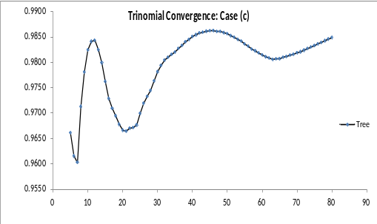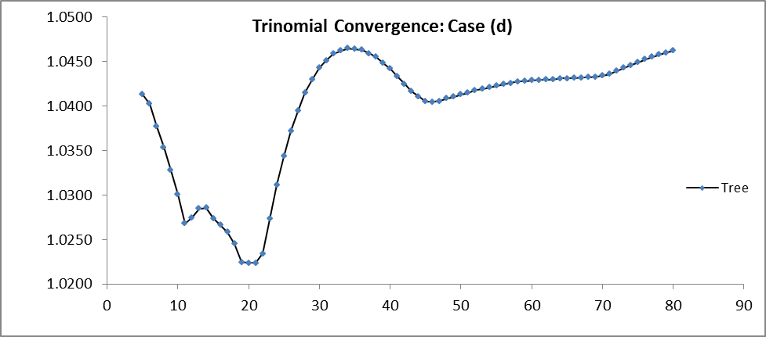

Figure S31.3: Tree for Problem 31.27

Problem 31.28.
Suppose that the (CIR) process for short-rate movements in the (traditional) risk-neutral world is
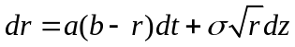
and the market price of interest rate risk is λ

          - What is the real world process for r?
          - What is the expected return and volatility for a 10-year bond in the risk-neutral world?
          - What is the expected return and volatility for a 10-year bond in the real world?

          - The volatility of r (i.e., the coefficient of rdz in the process for r) is 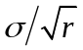. The drift in the real world process for r is therefore increased by 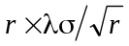 so that the process is
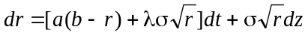
  - The expected return is r and the volatility is 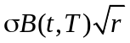 in the risk-neutral world.
  - The expected return is 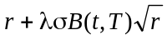 and the volatility is as in (b) in the real world.

