CHAPTER 32
HJM, LMM, and Multiple Zero Curves

Practice Questions

Problem 32.1.
Explain the difference between a Markov and a non-Markov model of the short rate.
In a Markov model the expected change and volatility of the short rate at time depend only on the value of the short rate at time . In a non-Markov model they depend on the history of the short rate prior to time .
Problem 32.2.
Prove the relationship between the drift and volatility of the forward rate for the multifactor version of HJM in equation (32.6).
Equation (32.1) becomes
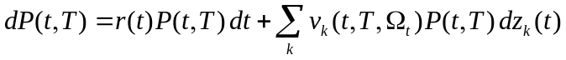
so that
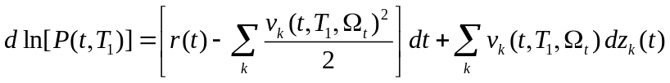
and
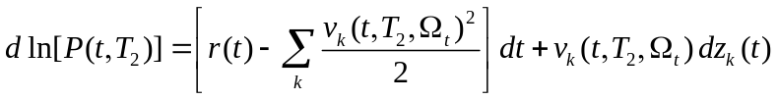
From equation (32.2)
Putting 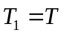 and 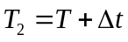 and taking limits as 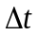 tends to zero this becomes
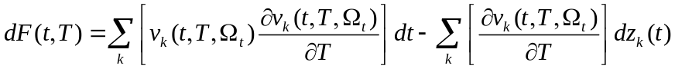
Using 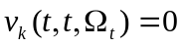
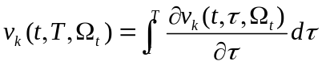
The result in equation (32.6) follows by substituting
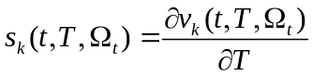

Problem 32.3.
“When the forward rate volatility 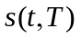 in HJM is constant, the Ho–Lee model results.” Verify that this is true by showing that HJM gives a process for bond prices that is consistent with the Ho–Lee model in Chapter 31.
Using the notation in Section 32.1, when is constant,
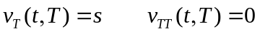
Integrating 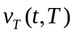
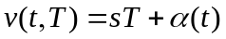
for some function . Using the fact that 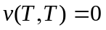, we must have
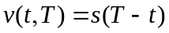
Using the notation from Chapter 31, in Ho–Lee 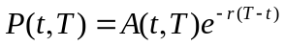. The standard deviation of the short rate is constant. It follows from Itô’s lemma that the standard deviation of the bond price is a constant times the bond price times 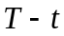. The volatility of the bond price is therefore constant times . This shows that Ho–Lee is consistent with a constant .
Problem 32.4.
“When the forward rate volatility, in HJM is 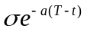 the Hull–White model results.” Verify that this is true by showing that HJM gives a process for bond prices that is consistent with the Hull–White model in Chapter 31.
Using the notation in Section 32.1, when 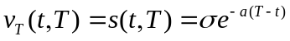
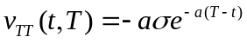
Integrating
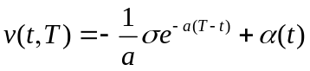
for some function . Using the fact that , we must have
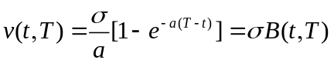
Using the notation from Chapter 31, in Hull–White 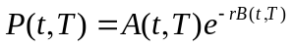. The standard deviation of the short rate is constant, . It follows from Itô’s lemma that the standard deviation of the bond price is 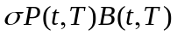. The volatility of the bond price is therefore 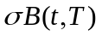. This shows that Hull-White is consistent with 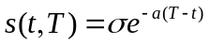.

Problem 32.5.
What is the advantage of LMM over HJM?
LMM is a similar model to HJM. It has the advantage over HJM that it involves forward rates that are readily observable. HJM involves instantaneous forward rates.
Problem 32.6.
Provide an intuitive explanation of why a ratchet cap increases in value as the number of factors increase.
A ratchet cap tends to provide relatively low payoffs if a high (low) interest rate at one reset date is followed by a high (low) interest rate at the next reset date. High payoffs occur when a low interest rate is followed by a high interest rate. As the number of factors increase, the correlation between successive forward rates declines and there is a greater chance that a low interest rate will be followed by a high interest rate.

Problem 32.7.
Show that equation (32.10) reduces to (32.4) as the 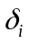 tend to zero.
Equation (32.10 ) can be written
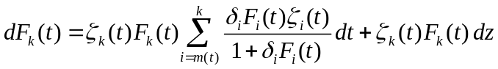
As tends to zero, 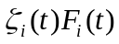 becomes the standard deviation of the instantaneous -maturity forward rate at time . Using the notation of Section 32.1 this is 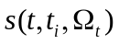. As tends to zero
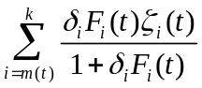
tends to
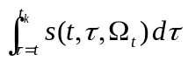
Equation (32.10) therefore becomes
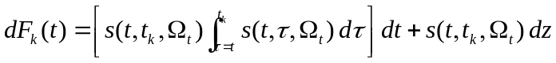
This is the HJM result.
Problem 32.8.
Explain why a sticky cap is more expensive than a similar ratchet cap.
In a ratchet cap, the cap rate equals the previous reset rate, , plus a spread. In the notation of the text it is 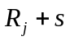. In a sticky cap the cap rate equal the previous capped rate plus a spread. In the notation of the text it is 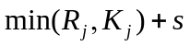. The cap rate in a ratchet cap is always at least a great as that in a sticky cap. Since the value of a cap is a decreasing function of the cap rate, it follows that a sticky cap is more expensive.
Problem 32.9.
Explain why IOs and POs have opposite sensitivities to the rate of prepayments
When prepayments increase, the principal is received sooner. This increases the value of a PO. When prepayments increase, less interest is received. This decreases the value of an IO.
Problem 32.10.
“An option adjusted spread is analogous to the yield on a bond.” Explain this statement.
A bond yield is the discount rate that causes the bond’s price to equal the market price. The same discount rate is used for all maturities. An OAS is the parallel shift to the Treasury zero curve that causes the price of an instrument such as a mortgage-backed security to equal its market price.

Problem 32.11.
Prove equation (32.15).
When there are  factors equation (32.7) becomes
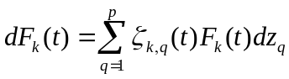
Equation (32.8) becomes
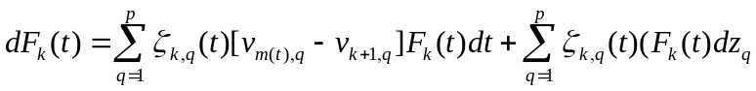
Equation coefficients of 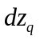 in
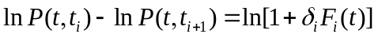
Equation (32.9) therefore becomes
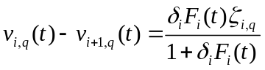
Equation (32.15) follows.

Problem 32.12.
Prove the formula for the variance, 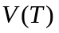, of the swap rate in equation (32.17).
From the equations in the text
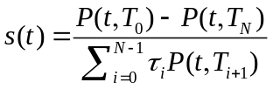
and
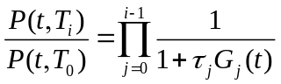
so that
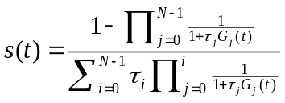
(We employ the convention that empty sums equal zero and empty products equal one.) Equivalently
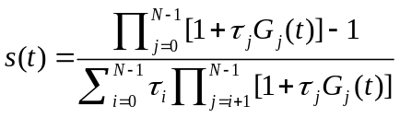
or
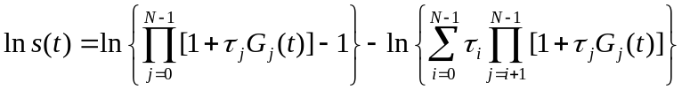
so that
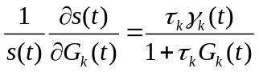
where
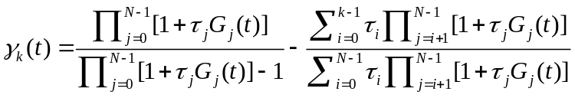
From Ito’s lemma the th component of the volatility of 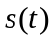 is
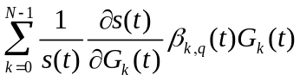
or
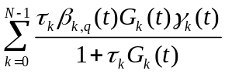
The variance rate of is therefore
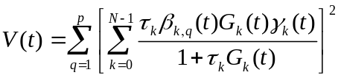

Problem 32.13.
Prove equation (32.19).
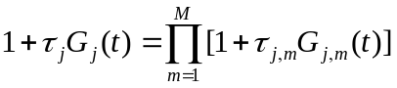
so that
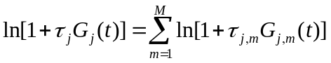
Equating coefficients of
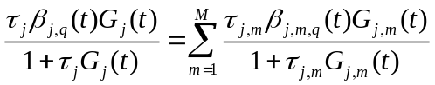
If we assume that 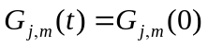 for the purposes of calculating the swap volatility we see from equation (32.17) that the volatility becomes
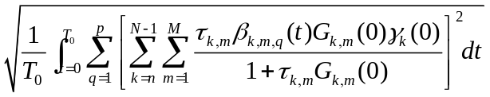
This is equation (32.19).

Further Questions

Problem 32.14.
In an annual-pay cap the Black volatilities for at-the-money caplets which start in one, two, three, and five years and end one year later are 18%, 20%, 22%, and 20%, respectively. Estimate the volatility of a one-year forward rate in the LIBOR Market Model when the time to maturity is (a) zero to one year, (b) one to two years, (c) two to three years, and (d) three to five years. Assume that the zero curve is flat at 5% per annum (annually compounded). Use DerivaGem to estimate flat volatilities for two-, three-, four-, five-, and six-year at-the-money caps.
The cumulative variances for one, two, three, and five years are 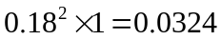, 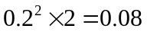, 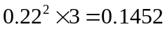, and 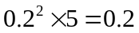, respectively. If the required forward rate volatilities are 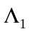, 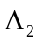, Λ₃, and 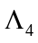, we must have
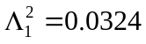

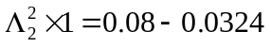

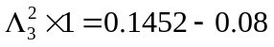

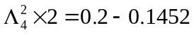
It follows that 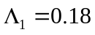, 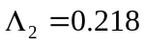, 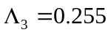, and 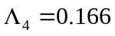
For the last part of the question we first interpolate to obtain the spot volatility for the four-year caplet as 21%. The yield curve is flat at 4.879% with continuous compounding. We use DerivaGem to calculate the prices of caplets with a strike price of 5% and principal of 100 which start in one, two, three, four, and five years and end one year later. The results are 0.3252, 0.4853, 0.6196, 0.6481, and 0.6552, respectively. This means that the prices two-, three-, four-, five-, and six-year caps are 0.3252, 0.8106, 1.4301, 2.0782, and 2.7335. We use DerivaGem again to imply flat volatilities from these prices. The flat volatilities for two-, three-, four-, five-, and six-year caps are 18%, 19.14%, 20.28%, 20.50%, and 20.38%, respectively

Problem 32.15.
In the flexi cap considered in Section 32.2 the holder is obligated to exercise the first  in-the-money caplets. After that no further caplets can be exercised. (In the example, 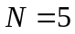.) Two other ways that flexi caps are sometimes defined are:
- The holder can choose whether any caplet is exercised, but there is a limit of on the total number of caplets that can be exercised.
- Once the holder chooses to exercise a caplet all subsequent in-the-money caplets must be exercised up to a maximum of .
Discuss the problems in valuing these types of flexi caps. Of the three types of flexi caps, which would you expect to be most expensive? Which would you expect to be least expensive?
The two types of flexi caps mentioned are more difficult to value than the flexi cap considered in Section 32.2. There are two reasons for this.
- They are American-style. (The holder gets to choose whether a caplet is exercised.) This makes the use of Monte Carlo simulation difficult.
- They are path dependent. In (a) the decision on whether to exercise a caplet is liable to depend on the number of caplets exercised so far. In (b) the exercise of a caplet is liable to depend on a decision taken some time earlier.
In practice, flexi caps are sometimes valued using a one-factor model of the short rate in conjunction with the techniques described in Section 27.5 for handling path-dependent derivatives.
The flexi cap in (b) is worth more than the flexi cap considered in Section 32.2. This is because the holder of the flexi cap in (b) has all the options of the holder of the flexi cap in the text and more. Similarly the flexi cap in (a) is worth more than the flexi cap in (b). This is because the holder of the flexi cap in (a) has all the options of the holder of the flexi cap in (b) and more. We therefore expect the flexi cap in (a) to be the most expensive and the flexi cap considered in Section 32.2 to be the least expensive.

