CHAPTER 33
Swaps Revisited

Practice Questions

Problem 33.1.
Calculate all the fixed cash flows and their exact timing for the swap in Business Snapshot 33.1. Assume that the day count conventions are applied using target payment dates rather than actual payment dates.
Results are as follows

Target payment date | Day of week | Actual payment date | Days from previous to current target pmt dates | Fixed  Payment ($)
Jul 11, 2013 | Thursday | Jul 11, 2013 | 181 | 2,975,342
Jan 11, 2014 | Saturday | Jan 13, 2014 | 184 | 3,024,658
Jul 11, 2014 | Friday | Jul 11, 2014 | 181 | 2,975,342
Jan 11, 2015 | Sunday | Jan 12, 2015 | 184 | 3,024,658
Jul 11, 2015 | Saturday | Jul 13, 2015 | 181 | 2,975,342
Jan 11, 2016 | Monday | Jan 11, 2016 | 184 | 3,024,658
Jul 11, 2016 | Monday | Jul 11, 2016 | 182 | 2,991,781
Jan 11, 2017 | Wednesday | Jan 11, 2017 | 184 | 3,024,658
Jul 11, 2017 | Tuesday | Jul 11, 2017 | 181 | 2,975,342
Jan 11, 2018 | Thursday | Jan 11, 2018 | 184 | 3,024,658

The fixed rate day count convention is Actual/365. There are 181 days between January 11, 2013 and July 11, 2013. This means that the fixed payments on July 11, 2013 is
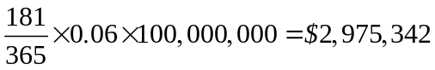
Other fixed payments are calculated similarly.

Problem 33.2.
Suppose that a swap specifies that a fixed rate is exchanged for twice the LIBOR rate. Can the swap be valued using the “assume forward rates are realized” rule?
Yes. The swap is the same as one on twice the principal where half the fixed rate is exchanged for the LIBOR rate.
Problem 33.3.
What is the value of a two-year fixed-for-floating compounding swap where the principal is $100 million and payments are made semiannually? Fixed interest is received and floating is paid. The fixed rate is 8% and it is compounded at 8.3% (both semiannually compounded). The floating rate is LIBOR plus 10 basis points and it is compounded at LIBOR plus 20 basis points. The LIBOR zero curve is flat at 8% with semiannual compounding and is used for discounting.
The final fixed payment is in millions of dollars:
The final floating payment assuming forward rates are realized is
The value of the swap is therefore 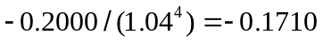 or –$171,000.
Problem 33.4.
What is the value of a five-year swap where LIBOR is paid in the usual way and in return LIBOR compounded at LIBOR is received on the other side? The principal on both sides is $100 million. Payment dates on the pay side and compounding dates on the receive side are every six months and the LIBOR zero curve is flat at 5% with semiannual compounding (and is used for discounting).
The value is zero. The receive side is the same as the pay side with the cash flows compounded forward at LIBOR. Compounding cash flows forward at LIBOR does not change their value.
Problem 33.5.
Explain carefully why a bank might choose to discount cash flows on a currency swap at a rate slightly different from LIBOR.
In theory, a new floating-for-floating swap should involve exchanging LIBOR in one currency for LIBOR in another currency (with no spreads added). In practice, macroeconomic effects give rise to spreads. Financial institutions often adjust the discount rates they use to allow for this. Suppose that USD LIBOR is always exchanged Swiss franc LIBOR plus 15 basis points. Financial institutions would discount USD cash flows at USD LIBOR and Swiss franc cash flows at LIBOR plus 15 basis points. This would ensure that the floating-for-floating swap is valued consistently with the market.
Problem 33.6.
Calculate the total convexity/timing adjustment in Example 33.3 of Section 33.4 if all cap volatilities are 18% instead of 20% and volatilities for all options on five-year swaps are 13% instead of 15%. What should the five year swap rate in three years’ time be assumed for the purpose of valuing the swap? What is the value of the swap?
In this case, 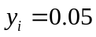, 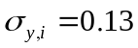, 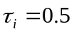, 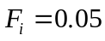, 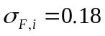, and 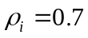 for all . It is still true that 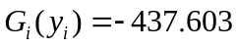 and 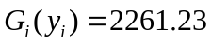. Equation (33.2) gives the total convexity/timing adjustment as 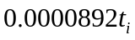 or 0.892 basis points per year until the swap rate is observed. The swap rate in three years should be assumed to be 5.0268%. The value of the swap is $119,069.
Problem 33.7.
Explain why a plain vanilla interest rate swap and the compounding swap in Section 33.2 can be valued using the “assume forward rates are realized” rule, but a LIBOR-in-arrears swap in Section 33.4 cannot.
In a plain vanilla swap we can enter into a series of FRAs to exchange the floating cash flows for their values if the “assume forward rates are realized rule” is used. In the case of a compounding swap Section 33.2 shows that we are able to enter into a series of FRAs that exchange the final floating rate cash flow for its value when the “assume forward rates are realized rule” is used. (As shown in footnote 1 there may be a small approximation here.) There is no way of entering into FRAs so that the floating-rate cash flows in a LIBOR-in-arrears swap are exchanged for their values when the “assume forward rates are realized rule” is used.
Problem 33.8.
In the accrual swap discussed in the text, the fixed side accrues only when the floating reference rate lies below a certain level. Discuss how the analysis can be extended to cope with a situation where the fixed side accrues only when the floating reference rate is above one level and below another.
Suppose that the fixed rate accrues only when the floating reference rate is below 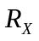 and above 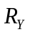 where 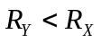. In this case the swap is a regular swap plus two series of binary options, one for each day of the life of the swap. Using the notation in the text, the risk-neutral probability that LIBOR will be above on day is 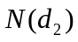 where
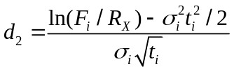
The probability that it will be below where is 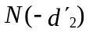 where
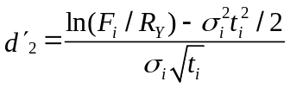
From the viewpoint of the party paying fixed, the swap is a regular swap plus binary options. The binary options corresponding to day have a total value of
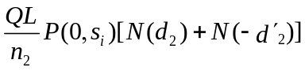
(This ignores the small timing adjustment mentioned in Section 33.6.)
Further Questions

Problem 33.9.
LIBOR zero rates are flat at 5% in the U.S and flat at 10% in Australia (both annually compounded). In a four-year diff swap Australian LIBOR is received and 9% is paid with both being applied to a USD principal of $10 million. Payments are exchanged annually. The volatility of all one-year forward rates in Australia is estimated to be 25%, the volatility of the forward USD–AUD exchange rate (AUD per USD) is 15% for all maturities, and the correlation between the two is 0.3. What is the value of the swap?
The fixed side consists of four payments of USD 0.9 million. The present value in millions of dollars is
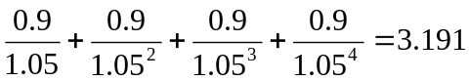

The forward Australian LIBOR rate is 10% with annual compounding. From Section 30.3 the quanto adjustment to the floating payment at time 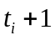 is
0.1×0.3×0.15×0.25t_{i} = 0.01125t_{i}

The value of the floating payments is therefore

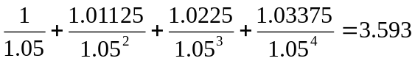

The value of the swap is 3.593 – 3.191 = 0.402 million.
Problem 33.10.
Estimate the interest rate paid by P&G on the 5/30 swap in Section 33.7 if a) the CP rate is 6.5% and the Treasury yield curve is flat at 6% and b) the CP rate is 7.5% and the Treasury yield curve is flat at 7% with semiannual compounding.
When the CP rate is 6.5% and Treasury rates are 6% with semiannual compounding, the CMT% is 6% and an Excel spreadsheet can be used to show that the price of a 30-year bond with a 6.25% coupon is about 103.46. The spread is zero and the rate paid by P&G is 5.75%. When the CP rate is 7.5% and Treasury rates are 7% with semiannual compounding, the CMT% is 7% and the price of a 30-year bond with a 6.25% coupon is about 90.65. The spread is therefore
or 28.64%. The rate paid by P&G is 35.39%.
Problem 33.11.
Suppose that you are trading a LIBOR-in-arrears swap with an unsophisticated counterparty that does not make convexity adjustments. To take advantage of the situation, should you be paying fixed or receiving fixed? How should you try to structure the swap as far as its life and payment frequencies?
Consider the situation where the yield curve is flat at 10% per annum with annual compounding. All cap volatilities are 18%. Estimate the difference between the way a sophisticated trader and an unsophisticated trader would value a LIBOR-in-arrears swap where payments are made annually and the life of the swap is (a) 5 years, (b) 10 years, and (c) 20 years. Assume a notional principal of $1 million.

You should be paying fixed and receiving floating. The counterparty will value the floating payments less than you because it does not make a convexity adjustment increasing forward rates. The size of the convexity adjustment for a forward rate increases with the forward rate, the forward rate volatility, the time between resets, and the time until the forward rate is observed. We therefore maximize the impact of the convexity adjustment by choosing long swaps involving high interest rate currencies, where the interest rate volatility is high and there is a long time between resets.
The convexity adjustment for the payment at time is
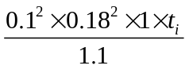
This is 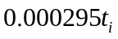. For a five year LIBOR-in-arrears swap the value of the convexity adjustment is
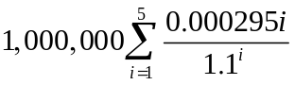
or $3137.7. Similarly the value of the convexity adjustments for 10 and 20 year swaps is $8,552.4 and $18,827.5.

Problem 33.12.
Suppose that the LIBOR zero rate is flat at 5% with annual compounding and is used for discounting. In a five-year swap, company X pays a fixed rate of 6% and receives LIBOR. The volatility of the two-year swap rate in three years is 20%.
- What is the value of the swap?
- Use DerivaGem to calculate the value of the swap if company X has the option to cancel after three years.
- Use DerivaGem to calculate the value of the swap if the counterparty has the option to cancel after three years.
- What is the value of the swap if either side can cancel at the end of three years?
  - Because the LIBOR zero curve is flat at 5% with annual compounding, the five-year swap rate for an annual-pay swap is also 5%. (As explained in Chapter 7 swap rates are par yields.) A swap where 5% is paid and LIBOR is receive would therefore be worth zero. A swap where 6% is paid and LIBOR is received has the same value as an instrument that pays 1% per year. Its value in millions of dollars is therefore
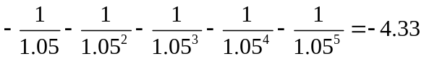

  - In this case company X has, in addition to the swap in (a), a European swap option to enter into a two-year swap in three years. The swap gives company X the right to receive 6% and pay LIBOR. We value this in DerivaGem by using the Caps and Swap Options worksheet. We choose Swap Option as the Underling Type, set the Principal to 100, the Settlement Frequency to Annual, the Swap Rate to 6%, and the Volatility to 20%. The Start (Years) is 3 and the End (Years) is 5. The Pricing Model is Black-European. We choose Rec Fixed and do not check the Imply Volatility or Imply Breakeven Rate boxes. All zero rates are 4.879% with continuous compounding. We therefore need only enter 4.879% for one maturity. The value of the swap option is given as 2.18. The value of the swap with the cancelation option is therefore
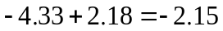

  - In this case company X has, in addition to the swap in (a), granted an option to the counterparty. The option gives the counterparty the right to pay 6% and receive LIBOR on a two-year swap in three years. We can value this in DerivaGem using the same inputs as in (b) but with the Pay Fixed instead of the Rec Fixed being chosen. The value of the swap option is 0.57. The value of the swap to company X is
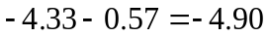

  - In this case company X is long the Rec Fixed option and short the Pay Fixed option. The value of the swap is therefore
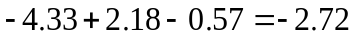

It is certain that one of the two sides will exercise its option to cancel in three years. The swap is therefore to all intents and purposes a three-year swap with no embedded options. Its value can also be calculated as
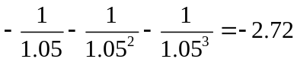

Problem 33.13.
How would you calculate the initial value the equity swap in Business Snapshot 33.3 if OIS discounting were used?

The change to OIS discounting does not affect the value of the equity amounts. Under OIS discounting the expected total return on the equity index is the OIS rate and discounting is at the OIS rate. Not surprisingly this means that the value of equity amounts is $100 million (as it is under LIBOR discounting)

To value the floating amounts we calculate forward LIBOR as indicated in Chapter 9 and discount at the OIS rate. This will usually increase the value of the LIBOR payments.

