CHAPTER 34
Energy and Commodity Derivatives

Practice Questions

Problem 34.1.
What is meant by HDD and CDD?
A day’s HDD is 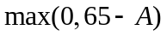 and a day’s CDD is 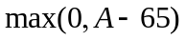 where  is the average of the highest and lowest temperature during the day at a specified weather station, measured in degrees Fahrenheit.
Problem 34.2.
How is a typical natural gas forward contract structured?
It is an agreement by one side to deliver a specified amount of gas at a roughly uniform rate during a month to a particular hub for a specified price.
Problem 34.3.
Distinguish between the historical data and the risk-neutral approach to valuing a derivative. Under what circumstances do they give the same answer?
The historical data approach to valuing an option involves calculating the expected payoff using historical data and discounting the payoff at the risk-free rate. The risk-neutral approach involves calculating the expected payoff in a risk-neutral world and discounting at the risk-free rate. The two approaches give the same answer when percentage changes in the underlying market variables have zero correlation with stock market returns. (In these circumstances all risks can be diversified away.)
Problem 34.4.
Suppose that each day during July the minimum temperature is 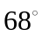 Fahrenheit and the maximum temperature is 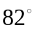 Fahrenheit. What is the payoff from a call option on the cumulative CDD during July with a strike of 250 and a payment rate of $5,000 per degree day?
The average temperature each day is 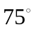. The CDD each day is therefore 10 and the cumulative CDD for the month is 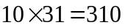. The payoff from the call option is therefore 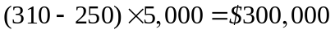.
Problem 34.5.
Why is the price of electricity more volatile than that of other energy sources?
Unlike most commodities electricity cannot be stored easily. If the demand for electricity exceeds the supply, as it sometimes does during the air conditioning season, the price of electricity in a deregulated environment will skyrocket. When supply and demand become matched again the price will return to former levels.
Problem 34.6.
Why is the historical data approach appropriate for pricing a weather derivatives contract and a CAT bond?
There is no systematic risk (i.e., risk that is priced by the market) in weather derivatives and CAT bonds.
Problem 34.7.
“HDD and CDD can be regarded as payoffs from options on temperature.” Explain this statement.
HDD is 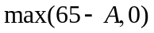 where is the average of the maximum and minimum temperature during the day. This is the payoff from a put option on with a strike price of 65. CDD is 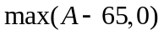. This is the payoff from call option on with a strike price of 65.

Problem 34.8.
Suppose that you have 50 years of temperature data at your disposal. Explain carefully the analyses you would carry out to value a forward contract on the cumulative CDD for a particular month.
It would be useful to calculate the cumulative CDD for July of each year of the last 50 years. A linear regression relationship
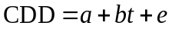
could then be estimated where and are constants, is the time in years measured from the start of the 50 years, and is the error. This relationship allows for linear trends in temperature through time. The expected CDD for next year (year 51) is then 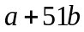. This could be used as an estimate of the forward CDD.
Problem 34.9.
Would you expect the volatility of the one-year forward price of oil to be greater than or less than the volatility of the spot price? Explain your answer.
The volatility of the one-year forward price will be less than the volatility of the spot price. This is because, when the spot price changes by a certain amount, mean reversion will cause the forward price will change by a lesser amount.
Problem 34.10.
What are the characteristics of an energy source where the price has a very high volatility and a very high rate of mean reversion? Give an example of such an energy source.
The price of the energy source will show big changes, but will be pulled back to its long-run average level fast. Electricity is an example of an energy source with these characteristics.
Problem 34.11.
How can an energy producer use derivative markets to hedge risks?
The energy producer faces quantity risks and price risks. It can use weather derivatives to hedge the quantity risks and energy derivatives to hedge against the price risks.
Problem 34.12.
Explain how a 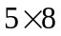 option contract for May 2009 on electricity with daily exercise works. Explain how a option contract for May 2009 on electricity with monthly exercise works. Which is worth more?
A contract for May, 2009 is a contract to provide electricity for five days per week during the off-peak period (11PM to 7AM). When daily exercise is specified, the holder of the option is able to choose each weekday whether he or she will buy electricity at the strike price at the agreed rate. When there is monthly exercise, he or she chooses once at the beginning of the month whether electricity is to be bought at the strike price at the agreed rate for the whole month. The option with daily exercise is worth more.
Problem 34.13.
Explain how CAT bonds work.
CAT bonds (catastrophe bonds) are an alternative to reinsurance for an insurance company that has taken on a certain catastrophic risk (e.g., the risk of a hurricane or an earthquake) and wants to get rid of it. CAT bonds are issued by the insurance company. They provide a higher rate of interest than government bonds. However, the bondholders agree to forego interest, and possibly principal, to meet any claims against the insurance company that are within a prespecified range.
Problem 34.14.
Consider two bonds that have the same coupon, time to maturity and price. One is a B-rated corporate bond. The other is a CAT bond. An analysis based on historical data shows that the expected losses on the two bonds in each year of their life is the same. Which bond would you advise a portfolio manager to buy and why?
The CAT bond has very little systematic risk. Whether a particular type of catastrophe occurs is independent of the return on the market. The risks in the CAT bond are likely to be largely “diversified away” by the other investments in the portfolio. A B-rated bond does have systematic risk that cannot be diversified away. It is likely therefore that the CAT bond is a better addition to the portfolio.

Problem 34.15
Consider a commodity with constant volatility and an expected growth rate that is a function solely of time. Show that, in the traditional risk-neutral world,

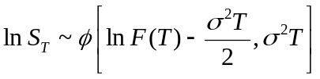

where 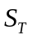 is the value of the commodity at time , 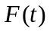 is the futures price at time 0 for a contract maturing at time , and 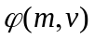 is a normal distribution with mean and variance .
In this case
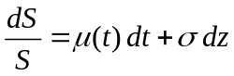
or
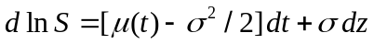
so that 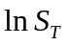 is normal with mean
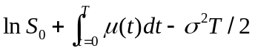
and standard deviation 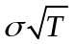. Section 34.4 shows that
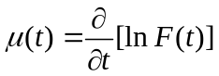
so that
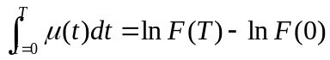
Since 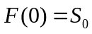 the result follows.

Further Questions
Problem 34.16.
An insurance company’s losses of a particular type are to a reasonable approximation normally distributed with a mean of $150 million and a standard deviation of $50 million. (Assume no difference between losses in a risk-neutral world and losses in the real world.) The 1-year risk-free rate is 5%. Estimate the cost of the following:
  - A contract that will pay in 1 year’s time 60% of the insurance company’s losses on a pro rata basis.
  - A contract that pays $100 million in 1 year’s time if losses exceed $200 million.

          - The losses in millions of dollars are approximately
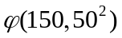
The reinsurance contract would pay out 60% of the losses. The payout from the reinsurance contract is therefore
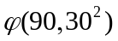
The cost of the reinsurance is the expected payout in a risk-neutral world, discounted at the risk-free rate. In this case, the expected payout is the same in a risk-neutral world as it is in the real world. The value of the reinsurance contract is therefore
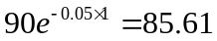

          - The probability that losses will be greater than $200 million is the probability that a normally distributed variable is greater than one standard deviation above the mean. This is 0.1587. The expected payoff in millions of dollars is therefore 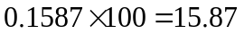 and the value of the contract is
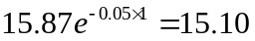

Problem 34.17.
How is the tree in Figure 34.2 modified if the 1- and 2-year futures prices are $21 and $22 instead of $22 and $23, respectively. How does this affect the value of the American option in Example 34.3.

To find the nodes at the end of one year we must solve
The solution is α₁ =3.025. To find the nodes at the end of two years we must solve
The solution is α₂ = 3.055. This gives the tree in Figure S34.1. The probabilities on branches are unchanged. Rolling back through the tree, the value of a three-year put option with a strike price of 20 is shown in Figure S34.2 to be 1.68.

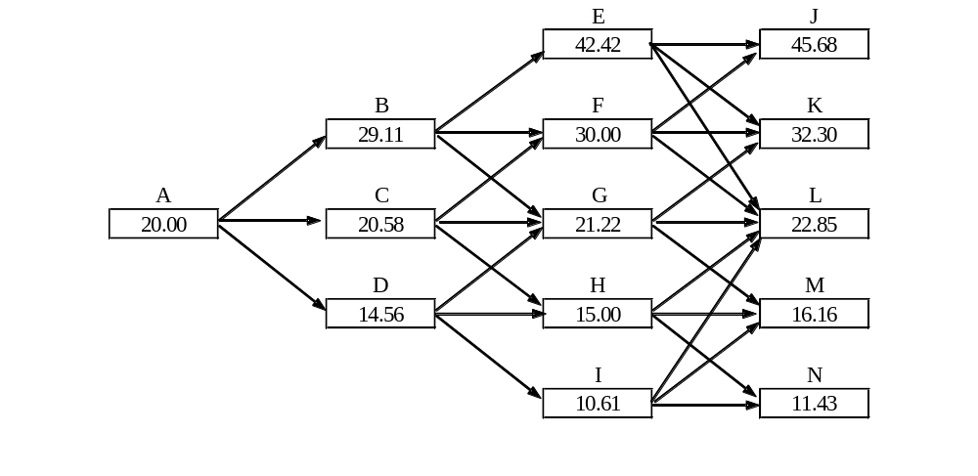
Figure S34.1: Commodity Prices in Problem 34.16
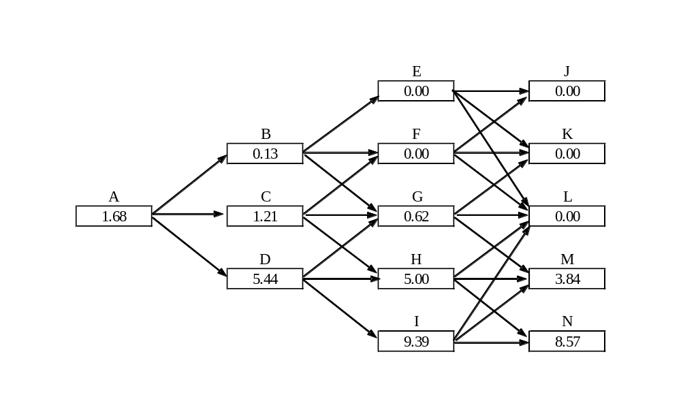
Figure S34.2: American option prices in Problem 34.16

