CHAPTER 35
Real Options

Practice Questions

Problem 35.1.
Explain the difference between the net present value approach and the risk-neutral valuation approach for valuing a new capital investment opportunity. What are the advantages of the risk-neutral valuation approach for valuing real options?
In the net present value approach, cash flows are estimated in the real world and discounted at a risk-adjusted discount rate. In the risk-neutral valuation approach, cash flows are estimated in the risk-neutral world and discounted at the risk-free interest rate. The risk-neutral valuation approach is arguably more appropriate for valuing real options because it is very difficult to determine the appropriate risk-adjusted discount rate when options are valued.
Problem 35.2.
The market price of risk for copper is 0.5, the volatility of copper prices is 20% per annum, the spot price is 80 cents per pound, and the six-month futures price is 75 cents per pound. What is the expected percentage growth rate in copper prices over the next six months?
In a risk-neutral world the expected price of copper in six months is 75 cents. This corresponds to an expected growth rate of 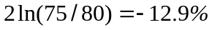 per annum. The decrease in the growth rate when we move from the real world to the risk-neutral world is the volatility of copper times its market price of risk. This is 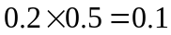 or 10% per annum. It follows that the expected growth rate of the price of copper in the real world is 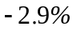.
Problem 35.3.
Show that, if y is a commodity’s convenience yield and u is its storage cost, the
commodity’s growth rate in a risk-neutral world is r − y + u, where r is the risk-free rate.
Deduce the relationship between the market price of risk of the commodity, its real-world
growth rate, its volatility, y, and u.

We explained the concept of a convenience yield for a commodity in Chapter 5. It is a measure of the benefits realized from ownership of the physical commodity that are not realized by the holders of a futures contract. If is the convenience yield and is the storage cost, equation (5.17) shows that the commodity behaves like an investment asset that provides a return equal to 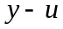. In a risk-neutral world its growth is, therefore,
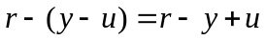

The convenience yield of a commodity can be related to its market price of risk. From Section 35.2, the expected growth of the commodity price in a risk-neutral world is 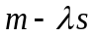, where is its expected growth in the real world, its volatility, and is its market price of risk. It follows that
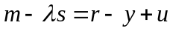

Problem 35.4.
The correlation between a company’s gross revenue and the market index is 0.2. The excess return of the market over the risk-free rate is 6% and the volatility of the market index is 18%. What is the market price of risk for the company’s revenue?
In equation (35.2) 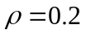, 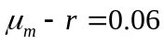, and 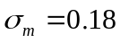. It follows that the market price of risk lambda is
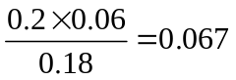

Problem 35.5.
A company can buy an option for the delivery of one million units of a commodity in three years at $25 per unit. The three year futures price is $24. The risk-free interest rate is 5% per annum with continuous compounding and the volatility of the futures price is 20% per annum. How much is the option worth?
The option can be valued using Black’s model. In this case 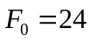, 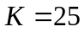, 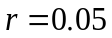, 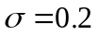, and 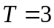. The value of an option to purchase one unit at $25 is
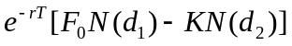
where
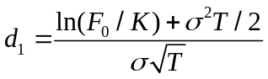
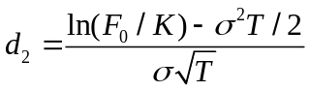
This is 2.489. The value of the option to purchase one million units is therefore $2,489,000.
Problem 35.6.
A driver entering into a car lease agreement can obtain the right to buy the car in four years for $10,000. The current value of the car is $30,000. The value of the car, , is expected to follow the process
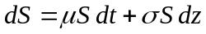
where 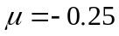, 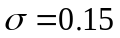, and 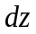 is a Wiener process. The market price of risk for the car price is estimated to be 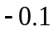. What is the value of the option? Assume that the risk-free rate for all maturities is 6%.
The expected growth rate of the car price in a risk-neutral world is 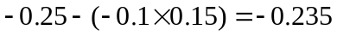 The expected value of the car in a risk-neutral world in four years, 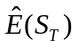, is therefore 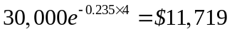. Using the result in the appendix to Chapter 15 the value of the option is
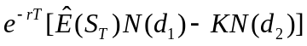
where
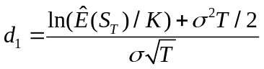

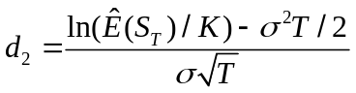
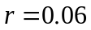, , 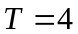, and 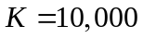. It is $1,832.

Further Questions
Problem 35.7.
Suppose that the spot price, 6-month futures price, and 12-month futures price for wheat are 250, 260, and 270 cents per bushel, respectively. Suppose that the price of wheat follows the process in equation (35.3) with 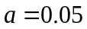 and . Construct a two-time-step tree for the price of wheat in a risk-neutral world.
A farmer has a project that involves an expenditure of $10,000 and a further expenditure of $90,000 in six months. It will increase wheat that is harvested and sold by 40,000 bushels in one year. What is the value of the project? Suppose that the farmer can abandon the project in six months and avoid paying the $90,000 cost at that time. What is the value of the abandonment option? Assume a risk-free rate of 5% with continuous compounding.

In this case and . We first define a variable  that follows the process
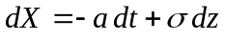
A tree for constructed in the way described in Chapters 31 and 34 is shown in Figure S35.1. We now displace nodes so that the tree models 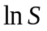 in a risk-neutral world where is the price of wheat. The displacements are chosen so that the initial price of wheat is 250 cents and the expected prices at the ends of the first and second time steps are 260 and 270 cents, respectively. Suppose that the displacement to give at the end of the first time step is 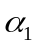. Then
so that 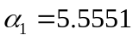 The probabilities of nodes E, F, G, H, and I being reached are 0.0257, 0.2221, 0.5043, 0.2221, and 0.0257, respectively. Suppose that the displacement to give at the end of the second step is 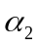. Then

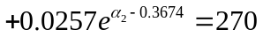
so that 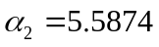. This leads to the tree for the price of wheat shown in Figure S35.2.
Using risk-neutral valuation the value of the project (in thousands of dollars) is
This shows that the project is worth undertaking. Figure S35.3 shows the value of the project on a tree. The project should be abandoned at node D for a saving of 2.41. Figure S35.4 shows that the abandonment option is worth 0.39.

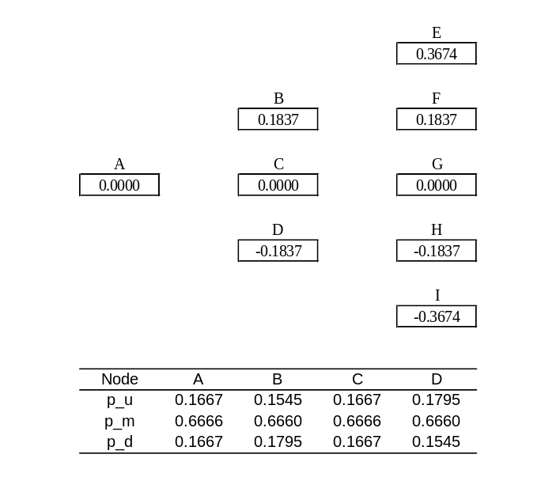

Figure S35.1: Tree for in Problem 35.7

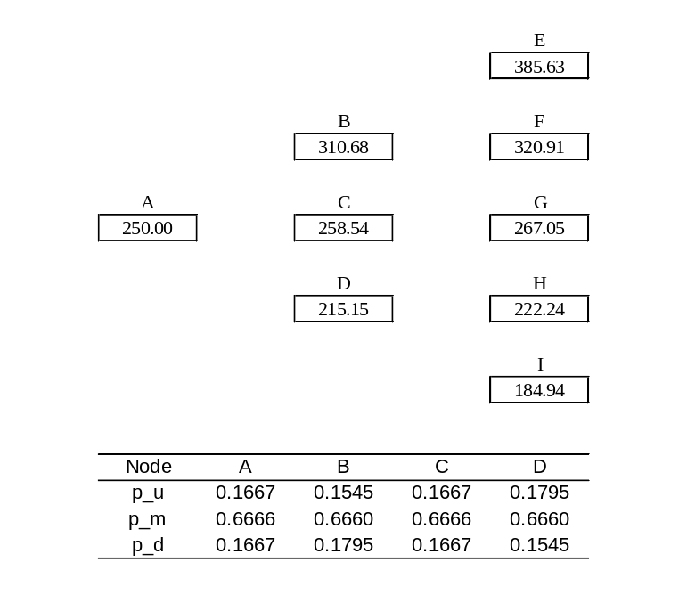

Figure S35.2: Tree for price of wheat in Problem 35.7

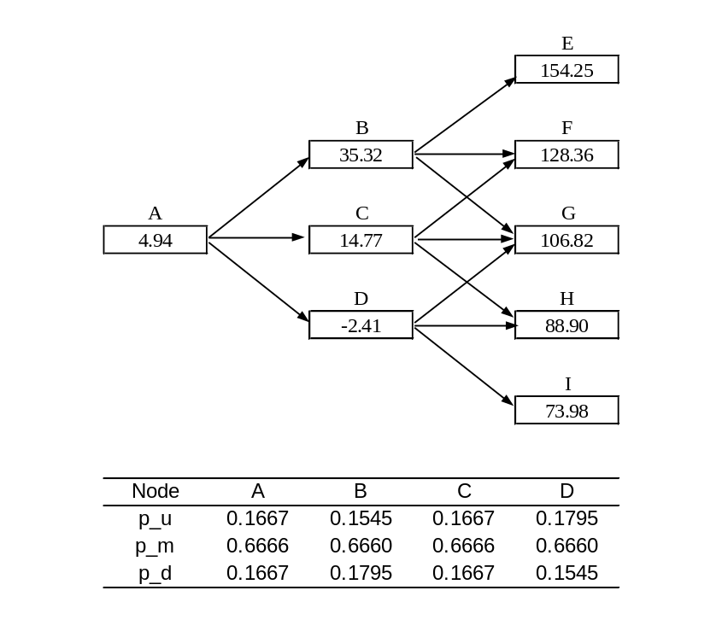

Figure S35.3: Tree for value of project in Problem 35.7

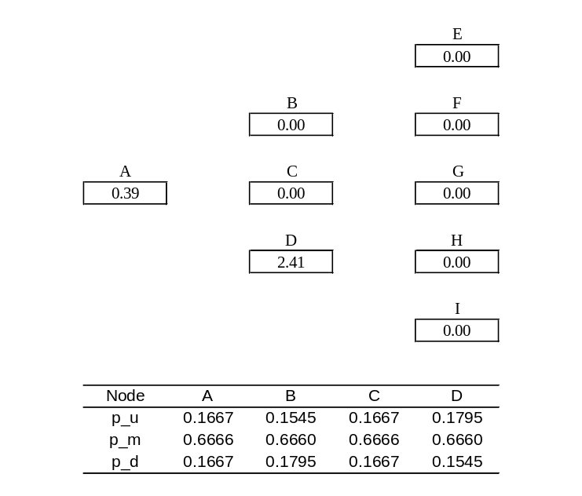
Figure S35.4: Tree for abandonment option in Problem 35.7

Problem 35.8.
In the example considered in Section 35.5
- What is the value of the abandonment option if it costs $3 million rather than zero?
- What is the value of the expansion option if it costs $5 million rather than $2 million?
Figure S35.5 shows what Figure 35.3 in the text becomes if the abandonment option costs $3 million. The value of the abandonment option reduces from 1.94 to 1.21. Similarly Figure S35.6 below shows what Figure 35.4 in the text becomes if the expansion option costs $5 million. The value of the expansion option reduces from 1.06 to 0.40.
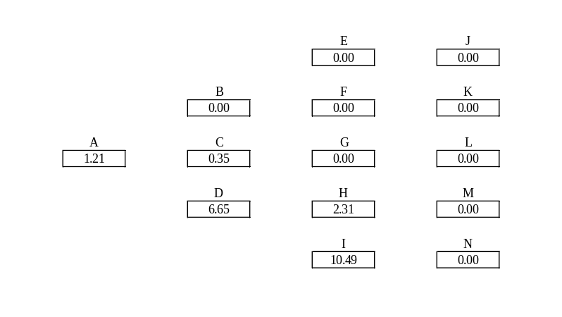
Figure S35.5: Tree for abandonment option in Problem 35.8

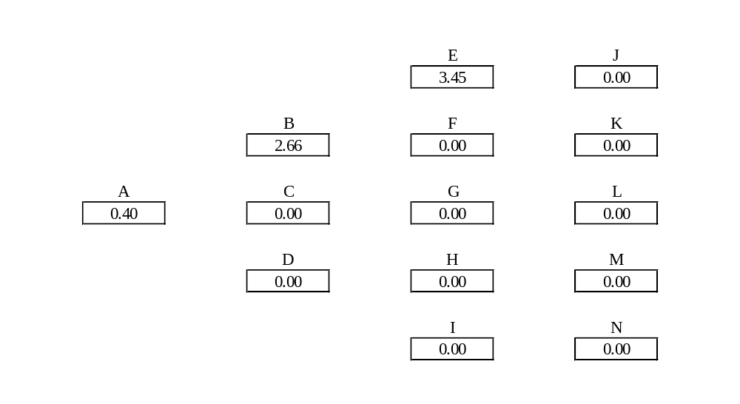
Figure S35.6: Tree for expansion option in Problem 35.8

