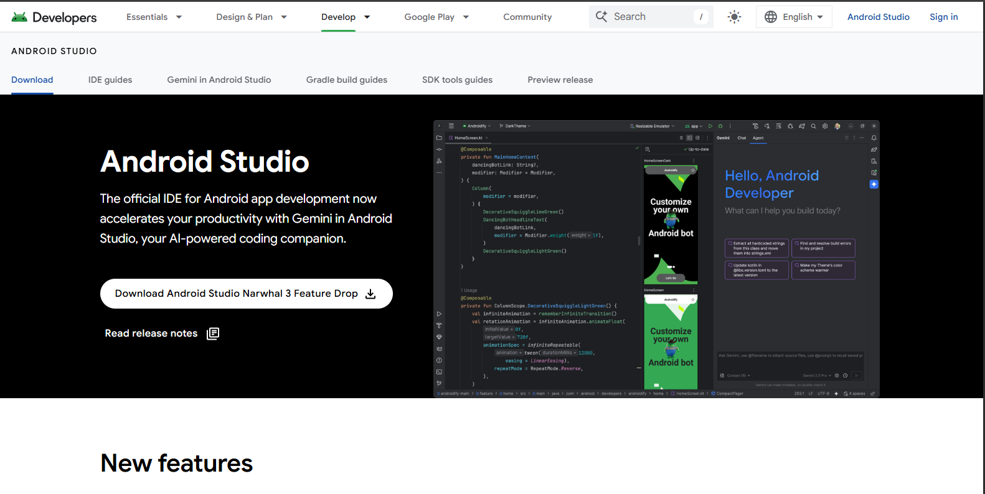



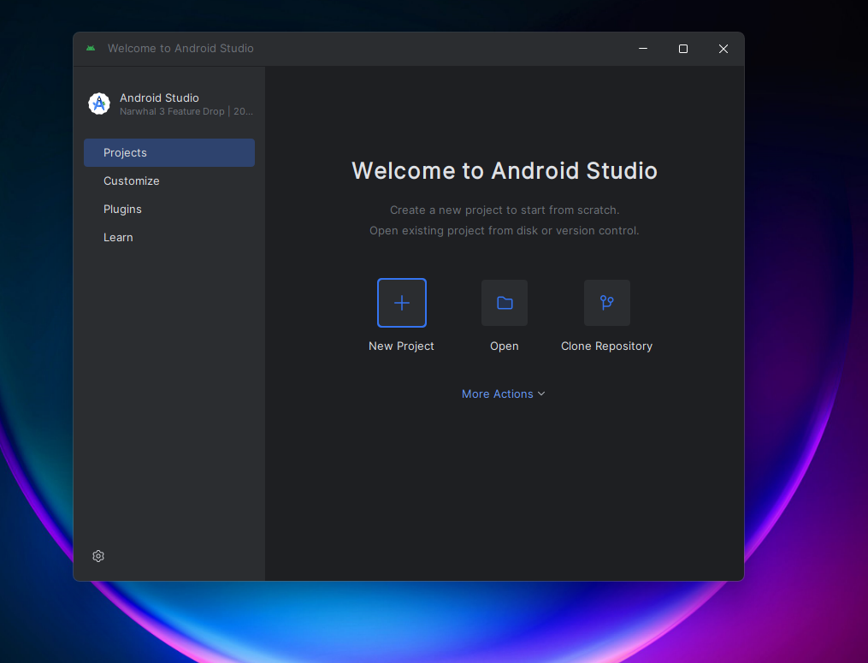

activity_main.xml

<?xml version="1.0" encoding="utf-8"?>  
<RelativeLayout xmlns:android="http://schemas.android.com/apk/res/android"  
 xmlns:app="http://schemas.android.com/apk/res-auto"  
 xmlns:tools="http://schemas.android.com/tools"  
 android:layout_width="match_parent"  
 android:layout_height="match_parent"  
 tools:context=".MainActivity">  
  
 <ImageView  
 android:id="@+id/imageView"  
 android:layout_width="match_parent"  
 android:layout_height="match_parent"  
 android:contentDescription="Canvas for drawing shapes" />  
  
</RelativeLayout>

MainActivity.java

package com.example.graphicalprimitivesapp;   
  
import androidx.appcompat.app.AppCompatActivity;  
  
import android.graphics.Bitmap;  
import android.graphics.Canvas;  
import android.graphics.Color;  
import android.graphics.Paint;  
import android.graphics.Path;  
import android.graphics.drawable.BitmapDrawable;  
import android.os.Bundle;  
import android.widget.ImageView;  
  
public class MainActivity extends AppCompatActivity {  
  
 @Override  
 protected void onCreate(Bundle savedInstanceState) {  
 super.onCreate(savedInstanceState);  
 setContentView(R.layout.*activity_main*);  
  
 Bitmap bgBitmap = Bitmap.*createBitmap*(720, 1280, Bitmap.Config.*ARGB_8888*);  
 ImageView imageView = (ImageView) findViewById(R.id.*imageView*);  
 Canvas canvas = new Canvas(bgBitmap);  
 Paint paint = new Paint();  
 paint.setTextSize(50);  
  
 // 1. To draw a Rectangle  
 paint.setColor(Color.*BLUE*);  
 canvas.drawText("Rectangle", 420, 150, paint);  
 canvas.drawRect(400, 200, 650, 700, paint);  
  
 // 2. To draw a Circle  
 paint.setColor(Color.*RED*);  
 canvas.drawText("Circle", 120, 150, paint);  
 canvas.drawCircle(200, 350, 150, paint);  
  
 // 3. To draw a Square  
 paint.setColor(Color.*GREEN*);  
 canvas.drawText("Square", 120, 800, paint);  
 canvas.drawRect(50, 850, 350, 1150, paint);  
  
 // 4. To draw a Triangle  
 paint.setColor(Color.*MAGENTA*);  
 paint.setStyle(Paint.Style.*FILL*);  
 canvas.drawText("Triangle", 480, 800, paint);  
  
 Path trianglePath = new Path();  
 trianglePath.moveTo(550, 850); // Top point  
 trianglePath.lineTo(450, 1050); // Bottom-left  
 trianglePath.lineTo(650, 1050); // Bottom-right  
 trianglePath.close();  
  
 canvas.drawPath(trianglePath, paint);  
  
 // 5. To draw a Line (with adjusted position for better spacing)  
 paint.setColor(Color.*BLACK*);  
 paint.setStrokeWidth(10);  
   
 canvas.drawText("Line", 530, 1170, paint);  
   
 canvas.drawLine(450, 1200, 650, 1200, paint);  
  
 // Finally, set the Bitmap as the content of the ImageView  
 imageView.setImageDrawable(new BitmapDrawable(getResources(), bgBitmap));  
 }  
}

